- Create “Azure AI Services” in any region of your choice
- Create a storage account
Use below configuration
- Name: Any name, Region: Any region
- Primary Service: Azure Blob storage or azure Data Lake Storage Gen2
- Performance: Standard
- Redundancy: LRS
- Review and create and then Create
Create following containers with exact same name as mentioned below
- feedback
- processed-feedback
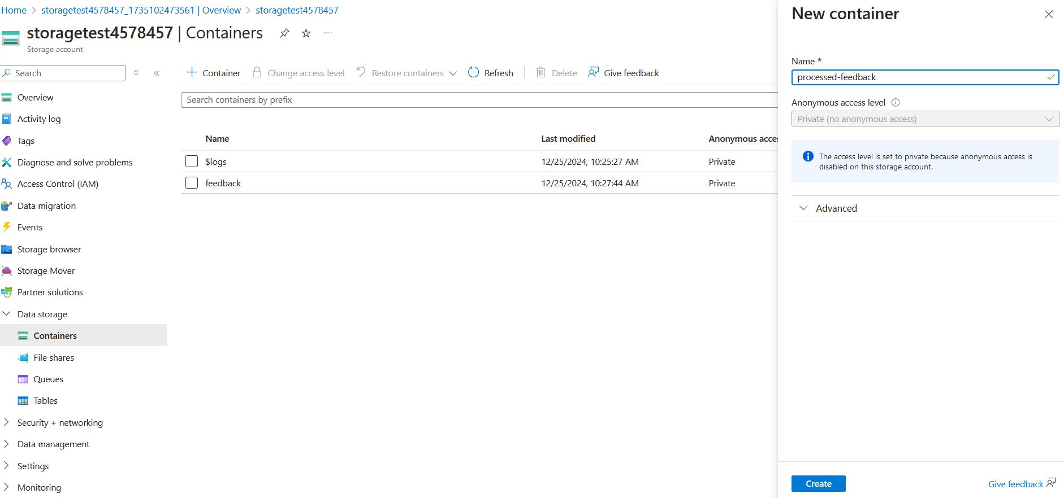
Add the test.txt file (available in the workshop folder) to the feedback container
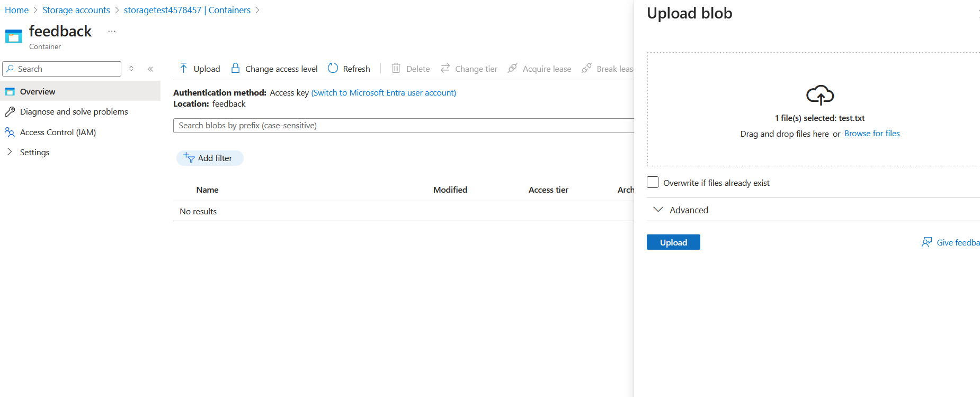

- Create function app
You can use the configuration as mentioned below
- Plan: Consumption
- Name: Any Name of your choice, Region: Any available region
- Runtime Stack: Node.js
- Version: 20LTS
- OS: Windows
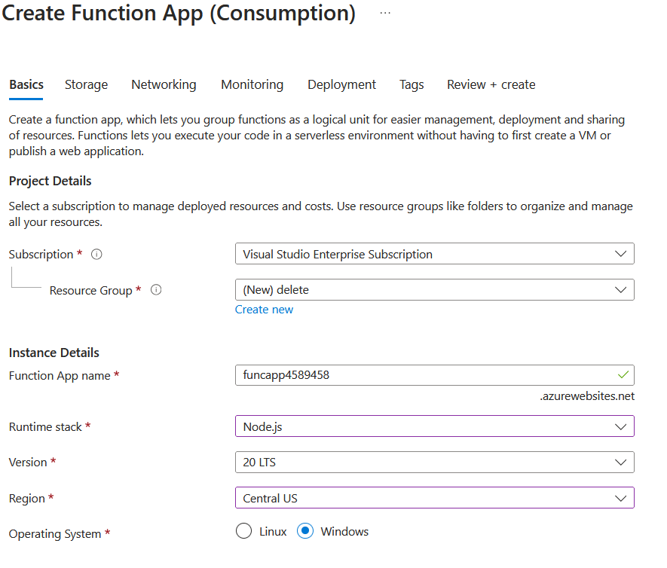
- Click on “Review + Create” and then create to create the function app

- Add function to functionapp
- Go to Overview Click on “Create function”
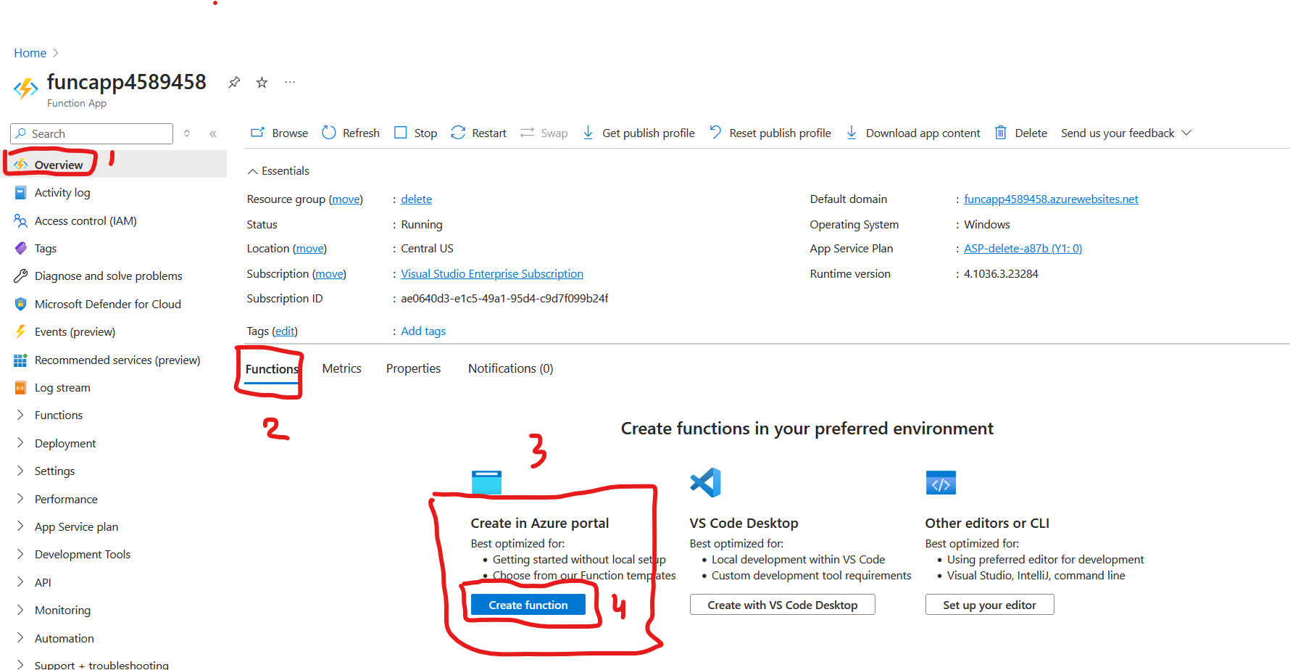
- Select template: Azure Blob Storage trigger
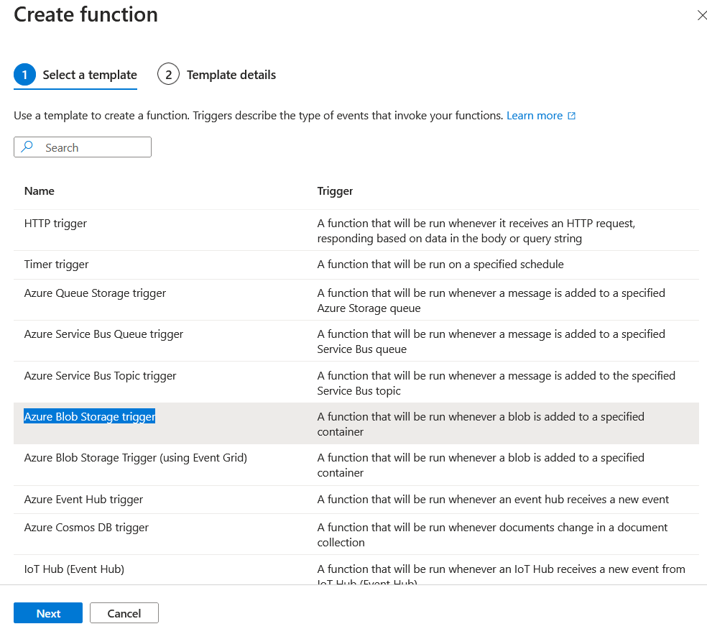
Click on Next
- Use the details below for template
  - Function name: BlobTrigger1
  - Path: feedback
  - Storage account connection: Click on New and select the storage account you had created earlier
  - Click on Create
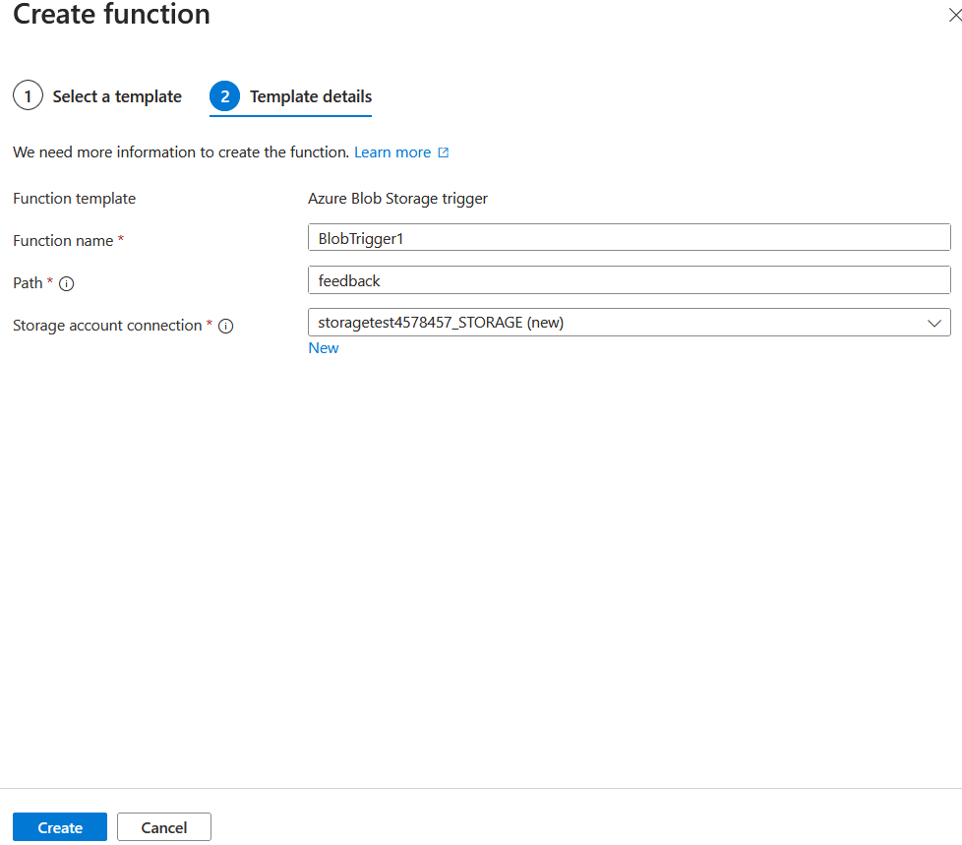
PS: You may get an error message: Failed to create BlobTrigger1, you can ignore it and refresh the page after 1-2 minutes and check if the function is created.
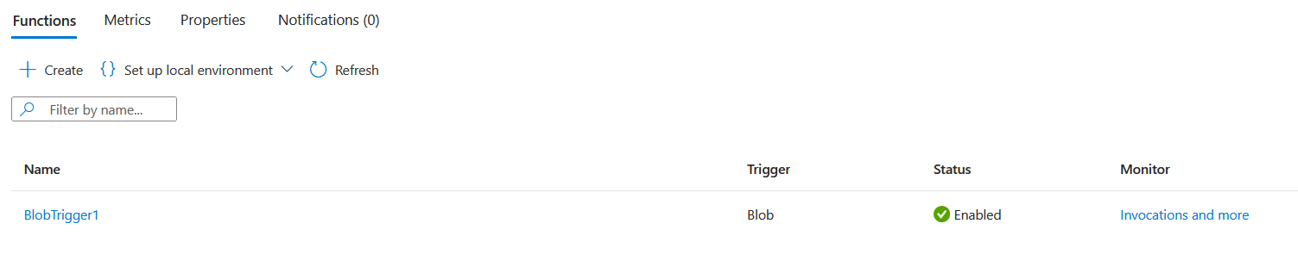
- Add required packages to the function you just created
- In your function app, search for Development tool and go to Advance tool
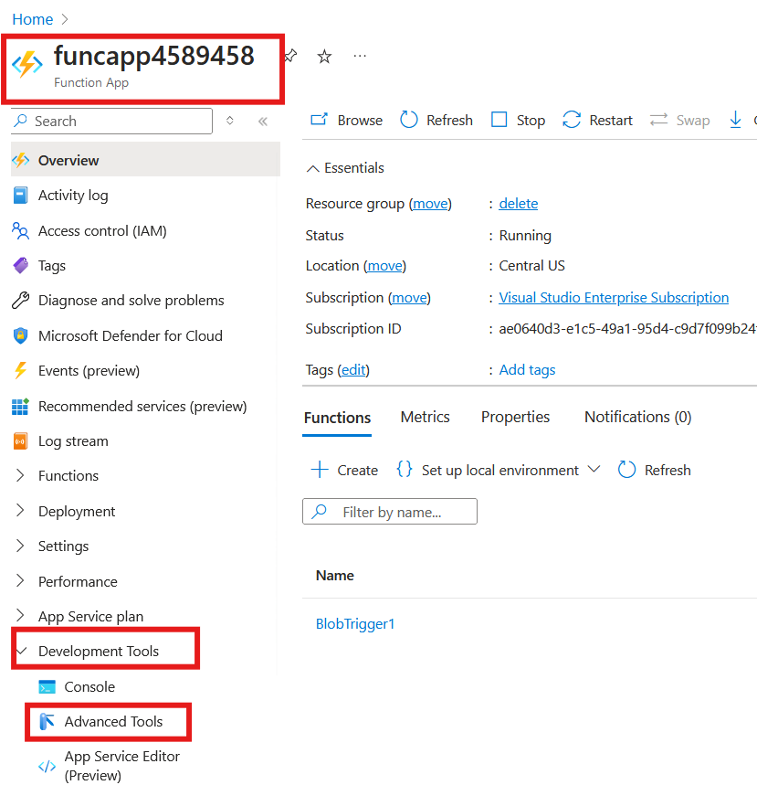

- Click on Go to open the console
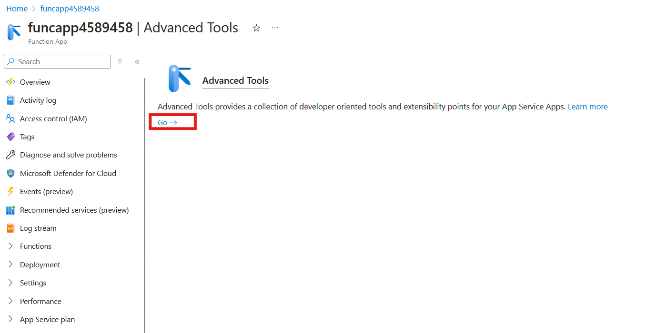
- Go to Debug console and select CMD
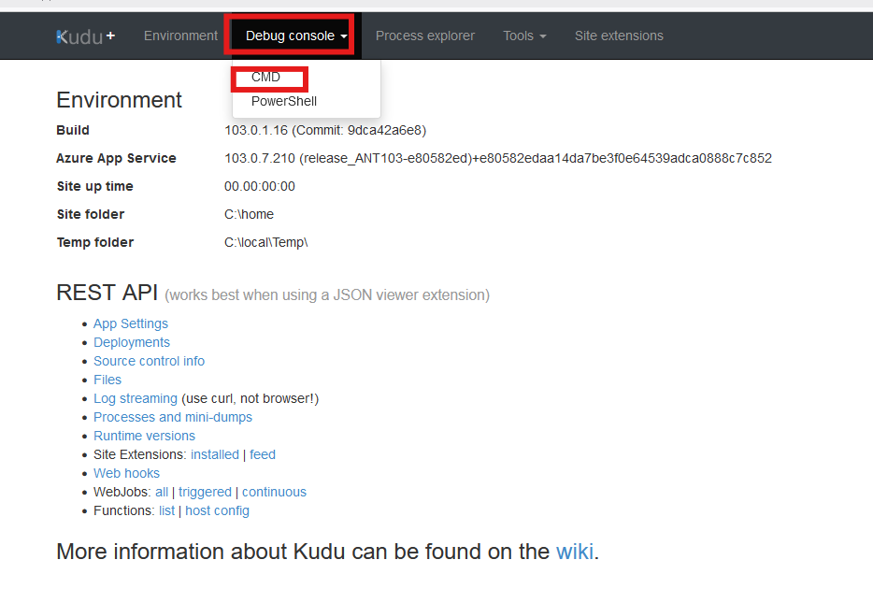
- Navigate to site wwwrootBlobTrigger1
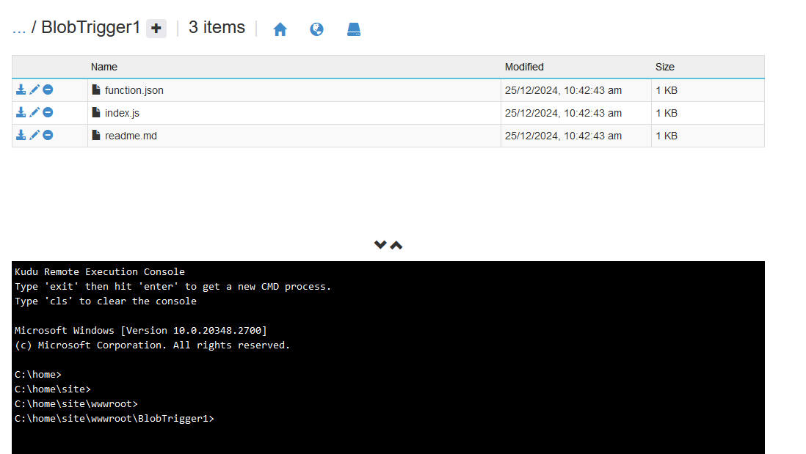
- Click on + => New file and give the file name : package.json
- Edit package.json by clicking on the pencil icon and add packages from the “package.txt” file located in the workshop folder and click on “save”
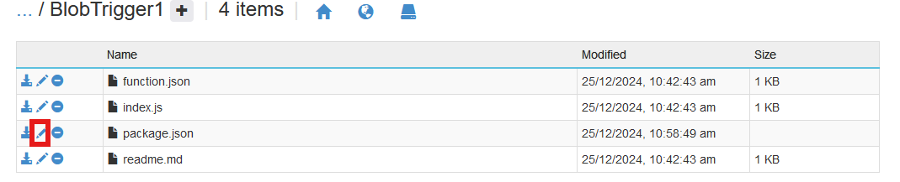

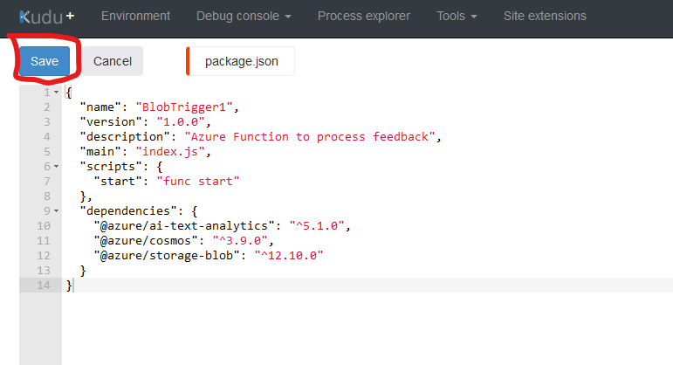
- In the terminal : type “npm install” and press enter
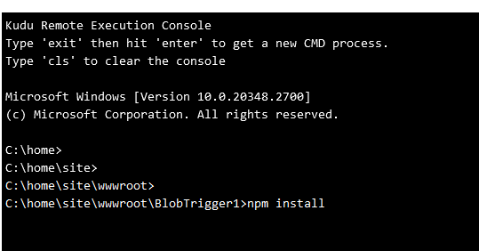
- Wait for few min till you see the message as below, also do note that a “node_modules” folder is also created

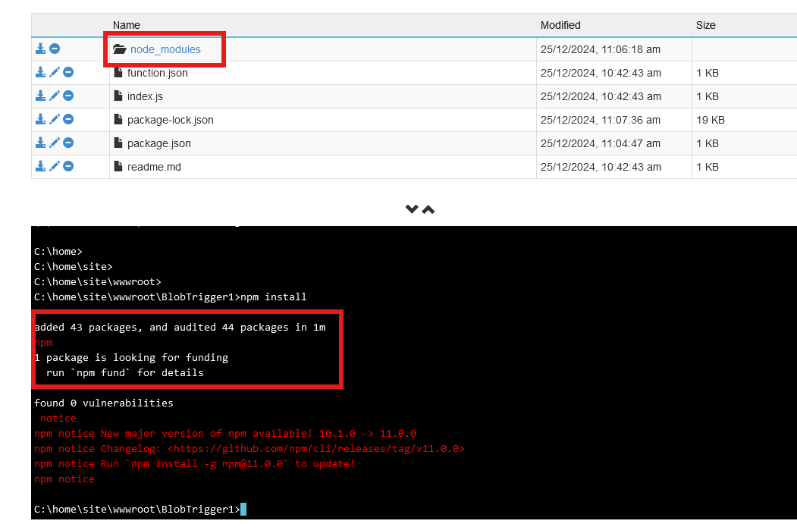

- Add the environment variables to the function app
Set Environment Variables:
- Go to functionapp you have created, Settings Environment Variables
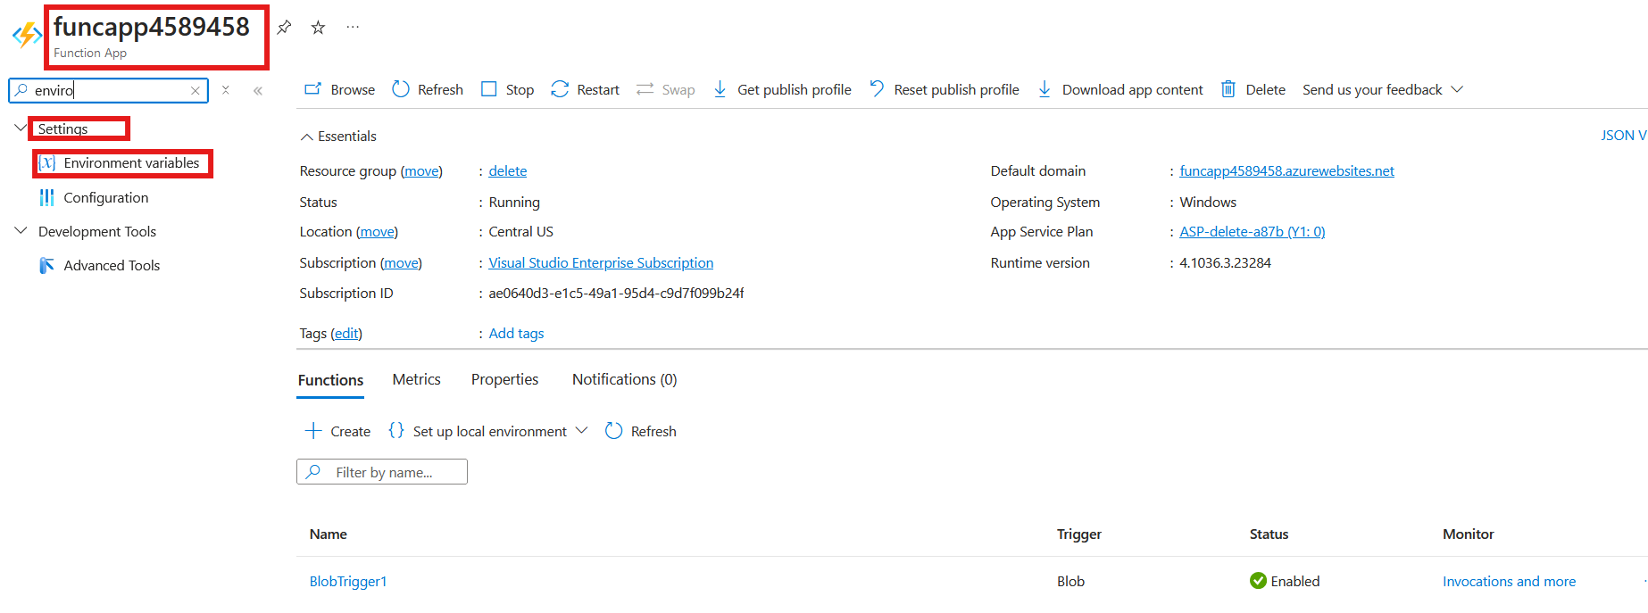
Add the following:
AZURE_TEXT_ANALYTICS_ENDPOINT: Your Azure AI Service endpoint.
AZURE_TEXT_ANALYTICS_KEY: Your Azure AI Service key.
AZURE_STORAGE_CONNECTION_STRING: Your Storage Account connection string.
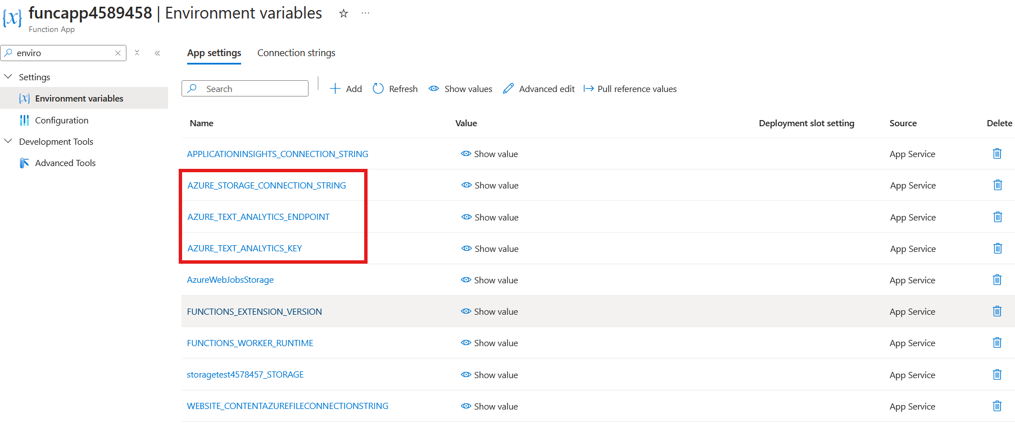
- Save the Configuration:
Click Apply and confirm to save the changes.
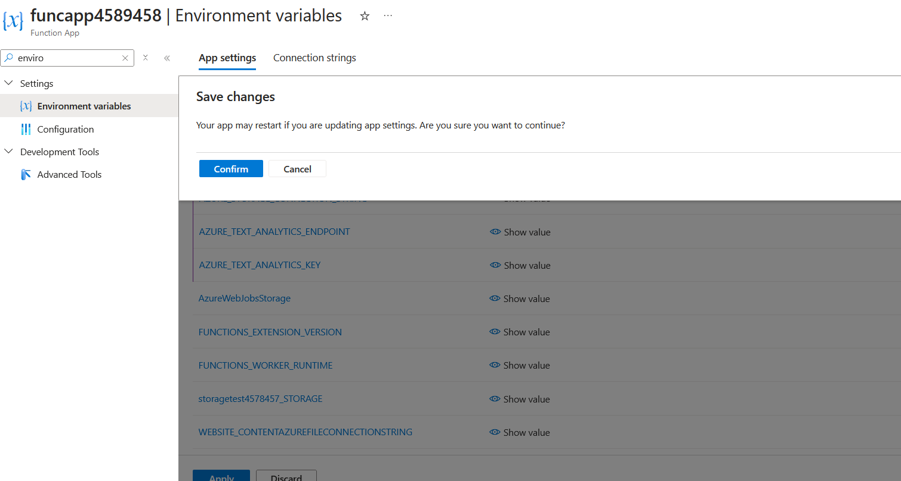

- Add code to the function and test
- Go to the “BlobTrigger1” function you had created earlier
- Click on “BlobTrigger1” and go to Code+test , replace the current code with the one inside “finalfunctioncode.txt” available in the workshop folder shared with you, and click on save
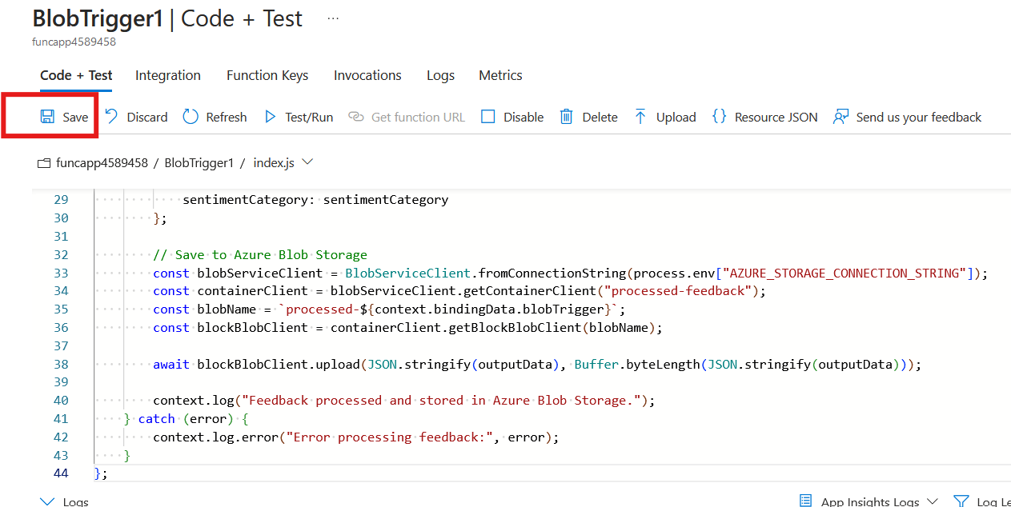
- Go to “test/run” and under input add: feedback/test.txt
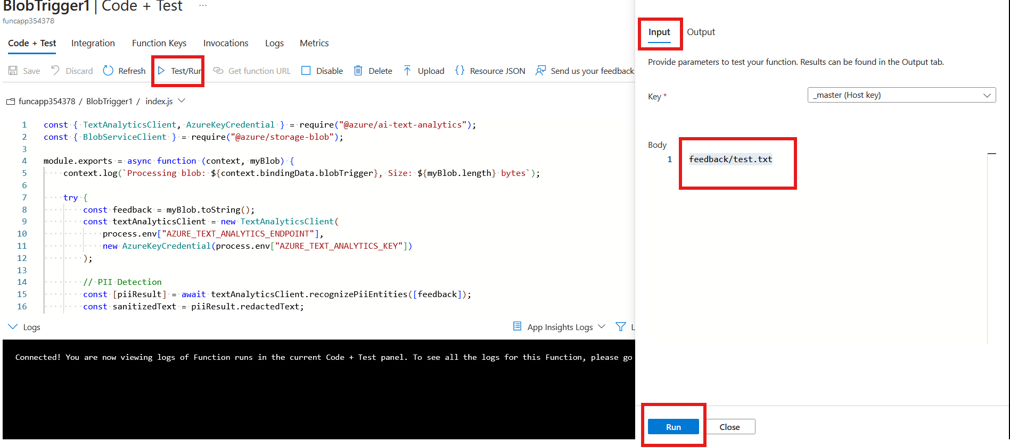

- If all goes well, you will see a success message like this

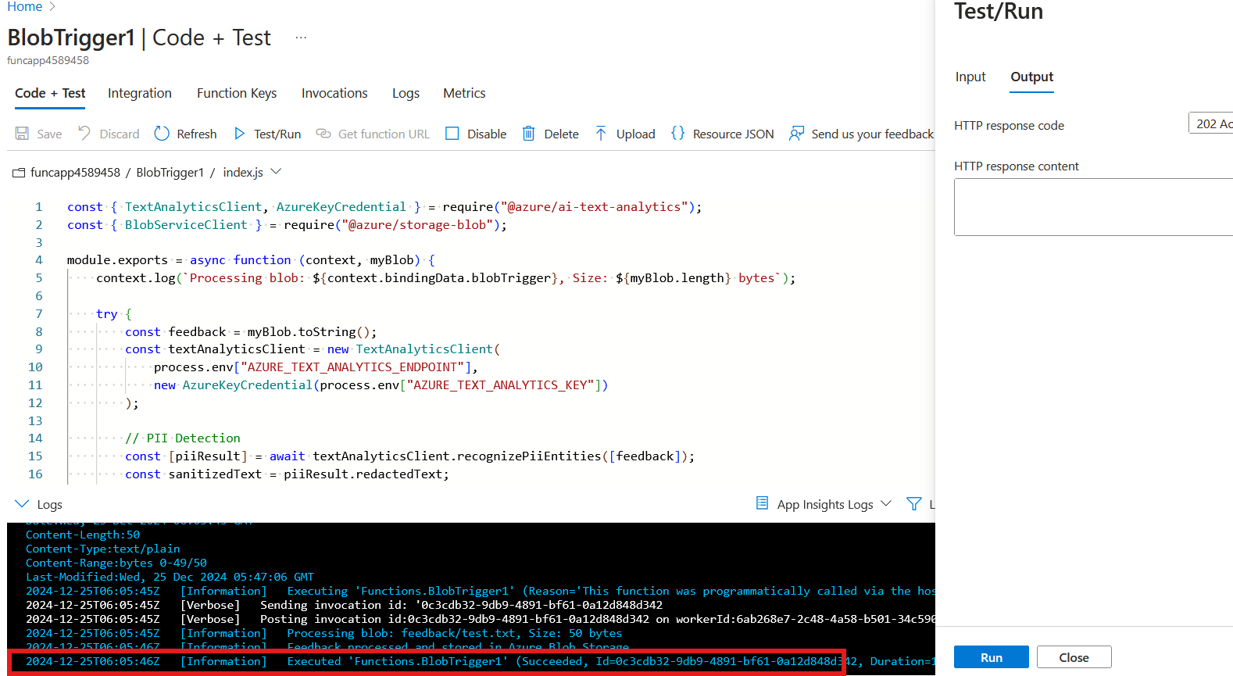

Also, you can go to the storage account, you created earlier and go to the “processed-feedback” container and check the result.
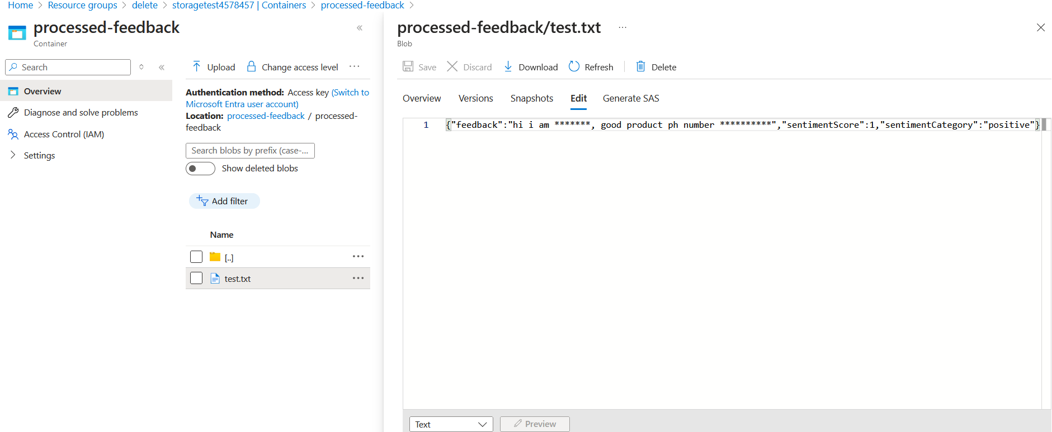

The function (we have created is taking the input from the “test.txt” blob in the “feedback” container of the storage account and using azure ai services PII and sentiment analysis capabilities (removing PII and identifying the sentiment), storing the result in the “processed-feedback” container of the same storage account.

Original text:
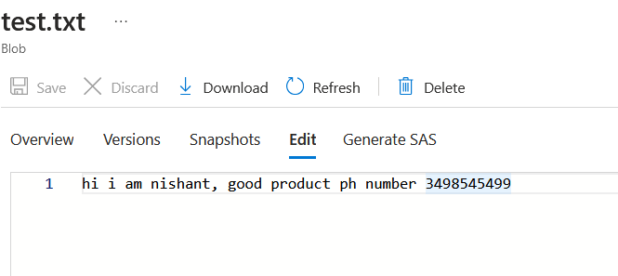

Processed text:
