**Operating System Warmup Project**

Name: Nishant Maurya PID: 5968168

The purpose of the project is to create multiple threads with the help of SimpleThread function given.

To compile the code just go to the directory where the code is stored and type the following commands in the Terminal.

The first command is used to compile and create an object of the program.

The second command is used to run the compiled object.

Command 1: gcc -o WarmupProject_NishantMaurya WarmupProject_NishantMaurya.c -lpthread

Command 2: ./WarmupProject_NishantMaurya

The Output for the program is:

Thread 0

Thread 1

Thread 2

Thread 3

Thread 4

Thread #1 sees value 0

Thread #0 sees value 0

Thread #4 sees value 0

Thread #3 sees value 0

Thread #2 sees value 0

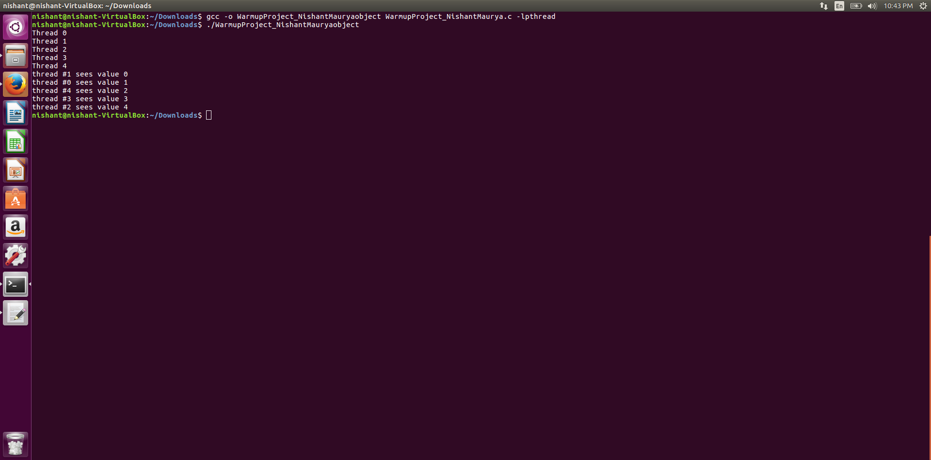

Screenshot of the output for the program