HEALTHCARE

GeekersAhead

Team Details

Participant Name | CT /DT Number | Role (Team Leader / Member) | Bachelors Discipline | Expected Year of Passing | Gender
Mayank | ct20172220946 | TeamLeader | Information Technology | 2020 | M
Ritwik Gupta | ct20182465759 | Member | Electrical Engineering | 2020 | M
Nishkarsh Gautam | ct20172224180 | Member | Information Technology | 2020 | M
Navnit Singh | ct20182406387 | Member | Information Technology | 2020 | M

Healthcare
- Problem Statement

Diabetes is a common chronic disease in mostly all countries worldwide. Blood Glucose Level monitoring is an important tool in managing treatment plan and forms part of diabetes care.It helps us to understand how diet and other factors, such as illness or stress, affect blood sugar levels. Any changes in normal Blood Glucose levels (<100mg/dl) adds to diabetic complications and the organs get prone to damage.

Blood glucose testing is the process used to measure the concentration of glucose in the blood and to obtain average levels. Conventional techniques of Glucose measurement are generally finger prick type of glucose meter or continuous glucose monitor which are invasive methods. Since invasive methods of glucose level measurement are painful, expensive and causes damage to nerves, non-invasive method is used as an alternative. The noninvasive method can be used which facilitates frequent testing, relieves pain and discomfort caused by frequent finger pricks
- Use Case Overview

Glucose monitoring is essential for the achievement of near-normal glycemic control and to avoid potentially dangerous episodes of hypo- and hyperglycemia. Self-monitoring of blood glucose (SMBG) has been a cornerstone of modern diabetes treatment with the introduction of home blood glucose monitors, but with the grave disadvantages.

Blood glucose level monitoring with invasive devices is both painful and expensive. Error in the results also occurs due to improper patient training, use of damaged or expired test pricks, an uncalibrated meter, an inadequate blood sample, and/or contaminated blood sample.

People with diabetes have longed for a glucose monitor that is non-invasive, non-intrusive, affordable, and allows testing without pain. Our technology works with an invisible infrared light beam that looks into your skin and counts glucose molecules.
This process is fast, painless, and cost-effective. You will be able to perform an unlimited amount of measurements and learn about your blood glucose level as it changes throughout the day and overnight.

- Use Case Description
  - Current system

Blood glucose monitoring is a way of testing the concentration of glucose in the blood (glycemia) particularly important in diabetes management. Hypo and Hyperglycemia are big medical emergencies involving serious complications including heart, kidneys and eyes. Blood glucose monitoring reveals individual patterns of blood glucose changes, and helps in the planning of meals, activities, and at what time of day to take medications.

A blood glucose test is typically performed by piercing the skin (typically, on the finger) to draw blood, then applying the blood to a chemically active disposable 'test-strip'. This strip is then inserted into the meter, which reads the strip and displays a number  your blood glucose level. Different manufacturers use different technology, but most systems measure an electrical characteristic, and use this to determine the glucose level in the blood. The test is usually referred to as capillary blood glucose.

The importance of monitoring and the optimal frequency of monitoring are not clear. Pain occurs from a lancet pricking of the finger-tip to produce the required blood drop for testing. Test strip problems, extreme temperatures, inadequate blood amount, testing site location
are some of the big problems which cause inaccurate reading.

  - Proposed solution

The proposed work is based on NIR(Near Infrared Sensor) optical technique. 940nm wavelength of light is chosen by referring to recent studies on blood glucose measurement using NIR. The sensing unit consists of NIR emitter and NIR receiver (photo detector) positioned on either side of the measurement site (fingertip/earlobe/forearm) . When the NIR light is propagated through the fingertip, it interacts with the glucose molecule, and a part of NIR light gets absorbed depending on the glucose concentration in blood and the remaining part is passed through the finger tip. The amount of NIR light passing through the fingertip depends on the amount of blood glucose concentration in the blood. The variation in the intensity of NIR light received from the photo detector after passing through the finger is used to determine the blood glucose level.
The output current of the photo detector is converted into voltage signal and is then filtered and amplified. This amplified signal is then fed into Arduino Uno Microcontroller. The inbuilt ADC(Analog Digital Convertor) block is used for converting the received analog signal to digital form. The data thus collected is processed by using a Machine Learning Algorithm (Linear /Polynomial Regression analysis) to predict the blood glucose value which is displayed on the LCD(16X2) display. A mobile application (App) is created in order to view and store the predicted blood glucose value after receiving it via Bluetooth. The Arduino Uno microcontroller communicates to the mobile app via Bluetooth by connecting a Bluetooth module (HC-05) to it. The flow chart of proposed work is shown below.
The measured glucose level is displayed in LCD display and also transmitted to the android application which is created in the mobile phone to display and store data via Bluetooth (HC-05 sensor)

- Architecture
The ERD (Entity Relationship Diagram) for the above solution is given below.
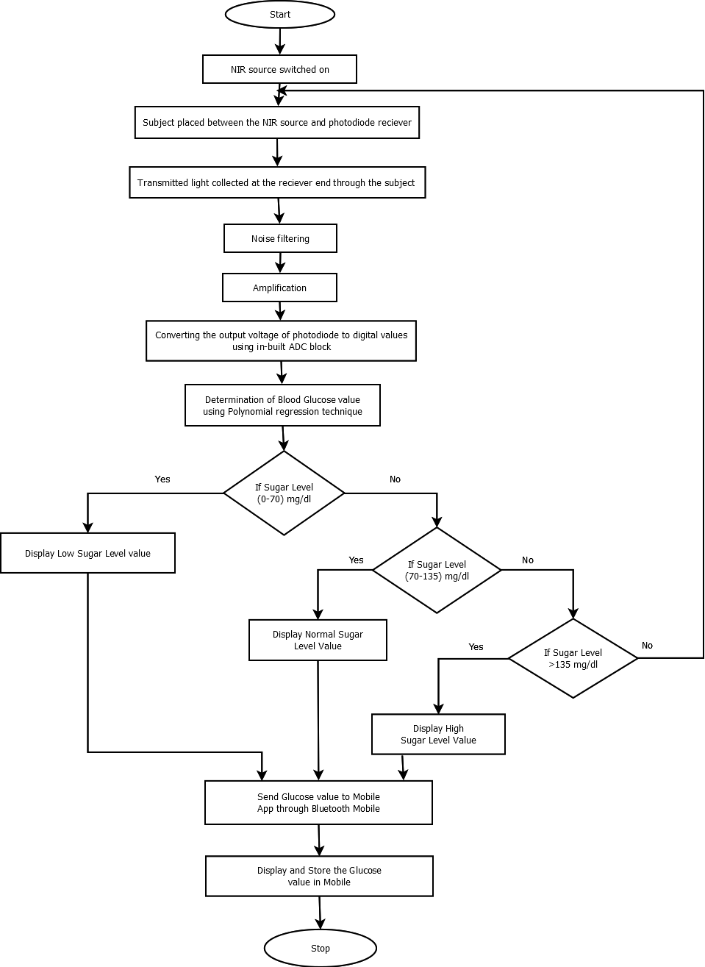
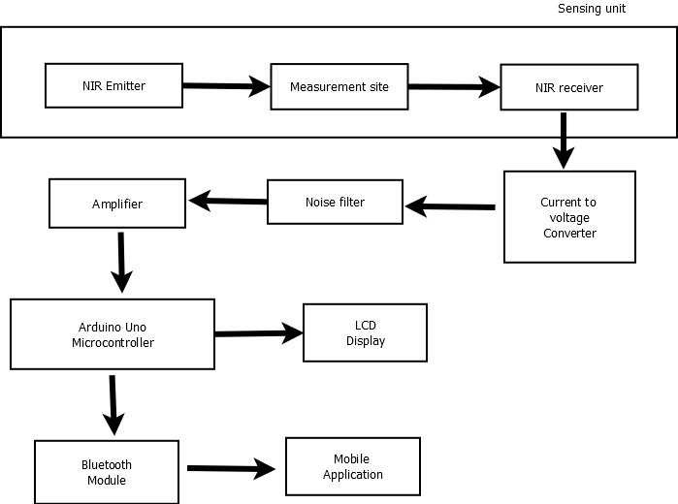
FLOW DIAGRAM AND CIRCUIT DAIGRAM

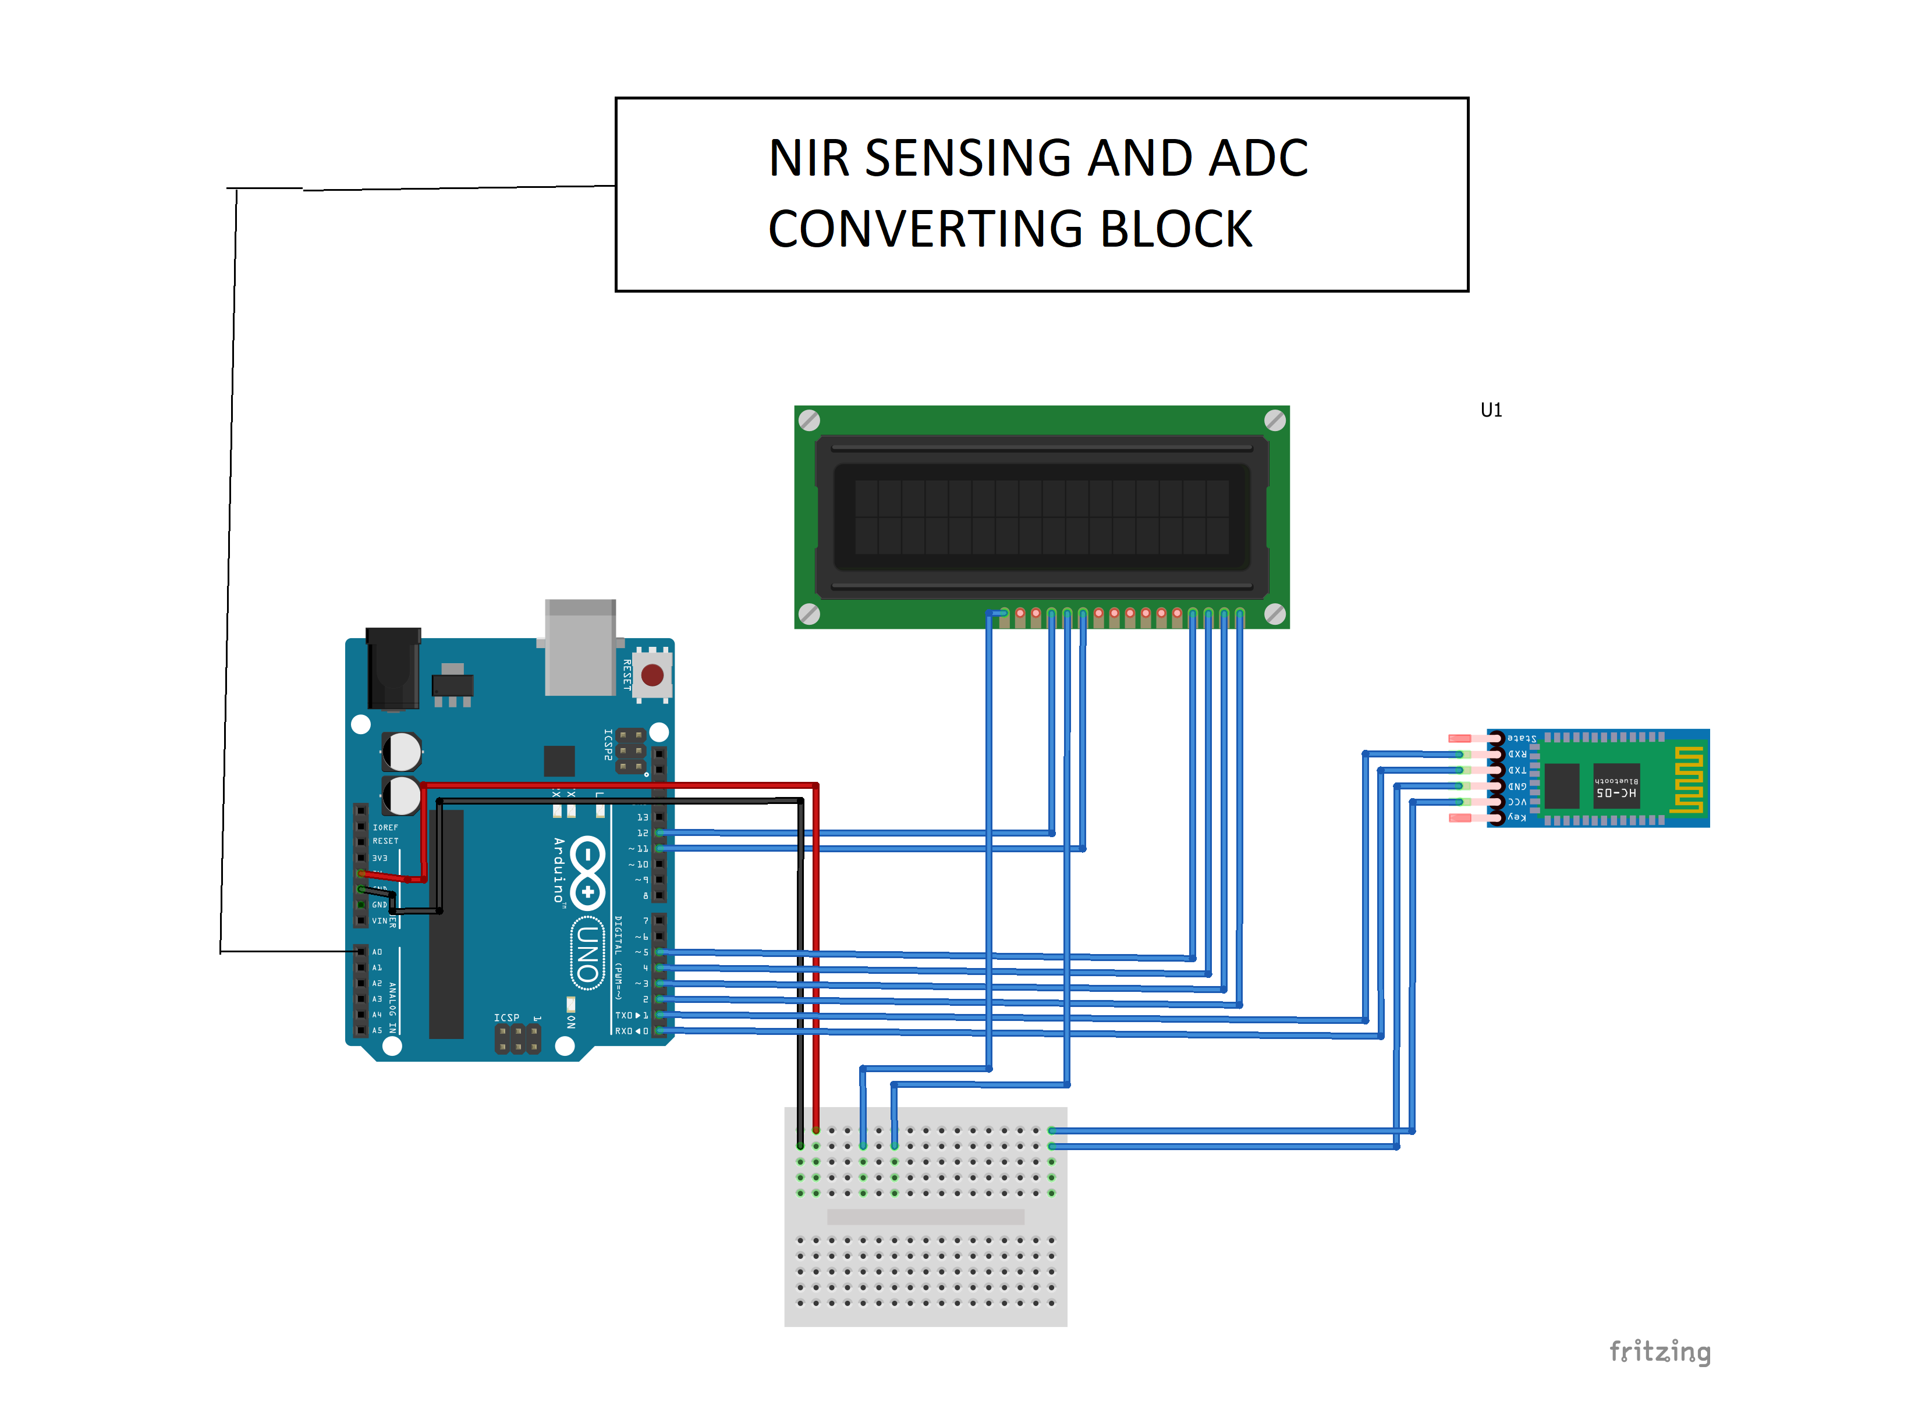

Unlike the generic invasive methods to measure blood glucose level, the proposed system uses non-invasive method to determine the glucose concentration in the subjects blood. The real time values of the blood glucose concentration is collected and sent to the smartphone using the Bluetooth sensor (HC-05). The system operates on IOT (Internet of Things) technology, as the data collected from the sensors in automatically sent over the smartphone by either using a Bluetooth module or a WiFi module.
Glucose level of the individuals is measured in the laboratory by the invasive method and at the same time the analog voltage corresponding to their glucose level is also measured. Machine Learning algorithms (Linear/Polynomial regression) are applied upon the data collected and a best fit line is obtained from the graph. The glucose level corresponding to the voltage The glucose level in the blood which is obtained from the photo detector is displayed in both the LCD display and the developed mobile app
- Productization

The proposed solution is still in prototype stage, and a lot of research and development is still under process, as a result the product is not ready for the current market. However, it has been shown in the past over and over again that it is in principle, possible to monitor glucose changes in the human body by Non Invasive systems.

- Tools and Environment

  - Simulation & Testing
The Clarke error grid analysis is used for analyzing accuracy in commercial glucose monitoring devices which are used in self-monitoring of glucose. The error grid analysis is done using MATLAB software where the reference glucose value and predicted glucose value is given as input data and the result obtained.
  - Cloud

Google Clouds IOT platform will be used as our cloud support of the project
  - Physical
Arduino Uno Microcontroller, mini breadboard HC-05 sensor / ESP 8266 wifi module, NIR sensing and ADC converter circuit and Android Smartphone are the hardware used in this
  - Interface
16x2 LCD display as well as an Android app is used for displaying the real-time values of the blood glucose level.
- References :

- https://www.diabetesaustralia.com.au/blood-glucose-monitoring
- https://www.slideshare.net/BariBerger/blood-glucose-monitoring
- https://bmjopen.bmj.com/content/5/1/e006579
- http://care.diabetesjournals.org/content/25/12/2268
- http://www.integrity-app.com/the-diabetes-market/glucose-monitoring-market/

