VITyarthi | Open Source Software



The Open Source Audit

A Capstone Project for OSS NGMC Course

Course: Open Source Software

Student Name | Registration Number
NISHA | 24BAI10441
Slot | Date of Submission
E11 | 31st March 2026

Introduction
In today’s digital world, a large part of software development relies on open-source technologies. Unlike proprietary software, open-source systems are built collaboratively and made available for anyone to use, study, and modify. This approach encourages transparency, faster innovation, and a shared learning environment among developers.
Python is one of the most widely used open-source programming languages today. It is known for its simple and readable syntax, which makes it suitable for beginners, while also being powerful enough for advanced applications like data science, web development, and automation. Its flexibility and strong community support have contributed to its rapid growth and adoption.
In this project, I examine Python as an open-source software system, focusing not only on what it does but also on why it was created, how it is licensed, and how it fits into the broader open-source ecosystem. This analysis helps in understanding the importance of collaboration, openness, and shared development in modern computing.

Your choice | Write your chosen software here before submission: Python

Part A — Origin and Philosophy (Units 1 & 2)

A1. The problem this software was created to solve
When Guido van Rossum created Python in 1991, most programming languages were not easy to use. Languages like C and C++ were powerful, but they were also quite complicated. They required a lot of detailed coding, manual memory handling, and a good understanding of system-level concepts. Because of this, programming was difficult for beginners and also time-consuming for developers.
At that time, there wasn’t really a language that was both simple and powerful at the same time. Some languages were too low-level, which made them hard to learn and slow to use, while others were not flexible enough for different types of applications. This created a gap that needed to be filled.
To solve this problem, Python was designed with a few clear goals in mind:
Main Goals:
- Make code easy to read and understand
- Reduce complexity with simple syntax
- Help developers focus more on logic than on writing complicated code
- Allow use in different areas like scripting, automation, web development, etc.

Another issue was productivity. In languages like C and C++, even simple programs needed many lines of code. This not only took more time but also increased the chances of errors. Python improved this by allowing developers to write shorter and cleaner code, which is easier to manage.
Python also improved readability by using indentation to structure code. This made programs look cleaner and more organized. Because of this, it became easier for developers to understand each other’s code and work together.
One more important decision was making Python open source. Instead of keeping it restricted, it was made freely available so that anyone could use it, modify it, and improve it. This helped Python grow quickly, as developers from around the world started contributing to it.
In simple terms, Python was created to make programming easier, faster, and more accessible. Its simple design and open-source nature are the main reasons why it is so widely used today.

A2. The license — what it actually says

In May 2000, Guido van Rossum and the core Python development team moved to BeOpen.com and formed the PythonLabs team. Later that same year, the team shifted to Digital Creations (which later became Zope Corporation). In 2001, the Python Software Foundation (PSF) was established as a non-profit organization to manage and protect Python’s intellectual property. Since then, the PSF has played an important role in maintaining and supporting Python’s development.

🔹 Four Freedoms of Free Software
The concept of free software is based on four basic freedoms:
- Freedom to run the program for any purpose
- Freedom to study how the program works and access its source code
- Freedom to modify the software according to needs
- Freedom to distribute copies, either original or modified

Python provides all four of these freedoms. Users can access its source code, make changes, and share it with others. In my understanding, this openness is one of the main reasons why Python has become so popular. It gives both beginners and developers the flexibility to learn and use it without restrictions.

Can a Company Modify and Sell Python?
Yes, a company can use Python, modify it, and even include it in commercial products without making their changes public.
This is because Python uses the PSF license, which is a permissive license. Unlike stricter licenses, it does not force companies to share their modified source code. However, companies still need to follow some basic rules, such as giving proper credit to the original software and including the license terms.

Difference Between GPL and MIT License
GPL and MIT are both open-source licenses, but they work in different ways:
- GPL License (General Public License):
This is a strict or “copyleft” license. If someone modifies the software and distributes it, they must also share their modified version openly. This ensures the software always remains open source.
- MIT License:
This is a permissive license. It allows users to modify and use the software freely, even in private or commercial projects, without the need to share changes.
Python’s PSF license is quite similar to the MIT license because it is flexible and easy to use.
If I were to build my own software, I would prefer a permissive license like MIT or PSF. The main reason is that it allows more people to use and adopt the software easily, which can help it grow faster.

“Free as in Free Beer” vs “Free as in Freedom”
There is a clear difference between these two ideas:
- Free as in free beer means something is available at no cost
- Free as in freedom means users have the right to use, modify, and share it

Python is free in both ways. It can be downloaded and used without any cost, and at the same time, users are free to modify and distribute it according to their needs.
For example, anyone can download Python for free and even customize it for their own projects. This shows that Python supports both cost-free usage and user freedom.

A3. The ethics of open source

Open source is not just about making software available for free; it is also about sharing knowledge and encouraging collaboration among developers. It creates an environment where people can learn from each other and improve software together. Python is a good example of this, as it has grown over time with contributions from a global community, focusing on simplicity and usability.

Should all software be open source?
There are valid arguments on both sides of this question.
- On one hand, open-source software like Python allows anyone to use, study, and modify it freely. This makes learning easier for students and beginners, especially because Python’s simple syntax and indentation make it more understandable compared to many other languages. In my opinion, this openness makes technology more accessible and encourages people to learn and experiment without restrictions.
- On the other hand, not all software can or should be open source. Many companies invest a lot of time, effort, and money into developing their products, so they may prefer to keep them private to protect their business. There are also concerns related to misuse and security. In some cases, especially in sensitive systems, making everything open may not be the best option.
Overall, I feel that while open source is highly beneficial, it may not be suitable for every type of software. A balance between open and proprietary systems is necessary.

Is it ethical for companies to profit from open source?
Companies like Red Hat, Google, and Meta use open-source technologies such as Linux and Python in their products.
This can be considered ethical if companies also contribute back to the community. Many organizations improve the software, fix issues, and provide tools or support, which helps the ecosystem grow.
However, if a company only uses open-source software for profit without giving anything back, it may not feel fair. In my opinion, companies should contribute in some way, such as sharing improvements or supporting development, so that the community also benefits.

“Standing on the shoulders of giants” in software
The phrase “standing on the shoulders of giants” means building new ideas based on existing work.
In the context of software, this means developers use existing open-source tools, libraries, and frameworks to create new applications. Open source actually supports innovation because it saves time and allows developers to focus on new ideas instead of starting from scratch.
While some people may think it reduces originality, I believe it actually encourages creativity. By providing a strong foundation, open source helps developers build better and more advanced solutions.

Part B — Linux Footprint (Unit 2)

In this section, I explored how Python works within a Linux-based environment. For this, I installed Python on my system and worked with it through the terminal. Linux is widely used for development purposes, and Python is one of the most commonly available programming languages on it.
While doing this, I observed how Python is installed, where its files are stored, and how it interacts with the operating system. This gave me a better understanding of how open-source software actually works in a real system, instead of just learning it theoretically. It also gave me some hands-on experience, which was helpful.

- Installation method — is it available via RPM, apt, or must it be compiled from source?
-Python is usually pre-installed on most Linux distributions. Sometimes, if it isn’t available, it can be installed using the package manager.

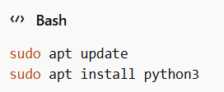

This shows that Python can be easily available and installed through APT (Advanced Package Tool), and there is no need to compile it manually in most of the cases.
- Key directories — where are its binaries, config files, and logs stored? (e.g., /usr/bin, /etc, /var/log)
-After installation, Python files are stored in different directories in the Linux system:
- /usr/bin/python3 → contains the Python executable files
- /usr/lib/python3 → contains standard libraries
- /etc/python3 → contains configuration files
- /var/log → stores system logs (not specific to Python but useful for debugging)
These directories help in organizing the software and separating executable files, libraries, and configurations.
- User and group — what Linux user and group does it run under? Why does this matter for security?
-Python runs under the current logged-in user by default. It does not require a special system user like some services (e.g., web servers).
This is important for security because:
  - It limits access based on user permissions
  - Prevents unauthorized system-level changes
  - Ensures that users only access their own files and not others
In my opinion, this makes Python safer and easier to use for regular users.

- Service management — can it be started, stopped, or restarted as a service? Show the commands.
-Python itself is not a background service, so it cannot be directly started or stopped like a service using systemctl.
However, Python scripts can be used to create services. For example, a Python-based application can be managed using systemd with commands like:

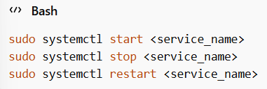

This shows that Python can still be used in service-based applications even though it is not a service itself.
- Update model — how does the open-source community push security patches to your machine?
-Python is updated through the Linux package manager and the open-source community.
Users can update Python using:

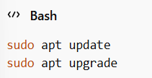

The open-source community regularly releases updates, bug fixes, and security patches. These updates are then distributed through Linux repositories. In my opinion, this update system is reliable because it ensures that users get secure and updated versions without much effort.

Part C — The FOSS Ecosystem (Units 3 & 4)

No open-source software works in isolation. It always depends on other tools, libraries, and a strong community. Python is a great example of this because it has a very large and supportive ecosystem. It is used in many areas such as web development, data science, automation, gaming, and application development.

- What other open-source tools does it depend on? (Libraries, compilers, runtimes)
Python depends on several underlying tools to function properly. It is mainly written in the C programming language, so it requires a C compiler like GCC for building and maintaining it. It also uses standard system libraries such as libc, which help it interact with the operating system.
In addition to this, Python comes with its own built-in standard library. This library includes many useful modules that make tasks like file handling, mathematics, and data processing much easier. Because of these dependencies, Python runs efficiently and integrates well with the system.

- What has it enabled or inspired? (Forks, spin-offs, tools built on top of it)
Python has helped in the creation of many powerful tools and frameworks. Some popular examples include:
- Django — widely used for building web applications
- Flask — a lightweight framework for web development
- Pandas — used for data handling and analysis
- TensorFlow — used in artificial intelligence and machine learning
In my opinion, Python’s simple syntax and readability make it very popular among developers. Because of this, many new tools and projects continue to be built using Python.

- Where does it fit in the LAMP stack, or how does it relate to the web?
Python also plays an important role in web development. In the traditional LAMP stack (Linux, Apache, MySQL, PHP), Python is often used as an alternative to PHP for backend development.
It works well with:
- Linux (operating system)
- Apache or Nginx (web servers)
- MySQL or PostgreSQL (databases)
With frameworks like Django and Flask, Python can be used to build complete web applications. This shows that Python easily fits into modern web development environments.

- Is there a community — mailing lists, forums, conferences, IRC channels? Who governs it?
One of the biggest strengths of Python is its strong and active community. It is managed by the Python Software Foundation, which supports its development and growth.
Developers contribute to Python through platforms like GitHub. There are also many mailing lists, forums, and conferences such as PyCon where people share knowledge and ideas.
From my perspective, this community plays a major role in improving Python. It helps in fixing bugs, adding new features, and supporting new learners. This strong community support is one of the main reasons why Python is so successful today.

Part D — Open Source vs Proprietary (Critical Analysis)

Dimension | Open Source (PYTHON) | Proprietary Alternative (MATLAB)
Cost | Free to use and download | Paid software, requires license
Security (who can audit the code?) | Source code is open, anyone can review it | Source code is closed, only company can access
Support and reliability | Community support (forums, GitHub, documentation) | Official company support and updates
Freedom to modify | Users can modify and distribute freely | Cannot modify source code
Community vs corporate control | Community-driven (Python Software Foundation) | Controlled by company (MathWorks)
Your overall verdict | In my opinion, Python is easy to use, flexible, and free, which makes it suitable for most users. | Proprietary software like MATLAB offers better official support but is expensive and less flexible.

I have personally worked with Python during this project, which helped me understand how open-source software works in practice. When I compared Python with MATLAB, I realized that both have their own advantages. Python is open-source, so anyone can use it freely, which makes it very suitable for students and beginners. It is also widely used around the world and has a strong community. Many developers use Python for web development, data science, machine learning, automation, and other real-world applications. In contrast, MATLAB provides professional support and some specialized features, especially for technical and engineering work, but it is expensive and not as flexible as Python.

From my experience, I feel that Python is more practical and easier to use in real-world situations. Its simple syntax makes learning easier, and the community support is very helpful when facing problems. Another major advantage is that Python is free to use, which allows users to experiment and build projects without restrictions. In the future, I would like to improve my Python skills and try contributing to open-source projects. This project helped me understand how important open-source software is and how it continues to influence the software industry.

4. Shell Script Tasks

Script 1 — System Identity Report (Unit 1 & 2)
Write a script that introduces the Linux system like a welcome screen. It should display:
- The Linux distribution name and kernel version
- The current logged-in user and their home directory
- System uptime and current date/time
- A message stating which open-source license covers the OS
Concepts to use: variables, echo, command substitution ($()), basic output formatting.

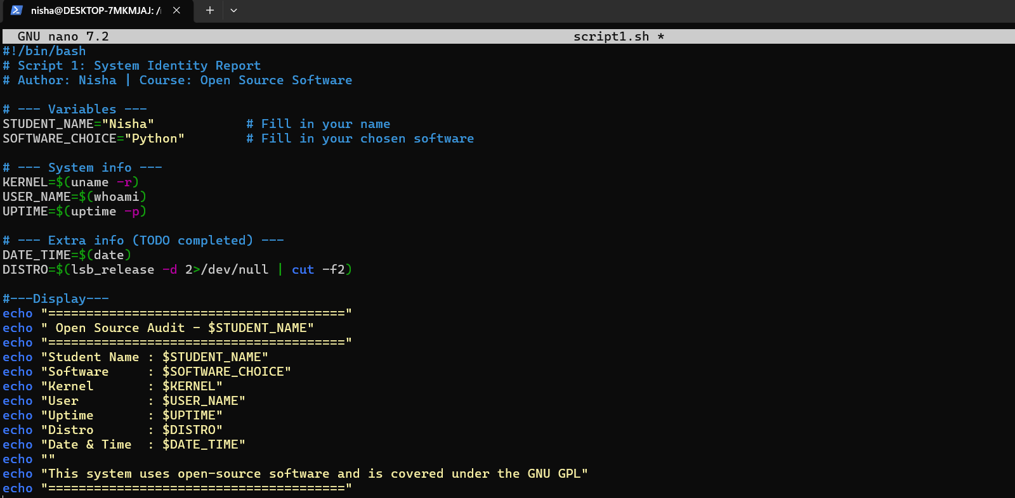

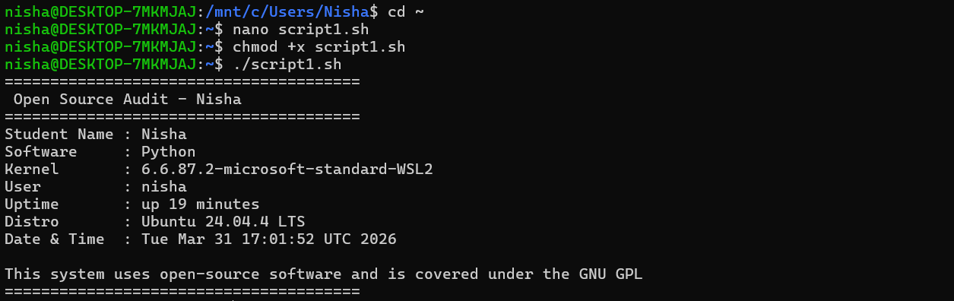

This script displays basic information about my Linux system in a simple and organized way. It shows details like the kernel version, the current user, home directory, system uptime, and the current date and time. While running this script, I understood how commands like uname, whoami, and uptime can be used to fetch real system data. I also learned how variables and command substitution help in making the script more dynamic and readable. Overall, this script gave me a clear idea of how shell scripting can be used to present system information in a user-friendly format.

Script 2 — FOSS Package Inspector (Unit 2)

Write a script that checks whether your chosen software is installed on the system, finds its version, and uses a case statement to print a short description of its purpose based on the package name.Concepts to use: if-then-else, case statement, rpm -qi or dpkg -l, pipe with grep.

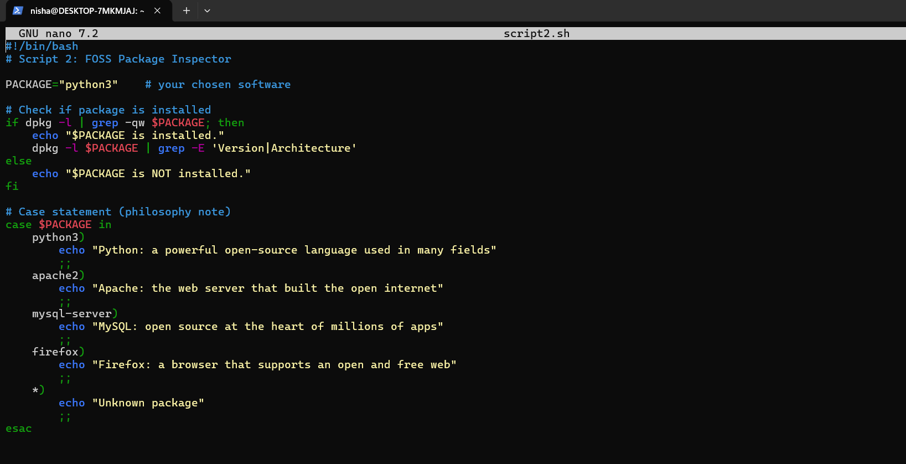

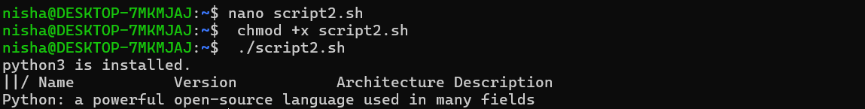

This script checks if Python is installed on my system. When I ran it, it confirmed that Python is already installed and showed its version details. If the software wasn’t installed, it would just display a message saying it is not available. I also used a case statement to give a brief description of Python. In the process, I learned how conditions work in shell scripting and how to check software details using simple commands. This script helped me understand how to access system-level information easily.

Script 3 — Disk and Permission Auditor (Unit 2)

Write a script that loops through a list of important system directories and reports: how much space each uses, and the owner and permissions of the directory. Use a for loop.
Concepts to use: for loop, df, ls -ld, awk or cut to extract fields.

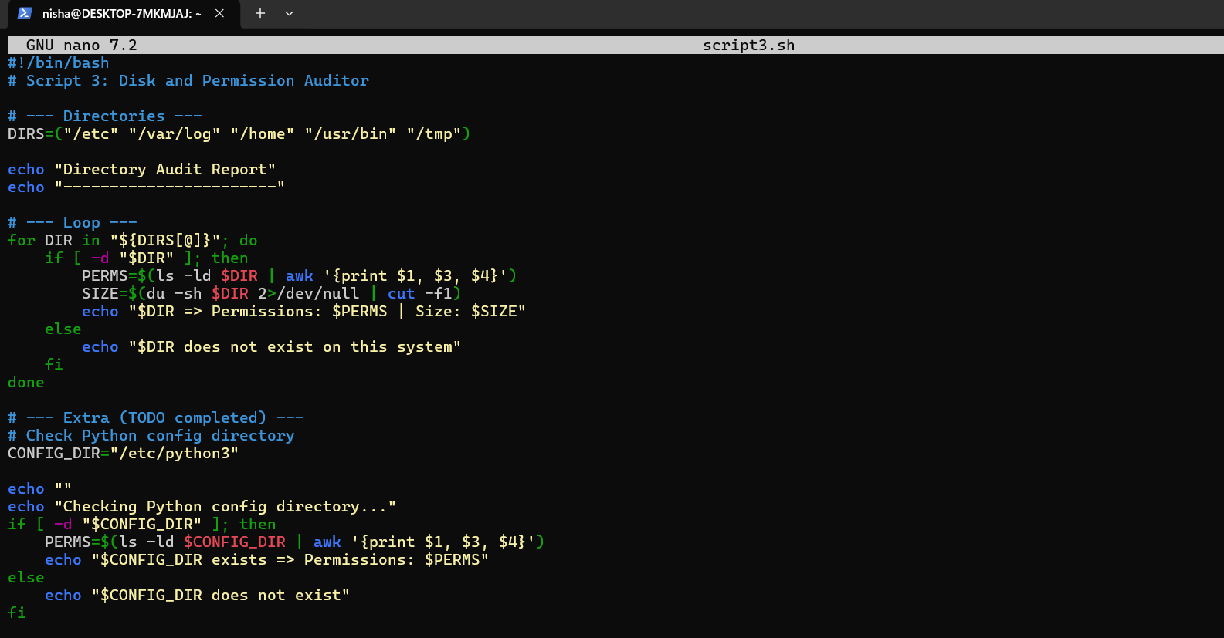

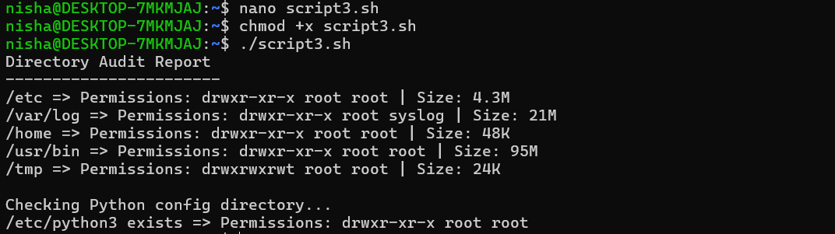

This output shows the details of important system directories on my Linux system. It displays the permissions, owner, group, and size of each directory using basic Linux commands.

While running the script, I observed how different directories have different sizes and permissions. The script also checks the Python configuration directory and confirms whether it exists along with its permissions.

In my opinion, this script helped me understand how file system information can be accessed and analysed using shell scripting in a simple and practical way.

Script 4 — Log File Analyzer (Units 2 & 5)

Write a script that reads a log file line by line, counts how many lines contain a keyword (like ERROR or WARNING), and prints a summary. Use a while-read loop and an if-then inside it.
Concepts to use: while read loop, if-then, counter variables, command-line arguments ($1).

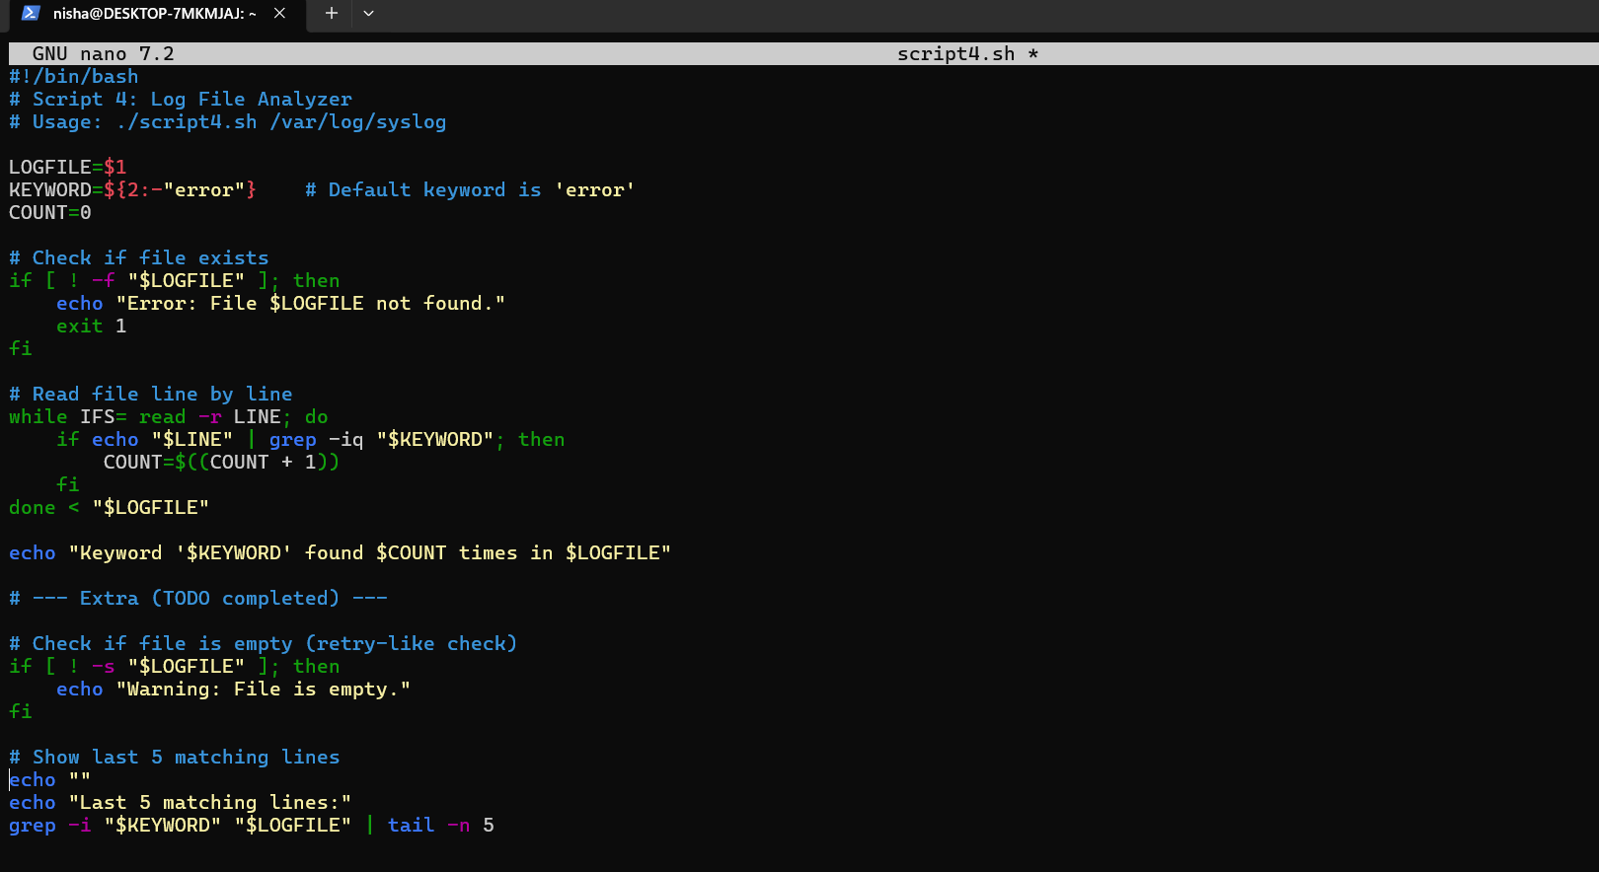

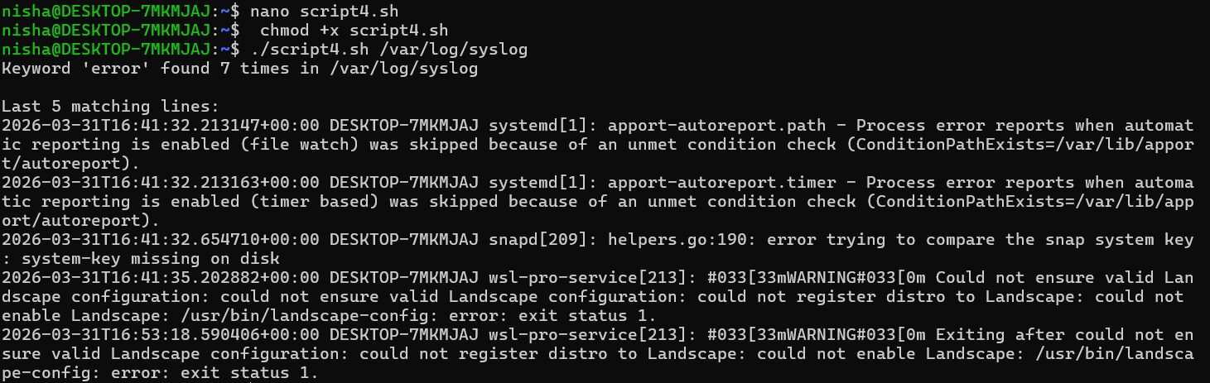

This script counts the instances of a particular keyword (such as "error") in a log file. The script accurately counted the occurrences and displayed the final few lines from the file that matched.
I learned how to read a file line by line using a while loop and how conditions aid in verifying each line while doing this. Additionally, it taught me how to use basic shell commands to analyze log files. All things considered, this script helped me understand how errors can be monitored in a system.

Script 5 — The Open Source Manifesto Generator (Unit 5)

This is the most creative script. Write a script that generates a personalised open source philosophy statement by asking the user three questions interactively, then composing a short paragraph using their answers and saving it to a .txt file.

Concepts to use: read for user input, string concatenation, writing to a file with >, date command, aliases concept demonstrated via a comment.

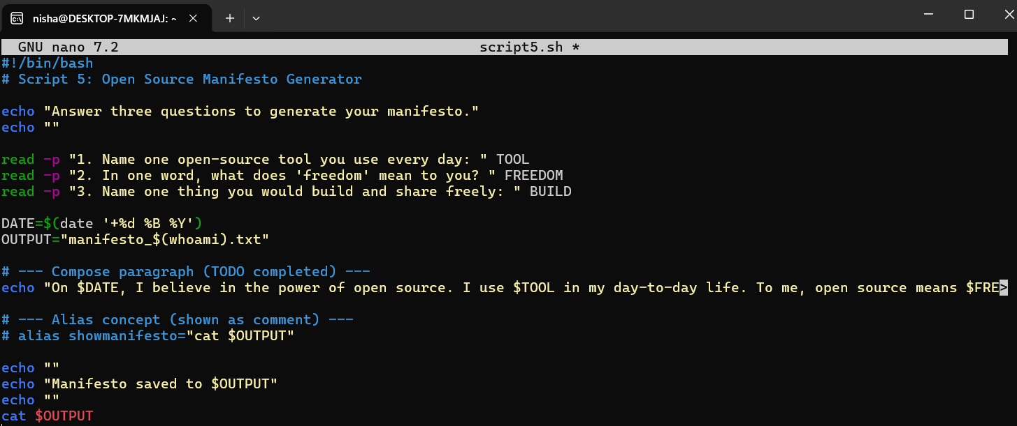

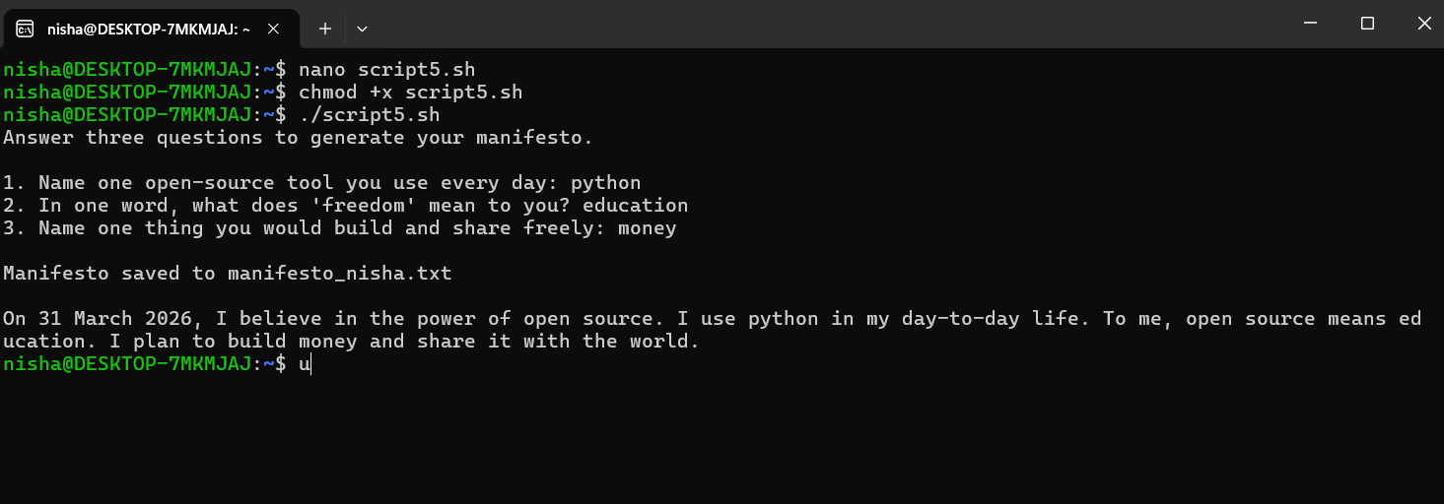

This script creates a simple open-source manifesto by asking a few questions to the user. It took my inputs and produced a brief paragraph based on my responses when I ran it; this paragraph was also saved in a text file. As I worked on this script, I learned how to use the read command to capture user input and how to combine various inputs to create a useful output. I also learned how to write data into a file thanks to it. All things considered, this script was enjoyable to write and demonstrated how shell scripting can be used to produce customized content.

