Name: Nisha Naik

USN:2GI19CS084

1.

package com.mycompany.incrmentbyone;

import java.util.\*;

public class IncrmentByone {

public static void main(String[] args) {

int a,i,n=10000,r=0,n1,d=1;

Scanner in=new Scanner(System.in);

System.out.println("Enter a 5 digit number \n");

a=in.nextInt();

for(i=0;i<5;i++){

n1=(int)a/n;

n1+=1;

r=r\*10+n1 ;

a=a%n;

n/=10;

}

System.out.println(r);

}

}

Output:

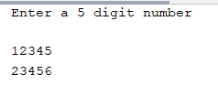

2.

package com.mycompany.denomination;

import java.util.\*;

/\*\*

\*

\* @author Lenovo

\*/

public class Denomination {

public static void main(String[] args) {

int a,d=1,r=0,n=1000;

Scanner in=new Scanner(System.in);

System.out.println("Entet the four digit number");

a=in.nextInt();

for(int i=0;i<4;i++){

r=(int)a/n;

r\*=n;

a%=n;

n=n/10;

System.out.println(r+"\n");

}

}

}

Output:

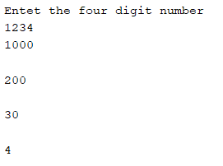

3.

/\*

\* Click nbfs://nbhost/SystemFileSystem/Templates/Licenses/license-default.txt to change this license

\* Click nbfs://nbhost/SystemFileSystem/Templates/Project/Maven2/JavaApp/src/main/java/${packagePath}/${mainClassName}.java to edit this template

\*/

package com.mycompany.countnum;

import java.util.\*;

/\*\*

\*

\* @author Lenovo

\*/

public class CountNum {

public static void main(String[] args) {

int a,c=0;

System.out.println("enter a num");

Scanner in=new Scanner(System.in);

a=in.nextInt();

while(a!=0){

a/=10;

c++;

}

System.out.println(c);

}

}

Output:

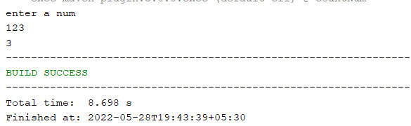

4.

/\*

\* Click nbfs://nbhost/SystemFileSystem/Templates/Licenses/license-default.txt to change this license

\* Click nbfs://nbhost/SystemFileSystem/Templates/Project/Maven2/JavaApp/src/main/java/${packagePath}/${mainClassName}.java to edit this template

\*/

package com.mycompany.pattern;

/\*\*

\*

\* @author Lenovo

\*/

public class Pattern {

public static void main(String[] args) {

int i,j,k;

for(i=1;i<=5;i++){

for(j=1;j<=i;j++) {

System.out.print(j);

}

j=j-1;

for(k=j-1;k!=0;k--){

System.out.print(k);

}

System.out.println("\n");

}

}

}

Output:

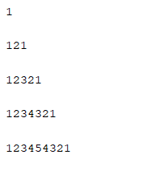

5.

/\*

\* Click nbfs://nbhost/SystemFileSystem/Templates/Licenses/license-default.txt to change this license

\* Click nbfs://nbhost/SystemFileSystem/Templates/Project/Maven2/JavaApp/src/main/java/${packagePath}/${mainClassName}.java to edit this template

\*/

package com.mycompany.prime;

/\*\*

\*

\* @author Lenovo

\*/

public class Prime {

public static void main(String[] args) {

int a,i=5;

for(i=i+1;i<15;i++){

a=primeCheck(i);

if(a!=0)

System.out.println(a+" ");

}

}

public static int primeCheck(int i){

int f=1;

int b=(int)Math.sqrt(i);

for(int j=2;j<i;j++)

if(i%2==0)

f=0;

if(f==0)

return 0;

return i;

}

}

Output:

