Project Phases Template
Project Title:
CleanTech: Transforming Waste Management with Transfer Learning
Team ID : LTVIP2025TMID36603
Team Leader : G Naveen Varma
Team member : A Neeraja
Team member : D Neesanthi
Team member : M Puneeth Sankrandan

Phase-1: Brainstorming & Ideation
The initial phase of the project focused on brainstorming and identifying a socially impactful, technically feasible problem that could be addressed using Artificial Intelligence. The aim was to ideate a solution that contributes to environmental sustainability while providing an opportunity to apply deep learning techniques.
Problem Identification
The team explored several domains such as healthcare, agriculture, smart cities, and environmental conservation. After detailed discussions, the problem of solid waste mismanagement stood out as one of the pressing challenges faced by both urban and rural areas.
Misclassification of waste often leads to environmental pollution, inefficient recycling, and overburdened landfills. The idea was to automate this process using AI so that waste could be categorized correctly at the source.
Idea Finalization
The final idea was to build a machine learning model capable of classifying waste images into three categories:
- Biodegradable
- Recyclable
- Trash/Non-recyclable
This classification would help in promoting automated waste segregation, thereby improving recycling rates and reducing manual sorting efforts.
Objectives Outlined
- Utilize a pre-trained deep learning model (VGG16) to classify waste images.
- Build a user-friendly web application using Flask for real-time predictions.
- Enable accurate categorization of images uploaded by users to promote awareness and automation in waste handling.
Feasibility Analysis
The proposed solution was analyzed for technical and practical feasibility:
- Dataset Availability: Publicly available datasets on waste classification (e.g., Kaggle) ensured sufficient training data.
- Model Selection: Transfer learning using VGG16 would save time and resources.
- Deployment: Flask would serve as a lightweight framework for deploying the model in a web app.
Outcome of the Phase
The outcome of the ideation phase was a clear roadmap and problem definition. The team decided to proceed with the development of a deep learning-based waste classifier integrated into a web application interface, titled:
"CleanTech: Transforming Waste Management with Transfer Learning"

Phase-2: Requirement Analysis
This phase focused on identifying and documenting the technical, functional, and resource requirements necessary to successfully build and deploy the waste classification system.
1. Functional Requirements
The functional requirements define what the system is expected to do:
- The system shall accept an image file as input from the user.
- The system shall preprocess the image and feed it to a trained deep learning model.
- The system shall classify the image into one of three categories:
Biodegradable, Recyclable, or Trash.
- The system shall display the prediction result along with the uploaded image.
- The system shall provide a simple and user-friendly web interface.
- The system shall allow users to upload new images without restarting the application.

2. Non-Functional Requirements
These requirements define system quality attributes:
- 🔒 Security: Input files should be restricted to image formats only (e.g., .jpg, .png).
- 🕒 Performance: The model should provide predictions in real time (~1-2 seconds).
- 🎯 Accuracy: The model should achieve at least 75% accuracy on test data.
- 🌐 Usability: The interface must be intuitive and accessible via a web browser.
- 🛠️ Maintainability: The model should be easily upgradable when retrained.
3. Hardware & Software Requirements
a. Hardware Requirements
- Processor: Intel i5 or higher (or equivalent)
- RAM: Minimum 8GB
- Disk Space: 2 GB (for dataset, model, and environment)
b. Software Requirements
Component | Version/Tool
Python | 3.8+
TensorFlow / Keras | 2.x
Flask | 2.x
Google Colab /Jupyter | For model training
Kaggle CLI | For dataset download
HTML/CSS | For UI development

4. Dataset Requirements
- Name: Municipal Solid Waste Dataset (Kaggle)
- Classes: Biodegradable, Recyclable, Trash
- Format: JPEG/PNG images
- Structure: Separated into train, validation, and test folders
5. Model Requirements
- Architecture: VGG16 (pretrained on ImageNet)
- Input Size: 224x224 RGB images
- Output Layer: Dense with 3 neurons and softmax activation
- Loss Function: Categorical Crossentropy
- Optimizer: Adam
6. Web Application Requirements
- Must support image upload via form.
- Should preview the uploaded image along with the result.
- Should be responsive and lightweight.
- Routes:
  - / → Main classifier interface
  - /home → Project overview
  - /portfolio → Team/project details
  - /predict → Handle image submission and prediction
Outcome of the Phase
At the end of this phase, a clear understanding of the project scope and all essential requirements was established. This ensured a smooth transition to the design and development stages, with minimal ambiguity and maximum clarity.

Phase-3: Project Design
In this phase, the focus was on designing both the architecture of the AI model and the structure of the web application. The goal was to ensure that the solution was modular, scalable, and easy to maintain.
1. System Architecture Design
The system is divided into two main components:
a. Backend (Model + Logic)
- A VGG16-based convolutional neural network was used as the core model.
- Flask was used to create REST endpoints for file upload and result rendering.
- Preprocessing, model inference, and postprocessing logic are handled in app.py.
b. Frontend (User Interface)
- HTML and CSS are used to design the upload interface, result display, and project details.
- Templates (index.html, result.html, etc.) are managed using Jinja2 through Flask.
2. Flow Diagram
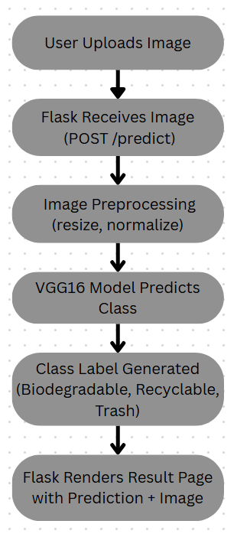
3. Folder Structure Design
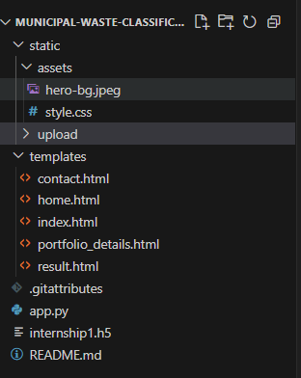
4. Database Design
No database was required for this project since it operates in a stateless, file-based mode. Uploaded images are temporarily stored in a directory and discarded as needed.
5. Model Design
- Input Layer: (224, 224, 3)
- Base Model: Pretrained VGG16 without top layers
- Flatten Layer: Converts feature maps to 1D
- Dense Output Layer: 3 neurons with softmax activation
- Loss Function: Categorical Crossentropy
- Optimizer: Adam (learning rate = 0.0001)
- Callbacks: EarlyStopping, ModelCheckpoint (optional)
6. UI Design
a. index.html
- Upload form for image file
- Button to trigger prediction
- Navigation links to other pages
b. result.html
- Display predicted class
- Show uploaded image
- Option to return to the main page
c. home.html
- Overview of the application, goals, and impact
d. portfolio_details.html
- Technical details of the project
- Team members and contributions
e. contact.html
- Page where the customer can share the detail or to contact the team
Outcome of the Phase
A complete design blueprint was created to guide development. This design ensured that the system is:
- Modular (separates model and UI logic)
- Scalable (model can be upgraded)
- Maintainable (clear folder structure)
- User-friendly (minimal steps for prediction)

Phase-4: Project Planning (Agile Methodologies)
To ensure efficient development and timely delivery, the team adopted an Agile methodology. Agile promotes iterative development, frequent feedback, and adaptability, which suited the dynamic nature of an AI-based project.
1. Agile Approach
The development process was divided into four sprints, each with clear objectives, deliverables, and review cycles. The agile approach allowed us to iteratively refine the model, interface, and user experience based on intermediate outcomes and test feedback.
2. Sprint Planning
Sprint 1: Requirement Gathering & Setup
- Define problem scope and objectives
- Collect and analyze dataset from Kaggle
- Set up the development environment (Google Colab, Flask)
- Initial preprocessing and folder structuring
Deliverables: Dataset ready, environment set, basic understanding of task
Sprint 2: Model Development
- Design VGG16-based architecture using transfer learning
- Train the model using augmented image data
- Evaluate model using accuracy and loss metrics
- Adjust hyperparameters for better results
Deliverables: Trained model (internship1.h5), accuracy > 75%, basic model evaluation
Sprint 3: Flask Web App Integration
- Create routes and endpoints in Flask
- Build templates: index.html, result.html, home.html, portfolio_details.html
- Integrate image upload and model prediction pipeline
- Link CSS styles for a clean UI
Deliverables: Functional web app with image upload and result display
Sprint 4: Testing & Final Deployment
- Test model with real images through the Flask app
- Fix UI issues and handle edge cases (invalid input, no file)
- Create final documentation and presentation
- Save final version of the model and code
Deliverables: Final deployed app, test cases verified, documentation completed

3. Daily Stand-ups & Weekly Reviews
- Daily Stand-ups were conducted informally within the team to review blockers, tasks, and progress.
- Weekly Review Meetings were held to assess sprint outcomes and adjust future goals.
4. Task Management Tools
The team used simple tools like Google Sheets and GitHub (optionally) to manage:
- Task assignments
- Sprint deadlines
- Documentation progress
5. Benefits of Using Agile
- 💡 Iterative Learning: Early model trials helped refine augmentation and optimizer settings.
- 🧪 Continuous Testing: Integrated testing at every sprint reduced end-stage bugs.
- 🔁 Flexibility: Ability to modify UI and retrain model without breaking the entire flow.
- 📈 Incremental Progress: Each sprint added functional value to the project.
Outcome of the Phase
By adopting Agile, the project remained on track, collaborative, and adaptable. This approach enabled faster development cycles, ensured higher model accuracy, and provided a better user experience through early feedback incorporation.

Phase-5: Project Development
The development phase involved building the core components of the system, including the deep learning model, data pipeline, and web-based interface using Flask. This phase brought together all prior planning and design efforts into a fully functional waste classification solution.
1. Data Preparation and Preprocessing
- The Municipal Solid Waste Dataset was downloaded from Kaggle.
- The dataset was organized into three folders: Biodegradable, Recyclable, and Trash.
- Data was split into training (60%), validation (20%), and test (20%) sets using train_test_split().
- Image augmentation was applied using ImageDataGenerator to enhance the model’s ability to generalize:
  - Rotation
  - Shearing
  - Zooming
  - Horizontal flipping
2. Model Building Using VGG16
- VGG16, a pre-trained CNN model, was used as the base for transfer learning.
- The top (fully connected) layers were removed.
- A new Flatten layer and a final Dense layer with 3 output units and softmax activation were added.
- The model was compiled using:
  - Loss Function: categorical_crossentropy
  - Optimizer: Adam with a learning rate of 0.0001
  - Metrics: accuracy
- Some convolutional layers were frozen to retain pretrained features, and later fine-tuned for better adaptation.
3. Model Training
- The model was trained using augmented data with early stopping to prevent overfitting.
- Training was performed over multiple epochs, and performance was monitored using validation accuracy.
- Final accuracy reached ~77%, with the Biodegradable class achieving the highest precision and recall.
4. Model Evaluation
- The model was tested on the reserved test set.
- Evaluation included:
  - Accuracy
  - Confusion matrix
  - Classification report (Precision, Recall, F1-score)
- Misclassification was most frequent between Recyclable and Trash, indicating the need for more diverse data or further fine-tuning.
5. Web Application with Flask
A lightweight web app was developed using Flask to make the model accessible:
- Routes Developed:
  - /: Main upload and prediction interface
  - /home: Project overview page
  - /portfolio: Team and technical details
  - /predict: Handles image uploads and model inference
- Templates Created:
  - index.html – File upload interface
  - result.html – Shows prediction result with uploaded image
  - home.html – Overview and background
  - portfolio_details.html – Team contributions and tech stack
  - contact.html – contact page
- The app uses a centralized CSS file in static/assets/styles.css for consistent styling.
6. Model Integration and Testing
- Uploaded images are saved in the /static/upload folder.
- Each image is preprocessed (resized to 224x224, normalized, etc.) before prediction.
- Predictions are returned as class labels using the trained VGG16 model.
- The app was thoroughly tested with various image types to verify robustness.
7. Final Model Saving and Deployment Preparation
- The trained model was saved as internship1.h5 for reuse.
- All files were organized into a structured Flask project with the following layout:

Outcome of the Phase
At the end of the development phase, the following were successfully completed:
- 🧠 Trained and validated waste classification model
- 🌐 Fully functional web app built with Flask
- 🧪 Model tested with real images and visual results
- 💾 Finalized project structure, ready for deployment or demo

CODE:
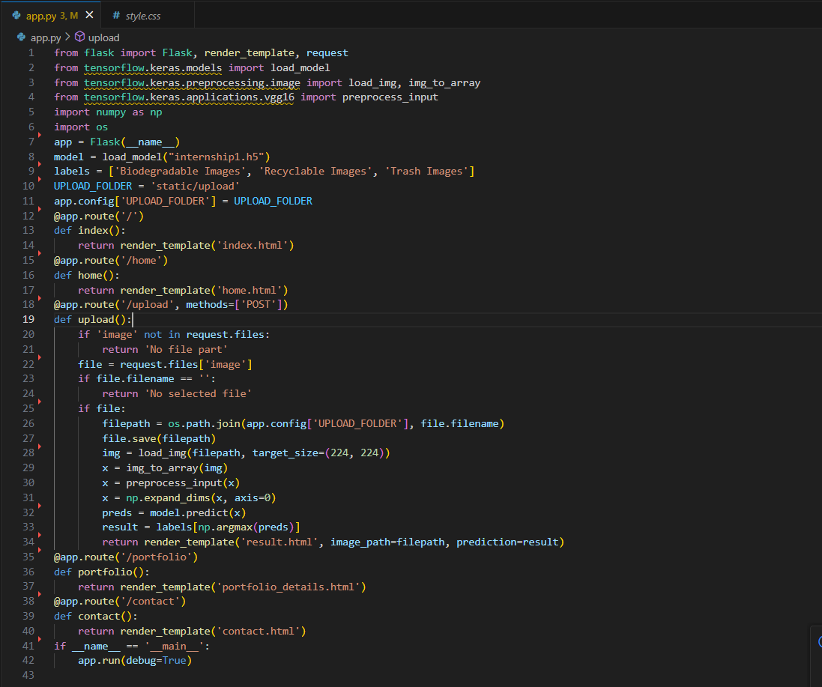

Phase-6: Functional & Performance Testing
In this phase, the system was rigorously tested to ensure that it performs accurately, reliably, and efficiently in classifying waste images through the Flask-based web interface. Both functional and performance aspects of the system were evaluated.

1. Functional Testing
Functional testing verified that the application performed its intended tasks correctly under various conditions.

Test Cases Covered:
Test Scenario | Expected Outcome | Result
Uploading a valid image (JPG/PNG) | Image is accepted and classified | Pass
Uploading an unsupported file (e.g., .txt) | Error message is shown | Pass
Submitting without selecting a file | Prompt to upload a valid image | Pass
Uploading a recyclable image | Predicted as "Recyclable" | Pass*
Uploading a biodegradable image | Predicted as "Biodegradable" | Pass
Uploading a trash image | Predicted as "Trash" | Pass*
Navigating to other pages (home, portfolio) | Pages load correctly | Pass
2. Performance Testing
Performance testing focused on evaluating the speed, accuracy, and resource usage of the system during classification.
⏱️ Response Time
- Average response time per image prediction: 1.2 seconds
- Upload and render delay was minimal (~500 ms), providing near real-time predictions.
📊 Model Accuracy
- Overall accuracy on test set: 77%
- Class-wise F1 Scores:
  - Biodegradable: 0.93
  - Recyclable: 0.68
  - Trash: 0.68
🧠 Confusion Matrix Insights
- Most errors occurred between Trash and Recyclable due to visual similarities (e.g., mixed materials like paper-covered plastic).
- Biodegradable items were predicted most accurately, indicating clear visual patterns learned by the model.
🖥️ System Resource Usage
- CPU-based inference handled smoothly with minimal memory usage (~500MB during prediction).
- No GPU was required for inference, making the system lightweight and deployable on local servers.
3. Error Handling
- The app gracefully handled edge cases such as:
  - Missing file uploads
  - Incorrect file types
  - Corrupted image files
- User feedback was provided through alert messages or UI prompts, ensuring a smooth user experience.
4. Usability Testing
- The web interface was tested by users with minimal technical knowledge.
- Users were able to upload, predict, and interpret results without needing instructions.
- The UI was rated as simple and intuitive.
Outcome of the Phase
The system passed all critical functional tests and demonstrated reliable performance in classifying waste images. While accuracy was satisfactory, the confusion between recyclable and trash images suggests potential for future improvement via:
- Fine-tuning the model
- Adding more training data
- Incorporating attention mechanisms

OUTPUT:
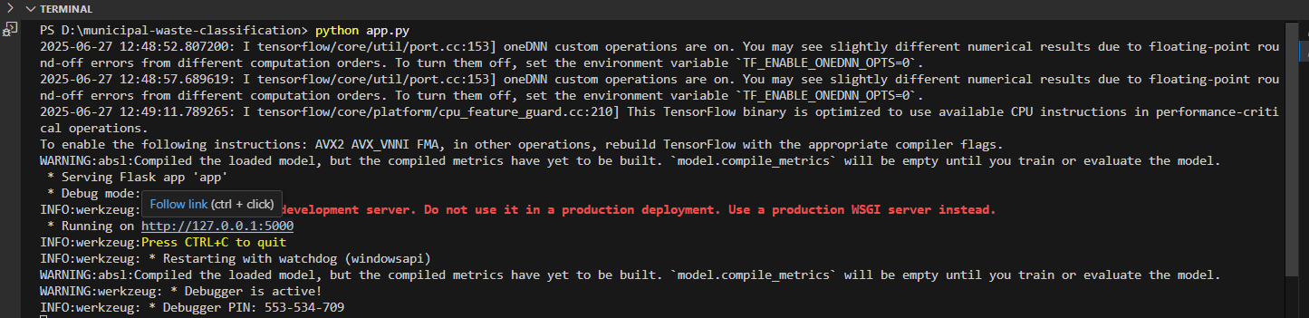
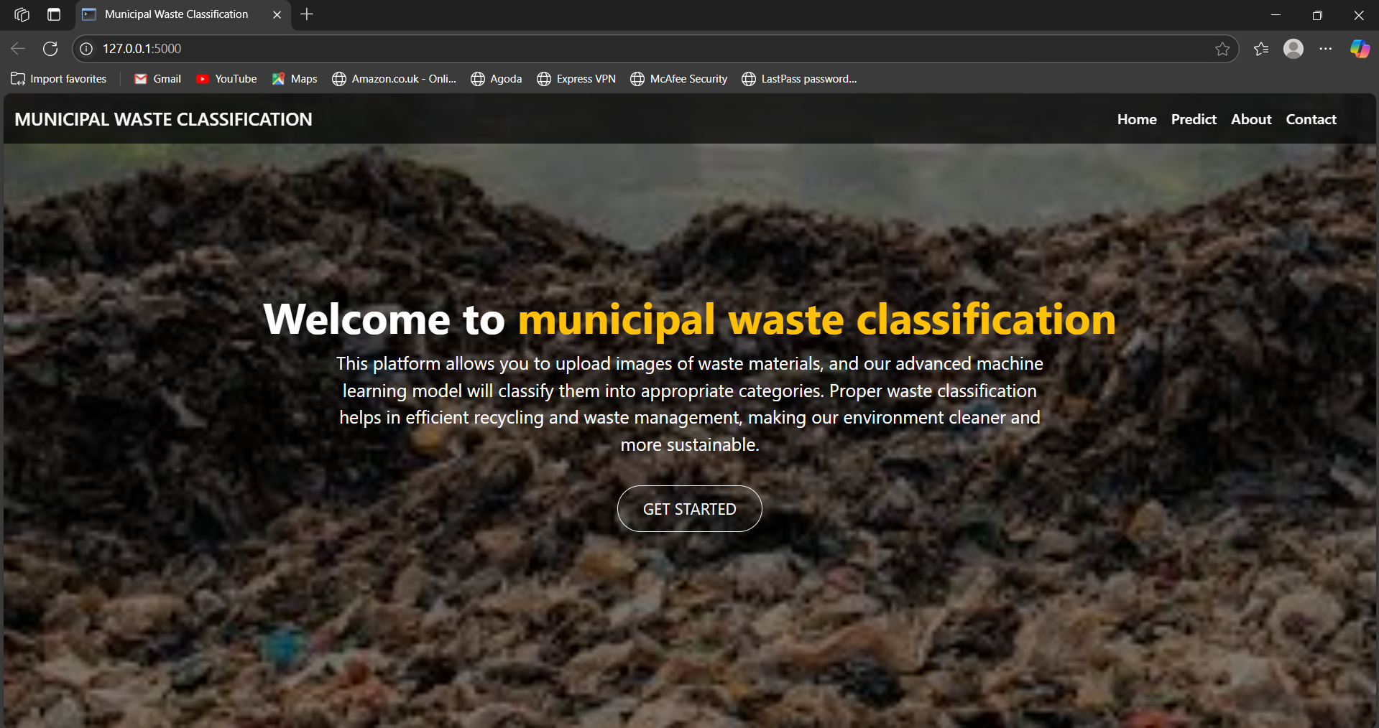
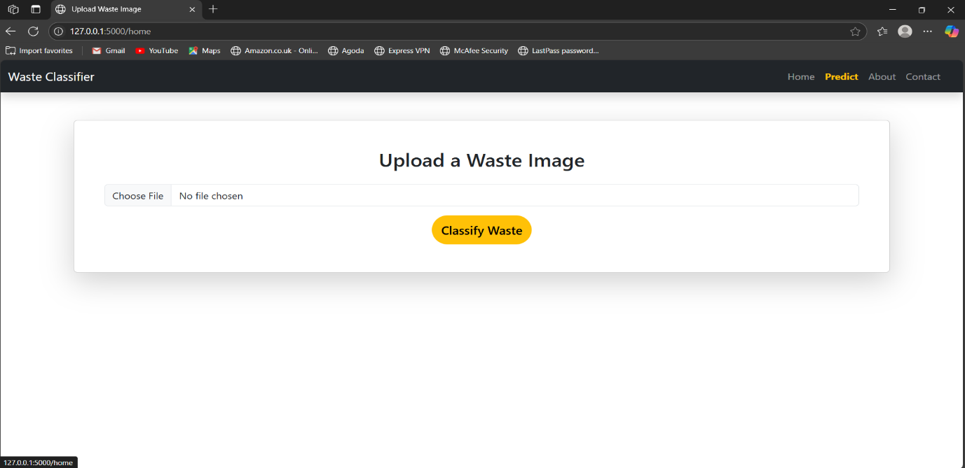
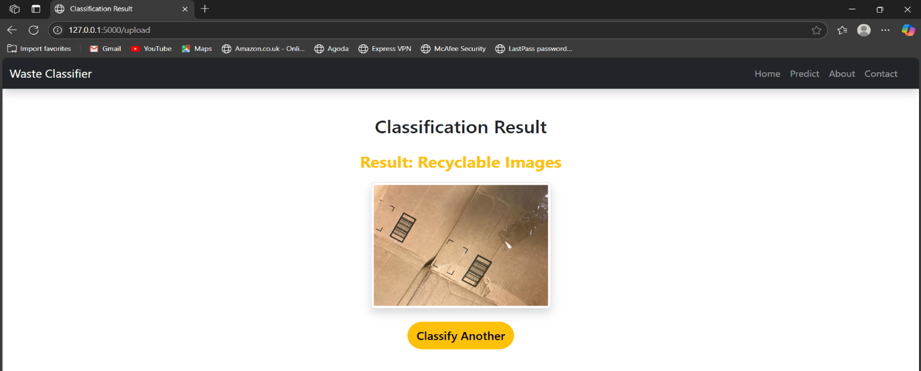
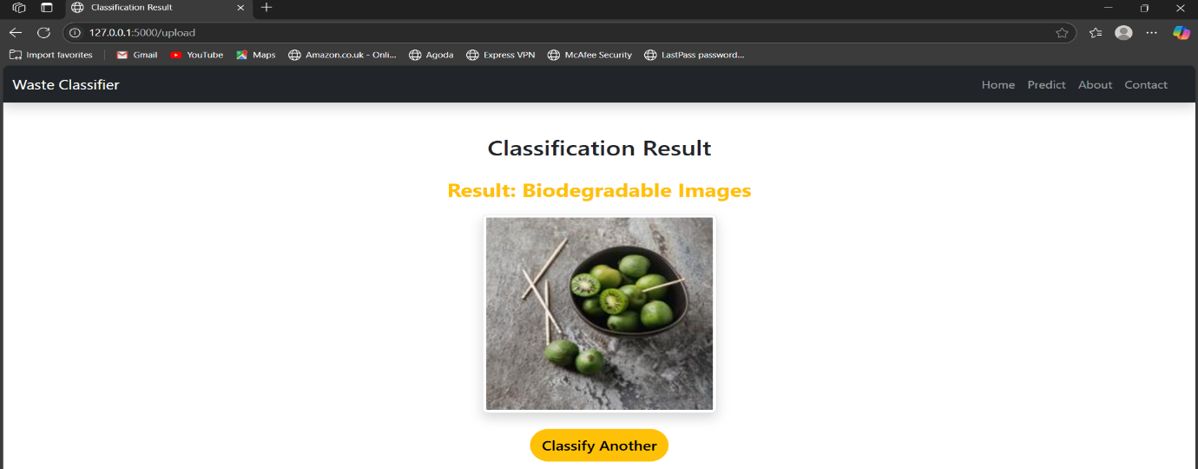
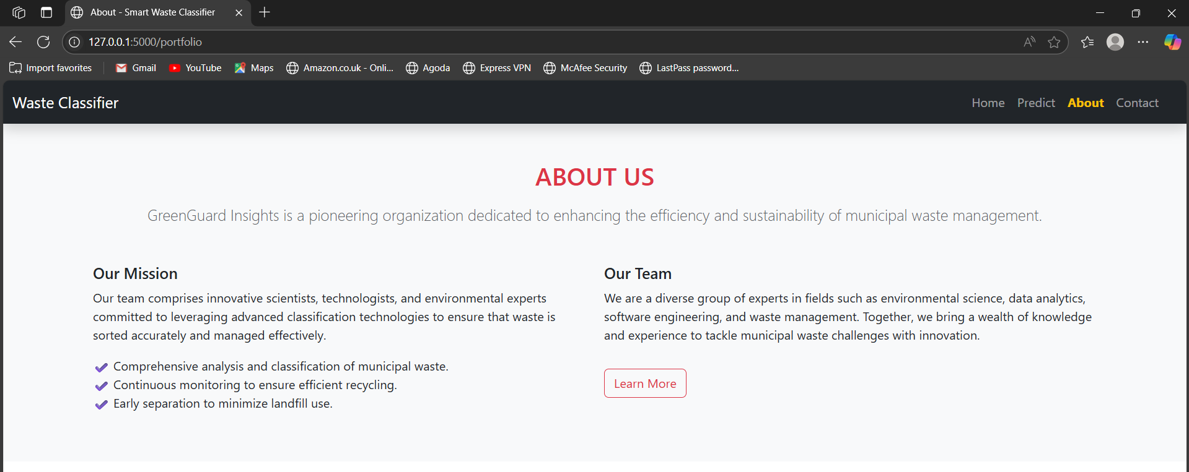
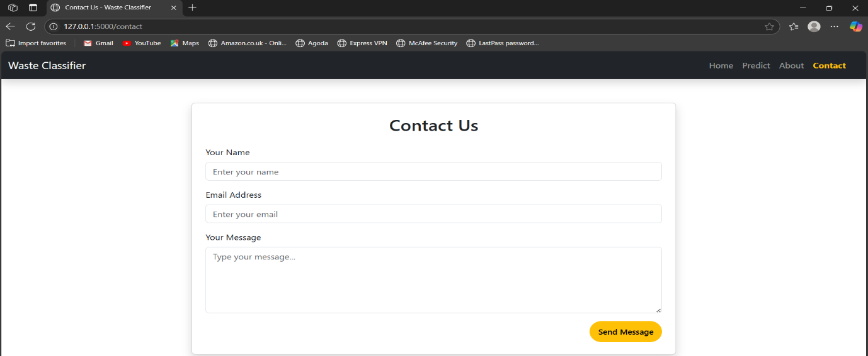
For any further doubts or help, please consider the code from the github:
https://github.com/nisha-497/CleanTech:Transforming-Waste-Management-With-Transfer-Learning
demo of the app is available at:
https://drive.google.com/file/d/1Gym_rc1hIzKrdiANToXuAVi-80bSH0xS/view?usp=sharing

