Retail Sales & Customer Purchase Prediction
Group A Internship Project
Final Reports
Team Members
Nisha Kafle — Project Lead / Business Analyst
Soniya Pandey — Data Collection & Quality
Susmita Balami — Python Data Analyst
Swikriti Bhusal — Visualization Analyst
Pratish Shakya — Machine Learning Analyst
20-Day Data Analytics & Machine Learning Student Project

2. Executive Summary
This report documents the design, implementation and results of a customer purchase-prediction project built on the Online Retail II dataset, a two-year transaction log (2009-12-01 to 2011-12-09, 1,067,371 raw rows) from a UK-based online gift retailer. The project follows the complete analytics pipeline required by the course manual: problem definition, data profiling, cleaning, exploratory analysis, feature engineering, machine learning and business recommendations.
After cleaning, 776,624 rows (72.8% of the merged dataset) represented valid completed sales, totalling 17,073,078.29 in revenue across 5,861 identifiable customers. A leakage-safe target was constructed using a historical/target time split: customer behavior before 2010-12-01 was used to build predictive features, and spending from 2010-12-01 onward was used only to define the label. Random Forest achieved the best results (Accuracy 0.831, Precision 0.644, Recall 0.722, F1-Score 0.681), clearly outperforming both a majority-class baseline and Logistic Regression.

3. Business Problem
A retail business wants to understand its sales performance and identify orders and customers that are likely to be high-value, so that retention, loyalty and marketing resources can be directed where they generate the greatest return.

4. Objectives and KPIs
- Quantify overall sales performance: total revenue, monthly trend, top products, top countries.
- Define a transparent, reproducible rule for what counts as a 'high-value' customer.
- Predict, using only historical behavior, whether a customer will become high-value in a later period.
- Compare a baseline, Logistic Regression and Random Forest Classifier using Accuracy, Precision, Recall and F1-Score.
- Translate findings into specific, evidence-based business recommendations.
KPIs tracked: total revenue, average order value, high-value customer rate (25%), and the four standard classification metrics for each model.

5. Data Collection Method
The dataset was provided as a pre-existing operational export (online_retail_II.xlsx) rather than collected first-hand by the team. It contains two sheets covering two consecutive years (Year 2009-2010 and Year 2010-2011), each with identical schema, which were verified and then merged programmatically in Notebook 1 and Notebook 2. No data was invented, simulated, or collected manually; every figure in this report is computed directly from the uploaded file.

6. Data Dictionary
Column | Type | Meaning | Missing
Invoice | Text | Transaction ID; 'C' prefix = cancellation, 'A' = adjustment | 0
StockCode | Text | Product code (some are non-product admin codes) | 0
Description | Text | Product name | 4,382
Quantity | Integer | Units purchased (negative = cancellation) | 0
InvoiceDate | Datetime | Transaction date/time | 0
Price | Float | Unit price (GBP) | 0
Customer ID | Float | Customer identifier | 243,007 (22.8%)
Country | Text | Customer/shipping country | 0
Full data dictionary, including every derived column created during cleaning and feature engineering, is provided in data/data_dictionary.md and Notebook 1.

7. Data Cleaning and Preprocessing
Cleaning used documented, flag-based rules rather than blind deletion — every excluded row is retained with a reason flag in the cleaned dataset, so decisions are auditable.
Rule | Rows affected
Exact duplicate rows removed | 34,335
Cancelled invoices (flagged, excluded from sales analysis) | 19,104
Adjustment / bad-debt invoices (flagged, excluded) | 6
Non-product stock codes: postage, fees, manual entries (flagged, excluded) | 5,524
Invalid (<=0) quantity outside cancellations (flagged, excluded) | 22,496
Invalid (<=0) price (flagged, excluded) | 6,019
Missing Customer ID (flagged, excluded from customer-level analysis) | 235,151
Valid completed sales used for analysis | 776,624 (72.8% of merged data)

8. Exploratory Data Analysis
Twelve business questions were answered directly from the cleaned valid-sales dataset (Notebook 2, Section 8), covering total revenue, monthly trend, top products and countries, average order value, top customers, purchase timing by weekday/hour, and the quantity-revenue relationship.
- Total revenue (valid completed sales): 17,073,078.29
- Unique customers with valid sales: 5,861
- Revenue is strongly seasonal, peaking in October-November each year
- The business is heavily UK-concentrated in both revenue and customer count
- A small set of products and customers account for a disproportionate share of revenue

9. Matplotlib Visualizations and Interpretation

Monthly Revenue Trend
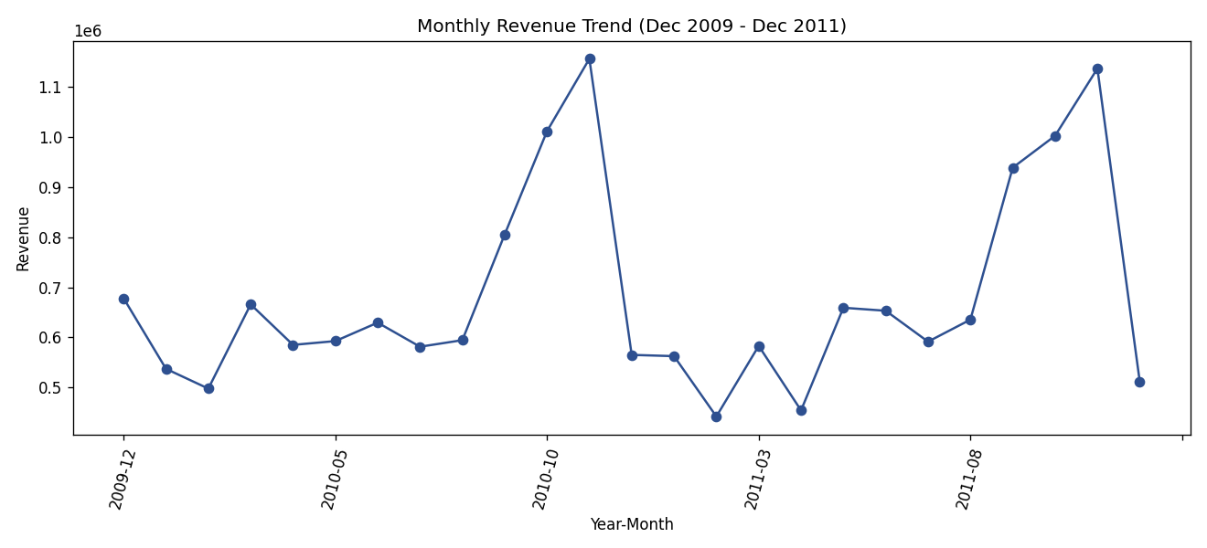
Revenue peaks around October-November each year (pre-holiday demand) and drops sharply after the December peak.

Top 10 Products by Revenue
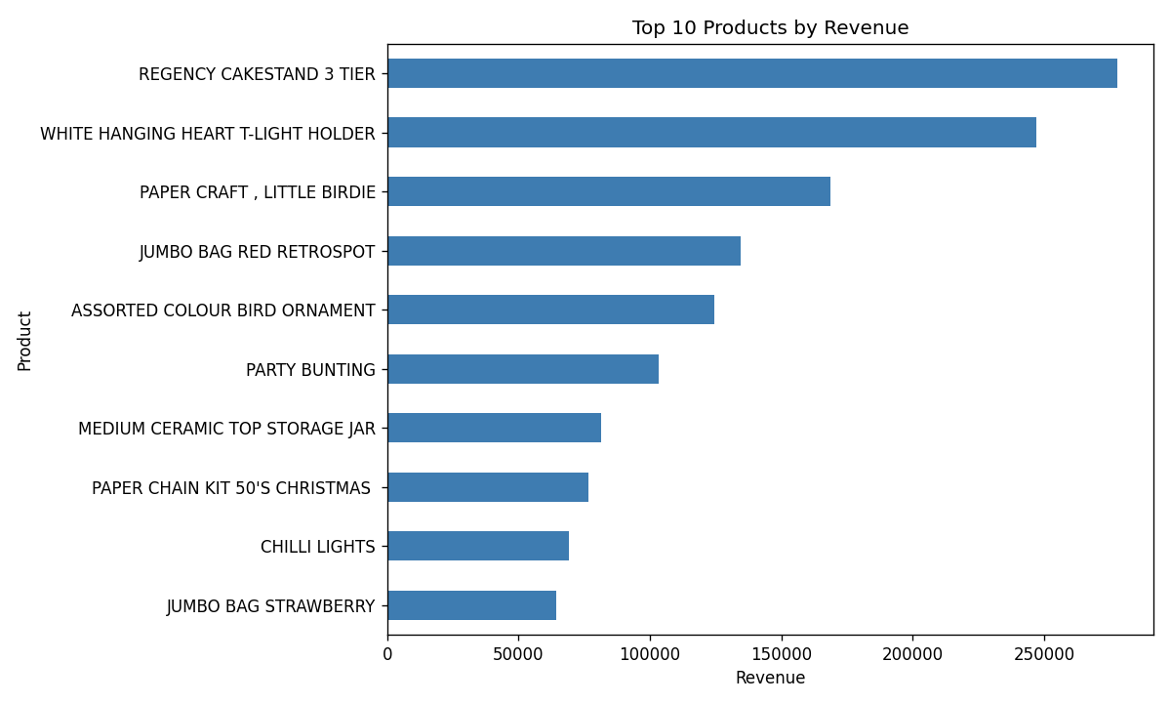
A small set of products dominates total revenue, making them priorities for stock and promotion.

Top 10 Countries by Revenue
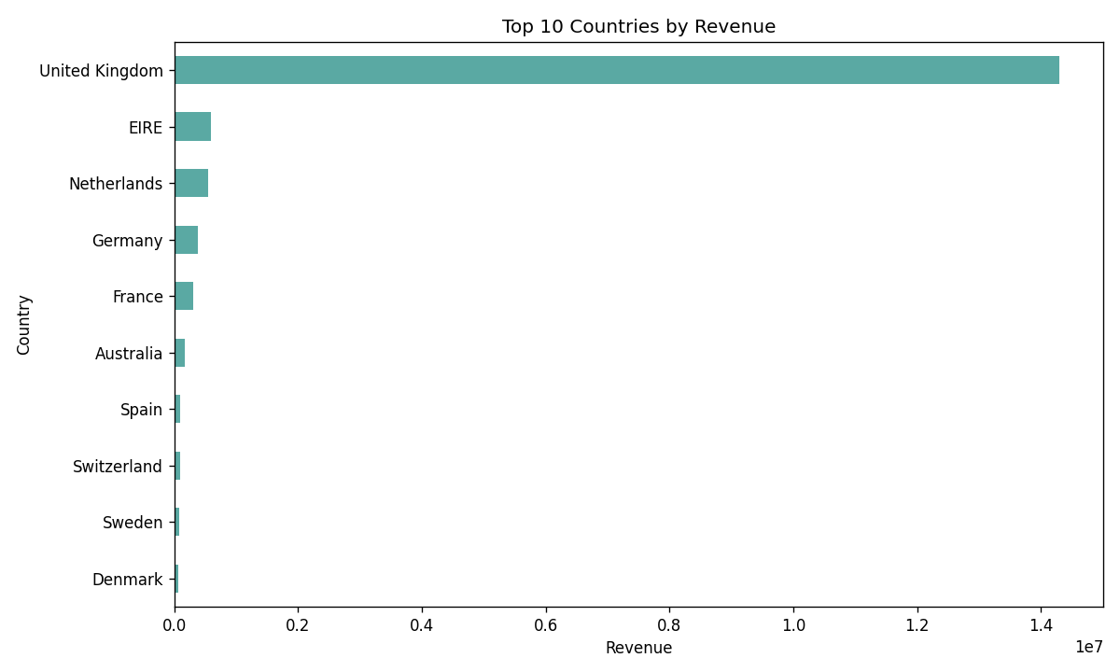
The United Kingdom dominates revenue; international sales are real but secondary.

Order Value Distribution
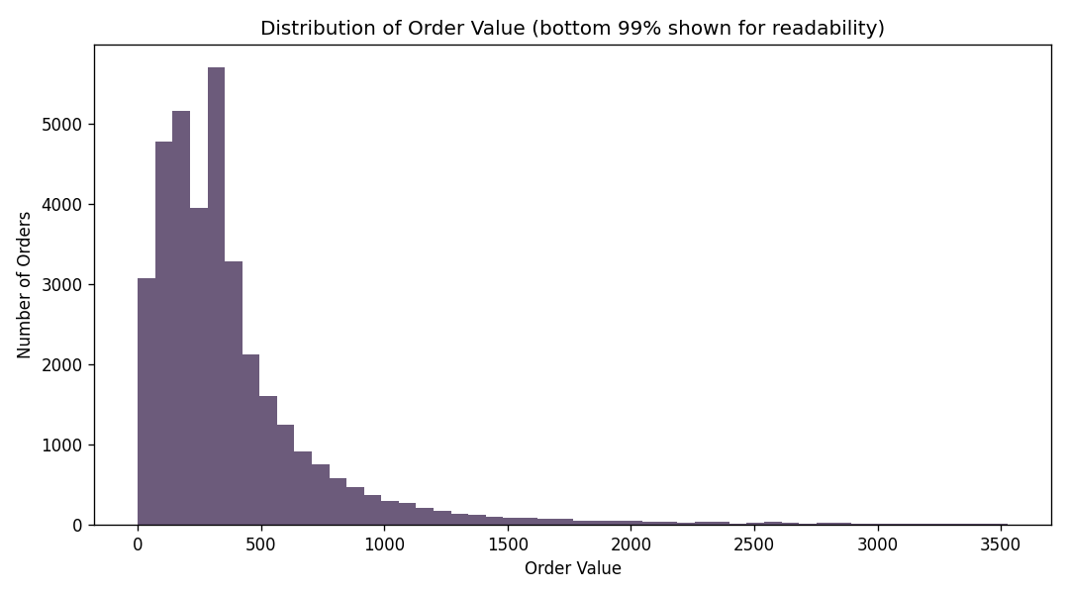
Order values are strongly right-skewed: most orders are modest, with a long tail of large orders.

Customer Spending Distribution
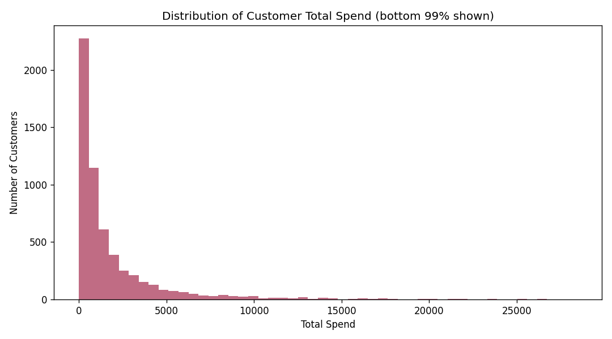
Customer spend follows the typical retail pattern of many low/moderate spenders and a smaller high-value tail.
Revenue vs Quantity
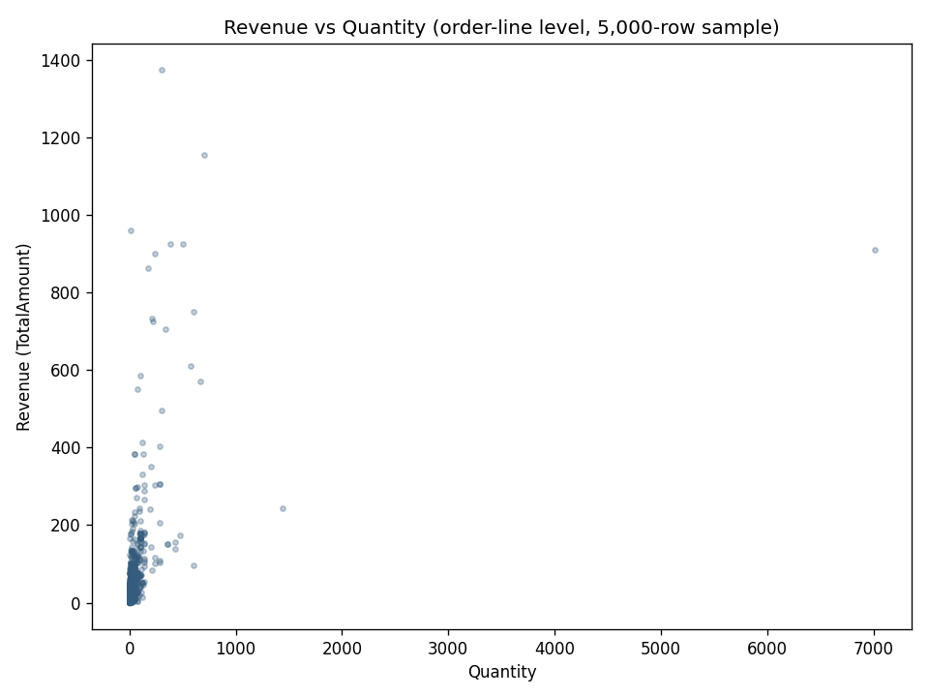
Revenue generally rises with quantity, though price differences across products mean the relationship is not perfectly linear.

Sales by Day of Week and Hour
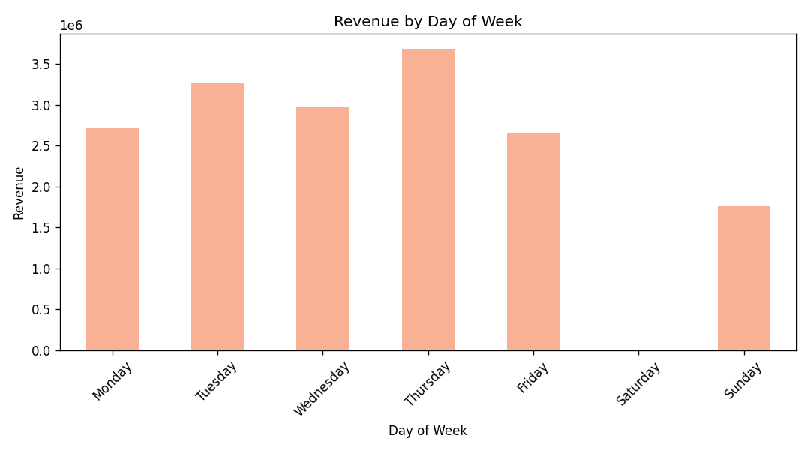
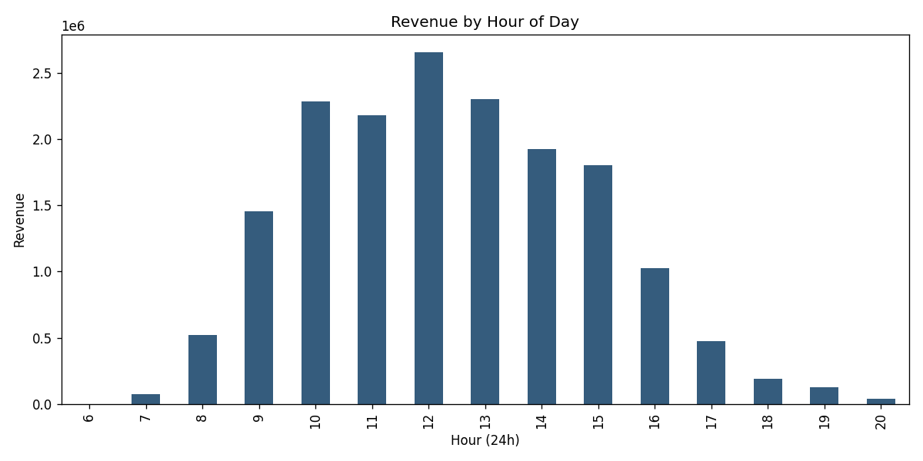
Sales concentrate on weekdays and during standard daytime business hours.
The complete set of 15 charts, each with title, axis labels and interpretation, is available in outputs/charts/ and embedded with full context in Notebook 2 and Notebook 3.

10. Feature Engineering
To prevent target leakage, the dataset was split by time rather than randomly. Transactions before 2010-12-01 ('feature period') were used to build nine historical customer features: HistTotalSpend, HistNumOrders, HistNumItems, HistNumUniqueProducts, HistAvgOrderValue, HistRecencyDays, HistLifespanDays, HistPurchaseFrequency, and IsUK. Transactions from 2010-12-01 onward ('target period') were used only to compute each customer's target-period spend, which in turn defines the label. No feature uses any information from the target period.

11. Machine Learning Methodology
Target: HighValue = 1 if a customer's target-period spend is at or above the 75th percentile of target-period spend among all 4,249 feature-period customers (non-returning customers correctly score 0), else 0. This produced a 75%/25% class split -- moderately imbalanced but workable.
A stratified 75/25 train-test split (random_state=42) was used for reproducibility. A majority-class DummyClassifier served as the baseline. Logistic Regression was trained on standardized features with class_weight='balanced'; Random Forest (300 trees, max_depth=8, class_weight='balanced') was trained on the original unscaled features.

12. Model Results and Comparison
Model | Accuracy | Precision | Recall | F1-Score
Baseline | 0.750 | 0.000 | 0.000 | 0.000
Logistic Regression | 0.804 | 0.591 | 0.707 | 0.644
Random Forest | 0.831 | 0.644 | 0.722 | 0.681
The baseline's high accuracy is misleading: it never predicts the high-value class, so its precision and recall for that class are both zero. Both trained models substantially improve on precision, recall and F1, which are the metrics that matter for this business objective. Random Forest leads on every metric and is the preferred model.

Feature Importance (Random Forest)
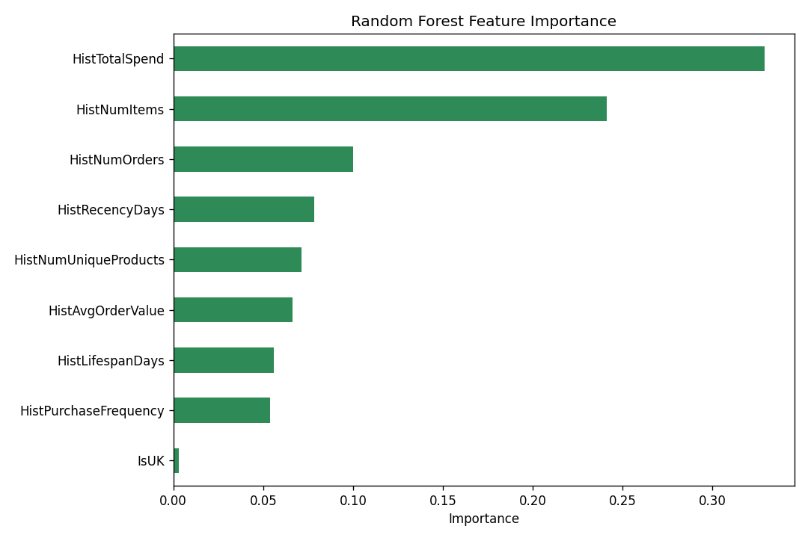
HistTotalSpend, HistNumItems and HistNumOrders are the strongest predictors. IsUK contributes almost nothing, indicating past purchasing behavior -- not geography -- drives the prediction. Feature importance reflects predictive usefulness only, not causation.

13. Business Insights
- About 25% of customers active in a period go on to become high-value in the following period.
- Historical spend and order count are far more predictive of future value than country.
- Revenue is highly seasonal, concentrated around October-November.
- A small set of products and customers drives a disproportionate share of revenue.
- The trained models can identify likely high-value customers with meaningfully better precision and recall than guessing.

14. Recommendations
Finding | Interpretation | Recommendation
Small set of products drives most revenue | These are core demand drivers | Prioritize stock availability and promotion for top-revenue products
Revenue peaks Oct-Nov | Strong seasonal, likely holiday-driven demand | Plan seasonal marketing and inventory buildup ahead of this window
~25% of customers become high-value | A meaningful, identifiable minority drives disproportionate value | Use the trained model to flag likely high-value customers early for loyalty/retention programs
Historical spend/frequency are strongest predictors | Past engagement best signals future value | Focus retention on customers showing rising order frequency or spend, not demographic targeting

15. Limitations and Ethical Considerations

Limitations
- Historical (2009-2011), public dataset; may not reflect current retail behavior.
- 22.8% of rows had no Customer ID and were excluded from customer-level analysis.
- No demographic, profit-margin, or satisfaction data available.
- The 75th-percentile threshold is a business choice, not an absolute definition of high value.
- Prediction and feature importance indicate association, not causation.

Ethical Considerations
- Only transaction data was used; no unnecessary personal information was collected or processed.
- Predictions should inform, not replace, human judgment in customer treatment decisions.
- Model outputs should not be used for discriminatory pricing or exclusionary targeting.
- Customer-level data should be stored and handled securely, consistent with data-protection practice.

16. Future Improvements
- Incorporate profit margin, not just revenue, into the value definition.
- Test alternative thresholds and cutoff dates for sensitivity analysis.
- Add product-category-level features if category metadata becomes available.
- Experiment with additional models (e.g. Gradient Boosting) and hyperparameter tuning.

17. Conclusion
This project demonstrates a complete, leakage-aware pipeline for predicting high-value customers from historical retail transaction data. Careful, documented cleaning preserved 72.8% of the merged data as valid sales; a time-split target design avoided leaking future information into the model; and Random Forest delivered the strongest, honestly-evaluated performance (F1-Score 0.681) against a transparent baseline. The resulting model and insights offer a practical basis for retention and marketing prioritization.

18. References / Data Sources
Dataset: Online Retail II (online_retail_II.xlsx), provided as course material for this project. Sheets: 'Year 2009-2010', 'Year 2010-2011'. Columns and structure verified directly from the file in Notebook 1 (01_data_profiling.ipynb).

