Document Title: Technical Documentation: Feature Development Prototype (EduTrack)
Prepared by: Sreenisha M
Feature Selected: User Adds a New Assignment
Date: October 4, 2026
1. Feature Recap and Objective
Feature Name: Create/Add New Assignment
Objective: This feature allows a logged-in student to input details about a new assignment (Course Name, Title, Due Date, Priority) and save it to their personal dashboard. The system must validate the input, ensure the user is authenticated, and securely store the record in the database.
2. Logical Steps and Functions Required
To build this feature, the workflow will be divided into three modules:
- Frontend (UI Component): A form with input fields. It requires a function handleSubmit() to capture the user's input and a state manager (e.g., React useState) to hold the data before sending it.
- Backend (API Route): An endpoint (POST /api/assignments) that receives the request. It requires an authentication middleware to verify the user's JWT (JSON Web Token).
- Backend (Controller Function): A function createAssignment() that validates the data, interacts with the database, and sends a success/error response.
- Database (Model): The MongoDB schema defining what an "Assignment" document looks like.
3. Algorithms and Data Structures Intended
- Data Structure (Frontend): A JavaScript Object will temporarily hold the form data before sending it:
{ title: "Math Homework", course: "Calculus 101", dueDate: "2026-10-15", priority: "High" }
- Algorithm (Backend Validation): Before saving to the database, the backend will run a validation algorithm:
  - Check if title and course strings are not empty.
  - Parse the dueDate string into a JavaScript Date object.
  - Check if the dueDate is in the past. If yes, return an error. If no, proceed.
  - Verify priority is one of the allowed Enums (High, Medium, Low).
4. Pseudocode (Plain Text Code Logic)
A. Frontend Logic (React-ish pseudocode):
text
FUNCTION handleFormSubmit(formData):
IF any field is empty THEN
DISPLAY error message "All fields are required"
RETURN
END IF

SET loading state to true

TRY:
RESPONSE = SEND POST request to "/api/assignments" WITH formData and UserToken
IF RESPONSE status is 201 (Created) THEN
DISPLAY success message "Assignment added!"
CLEAR form fields
REDIRECT user to Dashboard
ELSE
DISPLAY error message from server
END IF
CATCH error:
DISPLAY "Network error. Please try again."
FINALLY:
SET loading state to false
END TRY
END FUNCTION
B. Backend Logic (Node/Express-ish pseudocode):
text
FUNCTION createAssignment(request, response):
EXTRACT assignmentData FROM request.body
EXTRACT userId FROM request.user (from JWT middleware)

// Validation
IF assignmentData.dueDate < CURRENT_DATE THEN
RETURN response.status(400).json({error: "Due date cannot be in the past"})
END IF

TRY:
// Create new document instance
NEW_ASSIGNMENT = new AssignmentModel({
title: assignmentData.title,
course: assignmentData.course,
dueDate: assignmentData.dueDate,
priority: assignmentData.priority,
user: userId
})

// Save to database
SAVED_ASSIGNMENT = AWAIT NEW_ASSIGNMENT.save()

RETURN response.status(201).json(SAVED_ASSIGNMENT)

CATCH databaseError:
RETURN response.status(500).json({error: "Failed to save assignment"})
END TRY
END FUNCTION
5. Flowchart Representation

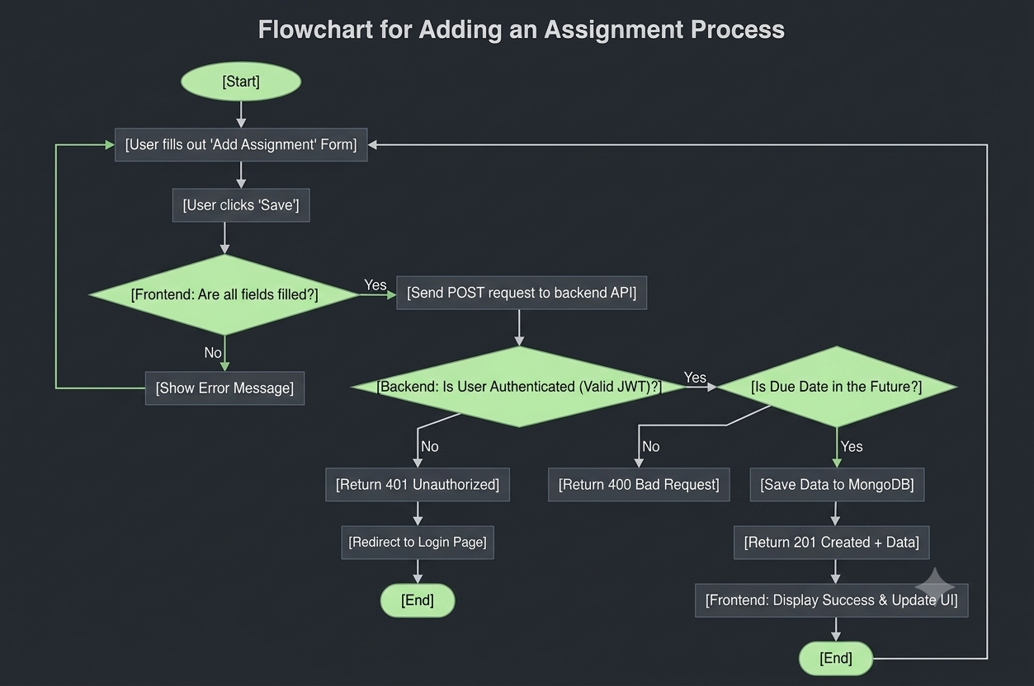

6. Potential Methods for Error Handling and Efficiency Improvements
- Error Handling:
  - Network Failures: The frontend try/catch block will catch dropped connections and display a user-friendly message rather than crashing the app.
  - Invalid Data: The backend validates the date format and string lengths before hitting the database, preventing database corruption.
  - Authentication Errors: If the JWT is expired, the backend returns a 401 error, and the frontend automatically redirects the user to the login page.
- Efficiency Improvements:
  - Database Indexing: Creating an index on the userId field in MongoDB ensures that when the user loads their dashboard, their assignments are fetched instantly, even if there are millions of records.
  - Optimistic UI Updates: Instead of waiting for the server to respond before updating the screen, React can optimistically add the assignment to the UI immediately, making the app feel instantaneous. If the server fails, it rolls back the change.
  - Debouncing: If we add a "search" feature later, we will use debouncing to prevent the API from being called on every single keystroke.

