# Assignment-based Subjective Questions

# Question 1. From your analysis of the categorical variables from the dataset, what could you infer about their effect on the dependent variable? (Do not edit)

# Total Marks: 3 marks (Do not edit)

# Answer: <Your answer for Question 1 goes below this line> (Do not edit)

# Season: spring season have low cnt ,

# year:in 2019 high cnt,

# mnth: in mid of the year high cnt(dependent variable)

# weathersit: In clear weather high cnt.

# 

**Question 2.** Why is it important to use **drop_first=True** during dummy variable creation? (Do not edit)

**Total Marks:** 2 marks (Do not edit)

# Answer: <Your answer for Question 2 goes below this line> (Do not edit)

# Using drop_first=True during dummy variable creation is important because it prevents

# multicollinearity by removing one dummy variable, thereby avoiding the "dummy variable trap."

# Additionally, it helps in reducing the extra column created during dummy variable creation.And we will find great model.

**Question 3.** Looking at the pair-plot among the numerical variables, which one has the highest correlation with the target variable? (Do not edit)

**Total Marks:** 1 mark (Do not edit)

# Answer: <Your answer for Question 3 goes below this line> (Do not edit)

# temp-target variable(cnt) and atemp- target variable(cnt) has highest positive correlation which is

# 0.63.As attached the heatmap of numeric variable.

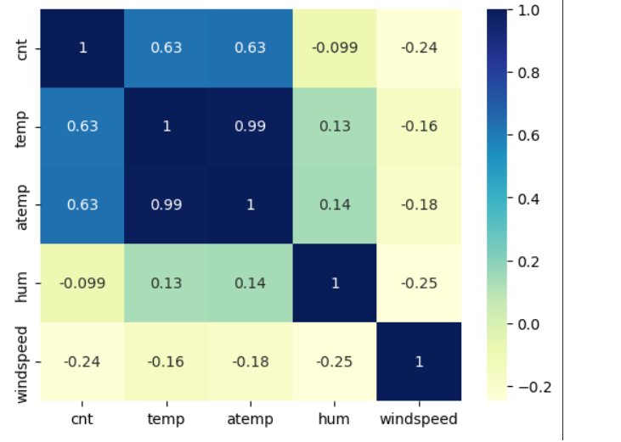

**Question 4.** How did you validate the assumptions of Linear Regression after building the model on the training set? (Do not edit)

**Total Marks:** 3 marks (Do not edit)

# Answer: <Your answer for Question 4 goes below this line> (Do not edit)

Plot the residuals (errors) against the predicted values. Residuals have constant variance across all levels of the independent variables.

Calculate Variance Inflation Factors (VIF); values exceeding 5 may indicate problematic multicollinearity.

Plotting y_test and y_pred to understand the spread.

**Question 5.** Based on the final model, which are the top 3 features contributing significantly towards explaining the demand of the shared bikes? (Do not edit)

**Total Marks:** 2 marks (Do not edit)

# Answer: <Your answer for Question 5 goes below this line> (Do not edit)

# Top 3 features contributing significantly below:

# atemp,summer,Dec

# General Subjective Questions

**Question 6.** Explain the linear regression algorithm in detail. (Do not edit)

**Total Marks:** 4 marks (Do not edit)

**Answer:** Please write your answer below this line. (Do not edit)

# <Your answer for Question 6 goes here>

# Linear regression is a statistical method that models the relationship between a

# dependent variable and one or more independent variables by fitting a linear equation

# to observed data. The simplest form, simple linear regression, involves one independent

# variable and one dependent variable, aiming to find the best-fitting straight line

# that predicts the dependent variable based on the independent variable.

# This method assumes a linear relationship between variables, meaning

# changes in the independent variable correspond to proportional

# changes in the dependent variable. The goal is to determine the

# line that minimizes the sum of squared differences between observed

# and predicted values, known as the least squares method. Linear regression

# is widely used for forecasting and determining the strength of predictors.

**Question 7.** Explain the Anscombe’s quartet in detail. (Do not edit)

**Total Marks:** 3 marks (Do not edit)

**Answer:** Please write your answer below this line. (Do not edit)

# <Your answer for Question 7 goes here>

# Anscombe's quartet comprises four datasets that share nearly identical summary

# statistics—such as mean, variance, and correlation—but differ significantly

# when visualized. Each dataset consists of eleven (x, y) points.

# Despite their statistical similarities, plotting these datasets reveals distinct patterns:

# one shows a linear relationship, another a non-linear curve, the third includes an outlier affecting the regression line, and the fourth has a vertical distribution with a single influential point.

**Question 8.** What is Pearson’s R? (Do not edit)

**Total Marks:** 3 marks (Do not edit)

**Answer:** Please write your answer below this line. (Do not edit)

# <Your answer for Question 8 goes here>

# Pearson's r, or the Pearson correlation coefficient, quantifies the strength

# and direction of a linear relationship between two variables.

# Its value ranges from -1 to 1:

# +1 indicates a perfect positive linear relationship.

# -1 indicates a perfect negative linear relationship.

# 0 indicates no linear relationship.

# This coefficient helps determine how changes in one variable are associated

# with changes in another, aiding in understanding and predicting

# relationships between variables.

**Question 9.** What is scaling? Why is scaling performed? What is the difference between normalized scaling and standardized scaling? (Do not edit)

**Total Marks:** 3 marks (Do not edit)

**Answer:** Please write your answer below this line. (Do not edit)

# <Your answer for Question 9 goes here>

# Scaling is a data preprocessing technique that adjusts the range of features in your dataset to ensure uniformity.

# This process is crucial because many machine learning algorithms perform better when input features have similar

# scales, preventing features with larger ranges from dominating the model's learning process.

# Normalization (or Min-Max scaling) transforms data to fit within a specific range,

# typically [0, 1]. This is achieved by subtracting the minimum value of the

# feature and dividing by the range. Normalization is particularly useful when

# you want to bound your data within a specific range.

# Standardization (or Z-score normalization) adjusts data to have a mean of zero and

# a standard deviation of one. This is done by subtracting the mean of the

# feature and dividing by the standard deviation. Standardization is beneficial

# when the data follows a Gaussian distribution and is essential for algorithms

# that assume a standard normal distribution.

# In summary, scaling enhances model performance by ensuring that each

# feature contributes equally. Normalization confines data within a

# specific range, while standardization centers data around the mean with unit variance.

# The choice between these methods depends on the specific requirements of your analysis

# and the algorithms employed.

**Question 10.** You might have observed that sometimes the value of VIF is infinite. Why does this happen? (Do not edit)

**Total Marks:** 3 marks (Do not edit)

**Answer:** Please write your answer below this line. (Do not edit)

# <Your answer for Question 10 goes here>

# A Variance Inflation Factor (VIF) quantifies how much the variance of a regression

# coefficient is inflated due to multicollinearity among independent variables.

# When VIF is infinite, it indicates perfect multicollinearity,

# meaning one independent variable is an exact linear combination of others.

# This perfect correlation leads to division by zero in VIF calculations,

# resulting in an infinite value. Such multicollinearity can destabilize

# regression models, making coefficient estimates unreliable. To address this,

# it's essential to identify and remove or combine the perfectly

# correlated variables to improve model stability.

**Question 11.** What is a Q-Q plot? Explain the use and importance of a Q-Q plot in linear regression.

(Do not edit)

**Total Marks:** 3 marks (Do not edit)

**Answer:** Please write your answer below this line. (Do not edit)

# <Your answer for Question 11 goes here>

# A Q-Q (Quantile-Quantile) plot is a graphical tool that compares the quantiles of a dataset

# against the quantiles of a theoretical distribution, such as the normal distribution.

# In linear regression, it's essential to check if the residuals (errors) are

# normally distributed, as this is a key assumption for valid inference.

# By plotting the residuals on a Q-Q plot, you can visually assess normality:

# if the points align closely along a straight line, the residuals are

# approximately normally distributed. Deviations from this line suggest

# departures from normality, indicating potential issues with the

# regression model's assumptions.