**HR ANALYTICS**

**OBJECTIVE** - The objective of the HR analytics project is to utilize the provided dataset containing employee information to gain insights and make data-driven decisions regarding the organization's human resources.

**Flow of Project**-

* Downloaded the dataset from Kaggle.
* Imported the dataset file into a MySQL database.
* Cleaned the fields and made necessary alterations in the table structure.
* Developed and executed SQL queries to analyse the data.
* Extracted the analysed data from the MySQL database.
* Exported the resulting dataset to Power BI.
* Use Power BI to create visualizations and dashboards based on the analysed HR data.
* Presented the findings and insights from the analysis through the visualizations created in Power BI.

**Overview of Dataset**-

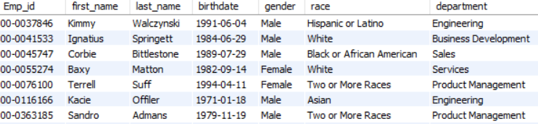

* **Cleaning Dataset**-

Altering the columns.

Augment the columns.

Performing feature engineering.

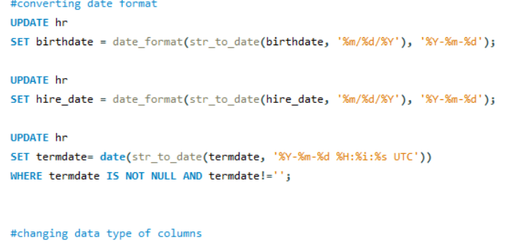

* **Analysing Data by SQL Queries**-

Creating Simple Questions to analyse it. Like

1.What is the distribution of employees by gender, race etc.

2.What is Diversity percentage across company.

3.What is the Average tenure of employees etc.

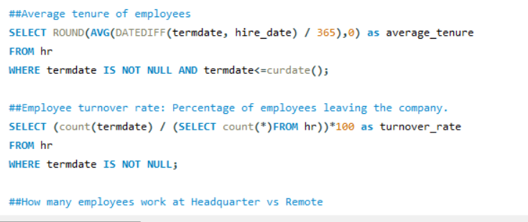

After analysing results table are exported into Power BI to visualize and take insights from it.

* **Power BI** - Visualizing Data to gather insights.

Resultant table after exporting data from MYSQL into Power BI.

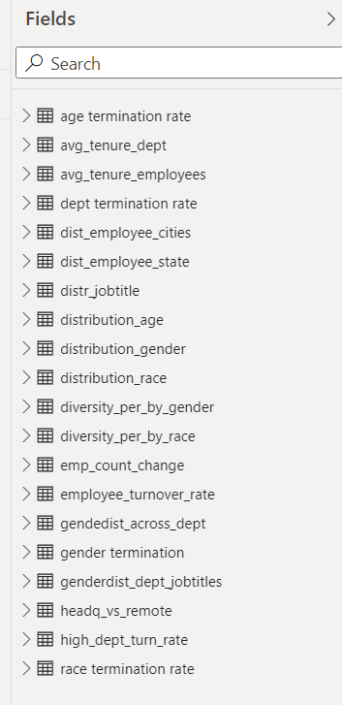

* **Visualization**

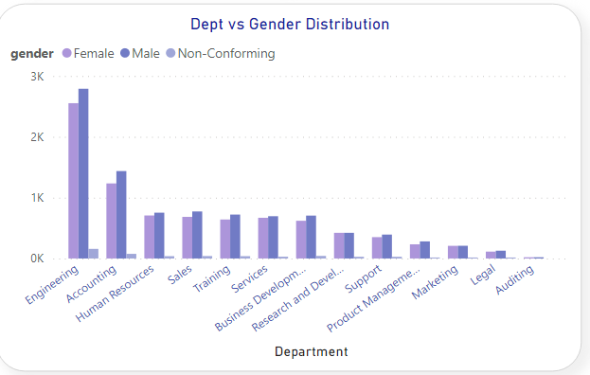

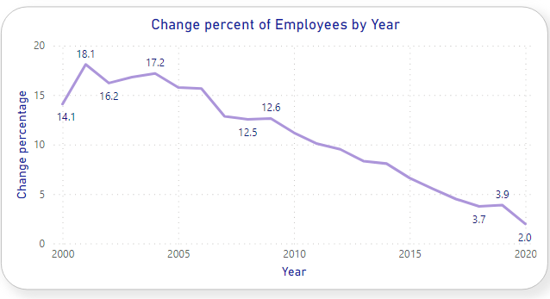

* **Insights** –

1. We can conduct the employee surveys to assess the satisfaction and productivity of those who working remotely to get the idea whether it affect the other factors or not.
2. By analysing performance and engagement levels of different age group we can develop training and development programs to ensure continuous growth.
3. We can promote diversity and inclusion initiatives to create a more equitable work environment through different races.
4. By the decrease in termination rates and stable hiring rates over the years we can refine the Hr strategies which have contributed to these trends.
5. By age group exits we can offer career development and mentorship programs to retain experienced talent and support career progression for employees in their late 30s.
6. Also, to improve the retention rate department wise we can address the specific issue in department.
7. As we have seen there is higher termination rates among American Indian and Native Hawaiian employees, we can implement diversity and inclusion initiatives to ensure all employees have equal opportunities and support.

* **Static Report** –

