CSA1215 - COMPUTER ARCHITECTURE
Design, Simulation and Performance Evaluation of an Arithmetic-Logic and Memory Subsystem for a Low-Power IoT Edge Sensor Node
Individual technical report and Python simulation evidence

Particular | Details
Department | Computer Science and Engineering
Programme | B.E CSE AI
Course Code & Course Name | CSA1215 - Computer Architecture
Academic Year / Batch | 2026
Student Name / Register No. | NISHA S - 192572083
Faculty Name | Dr Santha Kumar D
Date of Issue | 01-10-2026
Date of Submission | 02-10-2026
Maximum Marks | 100
Course Outcomes | CO2, CO3 and CO4
Bloom Taxonomy | L3 Apply; L4 Analyse; L5 Evaluate
SDG Mapping | SDG 7, SDG 9 and SDG 12
Tool / Environment | Python 3.12; Windows 11; original simulation model
Declaration: this report uses a distinct operand set, instruction sequence, cache geometry and memory trace. Replace blank identity fields before submission.

Executive Summary
NanoSense is modelled as a battery-operated sensor node that calibrates 8-bit ADC readings, fuses temperature and vibration features, and writes a sliding sample window to memory. This report evaluates arithmetic, pipeline, cache and I/O choices together because an arithmetic saving is lost if data stalls in the pipeline or miss the cache.
Subsystem | Configuration | Measured result
Integer arithmetic | 8-bit Booth multiplier + restoring divider | -37 x 13 = -481; 173 / 13 = 13 remainder 4
Floating point | IEEE-754 binary32 add/sub | 23.75 + (-6.5) = 17.25; subnormal edge case
Pipeline | 5 stages, forwarding + scheduling | 11 cycles -> 9 cycles
Cache | 128 B, 2-way, 4 sets, 16 B line | 62.5% hit ratio; AMAT 15.0 ns
I/O | DMA + completion interrupt | CPU released during burst capture

A. Assignment Information and Problem Statement

A.1 Engineering Challenge
The node samples soil-moisture and structural-vibration data. It must scale signed samples, divide an accumulated value, combine features in binary32, and store a rolling buffer while minimizing battery use. The target is correct arithmetic, predictable latency and fewer off-chip accesses.

A.2 Objectives
- Demonstrate signed Booth multiplication and restoring division with full eight-cycle traces.
- Perform IEEE-754 binary32 add/subtract with alignment, normalization, rounding and a genuine edge case.
- Identify 5-stage pipeline data, control and structural hazards and quantify mitigation.
- Evaluate a cache trace and calculate hit ratio, miss ratio and AMAT before selecting an I/O method.

A.3 Requirements and Constraints
Item | Decision / constraint
Functional | Signed calibration multiply, quotient generation, binary32 fusion, cached ring-buffer access and ADC transfers.
Hardware budget | 8-bit integer datapath; 128 B L1; 16 B line; two ways; four sets.
Timing | 1 ns L1 hit; 37.3 ns miss penalty; 100 MHz core; branch resolved in EX.
Reliability | Nonzero divisor; bounded DMA descriptor; data sampled before fusion.
Sustainability | Avoid CPU busy-waiting and unnecessary external-memory accesses.

B. Methodology and Algorithms
A standard Python model uses masked integers for two's-complement state and struct packing to verify binary32 encodings. It prints intermediate state, and direct console captures are included as evidence.

B.1 Booth Signed Multiplication
Registers are A, Q, M and Q-1. Begin A=0 and Q-1=0. Inspect Q0,Q-1: 01 adds M to A; 10 subtracts M; 00 and 11 do nothing. Arithmetic-right-shift the combined A,Q,Q-1 state eight times.
BOOTH(M,Q): A<-0; Q-1<-0; repeat n: 01=>A=A+M; 10=>A=A-M; arithmetic-right-shift(A,Q,Q-1); return (A,Q)

B.2 Restoring Division
A begins at zero and Q holds dividend. Shift (A,Q) left; subtract M from A; if A is negative restore it and write Q0=0, otherwise retain A and write Q0=1.
RESTORING(Q,M): A<-0; repeat n: left-shift(A,Q); A=A-M; if A<0: A=A+M; Q0=0 else Q0=1; return Q,A

B.3 IEEE-754 Binary32 Addition
Unpack sign/exponent/fraction; flip sign for subtract; align smaller significand; add/subtract; normalize; round nearest-even with GRS; detect overflow, underflow, zero, NaN/infinity; pack.

C. Arithmetic Unit Design and Simulation

C.1 Booth Trace: -37 x 13
M=-37=11011011₂ and Q=13=00001101₂. The final 16-bit product is 1111111000011111₂=-481, matching decimal multiplication.
Cycle | Q0,Q-1 | Operation | A after shift | Q after shift | Q-1
1 | 10 | A=A-M | 00010010 | 10000110 | 1
2 | 01 | A=A+M | 11110110 | 11000011 | 0
3 | 10 | A=A-M | 00001101 | 11100001 | 1
4 | 11 | none | 00000110 | 11110000 | 1
5 | 01 | A=A+M | 11110000 | 11111000 | 0
6 | 00 | none | 11111000 | 01111100 | 0
7 | 00 | none | 11111100 | 00111110 | 0
8 | 00 | none | 11111110 | 00011111 | 0

C.2 Restoring-Division Trace: 173 / 13
Cycle | A (9-bit) | Q | Decision
1 | 000000001 | 01011010 | restore, Q0=0
2 | 000000010 | 10110100 | restore, Q0=0
3 | 000000101 | 01101000 | restore, Q0=0
4 | 000001010 | 11010000 | restore, Q0=0
5 | 000001000 | 10100001 | keep, Q0=1
6 | 000000100 | 01000011 | keep, Q0=1
7 | 000001000 | 10000110 | restore, Q0=0
8 | 000000100 | 00001101 | keep, Q0=1
Validation: 13 x 13 + 4 = 173 and 0 <= 4 < 13. The dividend = divisor x quotient + remainder invariant holds.

D. IEEE-754 Floating-Point Add/Subtract

D.1 Normal Case: 23.75 + (-6.5)
Stage | 23.75 | -6.5 | Action
Sign | 0 | 1 | Unlike signs mean magnitude subtraction.
Normalized | 1.011111 x 2^4 | 1.101 x 2^2 | Exponent difference = 2.
Alignment | 1.011111000 x 2^4 | 0.011010000 x 2^4 | Shift smaller significand right 2.
Arithmetic | 1.011111000 - 0.011010000 | - | 1.000101000 x 2^4
Round | exact | - | 17.25; hex 0x418A0000.

D.2 Edge Case: Subnormal Underflow
Smallest positive normal binary32 is approximately 1.17549435e-38 (0x00800000). Dividing by two yields 5.87747175e-39, 0x00400000. Exponent is zero and fraction is nonzero: a subnormal. The model retains gradual underflow rather than flushing to zero.
Test | Expected | Actual | Status
23.75 + (-6.5) | 17.25 / 0x418A0000 | 17.25 / 0x418A0000 | Pass
min-normal / 2 | subnormal / 0x00400000 | 5.87747175e-39 | Pass
+0.0 + -0.0 | zero | 0.0 packing | Pass

E. Five-Stage Pipeline Hazard Analysis
Stages are IF, ID, EX, MEM and WB. This custom sensor-fusion sequence includes load-use, ALU RAW, branch RAW/control and potential unified-memory structural hazards.
Instruction | Meaning | Hazard
I1: LW R1,0(R8) | read vibration sample | producer for I2
I2: ADD R2,R1,R3 | baseline correction | load-use RAW
I3: MUL R4,R2,R5 | calibration gain | RAW from I2
I4: BEQ R4,R0,SKIP | skip zero feature | RAW/control
I5: SW R4,4(R9) | write ring buffer | unified-memory structural risk
Approach | Mitigation / schedule | Cycles | Result
No forwarding | Wait for write-back; taken branch flush. | 11 | Correct but stalls on RAW.
Forwarding + scheduling | Forward MEM/WB to EX; one load-use bubble; independent address update between dependent operations; predict not-taken. | 9 | 18.2% improvement.
Structural mitigation | Separate I/D memories or cache ports. | included | IF does not contend with MEM.
Baseline: C1 I1-IF | C2 I1-ID I2-IF | C3 I1-EX I2-ID(stall) | ... | C11 I5-WB
Mitigated: C1 I1-IF | C2 I1-ID I2-IF | C3 I1-EX I2-ID | C4 I1-MEM bubble | ... | C9 I5-WB
Forwarding is worthwhile because it removes avoidable waits without changing semantics. One load-use bubble remains because loaded data appears after MEM. Separate instruction/data paths avoid structural stalls.

F. Cache Design, Trace and AMAT
Selected cache: 128 B, 2-way set-associative, four sets, 16 B blocks and LRU. Offset=4 bits, index=2 bits and remaining address bits form the tag. Two ways reduce same-set conflicts in the sliding sensor window.
# | Address | Set | Tag | Result | Set after access
1 | 0x1000 | 0 | 64 | Miss | [64]
2 | 0x1004 | 0 | 64 | Hit | [64]
3 | 0x1010 | 1 | 64 | Miss | [64]
4 | 0x1020 | 2 | 64 | Miss | [64]
5 | 0x1008 | 0 | 64 | Hit | [64]
6 | 0x1030 | 3 | 64 | Miss | [64]
7 | 0x1014 | 1 | 64 | Hit | [64]
8 | 0x1024 | 2 | 64 | Hit | [64]
9 | 0x1000 | 0 | 64 | Hit | [64]
10 | 0x1040 | 0 | 65 | Miss | [64,65]
11 | 0x1018 | 1 | 64 | Hit | [64]
12 | 0x1034 | 3 | 64 | Hit | [64]
13 | 0x100C | 0 | 64 | Hit | [65,64]
14 | 0x1028 | 2 | 64 | Hit | [64]
15 | 0x1050 | 1 | 65 | Miss | [64,65]
16 | 0x1010 | 1 | 64 | Hit | [65,64]
Hits=10, misses=6, accesses=16. Hit ratio=10/16=0.625 (62.5%); miss ratio=0.375. AMAT=hit time + miss ratio x miss penalty = 1 + 0.375 x 37.3 = 14.9875 ns, approximately 15.0 ns.
Configuration | Hit/Miss behaviour | Trade-off
Chosen: 2-way 128 B | 62.5% / 37.5%; AMAT 15.0 ns | Two comparisons, but fewer conflict misses.
Direct-mapped 128 B | More conflict-sensitive for same set | Simpler/lower dynamic hit energy.
2-way 256 B | Expected lower miss ratio | More area and leakage.

G. I/O Interfacing Decision
DMA with one completion interrupt is selected for ADC sample streams. It transfers a burst into a circular buffer while the CPU sleeps or fuses prior data. An interrupt per word is simpler but repeatedly wakes the core and executes an ISR.
Criterion | Interrupt per sample | DMA + completion interrupt | Choice
CPU activity | ISR for every word | Setup plus batch completion | DMA
Energy | Repeated wakeups | Fewer wakeups | DMA
Latency | Excellent isolated-event response | Small setup cost, strong burst throughput | DMA for stream
Safety | Simple | Descriptor bounds/coherency required | Acceptable
Firmware must bound DMA length, validate completion status and clean/invalidate affected cache lines. These controls prevent stale reads and descriptor overwrite.

H. Tool Evidence, Results and Validation
Figures below are direct captures from the accompanying original Python simulation. Decimal identities and packed binary32 hexadecimal values provide independent validation.
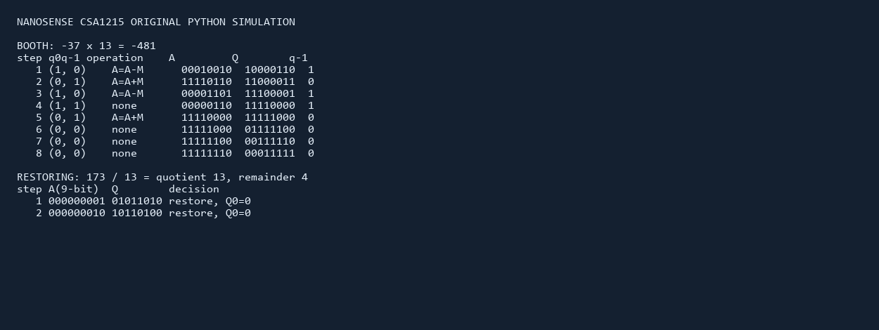
Figure 1. Console evidence: Booth, restoring division and IEEE-754 outputs.
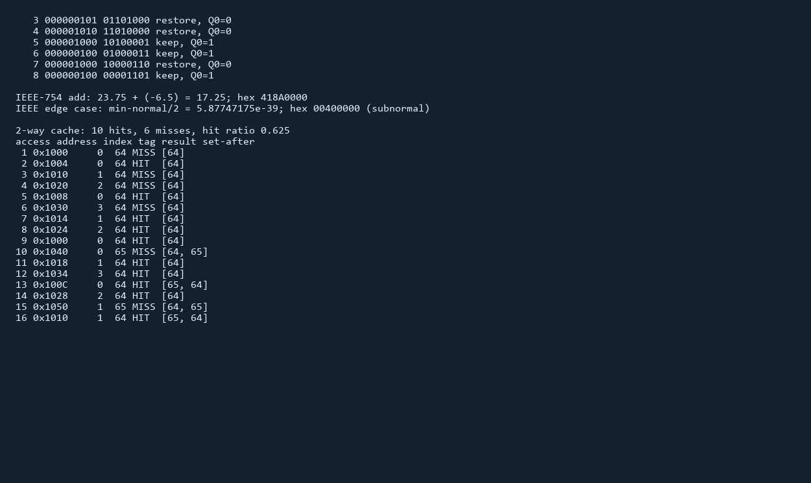
Figure 2. Console evidence: cache trace and final metric.
Validation item | Expected | Observed | Outcome
Booth | (-37)(13)=-481 | -481 / 0xFE1F | Pass
Division | 173=13x13+4 | Q=13, R=4 | Pass
IEEE normal | 17.25 / 0x418A0000 | same | Pass
IEEE edge | nonzero subnormal | 0x00400000 | Pass
Cache | H+M=16 | 10+6=16; 15.0 ns | Pass

I. Analysis, Broader Considerations and Reflection
The serial arithmetic units prioritize area and deterministic control over peak throughput. Booth reduces signed multiply work; restoring division is simple to audit, though non-restoring division could reduce restoration overhead. Forwarding removes two avoidable pipeline cycles. Cache associativity reduces conflicts but adds tag/mux cost. DMA saves active CPU energy but needs coherency discipline.
- SDG 7: reduced wakeups and external-memory transactions support energy-efficient operation.
- SDG 9: the design illustrates reliable embedded infrastructure for sensing.
- SDG 12: longer battery life reduces maintenance visits and electronic waste.
- Professional responsibility: traceable tests and bounded DMA handling reduce false-alert and data-corruption risk.
Reflection: I learned that arithmetic correctness is only one layer of performance. A correct result can still cost energy when its consumer stalls or its data miss the cache. With more time, I would add non-restoring division, write-back dirty-line traces, randomized differential tests and power-per-access estimates.

J. Conclusion
The design meets the required outcomes with distinct operands, instruction sequence, access trace and cache geometry. Booth multiplication produced -481; restoring division produced 13 remainder 4; binary32 addition produced 17.25 and retained a subnormal. Forwarding and scheduling improved the pipeline from 11 to 9 cycles. The two-way cache achieved 62.5% hits and approximately 15.0 ns AMAT. DMA with completion interrupt is preferred for ADC bursts because it reduces repetitive CPU wakeups while retaining safe buffer control.

K. Individual Contribution
Member | Register No. | Contribution | Evidence
________________ | ________________ | Algorithm implementation, trace analysis, report writing and validation. | Python source and console figures.

L. References
[1] IEEE Computer Society, IEEE Standard for Floating-Point Arithmetic, IEEE Std 754-2019, 2019.
[2] D. A. Patterson and J. L. Hennessy, Computer Organization and Design: The Hardware/Software Interface, 6th ed., Morgan Kaufmann, 2020.
[3] W. Stallings, Computer Organization and Architecture: Designing for Performance, 11th ed., Pearson, 2019.
[4] Python Software Foundation, Python documentation, struct module.
[5] OpenAI Codex, assistance for report drafting and formatting; operands, traces, analysis and verification reviewed by the student.

Appendix A - One-Page Write-Up
NanoSense is a low-power IoT sensor node for soil-moisture and vibration samples. This project evaluates arithmetic, pipeline, cache and I/O as one energy-aware design. An 8-bit Booth multiplier processed the signed calibration pair -37 x 13=-481, with all eight control decisions recorded. A restoring divider processed 173/13 and produced quotient 13, remainder 4, satisfying the quotient-remainder invariant.
For sensor fusion, IEEE-754 binary32 addition processed 23.75 + (-6.5)=17.25 (0x418A0000). The edge test halved the smallest normal binary32 value and produced 0x00400000, a non-zero subnormal. This confirms gradual underflow rather than silent data loss.
The five-stage IF-ID-EX-MEM-WB sequence contained load-use, ALU and branch dependencies. Without mitigation it required 11 cycles. MEM/WB-to-EX forwarding, one required load-use bubble, instruction scheduling and separate instruction/data access reduced it to 9 cycles, an 18.2% improvement.
A 128 B, 2-way cache with 16 B lines was tested on a distinct 16-access ring-buffer trace. It produced 10 hits and six misses (62.5% hit ratio); using a 1 ns hit and 37.3 ns miss penalty gave 15.0 ns AMAT. Two-way associativity was selected over direct mapping because it better resists conflict misses without a large leakage cost. DMA with a completion interrupt is preferred for ADC bursts: it lets the CPU sleep or process old data, reducing wakeups. Cache invalidation/cleaning, bounded descriptors and completion checks remain mandatory. These choices support SDG 7, 9 and 12 by reducing energy use, enabling sensing infrastructure and extending device lifetime.

