Title : Design and apply context-aware access controls based on user identity, device
posture, location, and application risk.

- Group details : Team ID : SWTID-2026-6767
Team Size : 5

- Name : Team Leader : Nisha B
Team member : Vismaya R
Team member : Meera Krishna
Team member : Infant Benson P
Team member : Srihari P K

- College Name : Sree Narayana Guru College

- Contact : 9037406271

Project details :
This project focuses on developing a system that controls user access based on identity and context. The system checks the user’s identity, device condition, and location before allowing access to applications or data. If the risk is high, the system may request extra authentication or block the access. This helps improve security and prevents unauthorized access.

Title :
Context-Aware Access Control Based on User Identity

Introduction :
Organizations today face increasing cyber threats due to the use of cloud services, remote work, and personal devices. Traditional security models that trust users inside a network are no longer effective. To solve this problem, this project proposes a Context-Aware Access Control System that evaluates different factors before granting access to applications and data.
Instead of relying only on usernames and passwords, the system analyzes contextual information such as the user’s identity and role, device security status, location, and the risk level of the application. Based on this analysis, the system can allow access, restrict certain features, request additional authentication like multi-factor authentication, or block the request.
This intelligent approach improves security by protecting sensitive data and reducing cyber risks while still allowing authorized users to access resources easily in a modern digital environment.

Abstract :
The rapid growth of cloud services, mobile devices, and hybrid work has made traditional network security models less effective. Organizations now face many security risks because users access company data from different devices and locations. Therefore, a more advanced and dynamic access control system is needed to protect sensitive data.
This project proposes a Context-Aware Access Control System that makes access decisions based on factors such as user identity, device security, location, and application risk level. The system analyzes these factors in real time and decides whether to allow access, require multi-factor authentication, limit access, or block the request.
Use case scenarios :

Scenario 1: Finance Department Access to ERP System
A senior accountant needs to access the company’s ERP system to process payroll. The user logs in from a remote location using a company-managed laptop and authenticates with MFA. The system checks the user identity, group membership, device security, and connection context. Since all conditions are valid, the system allows access only to the ERP application.
Output:
- User authenticated and authorized
- Secure connection provided only to ERP system
- Other internal systems remain inaccessible

Scenario 2: Contractor Access to Project Repository
A software contractor requires access to a specific project Git repository. The contractor is added to the “Project Contractors” group and logs in using the secure client. The system verifies identity and basic device security before granting access only to the repository during working hours.
Output:
- Time-based and role-based access allowed
- Access restricted to the Git repository only
- Other internal resources remain blocked

Scenario 3: Executive Access to Confidential Documents
A company executive needs to access sensitive financial documents stored in SharePoint while traveling abroad. The user logs in using MFA from a company tablet. Due to the foreign location and sensitive data, the system allows only restricted access and monitors the session.

Output:
- MFA authentication completed
- Read-only access granted
- Download and print actions restricted
- Security team notified of unusual login location

Scenario 4: IT Support Technician Remote Access
An IT technician needs access to ServiceNow and a remote desktop tool to assist employees. The technician logs in from home using a secure company device. The system verifies identity, group membership, and device status before granting access to the required tools only.
Output:
- Authorized access to support tools
- Secure connection established
- Access limited to necessary applications only

Scenario 5: Access from Public Wi-Fi
A marketing employee tries to access the Salesforce system from a coffee shop using public Wi-Fi. Even though the user and device are verified, the network is considered risky. The system allows access through a secure browser isolation environment.
Output:
- User authenticated and device verified
- Access allowed through secure browser isolation
- Data download and copy functions restricted

Stage – 1
Title:
Design and apply context-aware access controls based on user identity, device posture,
location, and application risk.
Overview:
In response to the evolving threat landscape and the dissolution of the traditional network perimeter, modern enterprises are rapidly shifting away from legacy VPN-centric remote access models. These conventional approaches often grant excessive network-level access, creating a significant attack surface and increasing the risk of lateral threat movement. To address these challenges, this project centers on the implementation of a Zero Trust security architecture, fundamentally operating on the principle of "never trust, always verify." By moving beyond location-based access, we aim to establish a security posture where trust is no longer implicit, and access is determined by granular context rather than network connectivity.
The core of this initiative involves the deployment of Zscaler Private Access (ZPA), a cloud-delivered Zero Trust Access solution designed to create identity-aware, application-specific connectivity. Unlike traditional VPNs that place users on the internal network, ZPA leverages a "service-initiated" model to establish direct, one-to-one connections between authorized users and specific applications, completely hiding the corporate network and IP address space from the internet. This ensures that users connect exclusively to the applications they are permitted to access, based on continuous identity verification and context, rendering the applications invisible to unauthorized users and preventing common attack vectors such as port scanning and distributed denial-of-service (DDoS) attacks.
Ultimately, this project will enforce a least-privilege access model, ensuring users and devices are granted the minimum required access necessary to perform their functions. By decoupling application access from network access, we will eliminate the risk of lateral movement across the network, as users have no visibility or connectivity to other hosts. This strategic move not only significantly enhances security by reducing the attack surface but also simplifies the user experience and reduces operational overhead associated with legacy remote access infrastructure, positioning the organization at theforefront of secure and efficient access management.

Sl.no | Vulnerability Name | CWE/CVE.no
1 | Absolute Path Traversal | CWE 36
2 | Sensitive Cookie in HTTPS Session Without 'Secure' Attribute | CWE 614
3 | Use of Unmaintained Third Party Components | CWE 1104
4 | Use of Predictable Algorithm in Random Number Generator | CWE 1241
5 | Improper Input Validation | CWE 20
6 | Improper Neutralization of Script-Related HTML Tags in a Web Page (Basic XSS) | CWE 80
7 | Session Fixation | CWE 384
8 | Inclusion of Functionality from Untrusted Control Sphere | CWE 829
9 | Improper Output Neutralization for Logs | CWE 117
10 | Missing Custom Error Page | CWE 756

Report:
1. Vulnerability name: Absolute Path Traversal
CWE: 36
OWASP category: A01:2025 Broken Access Control
Description
Absolute Path Traversal is a security vulnerability that allows an attacker to access files and directories outside the intended application folder. This happens when an application does not properly validate user input used in file paths. By manipulating file path parameters (for example using sequences like ../), an attacker may gain access to sensitive system files or restricted directories. As a result, unauthorized users may read confidential files stored on the server.
Business Impact
If this vulnerability is exploited, attackers may access sensitive information such as configuration files, database credentials, or system files. This can lead to data leakage, system compromise, and unauthorized access to important resources.
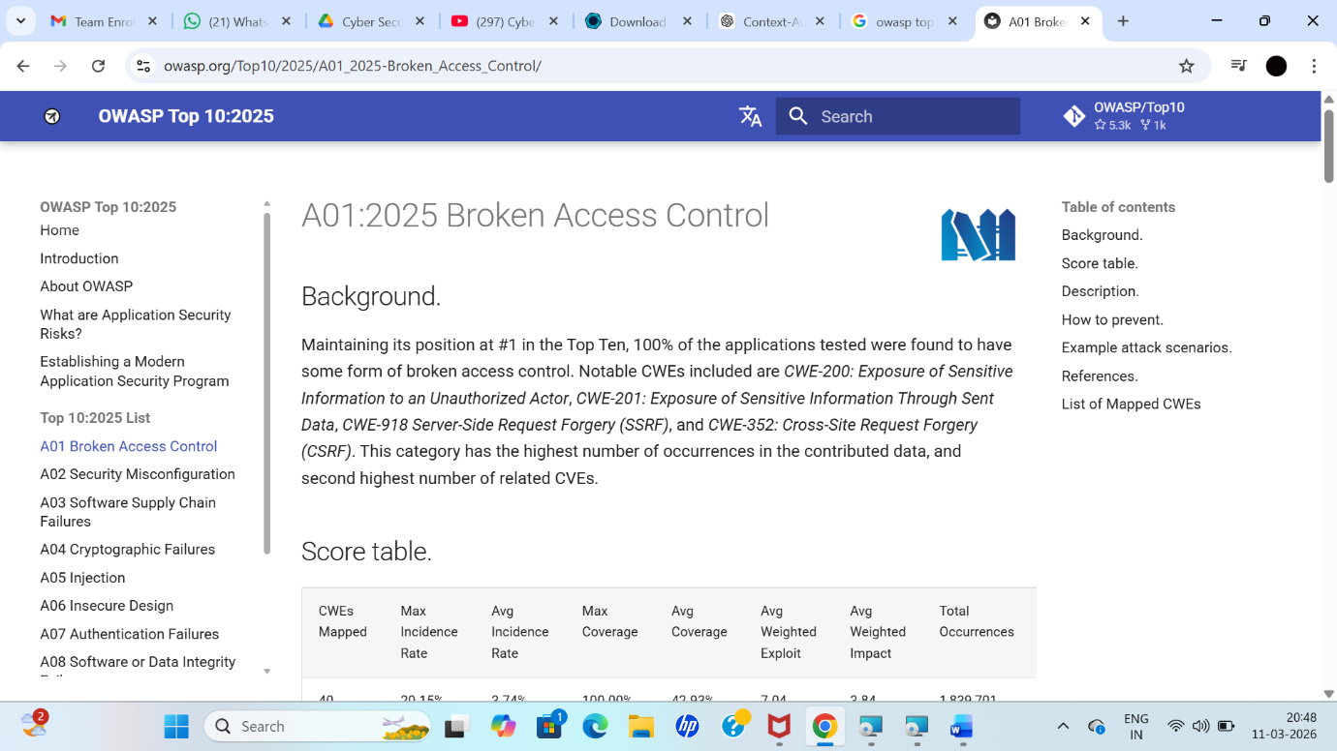

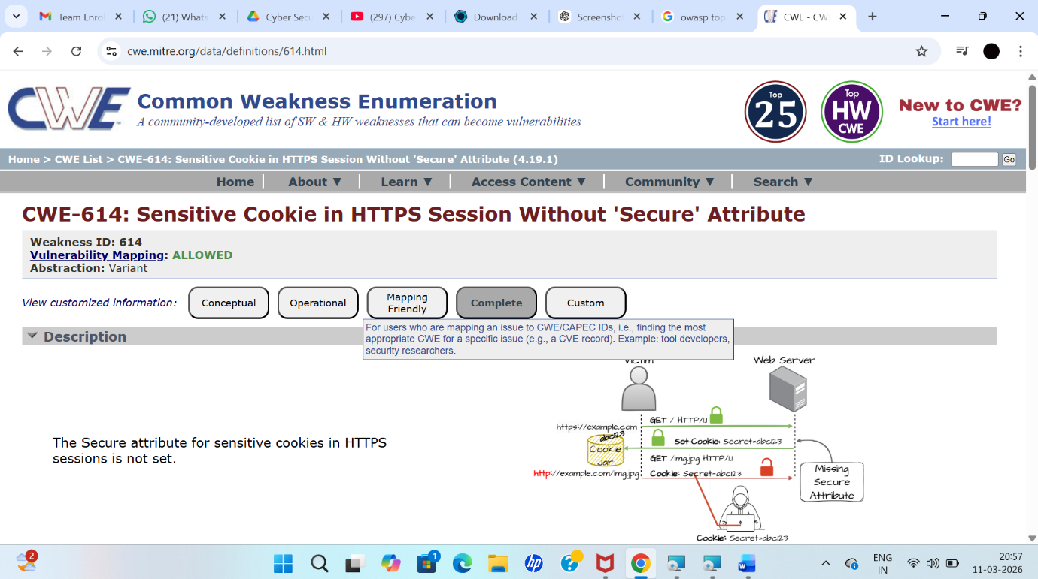
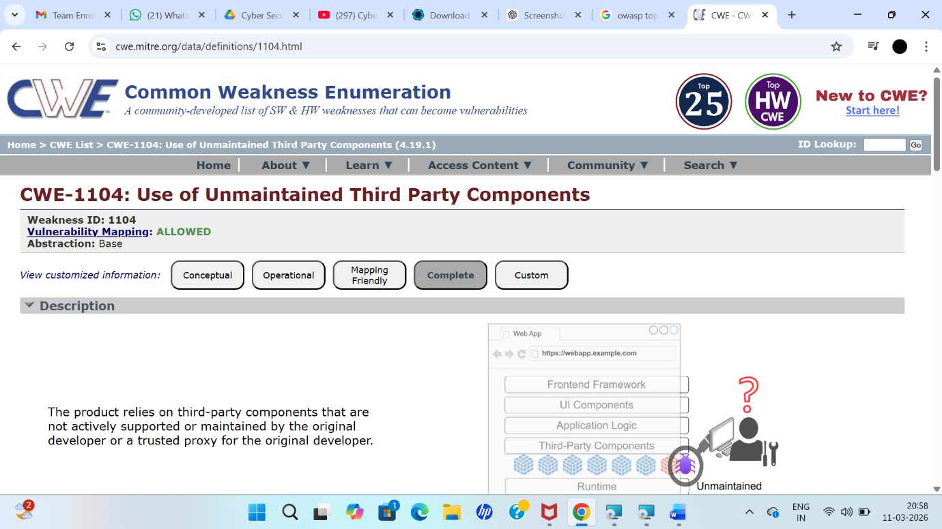

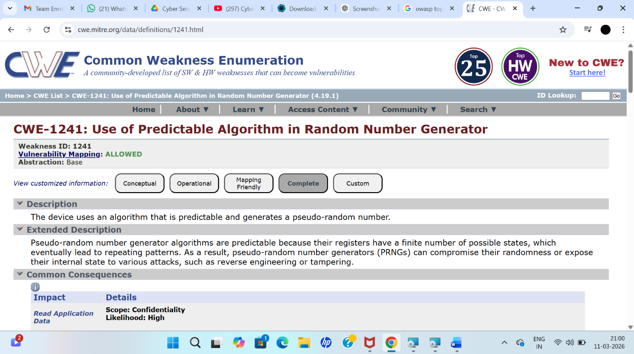
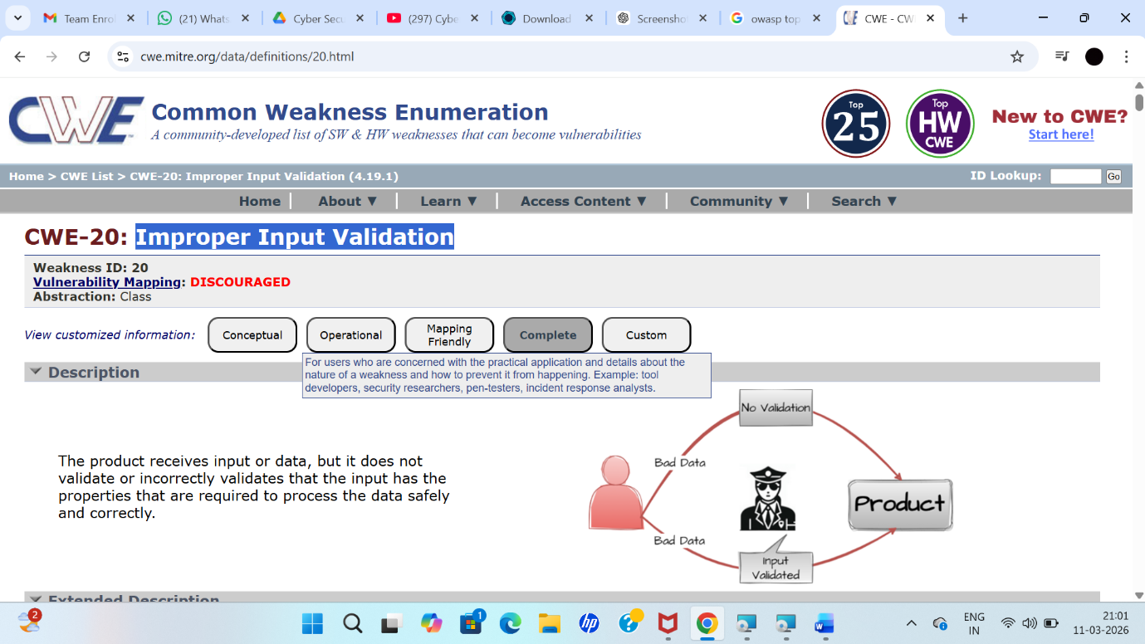

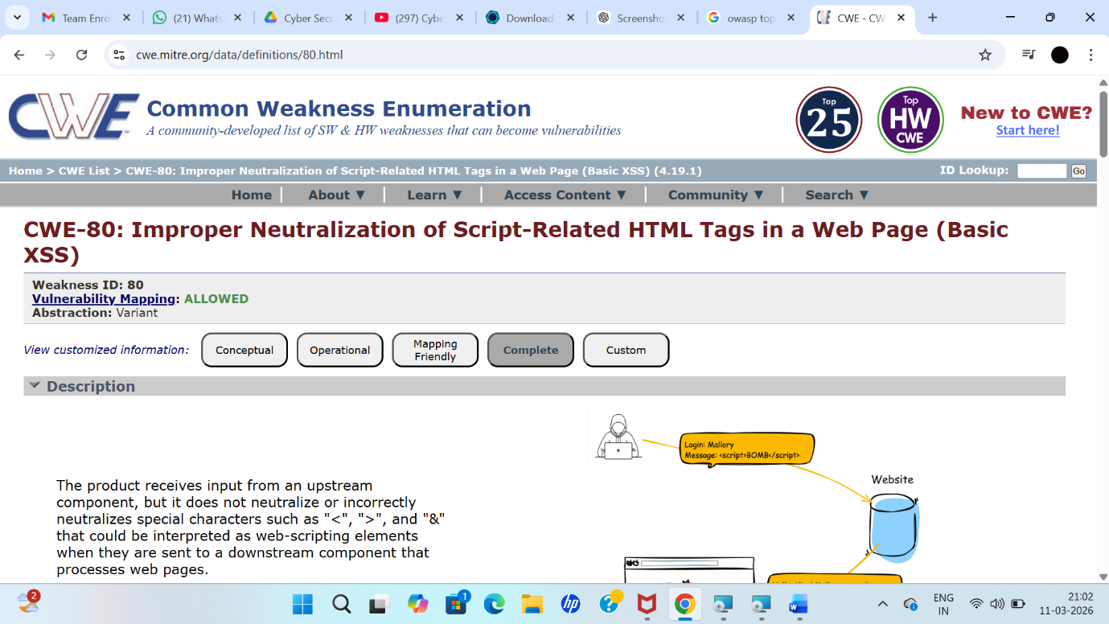
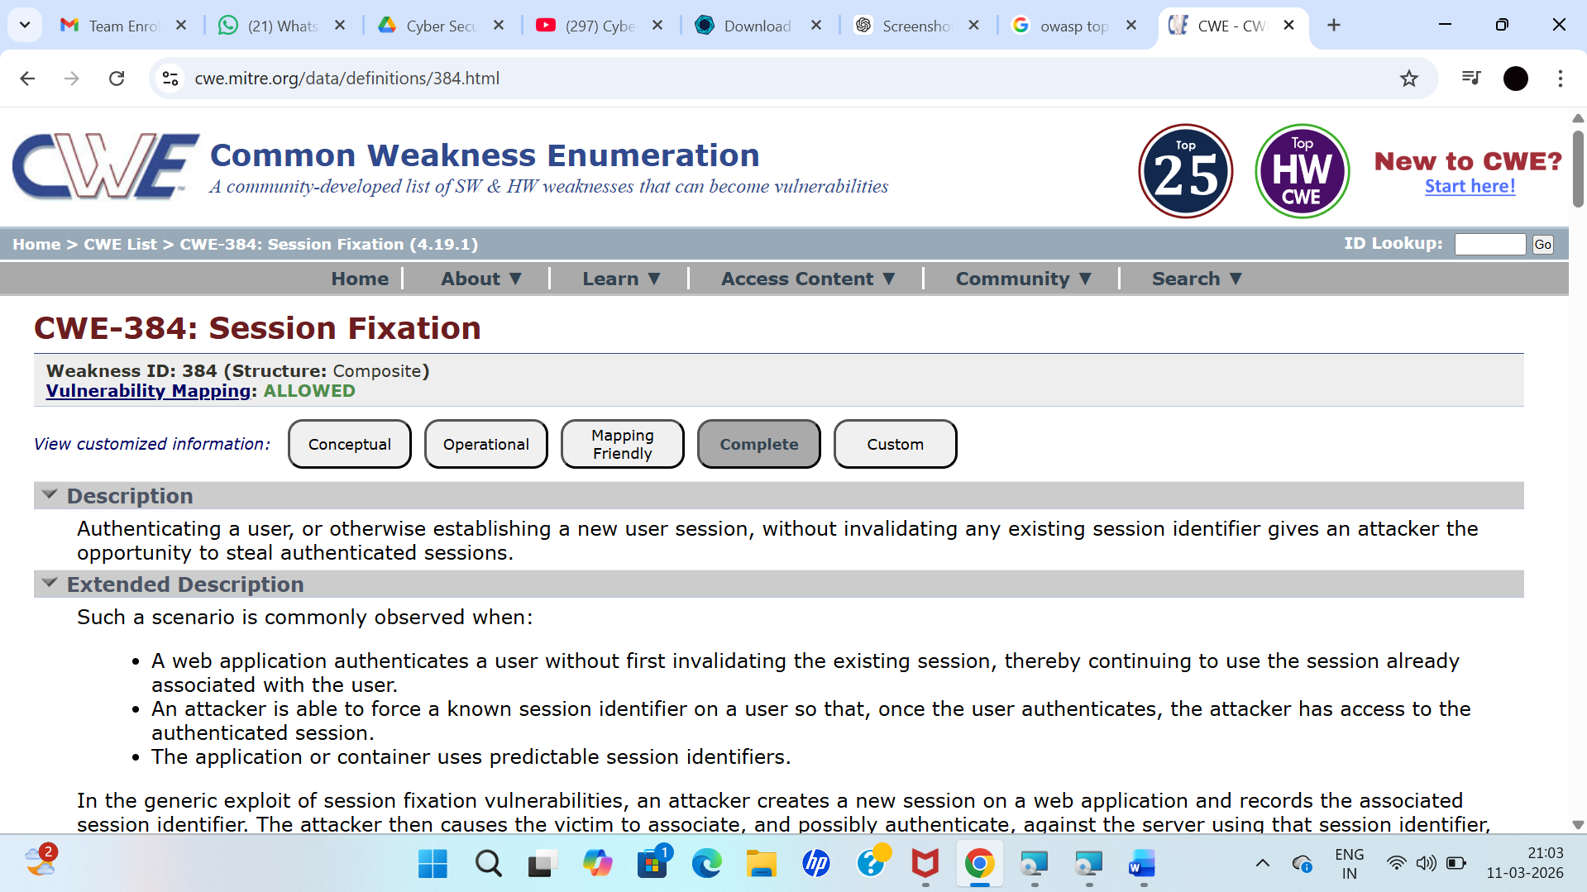

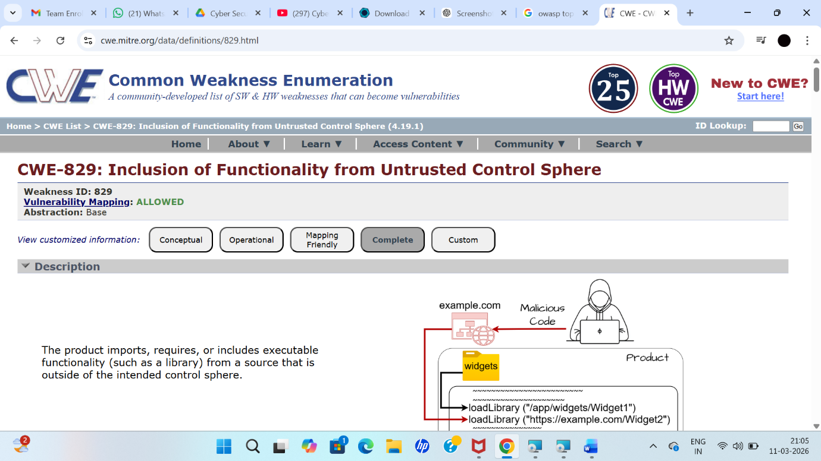
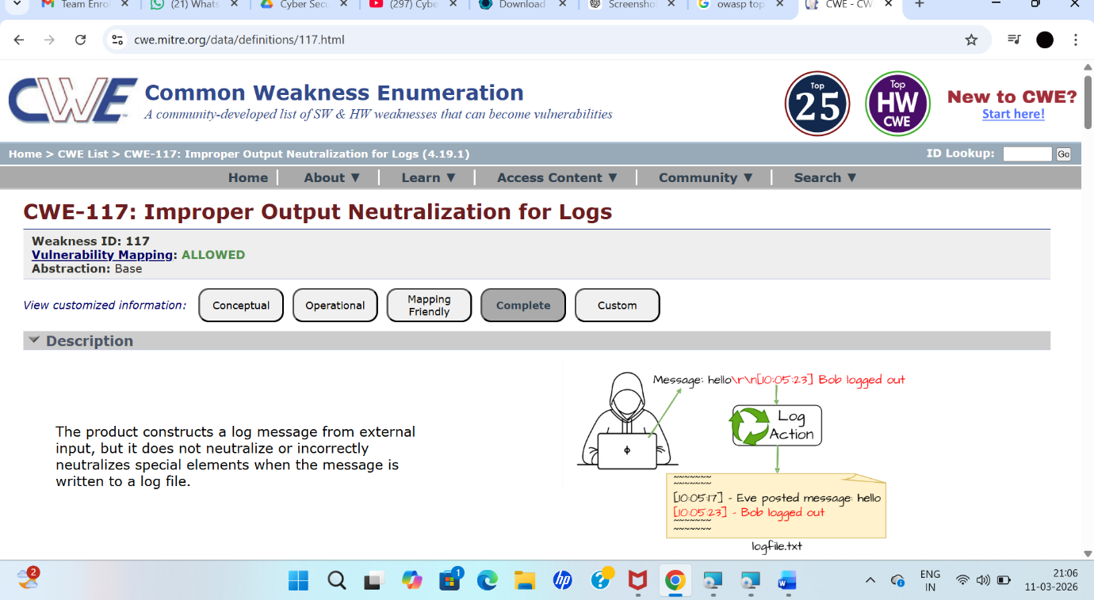

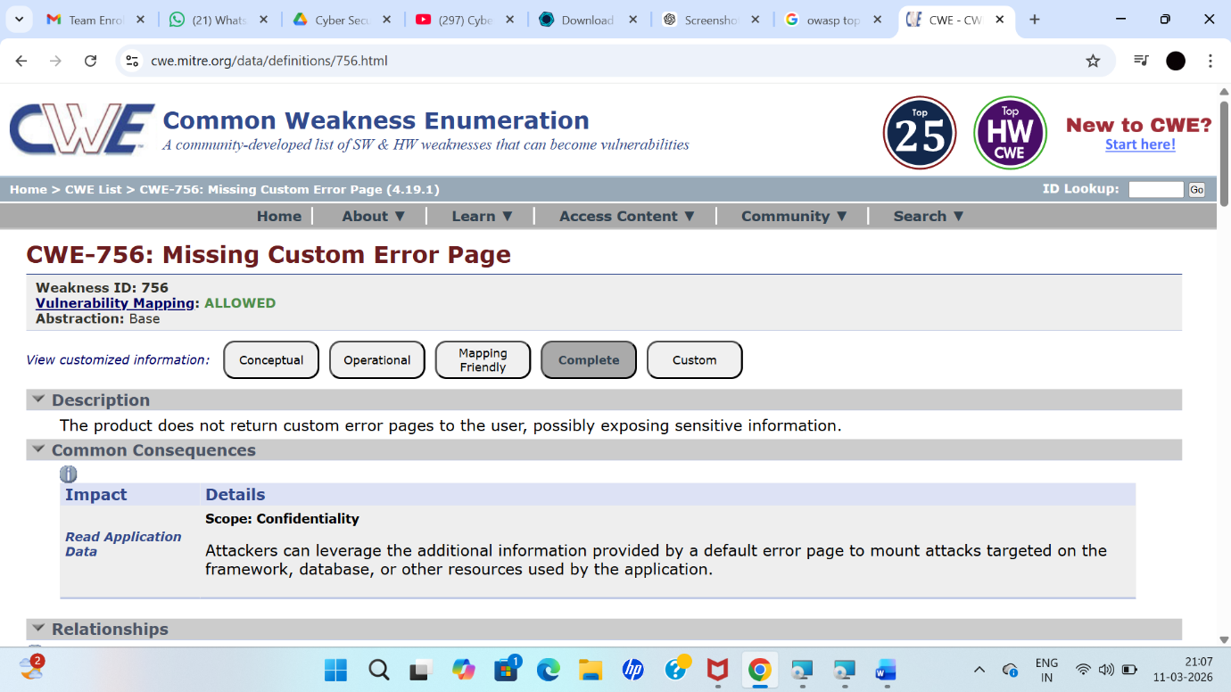
Stage – 2
Overview
A Nessus scan is used to identify security vulnerabilities in systems and networks. It helps organizations detect weaknesses such as missing patches, misconfigurations, open ports, and other security risks. Nessus is widely used by security professionals to improve system security and prevent cyber attacks.
1. Preparation
In this stage, the objectives of the scan are defined and the systems or networks to be scanned are identified. Proper permissions and access rights must be ensured before starting the scan.
2. Configuration
A scan policy is created by defining the parameters of the scan. The target assets such as IP addresses, hostnames, or network ranges are also specified.
3. Scanning
The Nessus scan is initiated using the configured policy. Nessus scans the target systems and checks for vulnerabilities using its plugin database.
4. Vulnerability Identification
Nessus analyzes the scanned systems and identifies vulnerabilities, misconfigurations, and security weaknesses. The vulnerabilities are categorized based on their severity levels.
5. Reporting
After the scan is completed, Nessus generates detailed reports that include vulnerability details, severity level, and recommended solutions. These reports help security teams understand and prioritize issues.
6. Remediation
Security teams review the scan results and take corrective actions such as applying patches, fixing configurations, or improving security controls.
7. Follow-up
Regular scans are conducted to monitor the security status of systems and ensure that previously identified vulnerabilities are fixed.
8. Compliance Auditing
Nessus can also check whether systems meet security standards and compliance requirements such as industry regulations.
9. Documentation
All scan results, remediation steps, and compliance reports are documented for auditing and future reference.
10. User Training
IT and security teams should be trained to use Nessus effectively and understand the scan reports.

Stage 2

Sl.no | Vulnerability Name | severity | plugins
1. | Cross-site scripting (stored | Low | Web application scanner
 | Broken Access Control | medium | SSH weak HMAC Algorithms supported
3 | SQL Injection | Medium | N/A
4 | Broken Authentication | Low | HSTS Missing from  server
5 | Insecure direct object reference | info | Service detection

1. Vulnerability Name: Cross-Site Scripting (Stored)
Severity: Low
Plugin: Web Application Scanner
Port: N/A
Description:
Stored XSS occurs when a malicious script is stored in the web application database and later executed in the user’s browser when the page is loaded.
Solution:
- Sanitize and validate all user inputs.
- Use output encoding to prevent script injection.
Business Impact:
Attackers can execute malicious scripts in users’ browsers, potentially stealing sensitive information or performing actions on behalf of users.

2. Vulnerability Name: Broken Access Control
Severity: Medium
Plugin: SSH Weak HMAC Algorithms Supported
Port: N/A
Description:
Occurs when access control checks are missing or not properly enforced, allowing users to access unauthorized data or perform restricted actions.
Solution:
- Implement strong authentication and authorization mechanisms.
- Use secure session management with strong session IDs and timeouts.
Business Impact:
Can lead to data leaks, unauthorized actions, financial loss, and damage to the organization’s reputation.

3. Vulnerability Name: SQL Injection
Severity: Medium
Plugin: N/A
Port: 80 / 443
Description:
SQL Injection occurs when attackers insert malicious SQL queries through user input fields, allowing them to access or manipulate database data.
Solution:
- Use parameterized queries or prepared statements.
- Validate and sanitize all user inputs.
Business Impact:
May result in data breaches, financial loss, legal issues, and damage to organizational reputation.

4. Vulnerability Name: Broken Authentication
Severity: Low
Plugin: HSTS Missing from HTTPS Server
Port: 443
Description:
Occurs when authentication mechanisms are weak, allowing attackers to access other users’ accounts or sensitive information.
Solution:
- Implement Multi-Factor Authentication (MFA).
- Use role-based access control and secure session management.
Business Impact:
Can lead to unauthorized account access, data theft, and loss of user trust.

5. Vulnerability Name: Insecure Direct Object Reference (IDOR)
Severity: Info
Plugin: Service Detection
Port: 80 / 443
Description:
IDOR occurs when attackers access or modify data by changing identifiers in URLs or parameters without proper authorization checks.
Solution:
- Implement proper access control checks.
- Use secure authentication and authorization mechanisms.
Business Impact:
Attackers may gain unauthorized access to sensitive data, leading to security and privacy risks.

Stage 3
Title:
Design and apply context-aware access controls based on user identity, device posture, location, and application risk.

Project Overview
The Context-Aware Access Control System is designed to improve security by controlling access to applications and data based on multiple factors. Traditional access control systems only use usernames and passwords, which are not always secure. This project uses additional contextual information such as user identity, device security status, location, and application risk level to make better access decisions. The system analyzes these factors in real time and decides whether to allow access, require additional authentication, restrict certain actions, or block the request. This helps organizations protect sensitive data while allowing authorized users to work safely.
User Identity
User identity refers to the process of verifying who the user is before granting access to a system or application. The system checks login credentials such as username, password, and sometimes multi-factor authentication (MFA). It also verifies the user’s role or group in the organization. This helps ensure that only authorized users can access specific resources.
Device Posture
Device posture refers to the security condition of the device used to access the system. The system checks whether the device is secure and compliant with security policies. This may include checking if antivirus is active, the operating system is updated, and disk encryption is enabled. If the device does not meet security requirements, access may be restricted or denied.
Application Risk
Application risk refers to the level of sensitivity or importance of the application being accessed. Some applications contain highly confidential information, such as financial systems or customer data. In such cases, the system applies stricter security controls, such as additional authentication or restricted access, to protect sensitive information.

Context-Aware Access
Context-aware access is a security approach where the system analyzes multiple factors before granting access. These factors may include user identity, device posture, location, and application risk. Based on this analysis, the system decides whether to allow full access, limited access, require extra verification, or block the request. This method improves security while still allowing trusted users to access resources easily.

Conclusion
Stage 1
In the first stage, the concept of Context-Aware Access Control was studied and analyzed. The importance of modern security systems was identified due to the increasing use of cloud services, mobile devices, and remote work environments. Traditional access control methods were found to be insufficient, and the need for a system that evaluates user identity, device posture, and application risk was understood.
Stage 2
In the second stage, security analysis was performed using vulnerability scanning tools such as Nessus. The scanning process helped identify security weaknesses, misconfigurations, and possible threats in the system. The scan reports provided information about vulnerabilities and recommended solutions to improve system security.
Stage 3
In the final stage, the findings from the analysis were used to design a context-aware access control framework. The system was developed to evaluate multiple contextual factors such as user identity, device status, location, and application risk before granting access. This approach improves security by preventing unauthorized access while allowing trusted users to access resources safely.

Future Scope
Stage 1
In the first stage, the system can be improved by adding more advanced identity verification methods such as biometric authentication, facial recognition, or behavioral analysis. This will make user authentication stronger and reduce the risk of unauthorized access.
Stage 2
In the second stage, the system can integrate more advanced security monitoring and vulnerability scanning tools. Regular vulnerability assessments and automated security updates can be implemented to detect and fix security issues faster.
Stage 3
In the third stage, the project can be enhanced by using Artificial Intelligence and Machine Learning to analyze user behavior and detect unusual activities automatically. This will help the system make smarter access decisions and provide stronger protection against cyber threats in modern digital environments.

Topics Explored : owsap top 10 , scanning , vulnerability , Awarness , identity
Tools Explored : Zscaler , nesses , owsap , hackthissite

