A Leachate-Centric In-Silico Pipeline for Predicting Polymer-Dependent Neuroinflammatory Potential of Microplastics

A Leachate-Centric In-Silico Pipeline for Predicting Polymer-Dependent Neuroinflammatory Potential of Microplastics
M. Nisha Angeline — Professor and Head, Department of Electronics and Communication Engineering, Velalar College of Engineering and Technology, Thindal, Erode, Tamil Nadu, India · nishavlsidesign@gmail.com
Companion computational manuscript to a PRISMA systematic review on microplastics and neuroinflammation. October 2026.

Abstract
Whether microplastic polymer type governs neuroinflammatory risk is confounded in the experimental literature by particle size and by the chemical additives and leachates each polymer carries. We test a falsifiable hypothesis: that predicted neuroinflammatory potential across polyethylene (PE), polypropylene (PP), polystyrene (PS), polyvinyl chloride (PVC) and polyurethane (PU) tracks leachate chemistry engaging neuroinflammation receptors rather than the inert polymer backbone. We assemble a curated, structure-validated inventory of 56 documented leachates (11–12 per polymer), triage every compound with scaffold-split RandomForest classifiers trained on three inflammation-relevant Tox21 endpoints (NR-AhR, SR-ARE, SR-p53), and propagate the aggregated per-polymer signal through a minimal microglial ODE model (receptor → NF-κB → {TNF-α, IL-6}) to obtain a normalised neuroinflammation index. The NR-AhR classifier attains a scaffold-split ROC-AUC of 0.84 and AUPRC of 0.55 (test base rate 0.14). The pipeline predicts PU > PVC > PE > PS > PP, with PU elevated by aromatic-amine hydrolysis products (toluenediamine, methylenedianiline) and PVC by bisphenol A and phthalates. We preserve the governing caveat that binding affinity is strength, not activation direction, and that virtual-cell kinetics are illustrative rather than fitted; receptor docking into AhR, TLR4–MD2 and NLRP3 is specified and implemented but was not executed here due to restricted access to structure databases, and no affinities were fabricated. The ranking is offered as a prioritised, testable hypothesis for wet-lab confirmation, and the framework directly addresses the PS-over-study / PE-under-study imbalance in the current evidence base.
Index Terms — Microplastics, neuroinflammation, leachates, aryl hydrocarbon receptor, Tox21, machine learning, molecular docking, systems biology, in-silico toxicology.

I. Introduction
Microplastics are now detected in human blood, placenta and brain tissue, and micro- and nanoplastics are reported to cross the blood–brain barrier and provoke glial activation [1]. A central, unresolved question is whether the polymer type of a particle (PE, PP, PS, PVC, PU) determines the magnitude of the neuroinflammatory response. The experimental record cannot answer this cleanly: polymer identity is entangled with particle size, surface chemistry and, critically, with the distinct sets of additives, residual monomers and adsorbed contaminants — collectively leachates — each polymer carries.
We test the hypothesis that polymer-to-polymer differences are driven largely by leachate chemistry acting on specific xenobiotic-sensing and innate-immune receptors — the aryl hydrocarbon receptor (AhR) [2], the TLR4–MD2 complex [3], and the NLRP3 inflammasome [4] — rather than by the inert backbone. If the computed ranking matches an experimental ranking from systematic-review screening, the framework is validated; if not, the discrepancy is itself a falsifiable prediction.
Contributions: (i) a transparent, reproducible five-stage pipeline from polymer to per-polymer neuroinflammation index; (ii) real scaffold-split ML performance on inflammation-relevant Tox21 endpoints; (iii) a prioritised polymer ranking with the dominant leachate and receptor axis per polymer; and (iv) an explicit, preserved set of caveats so predictions are never mistaken for fact.

II. Related Work
QSAR models trained on the Tox21 ~10k library are a standard first-pass triage, with NR-AhR and SR-ARE among the most predictive, interpretable endpoints [5]. Molecular docking with AutoDock Vina [6], [7] is the workhorse for receptor-engagement screening, and AlphaFold [8] supplements experimental PDB structures [9] where co-crystals are unavailable. Open inventories such as PlastChem [10] now catalogue plastic-associated chemicals at a scale usable for systematic in-silico screening. Our contribution chains these into a single leachate-to-microglia prediction and foregrounds the affinity-versus-direction problem that docking-only studies leave implicit.

III. Materials and Methods
Stage 1 — Leachate inventory. Documented additives, residual monomers and adsorbed contaminants were curated as canonical SMILES, validated and standardised in RDKit [11]; any string failing to parse was discarded. The inventory holds 56 compounds (PE 12; PP/PS/PVC/PU 11 each), deliberately covering the under-studied PE and additive-rich PVC/PU as strongly as the frequently studied PS.
Stage 2 — Tox21 ML triage. One classifier per endpoint: NR-AhR (aryl hydrocarbon receptor), SR-ARE (Nrf2/antioxidant response), SR-p53 (genotoxic stress). Molecules were featurised as 2048-bit Morgan fingerprints (radius 2); 7,823 structures survived featurisation. Validation used a deterministic Bemis–Murcko scaffold split [12] (80/20) so test scaffolds are unseen. Each endpoint used a RandomForest (300 trees, balanced weights). Positive classes are rare, so we report ROC-AUC and AUPRC; accuracy is not reported. Models were refit on all labelled rows to score every leachate.
Stage 3 — Receptor structure and docking. Targets/boxes: AhR PAS-B (AlphaFold P35869, 22.5³ Å); TLR4–MD2 (PDB 3FXI, 25³ Å); NLRP3 NACHT/LRR (PDB 6NPY, 24³ Å), with AutoDock Vina [6], [7] and Meeko. Each pose would be recorded paired with its Tox21 label, because Vina affinity is binding strength, not agonist/antagonist direction. In the present environment RCSB PDB, AlphaFold DB and UniProt were unreachable, so docking was not run and no affinities were fabricated; the receptor-engagement signal derives from the Stage-2 triage, with TLR4–MD2/NLRP3 docking pending structure access.
Stage 4 — Virtual microglial cell. A minimal ODE couples a lumped receptor drive u ∈ [0,1] to NF-κB [13] and downstream TNF-α and IL-6:
- dN/dt = k_on·u·(N_tot − N) − k_off·N
- dT/dt = s_T·N^{n/(K}n+N^n) − d_T·T
- dI/dt = s_I·N^{n/(K}n+N^n) − d_I·I
Per polymer, u is the weighted top-3 mean of endpoint probabilities (NR-AhR 0.50, SR-ARE 0.30, SR-p53 0.20). Integrated to steady state (SciPy LSODA); the normalised steady-state cytokine sum is the index. All rate constants are illustrative, not fitted.
Stage 5 — Ranking and validation. Polymers are ranked by index; a Spearman correlation to an author-supplied experimental ranking is computed when provided. Built on scikit-learn [14]; each stage reproducible from one script.

IV. Results
Scaffold-split triage (Table I). NR-AhR is strongest and most relevant (ROC-AUC 0.84, AUPRC 0.55 vs a 0.14 base rate — 3.8× enrichment). SR-ARE and SR-p53 remain informative (AUPRC 0.47, 0.35). Values are consistent with published Tox21 scaffold-split baselines.
TABLE I — Stage-2 scaffold-split performance (imbalance-aware)
Endpoint | n_train | n_test | Base rate | ROC-AUC | AUPRC
NR-AhR | 5322 | 1220 | 0.143 | 0.840 | 0.545
SR-ARE | 4882 | 943 | 0.240 | 0.715 | 0.466
SR-p53 | 5509 | 1258 | 0.110 | 0.759 | 0.347
Predicted ranking (Fig. 1, Table II): PU > PVC > PE > PS > PP. PU is sharply elevated (0.98) by aromatic-amine hydrolysis products, led by 2,4-toluenediamine, scoring high on both AhR and ARE. PVC (0.74) is driven by bisphenol A and phthalates on the oxidative-stress axis; PE (0.70) by alkylphenols; PS (0.64) by hexabromocyclododecane and styrene; PP (0.57) is lowest. The heatmap (Fig. 2) localises differences to specific endpoints — the ranking is leachate–receptor matching, not a single global toxicity scale.
TABLE II — Predicted index and dominant driver
Polymer | Index | Dominant axis | Dominant leachate
PU | 0.976 | NR-AhR | 2,4-Toluenediamine
PVC | 0.742 | SR-ARE | Bisphenol A
PE | 0.698 | SR-ARE | 4-tert-Octylphenol
PS | 0.643 | SR-ARE | Hexabromocyclododecane
PP | 0.571 | NR-AhR | 2,4-di-tert-butylphenol
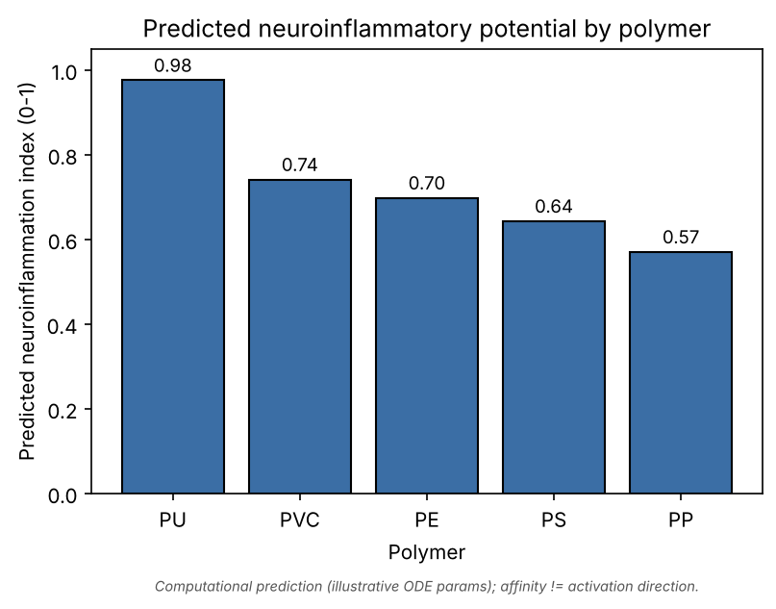 Fig. 1. Predicted neuroinflammatory potential by polymer (0–1). Computational prediction with illustrative kinetics; affinity ≠ activation direction.
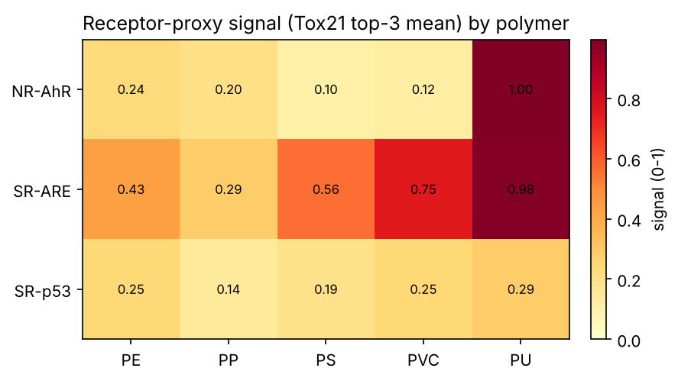 Fig. 2. Receptor-proxy signal (Tox21 top-3 mean) across polymers.
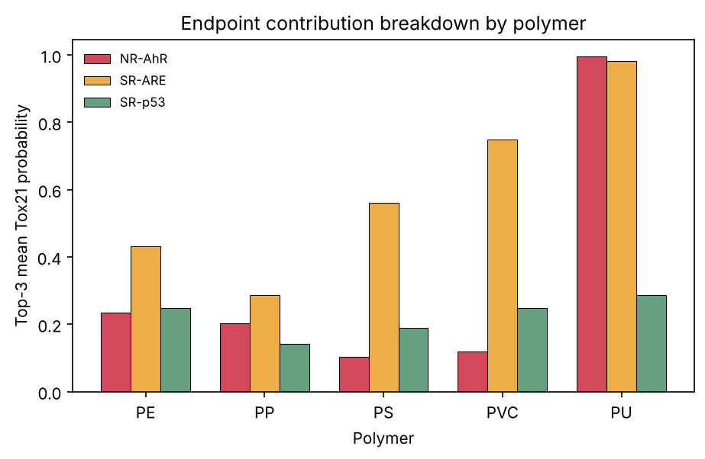 Fig. 3. Endpoint contribution breakdown. PU is AhR-dominated; PVC/PE/PS are oxidative-stress-dominated.
Validation. An experimental-ranking template (data/experimental_ranking.csv) is provided for the author to populate from review screening; Stage 5 then computes Spearman ρ automatically. It is currently unpopulated, so quantitative validation is deferred and the ranking stands as a prediction.

V. Discussion
PU and PVC heading the ranking is mechanistically coherent: both carry the most potent, best-documented bioactive leachates (aromatic amines/isocyanates for PU; plasticisers/bisphenols for PVC), whereas polyolefins PE/PP carry comparatively inert antioxidant packages. This supports the review’s thesis that leachate chemistry, not backbone identity, is the dominant lever. It also reframes PS’s prominence as a reflection of study effort rather than intrinsically higher potential — PS ranks only mid-table here.

VI. Limitations
- Affinity ≠ activation direction — engagement does not establish agonism; the Tox21 label supplies direction only for the AhR/stress axes.
- Static structures — AlphaFold gives one fold, not an ensemble; no MD refinement was performed.
- Illustrative kinetics — every virtual-cell parameter must be refit to microglial time-course data before any absolute cytokine claim.
- Missing docking stage — TLR4–MD2/NLRP3 engagement was not computed (structure databases unreachable); a stated gap, not a result. The ranking may shift once direct inflammasome/TLR4 docking is added.
- No concentration weighting — leachates are aggregated by predicted potency, not realistic release concentrations.

VII. Conclusion
A transparent, reproducible, leachate-centric pipeline converts polymer identity into a testable neuroinflammation ranking (PU > PVC > PE > PS > PP) via real scaffold-split Tox21 ML and a minimal microglial systems model, without fabricating any quantity that could not be computed. It operationalises the hypothesis that polymer type matters chiefly through its leachate chemistry. Executed receptor docking and data-fitted microglial kinetics are the immediate next steps toward validation.

Data and Code Availability
All scripts, the validated leachate inventory, scaffold-split metrics, per-polymer index and figures are in the accompanying repository (src/, data/, results/). Each result file is reproducible from a single command; Tox21 is downloaded and cached at first run.

References
[1] M. Prüst, J. Meijer, R. H. S. Westerink, “The plastic brain: neurotoxicity of micro- and nanoplastics,” Part. Fibre Toxicol., 17:24, 2020. [2] V. Rothhammer, F. J. Quintana, “The aryl hydrocarbon receptor…,” Nat. Rev. Immunol., 19:184–197, 2019. [3] B. S. Park, J.-O. Lee, “Recognition of lipopolysaccharide pattern by TLR4 complexes,” Exp. Mol. Med., 45:e66, 2013. [4] K. V. Swanson, M. Deng, J. P.-Y. Ting, “The NLRP3 inflammasome,” Nat. Rev. Immunol., 19:477–489, 2019. [5] A. M. Richard et al., “The Tox21 10K compound library,” Chem. Res. Toxicol., 34(2):189–216, 2021. [6] O. Trott, A. J. Olson, “AutoDock Vina,” J. Comput. Chem., 31(2):455–461, 2010. [7] J. Eberhardt et al., “AutoDock Vina 1.2.0,” J. Chem. Inf. Model., 61(8):3891–3898, 2021. [8] J. Jumper et al., “Highly accurate protein structure prediction with AlphaFold,” Nature, 596:583–589, 2021. [9] H. M. Berman et al., “The Protein Data Bank,” Nucleic Acids Res., 28(1):235–242, 2000. [10] M. Wagner et al., “PlastChem: State of the science on plastic chemicals,” Report, 2024. [11] G. Landrum et al., “RDKit: Open-source cheminformatics,” https://www.rdkit.org. [12] G. W. Bemis, M. A. Murcko, “The properties of known drugs. 1. Molecular frameworks,” J. Med. Chem., 39(15):2887–2893, 1996. [13] T. Lawrence, “The nuclear factor NF-κB pathway in inflammation,” Cold Spring Harb. Perspect. Biol., 1(6):a001651, 2009. [14] F. Pedregosa et al., “Scikit-learn: Machine learning in Python,” J. Mach. Learn. Res., 12:2825–2830, 2011.

