Mutational signatures in angiosarcoma, thymic epithelial tumours and adrenocortical carcinoma across 54,331 clinically sequenced tumours: what a targeted panel can and cannot resolve
M. Nisha Angeline^{1*}, [Co-author names to be added]
¹Department of Electronics and Communication Engineering, Velalar College of Engineering and Technology, Thindal, Erode, Tamil Nadu, India
*Corresponding author. E-mail: [corresponding author e-mail]; ORCID: [to be added]

Abstract
Purpose Mutational signatures are increasingly read from clinical gene panels, but their reliability in rare, low-mutation-burden cancers is unknown. We tested, under a pre-specified protocol with explicit quality gates, whether signatures can be resolved in angiosarcoma (ASI), thymic epithelial tumours (THYM) and adrenocortical carcinoma (ACC) within the MSK-IMPACT 50K cohort.
Methods We analysed 54,331 tumours (48,179 patients) from the public MSK-IMPACT 50K study. One tumour per patient was retained for 125 ASI, 73 THYM and 86 ACC cases. Trinucleotide opportunity of the capture territory was modelled, and reference signatures (COSMIC v3.5) were refitted in a panel frame. Dominant processes were called by three methods (SigProfilerAssignment, the study-supplied COSMIC v2 decomposition, and a cosine classifier) and combined by 2-of-3 consensus. Performance was assessed by simulation, pan-cohort positive controls, and in-silico panel down-sampling of independent exomes.
Results The basket carried a median of 2 single-nucleotide variants (SNVs) per tumour; 46% of tumours had fewer than 2 and were unanalysable. Simulated exposure recovery reached the pre-specified cosine of 0.90 only at ≥50 SNVs, a depth met by one basket tumour. None of the four quality gates was met in full. Two analyses nevertheless survived. Pooled spectra attributed 67% (95% CI 45–82%) of SNVs in cutaneous/head-and-neck angiosarcoma to ultraviolet light versus 0% (0–12%) in breast angiosarcoma, and consensus UV-dominance was confined to angiosarcoma (15/82 tumours; site odds ratio 10.4, P = 1.9 × 10⁻⁴). This replicated in Angiosarcoma Project exomes (14/15 versus 3/41; P = 1.6 × 10⁻⁹). ACC spectra were clock-like. UV-dominance was not associated with survival (hazard ratio 1.39, 0.43–4.43).
Conclusion In low-burden rare cancers, panel sequencing supports cohort-level spectra and confident calls of sharply featured processes such as UV, but not per-tumour exposure estimates or flat signatures. Per-tumour signature biomarkers in these diseases require broader sequencing.
Keywords Mutational signatures · Targeted sequencing · MSK-IMPACT · Angiosarcoma · Thymic epithelial tumour · Adrenocortical carcinoma · Rare cancer

1 Introduction
Rare cancers, conventionally defined as those with fewer than 15 incident cases per 100,000 population per year, together account for about a quarter of adult malignancies yet remain under-represented in genomic studies [1]. Angiosarcoma, thymic epithelial tumours and adrenocortical carcinoma each fall well below this threshold. Their exome-scale landscapes have been described in cohorts of tens to low hundreds of patients [11–18], but routine clinical care now generates far larger numbers of targeted-panel profiles for the same diseases.
Mutational signatures summarise the trinucleotide patterns left by endogenous and exogenous mutational processes [2–4]. Several signatures carry aetiological or therapeutic meaning: ultraviolet (UV) light, tobacco, APOBEC cytidine deaminases, homologous-recombination deficiency (HRD), polymerase-ε proofreading defects and mismatch-repair (MMR) deficiency. Signatures were defined on genomes and exomes containing thousands of mutations. A clinical panel such as MSK-IMPACT [5, 6] interrogates roughly one megabase and typically returns a handful of substitutions per tumour, which creates two problems. The capture territory has a different trinucleotide composition from the genome, and the sampling noise at single-digit mutation counts is severe [4, 9, 28].
Dedicated approaches have been proposed for panels. Likelihood- and embedding-based classifiers call a single dominant process rather than a full exposure vector [8, 10], and a panel-scale analysis of more than 60,000 tumours reported that dominant UV, tobacco and APOBEC signatures were associated with better survival independently of mutation burden [8]. Whether such calls are dependable in rare cancers with low mutation burden has not been examined, and published performance figures are driven by high-burden tumour types.
The MSK-IMPACT 50K study recently released matched tumour–normal panel data for 54,331 tumours from 48,179 patients spanning 448 histological subtypes [7]. We used it to ask a deliberately constrained question: in a basket of three rare cancers, which signature analyses are supportable from panel data, and which are not? The analysis followed a written protocol with four pre-specified quality gates. We report the outcome of every gate, including those that failed, because the boundary of what the data can support is itself the main result.

2 Materials and methods

2.1 Study design and data sources
This is a retrospective observational analysis of de-identified public data, reported according to the STROBE statement [31]. The study msk_impact_50k_2026 [7] was obtained from the cBioPortal for Cancer Genomics [19–21] on 11 November 2026 through the public datahub archive, and cross-checked against the REST API (54,331 samples in both; no missing sample identifiers). SHA-256 checksums of the archive and of the mutation annotation file are recorded with the code. The mutation file is aligned to GRCh37, and all analyses used that build. Clinical variables were age at diagnosis, sex, sample type, primary site, gene-panel version, tumour mutational burden (TMB), MSIsensor score and class [27], and overall survival measured from the date of sequencing. For external validation we used whole-exome data from the Angiosarcoma Project (the published 2020 release [11] and the provisional April 2025 release) and from The Cancer Genome Atlas adrenocortical carcinoma [15] and thymoma [17] cohorts, all retrieved from the same datahub.

2.2 Cohort definition and quality control
Tumours were assigned to three groups by OncoTree code, cross-verified against the detailed cancer-type label: angiosarcoma (ASI; codes ANGS and BA), thymic epithelial tumours (THYM; thymoma and thymic carcinoma) and adrenocortical carcinoma (ACC). Glomangiosarcoma, thymic neuroendocrine tumours and adrenocortical adenoma were excluded. One specimen per patient was kept, preferring primary over metastatic samples and the earliest specimen on ties. All samples had a matched normal. Tumours were classed by SNV count as FULL (≥4 SNVs), SPARSE (2–3 SNVs; calls accepted only at a stricter similarity threshold of 0.80 instead of 0.60) or DROP (<2 SNVs). Tumours with more than 50 SNVs were flagged as hypermutators. Angiosarcomas were further grouped by primary site into cutaneous/head-and-neck (skin, scalp, forehead, neck, parotid), breast, and visceral/soft tissue/other.

2.3 Mutation matrices and panel opportunity correction
Single-nucleotide variants were converted to the 96 pyrimidine-centred trinucleotide classes using the hg19 reference sequence; the reference allele matched the genome for all 396,977 SNVs. The vendor capture design is not distributed with the public study, so the capture territory of each panel version (341, 410, 468 and 505 genes) was approximated by the coding exons of its genes with 10-bp flanks (RefSeq Select transcripts). Trinucleotide frequencies were counted in this territory and in the whole genome. Reference signatures were moved into the panel frame by multiplying each channel by the panel-to-genome opportunity ratio and renormalising; sample counts were never rescaled. COSMIC v3.5 signatures [3, 26] were used, with a curated set of 19 signatures grouped into eight process families: clock-like (SBS1, SBS5), APOBEC (SBS2, SBS13), UV (SBS7a–d, SBS38), tobacco (SBS4), HRD (SBS3), POLE (SBS10a, SBS10b), MMR (SBS6, SBS15, SBS21, SBS26, SBS44) and temozolomide (SBS11).

2.4 Simulation gate
Synthetic tumours with known exposures were generated by multinomial sampling from panel-frame signatures under four scenarios (UV-dominant, clock-only, APOBEC-dominant and HRD-dominant; 50 tumours each, dominant process contributing 60–90% of mutations over a clock-like background). This was repeated at 3 to 2,000 SNVs per tumour. Exposures were re-estimated by non-negative least squares (NNLS) against uncorrected genome-frame, exome-frame and panel-frame references. The gate required a mean cosine similarity of at least 0.90 between true and inferred family-level exposures.

2.5 Signature assignment and consensus
Three methods were applied to each tumour with at least 2 SNVs. Method 1 was SigProfilerAssignment [22] (cosmic_fit, COSMIC v3.5, GRCh37, exome normalisation), with the dominant family taken from summed activities and calls accepted only if the reconstruction cosine met the class threshold. Method 2 was the COSMIC v2 signature decomposition distributed with the study, produced by the MSK mutation-signatures algorithm and mapped to the same families. Method 3 was a cosine classifier in the spirit of dominant-signature callers [8]: the normalised 96-channel profile was compared with each family's panel-frame references, and the best match was accepted if it met the class threshold. The consensus call was the family supported by at least two methods; tumours without a majority were labelled AMBIGUOUS. Agreement was measured with Cohen's κ on tumours called by both methods, with a gate of mean pairwise κ ≥ 0.60.
Because per-tumour counts were low, we also pooled SNVs across patients within each group and site stratum and fitted the pooled spectrum by NNLS in the panel frame. Confidence intervals were obtained from 1,000 bootstrap resamples of patients.

2.6 Positive controls and external validation
Classifier behaviour was checked in the full cohort among tumours with at least 4 SNVs, using contexts with a known answer: UV in cutaneous melanoma, MMR in MSIsensor-unstable tumours, APOBEC in bladder cancer and tobacco in non-small-cell lung cancer. In the external exome cohorts, exposures were fitted in the exome frame. To measure directly what a panel loses, exome mutations were restricted to the modelled panel territory and the same tumours were re-called; the exome-derived dominant family (tumours with ≥50 exome SNVs) served as the reference.

2.7 Statistical analysis
Composition of consensus calls across groups was compared with a χ² test, with a 10,000-permutation P value because expected counts were small, and adjusted standardised residuals. Overall survival was summarised by the Kaplan–Meier method and compared by log-rank test. Multivariable Cox models included age, group, log10(TMB + 1), SNV count and MSI score as specified in the protocol; within-group models were fitted where the pooled model violated proportional hazards, which was tested with Schoenfeld residuals [30]. Gene–signature enrichment used Fisher's exact test for every gene with at least 3 SNVs against each family, with each mutation attributed to its maximum-posterior family, and Benjamini–Hochberg correction at 5% [29]. De novo extraction used SigProfilerExtractor [24] with 250 NMF replicates on tumours whose best similarity to every reference was below 0.75; a candidate novel signature required stability ≥0.8 and a maximum cosine below 0.6 to all COSMIC v3.5 signatures. Random seeds were fixed at 42. Analyses were run in Python 3.11 with SigProfilerAssignment 1.1.5, SigProfilerExtractor 1.5.0 and lifelines.

2.8 Deviations from the protocol
Seven deviations were forced by the data or the computing environment and are listed in Table 1. None was made after seeing outcome data.
Table 1 Deviations from the pre-specified protocol
Protocol item | What was done | Reason
Genome build GRCh38 | GRCh37 used throughout | The released mutation file is aligned to GRCh37
Capture BED of the 505-gene panel | Coding exons ±10 bp of panel genes, per panel version | Capture design is not public; 98.0% of observed SNVs fall inside the modelled territory
DeepSig as second method | Study-supplied COSMIC v2 decomposition (MSK mutation-signatures) | No container runtime was available; DeepSig has no cancer-type models for these diseases
SigProfilerSimulator for the gate | Multinomial simulator from panel-frame signatures | Known ground-truth exposures were required
Treatment fields; immunotherapy benchmarking | Not analysed | Treatment data are not included in the public release
GENIE replication | Angiosarcoma Project and TCGA exomes used instead | GENIE requires registered access
Licence stated as ODbL | Data handled under CC BY-NC-ND 4.0 | This is the licence stated in the study metadata

3 Results

3.1 Cohort and mutation yield
The basket comprised 294 tumours from 284 patients: 125 ASI, 73 THYM and 86 ACC after de-duplication (Fig. 1, Table 2). These tumours carried 920 SNVs in total, with a median of 2 per tumour (interquartile range 0–4). By SNV count, 72 tumours were FULL, 81 SPARSE and 131 (46%) DROP. Only angiosarcoma retained the pre-specified minimum of 50 analysable tumours (82); ACC retained 48 and THYM 23. The first quality gate was therefore met for one group of three. A single tumour exceeded 50 SNVs, an angiosarcoma of colorectal site with 53 SNVs and a microsatellite-stable profile.
The low yield is not peculiar to these diseases. Across all 54,331 tumours the median was 3 SNVs; 50% of tumours had at least 4 SNVs and 1.8% had at least 50.
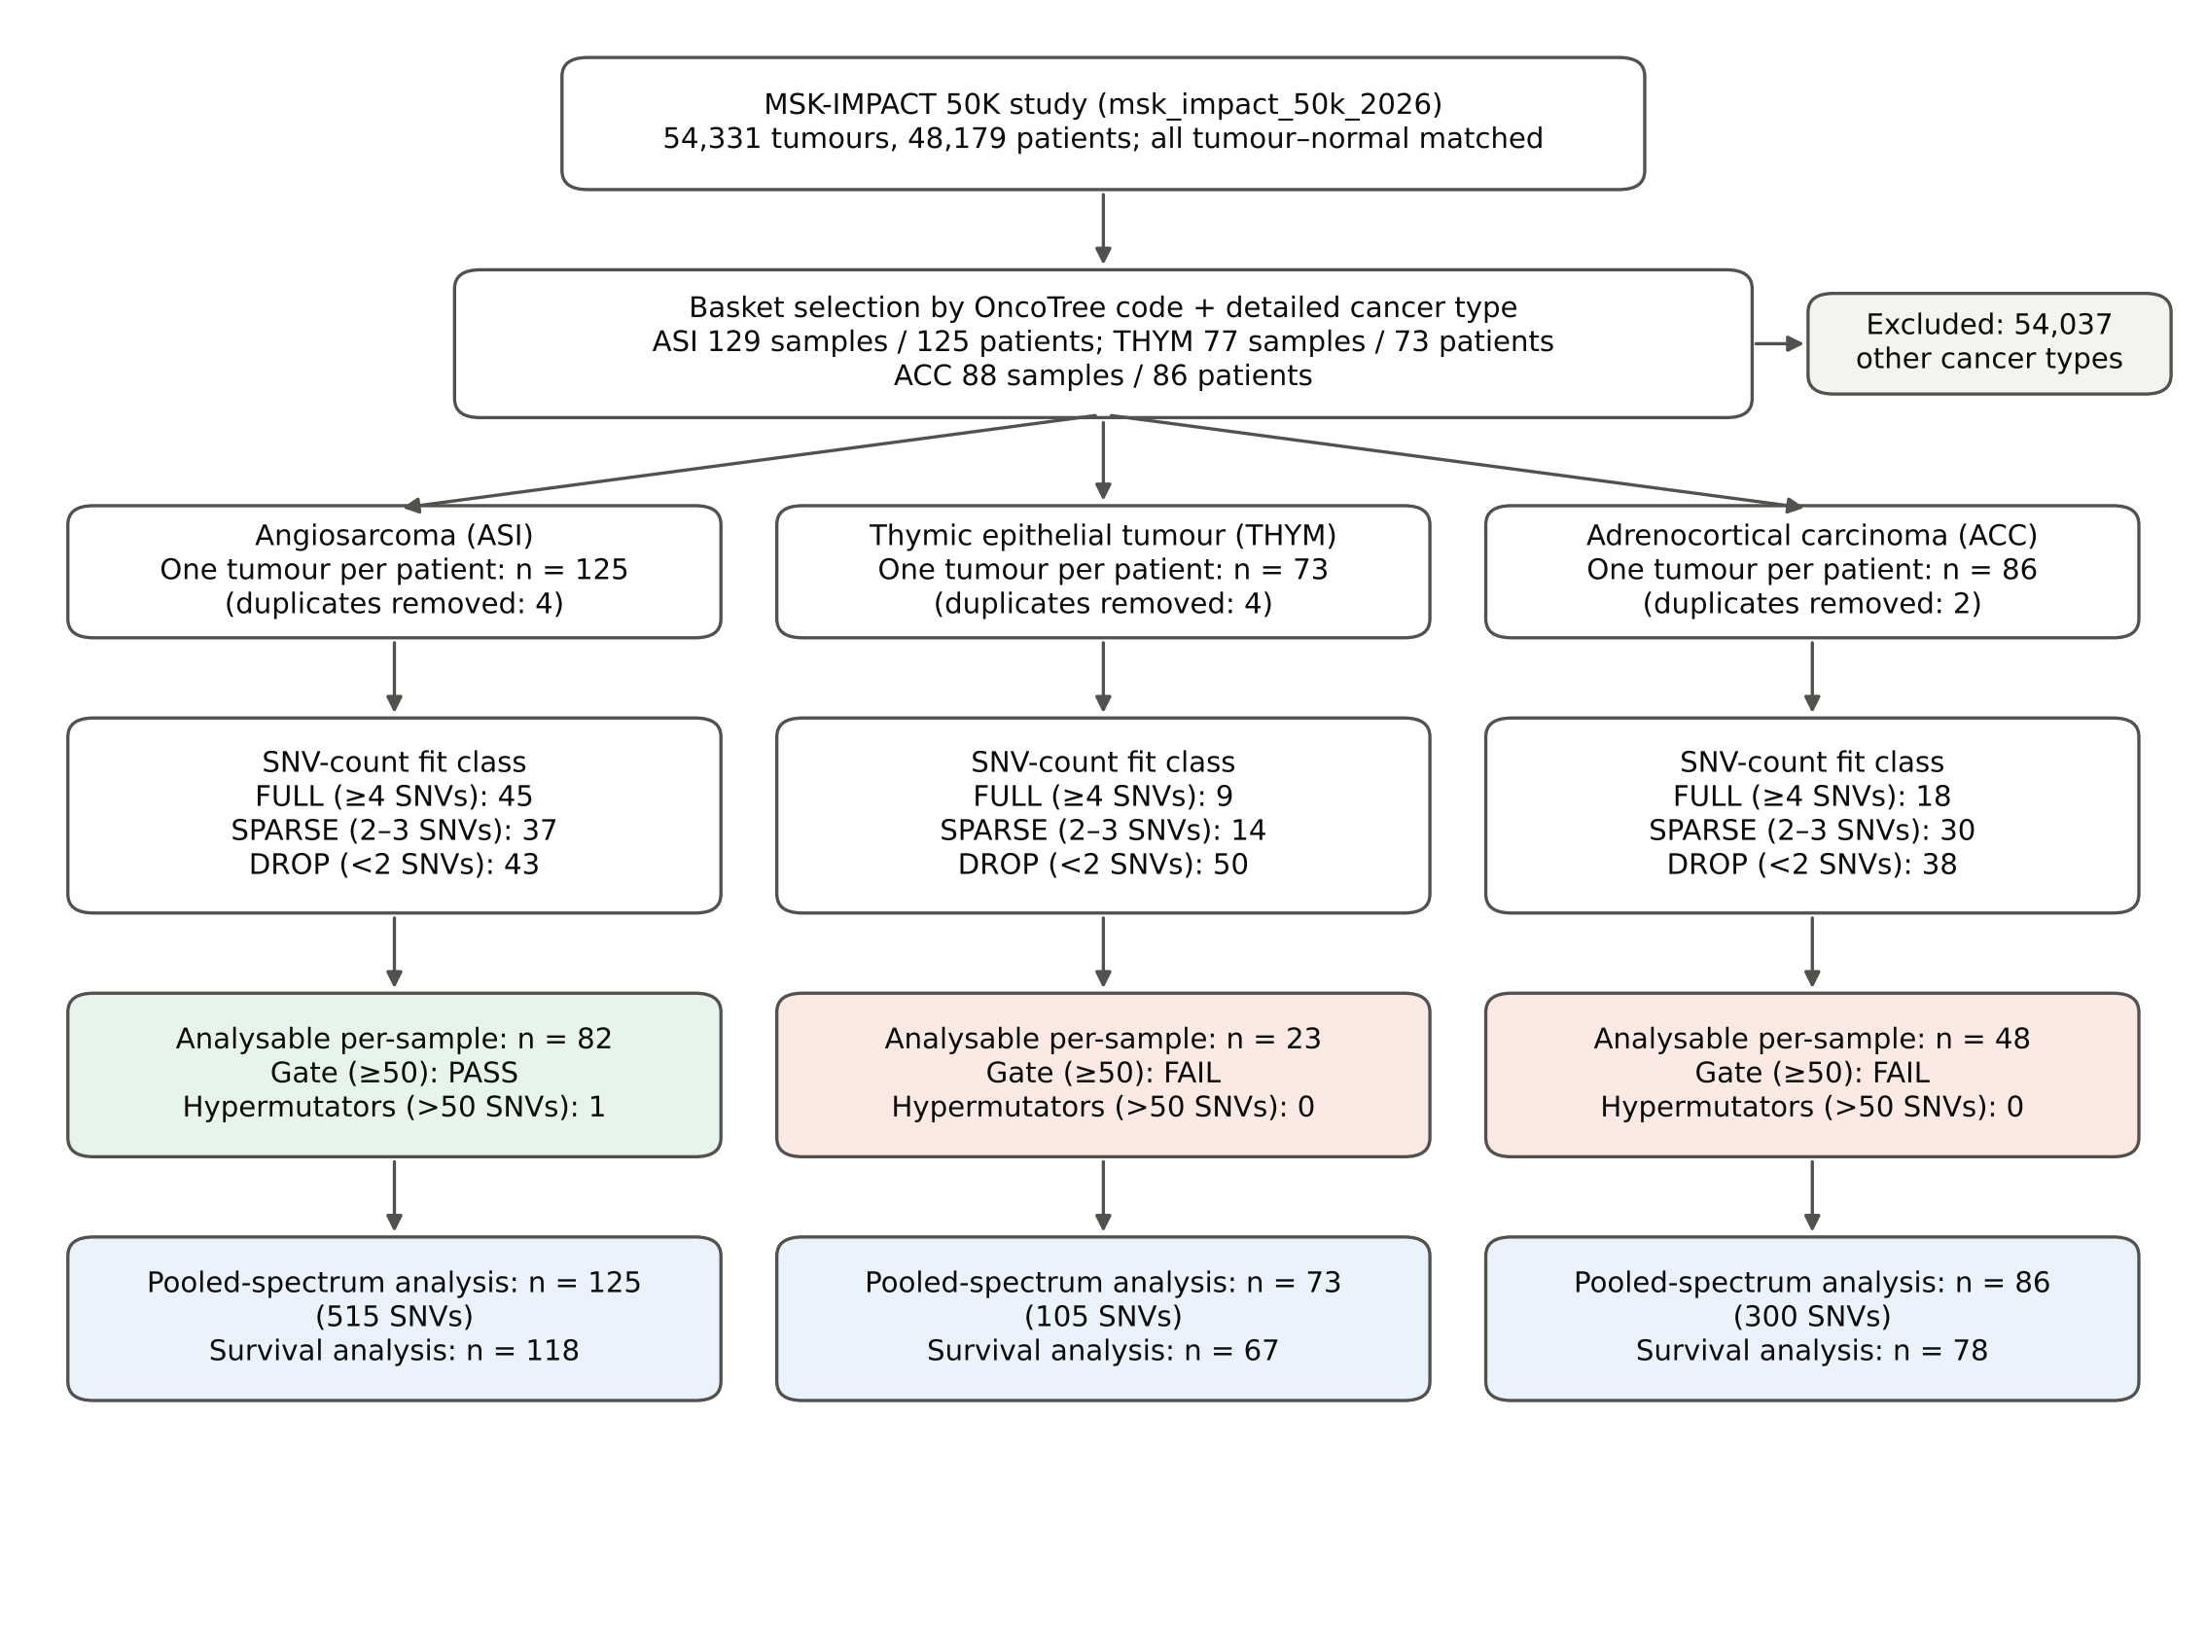
Fig. 1 Cohort selection and analysable sample counts. Green and red boxes show the outcome of the pre-specified gate of at least 50 analysable tumours per group. ASI angiosarcoma, THYM thymic epithelial tumours, ACC adrenocortical carcinoma, SNV single-nucleotide variant
Table 2 Characteristics of the basket cohort (one tumour per patient)
Characteristic | ASI (n = 125) | THYM (n = 73) | ACC (n = 86)
Age at diagnosis, years, median (IQR) | 54.0 (42.5–66.0) | 56.0 (46.0–61.0) | 52.0 (41.0–62.0)
Female, n (%) | 74 (59) | 40 (55) | 53 (62)
Primary-site specimen, n (%) | 96 (77) | 48 (66) | 55 (64)
Histology / site | Cutaneous/H&N 38; breast 29; visceral/other 58 | Thymoma 46; thymic carcinoma 27 | —
TMB, mutations/Mb, median (IQR) | 2.6 (1.8–4.4) | 0.9 (0.0–2.0) | 1.8 (0.9–3.5)
SNVs per tumour, median (IQR) | 2 (1–4) | 1 (0–2) | 2 (0–3)
Total SNVs | 515 | 105 | 300
Fit class FULL / SPARSE / DROP | 45 / 37 / 43 | 9 / 14 / 50 | 18 / 30 / 38
MSIsensor-unstable, n | 0 | 1 | 1
Whole-genome doubling, n (%) | 22 (18) | 7 (10) | 47 (55)
Survival data available / deaths | 118 / 60 | 67 / 18 | 78 / 36
Follow-up, months, median (IQR) | 13.4 (5.8–28.7) | 35.8 (18.4–51.9) | 17.4 (4.0–36.5)
H&N head and neck, IQR interquartile range, TMB tumour mutational burden

3.2 Panel territory bias and the simulation gate
The modelled capture territory covered 1.00–1.36 Mb depending on panel version and contained 98.0% of all observed SNVs; most of the remainder were 5′-flank variants. Its trinucleotide composition differed from the genome (cosine 0.933), with CpG-containing contexts over-represented up to 3.7-fold and A/T-rich contexts depleted to 0.45-fold (Fig. 2a). The four panel versions were effectively identical to each other (cosine ≥0.9999) and close to the whole exome (0.9987), so exome normalisation is an adequate stand-in for a panel-specific correction.
In simulation, opportunity correction mattered only once enough mutations were present (Fig. 2b). With correction, mean family-level cosine was 0.55 at 3 SNVs, 0.72 at 10, 0.83 at 20 and 0.91 at 50, reaching 0.98 at 500. Without correction, recovery crossed 0.90 only at 100 SNVs and plateaued at 0.94. The gate was therefore passed at 50 or more SNVs per tumour and failed at the depth of the basket, where the median tumour had 2. Recovery of the dominant process was better than recovery of exposures and depended on the process (Fig. 2c): at 10 SNVs, UV and APOBEC were correctly identified in 88% of synthetic tumours, clock-like in 46%. HRD could not be called by the cosine classifier below 50 SNVs (call rate ≤6%).
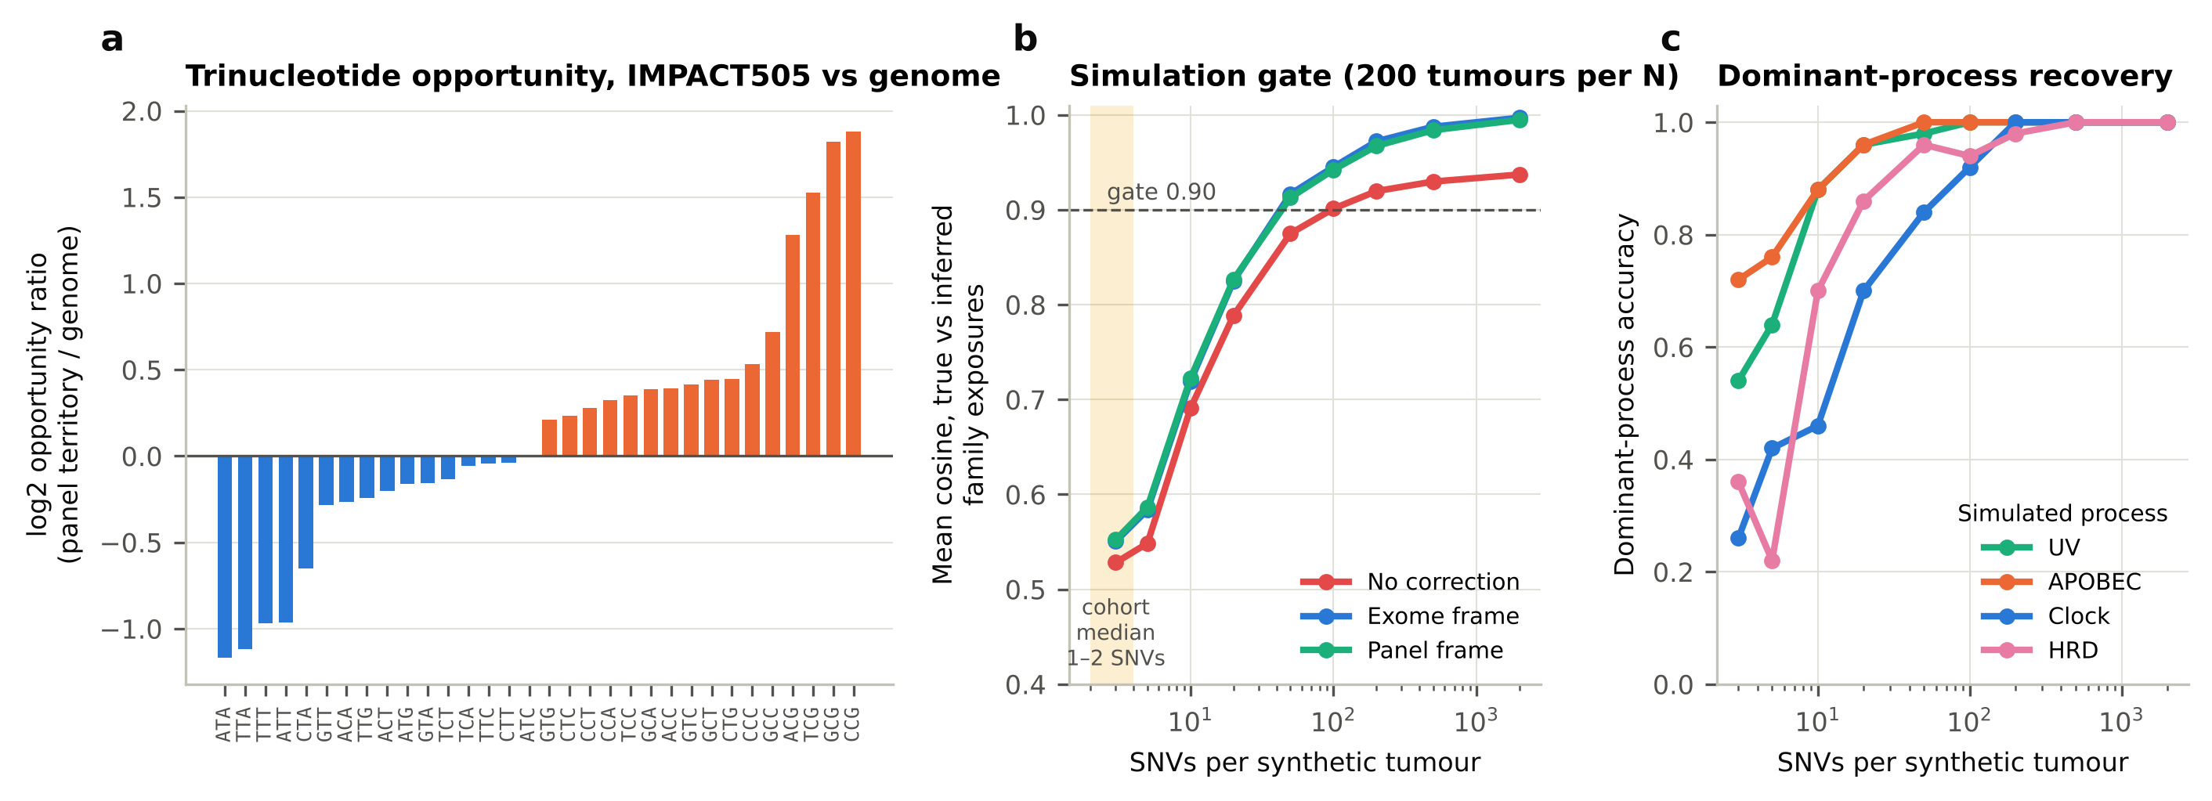
Fig. 2 Panel bias and simulation gate. a Trinucleotide opportunity of the modelled 505-gene capture territory relative to the genome. b Mean cosine similarity between true and inferred family-level exposures in 200 synthetic tumours per mutation count, under three reference frames; the dashed line is the pre-specified gate and the shaded band marks the mutation counts typical of the basket. c Accuracy of the dominant process (NNLS, panel frame) by simulated scenario

3.3 Method concordance and positive controls
Among the 153 analysable basket tumours, the cosine classifier declined to call 117 and SigProfilerAssignment 80; the study-supplied decomposition always returned a call. On tumours called by both methods, κ was 0.68 for SigProfilerAssignment versus the cosine classifier (n = 36), 0.63 for the study decomposition versus the cosine classifier (n = 36) and 0.44 for SigProfilerAssignment versus the study decomposition (n = 73). The mean, 0.585, fell just short of the 0.60 gate (Fig. 3a). In the full cohort at 20 or more SNVs, agreement between the study decomposition and the cosine classifier rose to 0.76 (n = 3,122).
Positive controls showed a consistent pattern of high specificity and process-dependent sensitivity (Fig. 3b). For UV in cutaneous melanoma (838 tumours against 23,859 non-skin tumours), consensus sensitivity was 81% and specificity 99.6%. For MMR in microsatellite-unstable tumours, sensitivity was 48% and specificity 97.7%; for APOBEC in bladder cancer 44% and 99.4%. Tobacco was almost never called in lung cancer by consensus (3%). As a continuous score, the NNLS UV fraction separated cutaneous melanoma with an area under the curve of 0.95 at ≥4 SNVs, and the MMR fraction separated microsatellite-unstable tumours with 0.84 at ≥4 SNVs, 0.93 at ≥10 and 0.96 at ≥20 (Fig. 3c).
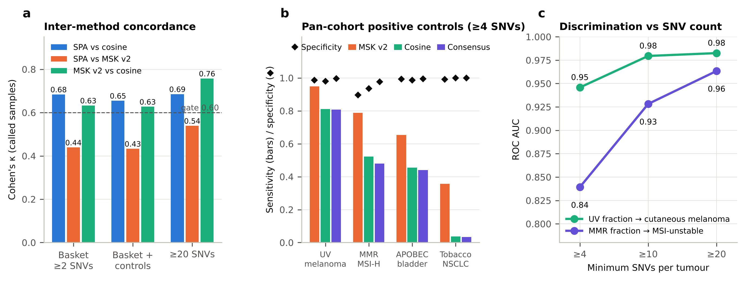
Fig. 3 Concordance and positive controls. a Pairwise Cohen's κ between methods on tumours called by both; the dashed line is the pre-specified gate. b Sensitivity (bars) and specificity (diamonds) of dominant-process calls in contexts with a known answer, tumours with ≥4 SNVs. c Area under the ROC curve for NNLS family fractions by minimum SNV count. SPA SigProfilerAssignment, MSI-H microsatellite-unstable, NSCLC non-small-cell lung cancer

3.4 Signature landscape of the three cancers
Two thirds of analysable tumours (103/153) had no two-method majority and were labelled AMBIGUOUS. Among the rest, composition differed between groups (χ² = 21.3, 8 degrees of freedom, permutation P = 0.008). The difference was carried by UV: 15 of 82 angiosarcomas were UV-dominant against none of 48 ACC and none of 23 THYM (adjusted residuals +3.8 and −2.8 for ASI and ACC). Within angiosarcoma, UV-dominance was called in 11 of 25 cutaneous/head-and-neck tumours and 4 of 57 at other sites (odds ratio 10.4, P = 1.9 × 10⁻⁴), and in none of 20 breast angiosarcomas (Fig. 4b).
Pooled spectra gave the same picture with quantified uncertainty (Fig. 4a, Fig. 5). In cutaneous/head-and-neck angiosarcoma, 67% (95% CI 45–82%) of 221 pooled SNVs were attributed to UV, with the characteristic excess of C>T substitutions at dipyrimidines. In breast angiosarcoma the UV fraction was 0% (0–12%) and the spectrum was predominantly clock-like (68%, 8–85%). Visceral and soft-tissue angiosarcomas were intermediate (UV 31%, 8–48%); the difference from cutaneous tumours was 36 percentage points (7–62). The pooled ACC spectrum (300 SNVs) was clock-like (62%, 33–74%), and SigProfilerAssignment explained it with SBS1 and SBS5 alone. For THYM only 105 SNVs were available; the spectrum was mainly clock-like (63%, 15–82%) with an MMR-like component whose interval included zero (24%, 0–62%), and thymoma contributed just 28 SNVs from 46 patients. We do not consider the THYM composition established.
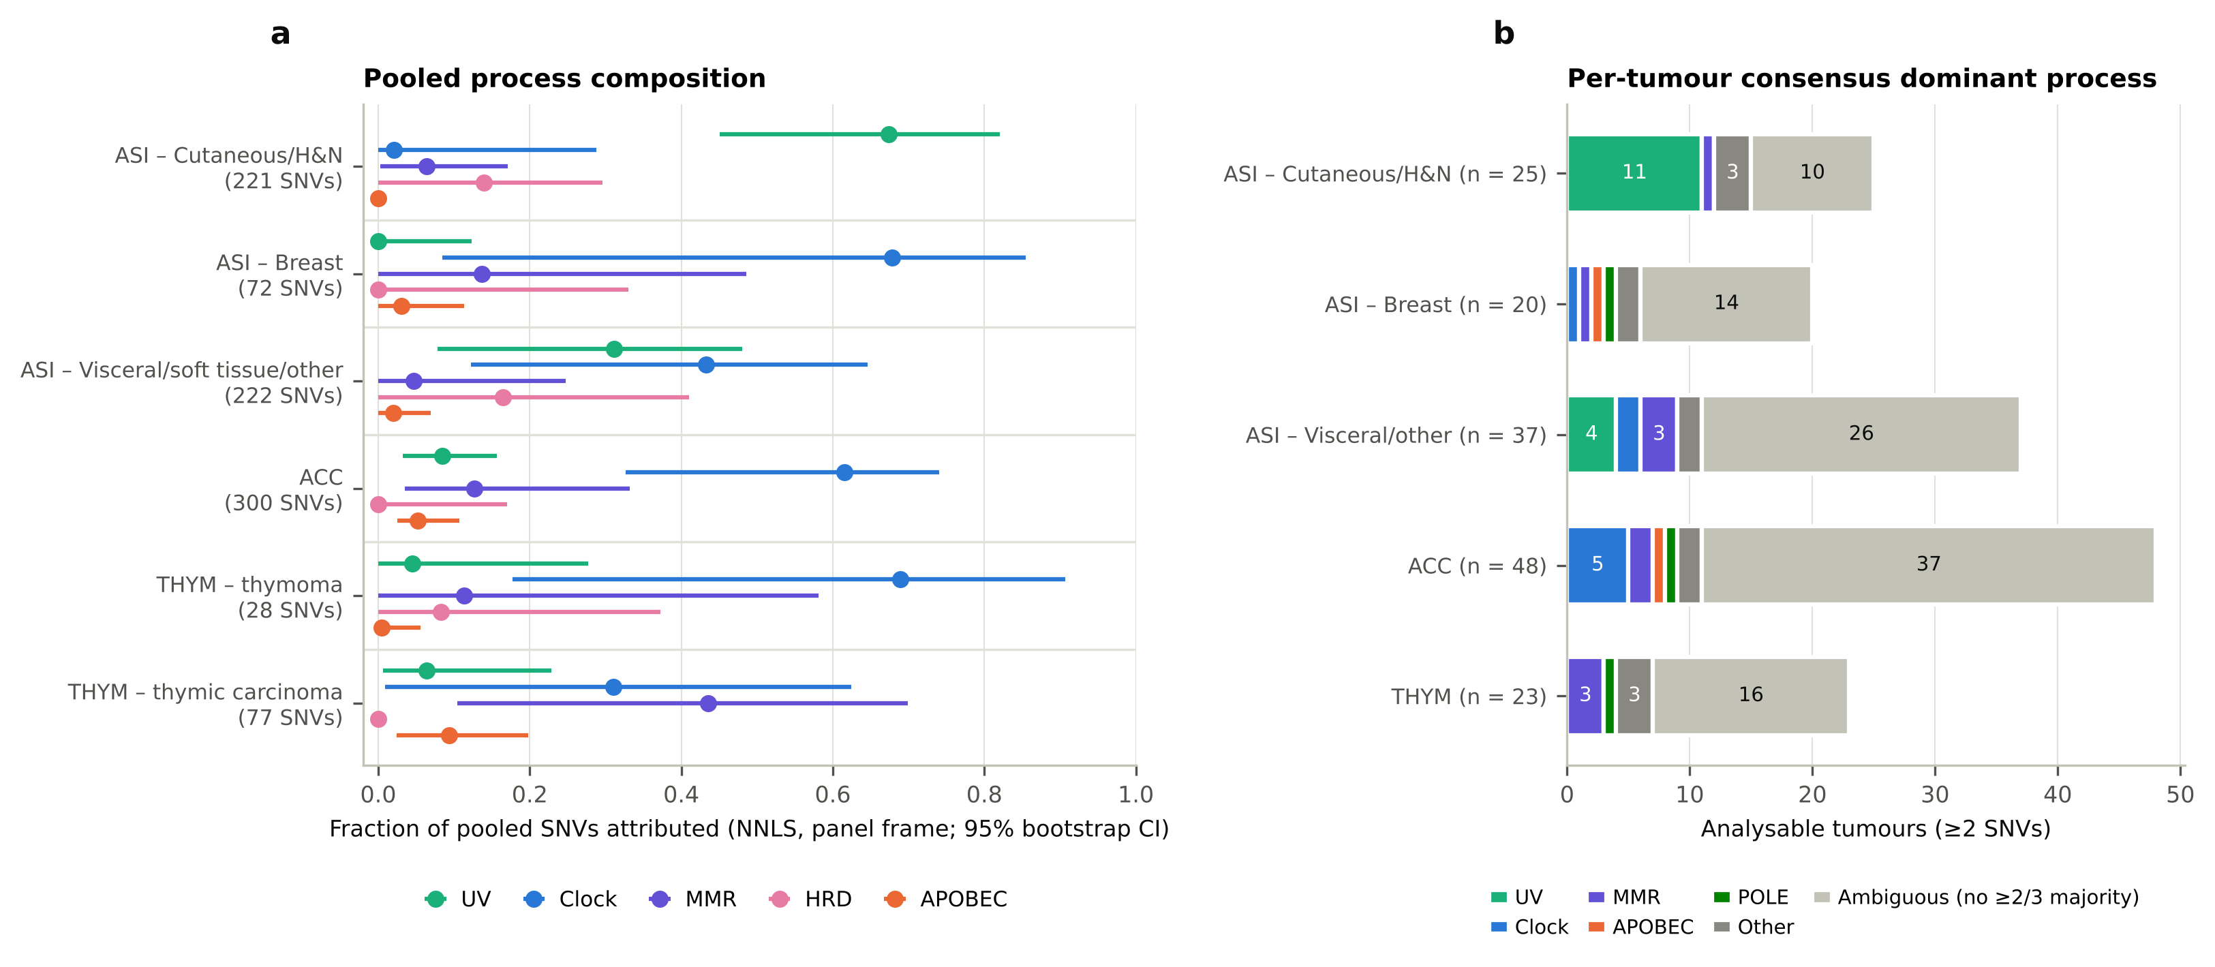
Fig. 4 Signature landscape. a Fraction of pooled SNVs attributed to each process family by NNLS in the panel frame; bars are 95% bootstrap confidence intervals over patients. b Per-tumour consensus dominant process among analysable tumours. H&N head and neck
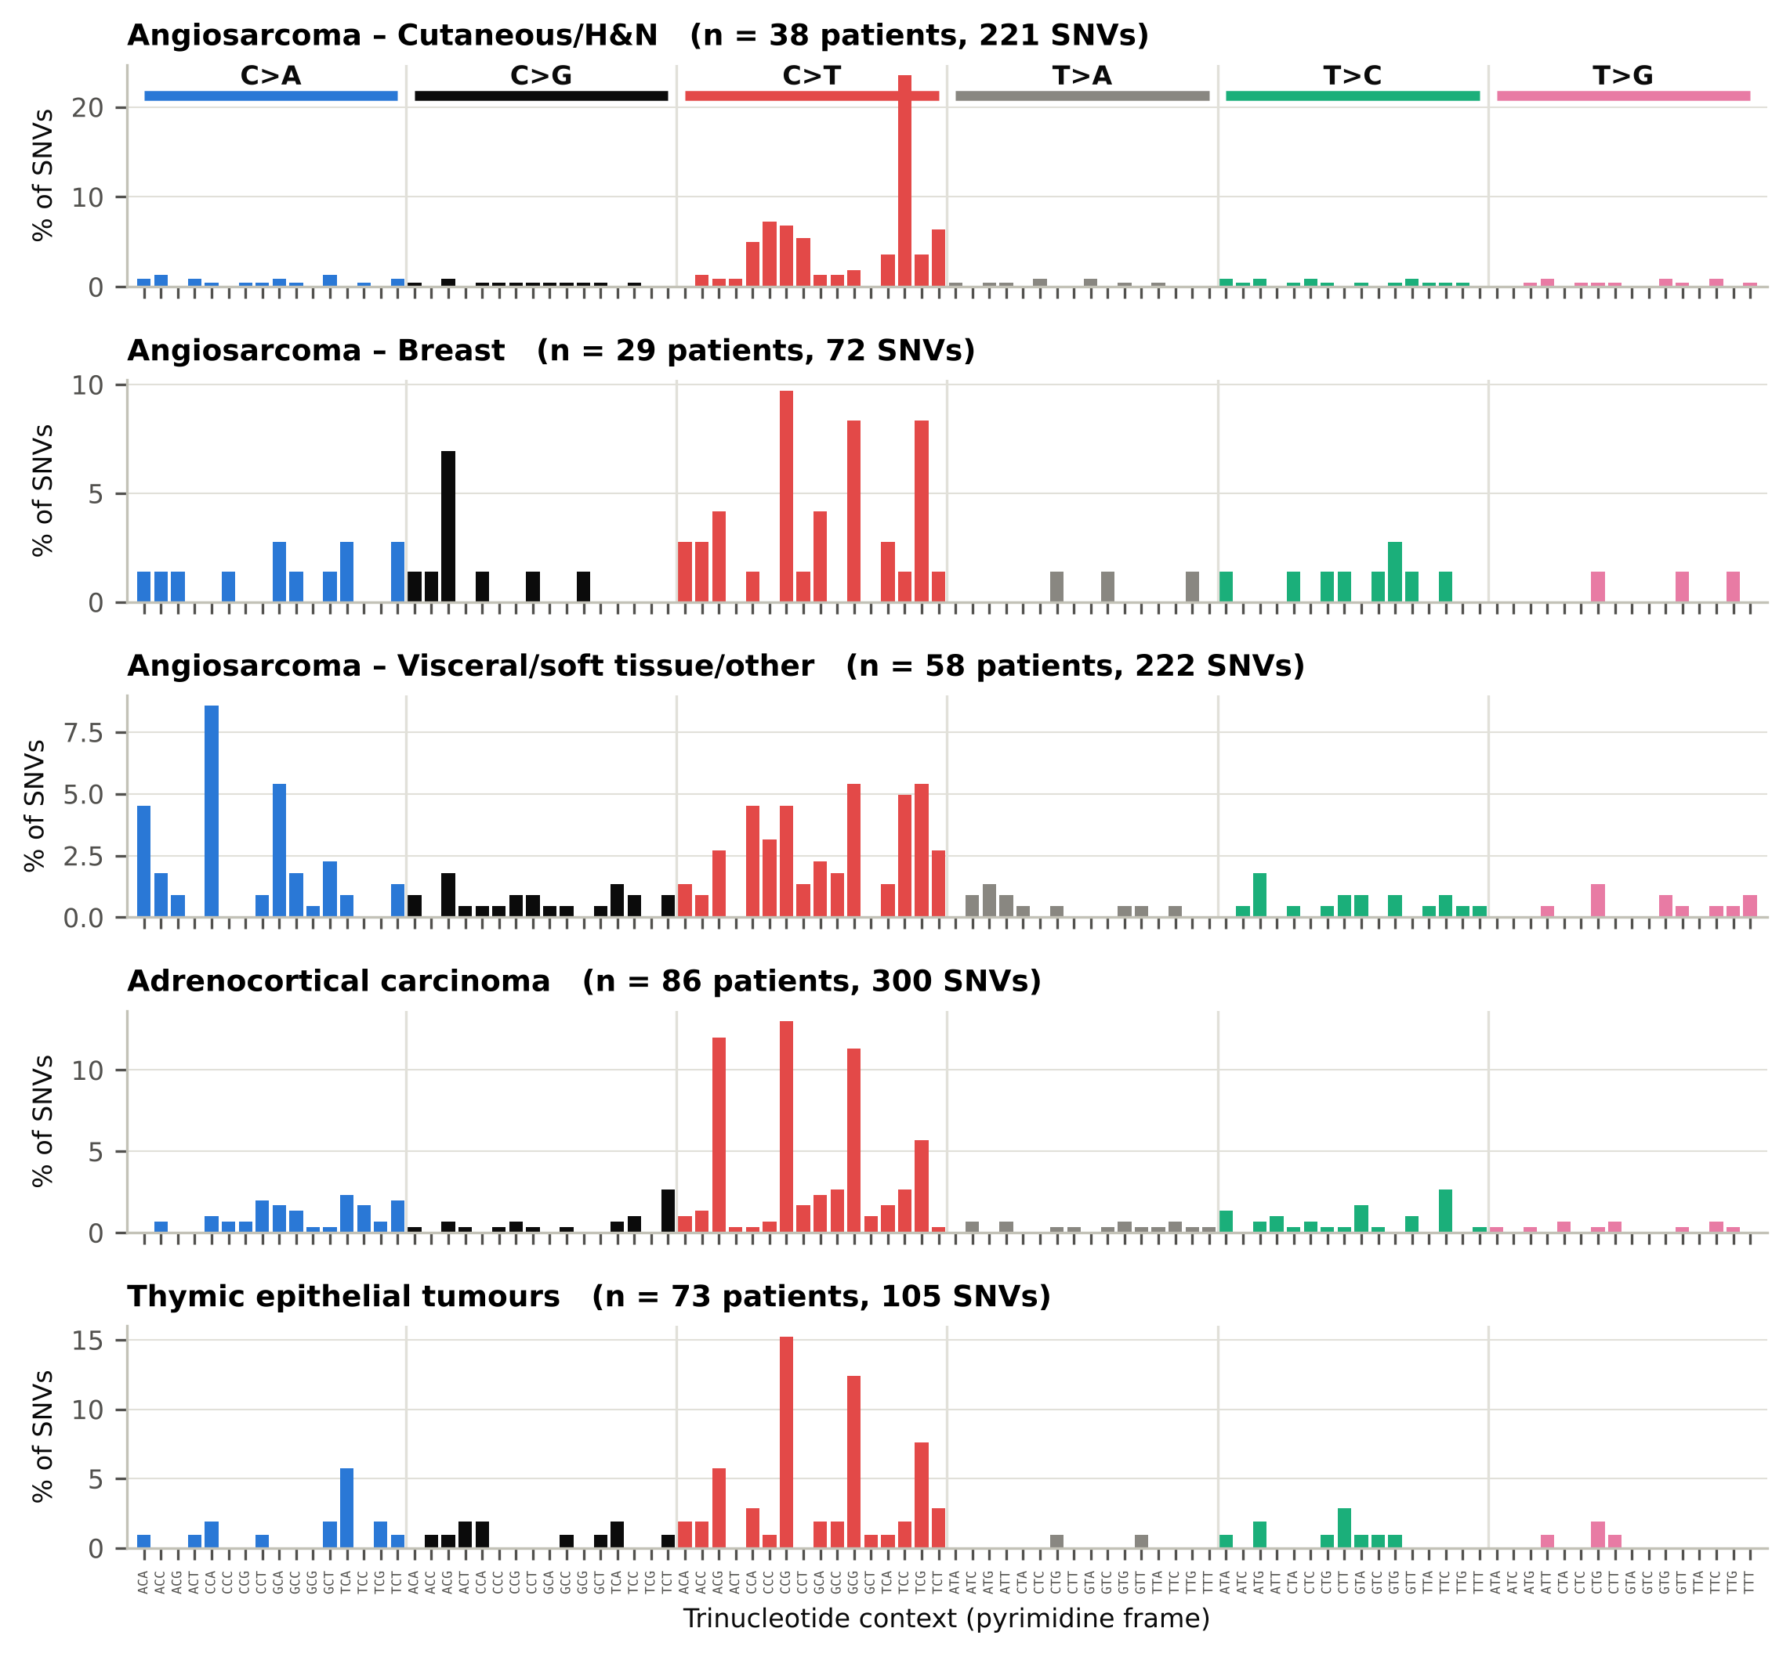
Fig. 5 Pooled 96-channel substitution spectra by group and angiosarcoma site. Bars show the percentage of pooled SNVs in each trinucleotide class

3.5 Biomarker checks, gene associations and de novo extraction
Both microsatellite-unstable tumours in the basket (one ACC, one thymic tumour; MSIsensor scores 16.6) were called MMR-dominant by consensus. However, ten tumours received a consensus MMR call, and of the seven with a definitive MSI class five were microsatellite-stable. In these diseases a panel-derived MMR call therefore has low positive predictive value and should not be read as evidence of MMR deficiency without orthogonal testing. HRD could not be assessed, in line with the simulation.
The most frequently altered genes matched the known biology of each disease: TP53 (25%), KDR (18%) and FLT4 (10%) in angiosarcoma [11, 14]; TP53 (27%), CTNNB1 (20%), MEN1 (12%) and ATRX (9%) in ACC [15, 16]; and TP53 (15%) in THYM. No gene–signature pair was significant after correction across 920 tests on 861 attributed SNVs; the strongest was an excess of C>A-type substitutions in KDR (6 of 13 SNVs, q = 0.08). At the tumour level, ROS1 mutations were confined to UV-dominant angiosarcomas (5 of 5, q = 0.002); ROS1 is a large gene and this most likely reflects the higher mutation count of UV-exposed tumours rather than selection.
De novo extraction was run on 130 tumours (565 SNVs) whose profiles did not resemble any reference. Only the one-signature solution was stable (average silhouette 1.00); solutions with two, three and four signatures had minimum stabilities of 0.34, 0.18 and 0.15, far below the required 0.8. The single stable component resembled SBS5 (cosine 0.83), and every component in the unstable solutions had a cosine of at least 0.76 to a known COSMIC v3.5 signature. No candidate novel signature was found, and at this input depth the extraction had no power to find one.

3.6 Survival
Survival data were available for 263 patients (114 deaths). Median overall survival from sequencing was 22.3 months in angiosarcoma, 36.5 months in ACC and 60.1 months in THYM (log-rank P = 0.0003; Fig. 6a). The pooled protocol model violated proportional hazards for SNV count, TMB and the THYM indicator, and stratification by group did not remove the violation; the fourth gate was therefore not met for the pooled model, and inference was restricted to within-group models, in which the assumption held.
In angiosarcoma, consensus UV-dominance was not associated with survival (14 UV-dominant tumours with 7 deaths; adjusted hazard ratio 1.39, 95% CI 0.43–4.43; log-rank P = 0.65; Fig. 6b), and the estimate was unchanged when SPARSE tumours were excluded (1.23, 0.37–4.09). The interval is wide enough to include both a clinically relevant benefit and harm. Cutaneous/head-and-neck site showed a non-significant trend towards longer survival (0.62, 0.33–1.19). In THYM, higher TMB was associated with shorter survival (hazard ratio 4.26 per log10 unit, 1.24–14.64; 18 events), and the same direction was seen in TCGA thymoma (32.8, 3.6–297; 9 events). In ACC, age was associated with shorter survival (1.03 per year, 1.00–1.06); TMB was not (1.42, 0.56–3.60), although it was in TCGA ACC (3.87, 1.71–8.79). These associations were not corrected for multiplicity and are hypothesis-generating.
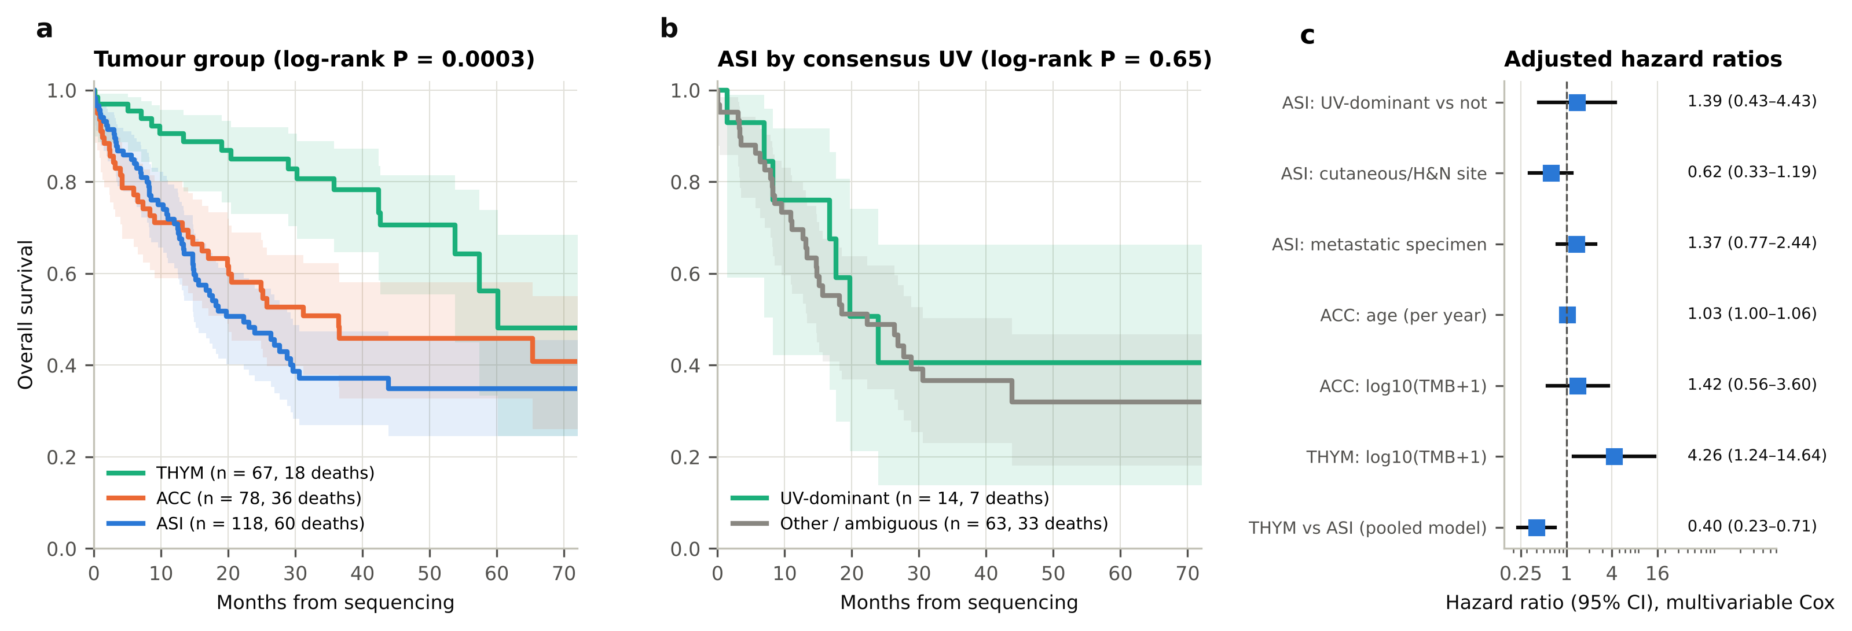
Fig. 6 Overall survival from the date of sequencing. a Kaplan–Meier curves by tumour group with 95% confidence bands. b Angiosarcoma by consensus UV-dominance. c Adjusted hazard ratios from multivariable Cox models with 95% confidence intervals. TMB tumour mutational burden

3.7 External validation in exomes
In the 2025 Angiosarcoma Project release (56 patients with ≥20 exome SNVs), 14 of 15 head, neck, face or scalp tumours were UV-dominant against 3 of 41 at other sites (odds ratio 177, P = 1.6 × 10⁻⁹; median UV fraction 0.77 versus 0.07; Fig. 7a). The published 2020 release gave the same result (7 of 9 versus 3 of 23, P = 0.001; Fig. 7b), in agreement with the original reports [11–13]. The pooled UV fraction of head-and-neck tumours was 85% (79–87%) from whole exomes and 83% (72–87%) when the same tumours were restricted to the panel territory, which supports the pooled panel estimate in Section 3.4.
Restricting exomes to the panel territory left a median of 4–5 SNVs per angiosarcoma, 2 per ACC and 1 per thymoma. On these down-sampled profiles the cosine classifier made a call in 44% and 52% of angiosarcomas and in 23% and 25% of ACC and thymomas, and was correct against the exome reference in 86%, 92%, 86% and 100% of the calls it made (Fig. 7c). For UV specifically, sensitivity was 67% and 90% with no false positives. Forcing a call on every tumour by NNLS gave accuracies of only 43–78%.
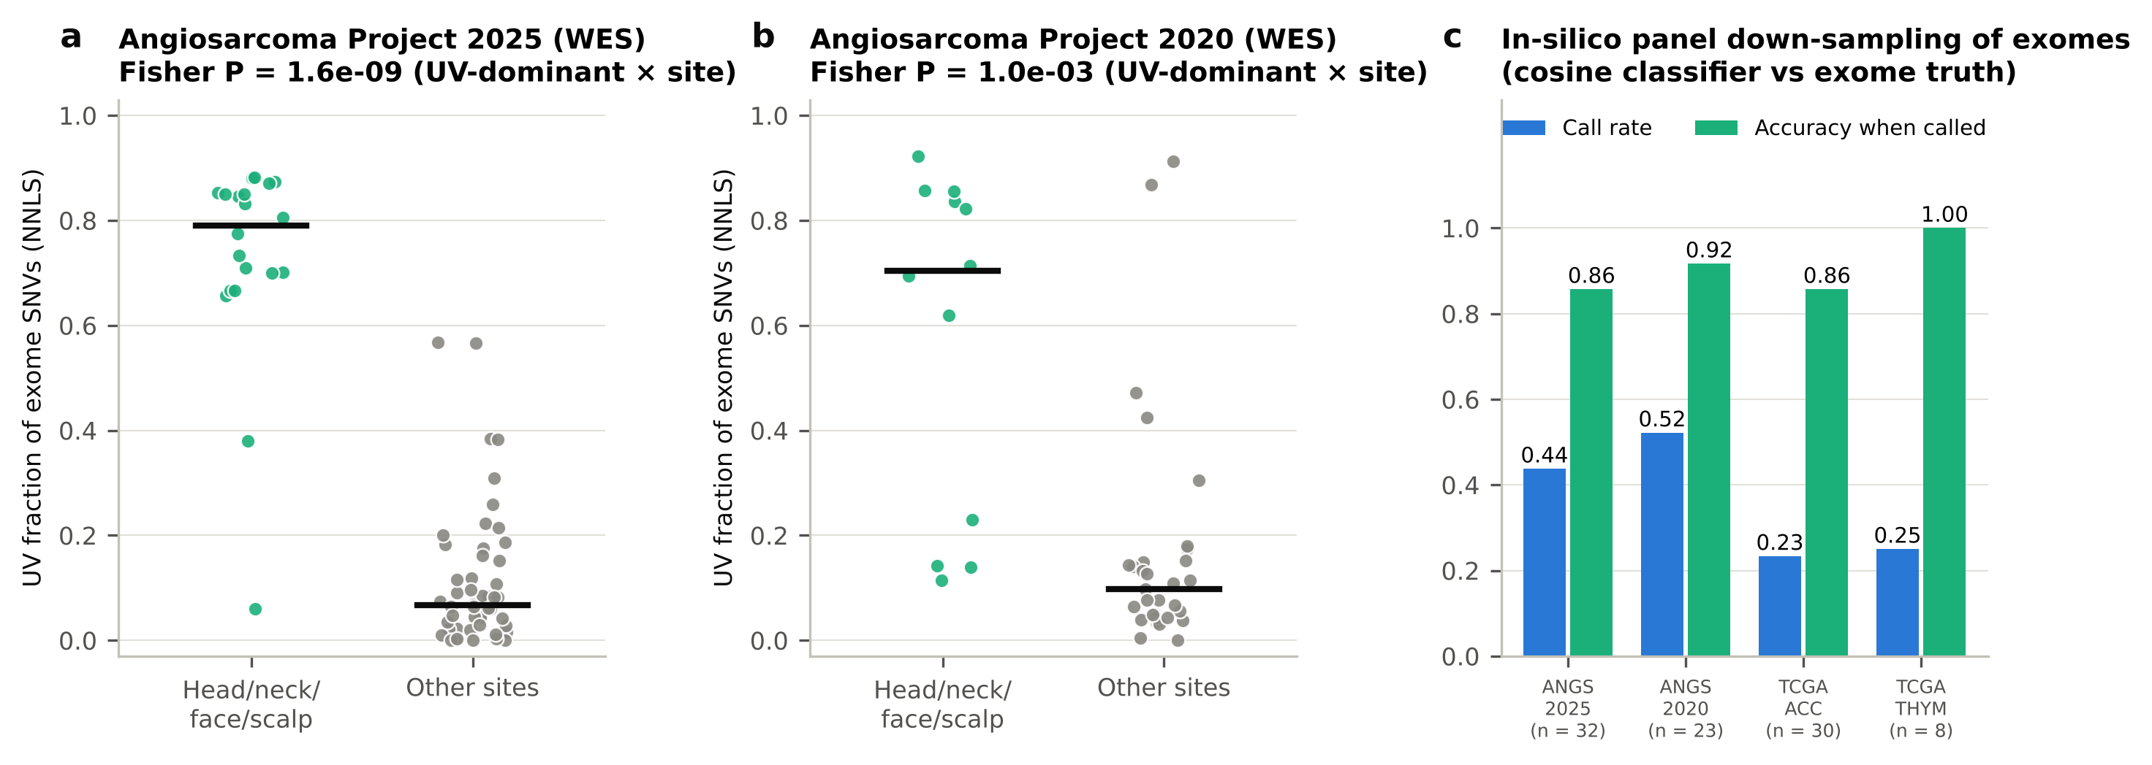
Fig. 7 External validation. a, b UV fraction of exome SNVs by biopsy site in two releases of the Angiosarcoma Project; each point is one patient, bars are medians. c In-silico panel down-sampling: call rate of the cosine classifier on exome mutations restricted to the panel territory, and its accuracy against the exome-derived dominant process; n is the number of tumours with ≥2 SNVs in the territory. WES whole-exome sequencing

3.8 Quality-gate summary
Table 3 Outcome of the pre-specified quality gates
Gate | Criterion | Observed | Outcome
Cohort size | ≥50 analysable tumours per group | ASI 82; ACC 48; THYM 23 | Met for ASI only
Simulation | Mean cosine ≥0.90, true vs inferred exposures | 0.55–0.59 at 3–5 SNVs; 0.91 at 50 SNVs | Not met at cohort depth; met at ≥50 SNVs
Concordance | Mean pairwise Cohen's κ ≥0.60 | 0.585 (pairs 0.68, 0.63, 0.44) | Not met
Proportional hazards | Schoenfeld test non-significant | Violated in pooled model; satisfied within groups | Not met for pooled model
Under the protocol, a failed global gate means that per-tumour exposure results are not frozen. The analyses retained are those that do not depend on per-tumour exposures: pooled spectra, high-confidence dominant-process calls, and within-group survival models

4 Discussion
We set out to profile mutational signatures in three rare cancers using one of the largest clinical sequencing cohorts available, and found that the limiting factor was the number of mutations per tumour and not the number of patients. Half of the basket tumours had fewer than two substitutions on the panel. None of the four pre-specified quality gates was met in full, and we have reported them as such instead of relaxing the thresholds after the fact.
Two results are robust to these limits. First, UV light is the dominant mutational process in cutaneous and head-and-neck angiosarcoma and is absent from breast angiosarcoma. This was visible in pooled spectra, in per-tumour consensus calls, and in two independent exome releases, and it agrees with earlier exome and genome studies [11–13]. The finding is not new, but its recovery from a median of two to four SNVs per tumour shows which kind of signal a panel can carry: a process with a sharply peaked spectrum and a large share of the mutations. Second, the ACC spectrum is clock-like, consistent with exome data [15, 16].
The simulation and the down-sampling experiment explain the boundary. Exposure vectors could not be estimated below about 50 SNVs, whichever reference frame was used. A dominant-process call that is allowed to abstain was accurate when made (86–100% against exome truth) but was made in only a quarter to a half of tumours. Flat signatures such as SBS3 and SBS5 were not identifiable. Opportunity correction is necessary in principle, and uncorrected fitting plateaued at a cosine of 0.94, but it is a second-order effect at single-digit counts and the standard exome normalisation was as good as a panel-specific one.
These observations bear on how published panel-scale results should be read. A previous analysis of more than 60,000 panel tumours reported that dominant UV, tobacco and APOBEC signatures predicted better survival independently of mutation burden [8]. In angiosarcoma we could neither confirm nor exclude this: the hazard ratio for UV-dominance was 1.39 with an interval from 0.43 to 4.43, based on 14 UV-dominant tumours. A cohort several times larger, or exome-level data, would be needed. We also observed that MMR-like calls in these low-burden tumours were mostly false when checked against MSIsensor, which argues against using panel-derived signature labels as stand-alone biomarkers in rare cancers.
The association between higher TMB and shorter survival in thymic tumours was directionally replicated in TCGA thymoma. It probably reflects histology, since thymic carcinomas carry more mutations and a worse prognosis than thymomas [17, 18], and we did not have the events to adjust for histological subtype.
This study has limitations beyond mutation yield. The capture territory was approximated from coding exons because the design file is not public. Overall survival was measured from sequencing and is subject to left truncation; age was recorded at diagnosis. Treatment data were unavailable, so therapy-related signatures and treatment effects could not be examined. The second method was a COSMIC v2 decomposition and is not independent of the cohort's own pipeline. Site annotation for angiosarcoma was taken from a free-text primary-site field, and radiation-associated breast angiosarcoma could not be distinguished. The external cohorts are small. Finally, three diseases were selected in advance, and the conclusions may not extend to rare cancers with higher mutation burden.

5 Conclusions
In angiosarcoma, thymic epithelial tumours and adrenocortical carcinoma, targeted-panel sequencing supports cohort-level substitution spectra and confident identification of sharply featured processes, of which UV in cutaneous and head-and-neck angiosarcoma is the clear example. It does not support per-tumour exposure estimates, detection of flat signatures such as HRD, or discovery of new signatures. For signature-based biomarkers in low-burden rare cancers, exome or genome sequencing remains necessary, and panel-derived calls should be reported with an explicit abstention class and their mutation count.

Supplementary information
The analysis code, environment specification, provenance record and aggregate result tables accompany this article in the code repository. Tumour-level derived tables can be regenerated from the public study with the supplied scripts.

Acknowledgements
The authors thank the patients and investigators of the MSK-IMPACT 50K study, the Angiosarcoma Project (Count Me In) and The Cancer Genome Atlas, and the cBioPortal team for maintaining public access to these data. [Further acknowledgements to be added.]

Declarations
Funding [To be completed by the authors.]
Competing interests [To be completed by the authors.]
Ethics approval and consent to participate This study used only de-identified, publicly released data; the original studies obtained consent and ethics approval as described in their publications [7, 11, 15, 17]. [Institutional exemption determination and reference number to be added.]
Consent for publication Not applicable.
Data availability All data are publicly available from the cBioPortal datahub (study identifiers msk_impact_50k_2026, angs_painter_2025, angs_project_painter_2018, acc_tcga_pan_can_atlas_2018 and thym_tcga_pan_can_atlas_2018). The MSK-IMPACT 50K data are released under the Creative Commons BY-NC-ND 4.0 licence; users should cite the original study [7] and cBioPortal [19–21].
Code availability Analysis scripts and the Conda environment file are available at [repository URL and archived DOI to be added].
Author contributions [To be completed by the authors.]

References
1. Greenlee RT, Goodman MT, Lynch CF, et al (2010) The occurrence of rare cancers in U.S. adults, 1995–2004. Public Health Rep 125:28–43. https://doi.org/10.1177/003335491012500106
2. Alexandrov LB, Nik-Zainal S, Wedge DC, et al (2013) Signatures of mutational processes in human cancer. Nature 500:415–421. https://doi.org/10.1038/nature12477
3. Alexandrov LB, Kim J, Haradhvala NJ, et al (2020) The repertoire of mutational signatures in human cancer. Nature 578:94–101. https://doi.org/10.1038/s41586-020-1943-3
4. Koh G, Degasperi A, Zou X, Momen S, Nik-Zainal S (2021) Mutational signatures: emerging concepts, caveats and clinical applications. Nat Rev Cancer 21:619–637. https://doi.org/10.1038/s41568-021-00377-7
5. Cheng DT, Mitchell TN, Zehir A, et al (2015) Memorial Sloan Kettering-Integrated Mutation Profiling of Actionable Cancer Targets (MSK-IMPACT): a hybridization capture-based next-generation sequencing clinical assay for solid tumor molecular oncology. J Mol Diagn 17:251–264. https://doi.org/10.1016/j.jmoldx.2014.12.006
6. Zehir A, Benayed R, Shah RH, et al (2017) Mutational landscape of metastatic cancer revealed from prospective clinical sequencing of 10,000 patients. Nat Med 23:703–713. https://doi.org/10.1038/nm.4333
7. Bandlamudi C, Muldoon D, de Bruijn I, et al (2026) Cancer type-specific variation in patterns of driver alterations across 50,000 tumors. Cancer Cell 44:1045–1062.e6. https://doi.org/10.1016/j.ccell.2026.03.003
8. Yaacov A, Ben Cohen G, Landau J, et al (2024) Cancer mutational signatures identification in clinical assays using neural embedding-based representations. Cell Rep Med 5:101608. https://doi.org/10.1016/j.xcrm.2024.101608
9. Lawrence L, Kunder CA, Fung E, et al (2021) Performance characteristics of mutational signature analysis in targeted panel sequencing. Arch Pathol Lab Med 145:1424–1431. https://doi.org/10.5858/arpa.2020-0536-OA
10. Gulhan DC, Lee JJ, Melloni GEM, et al (2019) Detecting the mutational signature of homologous recombination deficiency in clinical samples. Nat Genet 51:912–919. https://doi.org/10.1038/s41588-019-0390-2
11. Painter CA, Jain E, Tomson BN, et al (2020) The Angiosarcoma Project: enabling genomic and clinical discoveries in a rare cancer through patient-partnered research. Nat Med 26:181–187. https://doi.org/10.1038/s41591-019-0749-z
12. Chu H, Hollyer M, Borden BA, et al (2026) Patient-partnered multiomics reveals the molecular architecture of angiosarcoma. Nat Commun 17. https://doi.org/10.1038/s41467-026-75810-2
13. Chan JY, Lim JQ, Yeong J, et al (2020) Multiomic analysis and immunoprofiling reveal distinct subtypes of human angiosarcoma. J Clin Invest 130:5833–5846. https://doi.org/10.1172/JCI139080
14. Behjati S, Tarpey PS, Sheldon H, et al (2014) Recurrent PTPRB and PLCG1 mutations in angiosarcoma. Nat Genet 46:376–379. https://doi.org/10.1038/ng.2921
15. Zheng S, Cherniack AD, Dewal N, et al (2016) Comprehensive pan-genomic characterization of adrenocortical carcinoma. Cancer Cell 29:723–736. https://doi.org/10.1016/j.ccell.2016.04.002
16. Assié G, Letouzé E, Fassnacht M, et al (2014) Integrated genomic characterization of adrenocortical carcinoma. Nat Genet 46:607–612. https://doi.org/10.1038/ng.2953
17. Radovich M, Pickering CR, Felau I, et al (2018) The integrated genomic landscape of thymic epithelial tumors. Cancer Cell 33:244–258.e10. https://doi.org/10.1016/j.ccell.2018.01.003
18. Petrini I, Meltzer PS, Kim IK, et al (2014) A specific missense mutation in GTF2I occurs at high frequency in thymic epithelial tumors. Nat Genet 46:844–849. https://doi.org/10.1038/ng.3016
19. Cerami E, Gao J, Dogrusoz U, et al (2012) The cBio cancer genomics portal: an open platform for exploring multidimensional cancer genomics data. Cancer Discov 2:401–404. https://doi.org/10.1158/2159-8290.CD-12-0095
20. Gao J, Aksoy BA, Dogrusoz U, et al (2013) Integrative analysis of complex cancer genomics and clinical profiles using the cBioPortal. Sci Signal 6:pl1. https://doi.org/10.1126/scisignal.2004088
21. de Bruijn I, Kundra R, Mastrogiacomo B, et al (2023) Analysis and visualization of longitudinal genomic and clinical data from the AACR Project GENIE Biopharma Collaborative in cBioPortal. Cancer Res 83:3861–3867. https://doi.org/10.1158/0008-5472.CAN-23-0816
22. Díaz-Gay M, Vangara R, Barnes M, et al (2023) Assigning mutational signatures to individual samples and individual somatic mutations with SigProfilerAssignment. Bioinformatics 39:btad756. https://doi.org/10.1093/bioinformatics/btad756
23. Bergstrom EN, Huang MN, Mahto U, et al (2019) SigProfilerMatrixGenerator: a tool for visualizing and exploring patterns of small mutational events. BMC Genomics 20:685. https://doi.org/10.1186/s12864-019-6041-2
24. Islam SMA, Díaz-Gay M, Wu Y, et al (2022) Uncovering novel mutational signatures by de novo extraction with SigProfilerExtractor. Cell Genom 2:100179. https://doi.org/10.1016/j.xgen.2022.100179
25. Bergstrom EN, Barnes M, Martincorena I, Alexandrov LB (2020) Generating realistic null hypothesis of cancer mutational landscapes using SigProfilerSimulator. BMC Bioinformatics 21:438. https://doi.org/10.1186/s12859-020-03772-3
26. Sondka Z, Dhir NB, Carvalho-Silva D, et al (2024) COSMIC: a curated database of somatic variants and clinical data for cancer. Nucleic Acids Res 52:D1210–D1217. https://doi.org/10.1093/nar/gkad986
27. Middha S, Zhang L, Nafa K, et al (2017) Reliable pan-cancer microsatellite instability assessment by using targeted next-generation sequencing data. JCO Precis Oncol 2017:PO.17.00084. https://doi.org/10.1200/PO.17.00084
28. Maura F, Degasperi A, Nadeu F, et al (2019) A practical guide for mutational signature analysis in hematological malignancies. Nat Commun 10:2969. https://doi.org/10.1038/s41467-019-11037-8
29. Benjamini Y, Hochberg Y (1995) Controlling the false discovery rate: a practical and powerful approach to multiple testing. J R Stat Soc Series B Stat Methodol 57:289–300. https://doi.org/10.1111/j.2517-6161.1995.tb02031.x
30. Davidson-Pilon C (2019) lifelines: survival analysis in Python. J Open Source Softw 4:1317. https://doi.org/10.21105/joss.01317
31. von Elm E, Altman DG, Egger M, et al (2007) The Strengthening the Reporting of Observational Studies in Epidemiology (STROBE) statement: guidelines for reporting observational studies. Lancet 370:1453–1457. https://doi.org/10.1016/S0140-6736(07)61602-X

