Supplementary Information
A Wearable Phased-Array CMUT Ultrasound Platform for Mechanotransductive Modulation of Tumour Proliferation: An In-Silico Design and Feasibility Study
M. Nisha Angeline and S. K. Manikandan

Contents
- Note S1. Model implementation and assumptions
- Note S2. Governing equations
- Note S3. Reproduction results (Tables S0–S12, Figs S1–S12)
- Note S4. Hardware digital twin: emulated bench characterisation (Tables E1–E5, Figs E1–E5)
- Note S5. Code and data availability
Status of results. Every number in this document comes from a simulation. Notes S1–S3 are deterministic model results. Note S4 is a Monte Carlo emulation of expected hardware measurements. No device has been fabricated and no measurement has been made. All Note S4 items are labelled EMULATED.

Note S1. Model implementation and assumptions
The models were implemented independently in Python (NumPy/SciPy) in the open-source package cmutsim. One script, run_all.py, regenerates every table and figure, with a fixed random seed (20261019). A full run takes about 184 s on a single CPU core.
Table S-A. Parameters used in addition to manuscript Tables I–II.
Quantity | Value | Basis
Plate material | Si₃N₄, E = 250 GPa, ν = 0.23, ρ = 3100 kg/m³ | Literature values for LPCVD nitride
Insulation layer | 0.15 µm SiO₂ (ε_r = 3.9) | Typical CMUT process
Element elevation height | 6 mm (unfocused) | Assumed
Cell pitch / cells per element | 66 µm / 540 | Assumed
Element clamped capacitance | 67.6 pF | Derived
Effective coupling k² (BVD) | 0.5 | Assumed (biased near 0.8 V_c)
Homogeneous attenuation | 0.54 dB/cm/MHz | Soft tissue
Field discretisation | 4 strips per element; Fresnel elevation integral | —
Field grid | 0.1 mm (maps); 5 µm lateral, 20 µm axial (profiles) | Convergence-checked
Thermal/elastic grid | 0.3 mm, 3-D, 48 × 48 × 64 mm domain | —
Thermal properties | IT’IS v4.1 (tumour; fat as worst case) | Ref. [18] of the manuscript

Note S2. Governing equations
CMUT cell. Clamped-plate rigidity D = Et³/12(1−ν²) and piston-equivalent stiffness k = 64πD/a². The collapse voltage is
$$V_{c}=\sqrt{\frac{8k g_{eff}^{3}}{27ε_{0}πa^{2}}}, g_{eff}=g_{0}+t_{i}/ε_{r}.$$
The vacuum resonance is f = 10.21/(2πa²)·√(D/ρt). Fluid loading enters through the added-mass factor β = 0.6689(ρ_f/ρ_p)(a/t), and the bias softens the spring as k − ε₀AV²/(g−x)³.
Acoustic field. The Rayleigh–Sommerfeld integral is discretised over element strips, and the elevation integral is evaluated in closed form (Fresnel):
pr=n​wne−jωτnjk2π 1+cosθn2 e−jkRn−αRnRn−H/2H/2e−jky2/2Rndy.
In the layered model, phase, attenuation and normal-incidence transmission coefficients accumulate along straight rays through each layer.
Safety indices. I = |p|²/2ρc and MI = p_r[MPa]/√f[MHz]. TIS = W·f/210 mW·MHz and TIB = √(W·I_ta)/50, following IEC 62359.
Bioheat. The Pennes equation is solved exactly in k-space:
$$\hat{T}\left(k,t\right)=\frac{\hat{q}\left(k\right)}{ρc λ\left(k\right)}\left(1−e^{−λt}\right), λ=\frac{κ}{ρc}{\left|k\right|}^{2}+\frac{w_{b}ρ_{b}c_{b}}{ρc}, q=2αI_{ta}.$$
Radiation force. The body force is F = 2αI_ta/c. The static displacement uses the incompressible Kelvin solution u_z = F/(8πμr)(1 + Δz²/r²), convolved by FFT.
Control. The plant is first-order-plus-dead-time, G(s) = K e^(−θs)/(τs + 1), with K = 1, τ = 60 ms and θ = 5 ms (zero-order hold of a 100 Hz estimate). The controller is a discrete PI (K_p = 4, K_i = 55 s⁻¹) with conditional-integration anti-windup, and the plant output is clipped at 0.
Sample size. A two-sided two-sample t-test, using the non-central t distribution, at α = 0.05 (Bonferroni-corrected for 4 doses) and power 0.8.

Note S3. Reproduction results
Table S0. Manuscript values vs independent reproduction vs emulated hardware.
Metric | Manuscript | Reproduced (model) | Emulated hardware | Note
Collapse voltage (V) | 46.5 | 51.6 | 51.6 +/- 3.2 | Within 11 %; depends on E and insulator (assumed)
Immersed cell resonance (MHz) | 1.5 (implied) | 2.60 | - | MISMATCH: a ~ 37.7 um needed for 1.5 MHz
-6 dB fractional BW (%) | 51.8 | 47.8 | - | Consistent with Q = 3.5
Lateral FWHM (mm) | 0.69 | 0.94 (-6 dB) / 0.69 (-3 dB) | 0.938 +/- 0.023 | Manuscript value equals the -3 dB (intensity) width
Axial FWHM (mm) | 3.74 | 5.50 (-6 dB) / 3.95 (-3 dB) | 5.476 +/- 0.020 | Manuscript value close to -3 dB width
Peak focal pressure (kPa) | 12.0 | 12.0 (set) | 12.365 +/- 0.842 | Hardware spread from cal. uncertainty + element errors
Steering loss at +/-20 deg (dB) | -0.33 | -0.28 | - | -
Isppa (mW/cm^2) | 4.45 | 4.45 | - | rho*c = 1050*1540
MI | 0.010 | 0.0098 | - | Agrees
Peak dT, 20 % duty (mK) | 0.37-0.4 | 0.419 | below thermocouple LOD | Same order; 3-D model
Thermal index | 0.0004 (= dT) | TIS 6.58e-04 | - | Manuscript TI equals dT numerically; use IEC 62359 TIS/TIB
Settling time (ms) | 150 | 170 | - | Plant fitted (FOPDT)
Disturbance recovery (ms) | 426 | 181 | - | Depends on disturbance definition (n.r. in manuscript)
Peak with HW errors, flat (kPa) | - | 12.0 | 11.803 +/- 0.224 | Expect ~0.5-1 dB loss on hardware
Pressure at target, curved R=60 mm uncorrected (kPa) | - | 12.0 | 3.344 +/- 0.177 | Focus moves toward skin; shape sensing required
Pressure at target, curved R=60 mm corrected (kPa) | - | 12.0 | 11.365 +/- 0.230 | Restored by correction
Table S1. CMUT cell and element.
Quantity | Manuscript | Reproduced
Collapse voltage Vc (V) | 46.5 | 51.59
Clamped capacitance per cell C0 (pF) | 0.125 | 0.125
Vacuum resonance (MHz) | n.r. | 7.214
Immersed resonance, 0 V (MHz) | n.r. | 3.067
Immersed resonance, 0.8 Vc (MHz) | 1.5 (implied) | 2.6
Radius for 1.5 MHz immersed at 0.8 Vc (um) | 30.0 | 37.67
Cells per element (assumed 6 mm elevation) | n.r. | 540
Element C0 (pF) | n.r. | 67.59
-6 dB fractional bandwidth (%) | 51.8 | 47.85
-3 dB fractional bandwidth (%) | n.r. | 28.12
Surface pressure per volt at 0.8 Vc (Pa/V) | n.r. | 5428
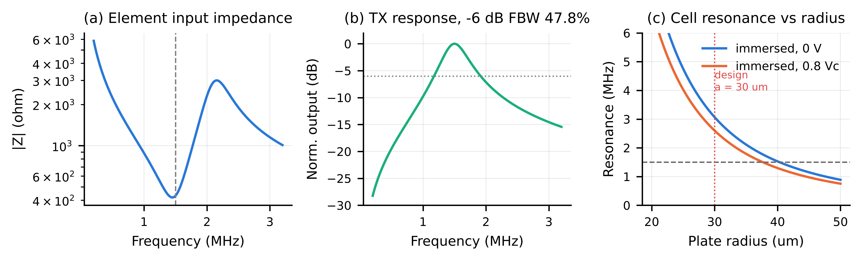
Fig. S1. (a) Element input impedance (BVD). (b) Normalised transmit response. (c) Immersed first resonance against plate radius, at 0 V and 0.8 Vc. The 1.5 MHz line crosses the biased curve at a ≈ 37.7 µm.
Table S2. Focused field at 20 mm (homogeneous medium, rectangular apodization).
Quantity | Manuscript | Reproduced
Focal depth of peak (mm) | 20.0 | 19.78
Peak focal pressure (kPa) | 12.0 | 12
Lateral FWHM, pressure -6 dB (mm) | 0.69 | 0.941
Lateral FWHM, intensity -3 dB (mm) | - | 0.693
Axial FWHM, pressure -6 dB (mm) | 3.74 | 5.503
Axial FWHM, intensity -3 dB (mm) | - | 3.954
Isppa (mW/cm^2) | 4.45 | 4.453
Ispta at 20 % duty (mW/cm^2) | 0.891 | 0.891
Required surface pressure (kPa) | n.r. | 2.792
Required AC drive at 0.8 Vc bias (V) | n.r. | 0.514
Acoustic output power, CW (mW) | n.r. | 0.416
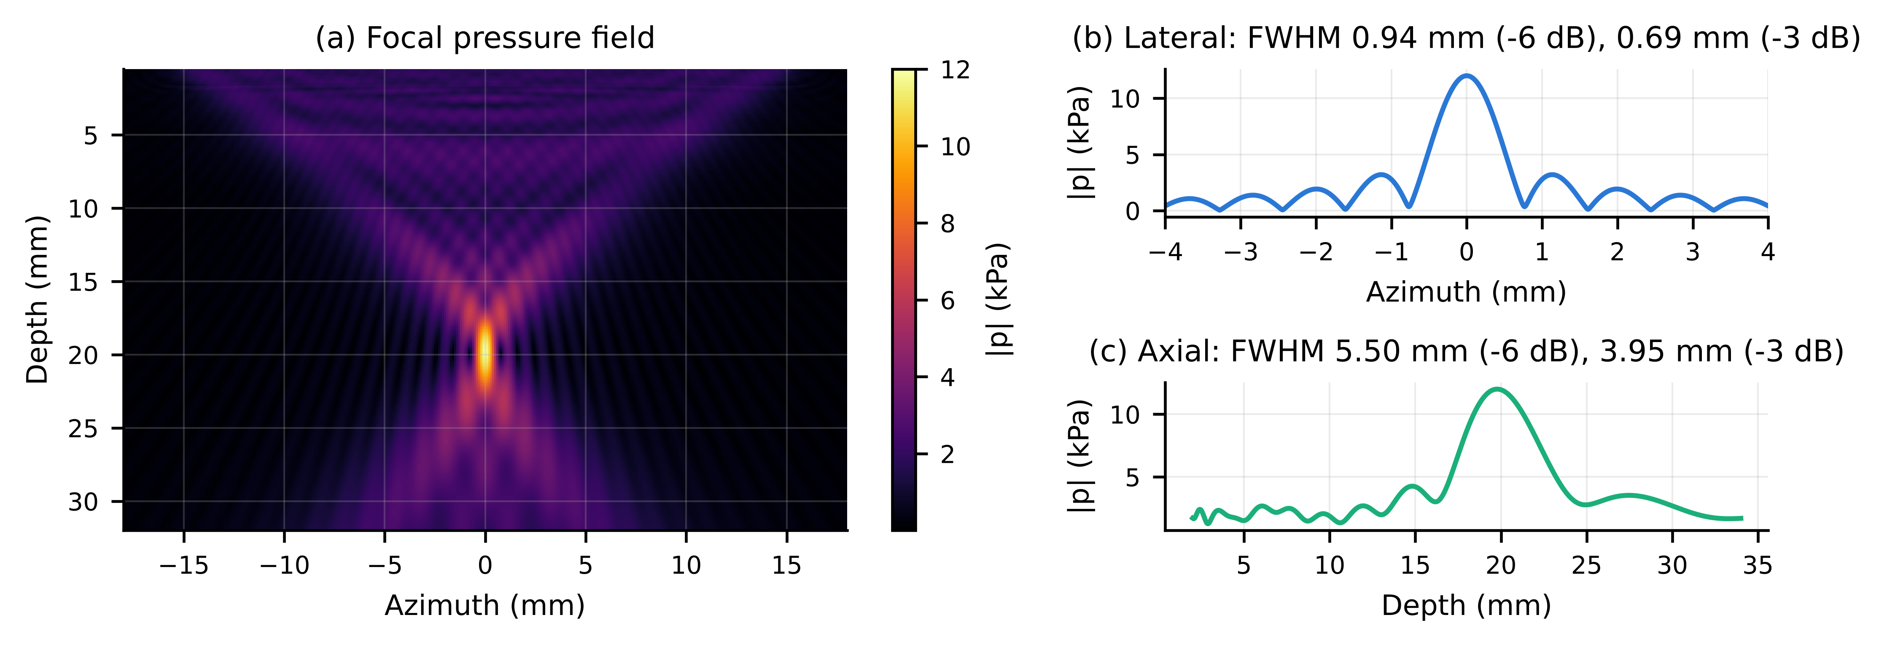
Fig. S2. (a) Pressure map at 12 kPa. (b) Lateral profile through the peak. (c) Axial profile. Widths are given at both −6 dB (pressure FWHM) and −3 dB (intensity FWHM).
Table S3. Beam steering at a 20 mm focal range.
Steer (deg) | Peak (kPa) | Peak change (dB) | Lateral FWHM along x (mm) | FWHM perp. to beam -6 dB (mm) | FWHM perp. to beam -3 dB (mm) | Focal position error (mm)
-20 | 11.61 | -0.284 | 0.978 | 0.96 | 0.706 | 0.08
-10 | 11.9 | -0.0722 | 0.95 | 0.946 | 0.696 | 0.18
0 | 12 | 0 | 0.941 | 0.941 | 0.693 | 0.22
10 | 11.9 | -0.0722 | 0.95 | 0.946 | 0.696 | 0.18
20 | 11.61 | -0.284 | 0.978 | 0.96 | 0.706 | 0.08
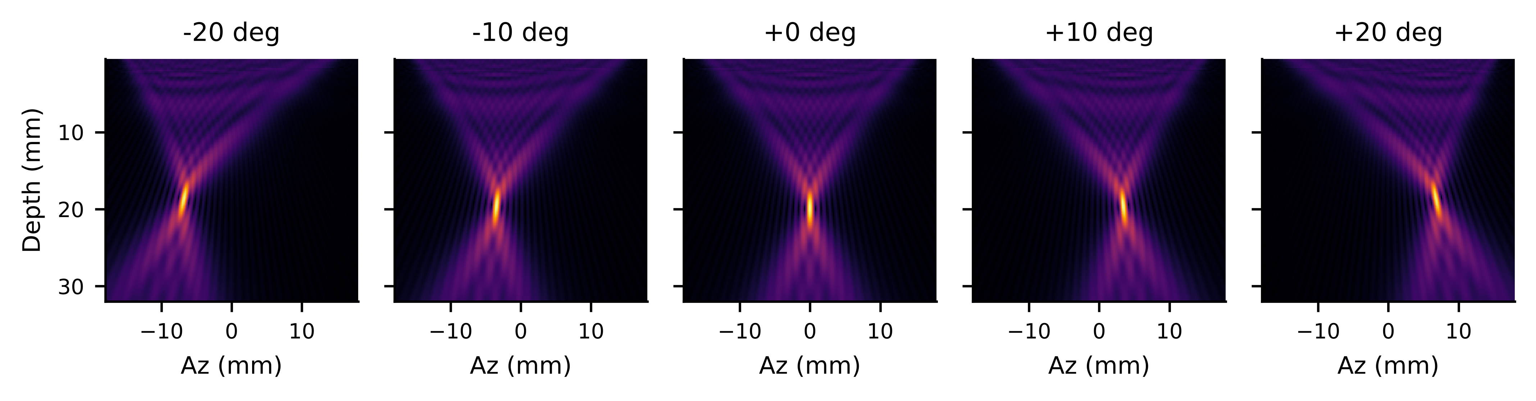
Fig. S3. Steered fields from −20° to +20°, on a common colour scale.
Table S4. Grating lobes against pitch, 20° steer, evaluated on the 20 mm arc.
Pitch (lambda) | Pitch (mm) | Predicted GL angle (deg) | Grating-lobe level (dB) | Peak lobe outside main lobe (dB)
0.5 | 0.513 | - | - | -15.99
0.75 | 0.77 | -82.44 | -13 | -12.22
1 | 1.027 | -41.15 | -12.05 | -12.05
1.5 | 1.54 | -18.94 | -5.011 | -5.011
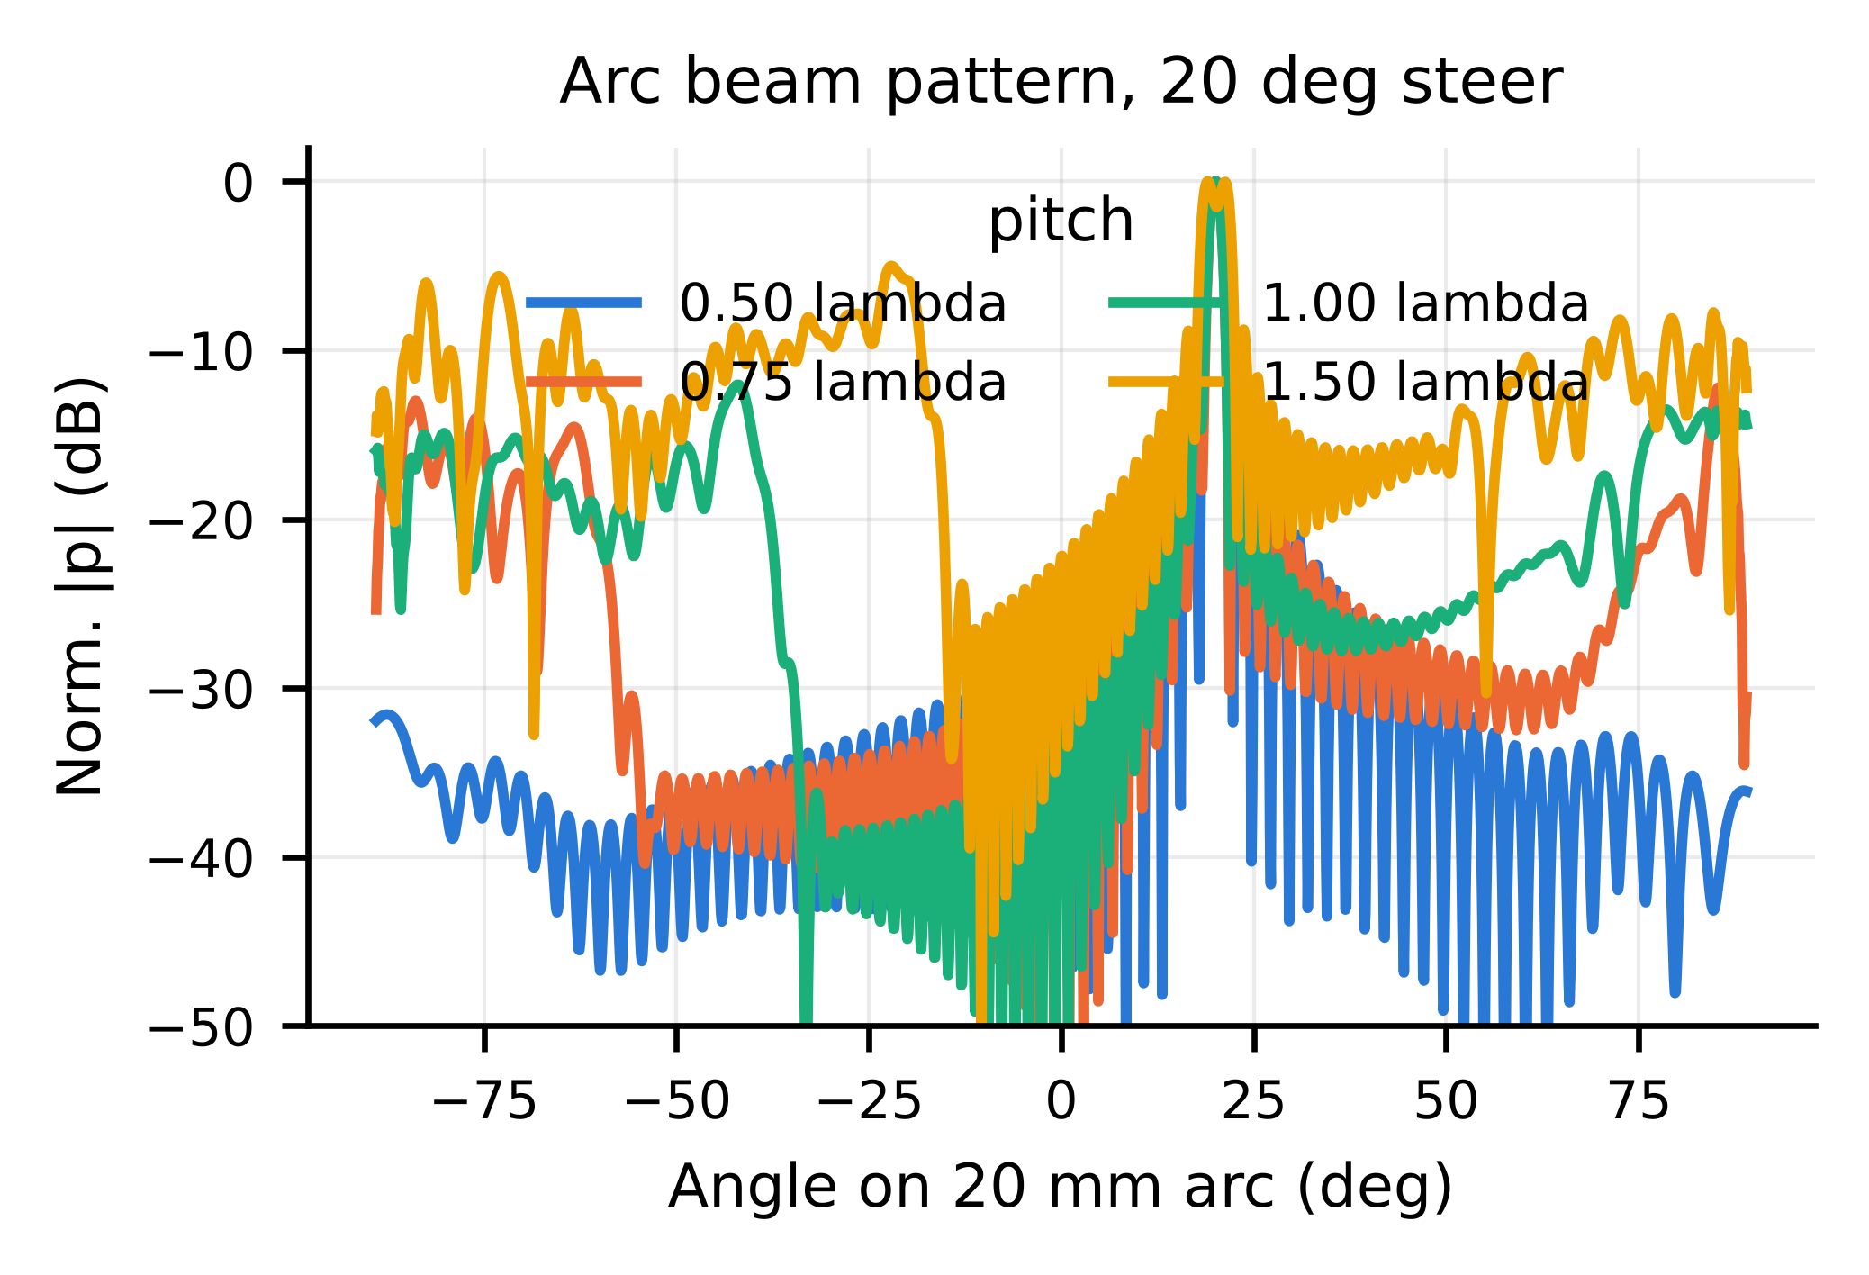
Fig. S4. Arc beam patterns for pitches of 0.5–1.5 λ. A grating lobe is predicted at sin θg = sin θs − λ/p.
Table S5. Apodization trade-off.
Window | Main lobe -6 dB (mm) | Main lobe -3 dB (mm) | Peak side lobe (dB) | Focal gain vs rect (dB)
Rect | 0.941 | 0.693 | -11.49 | 0
Hann | 1.401 | 1.015 | -21.99 | -5.2
Hamming | 1.334 | 0.966 | -23.76 | -4.862
Tukey | 1.161 | 0.851 | -13.04 | -2.173
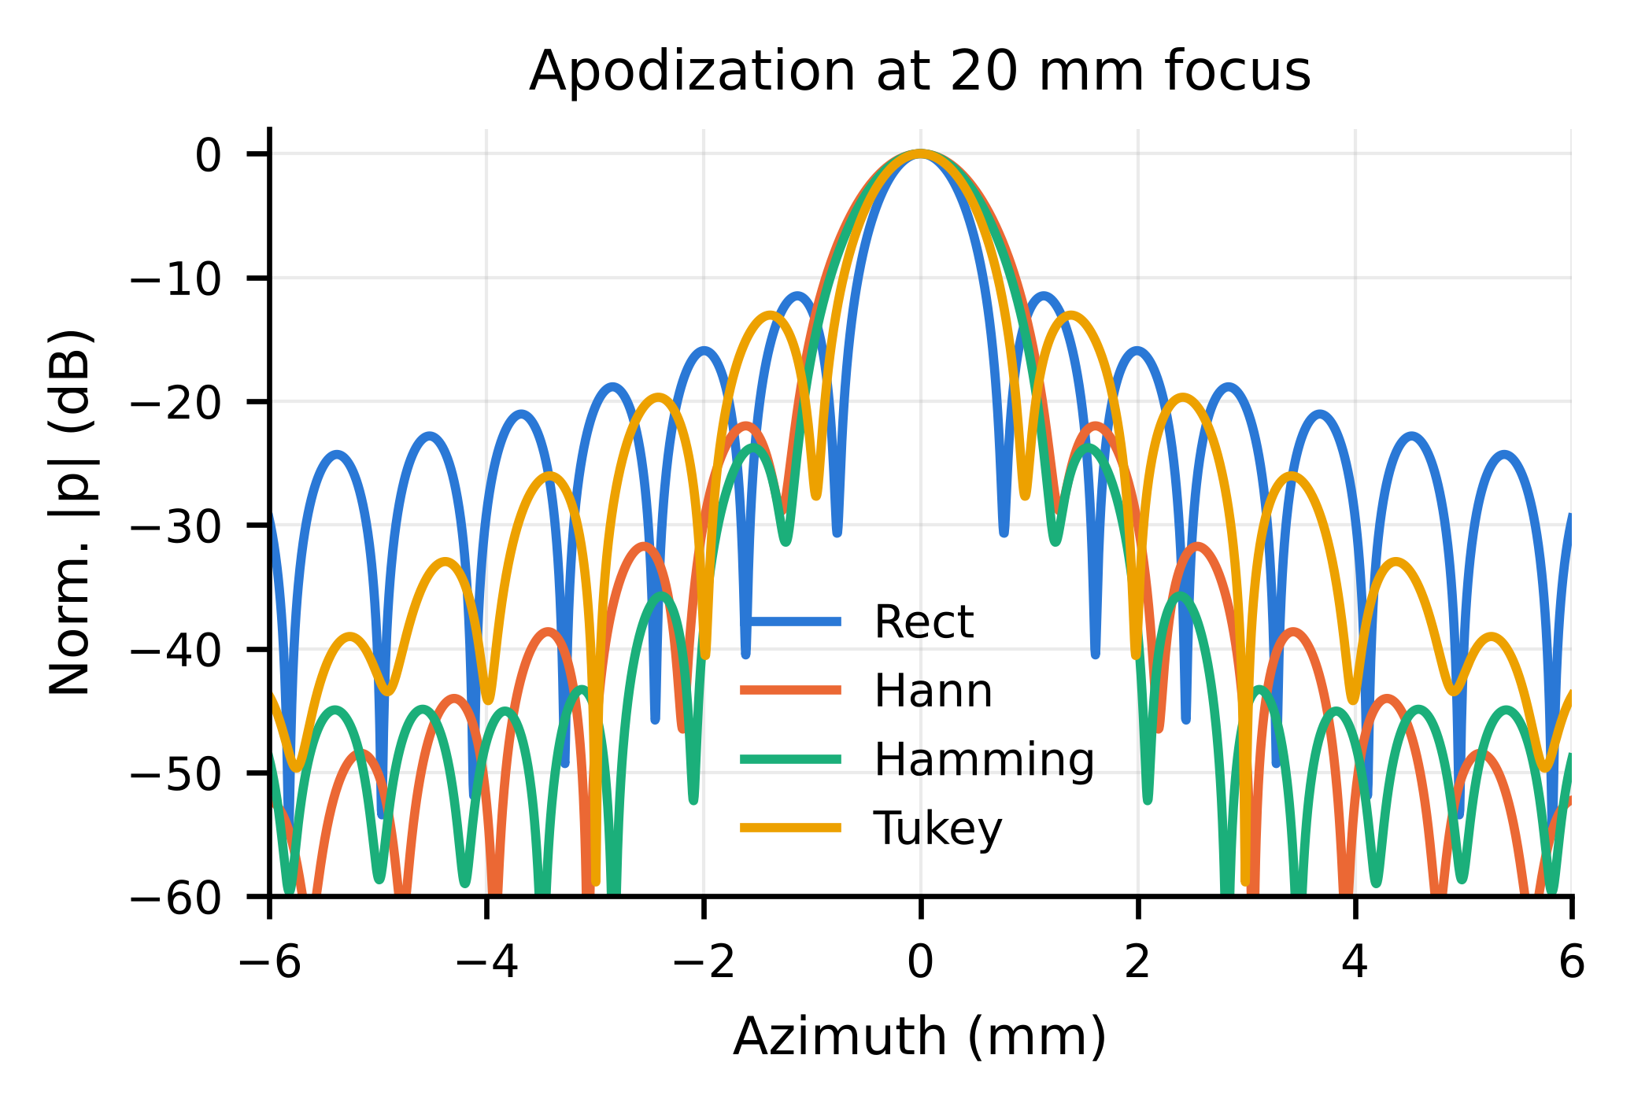
Fig. S5. Lateral beam profiles at the focus for four apodization windows.
Table S6. Effect of the skin–fat–muscle–tumour stack.
Delay law | Peak depth (mm) | Lateral FWHM (mm) | Axial FWHM (mm) | Drive increase vs homogeneous (dB)
homogeneous-delay | 19.98 | 0.941 | 5.4 | 0.474
layer-corrected | 19.78 | 0.933 | 5.308 | 0.436
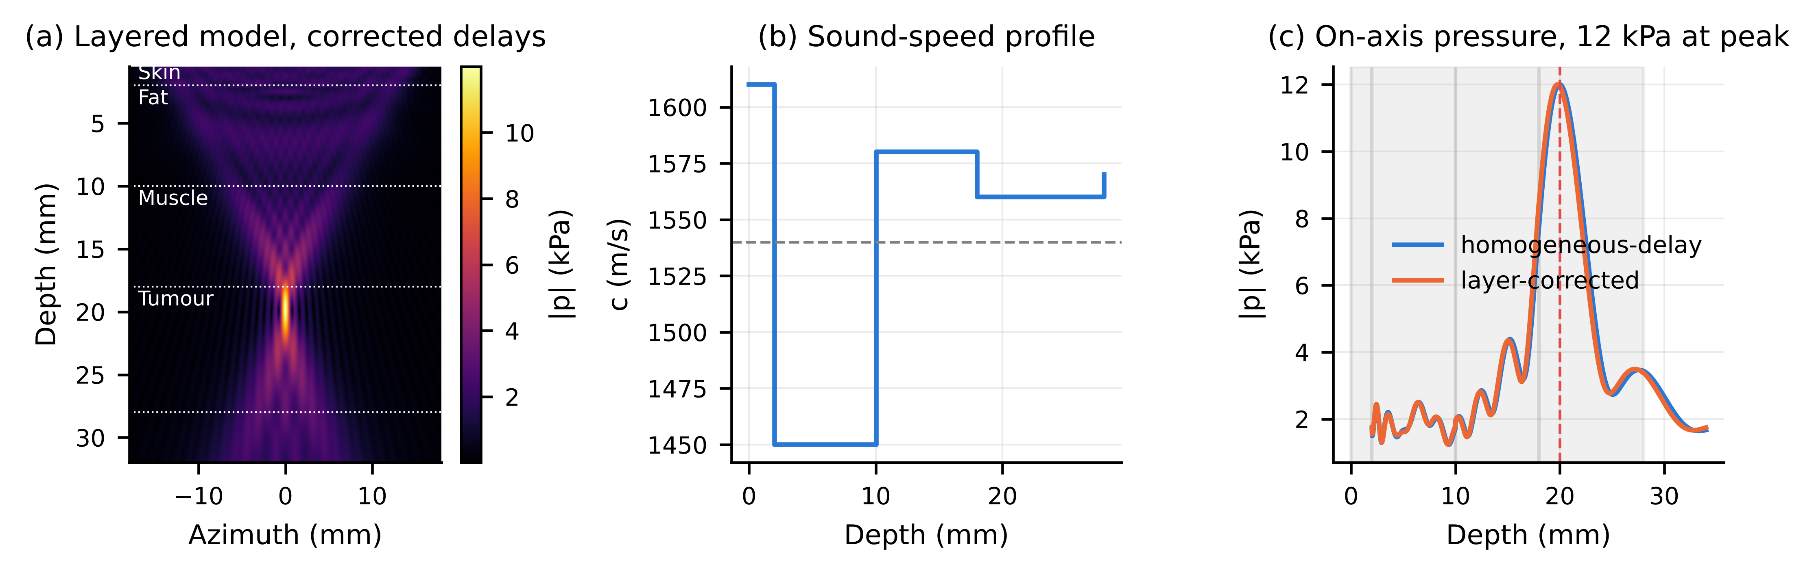
Fig. S6. (a) Field in the layered model with layer-corrected delays. (b) Sound-speed profile. (c) On-axis pressure with homogeneous and with layer-corrected delays.
Table S7. Pennes bioheat (3-D) and IEC thermal indices.
Thermal props | Duty (%) | Steady dT (mK) | dT at 4 min (mK) | Hot-spot depth (mm) | Ispta (mW/cm^2) | TIS | TIB
Tumour | 5 | 0.105 | 0.0869 | 20.1 | 0.223 | 0.000164 | 0.00143
Tumour | 20 | 0.419 | 0.348 | 20.1 | 0.891 | 0.000658 | 0.00573
Tumour | 50 | 1.048 | 0.869 | 20.1 | 2.226 | 0.00164 | 0.0143
Tumour | 100 | 2.096 | 1.738 | 20.1 | 4.453 | 0.00329 | 0.0286
Fat | 5 | 0.246 | 0.198 | 20.1 | 0.223 | 0.000164 | 0.00143
Fat | 20 | 0.985 | 0.792 | 20.1 | 0.891 | 0.000658 | 0.00573
Fat | 50 | 2.464 | 1.979 | 20.1 | 2.226 | 0.00164 | 0.0143
Fat | 100 | 4.927 | 3.959 | 20.1 | 4.453 | 0.00329 | 0.0286
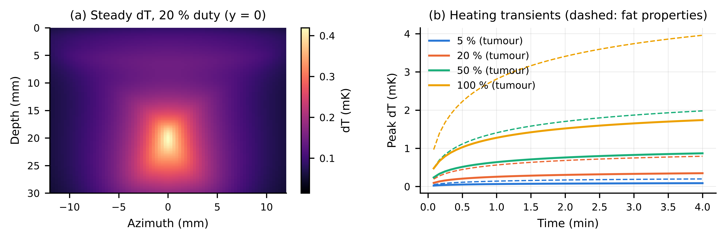
Fig. S7. (a) Steady-state temperature rise at 20 % duty. (b) Peak-temperature transients over 4 min. Solid lines: tumour thermal properties. Dashed lines: fat thermal properties (worst case).
Table S8. Mechanical index and cavitation margin.
p (kPa) | MI | Isppa (mW/cm^2) | Margin to FDA MI 1.9 (x) | Margin to MI 0.7 nucleation (x)
10 | 0.00816 | 3.092 | 232.7 | 85.73
12 | 0.0098 | 4.453 | 193.9 | 71.44
15 | 0.0122 | 6.957 | 155.1 | 57.15
30 | 0.0245 | 27.83 | 77.57 | 28.58
50 | 0.0408 | 77.3 | 46.54 | 17.15
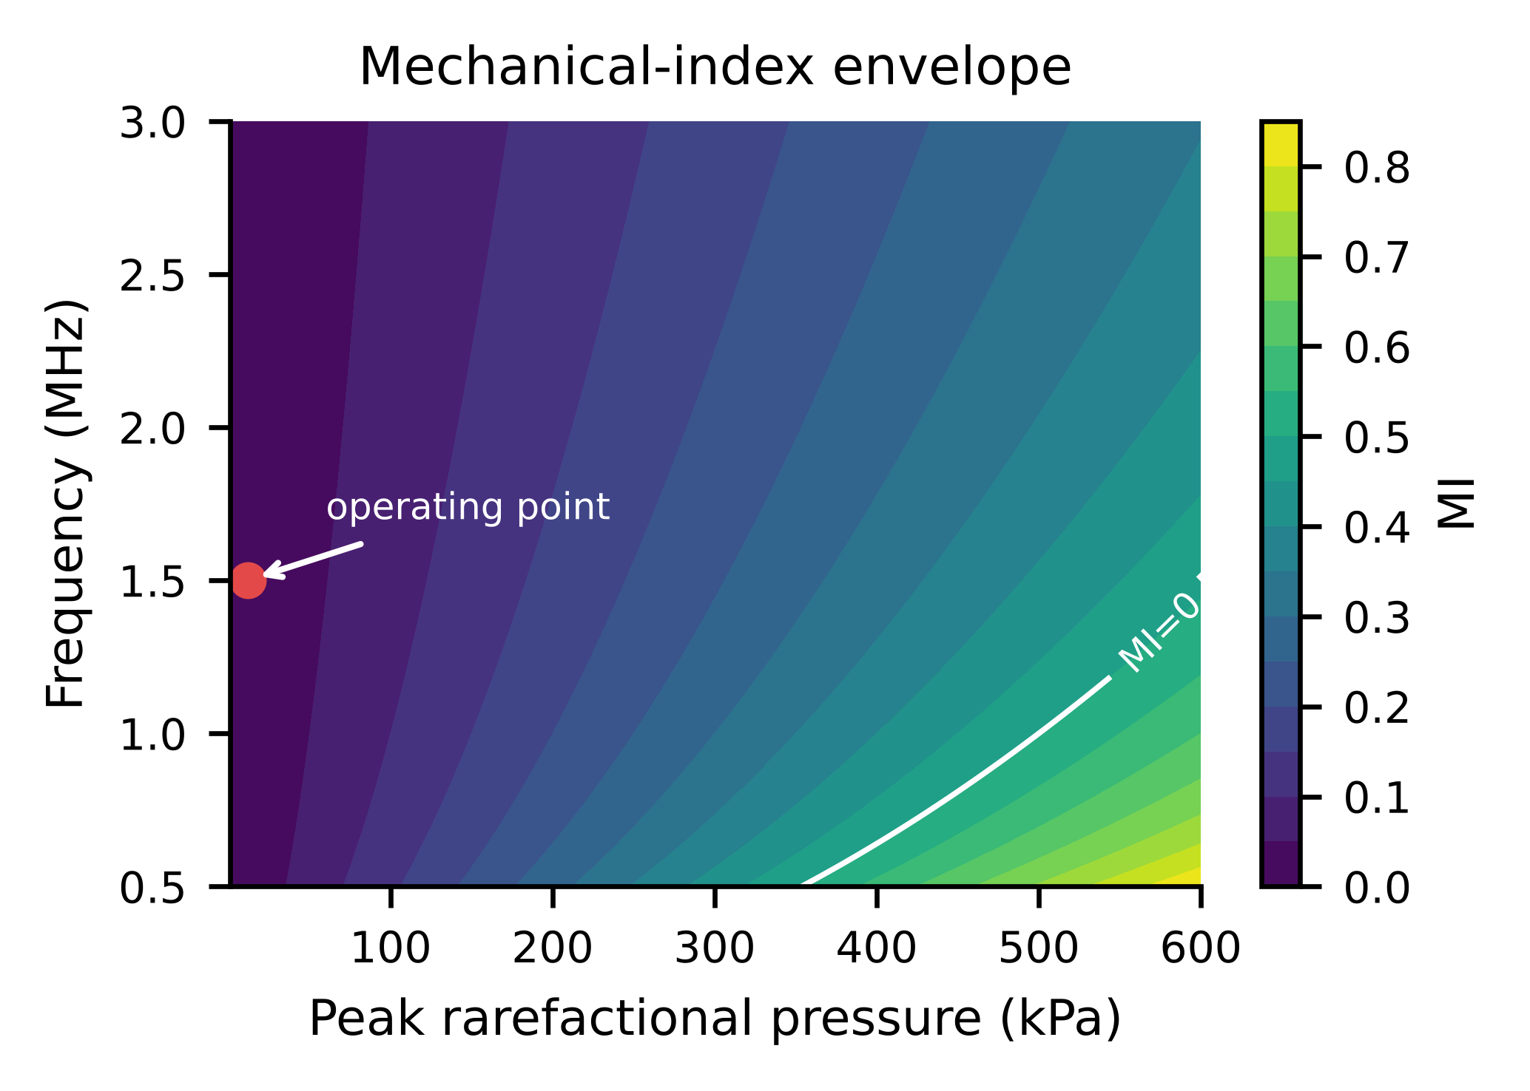
Fig. S8. Mechanical index over the frequency–pressure plane, with the MI = 0.5 design limit and the MI = 1.9 regulatory limit marked.
Table S9. Acoustic radiation force and static displacement (20 % duty).
Layer | Peak Isppa on axis (W/m^2) | Ispta at 20 % (W/m^2) | Peak body force (N/m^3) | Peak static displacement (nm) | Peak axial strain (-)
Skin | 1.841 | 0.368 | 0.00474 | 0.00248 | 1.23e-10
Fat | 1.902 | 0.38 | 0.00435 | 0.041 | 1.5e-09
Muscle | 16.41 | 3.282 | 0.0409 | 0.011 | 9.74e-10
Tumour | 44.52 | 8.904 | 0.138 | 0.005 | 3.84e-10
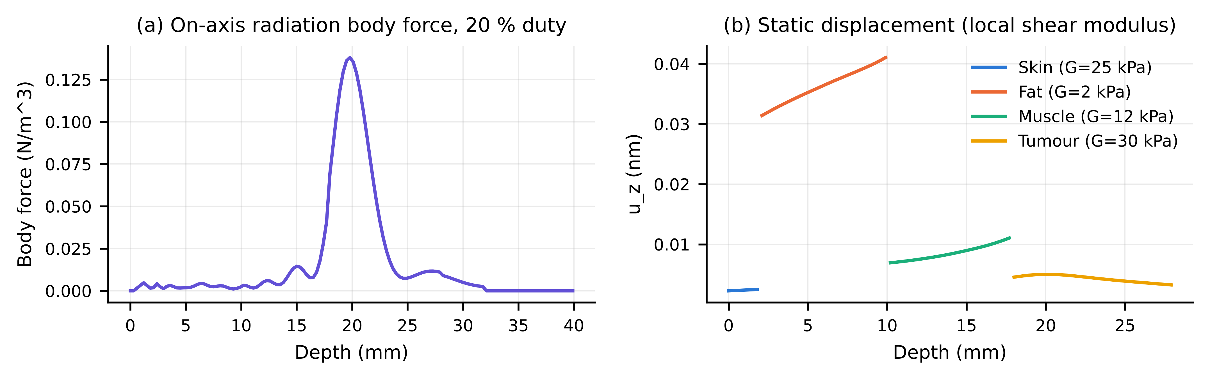
Fig. S9. (a) On-axis radiation body force. (b) Static axial displacement in each layer, from the Kelvin solution with the local shear modulus.
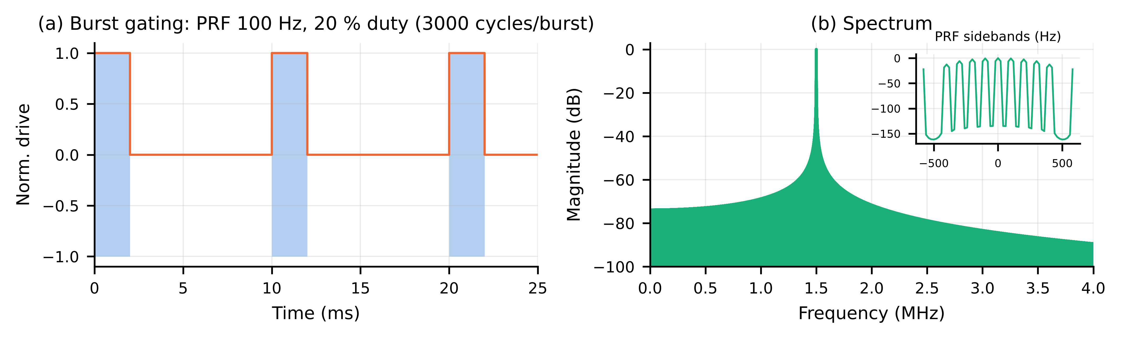
Fig. S10. (a) Burst gating at a 100 Hz PRF and 20 % duty: 3000 cycles per 2 ms burst. (b) Spectrum, with the PRF sidebands shown inset.
Table S10. Closed-loop regulation.
Metric | Manuscript | Reproduced
Kp / Ki / Kd | 4 / 55 / 0 | 4 / 55 / 0
Plant (K, tau, dead time) | FOPDT (n.r.) | 1, 60 ms, 5 ms
Settling time, 2 % (ms) | 150 | 170.0
Overshoot (%) | 0.0 | 0.0
Steady-state error (Pa) | 0.03 | 0.038
Recovery after 40 % coupling loss (ms) | 426 | 181.0
Pressure dip during disturbance (kPa) | n.r. | 1.2
Settling, 5 % band, with 0.3 kPa sensor noise (ms) | n.r. | 118.0
MC +/-50 % plant: settling median [95th pct] (ms) | n.r. | 173 [244]
MC +/-50 % plant: overshoot max (%) | n.r. | 55.89
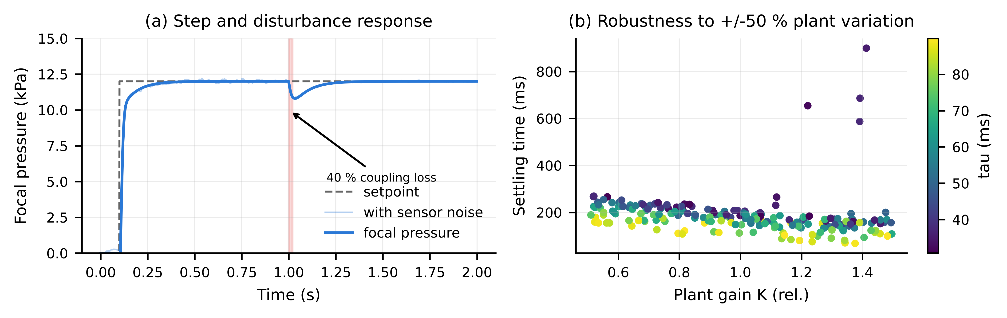
Fig. S11. (a) Step response and response to a 40 % coupling loss, with and without sensor noise. (b) Settling time across 200 plants with ±50 % uncertainty in gain and lag.
Table S11. Phase III spheroid sample size.
Effect (% reduction) | CV of spheroid assay (%) | n/group (2 groups) | n/group (4 doses vs sham, Bonferroni)
10 | 10 | 17 | 24
10 | 15 | 37 | 52
10 | 20 | 64 | 91
15 | 10 | 9 | 12
15 | 15 | 17 | 24
15 | 20 | 29 | 42
20 | 10 | 6 | 8
20 | 15 | 10 | 15
20 | 20 | 17 | 24
30 | 10 | 4 | 5
30 | 15 | 6 | 8
30 | 20 | 9 | 12
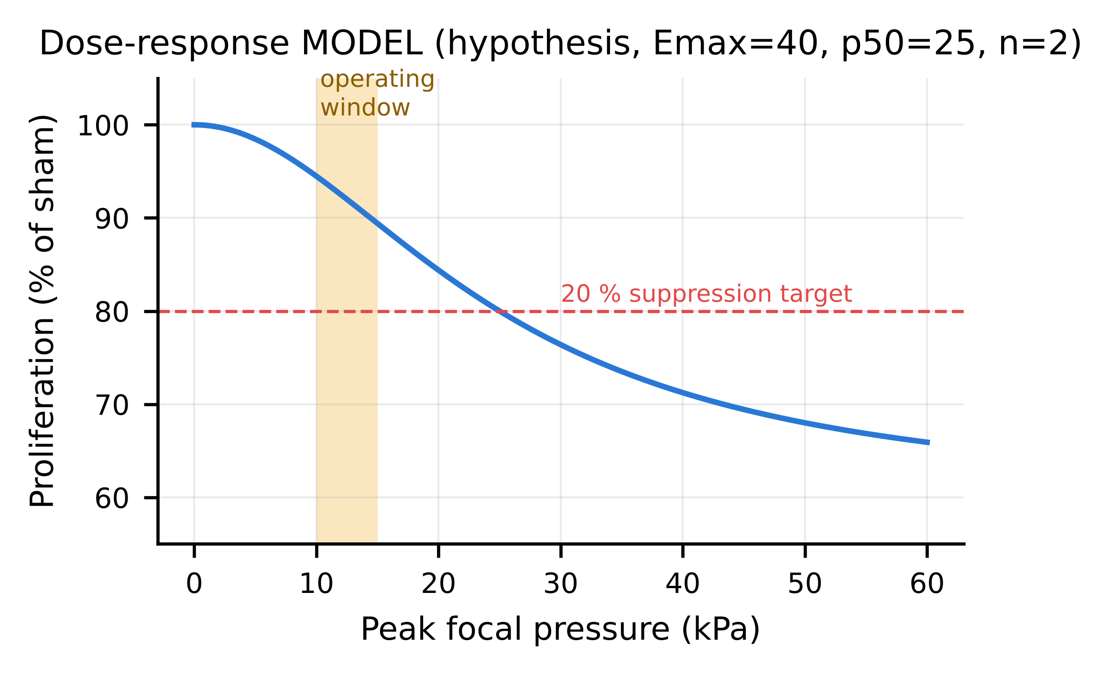
Fig. S12. Hypothesised Hill dose–response model. The parameters are placeholders to be estimated in Phase III. This is not a prediction.
Table S12. Estimated wearable power budget.
Block | Power (mW) | Basis
Low-power FPGA (beamformer, sequencer, PI) | 150 | vendor class
64-ch low-voltage TX drivers (linear, quiescent) | 192 | 3 mW/ch assumed
TX dynamic C*V^2*f*duty (computed) | 0.343 | Vac=0.51 V, C0=68 pF
DC bias generator (~41 V, leakage-limited) | 40 | boost + LDO
Feedback RX/ADC (8 channels, duty-cycled) | 50 | assumed
MCU + BLE link | 15 | assumed
TOTAL | 447.3 | -
Energy for 4 h session (Wh) | 1.789 | -
Battery @3.7 V, 80 % usable (mAh) | 604.5 | -

Note S4. Hardware digital twin (EMULATED results)
The tables and figures in this Note are emulated. They are Monte Carlo predictions of what a bench characterisation would be expected to report, given the error budget in Supplementary file S3. They are not experimental measurements. They set the acceptance bands for the Phase II protocol (Supplementary file S4).
Table E1. Fabrication Monte Carlo (EMULATED).
Quantity | Emulated value
Arrays simulated (64 elements each) | 300
Collapse voltage mean +/- SD (V) | 51.6 +/- 3.2
Collapse voltage 1st-99th percentile (V) | 44.5 - 59.2
Element sensitivity spread SD (dB) | 0.63
Element phase spread SD (deg) | 1.55
Array yield at fixed 41 V bias (no trim) (%) | 100.0
Bias for 99 % array yield (V) | 41.4
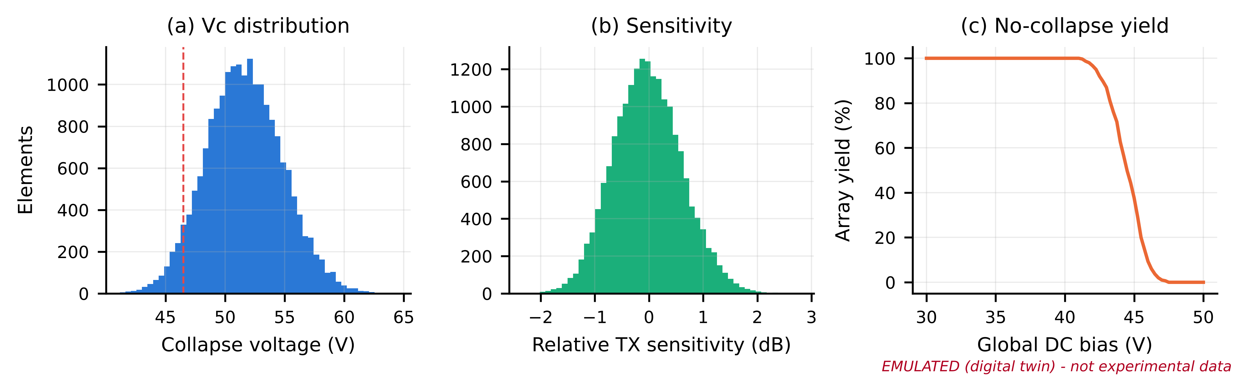
Fig. E1 (EMULATED). (a) Collapse-voltage distribution; the dashed line marks the manuscript value of 46.5 V. (b) Element sensitivity spread. (c) Array yield against a global DC bias.
Table E2. Beam quality under hardware non-idealities (EMULATED).
Condition | Peak (kPa) | Pressure at 20 mm target (kPa) | Lateral FWHM (mm) | Axial FWHM (mm) | Axial focus shift (mm) | Lateral focus shift (mm) | Peak side lobe (dB)
Ideal (model) | 12.000 | 11.949 | 0.941 | 5.503 | -0.220 | 0.000 | -11.487
Flat patch + HW errors | 11.803 +/- 0.224 | 11.753 +/- 0.223 | 0.941 +/- 0.009 | 5.501 +/- 0.068 | -0.225 +/- 0.018 | 0.000 +/- 0.000 | -11.351 +/- 0.458
Curved R=60 mm, uncorrected | 12.040 +/- 0.209 | 3.344 +/- 0.177 | 0.736 +/- 0.007 | 3.178 +/- 0.043 | -5.293 +/- 0.010 | 0.000 +/- 0.000 | -10.720 +/- 0.390
Curved R=60 mm, shape-corrected | 11.402 +/- 0.228 | 11.365 +/- 0.230 | 0.902 +/- 0.009 | 4.874 +/- 0.075 | -0.156 +/- 0.076 | 0.000 +/- 0.000 | -11.593 +/- 0.671
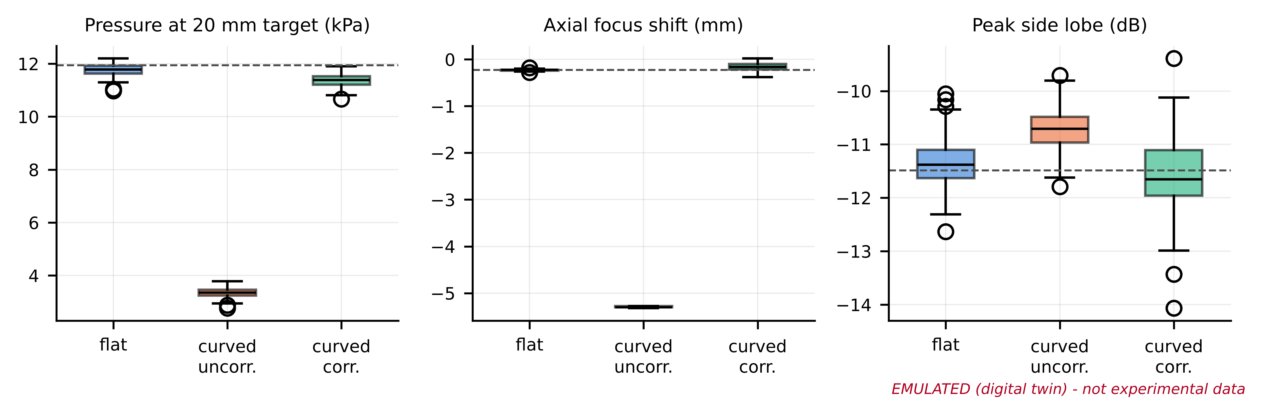
Fig. E2 (EMULATED). Monte Carlo results for a flat patch, an uncorrected curved patch (R = 60 mm) and a shape-corrected curved patch. The dashed lines show the ideal model.
Table E3. Emulated needle-hydrophone characterisation, n = 5 scans (EMULATED).
Quantity | Model (ideal) | Emulated mean +/- SD (n=5) | 95 % CI | Deviation (%)
Peak (kPa) | 12 | 12.365 +/- 0.842 | [11.320, 13.411] | 3
Lateral FWHM (mm) | 0.941 | 0.938 +/- 0.023 | [0.909, 0.966] | -0.4
Axial FWHM (mm) | 5.503 | 5.476 +/- 0.020 | [5.451, 5.500] | -0.5
Focus depth (mm) | 19.78 | 19.550 +/- 0.209 | [19.290, 19.810] | -1.2
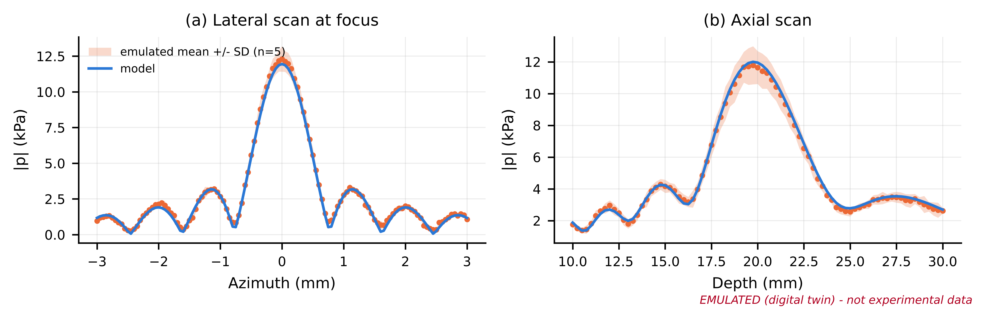
Fig. E3 (EMULATED). Emulated hydrophone scans (mean ± SD, n = 5) against the model.
Table E4. Emulated phantom thermometry (EMULATED).
Focal p (kPa) | True dT 100 % duty (mK) | Viscous artefact (mK) | Emulated reading mean (mK) | SD (mK) | LOD 3sigma (mK) | Resolvable?
12 | 2.096 | 0.629 | 6.58 | 11.25 | 9.487 | no
50 | 36.39 | 10.92 | 48.96 | 9.523 | 9.487 | yes
100 | 145.6 | 43.67 | 189.3 | 13.71 | 9.487 | yes
200 | 582.3 | 174.7 | 760.1 | 10.07 | 9.487 | yes
400 | 2329 | 698.8 | 3029 | 12.57 | 9.487 | yes
Table E5. Emulated 4 h closed-loop session (EMULATED).
Quantity | Emulated value
Session length (h) | 4
Time within 10-15 kPa window (%) | 99.66
Time within +/-5 % of 12 kPa (%) | 90.46
Mean focal pressure (kPa) | 12.03
SD focal pressure (kPa) | 0.485
Drive increase end vs start (dB) | 4.046
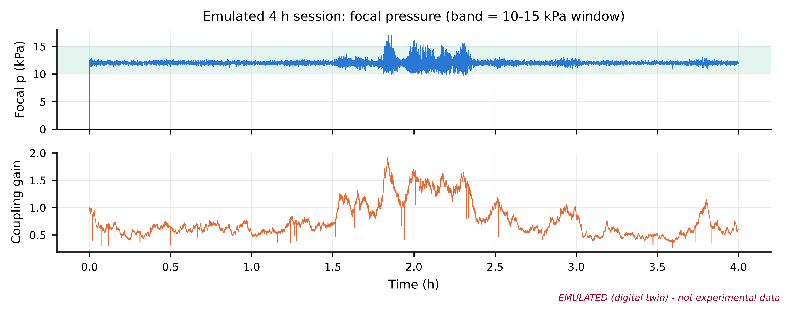
Fig. E5 (EMULATED). Focal pressure over a 4 h session with gel drying, a random-walk drift in coupling, and motion events.

Note S5. Code and data availability
The code (cmutsim, run_all.py), all raw numerical data (CSV/NPZ) and the figures are released under the MIT licence. They will be deposited in a public repository with a DOI before publication (see file S5).

