From identification-first to spectrum-native proteomics: a controlled benchmark of transformer models that learn directly from MS1 and MS2 signal
M. Nisha Angeline^{1,*}
¹ Department of Electronics and Communication Engineering, Velalar College of Engineering and Technology, Thindal, Erode, Tamil Nadu, India. * Corresponding author: nishavlsidesign@gmail.com
Article type: Research article (Problem solving protocol / benchmark) Suggested journals (Q1): Briefings in Bioinformatics; Computers in Biology and Medicine; Journal of Proteome Research

Abstract
Motivation. Mass-spectrometry proteomics is moving from an identification-first workflow — search MS2 spectra against a database, then do statistics on identified peptides — towards spectrum-native models that learn directly from MS1/MS2 signal. Examples include transformer de novo sequencing and ProFormer-style phenotype classifiers. Real data cannot tell us how much information identification discards, because the ground truth of real spectra is itself defined by identification.
Results. We built an open, CPU-trainable virtual instrument with known ground truth. It simulates b/y fragmentation (proline/aspartate effects, neutral losses, doubly charged ions, stochastic fragment dropout, ppm error, chemical noise) and multi-site LC-MS1 acquisition. In some cohorts a controlled fraction of biomarkers cannot be identified by MS2 search. On 250,000 training spectra we trained SpecNovo, an encoder–decoder transformer with three inductive biases: complementary-ion encoding, prefix-mass decoding and a differentiable ion-evidence term. The ablation showed that the ion-evidence term is decisive. It raised teacher-forced token accuracy from 0.582 to 0.864 and peptide recall from 0.005 to 0.416 at a similar training budget.
Database search was near-perfect on canonical peptides (recall 0.999) but recovered none of the variant or novel-proteome peptides. SpecNovo was database-independent (peptide recall 0.416, 0.389 and 0.387 on canonical, single-amino-acid-variant and novel-proteome spectra). It had the best precision–coverage AUC (0.663 vs 0.630 for a spectrum-graph baseline) and the highest precision at 25 % coverage (0.787 vs 0.716). A classical spectrum-graph algorithm remained more robust to incomplete and noisy spectra.
For phenotype prediction, removing the identification bottleneck was the largest single effect. With 50 % of biomarkers unidentifiable and 192 labelled runs, identification-free features gave AUROC 0.975 ± 0.015 versus 0.648 ± 0.013 for identification-first quantification. On an unseen acquisition site the figures were 0.986 vs 0.627. A ProFormer-style FeatureFormer beat identification-first statistics (0.767 vs 0.648) but not identification-free linear models at these cohort sizes. Masked-intensity pretraining improved site transfer (0.728 vs 0.651) but not in-distribution accuracy.
Conclusions. Spectrum-native learning recovers information that identification-first pipelines lose, especially for variant, novel and dark-proteome signal. At realistic data scales, though, its benefits depend strongly on physics-informed inductive biases and on corpus size. The benchmark, code and all measurements are released to support “proteomics GPT” development under controlled ground truth.
Keywords: de novo peptide sequencing; transformer; spectrum-to-phenotype; self-supervised learning; mass spectrometry; benchmark; explainable AI

Key points
- An open virtual instrument with exact ground truth quantifies, for the first time in a single framework, what identification-first proteomics loses relative to spectrum-native learning on both MS2 (sequencing) and MS1 (phenotype) tasks.
- Physics-informed inductive biases — above all a differentiable fragment-ion-evidence term — turn an under-trained sequence-to-sequence transformer (0.5 % peptide recall) into a database-free sequencer (41.6 %) with the best-calibrated confidence among tested methods.
- Identification-free MS1 features raise phenotype AUROC from 0.65 to 0.98 when half of the biomarkers are unidentifiable and remain stable from 0 % to 75 % “dark” biomarkers, whereas identification-first performance falls from 0.81 to 0.58.
- At cohort sizes of 24–384 samples, linear models on identification-free features outperform ProFormer-style transformers; self-supervised pretraining chiefly improves cross-site robustness — a quantitative argument for corpus-scale (MassNet-style) pretraining.

Introduction
Mass-spectrometry (MS)-based proteomics has, for two decades, followed an identification-first paradigm: tandem (MS2) spectra are matched to peptide sequences drawn from a protein database, matches are filtered by target–decoy competition at a fixed false-discovery rate (FDR), identified peptides are rolled up to proteins, and only then is the resulting quantitative matrix handed to statistics or machine learning [1–3]. The paradigm is mature and well controlled, but it is lossy by construction. In typical data-dependent acquisition (DDA) experiments, a majority of acquired MS2 spectra remain unassigned; peptides carrying single amino-acid variants (SAAVs), unanticipated post-translational modifications (PTMs), non-canonical open reading frames or organisms absent from the database are invisible; and the stochastic sampling of precursors for fragmentation produces missing values that are neither missing completely at random nor easy to impute [4,5]. Every downstream biological conclusion therefore inherits the blind spots of the identification step.
Two developments are now loosening this constraint. First, public repositories have grown into corpora of hundreds of millions of spectra (e.g., PRIDE and MassIVE-KB) [6,7], and are being curated into machine-learning-ready datasets in the spirit of “MassNet-style” corpora that can be consumed without bespoke search pipelines. Second, transformer architectures [8] have proved able to learn directly from the irregular, set-structured signal of mass spectra. Transformer-based de novo sequencing — Casanovo [9], InstaNovo [10], π-HelixNovo [11], NovoB [12], pairwise-attention encoders [13] and DIA-specific variants [14] — translates peaks into peptides without a database, building on the earlier deep-learning de novo work of DeepNovo [15] and PointNovo [16]. In parallel, ProFormer [17] showed that a transformer operating on MS1-level peptide-ion features can classify single-cell and plasma proteomes by phenotype without peptide identification, outperforming conventional machine learning and image-based convolutional networks; a related proteomics transformer (Proformer) [18] predicts multi-disease risk from large plasma cohorts. Spectrum representation learning (GLEAMS [19]) and fragment-intensity prediction (Prosit, AlphaPeptDeep) [20,21] complete the picture of a field moving from “identify peptides, then do statistics” to “learn directly from MS1/MS2 signal”.
This shift raises questions that are difficult to answer on public data alone, because the ground truth of real spectra is itself defined by identification pipelines. How much information is lost by identification-first workflows, and under what conditions? When does a database-free model beat a database search, and when does it not? Does self-supervised pretraining on unlabeled runs — the core premise of corpus-scale “proteomics GPTs” — translate into label efficiency for phenotype prediction? And are spectrum-native models interpretable at the level of individual fragment ions or peptide features?
Here we address these questions with a fully controlled, open-source virtual instrument: a physics-informed simulator of MS2 fragmentation and LC-MS1 acquisition with known ground truth, combined with CPU-trainable transformer models and strong classical baselines. Our contributions are:
- An open benchmark environment (Python/PyTorch, CPU-only) generating 250,000 labelled MS2 spectra from a 3,000-protein training proteome, ten held-out test sets that vary database membership, fragment completeness and chemical noise, and multi-site LC-MS1 cohorts in which a controllable fraction of biomarkers is unidentifiable by MS2 search.
- SpecNovo, an encoder–decoder transformer for database-free sequencing with three inductive biases — complementary-ion peak encoding, prefix-mass-conditioned decoding and a differentiable ion-evidence term — whose contributions are quantified in an ablation study.
- FeatureFormer, a ProFormer-style transformer over identification-free MS1 feature tokens, pretrained with masked-intensity modelling on unlabeled runs, benchmarked against identification-first, match-between-runs (MBR) and identification-free linear pipelines across label budgets, unseen acquisition sites and a “dark-proteome” sweep.
- Quantitative interpretability: peak-level gradient × input attribution for de novo sequencing and feature-level attribution for biomarker recovery, together with replicate-retrieval analysis of learned spectrum embeddings.
We report all results — including those in which classical baselines remain competitive — to give an honest map of where spectrum-native learning helps today.

Materials and methods

Virtual instrument
Chemistry. Monoisotopic residue masses were used with fixed carbamidomethylation of cysteine and variable oxidation of methionine (p = 0.25 per Met); isobaric Ile/Leu were merged. Peptide neutral mass is the residue sum plus H₂O, and singly protonated b- and y-ion ladders were computed exactly (proton mass 1.007276 Da).
Proteomes and peptides. Synthetic proteomes were sampled with UniProtKB/Swiss-Prot amino-acid background frequencies and protein lengths of 250–650 residues. Three independent proteomes were generated: a training proteome T (3,000 proteins; 73,126 unique tryptic peptides), a searchable proteome P (1,500 proteins; 36,961 peptides) and a novel proteome N (600 proteins; 14,636 peptides) absent from any database. Tryptic digestion cleaved after K/R except before P, allowing one missed cleavage and peptide lengths of 7–12 residues. Peptides shared between T and P or N and P were removed to prevent leakage.
MS2 fragmentation model. For each peptide we sampled precursor charge z ∈ {2, 3} (length-dependent), log-normal base intensities for every b/y cleavage (y ions 1.67× stronger than b ions), a four-fold enhancement of cleavage N-terminal to Pro, a two-fold enhancement C-terminal to Asp, attenuation of terminal fragments, neutral losses of H₂O (p = 0.35) and NH₃ (p = 0.2), and doubly charged fragments for z = 3. Each fragment is observed with probability p_{obs}, receives Gaussian mass error of 10 ppm, and Poisson-distributed chemical-noise peaks (mean λ) are added uniformly over [100 Da, M]. The 80 most intense peaks were retained and square-root-normalised. Training spectra were drawn with p_{obs} ∼ U(0.55, 0.95) and λ ∼ U(10, 100) to emulate heterogeneous acquisitions.
Test sets. inDB: 3,000 spectra of proteome-P peptides (p_{obs} = 0.8, λ = 40). SAAV: 1,500 spectra of P peptides carrying one non-K/R substitution that removes them from the database. novel: 1,500 spectra from proteome N. Robustness: four sets of 1,000 spectra with p_{obs} ∈ {0.95, 0.80, 0.65, 0.50} and four with λ ∈ {10, 40, 100, 200}.
LC-MS1 cohorts. Each cohort contains 300 peptide-ion features with m/z ∈ [400, 1200], retention time (RT) ∈ [3, 57] min, charge 2 or 3, log₂ abundance ∼ N(20, 1.6²) and feature-specific biological variance (σ ∈ [0.2, 0.45]). Seventy percent of features belong to the identification library; the remainder represent PTM-modified, variant or non-canonical peptides. Twenty features are phenotype-associated biomarkers with log₂ fold changes of ±(0.26–0.44); a fraction f_{unid} of them is drawn from the non-library set. Four acquisition sites introduce RT drift (σ = 0.6 min), m/z calibration offsets (σ = 4 ppm), global intensity shifts (σ = 0.5 log₂) and feature-specific site effects (σ = 0.25 log₂). Features below a limit of detection (log₂ 17.5 ± 0.3) are not detected; 80 spurious features are added per run. In the identification-first workflow each detected library feature is identified by DDA MS2 with probability 0.8. For visualisation, runs were also rendered as 64 × 256 RT × m/z images with Gaussian elution profiles and isotope envelopes (Fig. 2c–e).

Models
SpecNovo (Fig. 3a). Peaks are embedded by a sinusoidal mass encoder with wavelengths log-spaced between 10⁻³ and 10⁴ Da [9]. In the mass-aware variant each peak additionally receives the encoding of its complementary ion mass (M + 2 × 1.007276 − m/z), which maps y ions onto b-ion coordinates [11]. A three-layer pre-norm transformer encoder (d = 128, 4 heads, feed-forward 512) contextualises peaks. The autoregressive three-layer decoder receives a precursor token (mass encoding + charge embedding) followed by residue tokens; in the mass-aware variant each decoder position also receives encodings of the prefix mass and of the residual mass still to be explained. The ion-evidence term computes, for every candidate residue a at every step, the maximum observed intensity within 0.02 Da of eight theoretical ions (b, y, b−H₂O, y−H₂O, b²⁺, y²⁺ for the extended prefix and b, y for the current prefix); a two-layer MLP maps these eight values to an additive logit, a differentiable analogue of the ion-location features of DeepNovo [15]. Decoding uses beam search (K = 5) constrained so that the prefix mass never exceeds the precursor mass by more than 0.05 Da and termination is allowed only when the residue mass matches within 0.05 Da. The model has 1.44 M parameters.
FeatureFormer (Fig. 3b). Detected features are aligned to a consensus feature map without identification: a global RT shift is estimated as the median offset of nearest neighbours (15 ppm, 3 min), after which features are matched within 15 ppm and 0.7 min. Each consensus feature j becomes a token t_{j} = e_{j} + 0.1·W_{c}[sin(m/z_{j}); sin(RT_{j})] + v_{ij}·w_{j}, where v_{ij} is the run-median-centred, standardised log₂ intensity of feature j in run i, w_{j} is a feature-specific numeric embedding (FT-Transformer style [22]) and a learned missing-value token replaces v_{ij}·w_{j} when the feature is absent. A [CLS] token and two pre-norm transformer layers (d = 64, 4 heads) follow; the classifier sums a [CLS] logit and zero-initialised per-token evidence logits. For self-supervised learning (SSL) 30 % of observed values are replaced by a mask token and reconstructed (mean-squared error) on 800 unlabeled runs from all sites, analogous to masked modelling in BERT and MAE [23,24]. Fine-tuning used AdamW (head lr 10⁻³, body lr 2 × 10⁻⁴ after SSL), one-cycle schedule, 150 steps, batch 32, Gaussian intensity jitter (σ = 0.1) and 10 % feature dropout.

Baselines
Database search. A target–decoy search against proteome P (45,779 target entries including Met-oxidation variants; reversed decoys with fixed C-terminal residue) used a 10 ppm precursor window and a hyperscore-like PSM score, S = ln(ΣI_{matched}) + ln(n_{b}!) + ln(n_{y}!), with a 0.02 Da fragment tolerance. PSMs were accepted at 1 % FDR by target–decoy competition [3].
Spectrum-graph de novo. A classical spectrum graph [25,26] was built with nodes at every peak’s b-ion and complementary y-ion prefix mass (merged within 0.025 Da) and edges for single residues or residue pairs (pair penalty 0.25); the maximum-intensity path from 0 to M − H₂O was found by dynamic programming.
Phenotype pipelines. ID-first-LR: identified library features only → per-run median normalisation → minimum-value imputation → L2-regularised logistic regression with cross-validated regularisation (10 values, ≤5 folds, AUROC criterion). ID-first+MBR-LR: library features quantified wherever detected (match-between-runs). ID-free-LR: all aligned features, same statistics. FeatureFormer trained from scratch and FeatureFormer+SSL.

Training and evaluation
SpecNovo was trained with AdamW (lr 5 × 10⁻⁴, weight decay 10⁻⁴, 200 warm-up steps, cosine decay), batch 128, label smoothing 0.05 and gradient clipping at 1.0 on four CPU cores. The base model was trained for 3,500 steps (448k spectra); the mass-aware model for 2,000 steps; the ion-evidence model was initialised from the mass-aware checkpoint and trained for a further 1,200 steps (lr 3 × 10⁻⁴). Amino-acid precision/recall used mass-aligned matching (cumulative-mass tolerance 0.5 Da, residue tolerance 0.1 Da); peptide recall required a full-length match [9,15]. Precision–coverage curves ranked predictions by mean beam log-probability, with mass-inconsistent beams ranked last. Phenotype models were evaluated by AUROC and balanced accuracy on 500 held-out runs, for five label budgets (24–384, class-balanced) and three seeds; leave-one-site-out (LOSO) training used sites 1–3 and testing on site 4. Attribution used gradient × input [27]; t-SNE [28] visualised embeddings. All code uses PyTorch [29] and scikit-learn [30] and runs on a commodity CPU.

Results

A virtual instrument with exact ground truth
The simulator reproduces the qualitative structure of real data (Fig. 2). Simulated spectra show complementary b/y ladders with enhanced cleavage N-terminal to Pro, neutral-loss satellites and noise peaks interleaved with fragments (Fig. 2a). Training and test peptides have matched length distributions (Fig. 2b) but zero sequence overlap. LC-MS1 maps display isotope envelopes and elution profiles (Fig. 2c), and case–control difference maps place phenotype signal on both library and non-library ions (Fig. 2d). Site effects shift the total-ion chromatogram (Fig. 2e). Thirty percent of ions are not identifiable by design (Fig. 2f), and the abundance distribution is truncated by a limit of detection (Fig. 2g).
In the MS1 cohorts, ID-free alignment matched detected features to the correct consensus feature with ≥ 99.99 % accuracy. The fraction of missing values was 9.7 ± 2.7 % for identification-free quantification and 25.5 ± 1.2 % for DDA identification-first quantification. Table 1 summarises the corpora and Table 2 the model configurations.
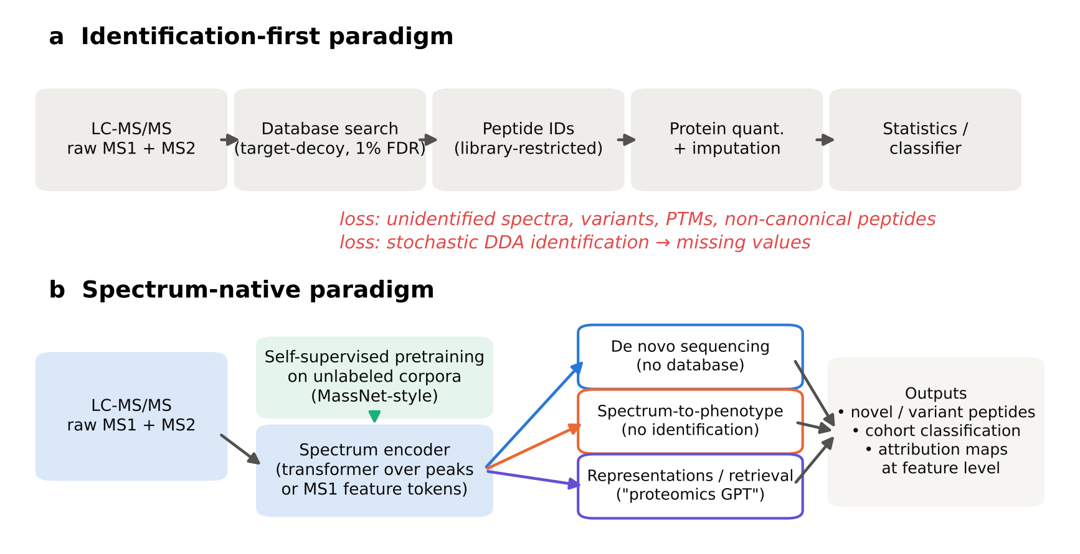
Fig. 1. From identification-first to spectrum-native proteomics. (a) The classical workflow loses unidentified spectra, variants, PTMs and non-canonical peptides at the search step, and creates missing values through stochastic DDA identification. (b) Spectrum-native models share an encoder that may be pretrained on unlabeled corpora and support database-free sequencing, identification-free phenotype prediction and representation learning.
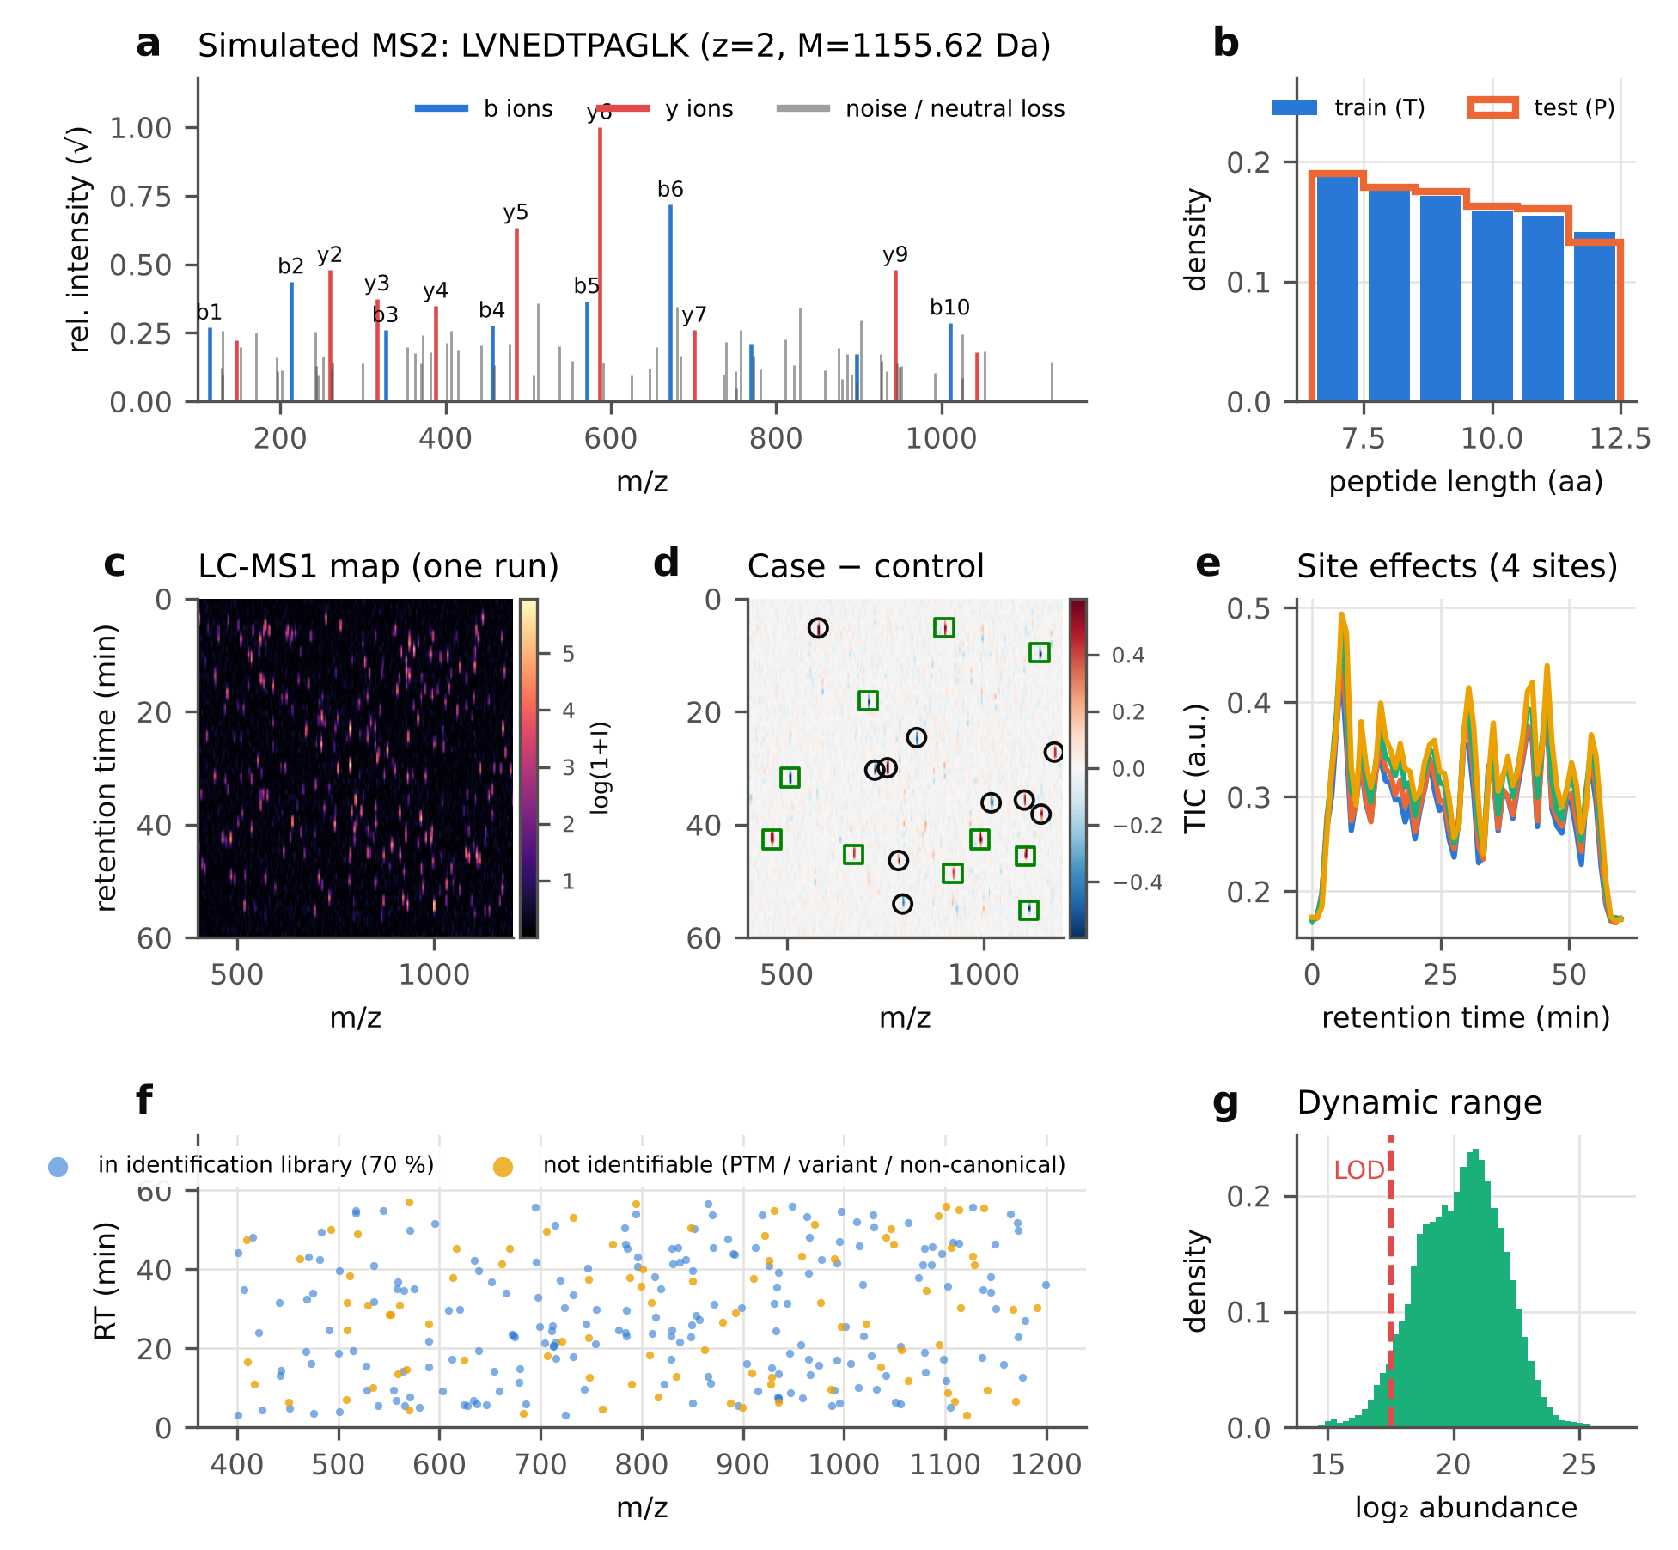
Fig. 2. The virtual instrument. (a) Simulated MS2 spectrum of LVNEDTPAGLK with annotated b (blue) and y (red) ions; grey, noise and neutral-loss peaks. (b) Peptide-length distributions of training (proteome T) and test (proteome P) spectra. (c) Rendered LC-MS1 map of one run (64 RT × 256 m/z bins). (d) Mean case − control difference map; circles, library biomarkers; squares, unidentifiable biomarkers. (e) Total-ion chromatograms of the four acquisition sites. (f) MS1 feature landscape coloured by identifiability. (g) Abundance distribution and limit of detection (LOD).
Table 1. Benchmark corpora generated by the virtual instrument.
Corpus / set | Source | Spectra | Unique peptides | Condition
Training | proteome T (3,000 proteins) | 250,000 | 73,126 | p_{obs} ∼ U(0.55, 0.95), λ ∼ U(10, 100)
Validation | proteome T | 2,000 | – | p_{obs} = 0.80, λ = 40
inDB | proteome P (in database) | 3,000 | 3,000 | p_{obs} = 0.80, λ = 40
SAAV | P + single AA variant | 1,500 | 1,500 | p_{obs} = 0.80, λ = 40
novel | proteome N (not in DB) | 1,500 | 1,500 | p_{obs} = 0.80, λ = 40
Robustness ×8 | proteome P | 8 × 1,000 | – | p_{obs} ∈ {0.95, 0.80, 0.65, 0.50}; λ ∈ {10,40,100,200}
Search database | proteome P targets (+Met-ox) | – | 45,779 | + equal number of reversed decoys
MS1 cohorts | 300 features, 4 sites | 800 unlabeled + 384 labelled + 500 test runs / seed | – | 20 biomarkers, absolute log₂FC 0.26–0.44
Table 2. Model and training configurations.
Item | SpecNovo | FeatureFormer
Input | ≤ 80 peaks (m/z, √I) + precursor (M, z) | 300 aligned MS1 features (value or missing)
Embedding | sinusoidal m/z (λ 10⁻³–10⁴ Da) + complementary m/z + intensity | feature ID + 0.1·sin(m/z, RT) + value × w_j (FT-style)
Encoder | 3 × pre-norm transformer, d = 128, 4 heads, FF 512 | 2 × pre-norm transformer, d = 64, 4 heads, FF 128
Decoder / head | 3-layer autoregressive decoder + prefix/residual mass + ion-evidence MLP (8→32→1) | [CLS] logit + zero-initialised additive token evidence
Parameters | 1.44 M | 0.14 M
Objective | cross-entropy, label smoothing 0.05 | SSL: masked-intensity MSE (30 %); fine-tune: cross-entropy, smoothing 0.1
Optimiser | AdamW, lr 5 × 10⁻⁴ (3 × 10⁻⁴ for evidence stage), cosine, batch 128 | AdamW, one-cycle, lr 10⁻³ (head) / 2 × 10⁻⁴ (body), batch 32, 150 steps
Inference | beam K = 5, precursor-mass constraint 0.05 Da | single forward pass
Hardware | 3 CPU threads; final model ≈ 1.45 h wall-clock (mass-aware + evidence stages) | 1 CPU thread per seed
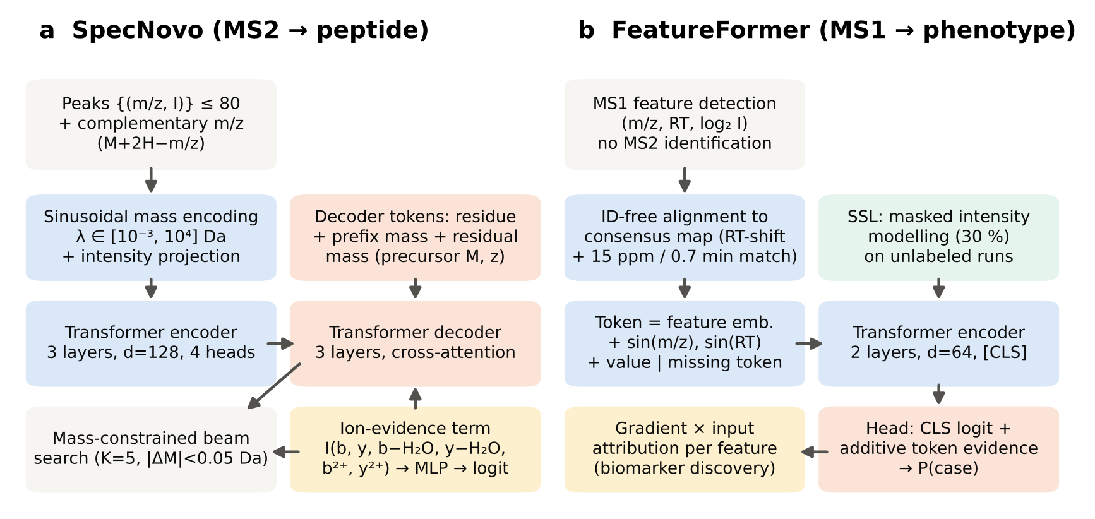
Fig. 3. Model architectures. (a) SpecNovo encodes peaks and their complementary masses, decodes residues conditioned on prefix and residual mass, and adds a differentiable ion-evidence logit; decoding is mass-constrained. (b) FeatureFormer tokenises identification-free MS1 features, is pretrained by masked-intensity modelling on unlabeled runs and fine-tuned for phenotype; gradient × input yields feature-level attributions.

Database-free sequencing recovers peptides that database search cannot
On canonical peptides, target–decoy database search was essentially perfect: recall 0.999 at 1 % FDR, with 0.03 % false identifications (Table 3, Fig. 4c). This is the regime for which identification-first proteomics was designed. Introducing a single amino-acid variant, or drawing peptides from a proteome absent from the database, reduced database-search recall to 0.000 (Table 3). Target–decoy competition correctly rejected the near-miss target matches, so no false identifications passed 1 % FDR; but every variant and novel peptide was lost.
Both de novo methods were, as expected, insensitive to database membership. SpecNovo recall was 0.416, 0.389 and 0.387, and spectrum-graph recall 0.475, 0.475 and 0.468, on the canonical, SAAV and novel sets respectively.
At full coverage the classical spectrum-graph algorithm had higher peptide recall and amino-acid precision (0.834 vs 0.687 on inDB). SpecNovo, however, produced better-ranked confidence scores, with precision–coverage AUC of 0.663 vs 0.630 (Fig. 4b). Its precision was higher whenever predictions were filtered by confidence:
Coverage (inDB) | SpecNovo precision | Spectrum-graph precision
10 % | 0.874 | 0.801
25 % | 0.787 | 0.716
50 % | 0.660 | 0.612
The same held for SAAV spectra, where precision at 10 % coverage was 0.905 vs 0.743. In practice, this is the regime that matters for database-free discovery, where only high-confidence de novo calls are followed up.
Table 3. Database-dependent and database-free peptide identification.
Test set | Method | AA precision | AA recall | Peptide recall | PR-AUC | False IDs (1 % FDR)
inDB | DB-search | – | – | 0.999 | – | 0.000
inDB | SpectrumGraph-DP | 0.834 | 0.876 | 0.475 | 0.630 | –
inDB | SpecNovo | 0.687 | 0.698 | 0.416 | 0.663 | –
SAAV | DB-search | – | – | 0.000 | – | 0.000
SAAV | SpectrumGraph-DP | 0.835 | 0.877 | 0.475 | 0.615 | –
SAAV | SpecNovo | 0.670 | 0.684 | 0.389 | 0.646 | –
novel | DB-search | – | – | 0.000 | – | 0.000
novel | SpectrumGraph-DP | 0.832 | 0.876 | 0.468 | 0.622 | –
novel | SpecNovo | 0.670 | 0.684 | 0.387 | 0.634 | –
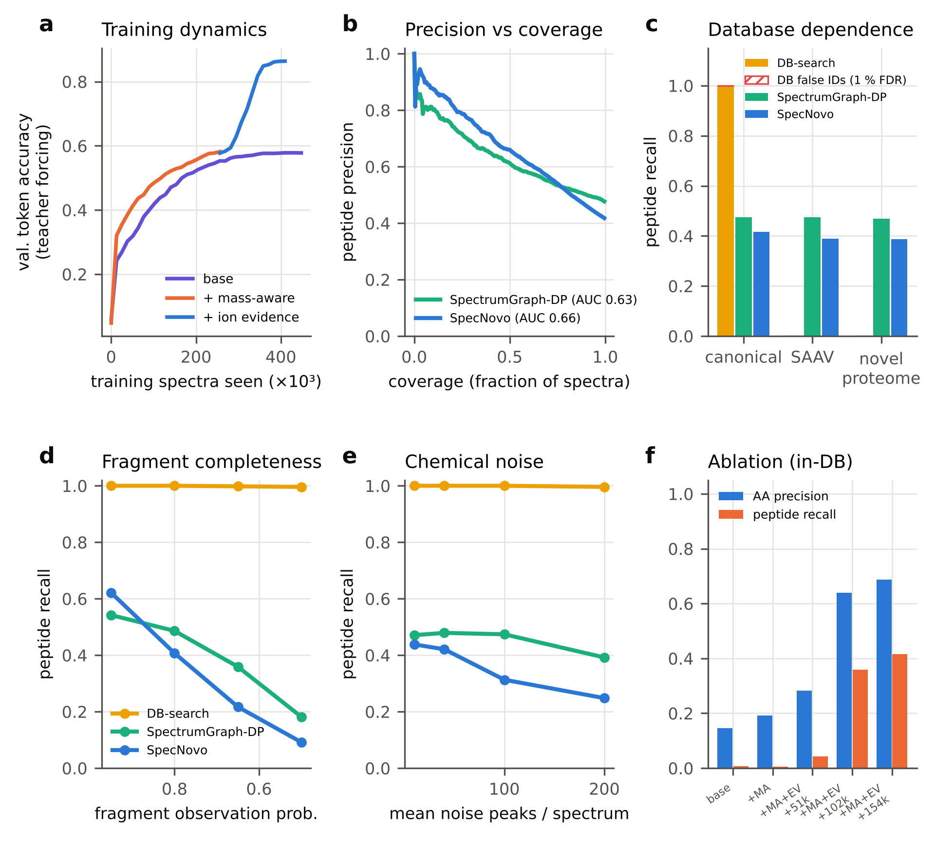
Fig. 4. De novo sequencing benchmark. (a) Validation token accuracy (teacher forcing) as a function of training spectra for the base transformer, the mass-aware variant and the ion-evidence variant (initialised from the mass-aware checkpoint). (b) Peptide precision–coverage curves on inDB. (c) Peptide recall of database search, spectrum-graph DP and SpecNovo on canonical, SAAV and novel-proteome spectra; hatched, database false identifications at 1 % FDR. (d, e) Peptide recall versus fragment observation probability and chemical-noise peaks. (f) Ablation: amino-acid precision and peptide recall on inDB; MA, mass-aware; EV, ion evidence; +Nk, additional training spectra.

Inductive biases, not capacity, determine data efficiency
The ablation (Table 5, Fig. 4a,f) is the most instructive result of this study. A standard Casanovo-style encoder–decoder reached a teacher-forced validation token accuracy of 0.578 after 448k training spectra. Under mass-constrained beam search, however, it achieved only 0.8 % peptide recall and 0.146 amino-acid precision. Inspection of greedy decodes showed that the model had learned the sequence prior (C-terminal K/R, residue frequencies) but very little of the spectrum: the decodes were plausible tryptic peptides that did not explain the observed peaks.
Complementary-ion encoding and prefix/residual-mass conditioning accelerated early learning (token accuracy 0.386 vs 0.303 at 38k spectra) but saturated at the same level (0.582). Adding the differentiable ion-evidence term broke this plateau within 1,200 further optimisation steps. Token accuracy rose to 0.674, 0.849 and 0.864 after 51k, 102k and 154k additional spectra, and peptide recall rose to 4.3 %, 35.9 % and 41.6 %. The total budget (410k spectra, ≈ 1.45 h of wall-clock time on three CPU threads) is two orders of magnitude below that used to train published de novo transformers (e.g., 30 M spectra for Casanovo [9]). The ablation therefore quantifies how much a physics-informed prior substitutes for data. It also explains why repository-scale corpora are a precondition for purely data-driven “proteomics GPTs”.
Table 5. Ablation of SpecNovo inductive biases on the inDB test set (beam K = 5).
Variant | Training spectra | Val. token acc. (TF) | AA precision | AA recall | Peptide recall | PR-AUC
Base transformer | 448k | 0.578 | 0.146 | 0.216 | 0.008 | 0.036
+ complementary ions & prefix-mass decoding | 256k | 0.582 | 0.192 | 0.214 | 0.005 | 0.021
+ ion-evidence term (+400 steps) | 307k | 0.674 | 0.282 | 0.305 | 0.043 | 0.123
+ ion-evidence term (+800 steps) | 358k | 0.849 | 0.639 | 0.656 | 0.359 | 0.598
+ ion-evidence term (+1,200 steps, final) | 410k | 0.864 | 0.687 | 0.698 | 0.416 | 0.663

Robustness: where classical algorithms still win
Fragment completeness was the dominant factor (Table 4, Fig. 4d). With nearly complete ladders (p_{obs} = 0.95), SpecNovo outperformed the spectrum graph: peptide recall 0.621 vs 0.542, PR-AUC 0.840 vs 0.693. Below p_{obs} ≈ 0.9 the ranking reversed, and at p_{obs} = 0.5 SpecNovo recalled 9.2 % of peptides against 18.2 % for the spectrum graph. SpecNovo was also more sensitive to chemical noise (Fig. 4e). From λ = 10 to 200 noise peaks its recall fell from 0.438 to 0.248, while the spectrum graph fell only from 0.471 to 0.392.
Database search was robust to both perturbations (≥ 0.996), confirming that the hard part of de novo sequencing is the missing information, not the spectrum quality per se. These results mark the current limits of small spectrum-native models. More training data that covers sparse and noisy spectra, or hybrid models that combine learned scoring with exhaustive graph search, are the obvious next steps.
Table 4. Robustness to fragment completeness and chemical noise (1,000 spectra per condition).
Condition | DB-search pep. recall | SpectrumGraph-DP pep. recall | SpecNovo pep. recall | DP AA prec. | SpecNovo AA prec. | DP PR-AUC | SpecNovo PR-AUC
p_{obs} = 0.95 | 1.000 | 0.542 | 0.621 | 0.865 | 0.808 | 0.693 | 0.840
p_{obs} = 0.80 | 1.000 | 0.486 | 0.407 | 0.841 | 0.679 | 0.623 | 0.640
p_{obs} = 0.65 | 0.998 | 0.359 | 0.217 | 0.776 | 0.533 | 0.504 | 0.440
p_{obs} = 0.50 | 0.996 | 0.182 | 0.092 | 0.655 | 0.393 | 0.312 | 0.216
λ = 10 | 1.000 | 0.471 | 0.438 | 0.844 | 0.707 | 0.619 | 0.669
λ = 40 | 1.000 | 0.479 | 0.421 | 0.836 | 0.673 | 0.641 | 0.686
λ = 100 | 1.000 | 0.474 | 0.313 | 0.833 | 0.625 | 0.620 | 0.535
λ = 200 | 0.996 | 0.392 | 0.248 | 0.784 | 0.526 | 0.540 | 0.495

Learned representations and peak-level attribution
We tested whether the SpecNovo encoder learns peptide identity without being trained to do so. We generated 12 independent noisy replicate spectra for each of 40 test peptides (p_{obs} = 0.75, λ = 60) and compared mean-pooled encoder embeddings with 0.5 Da binned spectra (Fig. 5a–c, Table 8).
The encoder embedding grouped replicates more compactly: cosine silhouette 0.273 vs 0.222. Its top-1 replicate retrieval (0.908) was slightly below that of binned spectra (0.996). In simulation, replicate spectra share exact fragment m/z values, which favours binned matching; on real data with calibration drift, learned embeddings such as GLEAMS [19] are expected to have the advantage.
Gradient × input attribution showed that SpecNovo bases its predictions on genuine fragment ions (Fig. 5d,e). Annotated b/y-family ions carried 42.2 % of the total intensity but received 80.0 % of the attribution mass, and attribution exceeded the intensity share in 299 of 300 spectra. The model therefore actively down-weights noise peaks, an interpretable behaviour that classical intensity-weighted scores do not provide.
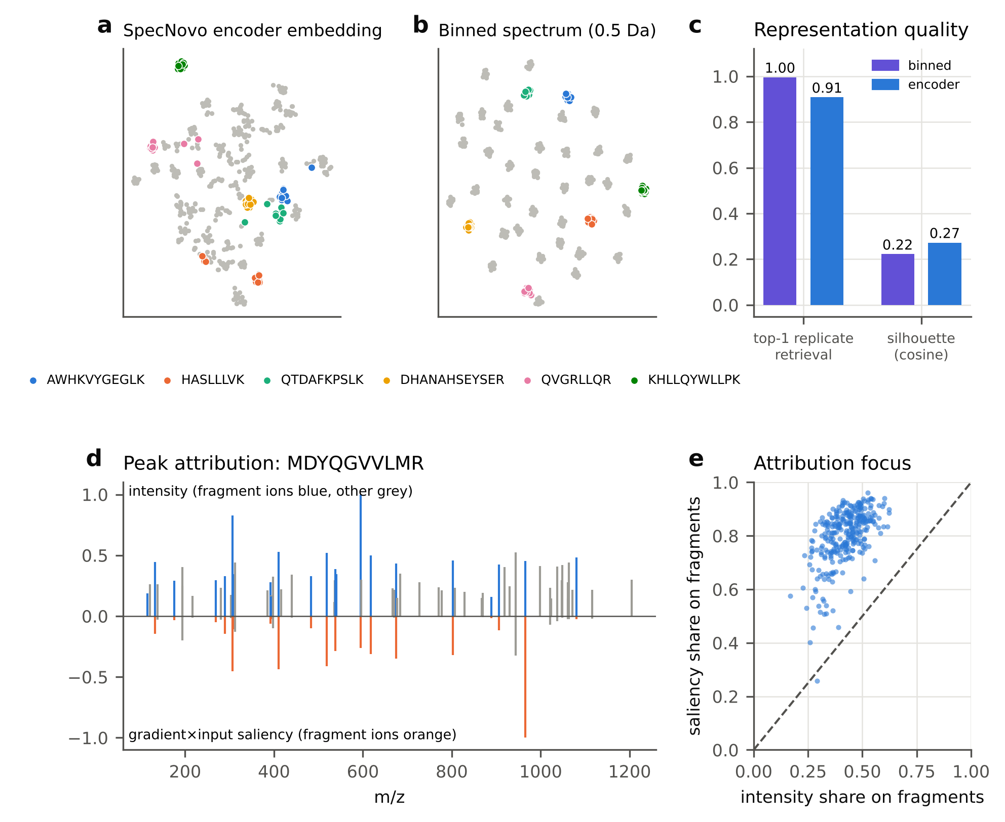
Fig. 5. Representations and interpretability of SpecNovo. (a, b) t-SNE of 480 replicate spectra (40 peptides × 12) using encoder embeddings (a) or binned spectra (b); six peptides highlighted. (c) Top-1 replicate retrieval and cosine silhouette. (d) Example spectrum: intensity (top; fragment ions blue) and gradient × input saliency (bottom; fragment ions orange). (e) Saliency share versus intensity share on annotated fragment ions for 300 inDB spectra; dashed line, identity.
Table 8. Representation quality, interpretability and compute.
Analysis | Metric | Value
Replicate retrieval (40 peptides × 12 spectra) | top-1 accuracy, encoder embedding | 0.908
 | top-1 accuracy, binned spectrum (0.5 Da) | 0.996
 | silhouette (cosine), encoder | 0.273
 | silhouette (cosine), binned | 0.222
Peak attribution (300 inDB spectra) | mean saliency share on annotated fragment ions | 0.800
 | mean intensity share on annotated fragment ions | 0.422
Inference cost | CPU seconds per 1,000 spectra (beam K=5, 2 threads) | 155
Feature attribution (seed 0, n = 384) | AUROC of abs(grad × input) for true biomarkers | 0.622
 | AUROC of Welch t-test −log10 p (ID-free matrix) | 1.000

Spectrum-to-phenotype: removing the identification bottleneck
The same theme dominated the MS1 experiments, at the cohort level (Table 6, Fig. 6). With half of the biomarkers unidentifiable, the identification-first pipeline reached AUROC 0.558 with 24 labelled runs and 0.672 with 384 (Fig. 6a). Two losses compound here: unidentified biomarkers, and 25 % missing values from stochastic DDA identification, which minimum-value imputation turns into noise.
Match-between-runs (MBR) recovered the missing-value loss but not the unidentified biomarkers (0.932 at n = 192). The identification-free linear model, which uses all aligned features, was best at every label budget: 0.820 at n = 24, 0.975 at n = 192 and 0.981 at n = 384. The ProFormer-style FeatureFormer improved substantially on identification-first statistics (0.767 vs 0.648 at n = 192; 0.802 vs 0.672 at n = 384). At these sample sizes it did not reach the identification-free linear model, because the simulated phenotype signal is additive and linear models are near-optimal for it.
Self-supervised masked-intensity pretraining on 800 unlabeled runs did not improve in-distribution accuracy (0.714 vs 0.767 at n = 192). It did improve transfer to an unseen acquisition site: leave-one-site-out AUROC rose from 0.651 ± 0.087 to 0.728 ± 0.054, with lower variance (Fig. 6b). Identification-free features also transferred best overall (0.986 ± 0.012), because ID-free RT-shift alignment absorbs site-specific chromatographic drift.
Table 6. Spectrum-to-phenotype AUROC (mean ± s.d. over three seeds; 500 test runs; 50 % of biomarkers unidentifiable).
Method | n = 24 | n = 48 | n = 96 | n = 192 | n = 384 | LOSO (unseen site)
ID-first-LR | 0.558 ± 0.050 | 0.587 ± 0.034 | 0.606 ± 0.007 | 0.648 ± 0.013 | 0.672 ± 0.040 | 0.627 ± 0.034
ID-first+MBR-LR | 0.660 ± 0.070 | 0.818 ± 0.031 | 0.864 ± 0.005 | 0.932 ± 0.020 | 0.945 ± 0.021 | 0.942 ± 0.019
ID-free-LR | 0.820 ± 0.046 | 0.903 ± 0.003 | 0.942 ± 0.017 | 0.975 ± 0.015 | 0.981 ± 0.015 | 0.986 ± 0.012
FeatureFormer | 0.661 ± 0.041 | 0.695 ± 0.023 | 0.693 ± 0.044 | 0.767 ± 0.037 | 0.802 ± 0.018 | 0.651 ± 0.087
FeatureFormer+SSL | 0.593 ± 0.026 | 0.652 ± 0.042 | 0.674 ± 0.020 | 0.714 ± 0.015 | 0.737 ± 0.025 | 0.728 ± 0.054
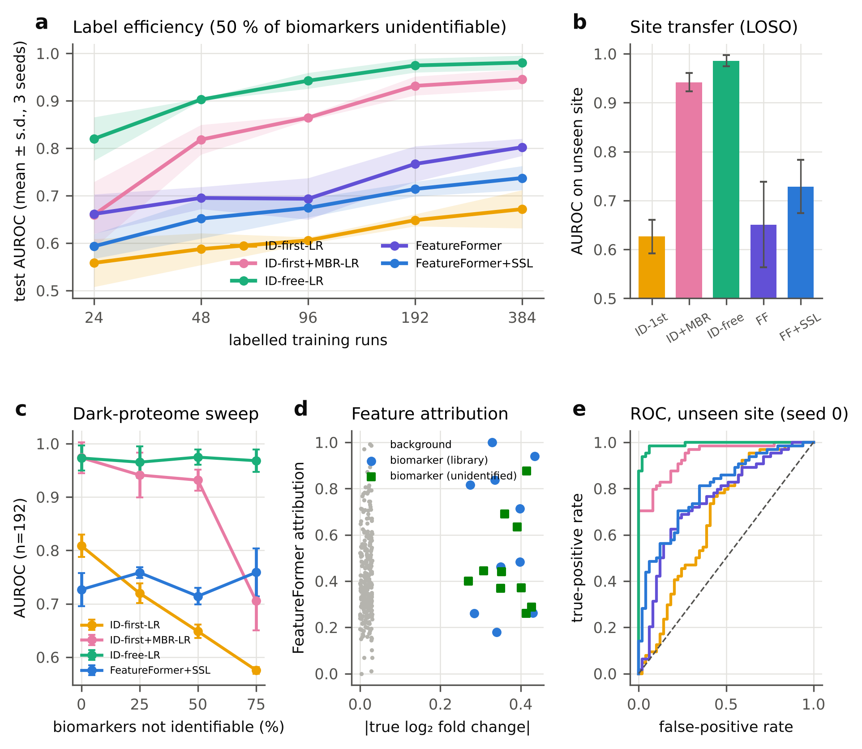
Fig. 6. Spectrum-to-phenotype benchmark. (a) Test AUROC versus number of labelled runs (mean ± s.d., three seeds; 50 % of biomarkers unidentifiable). (b) Leave-one-site-out AUROC on an unseen acquisition site. (c) AUROC (n = 192) versus fraction of biomarkers not identifiable by MS2 search. (d) FeatureFormer gradient × input attribution versus true effect size; library (circles) and unidentifiable (squares) biomarkers. (e) ROC curves on the unseen site (seed 0; colours as in a).

The dark-proteome sweep quantifies information loss
Varying the fraction of unidentifiable biomarkers from 0 % to 75 % separated the pipelines cleanly (Table 7, Fig. 6c). Identification-free linear models were invariant to identifiability (0.973 → 0.968). Identification-first AUROC declined monotonically (0.808 → 0.575), approaching chance once three quarters of the biomarkers were dark. MBR matched identification-free performance while most biomarkers were identifiable (0.973 at 0 %) but collapsed at 75 % (0.705 ± 0.055). FeatureFormer+SSL was likewise invariant to identifiability (0.714–0.759), confirming that it uses unidentified signal, but it remained limited by sample size.
Feature attribution recovered true biomarkers above chance (AUROC 0.622), including unidentifiable ones (Fig. 6d). However, a Welch t-test on identification-free features ranked all 20 biomarkers above all background features (AUROC 1.000). For biomarker discovery in additive settings, simple statistics on identification-free features therefore remain the reference against which deep attribution must be judged.
Table 7. AUROC (n = 192) as a function of the fraction of biomarkers that are not identifiable by MS2 database search.
Method | 0 % | 25 % | 50 % | 75 %
ID-first-LR | 0.808 ± 0.021 | 0.720 ± 0.019 | 0.648 ± 0.013 | 0.575 ± 0.006
ID-first+MBR-LR | 0.973 ± 0.029 | 0.941 ± 0.042 | 0.932 ± 0.020 | 0.705 ± 0.055
ID-free-LR | 0.973 ± 0.024 | 0.965 ± 0.029 | 0.975 ± 0.015 | 0.968 ± 0.021
FeatureFormer+SSL | 0.727 ± 0.031 | 0.758 ± 0.010 | 0.714 ± 0.015 | 0.759 ± 0.045

Discussion
The move from identification-first to spectrum-native proteomics is often framed as a contest between classical algorithms and deep learning. The controlled measurements here suggest a more useful framing: identification is an information bottleneck, and the main gains come from removing that bottleneck. The choice of model class matters less.
On the MS1 side, the bottleneck alone accounts for a 0.33 AUROC difference at n = 192 (0.648 vs 0.975), and it grows with the size of the dark proteome. This mirrors the ProFormer observation that identification-free MS1 classification is both faster and more accurate than interpretation-based workflows [17]. It also explains why match-between-runs is so valuable in practice [2]: MBR recovers the missing values, but not the biomarkers that were never identified.
On the MS2 side, database search remains unbeatable for canonical peptides but recovers nothing beyond its database. De novo sequencing provides access to variant and novel sequences at a fixed, database-independent rate, which matters for immunopeptidomics, metaproteomics, antibody sequencing and proteogenomic variant detection [9,10].
The second lesson concerns data efficiency. A generic sequence-to-sequence transformer trained on ≈ 0.45 M spectra learned a sequence language model but not spectrum interpretation, and was useless under mass-constrained decoding. A small, physics-informed ion-evidence term, analogous to the ion-location features of DeepNovo [15] and to pairwise mass-difference attention [13], made the same architecture competitive within a few hundred additional optimisation steps.
This result is directly relevant to the vision of proteomics GPTs trained on MassNet-style corpora. Corpus scale and inductive bias are substitutes, and at the scales available to most laboratories, inductive bias is cheaper. Conversely, the gap between our CPU-scale model and published models trained on tens of millions of spectra [9,10] is consistent with data scaling, not architectural limits, being the main driver of state-of-the-art de novo accuracy.
Third, self-supervised pretraining is not a free lunch at small scale. Masked-intensity pretraining on 800 unlabeled runs did not improve in-distribution phenotype prediction, but it consistently improved cross-site transfer and reduced variance. This pattern is expected if pretraining learns site-invariant co-abundance structure rather than phenotype-specific signal. It suggests that the payoff of corpus-scale pretraining will appear first in robustness and transfer across instruments, laboratories and cohorts.
Limitations. All conclusions are drawn from simulation. The virtual instrument omits several features of real data:
- fragment-intensity patterns learned from real data (e.g., Prosit or AlphaPeptDeep [20,21]);
- chimeric and DIA spectra;
- isotope and charge-state ambiguity in precursor selection;
- non-tryptic peptides;
- PTMs other than Met oxidation;
- non-additive biology.
The phenotype signal was deliberately additive, which favours linear models. Training budgets were limited to a few CPU-hours, and the SSL corpus contained 800 runs, far from repository scale. The spectrum-graph baseline is a simplified re-implementation, not a production de novo engine.
These choices are intentional: they make every quantity measurable and every experiment reproducible on a laptop. They also mean that the absolute numbers should not be compared with real-data benchmarks. Future work should:
- calibrate the simulator against real PSMs (e.g., MassIVE-KB [7]);
- add DIA multiplexing;
- benchmark published models (Casanovo, InstaNovo, ProFormer) inside the same controlled environment;
- scale SSL corpora by orders of magnitude.

Conclusions
We have provided a reproducible, ground-truth benchmark of the transition from identification-first to spectrum-native proteomics, with measurements of what each paradigm gains and loses:
- Sequencing. Database search is exact but blind beyond its database. Database-free transformer sequencing becomes viable only with physics-informed inductive biases at modest data scales, offers the best-calibrated confidence, and still trails classical graph search on sparse or noisy spectra.
- Phenotype. Removing identification is the dominant effect, and transformer classifiers and self-supervised pretraining add robustness rather than accuracy at cohort sizes of a few hundred.
These measurements support continued investment in large, shared, machine-learning-ready spectral corpora, and in hybrid models that unite learned representations with the physics of peptide fragmentation.

Data and code availability
All source code (simulator, models, baselines, evaluation and figure scripts), result files (JSON/pickle), trained model checkpoints and figures are available in the project repository (spectrum_native_proteomics/). Every experiment is reproducible on a CPU with Python ≥ 3.11, PyTorch ≥ 2.0, NumPy, SciPy, scikit-learn, pyteomics and matplotlib, using the commands listed in the repository README.

Funding
Not applicable.

Conflict of interest
The author declares no competing interests.

Author contributions
M.N.A.: conceptualisation, methodology, software, investigation, formal analysis, visualisation, writing — original draft, review and editing.

References
- Aebersold R, Mann M. Mass-spectrometric exploration of proteome structure and function. Nature 2016;537:347–355. doi:10.1038/nature19949
- Cox J, Mann M. MaxQuant enables high peptide identification rates, individualized p.p.b.-range mass accuracies and proteome-wide protein quantification. Nat Biotechnol 2008;26:1367–1372. doi:10.1038/nbt.1511
- Elias JE, Gygi SP. Target-decoy search strategy for increased confidence in large-scale protein identifications by mass spectrometry. Nat Methods 2007;4:207–214. doi:10.1038/nmeth1019
- Lazar C, Gatto L, Ferro M, et al. Accounting for the multiple natures of missing values in label-free quantitative proteomics data sets to compare imputation strategies. J Proteome Res 2016;15:1116–1125. doi:10.1021/acs.jproteome.5b00981
- Mann M, Kumar C, Zeng WF, Strauss MT. Artificial intelligence for proteomics and biomarker discovery. Cell Syst 2021;12:759–770. doi:10.1016/j.cels.2021.06.006
- Perez-Riverol Y, Bai J, Bandla C, et al. The PRIDE database resources in 2022: a hub for mass spectrometry-based proteomics evidences. Nucleic Acids Res 2022;50:D543–D552. doi:10.1093/nar/gkab1038
- Wang M, Wang J, Carver J, et al. Assembling the community-scale discoverable human proteome. Cell Syst 2018;7:412–421. doi:10.1016/j.cels.2018.08.004
- Vaswani A, Shazeer N, Parmar N, et al. Attention is all you need. Adv Neural Inf Process Syst 2017;30:5998–6008.
- Yilmaz M, Fondrie WE, Bittremieux W, et al. Sequence-to-sequence translation from mass spectra to peptides with a transformer model. Nat Commun 2024;15:6427. doi:10.1038/s41467-024-49731-x
- Eloff K, Kalogeropoulos K, Mabona A, et al. InstaNovo enables diffusion-powered de novo peptide sequencing in large-scale proteomics experiments. Nat Mach Intell 2025;7:565–579. doi:10.1038/s42256-025-01019-5
- Yang T, Ling T, Sun B, et al. Introducing π-HelixNovo for practical large-scale de novo peptide sequencing. Brief Bioinform 2024;25:bbae021. doi:10.1093/bib/bbae021
- Lee S, Kim H. Bidirectional de novo peptide sequencing using a transformer model. PLoS Comput Biol 2024;20:e1011892. doi:10.1371/journal.pcbi.1011892
- Lapin J, Nilsson A, Wilhelm M, Käll L. Pairwise attention: leveraging mass differences to enhance de novo sequencing of mass spectra. J Proteome Res 2025;24:3722–3730. doi:10.1021/acs.jproteome.5c00063
- Ebrahimi S, Guo X. Transformer-based de novo peptide sequencing for data-independent acquisition mass spectrometry. Proc IEEE Int Symp Bioinformatics Bioeng 2023:28–35. doi:10.1109/bibe60311.2023.00013
- Tran NH, Zhang X, Xin L, Shan B, Li M. De novo peptide sequencing by deep learning. Proc Natl Acad Sci USA 2017;114:8247–8252. doi:10.1073/pnas.1705691114
- Qiao R, Tran NH, Xin L, et al. Computationally instrument-resolution-independent de novo peptide sequencing for high-resolution devices. Nat Mach Intell 2021;3:420–425. doi:10.1038/s42256-021-00304-3
- Krull KK, Kühn A, Höhn J, et al. ProFormer: generalizable classification of single-cell and plasma proteomes using deep learning. Nat Commun 2026;17. doi:10.1038/s41467-026-78143-2
- Qiu S, Hu Y, Liu J, Wang Y. Proformer: a multimodal proteomics transformer model for multidisease early risk assessment. Brief Bioinform 2025;26:bbaf686. doi:10.1093/bib/bbaf686
- Bittremieux W, Avtonomov DM, Arora J, et al. Learned embeddings from deep learning to visualize and predict protein sets (GLEAMS). Nat Methods 2022;19:675–678. doi:10.1038/s41592-022-01496-1
- Gessulat S, Schmidt T, Zolg DP, et al. Prosit: proteome-wide prediction of peptide tandem mass spectra by deep learning. Nat Methods 2019;16:509–518. doi:10.1038/s41592-019-0426-7
- Zeng WF, Zhou XX, Willems S, et al. AlphaPeptDeep: a modular deep learning framework to predict peptide properties for proteomics. Nat Commun 2022;13:7238. doi:10.1038/s41467-022-34904-3
- Gorishniy Y, Rubachev I, Khrulkov V, Babenko A. Revisiting deep learning models for tabular data. Adv Neural Inf Process Syst 2021;34:18932–18943.
- Devlin J, Chang MW, Lee K, Toutanova K. BERT: pre-training of deep bidirectional transformers for language understanding. Proc NAACL-HLT 2019:4171–4186.
- He K, Chen X, Xie S, et al. Masked autoencoders are scalable vision learners. Proc IEEE/CVF CVPR 2022:16000–16009.
- Dančík V, Addona TA, Clauser KR, Vath JE, Pevzner PA. De novo peptide sequencing via tandem mass spectrometry. J Comput Biol 1999;6:327–342. doi:10.1089/106652799318300
- Ma B, Zhang K, Hendrie C, et al. PEAKS: powerful software for peptide de novo sequencing by tandem mass spectrometry. Rapid Commun Mass Spectrom 2003;17:2337–2342. doi:10.1002/rcm.1196
- Shrikumar A, Greenside P, Kundaje A. Learning important features through propagating activation differences. Proc ICML 2017;70:3145–3153.
- van der Maaten L, Hinton G. Visualizing data using t-SNE. J Mach Learn Res 2008;9:2579–2605.
- Paszke A, Gross S, Massa F, et al. PyTorch: an imperative style, high-performance deep learning library. Adv Neural Inf Process Syst 2019;32:8024–8035.
- Pedregosa F, Varoquaux G, Gramfort A, et al. Scikit-learn: machine learning in Python. J Mach Learn Res 2011;12:2825–2830.

