Intelligent Account Servicing Workflow (IASW)

Solution Design and Implementation
(Github)

Nishaank Singh Rawat

1. Executive Summary
I built an agentic AI prototype that automates the bank's Maker role, which is the staff member who reads change-request documents, validates them against the customer's existing record, and stages the change for a supervisor, while keeping the human Checker as the only authority that can commit a change to the (mocked) core banking system.
The flow is end-to-end working. A staff member submits a Legal Name Change request via a Streamlit form and uploads a Marriage Certificate PDF. A four-node LangGraph pipeline runs: Validation confirms the customer exists in mock RPS, Extraction uses Claude Vision to read structured fields and three forgery heuristics in one call, Scoring combines a deterministic rapidfuzz name-match with Claude across five 0-5 dimensions, and Summary writes a one-paragraph review and a recommended action. The request is staged with status AI_VERIFIED_PENDING_HUMAN. The Checker reviews everything side-by-side with the document, types a reason, and clicks Approve. That click, and only that click, fires a single audited write against the mock RPS.
The most important architectural decision in the project is that the Human-in-the-Loop boundary is enforced at the import graph, not just at runtime. The single function that mutates the customer record lives in app/api/rps.py, which is imported by exactly one file (app/api/main.py) and called from exactly one handler.

2. Problem Understanding & Scope
Banks process thousands of customer change requests every day, like name changes, address updates, DOB corrections, contact details. Most of this is manual: a Maker reads scanned documents, types data into a form, and a Checker re-verifies the work before submission.
The brief is to replace the Maker with an AI agent while keeping the Checker. The hard constraint we have is: the AI must never write to the core banking system on its own. Every commit needs a human click.

Scope Chosen
I scoped the prototype down to one change type — Legal Name Change, supported by a Marriage Certificate, or other relevant documents. The brief explicitly prefers depth over breadth, and one well-implemented end-to-end flow exercises every piece of the architecture: multi upload, document store, agent pipeline, audit log, staged record, Checker UI, the HITL boundary, and the mock RPS write. Adding more change types is very simple and not more architectural depth — the rps.commit_change function already shows the dispatch pattern for the others, with NotImplementedError on the unimplemented branches so I'm honest about what's done.

Out of scope (deliberately)
- Real FileNet integration — mocked with a local-filesystem store-by-ref interface, this can be replaced by other systems very easily, and everything else is already setup to support it.
- Real RPS / core banking integration — mocked with a Postgres customers table, where SQLite could have been used but I wanted to show a production level setup.
- Authentication, RBAC, is not taken into account.
- Other change types beyond Legal Name (the dispatch shape is shown but the branches are unimplemented).
- Production hardening — async, retries, rate limits — are not covered

3. Solution Architecture
The system is five layers, each owning exactly one responsibility. Layers don't bypass each other: the API owns all writes to canonical tables, agents only write to the audit log, and the UI never talks to the database directly.
Layer | Responsibility | Implementation
Frontend | Capture intake; let checker review and decide. | Streamlit (multi-page)
API | Validates the inputs, orchestrates pipeline, gate the HITL boundary. | FastAPI
Agentic pipeline | Verify document, score confidence, summarise for human review. | LangGraph + Claude Sonnet 4.5
Data | Canonical Customer (mock RPS), pending requests, audit trail. | Postgres 16
Document store | Archive supporting docs, retrievable by reference. | Local filesystem (FileNet mock)

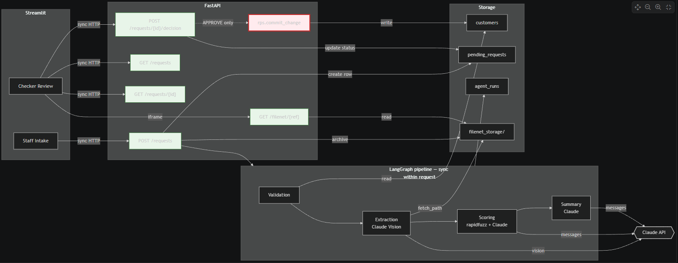

Why these tech choices
- FastAPI — async-first, automatic OpenAPI docs at /docs (auditable for free), and Pydantic integration that makes input validation very easy.
- SQLAlchemy 2.x - Modern, type-checkable, plays well with Pydantic at the API boundary.
- Postgres in Docker — I wanted the project to feel production ready from day one. SQLite would have been simpler for a prototype, but the DATABASE_URL env var keeps SQLite as a fallback if anyone wants it.
- LangGraph for orchestration. It compiles to a graph object I can render to Mermaid for the architecture doc — the diagram is generated from the actual code, not hand-drawn. Conditional edges and checkpointing are available if I extend the project later.
- Claude Sonnet 4.5 as the only LLM. Strong vision, strong reasoning, single vendor keeps the codebase simple. I use Claude Vision for OCR + extraction in one call instead of running Tesseract or Textract separately and then a second Claude call.
- Streamlit for the UI. For a two-role prototype it's the fastest path to something usable. The UI has zero business logic, every action is an HTTP call to FastAPI — so swapping it for React later would be a one-day job.
- structlog for observability. Every log line is one JSON record. I bind the request_id once at the start of an intake handler and every log line emitted downstream automatically carries it, so reconstructing a request's trace is a single grep.

Sync vs. async boundaries
The prototype runs everything synchronously inside one HTTP request. Submitting an intake blocks for 10–30 seconds while the pipeline runs. That's fine for a demo and dramatically simpler than the alternative. Production would move to a job queue and async response.

The HITL boundary — Three layers of enforcement
1. Physical separation. The only function in the codebase that mutates the Customer row lives in app/api/rps.py. Any future write path requires editing that file.
2. Single import site. app/api/main.py is the only file that imports app/api/rps.py. grep "from app.api import rps" returns one match. Adding a second importer is visible in code review.
3. Single call site. Within main.py, only the /decision handler calls rps.commit_change, gated behind body.decision == Decision.APPROVE. Pydantic validates the decision enum before the handler even runs.
Atomicity matters too: the customer mutation and the pending_requests status flip happen in the same SQLAlchemy session and commit together. Either both writes land or neither does. A crash mid-handler leaves the request in AI_VERIFIED_PENDING_HUMAN, so it is retryable, no half-state is assumed.

4. Agent Design & Prompt Engineering
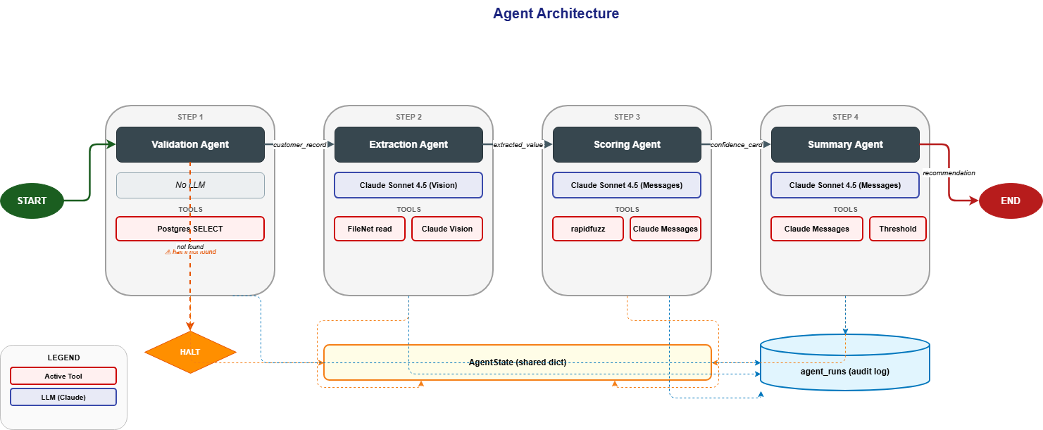
The pipeline is four nodes in a linear LangGraph state machine. Each node is a Python function that takes a shared AgentState dict and returns updates that LangGraph merges back. The state has three groups of fields: inputs (set once by the API), pipeline outputs (filled in node by node), and control fields which halt for short-circuit, errors are saved as a list-append reducer for accumulated failures.
Node | Reads from state | Tools / external | Writes to state
Validation | customer_id, change_type | Postgres SELECT | customer_record OR halt="CUSTOMER_NOT_FOUND"
Extraction | filenet_ref | FileNet read; Claude Vision (temp 0, max 2048) | extracted_value (7 fields), forgery_signals (3 × 0-5)
Scoring | requested_value, extracted_value, customer_record, forgery_signals | rapidfuzz token_set_ratio; Claude text (temp 0, max 1024) | confidence_card (5 dims × 0-5), overall_confidence ∈ [0, 1]
Summary | confidence_card, extracted_value, requested_value, overall_confidence | Claude text (temp 0.3, max 512); threshold compare in code | ai_summary (50-100 words), recommended_action

4.1 Validation Agent
Pure DB lookup, does not use LLM. Confirms the customer exists in mock RPS and loads their current record. If the customer doesn't exist, it sets state.halt = "CUSTOMER_NOT_FOUND" and downstream nodes early-return.

4.2 Extraction Agent
One Claude Vision call doing two jobs at once: structured field extraction (document type, bride name, groom name, married name, issue date, issuing authority, certificate number) and three forgery heuristics (visual quality, internal consistency, document structure), each scored 0–5 with reasoning. Splitting these into two Claude calls would double the cost and latency for no quality gain because the model is already looking at the image. Temperature is 0 for reproducibility; max tokens 2048 leaves headroom over the typical 500–800 token JSON output incase we need to add more fields later.

4.3 Scoring Agent (deliberately hybrid)
I compute a deterministic name-match ratio with rapidfuzz.token_set_ratio before calling Claude which is robust to spaces, reordering, and minor variants, and does the job of checking the validity of the names. That ratio is sent to Claude as a hint alongside the request, customer record, extracted fields, and forgery signals. Claude reasoning then produces five 0–5 scores with reasoning: name_match, document_type_relevance, document_authenticity, field_completeness, document_clarity.
Aggregation to overall_confidence ∈ [0, 1] is a Python weighted sum (0.30 / 0.20 / 0.20 / 0.15 / 0.15).
The weights are in code, not in the prompt. They're a product decision and so name match weighs most because it's the actual claim being verified, while authenticity is the fraud guard, completeness and clarity are additional sanity checks. Keeping them in code means I can tune them in the eval harness later without re-prompting, and a reviewer can audit the math line by line, since it is just a basic calc function.

4.4 Summary Agent
One Claude text call producing a 50–100 word paragraph aimed at the human Checker, plus a recommended action computed in code from overall_confidence against thresholds (APPROVE_THRESHOLD=0.85, REJECT_THRESHOLD=0.50).
The recommendation is not in the LLM's hands, hence keeping policy out of the prompt means the bank owns the threshold and can tune it without touching prompts. Temperature is 0.3 here (versus 0 elsewhere) because paraphrase tolerates and benefits from slight variation. The the audit log captures both input packet and output anyway.

4.5 Prompt design principles I applied
- System / user separation. Each prompt's fixed instructions live in the system message; per-request data goes in the user message. System messages are cacheable by Anthropic's prompt caching, and rubrics live in one place rather than spread all over in functions.
- In-prompt JSON schema + temperature 0. Each prompt embeds a literal JSON skeleton with field names and types. Combined with temperature=0, the output is effectively deterministic and parses on the first try. I added a defensive markdown-fence stripper for the rare case where Claude wraps JSON in fences anyway, to prevent incorrect inputs from going into the input or output fields.
- 0–5 rubric anchors. “5 = pristine, professionally printed; 3 = readable but degraded; 1 = barely readable” gives much more consistent scores than “score 0–5”. The model maps evidence to a specific rubric line, which is generally more accurate.
- Negative instructions. “Never invent values. Null is preferable. No prose, no markdown fences. Do not refuse the task.” These matter as much as positive instructions for keeping outputs clean.
- Calibration nudge. The scoring prompt ends with “Be conservative. The bank's reputation depends on you not rubber-stamping.” LLMs trained for helpfulness lean toward giving customers the benefit of the doubt; in a fraud-aware context I want the opposite bias.

4.6 Audit trail
Every node writes one row to agent_runs via the _agent_run context manager. Each row captures agent name, status (SUCCESS / ERROR / SKIPPED), input payload, output payload, error string if any, duration in milliseconds, and timestamp. A reviewer’s “what did agent X do for request Y at time T?” question becomes a single SQL query.

5. Assumptions, Constraints & Known Limitations
I've been very deliberate about what I implemented and what I left out.

Mocks
- FileNet is a local filesystem at ./filenet_storage/ with a UUID-keyed binary file plus a JSON metadata sidecar. The archive() / fetch_path() / fetch_bytes() / fetch_metadata() interface is what a real FileNet client would expose — swap is a one-day job.
- RPS is the Postgres customers table. The commit_change function maps 1:1 to what a real RPS client SDK call would be.
- Synthetic Marriage Certificate. I generate it via reportlab in samples/generate_sample_cert.py. It has the visual structure (header, particulars table, signature/seal block) the extraction prompt's heuristics expect, and is clearly labelled as synthetic so it can't be confused for a real document. I also later generated multiple Synthetic Certificates through Canva.

Stated assumptions
- Single change type implemented (LEGAL_NAME). The other three (ADDRESS, DATE_OF_BIRTH, CONTACT_EMAIL) raise NotImplementedError with the dispatch shape visible.
- Synchronous pipeline. The intake HTTP request blocks for 10–30 seconds while the four agents run. Acceptable for a prototype where the pipeline can be observed completing in real time.
- No authentication. Any browser hitting localhost:8501 can act as both Staff and Checker. There's no SSO, no role separation, no audit of who logged in.
- Drop-and-recreate seed script. python -m app.seed drops every table and recreates from Base.metadata. Fine for a prototype where the DB is throwaway.
- No retries / circuit-breakers around LLM calls. If Anthropic returns a 500, the pipeline errors and the request stays in PENDING_AI. The AgentRun audit row captures the failure for diagnosis.
- Forgery detection is heuristic. The three signals are useful proxies, not real fraud detection. A determined adversary with a Photoshopped certificate would likely pass these.
- Single Streamlit process. Both Staff and Checker pages run in the same Streamlit app — no isolation. For a demo this is fine.

6. Production Readiness — what's already here vs. what would change
I deliberately built this prototype with production patterns where they cost nothing extra, so the lift to a real deployment is a smaller and more focused list than it might appear.

Already production-shaped
- Layer separation. UI → API → Pipeline → Data → Storage. Each layer is replaceable without touching the others and is independent of each other.
- HITL boundary at the import graph. Survives refactors, visible at code review, doesn't require runtime checks to enforce.
- Pydantic validation at the API boundary. Bad inputs fail with 422 before reaching any handler. Constraints like min_length, enum membership, and field-level rules are declarative.
- Atomic transactions. The customer mutation and the pending_requests status flip commit in the same SQLAlchemy session. No partial writes possible.
- Postgres ENUM types for status fields — DB-level enforcement on top of application-level checks. An invalid status can't even reach the table.
- Structured JSON logging with request_id correlation. Every log line is grep-able and pipeable into any production aggregator (Splunk, CloudWatch, Loki, Datadog).
- 12-factor configuration. All settings come from environment. Pydantic-settings catches typos at startup.
- Pinned dependency versions. requirements.txt pins exact versions; builds are reproducible.
- Generated architecture diagram. The Mermaid in docs/architecture.md is rendered from the compiled LangGraph object diagram and code can't drift.
- Cacheable system prompts. System messages are separated from user messages so Anthropic prompt caching applies once we run at higher volume.
- Per-agent audit log. FK from agent_runs to pending_requests means reconstructing a request's full pipeline trace is a single SQL query.

What Can be change for a real production deployment
- Async pipeline + job queue. Intake returns a request_id immediately; pipeline runs in Celery / RQ / Temporal. UI polls or subscribes via WebSocket / SSE.
- Alembic migrations. Replace drop-and-recreate with incremental, version-controlled schema changes. Run migrations as part of deploy.
- Real document store. Swap app/filenet.py for a FileNet client or S3 with versioning, retention policies, and the bank's KMS keys.
- Managed Postgres. RDS / Cloud SQL with automated backups, point-in-time recovery, read replicas if the queue endpoint gets hot.
- LLM hardening. Retries with exponential backoff, circuit-breakers, JSON schema validation (jsonschema) on every LLM response, rate-limit awareness, fallback to a smaller model on timeout.
- Real fraud detection. Plug a dedicated forgery / liveness API (or in-house model) into the extraction node alongside the existing heuristics. The current three signals stay as cheap pre-filters.
- Richer observability. Langfuse for token-usage traces, OpenTelemetry for cross-service traces, dashboards in Grafana / Datadog. The structured JSON logs are already in the right shape.
- Eval harness. Golden test cases (clean docs, blurry docs, wrong-name docs, off-template docs) with pass/fail thresholds, run in CI on every change to prompts, weights, or models.
- Conditional LangGraph edges. Replace in-node halt checks with LangGraph conditional edges for cleaner skipping when validation fails.
- Multi-change-type support. Implement the ADDRESS / DATE_OF_BIRTH / CONTACT_EMAIL branches in rps.commit_change and add the corresponding intake form fields. The dispatch shape is already there.
- UI split. Separate Staff and Checker into two distinct apps so they can scale and authenticate independently.

