**Rollnumber:bsef17a557**

**OS _LAB1**

**QUESTION:1**

1:whoami is the command to see current user.

C:\Users\Adeel\Desktop\Capture1.PNG

2:To create file in tmp directory command used is “touch testingfile”.

C:\Users\Adeel\Desktop\Capture2.PNG

3:To see file type command used is “file testingfile”

C:\Users\Adeel\Desktop\Capture3.PNG

4:”rm” is the command to remove an empty file/directory while “rm –r” is used to delete non_empty,”rmdir” is used to delete empty directory

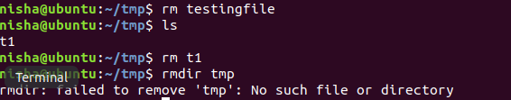

5:”cd” is the command to go to home directory

C:\Users\Adeel\Desktop\Capture5.PNG

6:command used to change the name is “mv tryit& tryit_now”

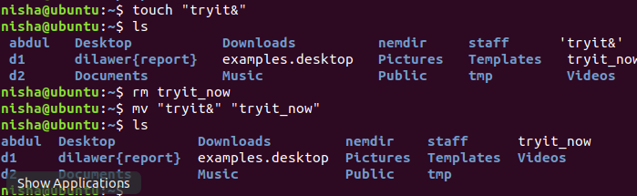

7: By changing myclear as clear it works the same as clear command.

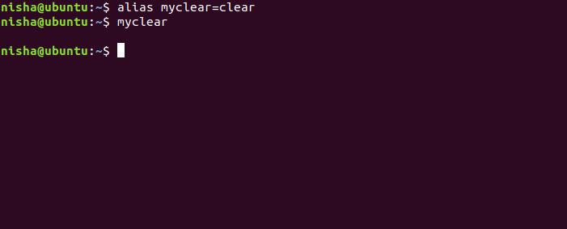

8:(a) If we assign cls clear command it works as same as clear and by assigning cls=ls then cls command work will like ls i-e: it shows all folders.

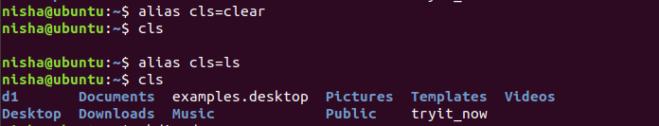

(b): mkdir d1 will create directry in home director then cd d1 will move into directory touch f1 f2 will create files in that directory then again a file then move to home directory then again it will not make the directory as it exists.

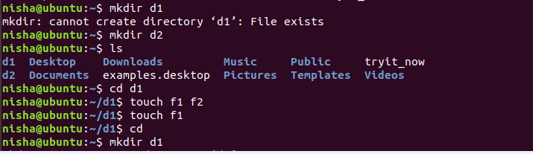

**Question :2**

1: “mkdir –p bsef17a557/{nisha/{os}}”

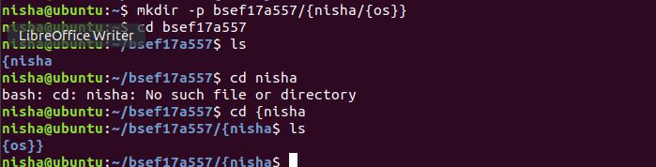

2: “ls –a”

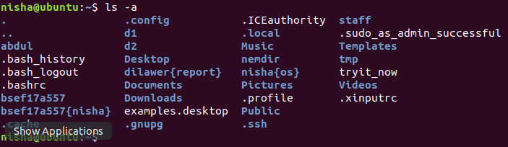

3:”rm –r bsef17a557”

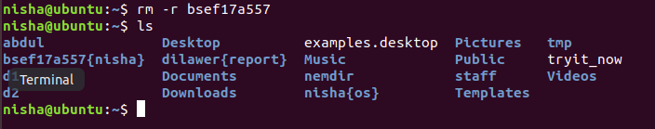

4: cd tmp

touch testfile

gedit testfile

cat –n testfile

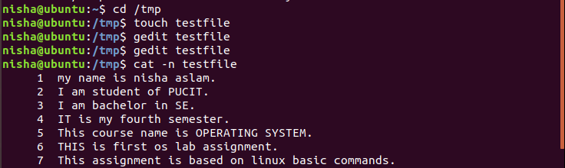

5: mv “testfile” “test@file!”

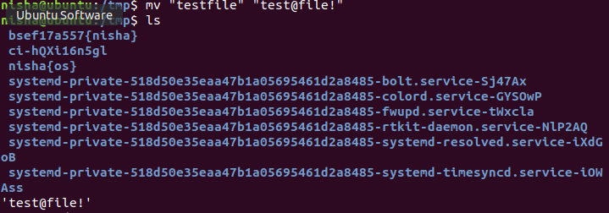

6: 

7: alias unleash=”ls –a”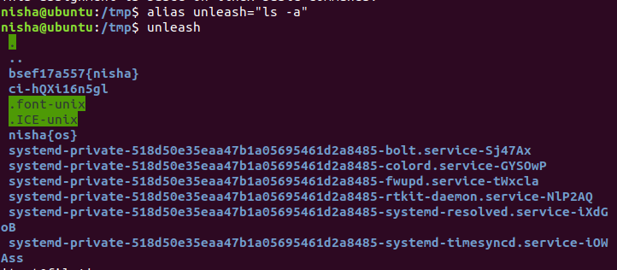

8:we use “man “ command

10:”rm –r” also used

C:\Users\Adeel\Desktop\Q2910.PNG

**QUESTION:3**

1: 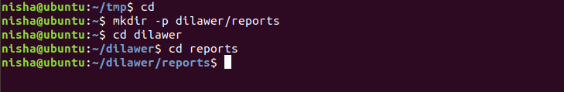

2: 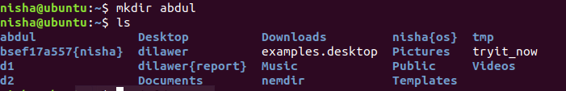

3: 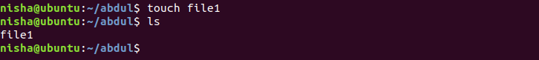

4:

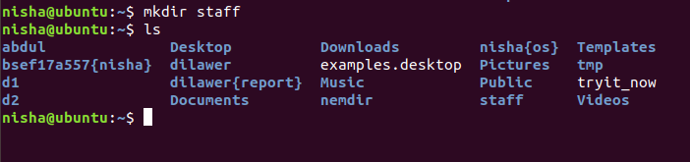

5:

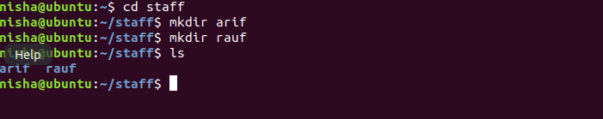

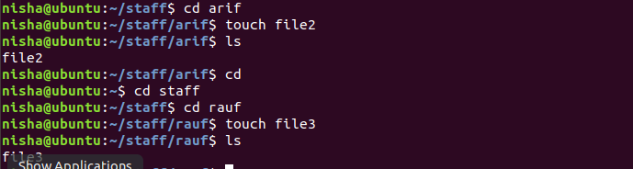

6:

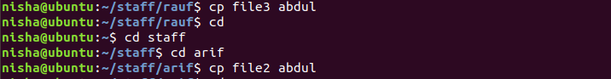

7: 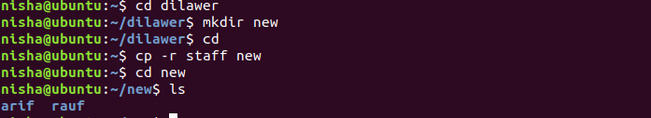

8:

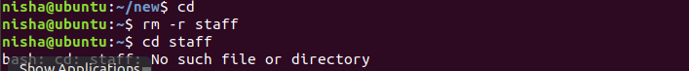

9:

