ROLL NUMBER:bsef17a557

OS_LAB2

QUESTION:1

A: Create a new user named Jamil using useradd command?

C:\Users\Adeel\Desktop\Capture11a.PNG

b) View the contents of the files /etc/passwd and /etc/shadow ?

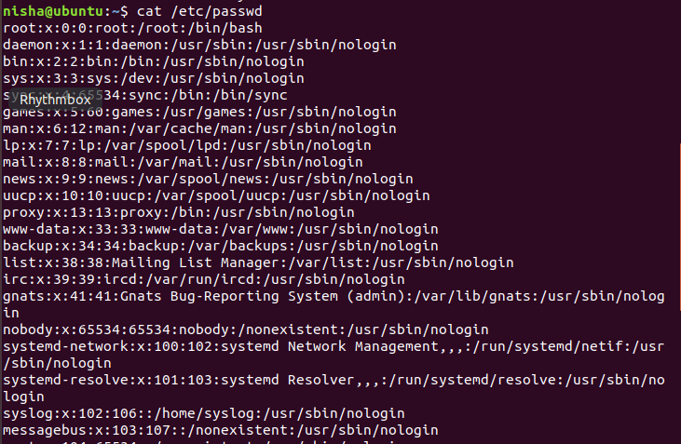



c) Now assign him a password “123456” ?

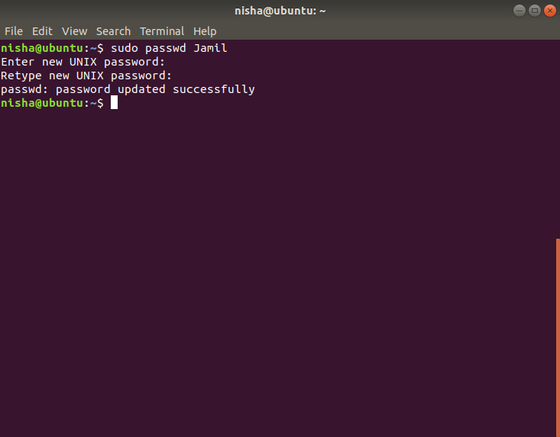

d) View the contents of the files /etc/passwd and /etc/shadow after creation of the account ?

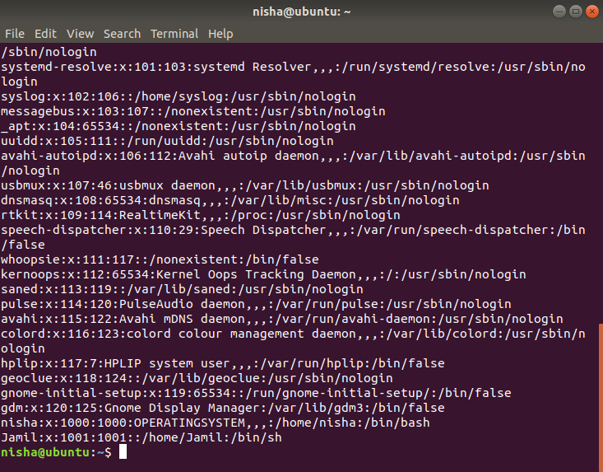

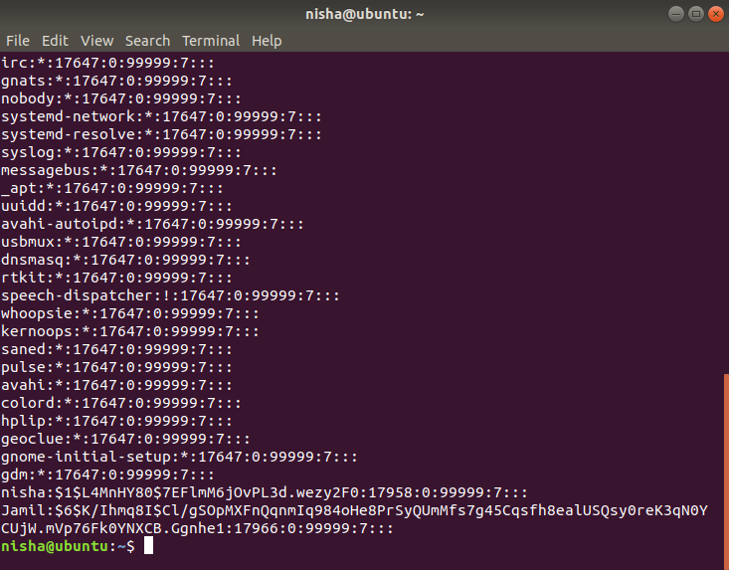

e) Now try logging as this user from another console.

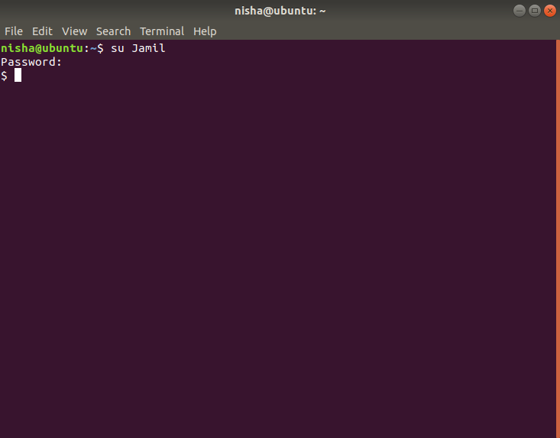

f) Display the default settings that will be given to a user when you create a new user with the useradd command

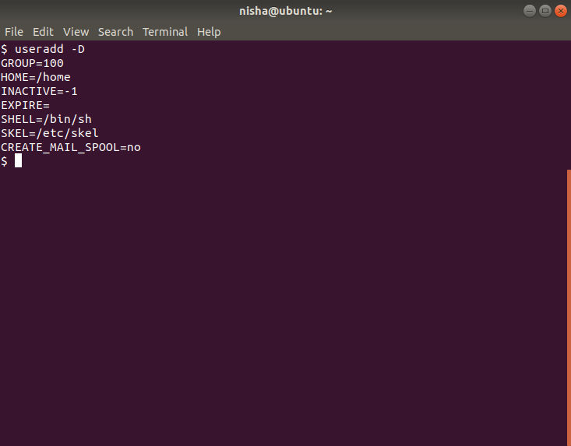

g) View the contents of the file /etc/default/useradd?

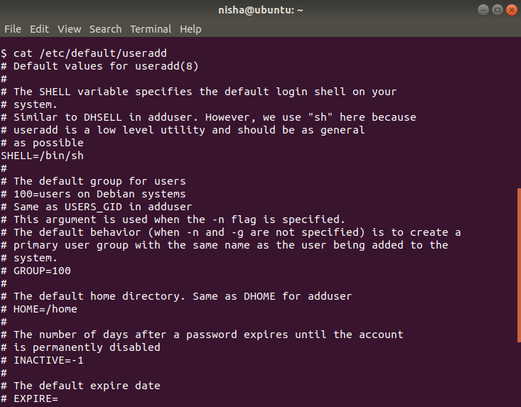

h) Login as root and try changing the password of Jamil from “123456” to “1” and try logging in again.

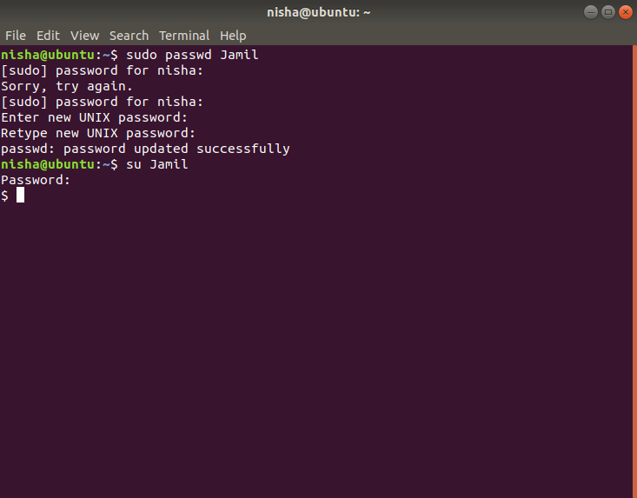

1. Login as Jamil and try changing his own password from “1” to “12345”or “Jamil”. What happened?

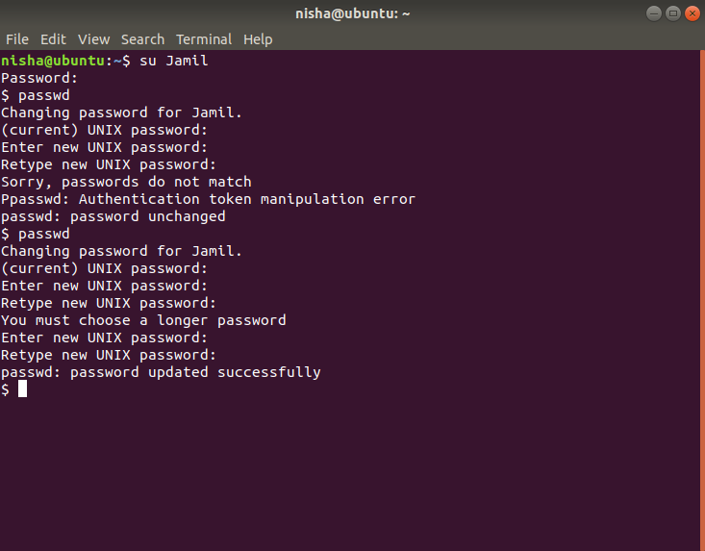

j) Change the personal information of Jamil using the chfn command. (Do it as root and then do it as

Jamil (note the diff).

C:\Users\Adeel\Desktop\1111.PNG

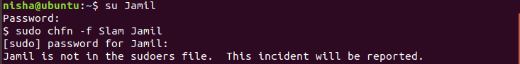

k) Now view the contents of /etc/passwd file

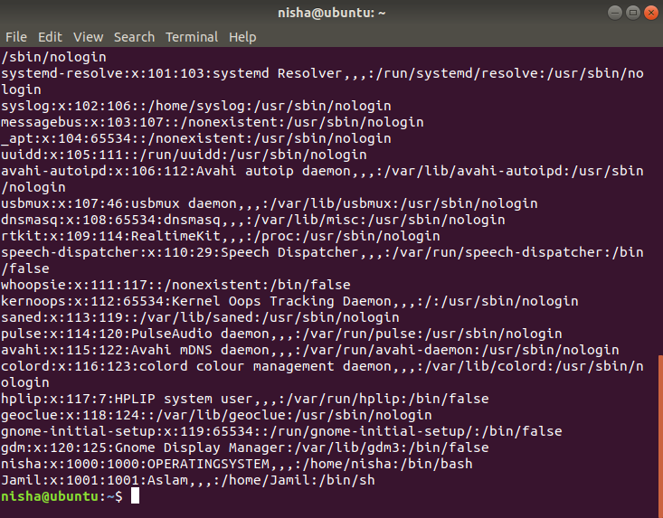

QUESTION:2

A:Write a command to lock the account of Jamil. (Confirm by trying to log in as Jamil, also view the contents of the file /etc/shadow).

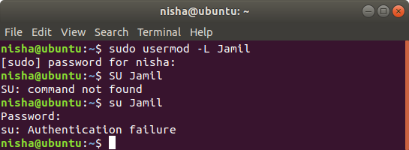

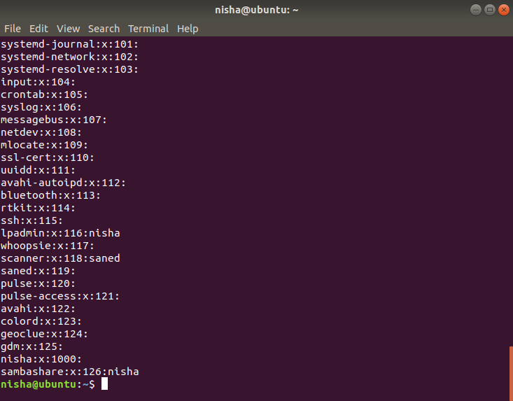

b) Now unlock Jamil. Confirm by trying to log in as Jamil, also view the contents of the file /etc/shadow.

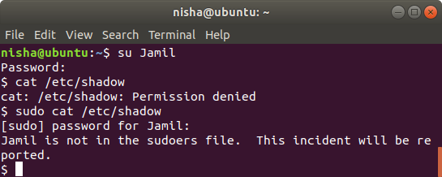

c) Delete the user Jamil, and then try logging in as Jamil.

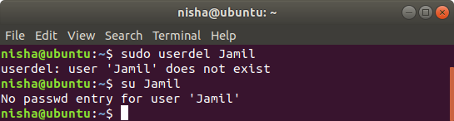

d) Check the home directory of Jamil in **/home**.

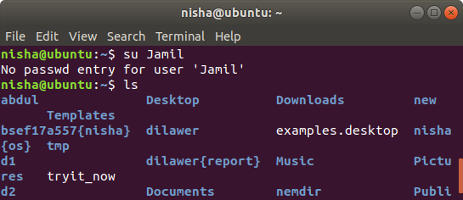

e) View the contents of /etc/passwd, /etc/shadow, and /etc/group files.

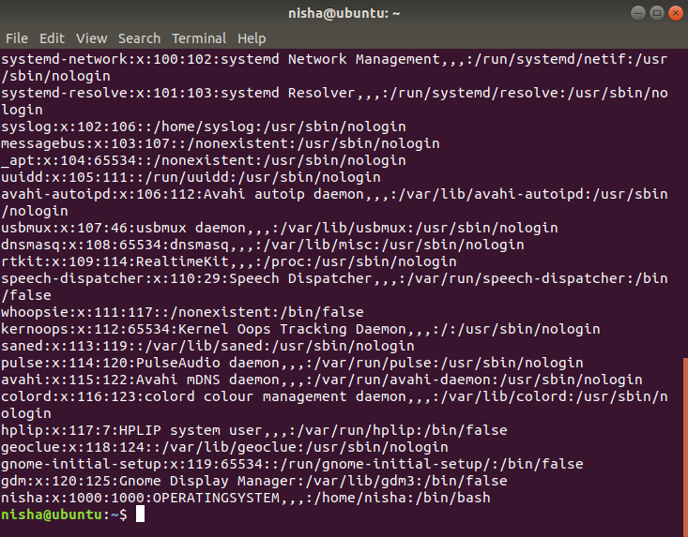

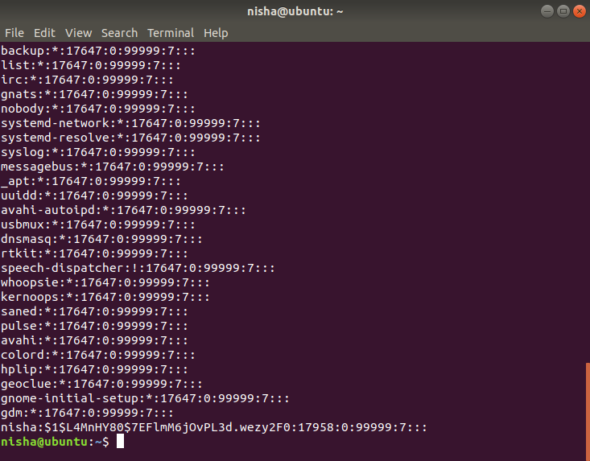

f) Change the name of user Jamil to Farhan.

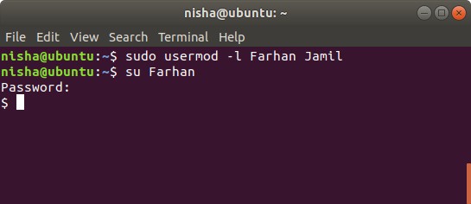

g) Try logging in as Jamil and then try to log on as Farhan. Use pwd command to check his home directory.

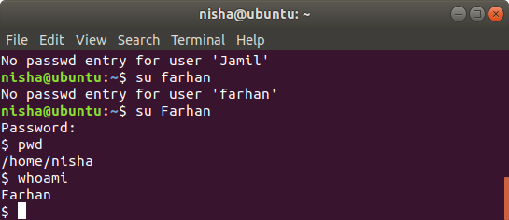

h) Log in as root and check the home directory of Farhan in **/home**.

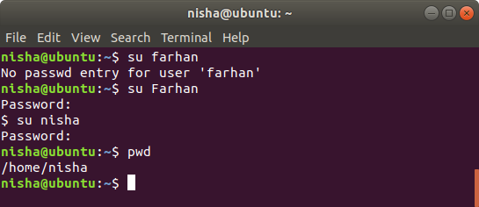

j) Delete the user Farhan by using the -r option you have created. After deletion check his home directory.

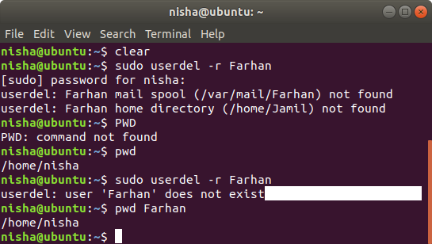

k) View the contents of /etc/passwd, /etc/shadow and /etc/group.

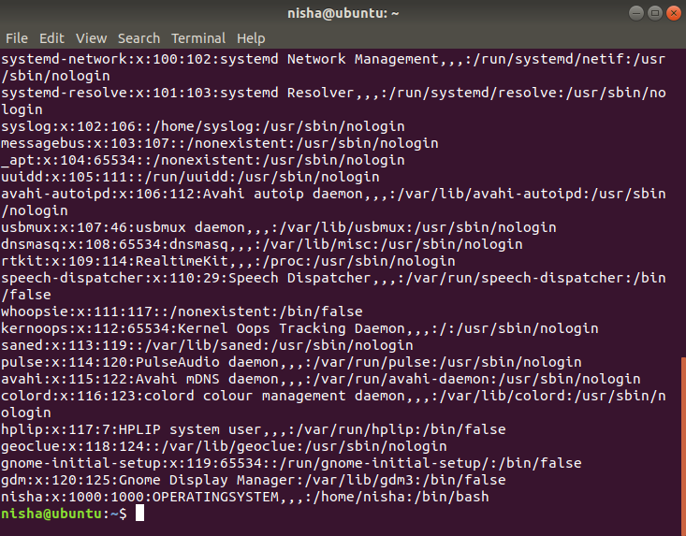

B)Now again try creating another user with the same name Mansoor. See what happens?

d) A user’s password related information is kept in /etc/shadow file. When you create a new user he is given the default password policies as per the configuration file /etc/login.defs. (View the file’s contents).

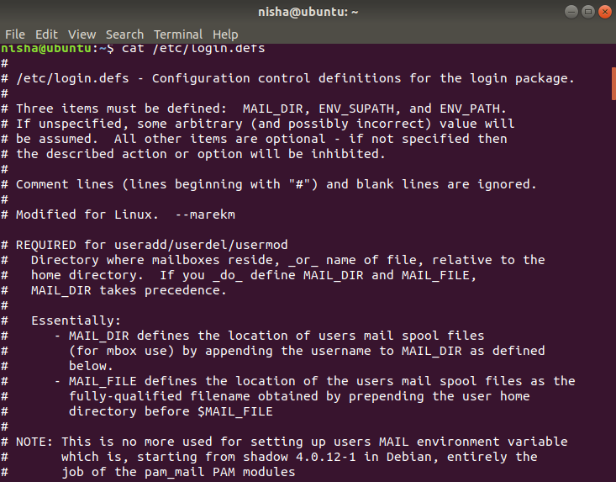

e) Now create a new user Jamal.

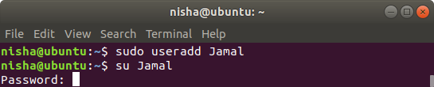

f) Display just the line associated with Jamalin the /etc/shadow file.

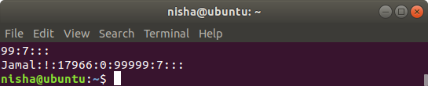

Question:4

1. Create a group with the names of sales the contents of /etc/group file after creating the group

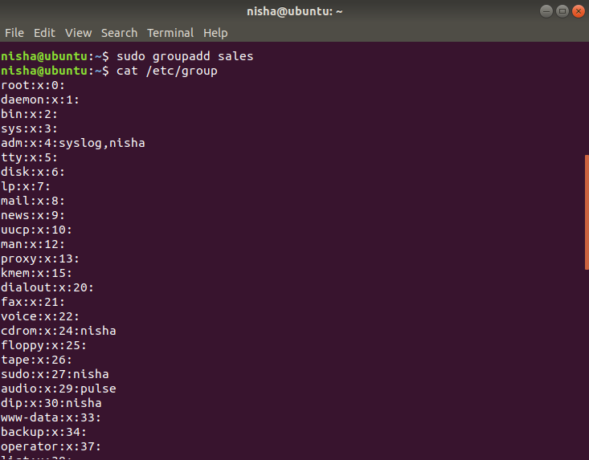

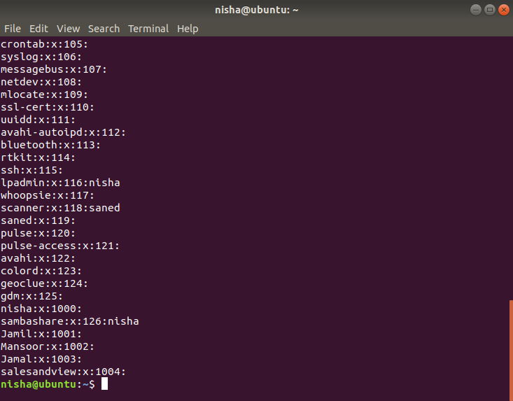

1. a) Create a group with the names of sales and view the contents of /etc/group file after creating the group

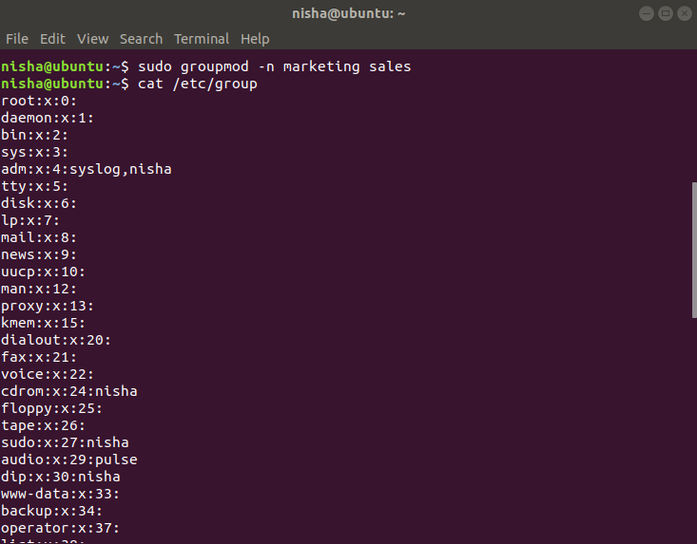

1. c) Delete the group and again view the /etc/groupfile.

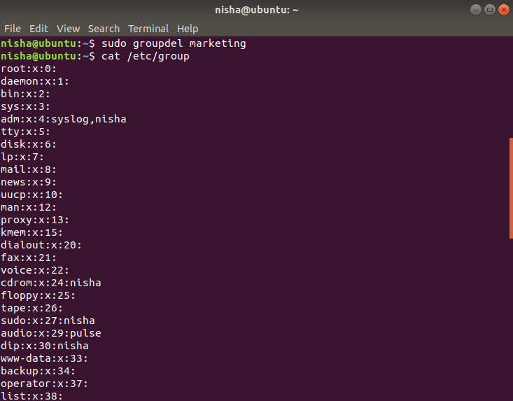

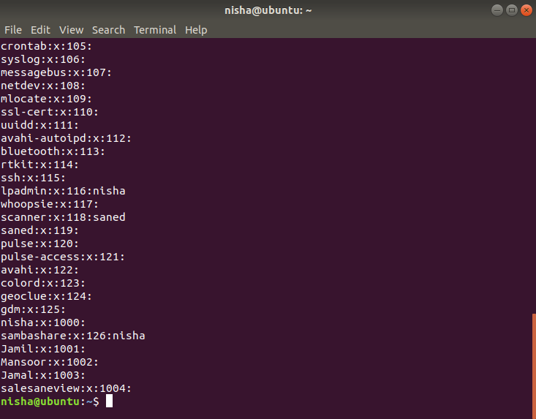

1. Create a new user named user1 and view the contents of /etc/passwd and /etc/group

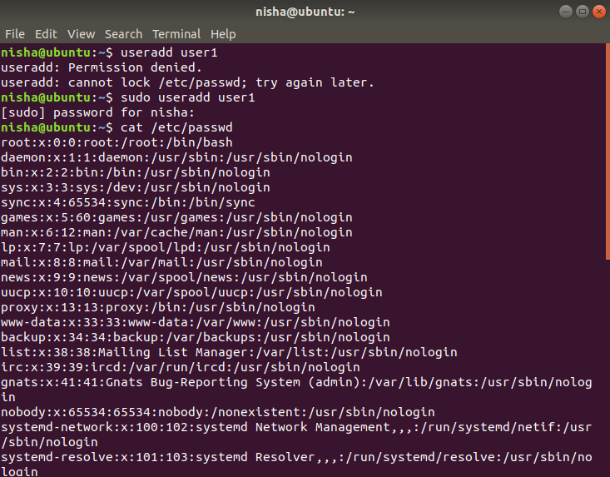

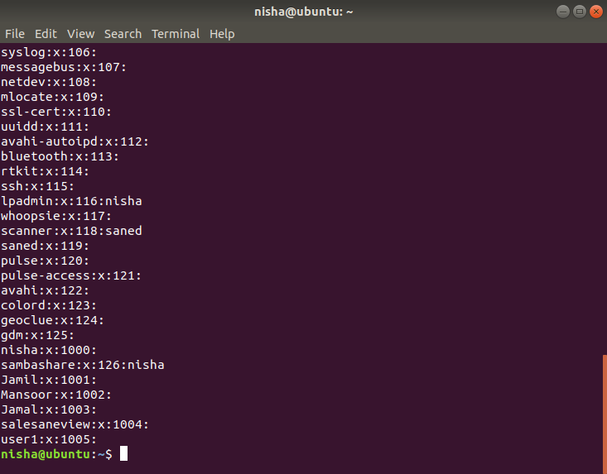

1. Try deleting the group user1; Oops! What happened & why it happened.

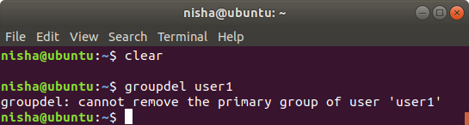

f) Create a group technology (view contents of /etc/group after creating group)

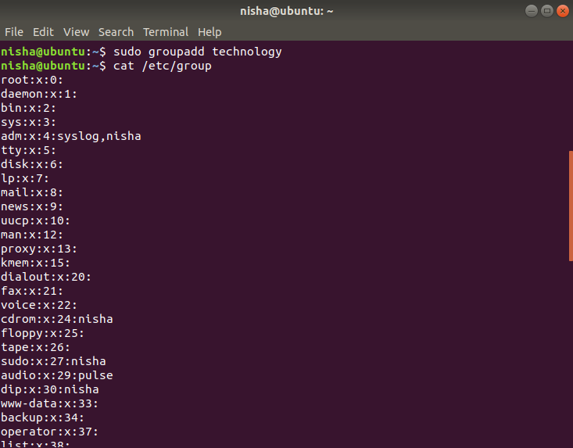

1. Create a new user Hadeed and after creation check his group information using id command

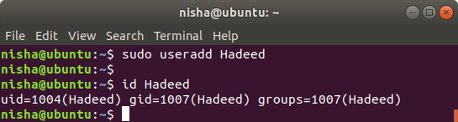

1. Make Hadeed a member of technology group. It should be his secondary group. (View contents of /etc/group again)



1. I)

Make Hadeed a member of technology group. It should be his secondary group. (View contents of /etc/group again) Now try deleting the group technology.

