* Create Table : Branch, Account holder and Loan

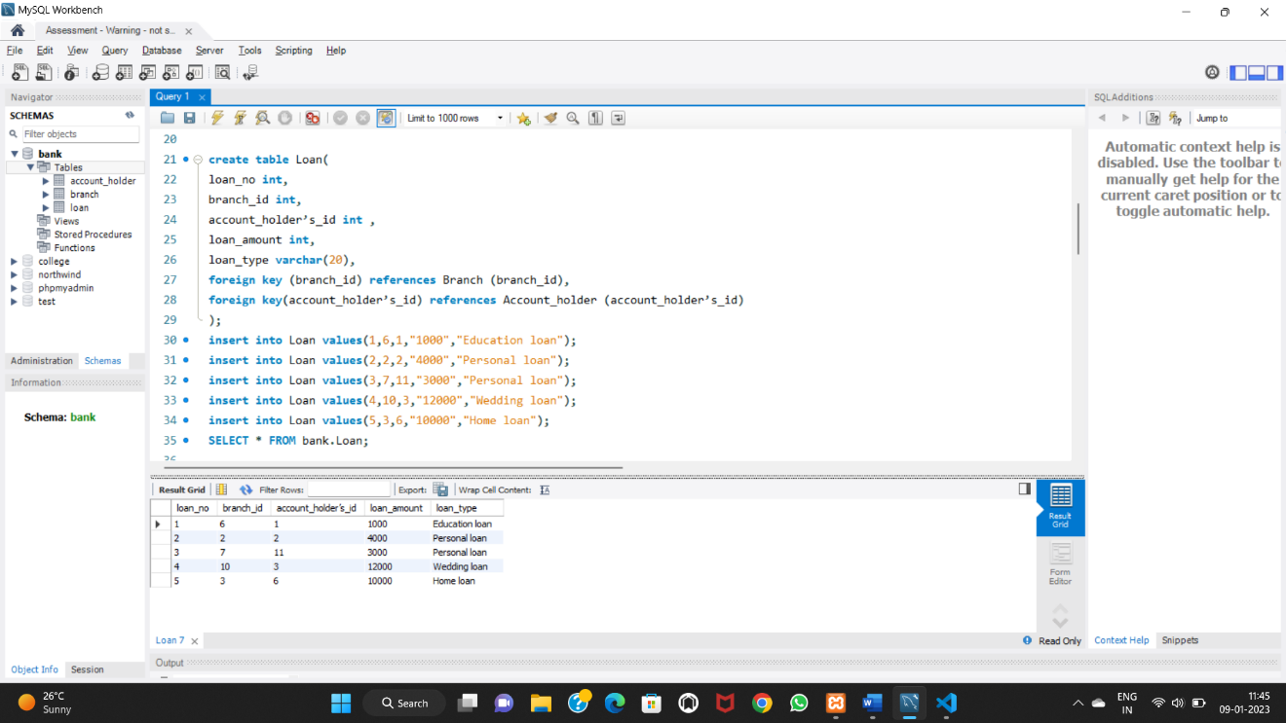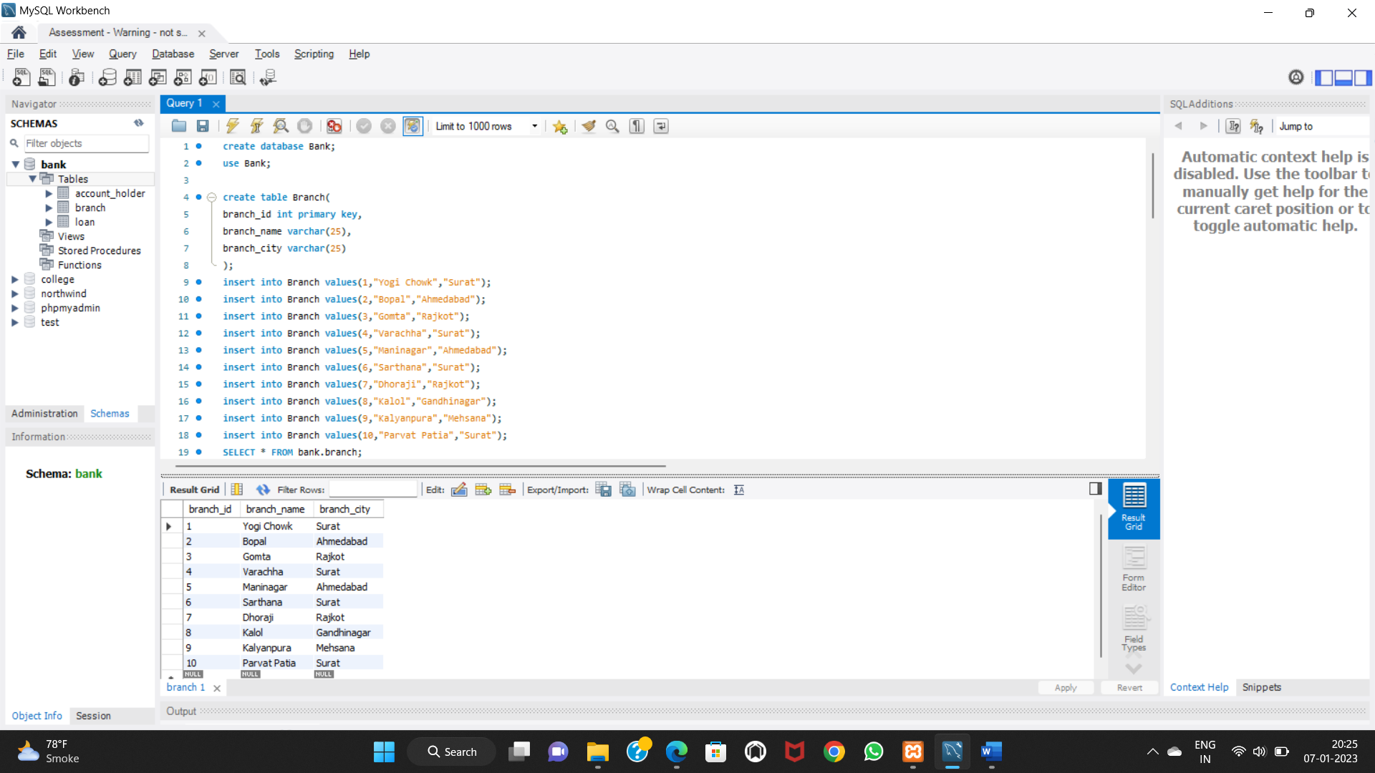

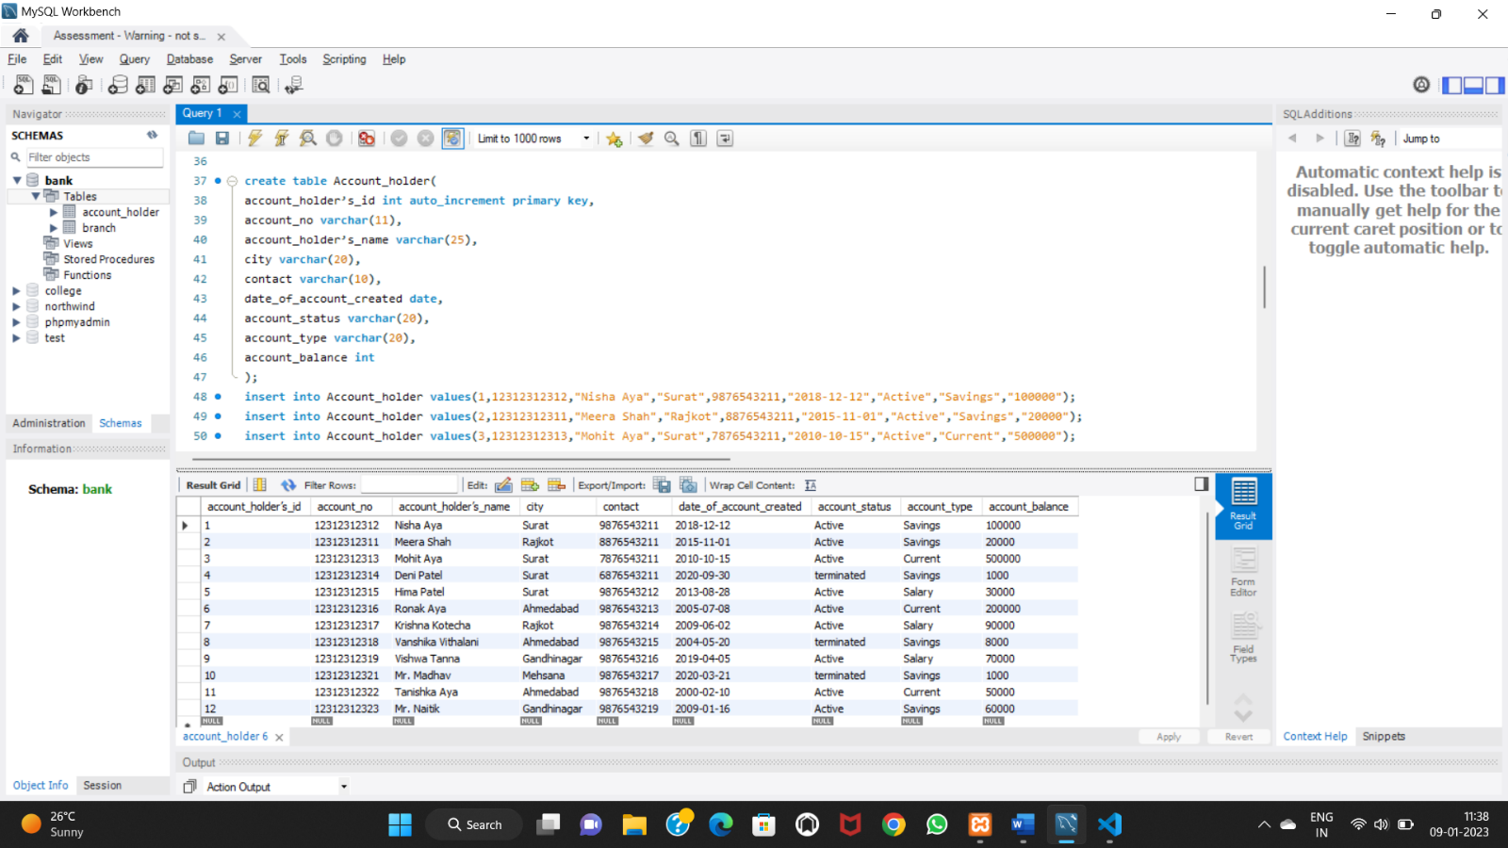

* Transaction:

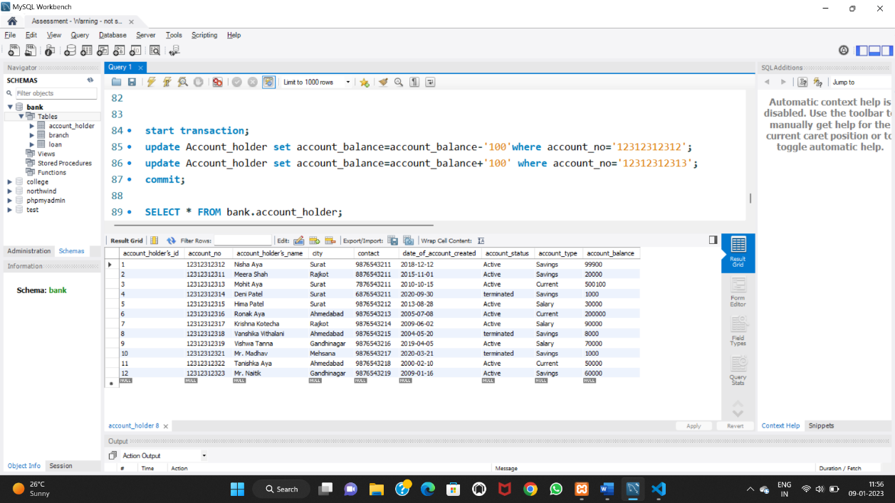

* Write a query to fetch account number and account holder name, whose accounts were created after 15th of any month.

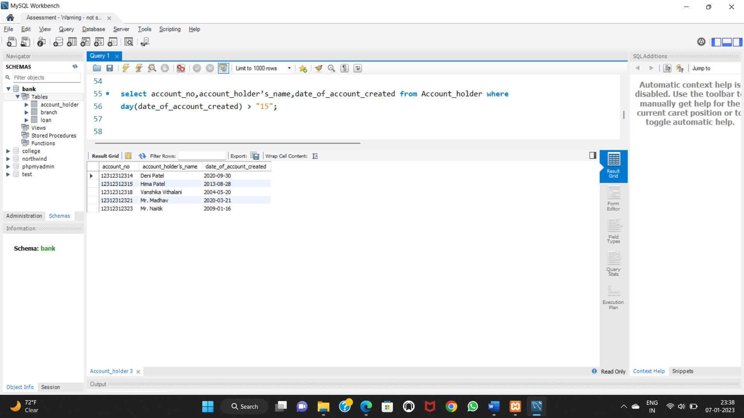

* Write a query to display the city name and count the branches in that city. Give the count of branches an alias name of Count Branch.

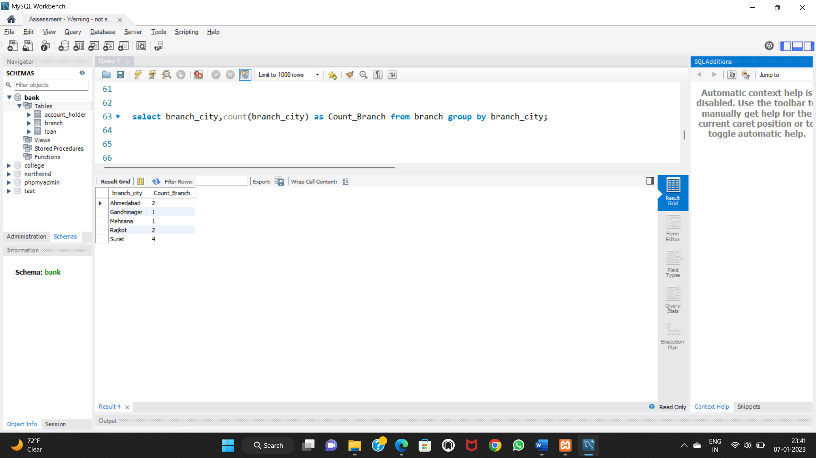

* Write a query to display the account holder’s id, account holder’s name, branch id, and loan amount for people who have taken loans.

