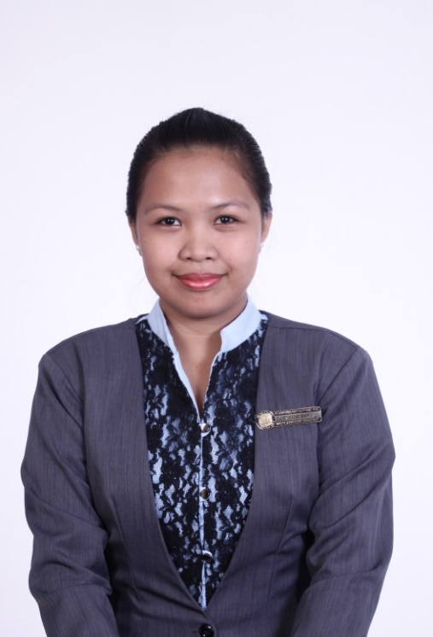

**LEA FRANCISCO SALAZAR**

SMO Bldg. #1964 M. Reyes St. Bangkal, Makati City

Contact Number: 09297471123

Email: [leasalazar23@yahoo.com](mailto:leasalazar23@yahoo.com)

**OBJECTIVES:** To obtain a position that would best fit my qualifications and where I can share my knowledge and skills to the company.

**EDUCATION**

**TERTIARY : Bachelor of Science in Hotel and Restaurant Management**

**June 2009 – March 2013**

Pilar College of Zamboanga City, Inc.

R.T Lim Boulevard, Zamboanga City

**SECONDARY : Immaculate Conception Archdiocesan School**

**June 2005 – March 2009**

Tetuan, Zamboanga City

**PRIMARY : Putik Central School**

**June 1999 – March 2005**

Putik, Zamboanga City

**WORK EXPIRIENCE**

**BARISTA**

**STARBUCKS PHILIPPINES**

**Rustan Coffee Corporation**

Seasonal hired

October 5, 2015-January 15, 2016

**INTERNSHIP**

**Grand Canyon National Park and Resort**

10 Albright Ave., Grand Canyon, Arizona 86023, USA

March 13, 2014 – March 13, 2015

**Cashier**

**Food and Beverage Department**

March 13 - July 17, 2014

**Lead Associate**

**Retail Department**

July 18 – Nov. 13, 2014

**Front Desk Attendant (Guest Service Attendant)**

**Rooms Department**

Nov. 15 – March 13, 2015

**PRACTICUM TRAINEE**

**Marriott Hotel Cebu**

Cebu Business Park, Cebu City

Nov. 12, 2012 – January 31, 2013

**Server Assistant**

**Food and Beverage Department**

**Gym attendant and Life Guard**

**Housekeeping-Recreation Department**

**Laundry Attendant**

**Housekeeping-Laundry Department**

**SKILLS**

**Language Ability :** English and Filipino

**Computer Skills :** MS Word, MS Powerpoint, MS Excel

**Hobbies :** Reading, watching TV, surfing the net and cooking

**PERSONAL INFORMATION**

Date of Birth April 23, 1992

Age 23

Place of Birth Isabela City, Basilan

Gender Female

Civil Status Single

Height 157cm

Weight 58kg

Citizenship Filipino

Religion Roman Catholic

**CHARACTER REFERENCES**

**Alvie Guarino**

IHMP Department Program Dean

Pilar College of Zamboanga City, Inc.

R.T Lim Boulevard, Zamboanga City

Contact Number: (062) 991-5410

Local 232-233

**Meg Rudge**

Human Resource Assistant Director

Xanterra South Rim LLC

10 Albright Ave., Grand Canyon Arizona, 86023

Contact number: 192863840

Email: [mrudge@xanterra.com](mailto:mrudge@xanterra.com)



**Lea Francisco Salazar**

Applicant