Boutique Platform — Architecture & DevOps Overview
Sep 28, 2026 · Vinayak Nishad

1. The three repositories
Boutique is an online men's formal-wear shop (brand Lux Atelier) on Azure Kubernetes Service, split into three Azure DevOps repos. Infra builds the ground, app builds the images, gitops deploys them.
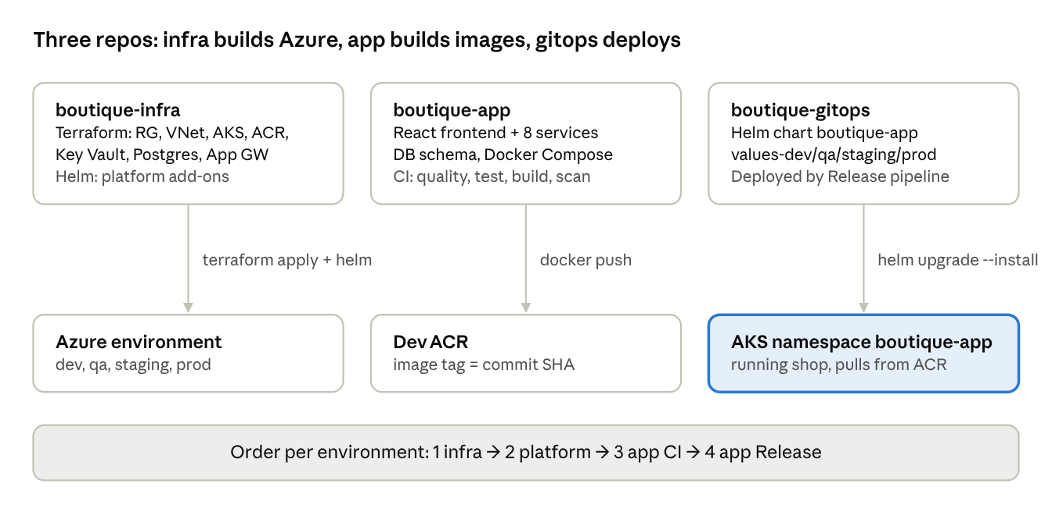
3 repos · what each owns · run order
Everything is created by pipelines, never by clicking in the portal. Only dev runs by default; qa, staging and prod are opt-in at queue time.

2. Application architecture
The browser only talks to one host. App Gateway sends / to the React site and /api to the gateway, which proxies to six Node.js services. Each service checks the JWT itself.
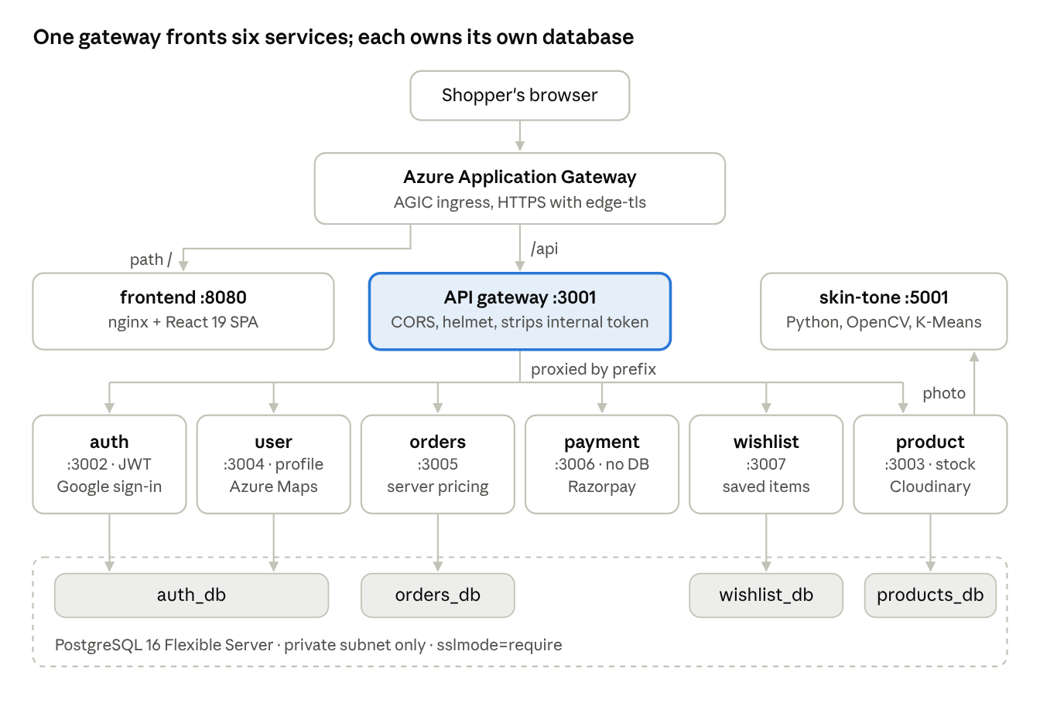
application architecture · 8 services · 4 databases
Internal call (direct, x-internal-token) | Why
orders → product | price and stock at order time, commit stock
payment → orders | order owner and total, mark paid or refunded
product → orders | only buyers with a delivered order may review
product → user | reviewer display name
product → skin-tone | Style Advisor: selfie → skin tone → outfit colours

3. Database schema
One PostgreSQL 16 server holds four logical databases, one per domain. A service never reads another service's tables; it asks that service over HTTP.
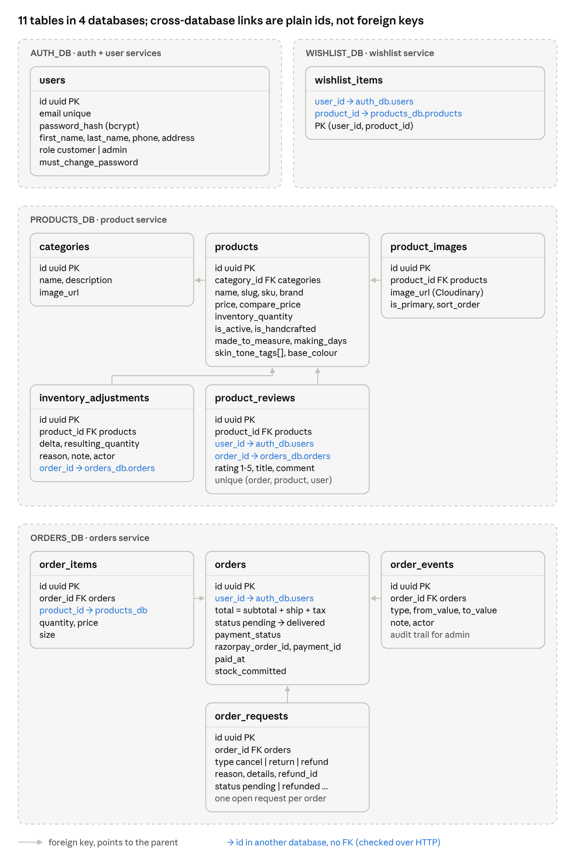
database schema · 4 databases · 11 tables
The schema lives in boutique-app/database/init/20-init-schema.sql. In AKS, postgres-init-job runs the same SQL from a ConfigMap in boutique-gitops, so the two copies must be kept in sync. All primary keys are UUIDs (gen_random_uuid()).

4. Azure infrastructure
Terraform in boutique-infra builds each environment as one resource group. Only App Gateway is public; AKS and PostgreSQL sit in private subnets.
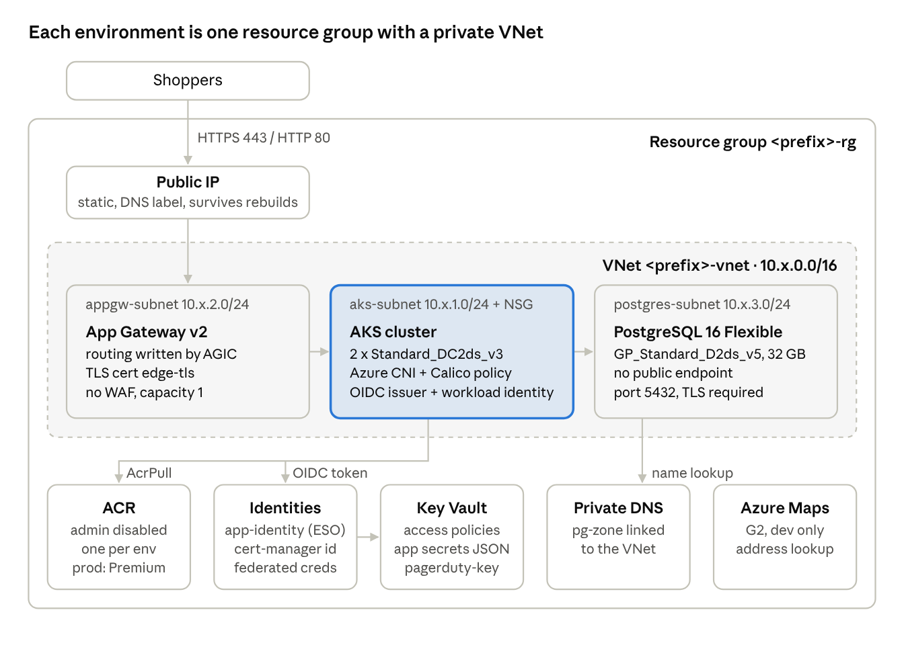
Azure resources in one environment · Terraform in boutique-infra
 | dev | qa | staging | prod
Prefix | bq-dev | bq-qa | bq-staging | boutique-prod
Region | UAE North | Central India | Central India | Central India
VNet | 10.1.0.0/16 | 10.3.0.0/16 | 10.4.0.0/16 | 10.2.0.0/16
ACR SKU | Standard | Standard | Standard | Premium
Runs by default | yes | opt-in | opt-in | opt-in

Terraform state lives in storage account boutiquetfstate2026v2 (container tfstate), one blob per environment.

5. Identity: OIDC and Workload Identity
No client secret or password is stored anywhere for Azure access. Both flows trade a short-lived signed token for an Entra ID token, and Entra only accepts it if the issuer and subject match a federated credential.
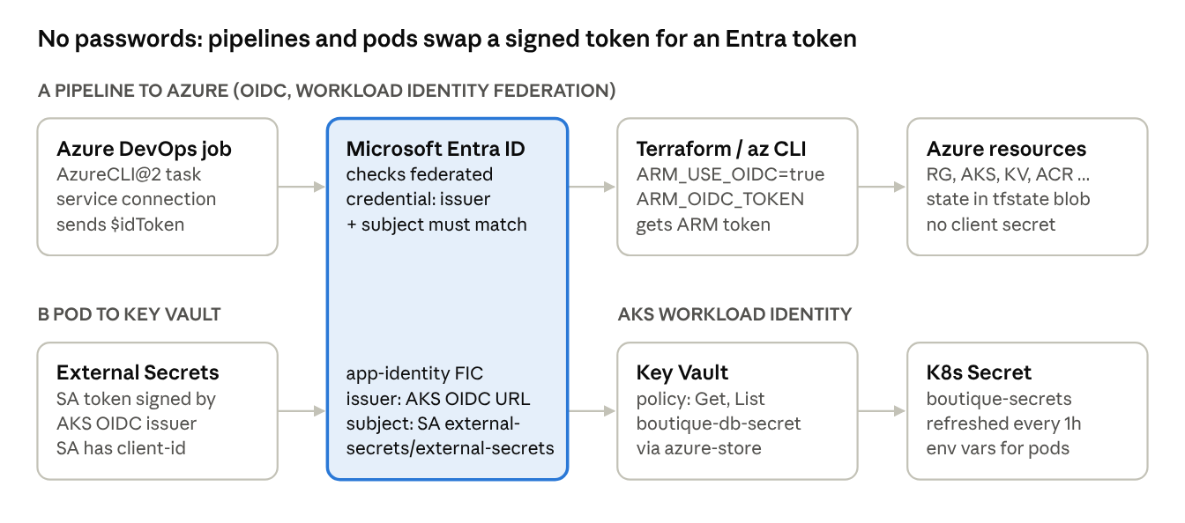
OIDC for pipelines · workload identity for pods
App pods never call Key Vault; they only read the Kubernetes Secret that External Secrets writes.
Identity | Type | Can do
Service connection Azure Resource Group | federated (OIDC) | Terraform, az aks get-credentials
<prefix>-app-identity | user-assigned, workload identity | External Secrets reads Key Vault (Get, List)
<prefix>-cert-manager-identity | user-assigned, workload identity | no roles yet (kept for DNS-01)
AKS kubelet identity | created by AKS | AcrPull on its own environment's ACR
AGIC identity | AKS add-on | writes App Gateway routes (Contributor, Reader, Network Contributor)

6. CI/CD pipelines
There are four YAML pipelines and one Release pipeline. A merge to main in boutique-app runs CI, and its build artifact triggers the Dev Release automatically.
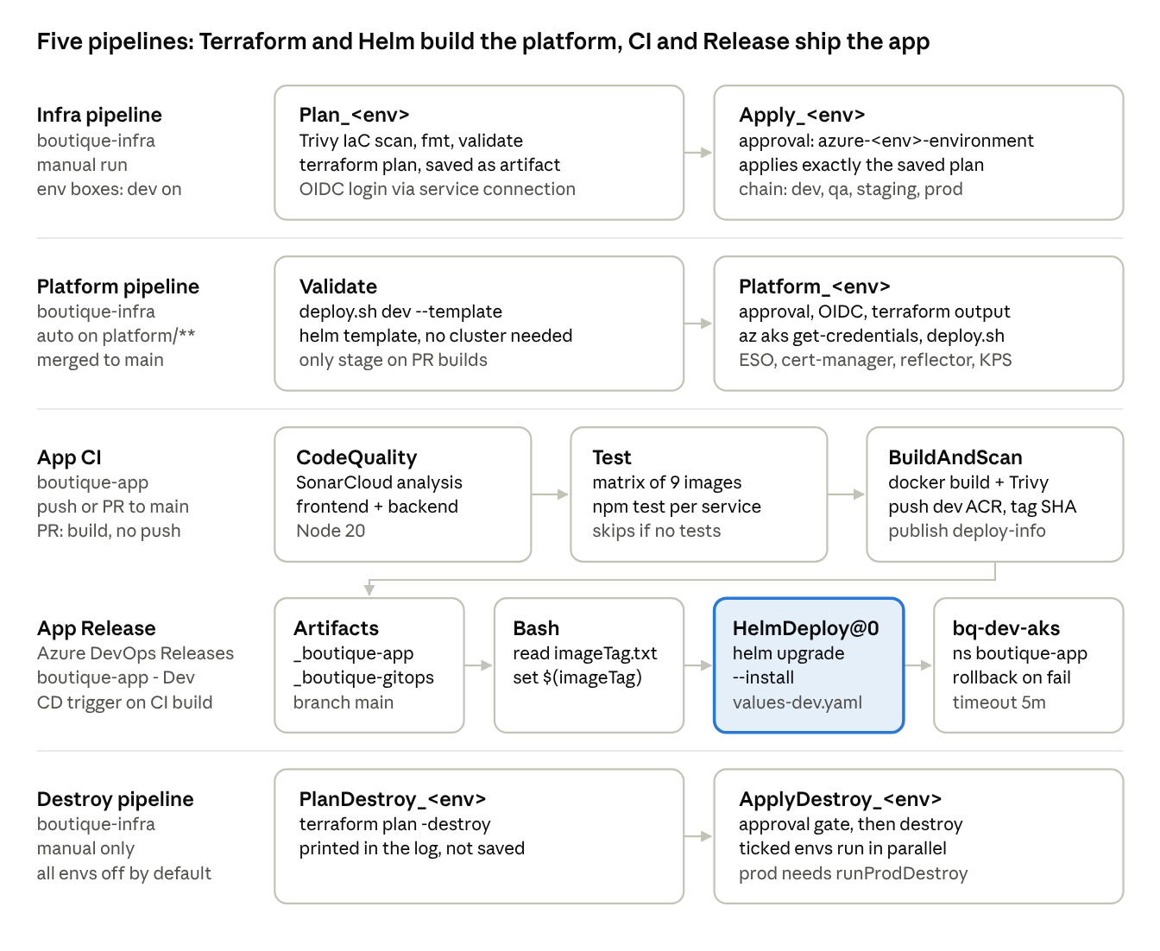
all pipelines · stages left to right
All of them run on Microsoft-hosted ubuntu-latest agents and log in with the same OIDC service connection. The Release pipeline is set up in the Azure DevOps UI (Pipelines → Releases), so it is not stored as YAML in any repo. Higher environments get images through az acr import: images are promoted, never rebuilt.

7. Deployment with boutique-gitops and Releases
boutique-gitops holds the Helm chart and one values file per environment. Nothing watches the repo; a change goes live on the next Release run.
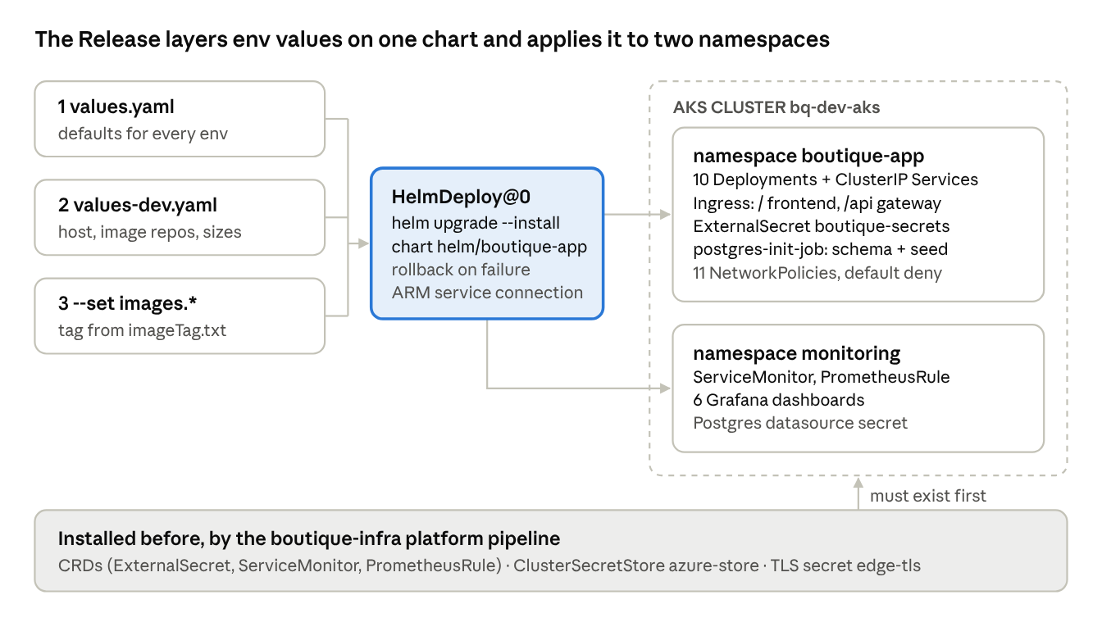
boutique-gitops chart · Release deploy into AKS
- Rollback: --rollback-on-failure undoes an upgrade that is not healthy within 5 minutes; helm rollback works by hand.
- Deployed today: dev only. QA, staging and prod have Terraform and values files but no Release pipeline yet.
- Network: default-deny-all, then each service accepts traffic only from its callers (for example orders accepts gateway, payment and product).

8. Monitoring and alerting
The platform pipeline installs kube-prometheus-stack; the gitops chart adds the scrape targets, rules and dashboards, so monitoring is all code.
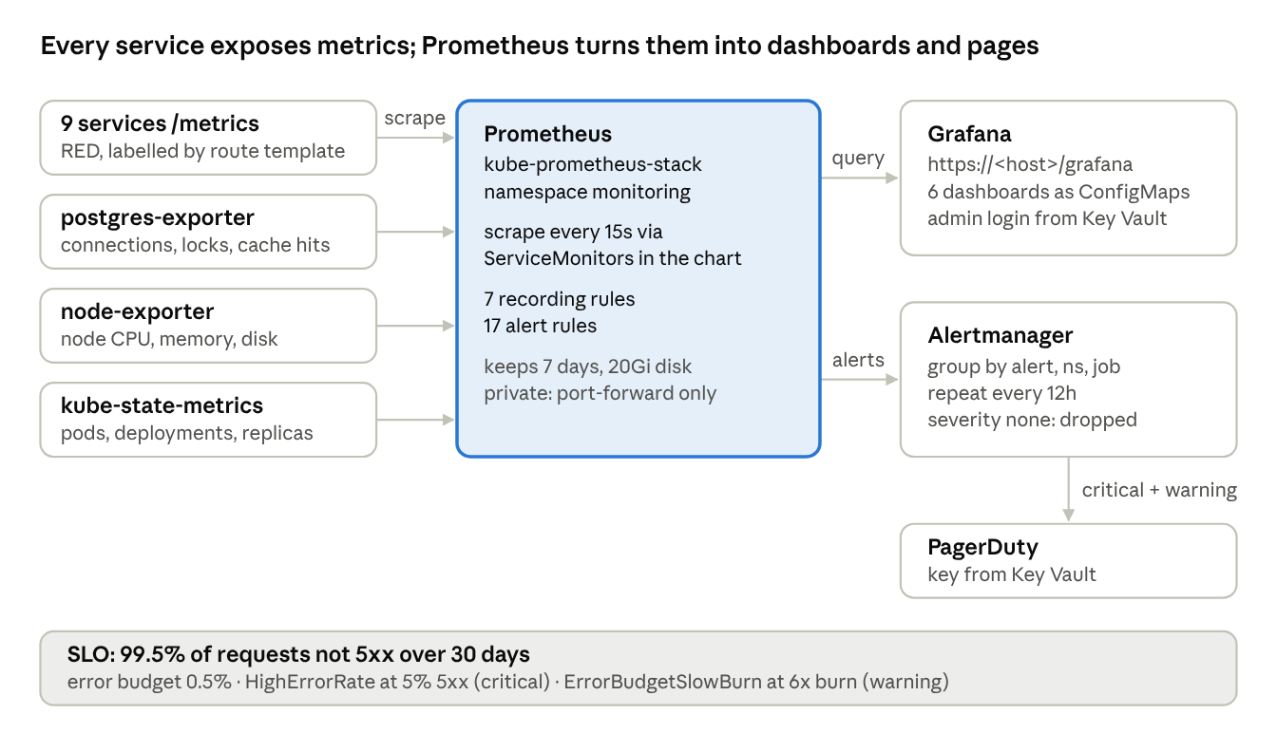
monitoring · metrics to dashboards and pages
Alert group | Examples | Severity
Availability | InstanceDown, ServiceScaledToZero, HighErrorRate | critical
Database | PostgresDown | critical
Latency | p95 over 1s, skin-tone p95 over 15s | warning
Runtime | restart loops, event-loop lag, DB pool exhausted | warning
Database health | too many connections, deadlocks, long transactions | warning
Business | payment verification rate under 50% | warning

In this setup the default route is PagerDuty, so warnings page too, not just critical alerts. Dashboards: Microservices RED, SLOs & Error Budget, Service Runtime, Infrastructure, PostgreSQL, Business KPIs.

9. Summary: the story in one line per slide
- Repos: three repos split the work: code, cloud and deployment are changed and reviewed separately.
- App: a React site and 8 services behind one gateway, with prices computed on the server.
- Data: 4 databases, one per domain, linked only by ids and HTTP calls.
- Azure: everything is Terraform; only App Gateway is public, Postgres has no public endpoint.
- Identity: no stored secrets for Azure access; OIDC for pipelines, workload identity for pods.
- Pipelines: plan is saved and applied exactly; approvals sit on Azure DevOps environments; images are scanned with Trivy.
- Deploy: a merge to main builds, pushes and releases to dev automatically, with rollback on failure.
- Monitoring: Prometheus scrapes every service, Grafana dashboards are code, and alerts page PagerDuty against a 99.5% SLO.
Open gaps worth saying out loud: QA, staging and prod have no Release pipeline yet, Trivy and terraform fmt never fail a build, and all environments share one set of pipeline variables.

