Honeypot Analysis

Goal
The primary goal of this project was to deploy a vulnerable Windows honeypot in the Microsoft Azure cloud to detect, log, and analyze Remote Desktop Protocol (RDP) brute-force attack attempts in a secure environment. By emulating a target system in the real world, the project was meant to entice malicious attackers and collect relevant metadata related to their attack patterns.

The objectives were:
- To simulate a weak cloud-based Windows environment that may be utilized to attract real-world RDP brute-force attacks for analysis and research.
- To collect detailed metadata on attempted unauthorized access, such as attacker IP addresses, geolocation, Internet Service Providers (ISPs), and common login credentials.
- To research and ascertain the behavior, frequency, and origin of RDP brute-force attacks on cloud infrastructure.
- In order to transform raw log data into actionable intelligence through centralized monitoring and advanced analytics.
- To enhance situational awareness and provide proactive threat detection via natively built tools within Microsoft Azure, such as Log Analytics and Microsoft Sentinel.
- To assist in contributing to cybersecurity awareness by identifying common attack vectors, attacker types, and new trends that could influence future defensive strategies.

The primary objective of this project was to simulate a real-world cyber threat scenario by setting up a vulnerable Windows-based virtual machine (VM) in Microsoft Azure as a Remote Desktop Protocol (RDP) brute-force honeypot attack. The firewalls were turned off and all the ports were opened, and the VM was made accessible to the public Internet to entice malicious users. With PowerShell scripting, the VM collected rich metadata on attack attempts such as IP address, username, ISP, and geolocation. Logs were enriched with third-party APIs and consumed by Azure Log Analytics to be stored and analyzed. Microsoft Sentinel was subsequently used to plot the data on custom dashboards and KQL queries, which gave detailed insights into attackers' behavior such as source countries, most attacked usernames, and utilized ISPs. The overall aim was to produce actionable threat intelligence, identify attack patterns, and demonstrate the advantage of utilizing cloud-native security tools to actively monitor and analyze threats.

Deployment of VM
One of the activities our project entailed was setting up our honeypot. To achieve this, a vulnerable VM was deployed in Azure Cloud and intentionally made more vulnerable by disabling firewalls. The intent behind setting up a vulnerable VM is to attract attackers and simulate a high-risk environment. When setting up the VM, we created our own inbound rule under the NIC network security group (firewall) that will allow all ports and any protocols and turned off the firewall on the local machine. As a result, allowing all traffic from the Internet into our VM and makes the VM very discoverable once it was online. The VM was deployed from February 25 to February 28, 2025. Some deployment details are listed below:
- IP Addresses:
  - Public: 172.206.3.236
  - Private: 10.0.0.4
- Location: East US 2 (Zone 1)
- RAM: 8 GiB
- VM Architecture: x64
- Source image: Windows-10

Log Ingestion

The Azure Log Analytics workspace is configured initially to consume the logs. The workspace is the location the logs generated by the intentionally vulnerable VM are stored. The VM will produce logs on unsuccessful login attempts. The PowerShell script is executed on the VM to obtain critical information, like the attackers' IP addresses. The IP addresses are processed by an API, IP-API, to ascertain the geographic source of the attacks and append location details like country, latitude, and longitude to the logs. The attacker metadata is stored within the log and workspace.

These logs are then ingested in the Log Analytics workspace that was created. To actually facilitate the logs being ingested into the Log Analytics workspace from the VM, we need to ensure both of those entities are connected to each other using Azure console. Once we successfully connected both entities to each other, the Log Analytics workspace now can access the VM log file. But this is not sufficient for the logs to be read and worked upon. We then also need to create a custom table to make querying the logs easier for us.

Creating a custom table consists of defining a set of data and then providing a name to it. This named table can be called on while querying to further ease the processes. Once the table is created, the first step would be to actually give a sample file of the data that is going to be ingested as a part of this custom table. A file path was also provided which informed Log Analytics of where the file was locally stored on the VM.

The custom log is consumed by the Log Analytics workspace along with geographic data. Custom logs are defined in Microsoft Sentinel so that the consumed data is parsed and formatted properly. The parsed data from the logs is used to plot the world map and graphically represent sources of the attempts on the world map. The whole scenario from the creation of the log on VM to its graphical representation in Microsoft Sentinel makes it easy to visualize global threat patterns.

Preparation and Execution of Script
After deploying the Azure VM and creating the Log Analytics agent, we turned on and connected to our VM. Once logged into the VM, we executed a PowerShell script. First, the script created a log file which will later be ingested into Log Analytics and Microsoft Sentinel for further analysis. Then, the script examined Windows Events, Security Logs, for failed login attempts or Event ID 4625 (Madakor, 2021). From those events, we gathered the following data points from the attackers who attempted to connect to the VM via RDP: their IP address, their ISP, the username they used during their sign-in attempt, and their geolocation. The information was added to the log file that was locally saved on the VM and ingested via Log Analytics. We executed this PowerShell script on February 25 through February 28, 2025. We collected 75,550 events using the PowerShell script.
Microsoft Sentinel Configuration and Queries

Microsoft Sentinel is a Microsoft cloud-native Security Information and Event Management (SIEM) system that consolidates smart security analytics and threat intelligence on an organization's overall landscape. Azure Sentinel assists an organization to identify, track, and react to security risks in real-time.

To properly configure Microsoft Sentinel, we need to link Log Analytic workspaces to Azure resources. This allows logs and security incidents to be ingested and further processed by Log Analytics. Log Analytics provides real-time monitoring of systems' security concerns as users can monitor failed login attempts, unauthorized access attempts, and potentially malicious attacks among other security metrics. One strong feature of Microsoft Sentinel is Workbooks which allows users to create interactive dashboards with data. Workbooks can display numerous kinds of visualizations that are customizable to represent the data in more insightful ways, ranging from charts and tables to geographic maps. We can conveniently query and filter our logs to better analyze security incidents.

Hence, once connected to the Log Analytics workspace, we can create a workbook and start working on editing the workbook to get our ideal visualizations. Since our logs have already leveraged the IP-API to generate the region and country of origin from the IPs, the logs are more insightful. We can also use the latitude and longitude values to be plotted against an interactive world map. So, we have the below queries from Azure Sentinel that were used as a part of this exercise:

- Failed Attemps by location: (Figure A.2)
Failed_RDP_Logins_Info_IP_CL | parse-kv RawData as (latitude:real, longitude:real, sourcehost:string, username:string, country:string, destinationhost:string, state:string, timestamp:date, label:string ) with (pair_delimiter=',', kv_delimiter=':') | summarize count() by country ,latitude, longitude, sourcehost, username, destinationhost, state, timestamp, label | order by count_ desc

- Top 20 Failed RDP Attempts by Username: (Figure D.2)
Failed_RDP_Logins_Info_IP_CL | parse-kv RawData as (latitude:real, longitude:real, sourcehost:string, username:string, country:string, distnationhost:string, state:string, timestamp:date, label:string) with (pair_delimiter=',', kv_delimiter=':') | summarize FailedLoginCount=count() by username | order by FailedLoginCount desc | top 20 by FailedLoginCount | render barchart title="Top 20 Failed RDP Login Attempts by Username" with (xcolumn=username, ycolumns=FailedLoginCount)

Analysis of Findings and Key Observations

Country Volume (Figure A.1 and Figure A.2)

Analysis of honeypot data collected between February 25 and February 28, 2025, from a Windows machine built and hosted in Microsoft Azure, reveals significant patterns in unsuccessful sign-in attempts. Geolocation analysis of the attempts indicates a concentrated source of attacks, with Germany, Poland, and India collectively accounting for over 70% of the observed failed login attempts. This distribution suggests a targeted approach, potentially leveraging compromised servers or automated scripts operating within these regions. The prevalence of attack sources in our data from South Asia and Western Europe further implies the potential involvement of botnet agents and infrastructure abuse of the in-country IaaS providers (Spamhaus Technology, 2025). Moderate levels of attacks from countries like the U.S., Vietnam, and Indonesia could indicate the potential for compromised virtual private servers or exploited end-user devices, as these 3 countries are listed as in the top 15 countries with exploited devices (Spamhaus Technology, 2025).

ISP Prevalence (Figure B.1)

Examination of the ISPs associated with failed login attempts reveals a high prevalence of attacks originating from the MEVSPACE ISP, which is a Polish hosting provider (MEVSPACE, 2025). This ISP was the source of approximately 70% of attacks involving unsuccessful login attempts, and this finding strongly correlates with the high volume of attacks originating from Poland. This suggests that the Polish ISP is being used for the automation of brute-force login tools. A notable observation is that the majority of the top 10 identified are cloud hosting companies or data centers, rather than residential internet service providers, this indicates the preference among attackers to utilize and exploit virtualized or compromised server infrastructure for large scale attacks and campaigns. The presence of hosting providers such as Maxihost (Latitude.sh, 2025), Flyservers (Flyservers, 2025), and LogicWeb (LogicWeb, 2025), all providers of commonly used VPS deployments, further supports the hypothesis that attackers favor flexible, on-demand infrastructure for persistent and automated login attempts.

Username Abuse and Attacks (Figure D.1)

Analysis of targeted usernames reveals a strong bias towards default administrative credentials, with “ADMINISTRATOR” being the most frequently attempted username by a significant margin. Other generic usernames like “admin” also appear with notable frequency, further emphasizing the prevalence of brute-force applications in attack campaigns. While brute-force campaigns seem to be the most prevalent, the appearance of other usernames, including ones in foreign languages or random strings, indicates a broader spectrum of attack strategies than just brute-force methods. The analysis of usernames used in these attacks reinforces the importance of resetting default passwords, not using default administrative accounts, and maintaining strict access control lists for all users, including admins.

Appendix

[A] Analysis of attacks by country
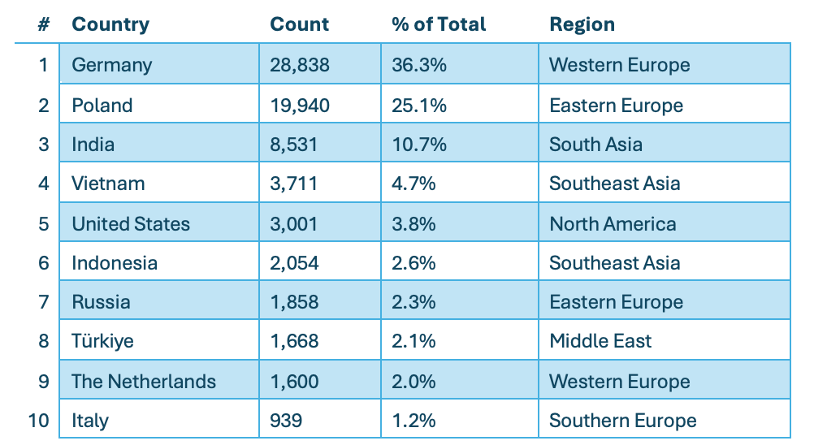
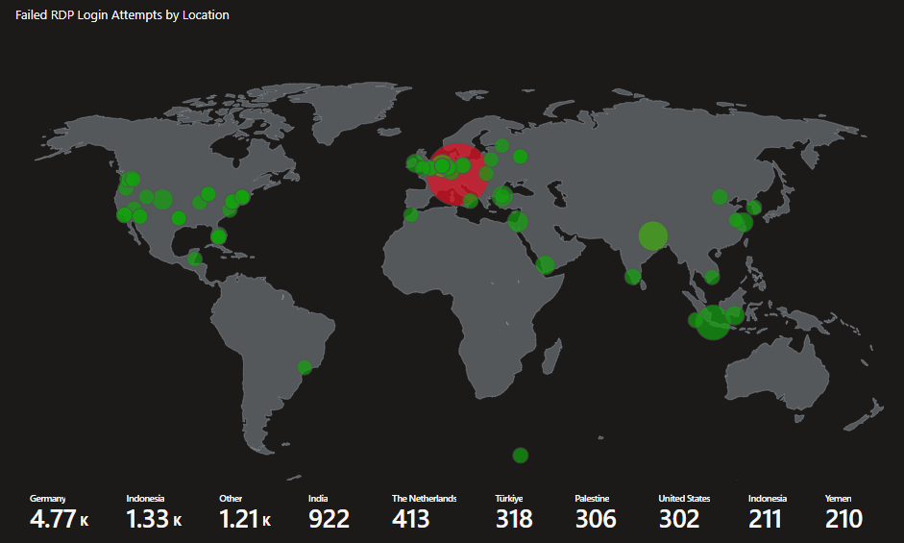
Failed Attempts by location
[B] Analysis of attacks by Internet Service Provider
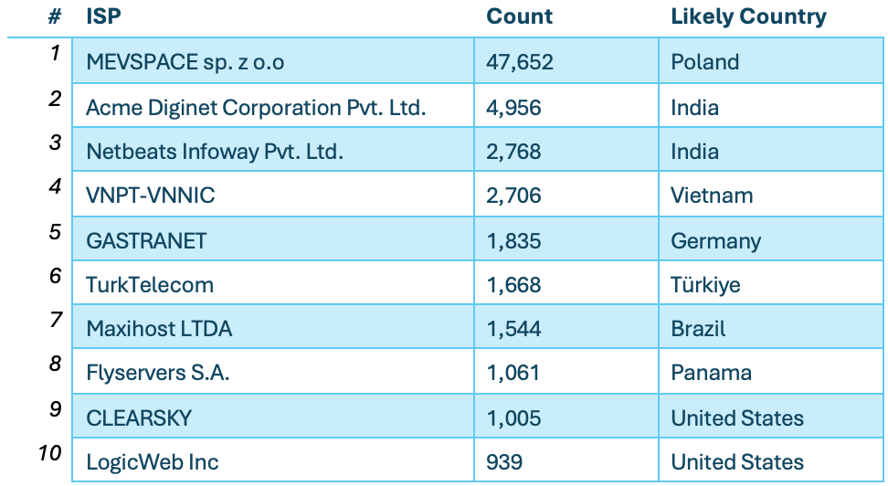

[C] Network Diagram for Honeypot Deployment
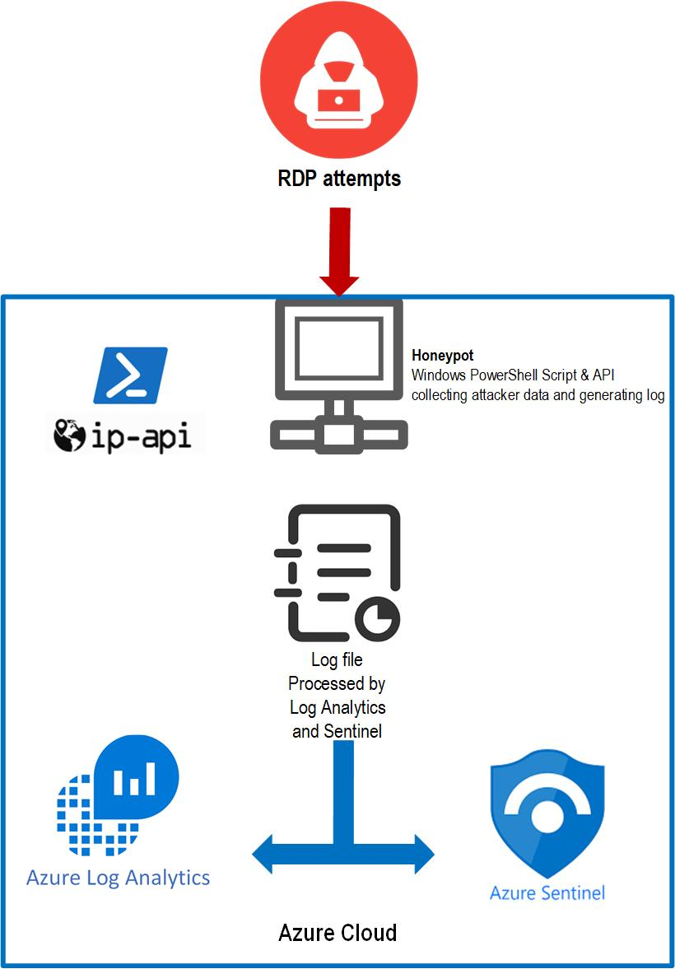
[D] Results of the Queries
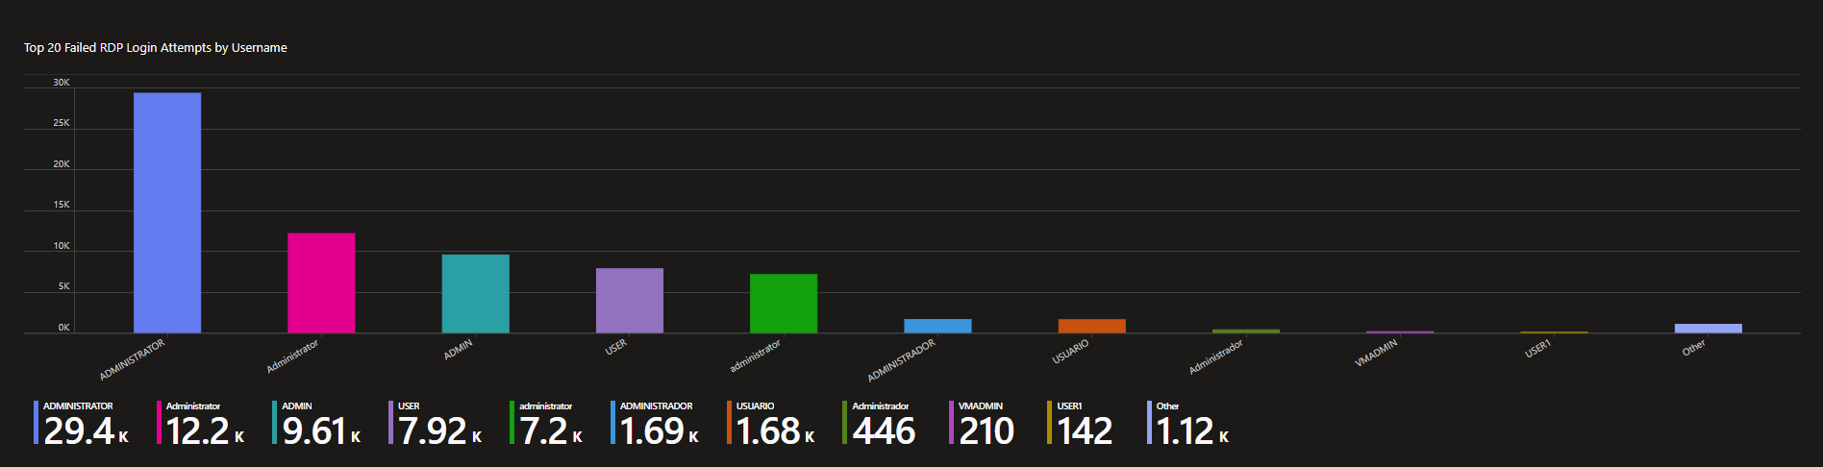
Top 20 Failed RDP Attempts by Username

References
Flyservers. (n.d.). Portal home. Retrieved April 21, 2025, from https://www.flyservers.com/.
IP-API.com. (2022). IP Geolocation API. Retrieved January 28, 2025 from https://ip-api.com/.
Latitude.sh. (n.d.). About Us. Retrieved April 21, 2025, from https://www.latitude.sh/about.
LogicWeb. (n.d.). Quality web hosting with Litespeed + nvme. try risk free. Retrieved April 21, 2025, from https://www.logicweb.com/.
Madakor, J. (2021, November 1). SIEM Tutorial for Beginners | Azure Sentinel Tutorial Map with Live Cyber Attacks! [Video]. YouTube. https://www.youtube.com/watch?v=RoZeVbbZ0o0.
Mevspace. (n.d.). VPS Cloud. Retrieved April 21, 2025, from https://mevspace.com/vps-cloud.
The Spamhaus Project. (n.d.). Countries hosting IPs associated with exploited devices. Retrieved April 21, 2025, from https://www.spamhaus.org/reputation-statistics/.
Spamhaus Technology. (n.d.). Spamhaus Live Botnet Threat Map. Retrieved April 21, 2025, from https://www.spamhaus.com/threat-map/.
Ultimate IT Security. (n.d.). Windows Security Log Event ID 4625. Retrieved April 4, 2025, from https://www.ultimatewindowssecurity.com/securitylog/encyclopedia/event.aspx?eventID=4625.

