Release ClassicPlayer 1.0.3 · guillermo-moran/ClassicPlayer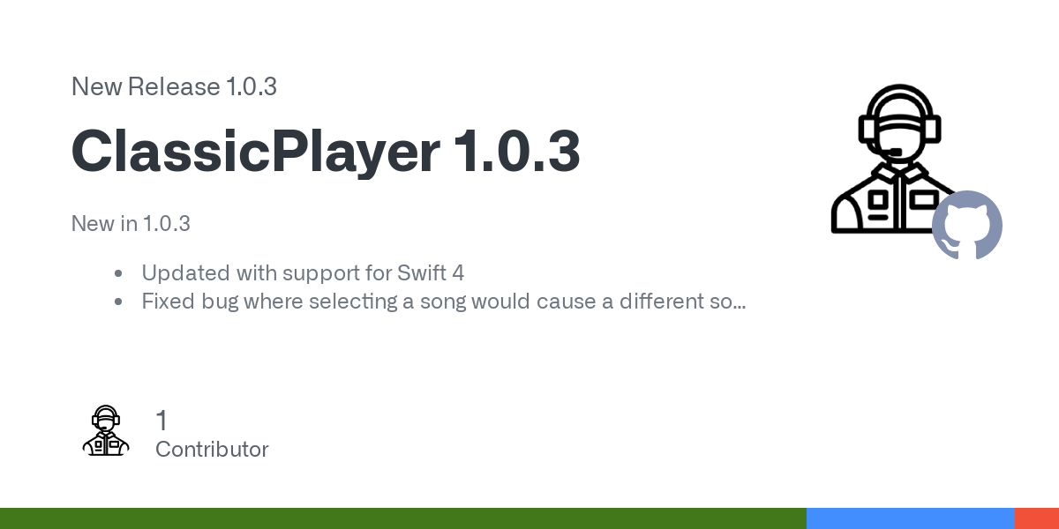  
  
<https://github.com/guillermo-moran/ClassicPlayer/releases/tag/1.0.3>  
  
  
  
  
"You know WWE is fake, right?"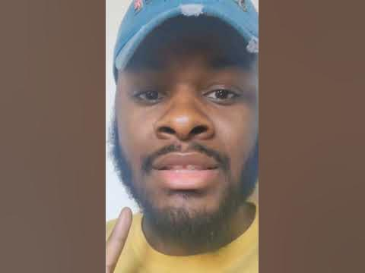  
  
<https://youtube.com/shorts/fvBkYvoSNMI?feature=share>  
  
  
  
  
Johnny Depp wait for it... 😂❤️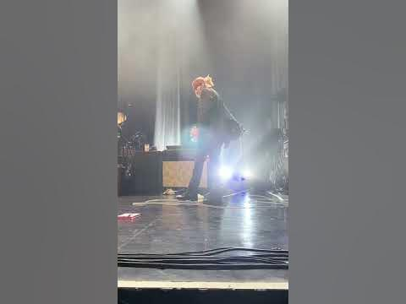  
  
<https://youtube.com/shorts/jAQJRc_6O2k?feature=share>  
  
  
  
  
WWE Promo Shoot - SNL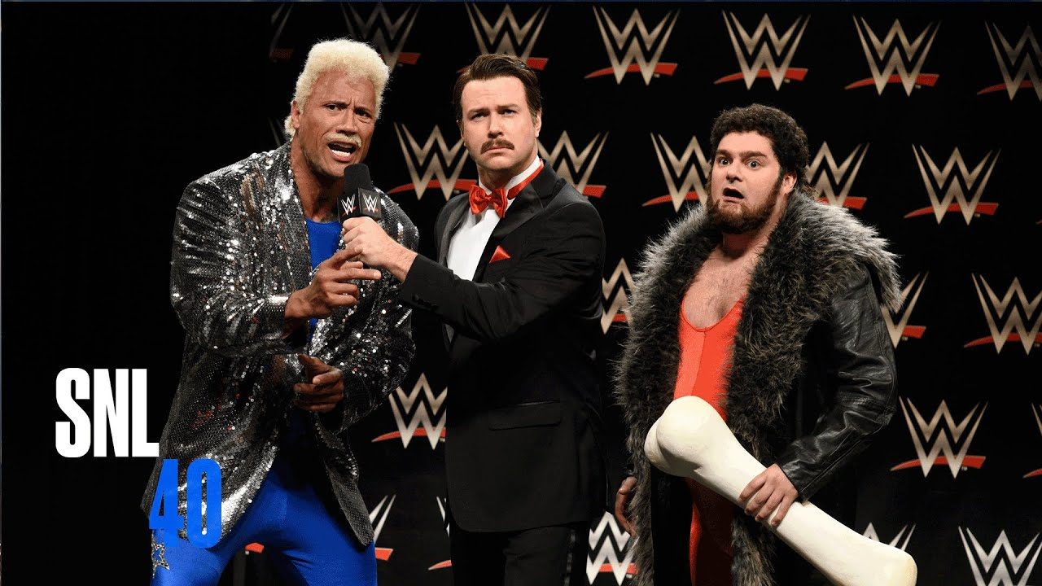  
  
<https://youtu.be/H_yWxB9VW0c>  
  
  
  
  
Dylan drops a literal Nuke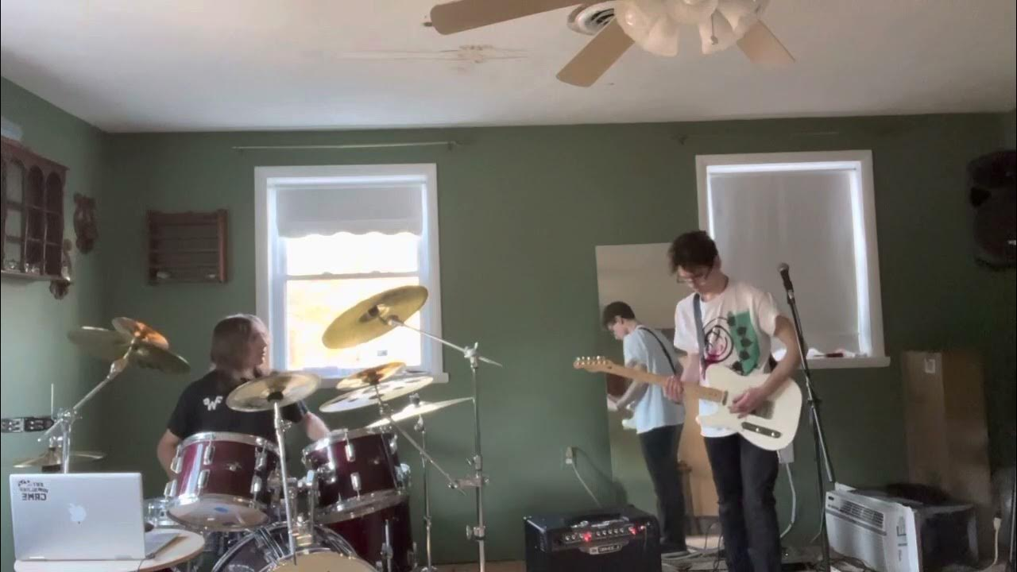  
  
<https://youtu.be/vX_pdOxW1Tg>  
  
  
  
  
Kurt Cobain : NIRVANA - IN UTERO Artwork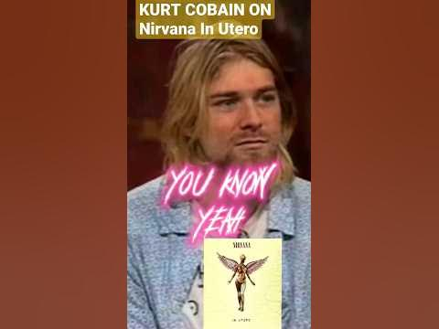  
  
<https://youtube.com/shorts/uD224GPD038?feature=share>  
  
  
  
  
South Park 25th Anniversary Concert | "Theme song" - Paramount+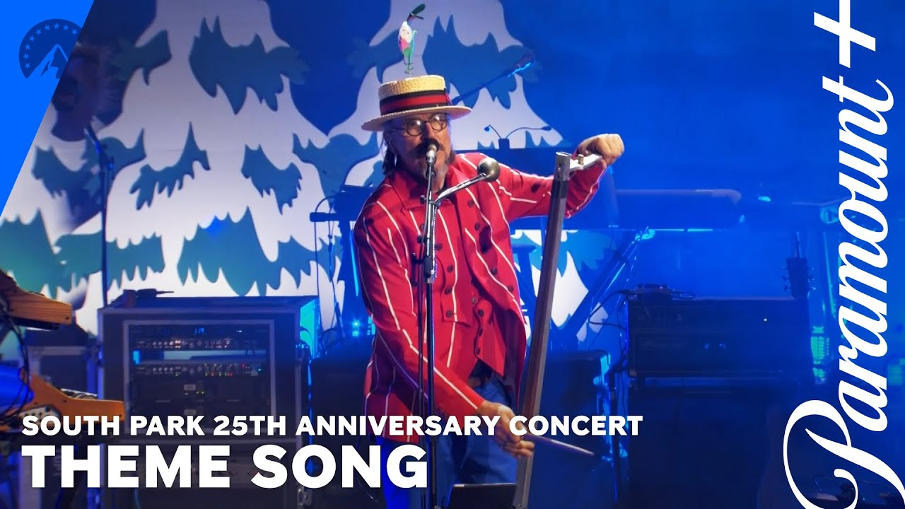  
  
<https://youtu.be/NqKAcaeGbW0>  
  
  
  
  
Will smith kills Chris rock 😳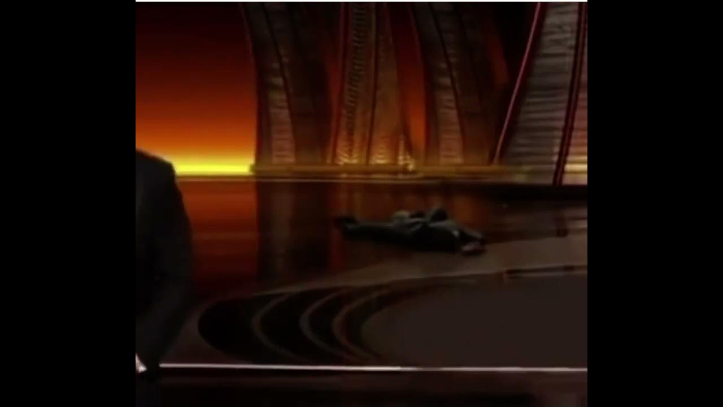  
  
<https://youtu.be/VauyRh9BOb8>  
  
  
  
  
when your phone rings in a jacob collier concert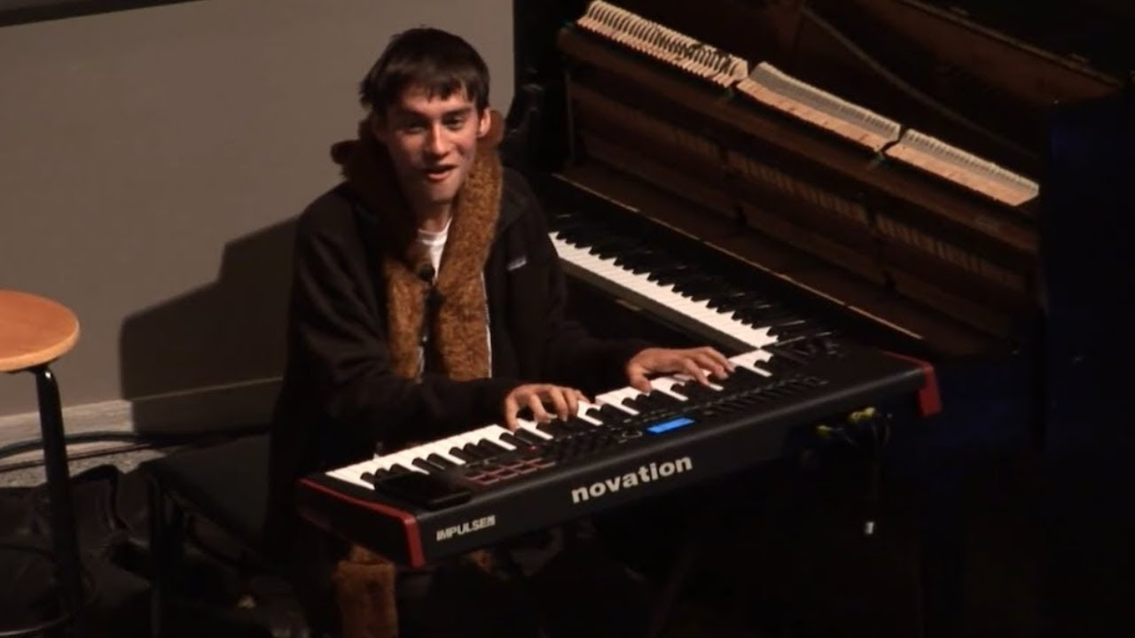  
  
<https://youtu.be/O8PB0EzJ4oA>  
  
  
  
  
Drowning Pool - Bodies Live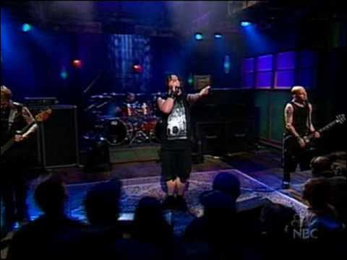  
  
<https://youtu.be/BYRZFmlhpqA>  
  
  
  
  
Nirvana's In Utero but with the SM64 soundfont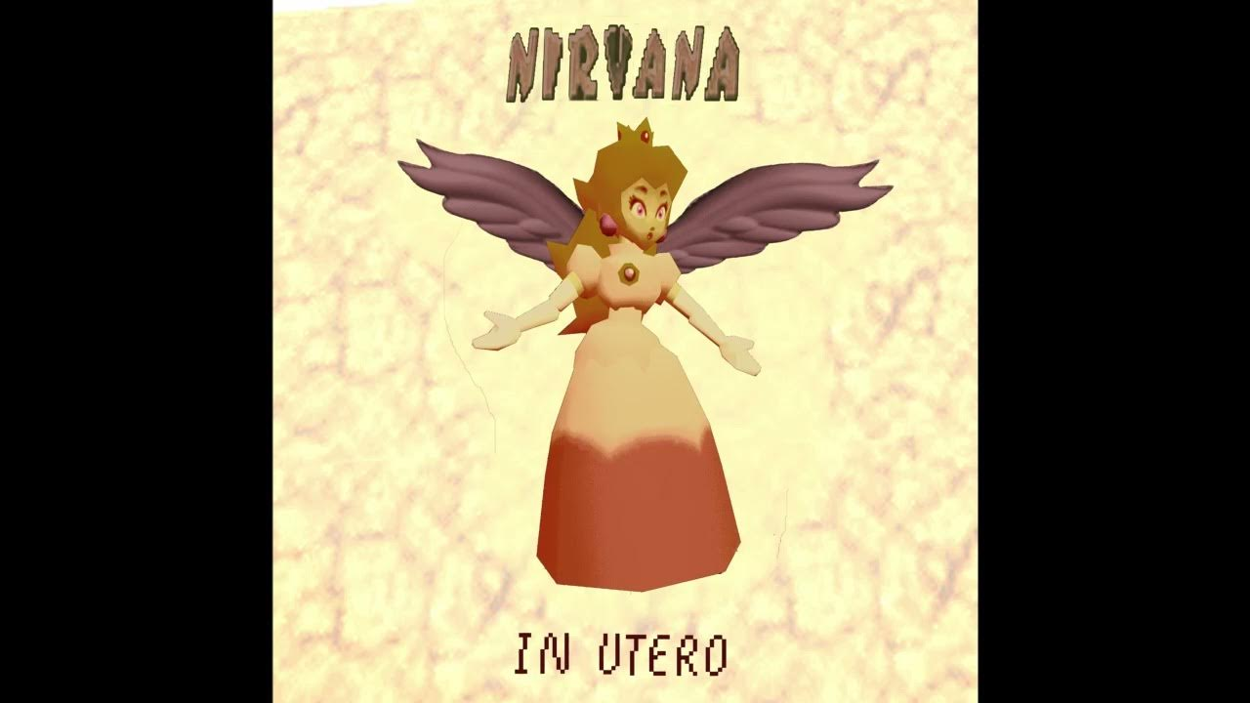  
  
<https://youtu.be/5kpqo0eaxZ4>  
  
  
  
  
Stan Twitter: Taylor Swift saying “you’re gay”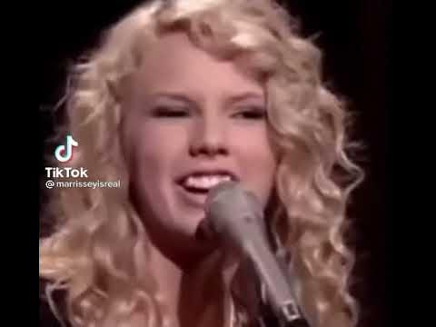  
  
<https://youtu.be/lorjPXHD1yQ>  
  
  
  
  
JaJBORInjOOraXXXyAzaoa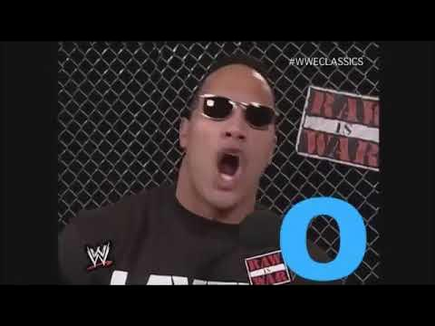  
  
<https://youtu.be/oFLjQgZtXfA>  
  
  
  
  
Radiohead Have Written THE MOST CONFUSING Easy Guitar Riff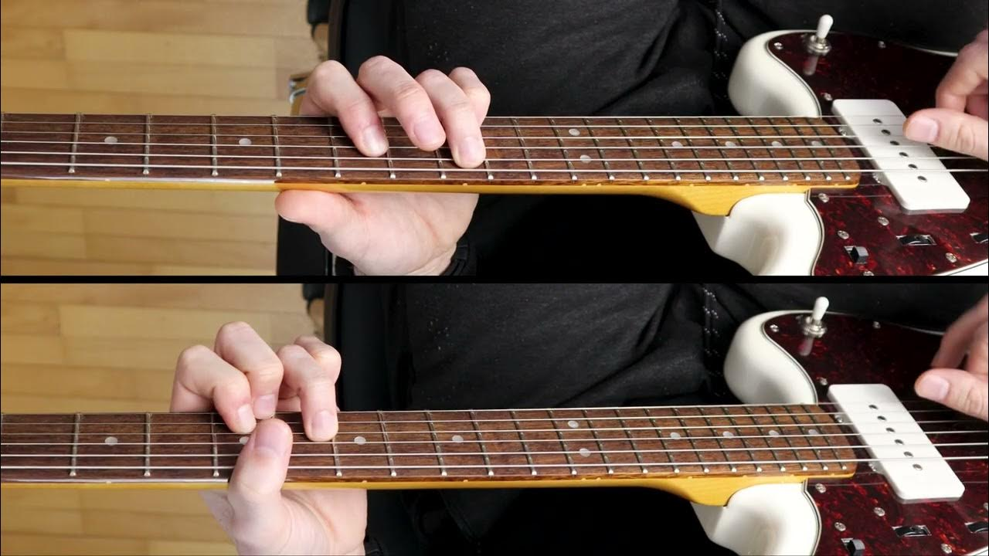  
  
<https://youtu.be/_jb8u46jWRo>  
  
  
  
  
John Cena And The Rock Speaks Chinese  
  
<https://youtube.com/shorts/K9377oH1qVU?feature=share>  
  
  
  
  
I put my amp underwater and it sounds UNREAL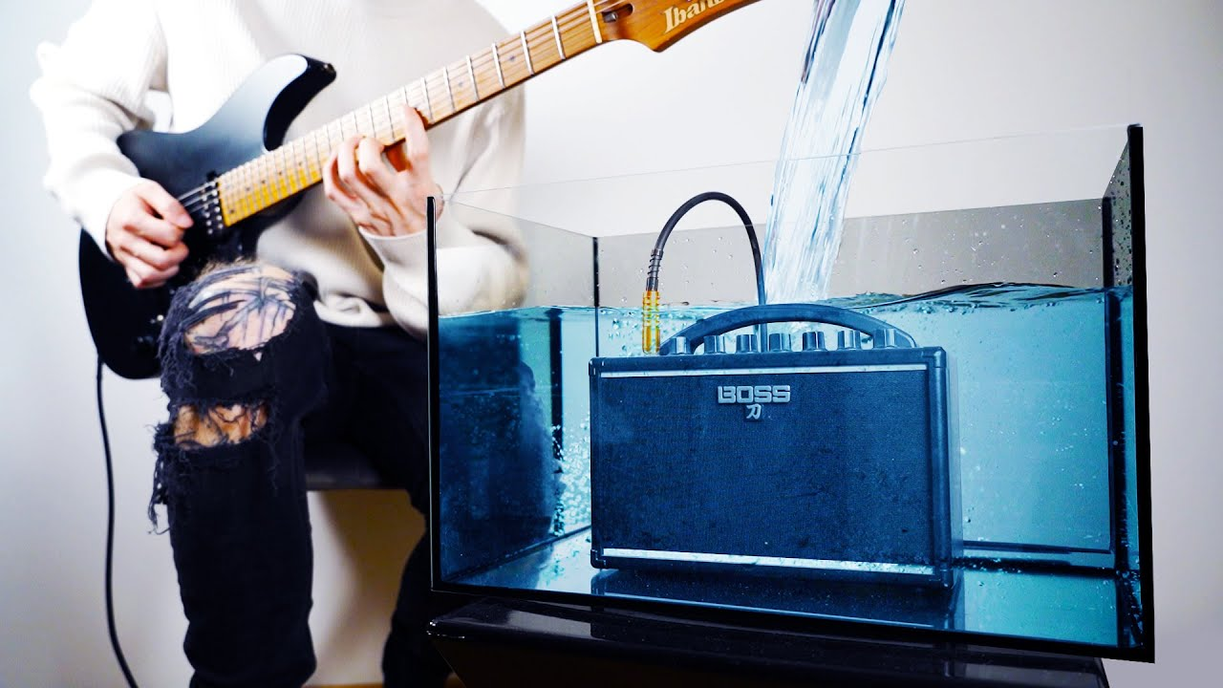  
  
<https://youtu.be/3vAO-hOXag4>  
  
  
  
  
The song everybody has heard but nobody knows the name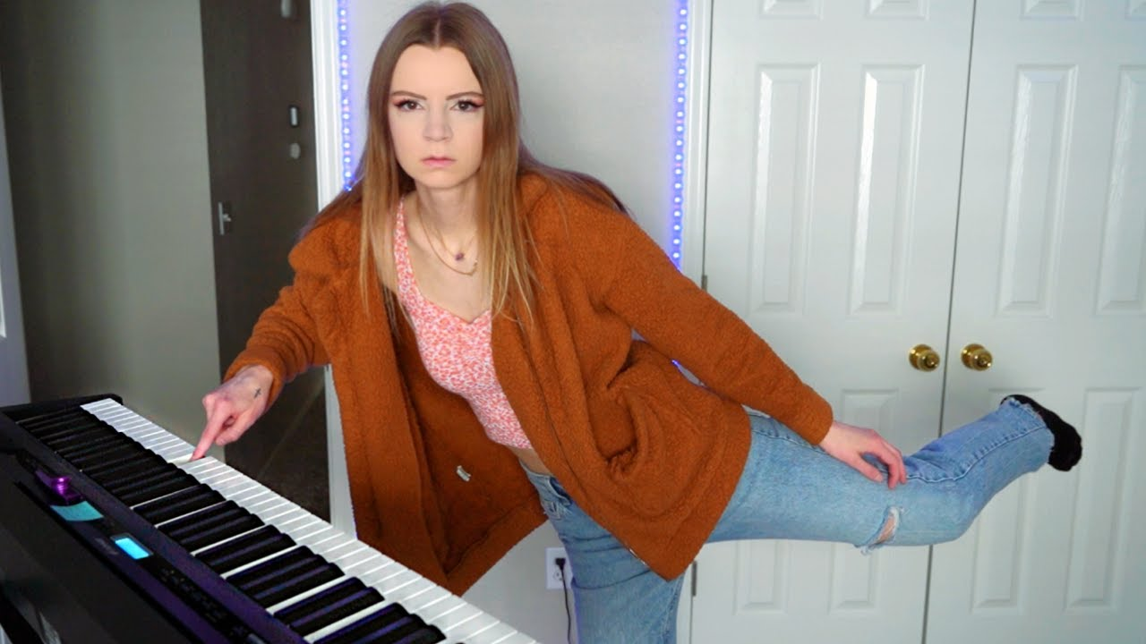  
  
<https://youtu.be/b6svLyxoitA>  
  
  
  
  
POV: We're on a date at my house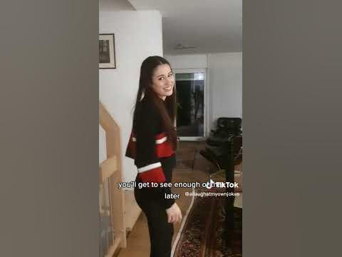  
  
<https://youtube.com/shorts/T1wecXTc_xo?feature=share>  
  
  
  
  
Statue of Liability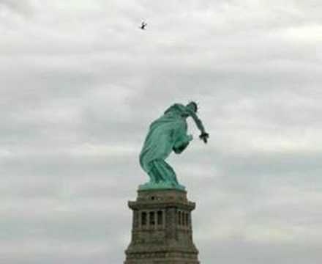  
  
<https://youtu.be/-BE6GyHcASE>  
  
  
  
  
If Videogame Bosses Were Actually Smart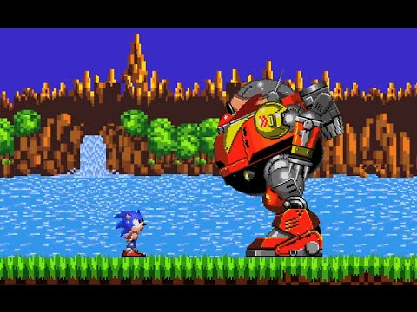  
  
<https://youtu.be/7BA4Texa1es>  
  
  
  
  
You've been hit by a GameCube Criminal.  
  
<https://youtu.be/GEBvHfBgTbA>  
  
  
  
  
Jack Black in the tv advert for Pitfall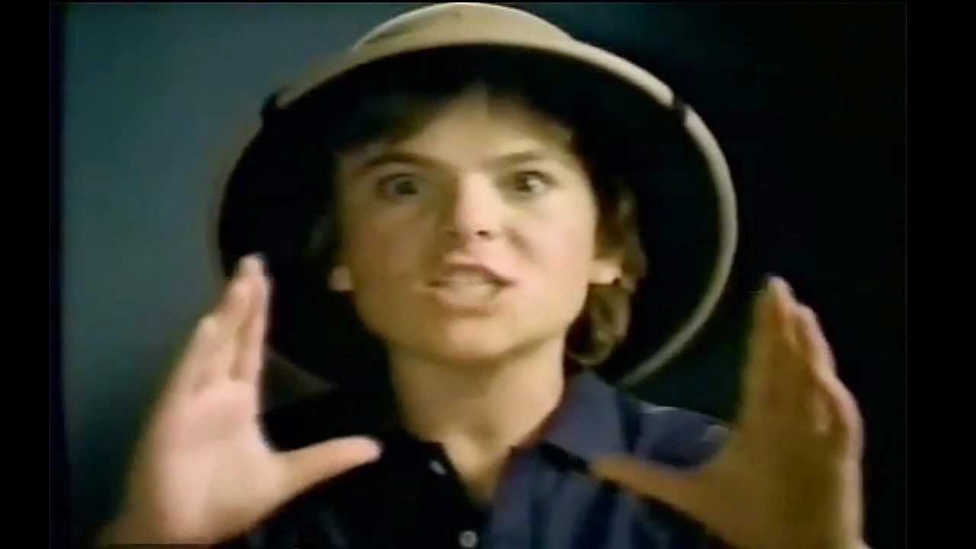  
  
<https://youtu.be/DA4V-n8Ft3g>  
  
  
  
  
82-Year-Old Man Covers DROWNING POOLS "Bodies" on Americas Got Talent!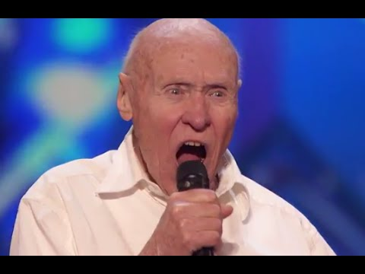  
  
<https://youtu.be/wFKBN3MGUGI>  
  
  
  
  
Drowning Pool - Bodies Live  
  
<https://youtu.be/BYRZFmlhpqA>  
  
  
  
  
Spanish Class - SNL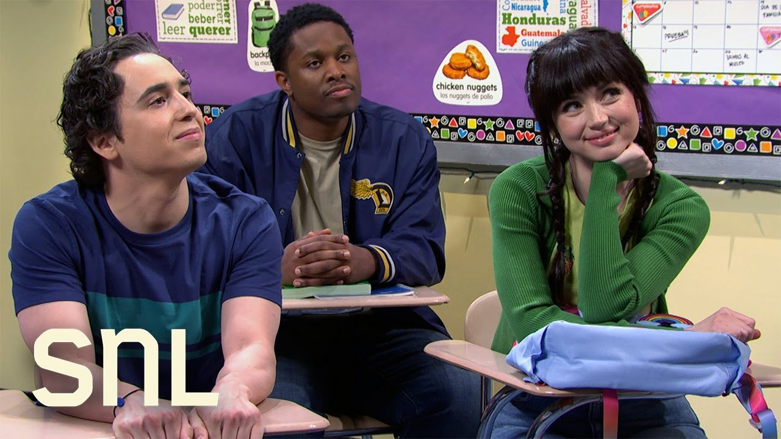  
  
<https://youtu.be/C25VhUJn038>  
  
  
  
  
Saxaboom on a real saxophone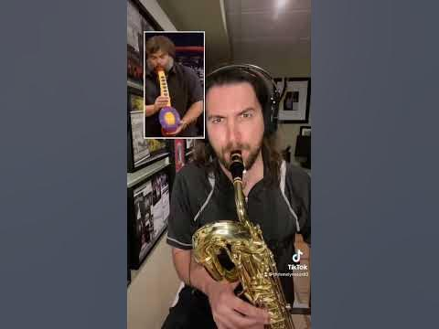  
  
<https://youtube.com/shorts/Y-kozXvgw6I?feature=share>  
  
  
  
  
Dolph Ziggler Sells Superkicks Like No One Else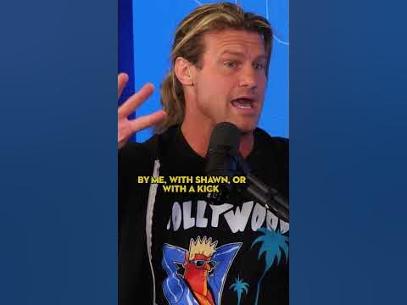  
  
<https://youtube.com/shorts/rtdt2Z2ulfc?feature=share>  
  
  
  
  
Eminem freestyle😳👑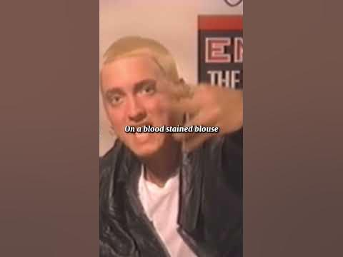  
  
<https://youtube.com/shorts/y3k9Bp6v_-s?feature=share>  
  
  
  
  
My name is Jeff meme  
  
<https://www.youtube.com/watch?v=dRYAeKXhi7I>  
  
  
  
  
Jack Black Vibing in Gta (Saxaboom)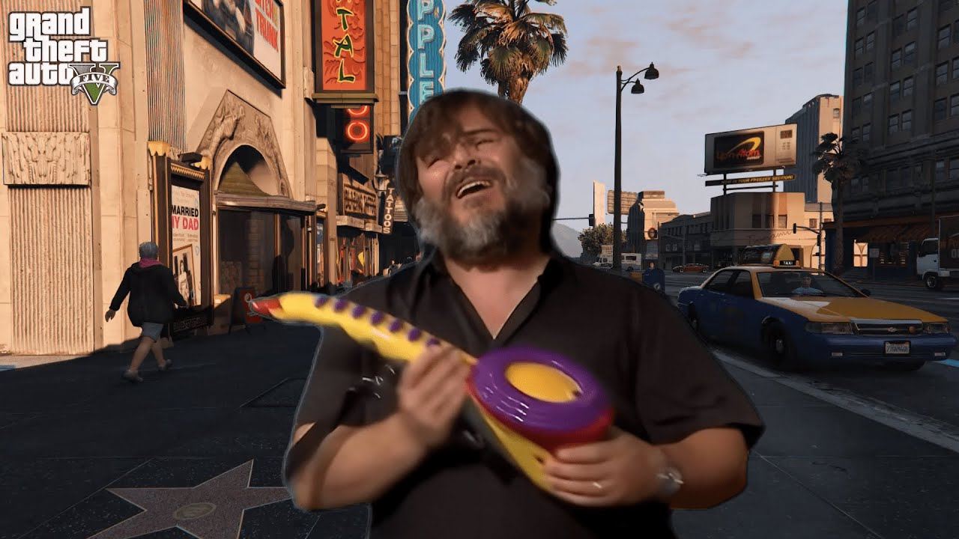  
  
<https://youtu.be/hHY4msMmk1I>  
  
  
  
  
Vince McMahon Recreates The Montreal Screwjob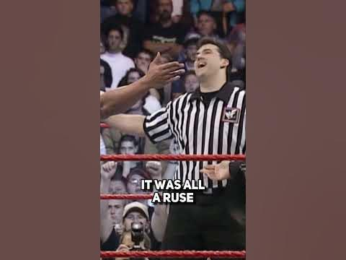  
  
<https://youtube.com/shorts/TryVUK1zq6M?feature=share>  
  
  
  
  
If a Day Was 38 Seconds.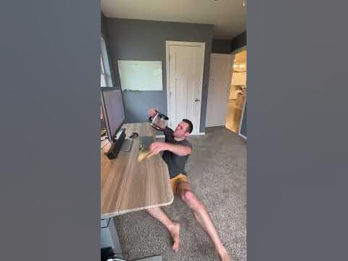  
  
<https://youtube.com/shorts/D8FxfJvuK9g?feature=share>  
  
  
  
  
Family Guy - Theme song (live)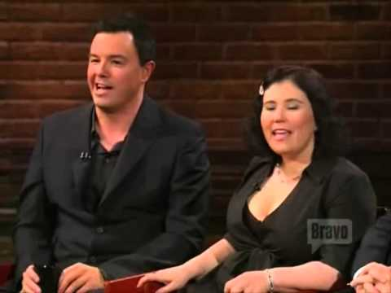  
  
<https://youtu.be/cpO5llTWa6U>  
  
  
  
  
Brock Lesnar has a message for Mustafa Ali 😂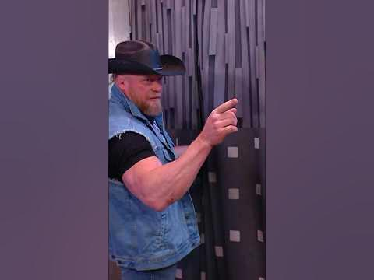  
  
<https://youtube.com/shorts/h6ujub-ik1s?feature=share>  
  
  
  
  
The Dennys Grand Slam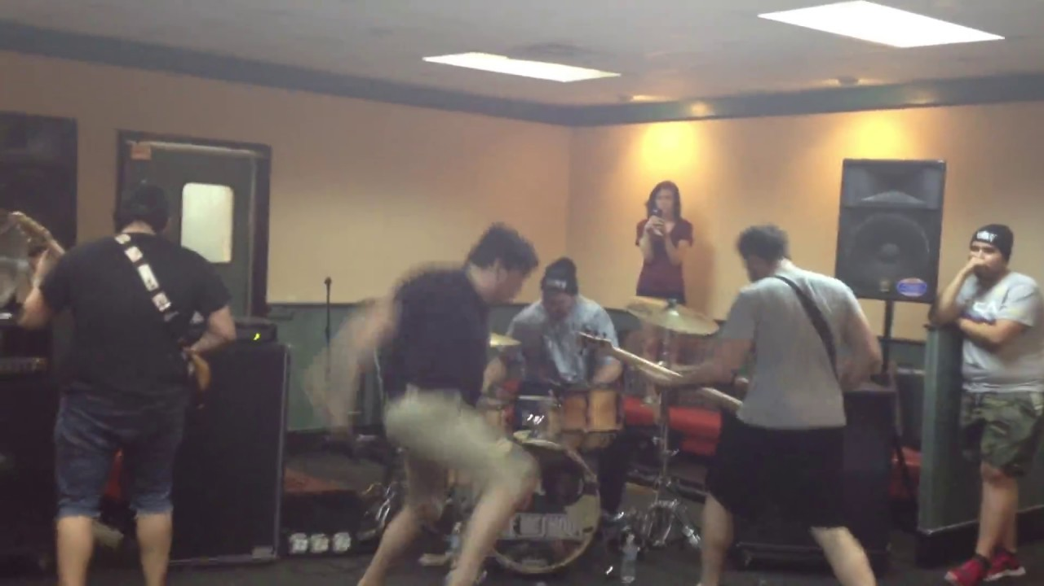  
  
<https://youtu.be/xbPwaAFHDG8>  
  
  
  
  
Family Family Family - Vin diesel meme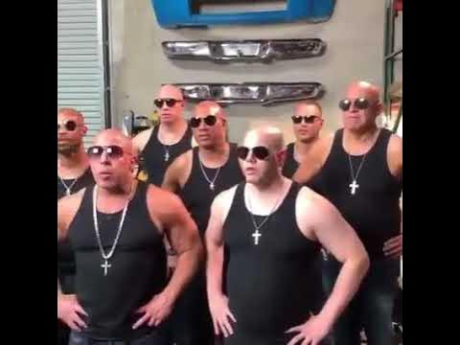  
  
<https://youtu.be/9hoEYaLuDdc>  
  
  
  
  
This dog is always the life of the party! #goldendoodle #celsiuslivefit #celsiusbrandpartner  
  
<https://youtube.com/shorts/ChyNYKSMEcc?feature=share>  
  
  
  
  
That one didn’t age quite so well  
  
<https://youtu.be/s_b4xpWZb3c>  
  
  
  
  
Terrible Mall Commercial  
  
<https://youtu.be/6bnanI9jXps>  
  
  
  
  
Spider-man 3 fart jump with Scooby Doo Laugh  
  
<https://youtu.be/VFckpH130QE>  
  
  
  
  
Marriage proposal gone wrong.. 😂  
  
<https://youtube.com/shorts/cYlmusyhI80?feature=share>  
  
  
  
  
Sugar baby life  
  
<https://youtube.com/shorts/hnzMskeVF88?feature=share>  
  
  
  
  
"Make Me Wanna Die" Cover out now!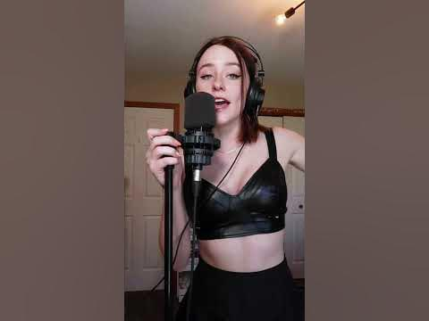  
  
<https://youtube.com/shorts/H_0R_ybepME?feature=share>  
  
  
  
  
What did Biggie say about Michael Jackson?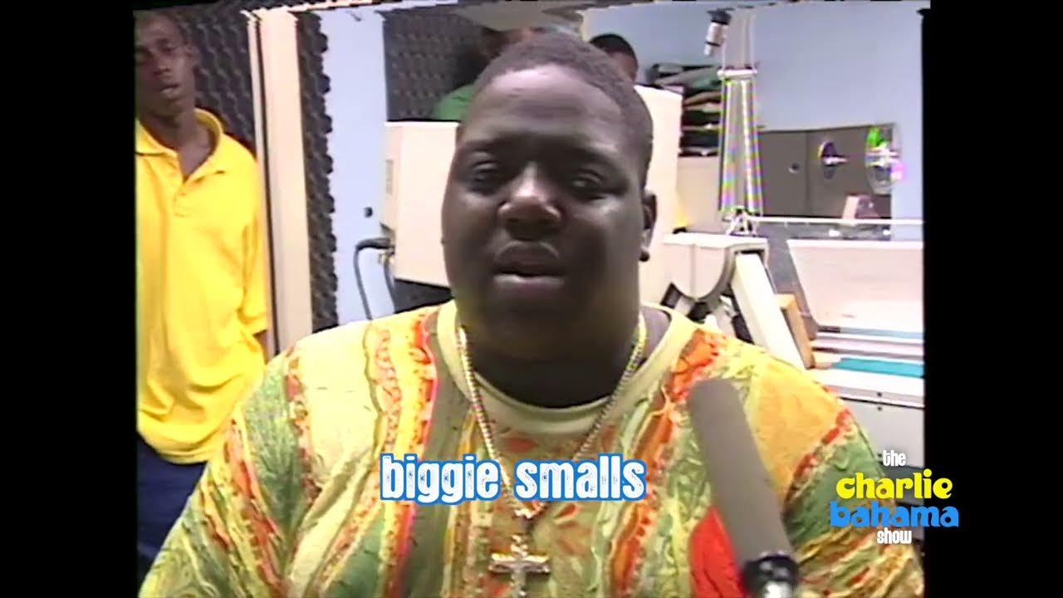  
  
<https://youtu.be/zdBn3hBTTfU>  
  
  
  
  
Jey Uso Turns On Roman Reigns & Sides With His Brother Jimmy : Friday Night Smackdown 6-16-23  
  
<https://youtu.be/SG4JyMbfYaA>  
  
  
  
  
Little kid impersonates The Rock! #Short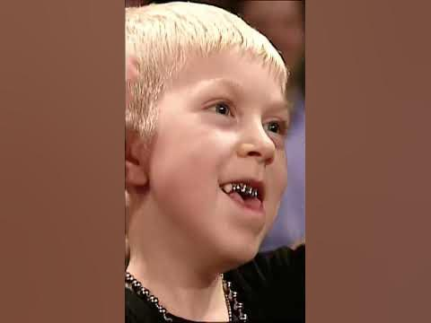  
  
<https://youtube.com/shorts/Iv8JSq_iC4o?feature=share>  
  
  
  
  
WHIPLASH DRUM SOLO - GREYSON NEKRUTMAN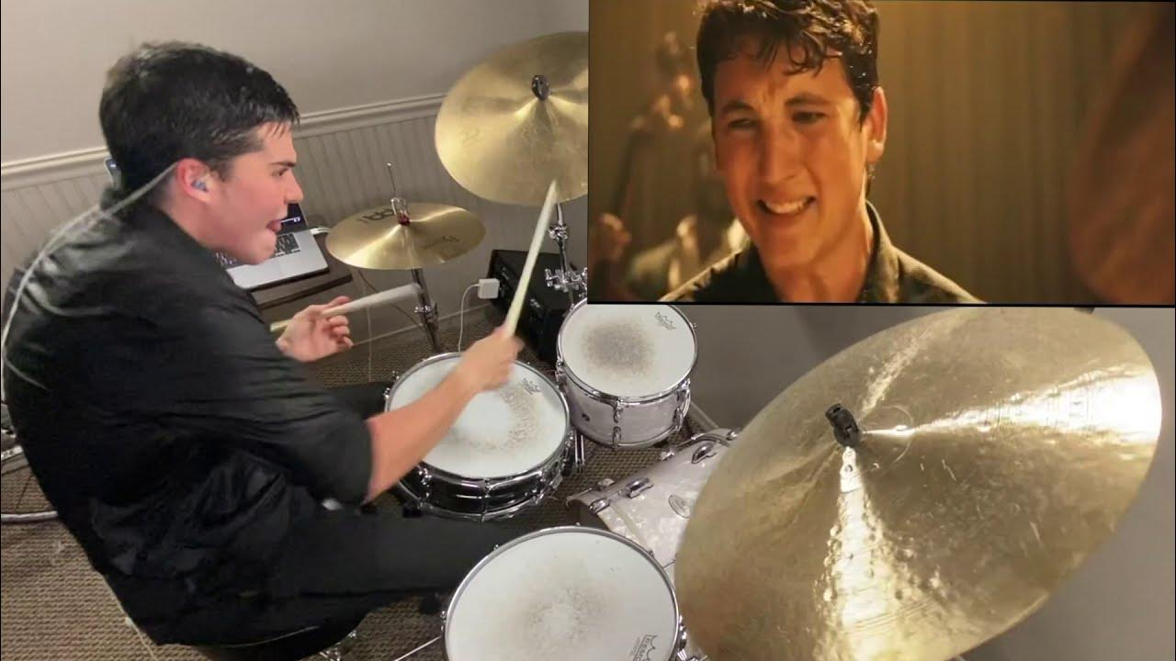  
  
<https://youtu.be/45UQSmiMGaI>  
  
  
  
  
Support The Second World Wars Online Course | Hillsdale College  
The Prodoggy | SMACK MY B17CH UP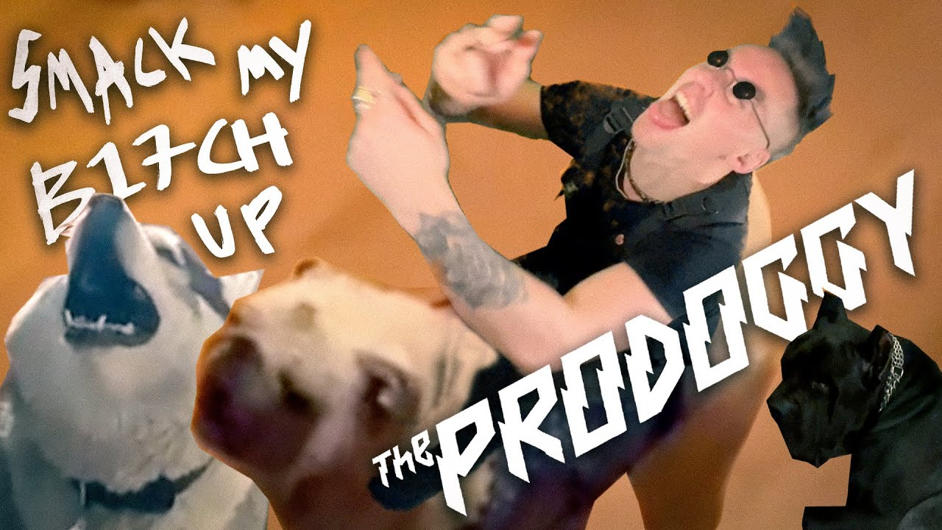  
  
<https://youtu.be/w3NwO24le2E>  
  
  
  
  
Wall of Death (EXTREME) - With Full Force 2014  
  
<https://youtu.be/ySPlanMCmM4>  
  
  
  
  
Highschoolers cover Smells like teen spirit during prom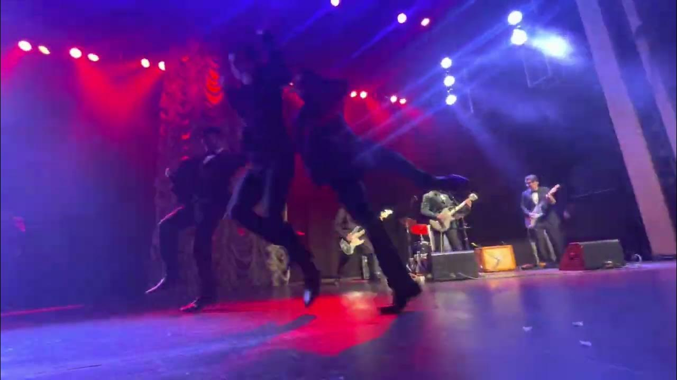  
  
<https://youtu.be/Wh0v6JkAabM>  
  
  
  
  
âRobokiller: Spam Call Blocker  
  
<https://apps.apple.com/us/app/robokiller-spam-call-blocker/id1022831885>  
  
  
  
  
If Roman Reigns Was Your Neighbor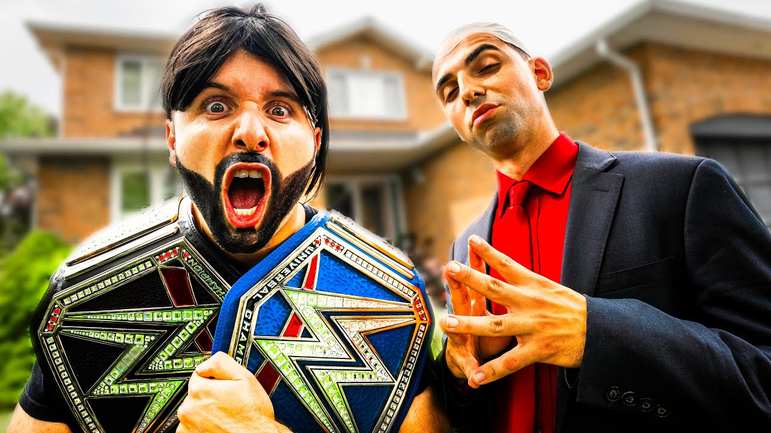  
  
<https://youtu.be/08QlSp1c6F0>  
  
  
  
  
This Drummer Is At The Wrong Gig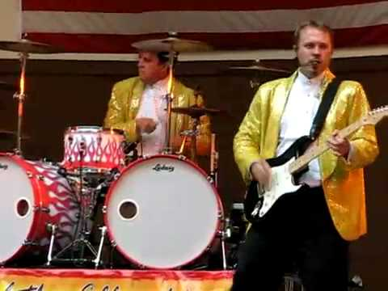  
  
<https://youtu.be/ItZyaOlrb7E>  
  
  
  
  
AEW Forbidden Door 2023 Daniel Garcia dance sequence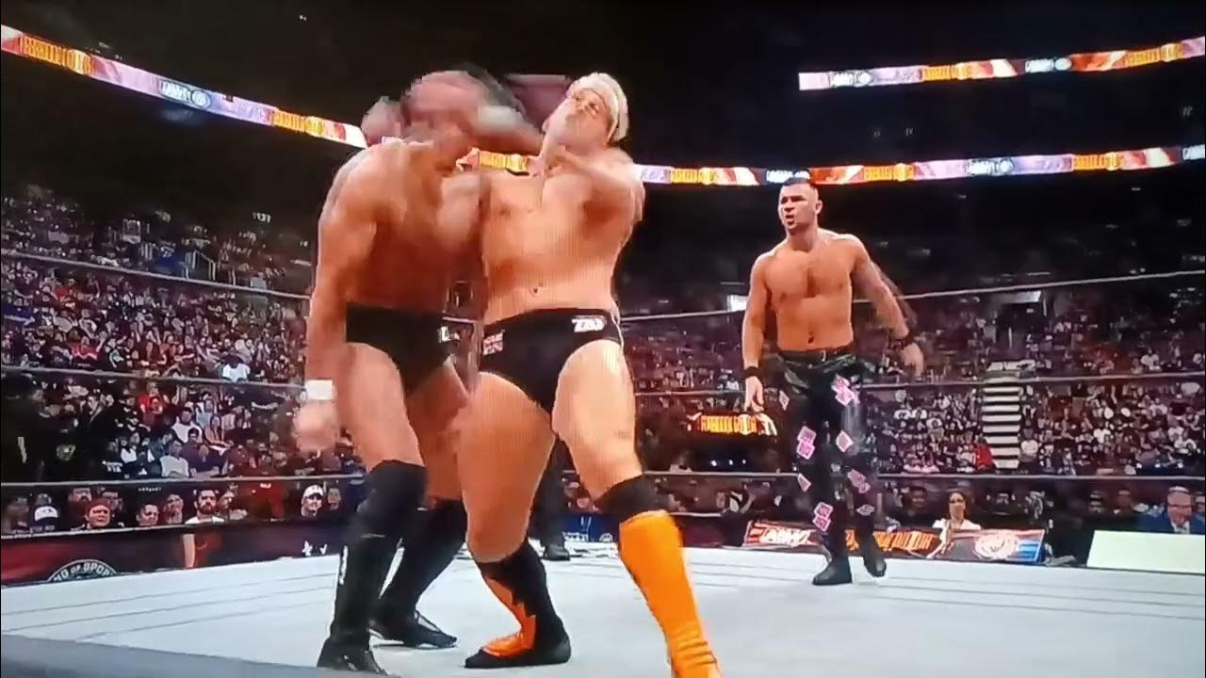  
  
<https://youtu.be/iqeahjrCGlY>  
  
  
  
  
The Last Matches of Chris Benoit; Ending this 11 year case once and for all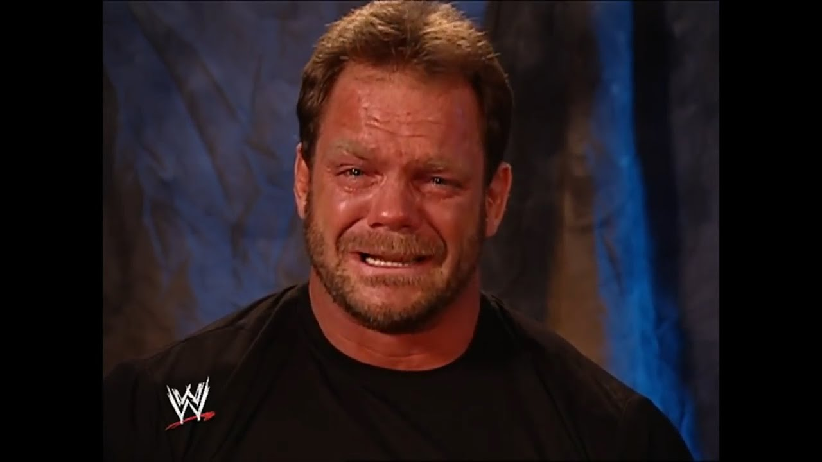  
  
<https://youtu.be/xgXcoAjX5kU>  
  
  
  
  
⚠️graphic⚠️ side effect of vaping… #quitwhileyoucan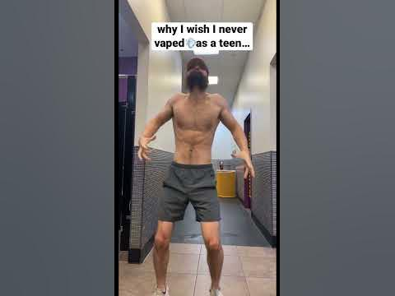  
  
<https://youtube.com/shorts/wMYRJqwersk?feature=share>