ATM SIMULATOR
Source Code & Project Documentation
Student Name | Nisha
Roll No. | 2443002
Assignment | ATM Simulator

1. Source Code (HTML, CSS & PHP)
The complete editable source code provided for the ATM Simulator is given below.
<?php
session_start();

// Default ATM details
if (!isset($_SESSION['balance'])) {
$_SESSION['balance'] = 10000;
}

if (!isset($_SESSION['pin'])) {
$_SESSION['pin'] = "1234";
}

$message = "";

// Login
if (isset($_POST['login'])) {
$pin = $_POST['pin'];

if ($pin == $_SESSION['pin']) {
$_SESSION['login'] = true;
} else {
$message = "❌ Incorrect PIN!";
}
}

// Logout
if (isset($_POST['logout'])) {
session_destroy();
header("Location: atm.php");
exit();
}

// ATM Operations
if (isset($_SESSION['login']) && $_SESSION['login'] == true) {

if (isset($_POST['deposit'])) {
$amount = $_POST['amount'];

if ($amount > 0) {
$_SESSION['balance'] += $amount;
$message = "✅ ₹$amount deposited successfully!";
} else {
$message = "❌ Enter a valid amount.";
}
}

if (isset($_POST['withdraw'])) {
$amount = $_POST['amount'];

if ($amount <= 0) {
$message = "❌ Enter a valid amount.";
} elseif ($amount > $_SESSION['balance']) {
$message = "❌ Insufficient Balance!";
} else {
$_SESSION['balance'] -= $amount;
$message = "✅ ₹$amount withdrawn successfully!";
}
}

if (isset($_POST['change_pin'])) {
$old_pin = $_POST['old_pin'];
$new_pin = $_POST['new_pin'];

if ($old_pin == $_SESSION['pin']) {
if (strlen($new_pin) == 4 && is_numeric($new_pin)) {
$_SESSION['pin'] = $new_pin;
$message = "✅ PIN changed successfully!";
} else {
$message = "❌ New PIN must contain 4 digits.";
}
} else {
$message = "❌ Old PIN is incorrect!";
}
}
}
?>

<!DOCTYPE html>
<html>
<head>
<title>Mini ATM Simulator</title>

<style>
body {
margin: 0;
padding: 0;
font-family: Arial, sans-serif;
background: linear-gradient(135deg, #141e30, #243b55);
display: flex;
justify-content: center;
align-items: center;
min-height: 100vh;
}

.atm {
width: 420px;
background: #f4f4f4;
padding: 25px;
border-radius: 18px;
box-shadow: 0 10px 30px rgba(0,0,0,0.5);
text-align: center;
}

.header {
background: #123c69;
color: white;
padding: 18px;
border-radius: 12px;
margin-bottom: 20px;
}

.header h1 {
margin: 0;
font-size: 28px;
}

.header p {
margin: 5px 0 0;
}

input {
width: 90%;
padding: 12px;
margin: 8px 0;
border: 1px solid #aaa;
border-radius: 7px;
font-size: 16px;
}

button {
width: 95%;
padding: 12px;
margin: 7px 0;
border: none;
border-radius: 7px;
background: #123c69;
color: white;
font-size: 16px;
cursor: pointer;
}

button:hover {
background: #0b2948;
}

.balance {
background: #dff0d8;
padding: 15px;
border-radius: 10px;
margin: 15px 0;
font-size: 20px;
font-weight: bold;
}

.message {
background: #fff3cd;
padding: 12px;
border-radius: 8px;
margin: 12px 0;
}

.section {
background: white;
padding: 15px;
margin: 12px 0;
border-radius: 10px;
}

.logout {
background: #c0392b;
}

.logout:hover {
background: #922b21;
}

h3 {
color: #123c69;
}
</style>
</head>

<body>

<div class="atm">

<div class="header">
<h1>🏧 MINI ATM</h1>
<p>Welcome to ATM Simulator</p>
</div>

<?php if ($message != "") { ?>
<div class="message">
<?php echo $message; ?>
</div>
<?php } ?>

<?php if (!isset($_SESSION['login']) || $_SESSION['login'] != true) { ?>

<h3>🔐 ATM Login</h3>

<form method="post">
<input type="password" name="pin"
placeholder="Enter 4 Digit PIN"
maxlength="4" required>

<button type="submit" name="login">
LOGIN
</button>
</form>

<p><b>Demo PIN:</b> 1234</p>

<?php } else { ?>

<h3>Welcome, Nisha 👋</h3>

<div class="balance">
Current Balance:
₹<?php echo number_format($_SESSION['balance'], 2); ?>
</div>

<!-- Deposit -->
<div class="section">
<h3>💰 Deposit Money</h3>

<form method="post">
<input type="number"
name="amount"
placeholder="Enter Amount"
required>

<button type="submit" name="deposit">
DEPOSIT
</button>
</form>
</div>

<!-- Withdraw -->
<div class="section">
<h3>💸 Withdraw Money</h3>

<form method="post">
<input type="number"
name="amount"
placeholder="Enter Amount"
required>

<button type="submit" name="withdraw">
WITHDRAW
</button>
</form>
</div>

<!-- Change PIN -->
<div class="section">
<h3>🔑 Change PIN</h3>

<form method="post">
<input type="password"
name="old_pin"
placeholder="Old PIN"
maxlength="4"
required>

<input type="password"
name="new_pin"
placeholder="New 4 Digit PIN"
maxlength="4"
required>

<button type="submit" name="change_pin">
CHANGE PIN
</button>
</form>
</div>

<!-- Logout -->
<form method="post">
<button type="submit" name="logout" class="logout">
🚪 LOGOUT
</button>
</form>

<?php } ?>

</div>

</body>
</html>

2. Images / Assets
The project interface uses CSS styling and does not require external image assets. The following screenshots are included as output images for the project.
Asset / Output 1: ATM Login Screen
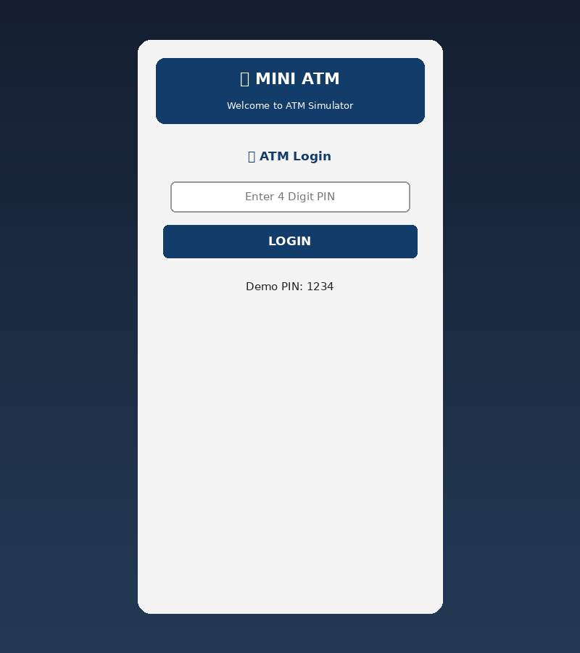
Asset / Output 2: ATM Dashboard
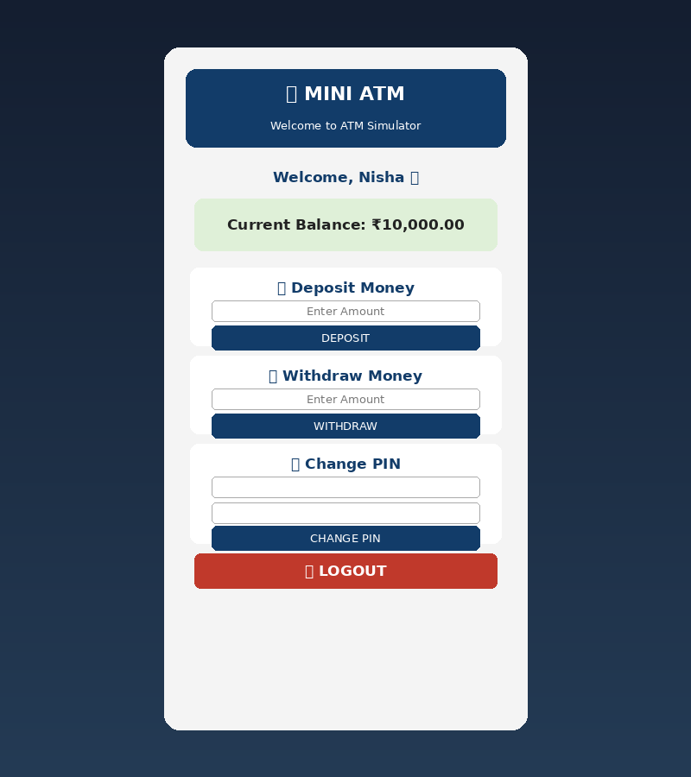
Asset / Output 3: Deposit Successful
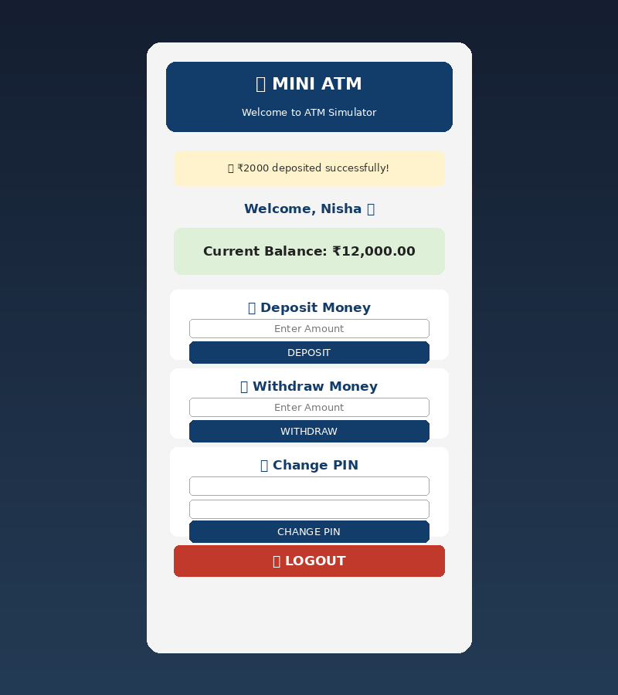
Asset / Output 4: Withdrawal Successful
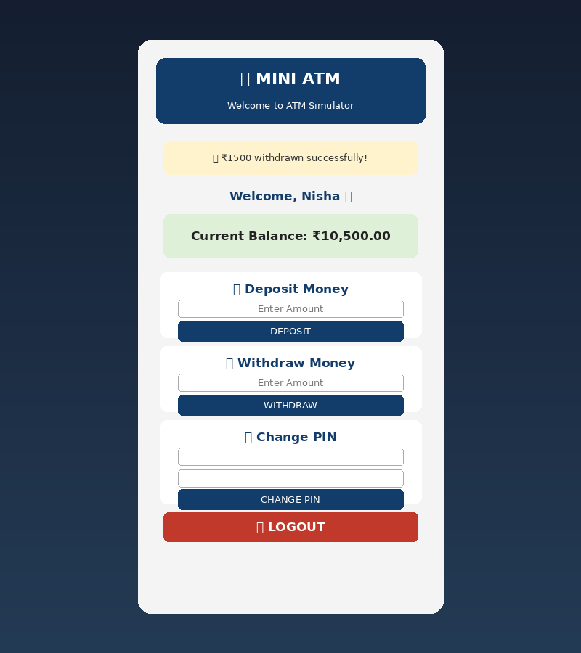

3. README.md – Project Documentation

3.1 Student Details
Student Name | Nisha
Roll No. | 2443002
Assignment | ATM Simulator
Project Type | PHP Web Application

3.2 Project Objective
The objective of the Mini ATM Simulator is to develop a simple web-based ATM system using PHP, HTML and CSS. The application demonstrates PIN authentication, balance management, deposit, withdrawal, PIN changing and logout. PHP sessions maintain the balance, PIN and login state during the session.

3.3 Features
- PIN-based ATM login with demo PIN 1234.
- Initial account balance of ₹10,000.
- Session-based balance and PIN storage.
- Deposit money with amount validation.
- Withdraw money with insufficient-balance checking.
- Change PIN after verifying the old PIN; new PIN must be 4 numeric digits.
- Success and error messages.
- Logout using PHP session destruction.
- Clean ATM interface using HTML and CSS.

3.4 Algorithm / Flowchart
1. Start application.
2. Start PHP session and initialize balance/PIN if not already present.
3. Show login screen.
4. Check entered PIN. If incorrect, display error; if correct, allow ATM operations.
5. Display current balance and operation forms.
6. Deposit: validate amount and add it to balance.
7. Withdraw: validate amount, check balance and deduct if sufficient.
8. Change PIN: verify old PIN and validate the new 4-digit PIN.
9. Logout: destroy session and return to login.
START
↓ Session + default balance/PIN
↓ Enter PIN
↓ PIN correct?
→ NO: Incorrect PIN message
→ YES: ATM Dashboard
↓ Deposit / Withdraw / Change PIN
↓ Validate + update session balance/PIN
↓ Display result
END / Continue

3.5 Technologies Used
Technology | Purpose | Application
PHP | Server-side processing and sessions | Login, ATM operations, PIN and logout
HTML | Structure and forms | ATM pages and input fields
CSS | Design and layout | Background, cards, buttons and messages

3.6 Steps to Run
- Install XAMPP, WAMP or another PHP server environment.
- Save the source code as atm.php.
- Place the file inside the server's project/htdocs folder.
- Start Apache/PHP.
- Open the ATM project in a web browser.
- Use demo PIN 1234 to log in.
- Test deposit, withdrawal, change PIN and logout.

3.7 Output Screenshots
The screenshots included above demonstrate the login screen, dashboard, deposit result and withdrawal result of the ATM Simulator.

3.8 Conclusion
The ATM Simulator successfully demonstrates the use of PHP sessions, HTML forms and CSS to create an interactive ATM-style web application. It provides authentication, balance management, deposit, withdrawal, PIN changing and logout in a simple interface.

