Predicting When Avocados Will Spoil
Nishad Wajge

Background
Model looks at daily photos of an avocado and predicts how many days are left until it spoils. Instead of one guess (“5 days”), it gives a range with odds (“likely 5 days until spoilage; 80 % chance it is between 4 and 7”).
How it works: the model keeps a hidden “ripeness score” for each fruit. Each day the score rises a little, with some randomness (similar to the way a stock price drifts). When the score crosses a fixed line, the fruit counts as spoiled. Each new photo updates the score. Temperature sets how fast the score rises, using a standard chemistry rule (the Arrhenius equation: reactions run faster when warm).

Main findings
- Accurate: on average the prediction is 1.2 days off, and the true spoilage day lands inside the model's “80% likely” range 93% of the time. [Chart 1]
- Works at new temperatures: when trained on two storage temperatures and tested on a third it never saw, the Arrhenius equation rule cuts the error by 1.5 to 2.4 times. [Chart 2]
- Weak spot: for fruit stored colder than anything trained on, it is about 5 days off and too confident.

Results
Table 1
What we measure | What it means | Main avocado photos | Microwave-scan avocados
Average error | How many days off the prediction is, on average.  Lower is better. | 1.2 days | 1.0 days
Range hit rate | How often the real spoilage day falls inside the model's “80 % likely” range. About 80–90 % means the ranges are honest. | 93 % | 89 %
Ordering accuracy | Given two fruits, how often the model correctly says which spoils first. 50 % is a coin flip; 100 % is perfect. | 93 % | 78 %
Range width | How wide the “80 % likely” range is. Narrower is more useful, as long as the hit rate stays high. | 4.3 days | 5.4 days
Overall forecast score (CRPS) | One number that scores the whole range of predictions at once, in days. It rewards being right and being confident in the right place. Lower is better. | 0.85 | 1.20

Comparing the two datasets. On the microwave-scan avocados the average error looks slightly better (1.0 vs 1.2 days), but that comes from only 9 predictions on 4 fruit, so it could easily be luck. The other measures favour the main dataset: the model orders fruit correctly 93 % of the time against 78 %, its ranges are a day narrower (4.3 vs 5.4 days), and its overall forecast score is better (0.85 vs 1.20).

Chart 1: How it compares with other AI models
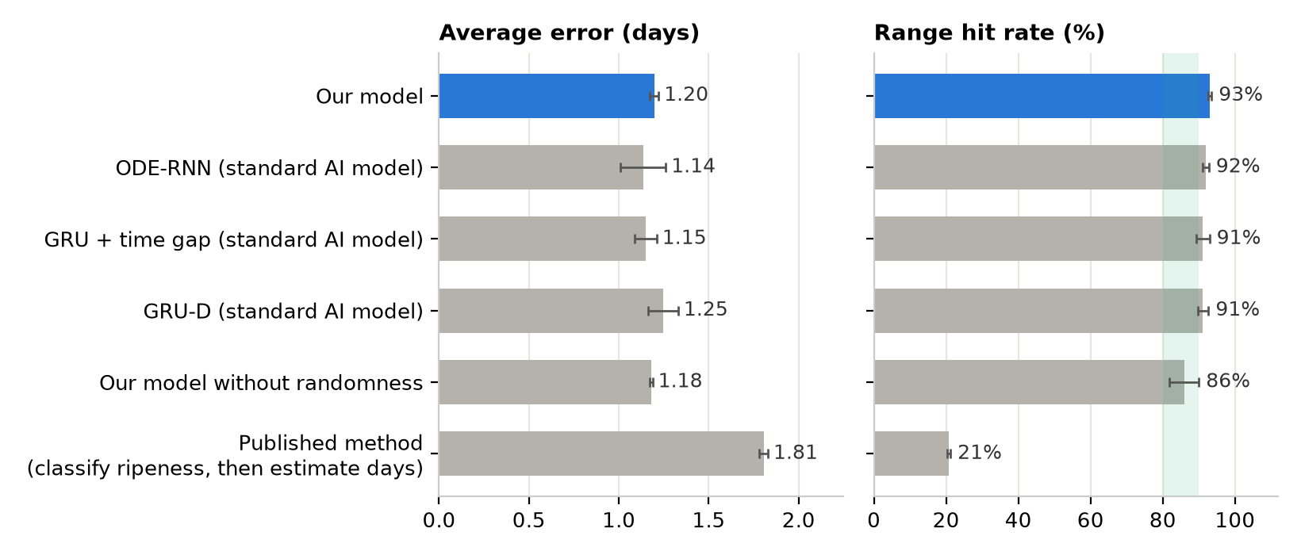
Main avocado photos. GRU, GRU-D and ODE-RNN are widely used neural networks for data that arrives over time. Bars are averages over 5 training runs, and the black lines show how much they vary between runs. The published method gives a single number with no range, so its “range” almost never contains the true day.

Chart 2: Why the temperature rule matters
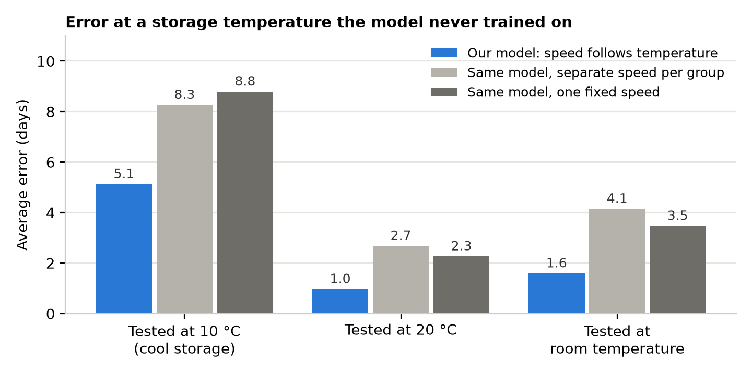
Each group of bars hides one storage temperature during training, then tests on it. The blue bar is our model; the grey bars are the same model without the temperature rule. Lower is better. (Results from the first round of experiments, 5 training runs each.)

