Predicting When Mangoes Will Spoil
Nishad Wajge

Background
Goal: tell how many days a mango has left before it spoils, from a photo, a microwave scan, or both. A lab bought 48 mangoes in one batch and stored them together for two weeks. Every other day they scanned every mango with a microwave sensor (weak radio waves that pass through the fruit and change as its water and sugar change). On each of those days they also cut open 6 mangoes to measure firmness and sweetness, and photographed those 6. A mango counts as spoiled when its flesh has gone fully soft (firmness 1 N or less). That happened only on days 12 and 14.
Teaching a photo model with microwave scans: a shopper has a phone camera, not a microwave scanner. So we also tried a training method from a 2023 paper (SAMD): a “teacher” model that sees both the photo and the microwave scan coaches a “student” model that sees only the photo. Once trained, the student needs only the photo.

Main findings
- Microwave beats photos: with the microwave scan, the forecast score improves by about a quarter (0.20 to 0.15) for every AI model we tried, a gap too large to be luck. The scan also estimates firmness and ripeness better. [Chart 1]
- Teaching did not help: the photo-only student coached by the microwave teacher was no better than a photo-only model trained on its own. It only helped models whose photo-only version was poor to begin with. [Chart 1]
- Age is most of the story: a simple rule (estimate how old the mango is, then look up how fast this batch spoiled) beats every AI model. Knowing the true age is best of all. [Chart 2]
- Weak spot: no model can tell which of two mangoes of the same age will spoil first, and the AI models expect spoilage 1 to 3 days too late.

Results
Table 1
What we measure | What it means | Photo only | Photo, taught by microwave | Microwave only | Photo + microwave
Forecast score | Scores the predicted chance of being spoiled by each future day against what happened to the batch. 0 is perfect; 0.25 is guessing 50/50 every time. Lower is better. | 0.20 | 0.21 | 0.15 | 0.15
“Spoiled now?” score | The same score for one question: is this mango spoiled today? Lower is better. | 0.16 | 0.19 | 0.16 | 0.14
Matches firmness | Do mangoes predicted to last longer really feel firmer? 1 is a perfect match; 0 is no relation. | 0.25 | 0.20 | 0.61 | 0.74
Predicted spoilage day | Average day the model expects a mango to spoil. The batch really spoiled between days 10 and 14. | day 15.2 | day 15.8 | day 14.6 | day 14.3
Firmness estimate | How far off the estimated firmness is, on average. For scale: about 38 N on day 0, 1 N when spoiled. | 6.6 N | — | 5.7 N | 5.6 N
Ripeness class | How often the estimated class (unripe, underripe, ripe, overripe, spoiled) is right or one step off. | 81 % | — | 94 % | 94 %
First four rows: the standard AI model (GRU), averaged over 3 training runs; every mango is scored once, by a model that never saw it in training. Last two rows: a simple read-out from the same inputs. The taught photo model only forecasts spoilage, so those two cells are empty.
Comparing the inputs. Adding the microwave scan helps on every measure. The forecast score drops from 0.20 to 0.15, and the match with firmness rises from 0.25 to 0.74. The firmness estimate is a newton closer, and the ripeness class is within one step 94 % of the time instead of 81 %. The photo still adds a little on top of the scan. It is what the cut fruit looked like on its last day, so it helps most with “spoiled now?” (0.16 to 0.14). Teaching the photo model with the scan left it about where it was (0.21 vs 0.20).

Chart 1: Which input helps
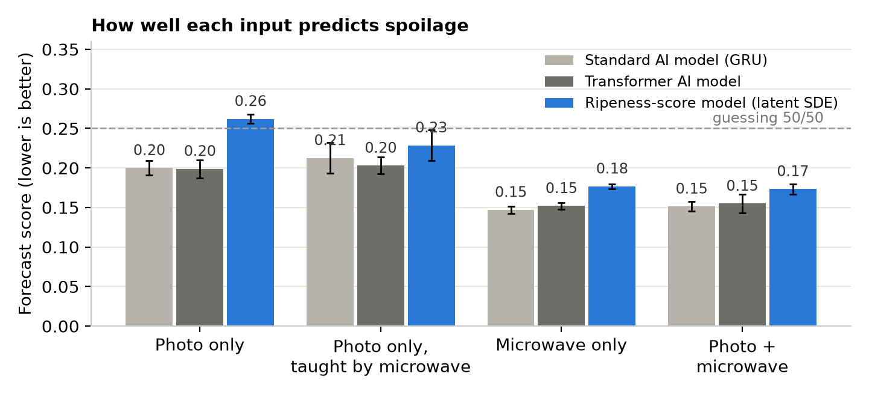
Each group is one choice of input. GRU and the transformer are widely used AI models for data that arrives over time. The ripeness-score model is the one from the avocado study: a hidden ripeness score that drifts upward until it crosses a spoilage line. Bars are averages over 3 training runs; black lines show how much they vary. The ripeness-score model, which led on avocados, trails here, because it was built to follow a fruit over many days and each mango here gives one snapshot.

Chart 2: Why age matters most
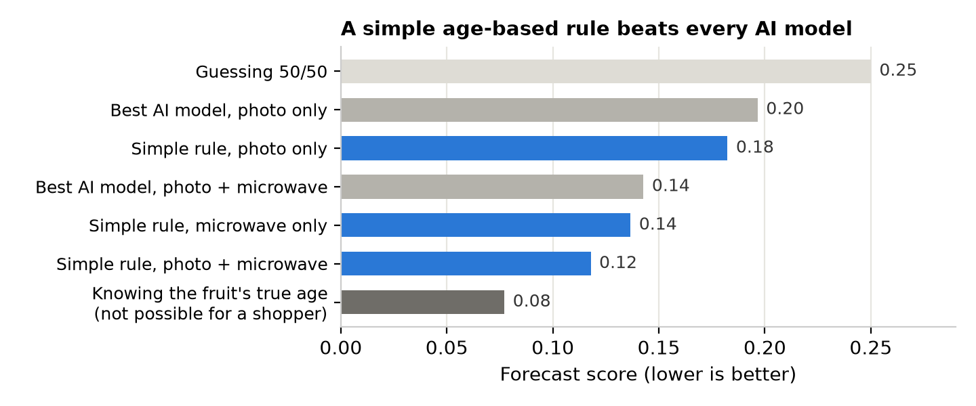
The blue “simple rule” bars guess the mango's age from its photo or scan, then read off how much of this batch had spoiled by that age. The grey bars are the best AI model for that input. The dark bar uses the true age, which a shopper never knows. Because all 48 mangoes ripened together, age explains most of when they spoiled.

