Which Microwave View Best Predicts Avocado Spoilage
Nishad Wajge

Background
Goal: find which of the microwave scanner's six views best predicts how many days an avocado has left, and whether the scanner can teach a photo-only model. The lab followed 15 avocados for two weeks. Four of them (avocados 1, 2, 3 and 11) were photographed and scanned every other day until they spoiled; the other 11 were photographed daily and scanned once, on the day they were cut open. Each scan turns the fruit and records six views, 60° apart (0°, 60°, 120°, 180°, 240° and 300°).
A change from the earlier results: in this dataset each visit's ripeness rating was set by the study day, not by looking at the fruit. If the model is given those ratings, it can read the answer off the calendar and never needs the scanner, so in this study the ratings were used only to grade the model, never as an input. Each model was trained with one of the four followed avocados held out and then scored on it, four times over, and every run was repeated 3 times.

Main findings
- Three of the six views work better: the 0°, 120° and 240° views predicted better than the 60°, 180° and 300° views in 14 of 16 comparisons (with and without the photo, before and after the correction step, on the four followed avocados and on all 15). No single view stands out within each group. [Chart 1]
- Best combination: the photo plus the average of the 0°, 120° and 240° views was off by 0.75 days on average, against 0.79 using all six views (as presented) and 1.10 with no sensor at all. [Table 1]
- The gains are small: all four followed avocados spoiled between day 7 and day 9, so knowing the date alone already gets within about a day. After the correction step, the photo alone does as well as any microwave setup.
- Teaching did not help: the photo + microwave teacher was no better than the photo alone, so it had nothing to pass on. None of the five ways of teaching a photo-only model reliably beat a photo-only model trained on its own. [Chart 2]

Results
Table 1
What we measure | What it means | No sensor (date only) | Photo only | Microwave, views 0/120/240 | Microwave, views 60/180/300 | Photo + views 0/120/240 | Photo + all six views
Forecast score | How much probability the model gave to the day the avocado really spoiled. Lower is better. | 1.03 | 0.92 | 0.91 | 1.03 | 0.88 | 0.96
Days off | Average gap between the predicted and real spoilage day. | 1.10 | 0.85 | 0.77 | 1.10 | 0.75 | 0.79
Forecast score, corrected | The same score after a correction step that makes the stated ranges honest, learned from the other held-out avocados. | 0.57 | 0.37 | 0.48 | 0.79 | 0.57 | 0.58
80 % range holds the real day | After correction. The model gives a range it is 80 % sure of; about 80 % is right. | 77% | 73% | 75% | 75% | 73% | 79%
The ripeness-score model (latent SDE), scored on the four followed avocados, averaged over 3 runs. Each avocado is scored by a model that never saw it in training. “Averaged” views: the model sees the average and spread of those views' readings.
Comparing the inputs. The 0°, 120° and 240° views beat the date-only model (forecast score 0.91 vs 1.03); the other three views add nothing (1.03). Adding the photo to the better three helps a little more (0.88). The best single view, 240°, does about as well on its own (0.83). After the correction step every model's ranges are honest (about 75 % instead of 100 %), and the differences between inputs shrink to within run-to-run variation.

Chart 1: Every view, alone and combined
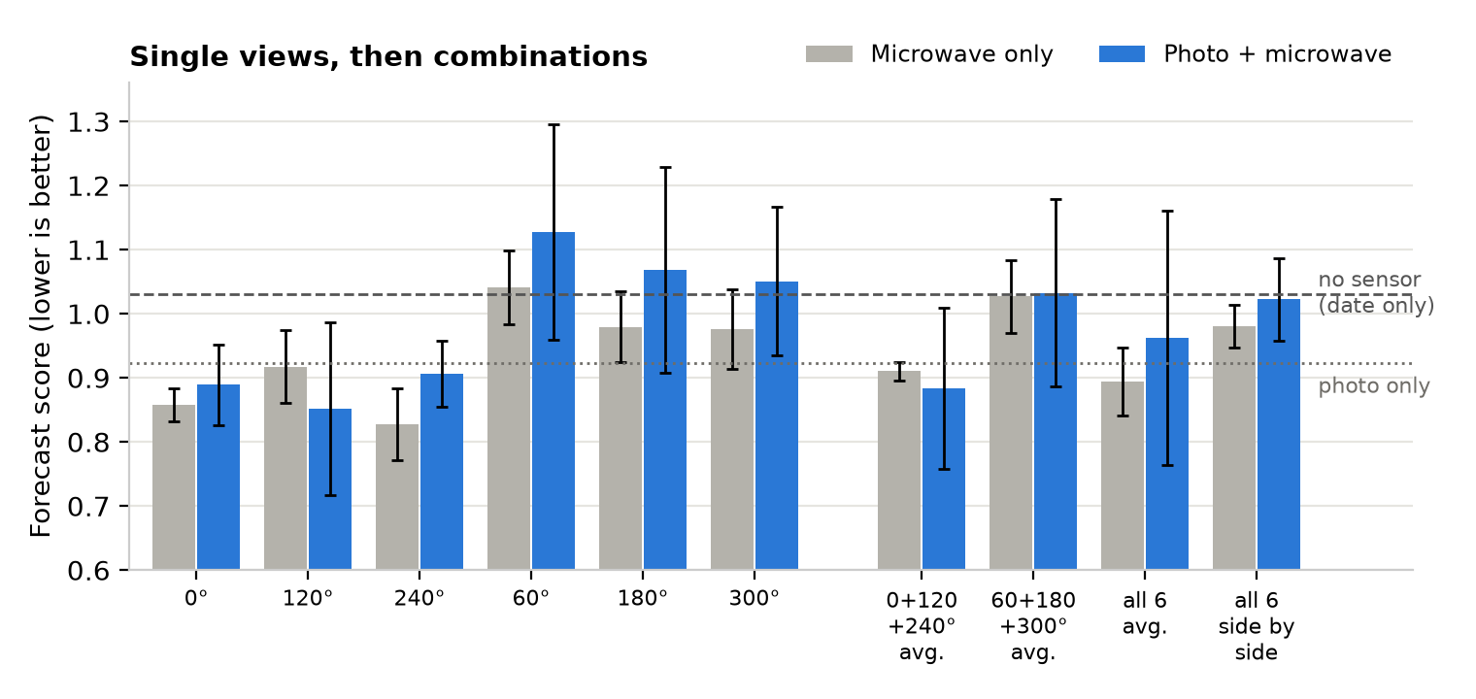
Each pair of bars is one choice of scanner view: grey with the microwave alone, blue with the photo added. Bars are averages over 3 runs; black lines show how much they vary. Dashed line: a model that knows only the date. Dotted line: the photo alone. Bars below the dashed line beat the calendar. The 0°, 120° and 240° views sit lower than the 60°, 180° and 300° views; the reason (for example how the scanner's antennas are arranged) is not known.

Chart 2: Teaching a photo-only model
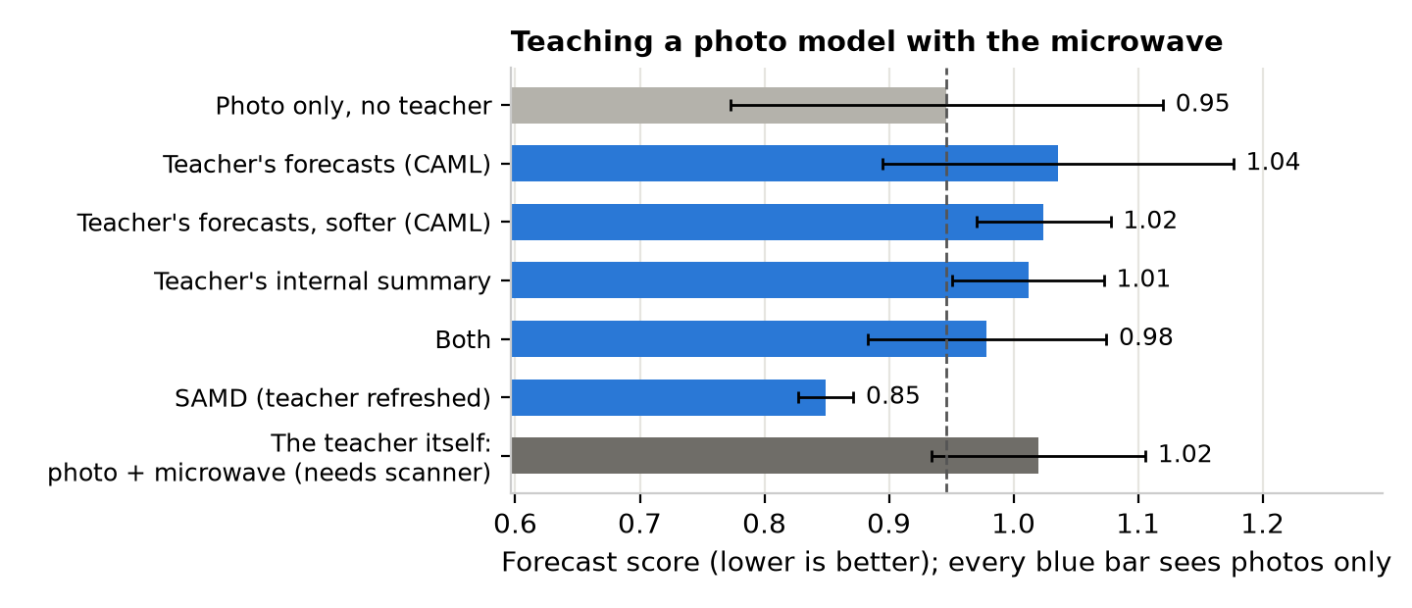
A shopper has a phone camera, not a microwave scanner. Each blue bar is a photo-only model trained with help from a “teacher” that sees the photo and the 0°, 120° and 240° scans. The teacher shares its forecasts (CAML, a 2025 method; the paper's setting and a softer one), a summary of what it has seen, or both; SAMD (a 2023 method) also refreshes the teacher from the student as they train. The dark bar is the teacher itself. SAMD came out lowest here, but its gap from the photo-only model is smaller than how much the photo-only model varies between runs, before and after the correction step.

