Scanner Views, Time-Series Models and Teaching a Photo Model: Avocados and Mangoes
Nishad Wajge

Background
This study asks three questions about the microwave scanner, on two fruits. First, which of the scanner's views carries the most information, and is it better to use one view, merge all of them, or train one model per view and combine their forecasts? Second, which kind of time-series model makes the best use of repeated scans? Third, can a model that sees both the photo and the scan teach a model that sees only the photo, which is what a shopper would have? For the third question we used the teaching methods in the lab's code (RepDistiller and TMC) and the lab's own method, plus two methods from our earlier work.
Avocados: 15 avocados followed for two weeks. Four (avocados 1, 2, 3 and 11) were photographed and scanned every other day until they spoiled; the other 11 were scanned once. Each scan records six views, 60° apart. Each model was trained with one followed avocado held out and scored on it, four times over, and every run was repeated 3 times. The score is how much probability the forecast gave to the day the avocado really spoiled (lower is better).
Mangoes: 48 mangoes from one batch, scanned every other day for two weeks; on each of those days 6 were cut open, photographed on two sides and checked for spoilage. The scanner is a ring of 10 antennas; we grouped the 45 antenna pairs by how far apart the two antennas are (1 to 5 places around the ring; 5 apart is straight across), plus the scanner's own image reconstruction. The score compares each mango's forecast with what happened to the other mangoes over the next days (0 is perfect, 0.25 is a coin flip; lower is better).

Main findings
- Avocado views: with the latent SDE the 0°, 120° and 240° views are again the most useful. With the latent ODE every view does about equally well, and the differences are small next to run-to-run variation. Training six separate models and combining their forecasts was no better than merging the views into one model. [Chart 1]
- Best avocado model: the latent ODE beat the latent SDE with every input (photo + 0/120/240°: 0.80 vs 0.88). [Table 1]
- Teaching a photo model, avocados: the methods that rebuild the teacher from the student each round (SAMD, the lab's method and its variants) beat the photo-only model, by up to a third (latent SDE: 0.95 to 0.60). Methods with a fixed teacher did not help. [Chart 2, Table 2]
- That gain does not come from the scanner: the same take-turns training with no teaching term at all does as well or better (latent SDE 0.55, latent ODE 0.42, against 0.95 and 0.67 for photo-only), and so does a teacher that sees only photos (SAMD: 0.67 and 0.39). What helps is the way the photo model is trained, not what the scanner teaches it. The teacher itself, with the scanner, was never better than the photo-only model. [Table 2]
- Mango views: every antenna spacing beats the photo alone (0.246). Spacings 1, 2, 4 and 5 are within 0.01 of each other (best: 5 apart, straight across, with the photo, 0.160). Antennas 3 apart are the weakest (0.202). Combining six per-view models (0.161) is as good as the best single spacing. The two photo sides are interchangeable. [Chart 3]
- Mango time series: once a model sees every earlier scan and knows how long the mango has been stored, elapsed time alone is enough. The latent ODE with time only (0.071) matches the known-age rule (0.077); adding the scans (0.082) or photos (0.100) does not help. The latent ODE beats the latent SDE with every input. [Chart 4, Table 3]
- Teaching a photo model, mangoes: no method beat the photo-only model (0.100); all landed within 0.012 of it, even though the teacher itself does better (0.082). [Chart 5]
- Correction step: the step that makes stated ranges honest improved most avocado scores. After it, the take-turns gains hold for the latent SDE (photo-only 0.53, take-turns 0.16) but not for the latent ODE (photo-only 0.22, best method 0.17). On mangoes it made every model worse in all six versions we tried, so mango numbers here are uncorrected.

Avocados

Chart 1: Every scanner view, two models
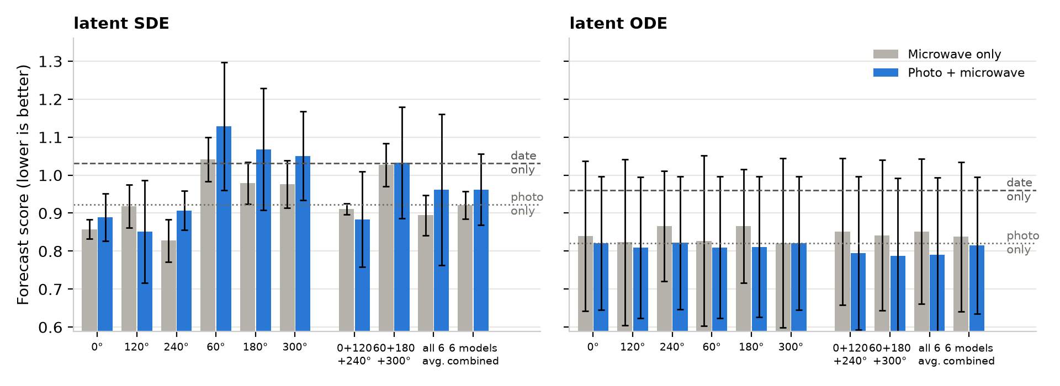
Each pair of bars is one choice of scanner view: grey with the microwave alone, blue with the photo added. Bars are averages over 3 runs; black lines show how much they vary. Dashed line: a model that knows only the date. Dotted line: the photo alone. “6 models combined”: one model per view, forecasts averaged afterwards.
Table 1: Two time-series models
Model | Date only | Photo only | Microwave 0/120/240° | Photo + 0/120/240° | Photo + all six | Photo + six models combined
Latent SDE | 1.03 (1.10 d) | 0.92 (0.85 d) | 0.91 (0.77 d) | 0.88 (0.75 d) | 0.96 (0.79 d) | 0.96 (0.92 d)
Latent ODE | 0.96 (0.73 d) | 0.82 (0.69 d) | 0.85 (0.65 d) | 0.80 (0.62 d) | 0.79 (0.62 d) | 0.82 (0.60 d)
Forecast score, lower is better, with the average days off in brackets. Followed avocados, 3 runs each. The latent SDE and latent ODE imagine a hidden ripeness that drifts over time (the SDE adds random jolts).

Chart 2: Teaching a photo-only model
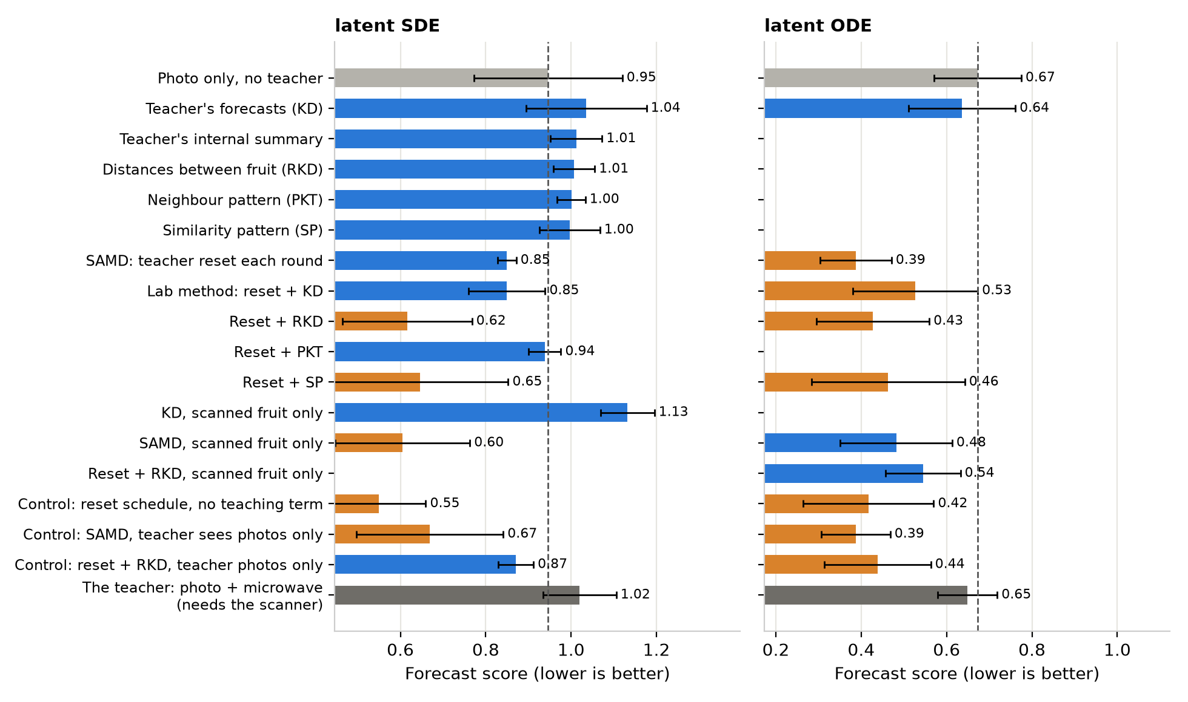
Each blue or orange bar is a photo-only model trained with help from a teacher that also sees the 0°, 120° and 240° scans. Orange: clearly better than the photo-only model (the 95 % range of the difference excludes zero). The dark bar is the teacher itself. The three “control” rows use the same training schedule, but either drop the teaching term or give the teacher photos only. Blank rows were not run for that model.
Table 2: Teaching methods, before and after the correction step
Method | Latent SDE | Latent SDE, corrected | Latent ODE | Latent ODE, corrected
Photo only, no teacher | 0.95 | 0.53 | 0.67 | 0.22
Teacher's forecasts (KD) | 1.04 | 0.85 | 0.64 | 0.25
SAMD | 0.85 | 0.46 | 0.39 | 0.27
Lab method: reset + KD | 0.85 | 0.26 | 0.53 | 0.31
Reset + RKD | 0.62 | 0.24 | 0.43 | 0.17
Reset + SP | 0.65 | 0.28 | 0.46 | 0.31
SAMD, scanned fruit only | 0.60 | 0.19 | 0.48 | 0.22
Control: no teaching term | 0.55 | 0.16 | 0.42 | 0.35
Control: SAMD, photo-only teacher | 0.67 | 0.23 | 0.39 | 0.27
Control: reset + RKD, photo-only teacher | 0.87 | 0.45 | 0.44 | 0.17
The teacher (needs the scanner) | 1.02 | 0.66 | 0.65 | 0.21
Forecast score, lower is better; followed avocados, 3 runs each. “Corrected”: after the step that makes stated ranges honest, learned from the other held-out avocados.
Tuning. We tried 3 teaching strengths × 3 learning speeds for the two best methods and picked the setting with the best score on fruit held aside for checking, not on the test avocados. For reset + RKD the pick was strength 1, speed 0.003 (score 0.44). For SAMD on scanned fruit it was strength 1, speed 0.001 (score 0.80; the same setting scored 0.60 in an earlier run, so repeat runs vary by about 0.2). The teaching strength barely mattered: tenfold changes moved the score less than repeating a run. The learning speed mattered much more, which fits the finding that the training schedule, not the teacher, is what helps.

Mangoes

Chart 3: One scan, by antenna spacing
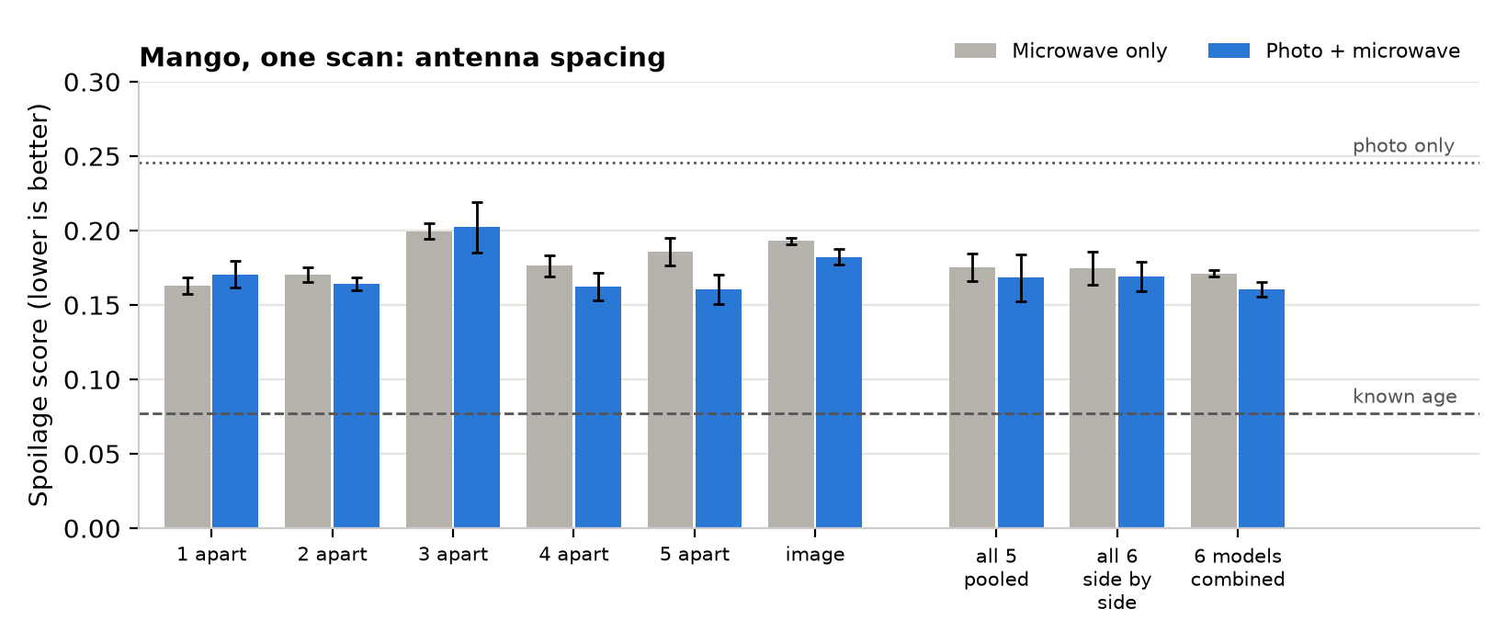
Latent SDE, one scan per mango, 3 runs each. Grey: microwave alone; blue: photo added. Dotted line: photo alone. Dashed line: a rule that knows each mango's true age and looks up how fast this batch spoiled. Every scanner input beats the photo; none comes near the known-age rule.

Chart 4: Every earlier scan, two time-series models
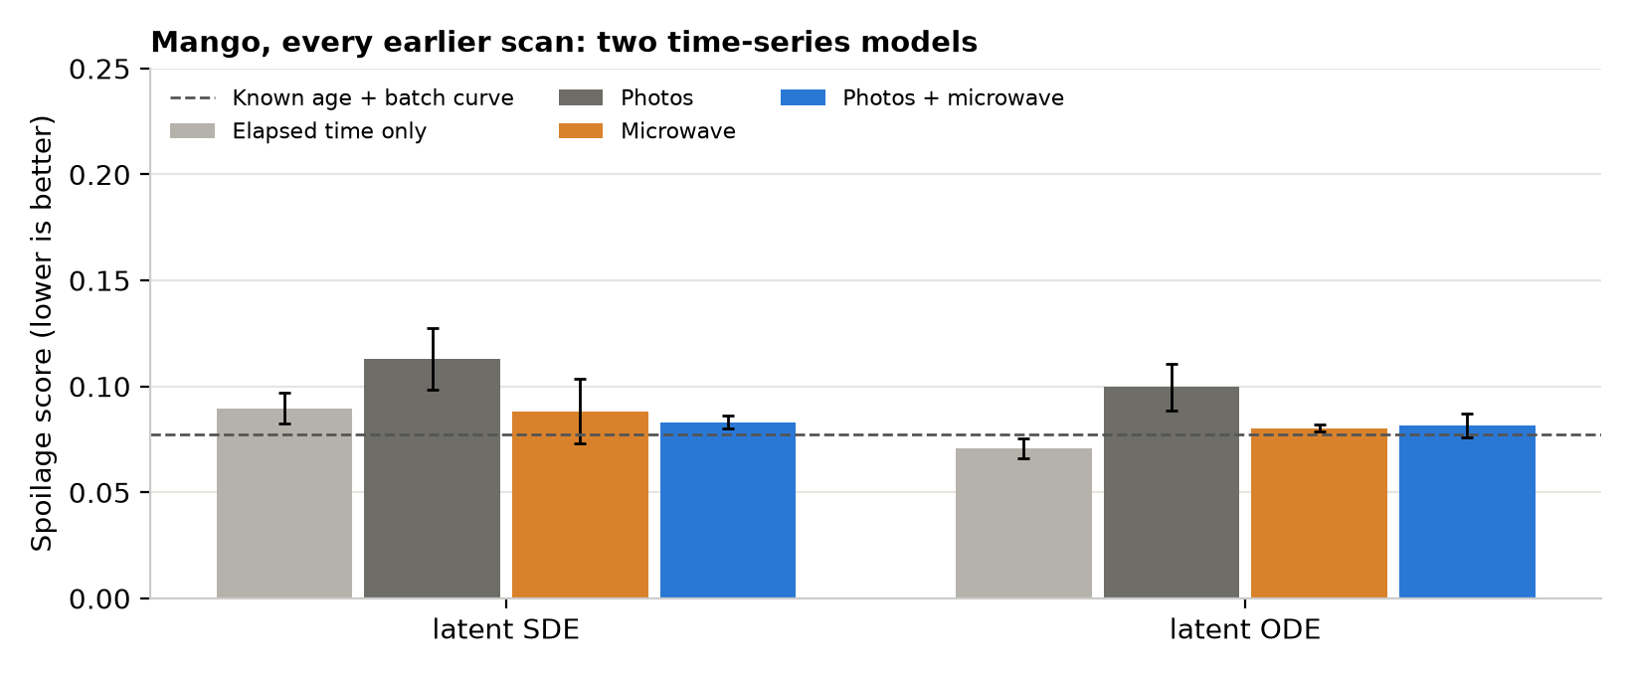
Here each forecast sees all of that mango's earlier scans and knows how long it has been stored. Microwave: all five antenna spacings averaged. The photo is taken only on the day the mango is cut, so “Photos” adds one photo to elapsed time.
Table 3: Mango, every earlier scan
Model | Elapsed time only | Photo | Microwave | Photo + microwave
Latent SDE | 0.090 | 0.113 | 0.088 | 0.083
Latent ODE | 0.071 | 0.100 | 0.080 | 0.082
Known age + batch curve | 0.077
Spoilage score, lower is better; 3 runs each.

Chart 5: Teaching a photo-only model
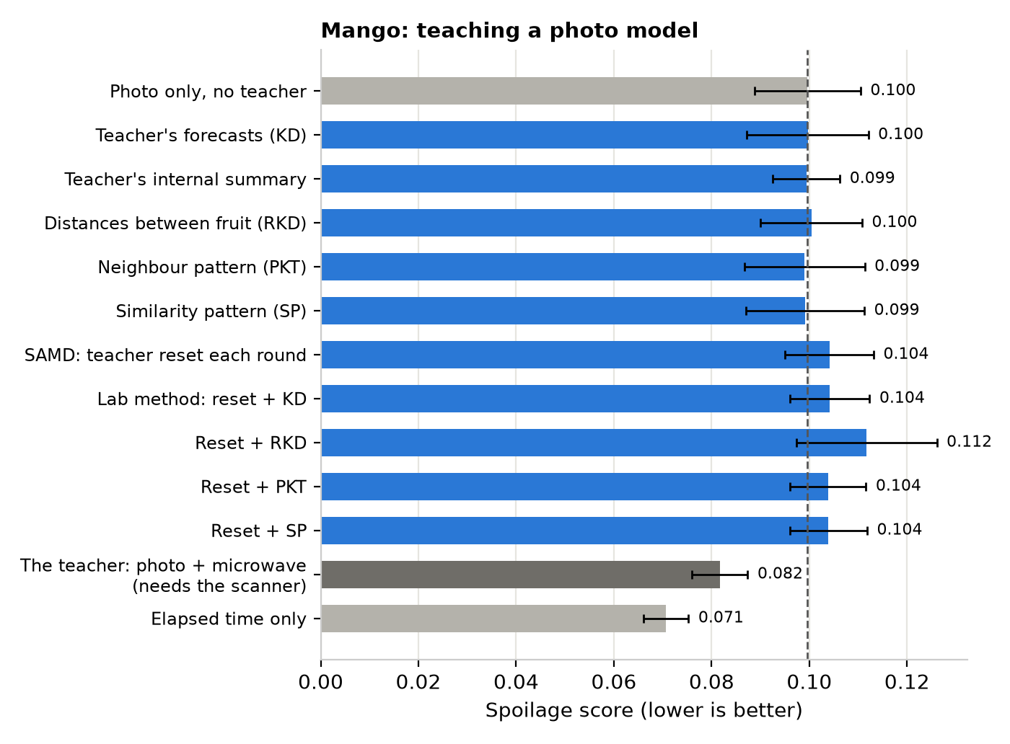
Latent ODE with every earlier scan. The teacher sees the photo and the microwave scans. No method moved the photo-only model by more than its run-to-run variation.

The teaching methods
- Teacher's forecasts (KD): the student is pushed to give the same forecast as the teacher.
- Teacher's internal summary: the student is pushed to build the same internal summary of the fruit.
- RKD, PKT, SP: instead of copying the summary itself, the student copies how the teacher sees fruit relative to each other: the distances between fruit (RKD), which fruit are near neighbours (PKT), or how similar each pair is (SP).
- SAMD and the lab's method (“reset”): the teacher and student share their last layer and take turns training. Every round the teacher is rebuilt from the student, keeps learning with the scan, and hands its last layer back. SAMD then matches the summaries; the lab's method matches the forecasts; “reset + RKD/SP” combine the reset with RKD or SP.
- Take-turns training (control): the same rounds as SAMD, with the shared last layer, but the student gets no teaching term; any gain then comes from the schedule itself. A second control gives the teacher photos only.
- Scanned fruit only: the teacher's terms count only for fruit that actually have scans.
- Six models combined: from the lab's TMC code: train one model per view and combine their forecasts afterwards, by averaging, by a geometric mean (views must agree), or weighting the more confident views more. Averaging was best; the three differed by less than run-to-run variation.

