Spoilage Forecasts: Models, Methods and Results
Avocados and mangoes · November 2026
Goal: from a few photos and/or microwave scans of a fruit, forecast the probability it has spoiled by each future day. Lower is better for every score. Avocado score = log score (how little probability the forecast gave to the day the fruit actually spoiled), on the 4 lab avocados tracked to spoilage, each held out in turn. Day error = days between the forecast's median and the true spoilage day. Mango score = Brier score of the forecast fraction spoiled against what the 48-fruit batch actually showed. Scanner = the microwave scanner's 0°, 120° and 240° rotation views.

1. The forecasting models
Model | How it works | What it outputs
Latent ODE (ordinary differential equation) | An encoder reads the photos/scans so far and estimates the fruit's hidden ripeness, which then rises along a smooth learned curve (no randomness). Spoilage = the curve crossing a learned line. | One path; the spread comes only from uncertainty about where the fruit started
Latent SDE (stochastic differential equation) | The same hidden ripeness curve plus random day-to-day drift (a learned noise term). Spoilage is the first time the drifting path crosses the line; its probability is computed exactly by solving a PDE. | A spread of paths; wider, more honest ranges

Input | ODE avocado score | ODE day error | ODE mango score | SDE avocado score | SDE day error | SDE mango score
Photo | 0.82 | 0.69 | 0.100 | 0.92 | 0.85 | 0.113
Scanner only | 0.85 | 0.65 | 0.080 | 0.91 | 0.77 | 0.088
Photo + scanner | 0.80 | 0.62 | 0.082 | 0.88 | 0.75 | 0.083

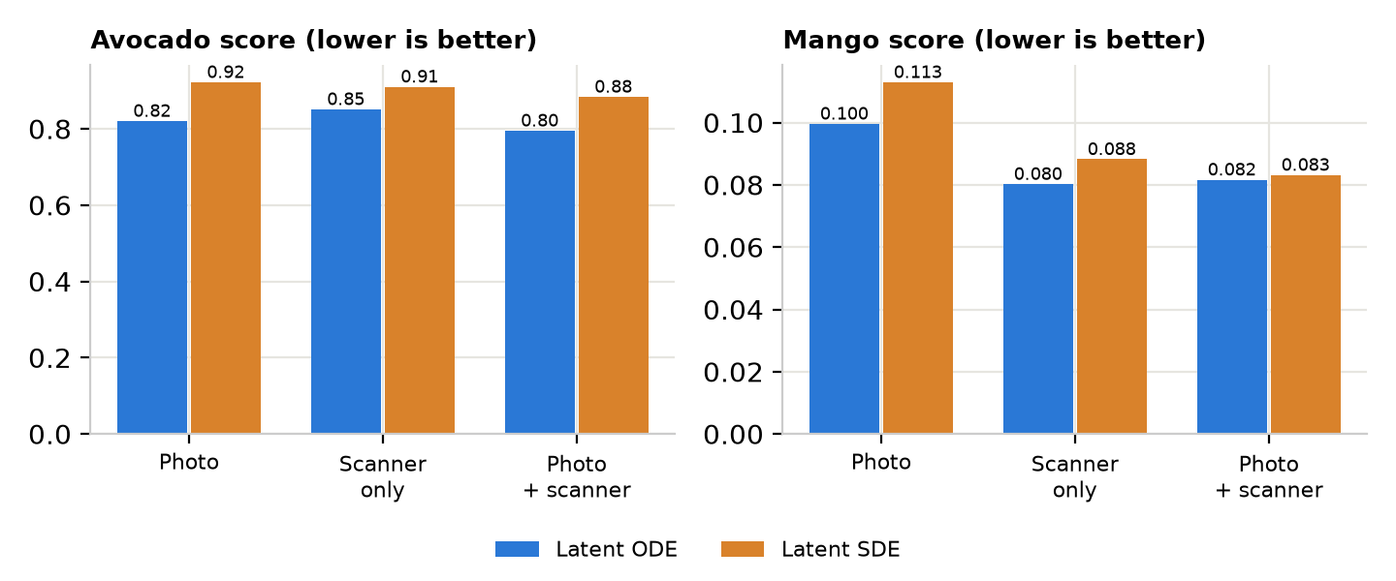
- Latent ODE is the better model on both fruits: photo + scanner is best on avocado (0.80), but photo alone (0.82) is close.
- On mango the scanner matters: scanner only beats photo for both models (ODE 0.080 vs 0.100; SDE 0.088 vs 0.113).
- No mango day error: every mango was cut open once and only 9 of 48 spoiled, so no fruit has an observed spoilage day.

2. Teaching a photo-only model with the scanner (auxiliary modality learning, AML)
The scanner is not available everywhere, so the aim is a student model that needs only photos at test time but learned, during training, from a teacher that also saw the scans. The methods differ in three choices: is the teacher fixed or rebuilt each round, does the student share the teacher's final layer, and what the student copies. All are ported from the lab's RepDistiller code (train_student.py, distiller_zoo/).
Method | Teacher | Shared final layer | What the student copies | Source / note
Photo only | None | No | Nothing (trained alone) | Baseline
Take-turns control | Photos only, rebuilt each round | Yes | Nothing | Isolates the schedule: no scanner anywhere
CAML-style KD | Photo + scanner, trained once, then fixed | No | Teacher's forecast (KD) | CAML's distillation loss, fixed teacher
SAMD | Photo + scanner, rebuilt from student each round | Yes | Teacher's internal features | Shen et al., ICML 2023
Lab method | Same as SAMD | Yes | Teacher's forecast (KD) | run_our_steering_distill.sh
Lab method + RKD | Same as SAMD | Yes | How the teacher arranges fruit: pairwise distances and triplet angles | Park et al., CVPR 2019
Teacher | — | — | — (it sees the scanner at test time) | Reference; needs the scanner

Rebuilt each round (SAMD, lab methods, take-turns control): copy the student's weights into the teacher (scanner inputs start at zero), train the teacher a few epochs with the scans, hand its final layer back to the student, then train the student a few epochs. Knowledge distillation (KD) = 0.1 × the student's own loss + 0.9 × match to the teacher's softened forecast (temperature 4), as in the lab scripts. Relational knowledge distillation (RKD) matches distances and angles between fruit rather than the fruit themselves.
Method | ODE avocado score | ODE day error | SDE avocado score | Mango score (ODE)
Photo only | 0.71 | 0.40 | 0.95 | 0.100
Take-turns control | 0.45 | 0.69 | 0.90 | —
CAML-style KD | 0.67 | 0.54 | 1.08 | 0.100
SAMD | 0.41 | 0.72 | 0.87 | 0.104
Lab method | 0.49 | 0.65 | 1.01 | 0.104
Lab method + RKD | 0.48 | 0.72 | 0.86 | 0.112
Teacher | 0.66 | 0.49 | 1.06 | 0.082

Avocado: 5 repeats × 4 held-out fruit, separate run from section 1 (compare rows within this table). Mango: 3 repeats; the take-turns control was not run on mango.
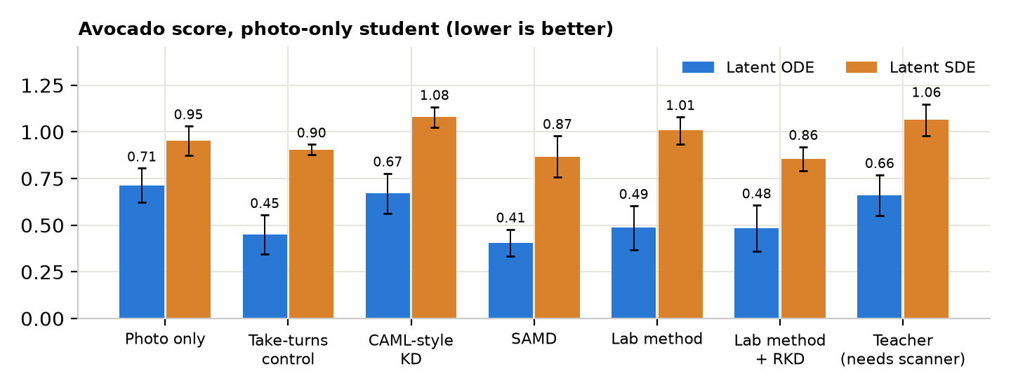
- Little for the student to learn: the teacher, with the scanner, is barely better than photo only (0.66 vs 0.71), so there is little to transfer. CAML-style KD, with a fixed teacher, matches photo only (0.67).
- Gains come from the training rounds: SAMD (0.41) ties the take-turns control (0.45), which never sees the scanner. The gain is the rebuild-and-share-final-layer schedule, not the scans.
- Trade-off: the lower score comes with a larger day error (0.40 → 0.72 d): forecasts become less over-confident, not more accurate.
- Mango: no student beats photo only (0.100); the teacher does (0.082).

