**SCS-2202 - Group project I**

**Group 3**

**PROJECT PROPOSAL**

**A web application for the legal needs**

**Details of Project Supervisor, Co-supervisor, Advisors, and Clients**

Proposed Project Supervisor (Academic Staff of UCSC)

Name of the supervisor: Dr Dinuni K Fernando

Signature of the supervisor:

Date:

Proposed Project Co-Supervisor (Assigned by Course Coordinator)

Name of the co-supervisor: Mr. Tharaka I Priyantha

Signature of the co-supervisor:

Date:

The client of the Project

Name of the client: Mr. W.M. Thusitha Madushanka Wijekoon (lawyer)

Address of the client: 326E, Weerasekara Mawatha, Thalawatugoda

Contact person at client: Mr. W.M. Thusitha Madushanka Wijekoon (lawyer)

The contact number of the contact person: 077-226-2864

E-mail address of the contact person: [thusithawijekoon@gmail.com](mailto:thusithawijekoon@gmail.com)

**Table of Contents**

**1. Introduction**

**1.1 Project background**

**1.2 Problem statement**

**1.3 Our solution**

**1.4 How are we different ?**

**2. Project goals**

**3. Project scope**

**3.1 Users**

**3.2 In-scope**

**3.3 Out-scope**

**4. Project Objectives**

**5. Project Feasibility**

**5.1 Social Feasibility**

**5.2 Technical Feasibility**

**5.3 Economical Feasibility**

**5.4 Legal and Ethical Feasibility**

**6. Deliverables of the project**

**7. Project Constraints**

**7.1 Constraints**

**7.2 Assumptions**

**8. Requirements**

**8.1 Functional requirements**

**8.2 Quality attributes**

**9. Technologies to be used**

**10. Project Timeline**

**11. Declaration**

**1. Introduction**

**1.1 Project Background**

The legal profession is inherently detail-oriented, requiring meticulous management of vast amounts of information. Legal professionals, including lawyers, junior counsels, and their support staff, constantly juggle multiple cases, each with its own set of documents, deadlines, and client communications. Efficiently managing these elements is crucial to ensuring effective representation and positive outcomes for clients. However, traditional methods of case management often fall short, leading to inefficiencies and potential oversights. To address these challenges, there is a pressing need for an advanced, comprehensive, and secure case management solution tailored specifically for the legal team.

**1.2 Problem Statement**

Lawyers in Sri Lanka face significant challenges in managing their caseloads efficiently due to the fragmented nature of their current tracking systems. They rely on a combination of diaries, notebooks, Google Calendars, and WhatsApp to organize and monitor their cases. This scattered approach results in numerous inefficiencies and potential oversights. For instance, without a centralized system, it is difficult to maintain a cohesive view of their schedules, deadlines, and client communications. This fragmentation often leads to missed appointments, overlooked deadlines, and a general lack of organization, ultimately affecting the quality of legal services provided.

The use of multiple, disconnected tools makes it hard to ensure that all necessary information is readily accessible and up to date. Diaries and notebooks can be misplaced or forgotten, Google Calendars might not sync properly across all devices, and important messages on WhatsApp can be buried under a flood of unrelated conversations. This patchwork system makes it challenging for lawyers to track their progress on various cases, leading to duplication of effort and wasted time.

Moreover, the process of citing legal cases in Sri Lanka is cumbersome due to the lack of efficient research tools. Available resources often lack quick filtering options and comprehensive databases, making legal research time-consuming and error prone. Lawyers spend an inordinate amount of time sifting through volumes of information to find relevant case law and precedents. This not only slows down their work but also increases the risk of missing crucial legal references, which can impact the outcomes of their cases.

These inefficiencies not only affect the productivity of legal professionals but also impact the quality of service they provide to their clients. Clients expect timely and efficient legal assistance, and any delays or errors can lead to dissatisfaction and potential loss of business. The legal profession demands a high level of precision and reliability, and the current fragmented systems undermine these requirements.

In summary, the current fragmented system used by lawyers in Sri Lanka creates numerous inefficiencies and potential oversights, adversely affecting their productivity and the quality of service provided to clients. A unified, streamlined legal case management system is essential to address these challenges, enabling lawyers to manage their cases more effectively and focus on delivering high-quality legal services.

**1.3 Our Solution**

The proposed project aims to develop a mobile-responsive web application designed to help lawyers and their teams manage cases efficiently. The application will feature an advanced query function that allows users to accurately quote legal citations. Key features will include comprehensive search and query capabilities, a robust case management system, collaboration tools, and mobile responsiveness, ensuring access to cases and research from any location. The user-friendly interface will make navigation and utilization of all functionalities straightforward. By integrating these features, the solution will streamline the legal research process, improve case management, and enhance the overall productivity of legal professionals.

**1.4 How are we different ?**

Currently, Sri Lanka does not have a dedicated system for handling legal management specifically designed for lawyers. Legal professionals in the country typically rely on traditional methods or generic software tools to manage their cases, research legal precedents, and collaborate with their teams. This gap in the market presents an opportunity to develop a specialized legal case management system tailored to the unique needs of Sri Lankan lawyers, enhancing their efficiency, collaboration, and overall productivity.

To provide a comprehensive understanding and highlight the benefits of our proposed legal case management system, we will compare it with similar tools available in other countries. This comparison will help identify best practices, essential features, and the advantages that these systems offer, providing valuable insights for developing a robust solution tailored to the needs of Sri Lankan lawyers. We aim to ensure that our application meets international standards and addresses the specific requirements of the local legal profession.

|  |  |  |  |
| --- | --- | --- | --- |
| **Features** | **Current manual method in Sri Lanka** | **International tools** | **Our software** |
| **Case related details** | Marked in diaries, notebooks or word processing software | Systemized in software | Systemized in software |
| **Communication methods** | Using WhatsApp or other messaging applications | Unavailable | Integrated into the system |
| **Access legal citations** | Manual research through physical documents or online documents without filtering options | Systemized in software | Systemized in software with advanced filter and searching options |
| **Payment management** | Cash or cheque payments | Integrated payment gateway | Integrated payment gateway |
| **Schedule Management** | Managed in diaries or google calendars | Integrated calendar | Integrated calendar that generates free slots with a single click |

1. **Project Goals**
2. **Enhance Legal Research**

* Develop advanced query functions to allow accurate quoting of legal citations.
* Integrate a comprehensive legal citation database and efficient search and filter algorithms.

1. **Improve Case Management**

* Implement a robust case management system to track case status and progress.
* Provide tools for document management and task assignment.

1. **Facilitate Collaboration**

* Enable seamless communication between team members through messaging, integrated chat functions.
* Offer shared calendars and secure file-sharing capabilities.

1. **Ensure Mobile Responsiveness**

* Design the application to be fully responsive, adapting to various screen sizes and devices.

1. **Deliver a User-Friendly Interface**

* Create an intuitive and easy-to-navigate interface with clear menus and options.

1. **Boost Productivity**

* Streamline the legal research process by integrating comprehensive search and query functionalities.
* Improve overall productivity for legal professionals through efficient case management and collaboration tools.

1. **Scalability and Performance:**

* Design the application to handle increasing amounts of data and users efficiently.

1. **Achieve Stakeholder Satisfaction:**

* Collaborate with the client and the stakeholders to ensure the application meets their needs and expectations.

**3. Project Scope**

**3.1 Project Users**

* Lawyer
* Junior counsel
* Attorney
* Client
* System Admin
* Historical database Admin

**3.2 In-scope**

* A mobile-responsive web application for lawyers to manage cases and teams efficiently.
* Team collaboration within the legal team and with clients using integrated messaging.
* Maintain a separate historical database accessible to authorized users with easy filtering and search capabilities.
* Implement a search interface for the legal team to quickly find cases using various filters.
* Simplify document management for the legal team to store, retrieve, and share documents easily.
* Provide facilities for sending quick memos that notify the receiver.
* Implement payment reminder notifications for client-lawyer bills and legal team salaries.
* Integrate a payment gateway to facilitate transactions for client-lawyer bills and legal team salaries.
* Develop an efficient calendar and schedule management system with meeting and hearing reminders.
* Develop a client portal for clients to access case updates and communicate with their legal team.

**3.3 Out-scope**

* Offering personalized legal advice or services within the application.
* Handling non-legal case management or administrative tasks outside the legal domain.
* Developing a comprehensive marketing or client acquisition platform for legal professionals.
* Provide multilingual support.
* Provide video conferencing facilities inside the system

**4. Project Objectives**

1. **Develop a Robust Case Management System**

Create a comprehensive system for managing case details, documents, timelines, and communications to ensure lawyers have all necessary information at their fingertips.

1. **Implement Advanced Legal Citation Query Features**

Incorporate a powerful query tool for searching legal citations with advanced filters, providing clear and precise outputs of case decisions and relevant legal precedents.

1. **Provide a User-Friendly Interface**

Design an intuitive and user-friendly interface that enhances the user experience, making it easy for lawyers and their teams to navigate and utilize the system effectively.

1. **Enable Team Collaboration**

Integrate features that facilitate collaboration among legal teams, including team messaging, private messaging, and shared workspaces for the main counsel and team members.

1. **Memo Format**

Include a memo feature for short memo passing between the team

1. **Incomplete Payment Reminders**

Implement a reminder system that alerts both the lawyer and the client in cases of incomplete payments, helping to ensure timely settlements.

1. **Online Payment Gateway**

Enable an online payment system for clients to make payments conveniently and securely through the platform.

1. **Calendar and Schedule Management**

Develop a calendar feature for managing client meetings, court hearings, and other important dates, ensuring all schedules are organized and easily accessible.

1. **Schedule Generator for Hearing Dates**

Include a feature that generates free dates for lawyers by comparing their schedules, assisting in setting the next hearing date efficiently.

**5. Project Feasibility**

**5.1 Social Feasibility**

The social feasibility has been confirmed through discussions with our lawyer who provided valuable insights and feedback. Their input highlighted the potential of the application to enhance accessibility, collaboration, and efficiency among legal professionals. By enabling lawyers and their teams to access case files, legal documents, and research materials from any location and on various devices, the application promotes flexibility and improved work-life balance. Seamless real-time collaboration ensures effective communication and reduces errors. The system's advanced query functions and streamlined case management features save time and reduce administrative burdens, allowing legal professionals to focus on substantive legal work. A user-friendly interface and comprehensive support make the system easy to adopt, fostering continuous learning and adaptation to new technologies. Overall, the application addresses practical needs while improving the quality and efficiency of legal services.

**5.2 Technical Feasibility**

The technical feasibility of the legal case management system is assured by leveraging core technologies for the front end, database, and back end without relying on additional frameworks. The front end will utilize HTML for structure, CSS for styling and responsiveness, and vanilla JavaScript for dynamic and interactive elements, ensuring compatibility across all devices and browsers. The MySQL database will provide robust performance, scalability, and data security, supporting the large volumes of data typical in legal case management while ensuring data integrity through ACID properties. On the back end, PHP, with its stability and ease of integration with MySQL, will be employed. Development will be streamlined using tools like Git for version control, Visual Studio Code for coding, and project management platforms like JIRA to track progress and ensure timely delivery. This combination of technologies guarantees that the application will be secure, scalable, and efficient, meeting the needs of legal professionals.

**5.3 Economical Feasibility**

The economic feasibility of the legal case management system project is highly favorable. The development team consists of undergraduate students undertaking the project as part of their learning experience, eliminating the need for salaries or contractor fees and significantly reducing overall development costs. The project utilizes open-source and free technologies, including HTML, CSS, JavaScript, MySQL, PHP, ensuring no licensing expenses. Development tools like Git, Visual Studio Code, and JIRA are available in free versions or through academic licenses, minimizing tool-related expenses. During development, free hosting solutions and APIs can be used. The scalable nature of the selected technologies keeps operational costs manageable. Furthermore, the educational benefits and skill development for the student developers represent an investment in human capital, enhancing the project's overall value. This combination of factors ensures that the project can be developed and maintained with minimal financial investment while providing significant learning opportunities.

**5.4 Legal and Ethical Feasibility**

Legal and ethical feasibility is paramount in the development of any legal case management system, as it ensures compliance with relevant laws and regulations. Ethical considerations, including transparency, fairness, and accountability, are integrated into every aspect of the system's design and operation. Legal safeguards and dispute resolution mechanisms, such as clear terms of service and privacy policies, protect users' rights and ensure fair and prompt resolution of issues.

**6. Project Deliverables**

At the conclusion of our project to develop the legal case management system, the final deliverables include:

* 1. **Completed and Deployed Web Application**:

The fully functional mobile-responsive web application accessible via a secure hosting environment.

* 1. **User Documentation:**

Comprehensive user manuals and guides detailing how to use the application effectively.

These deliverables ensure that the legal case management system is not only successfully developed and deployed but also supported and maintained effectively post-launch.

**7. Project Constraints**

**7.1 Project Constraints**

• **Single Account Constraint**: Ensuring that each user can have only one account helps maintain data integrity and user accountability within the system. To enforce this:

* Implement checks during registration to verify if an account already exists for the user.
* Use unique identifiers (such as email addresses or usernames) to prevent duplicate registrations.

• **Registered User Requirement**: Limiting access to registered users enhances security and ensures that only authorized individuals can interact with data. Key implementation measures include:

* **Authentication Mechanisms**: Require users to log in with valid credentials (username/password).
* **Access Controls**: Implement role-based access control (RBAC) to restrict functionalities based on user roles (e.g., admin, lawyer, paralegal).
  1. **Project Assumptions**
* The historical database admin is trusted to provide accurate data on the precedents

**8. Project Requirements**

* 1. **Functional Requirements**

Requirements are gathered from the client**.** Our client, a practicing lawyer, has provided us with comprehensive functional requirements for the development of a legal case management system. These requirements form the foundation of our project scope. By aligning our development efforts with these functional requirements, we aim to deliver a tailored solution that enhances case management efficiency and supports the client's professional activities effectively.

**Common Functionalities for the actors**

• Registering a User

• Logging In

• Viewing Profile

• Updating Profile

**Use cases narratives for the common use cases**

**Use Case: Register**

| **Use case ID** | **UC1** |
| --- | --- |
| **Use case Name** | Register |
| **Preconditions** | Unregistered actor must have access to the registration page. |
| **Postconditions** | The actor becomes a registered user. |
| **Trigger** | The unregistered actor wants to create an account. |
| **Primary actor** | Unregistered actor |
|  | |

**Main Scenario**

1. The actor navigates to the registration page and select the type of actor that he is
2. The actor fills in the registration form with necessary details (e.g., name, email, password).
3. The actor submits the registration form.
4. The system verifies the provided information.
5. The system sends a confirmation email to the counsel.
6. The actor confirms the email.
7. The system activates the actor's account.

**Alternate Scenarios**

* If the email is already in use, the system displays an error message.

**Use Case: Login**

| **Use case ID** | **UC2** |
| --- | --- |
| **Use case Name** | Login |
| **Preconditions** | The actor must have registered and have valid login credentials**.** |
| **Postconditions** | The actor is logged into the system. |
| **Trigger** | The actor wants to log into the system. |
| **Primary actor** | Registered actor |

**Main Scenario**

1. The actor navigates to the login page.
2. The actor enters their email and password.
3. The actor submits the login form.
4. The system verifies the credentials.
5. The system logs the counsel into the system and redirects to the dashboard.

**Alternate Scenarios**

* If the credentials are incorrect, the system displays an error message.
* If the counsel forgets the password, they can use the "Forgot Password" feature to reset it.

**Use Case: View Profile**

| **Use case ID** | **UC3** |
| --- | --- |
| **Use case Name** | View Profile |
| **Preconditions** | The actor must be logged in. |
| **Postconditions** | The counsel's profile is viewed or updated. |
| **Trigger** | The actor wants to view or update their profile. |
| **Primary actor** | Registered Actor |

**Main Scenario**

1. The actor navigates to the profile section.
2. The actor views their profile details.
3. The actor updates any necessary information (e.g., contact details).
4. The actor submits the updates.
5. The system saves the changes and confirms the update.

**Functionalities of the senior counsel (Main lawyer)**

* **Case Management:**
  + Create new cases with details including client information, case type, and key dates (filing, hearings).
  + Create team collaboration with legal team an client for communication purposes with individual and group messaging facilities.
  + Assign tasks to team members, set deadlines, and track progress.
  + Upload, store, and manage case-related documents securely.
* **Legal Research:**
  + Access comprehensive legal databases for case law, statutes, and precedents.
  + Perform advanced searches and query legal citations efficiently.
* **Communication:**
  + Communicate securely with clients and team members via integrated messaging.
  + Share updates, memos, and notifications related to case developments.
* **Schedule Management:**
  + Manage personal and team calendars, including court dates, meetings, and deadlines.
  + Set reminders and receive notifications for upcoming events and hearings.
* **Payment Processing:**
  + Facilitate the processing of salary payments through integrated payment gateway functionalities.

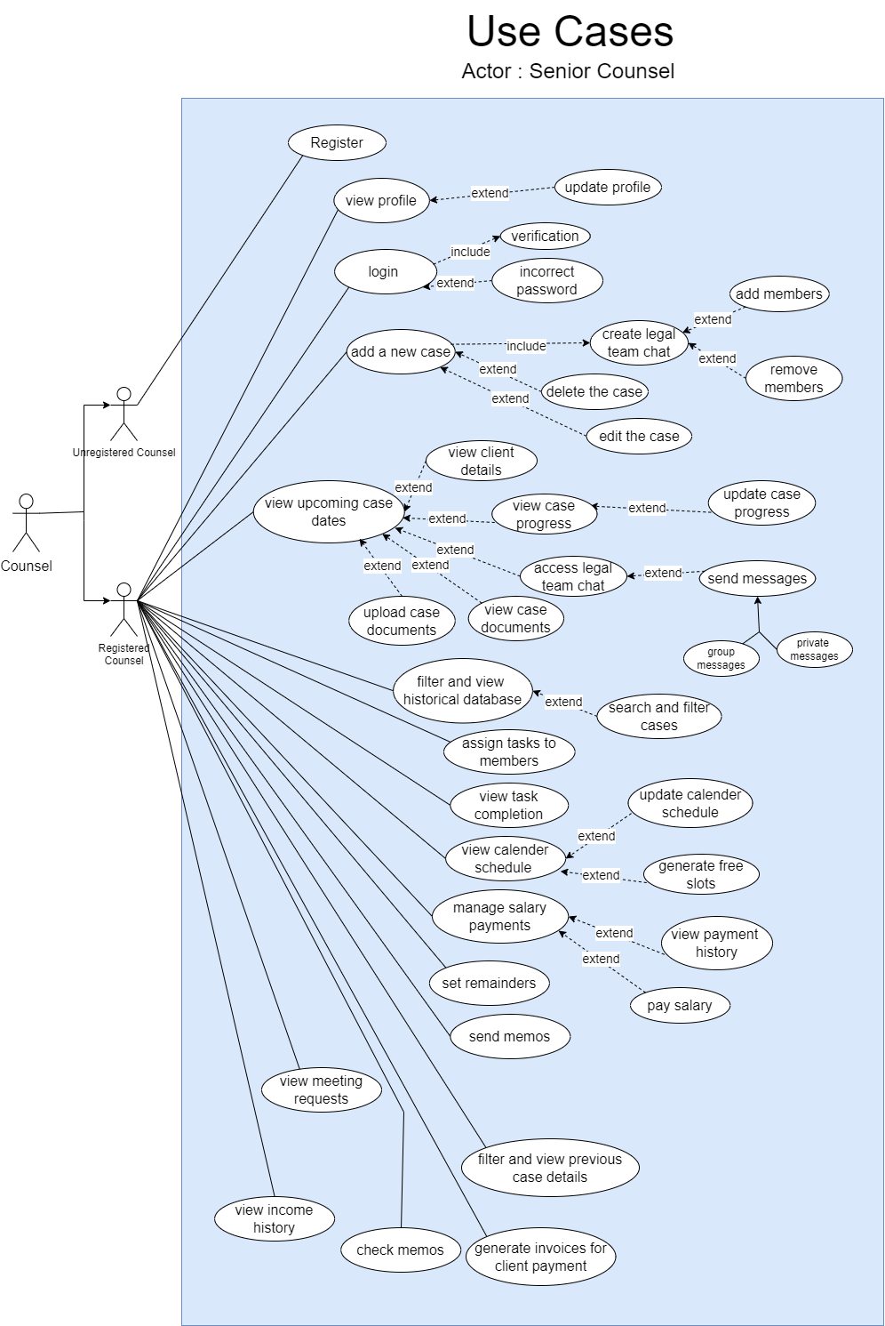

**Use cases narratives for the remaining use cases of the senior counsel**

**Use Case: Add a New Case**

| **Use case ID** | **UC4** |
| --- | --- |
| **Use case Name** | Add a New Case |
| **Preconditions** | The counsel must be logged in. |
| **Postconditions** | A new case is created and added to the system. |
| **Trigger** | The counsel wants to add a new case. |
| **Primary actor** | Registered Counsel |

**Main Scenario**

1. The counsel navigates to the "Add Case" section.
2. The counsel fills in the case details (e.g., client information, case type, key dates).
3. The counsel creates a legal team chat.
4. The counsel adds members to the team.
5. The counsel submits the new case form.
6. The system saves the case and notifies the team members.

**Alternate Scenarios**

* If the case creation fails, the system displays an error message.
* The counsel can remove members from the team if needed.
* The counsel can edit or delete the case if necessary.

**Use Case: View Upcoming Case Details**

| **Use case ID** | **UC5** |
| --- | --- |
| **Use case Name** | View Upcoming Case Details |
| **Preconditions** | The counsel must be logged in. |
| **Postconditions** | The counsel views upcoming case details and related details. |
| **Trigger** | The counsel wants to view upcoming case details. |
| **Primary actor** | Registered Counsel |

**Main Scenario**

1. The counsel navigates to the "Upcoming Case Details" section.
2. The counsel views the list of upcoming case details.
3. The counsel selects a case to view more details.
4. The system displays the case details, including client information, case progress, and legal team chat.
5. The counsel accesses and views case documents.
6. The counsel uploads new case documents if necessary.

**Use Case: Filter and View Historical Database**

| **Use case ID** | **UC6** |
| --- | --- |
| **Use case Name** | Filter and View Historical Database |
| **Preconditions** | The counsel must be logged in. |
| **Postconditions** | The counsel views filtered historical cases. |
| **Trigger** | The counsel wants to search and filter historical cases. |
| **Primary actor** | Registered Counsel |

**Main Scenario**

1. The counsel navigates to the "Historical Database" section.
2. The counsel enters search criteria and applies filters.
3. The counsel submits the search query.
4. The system retrieves and displays the filtered cases.
5. The counsel views the details of the selected case.

**Alternate Scenarios**

* If the system fails to retrieve cases, it displays an error message.
* If the system does not find any data related to the query, it displays an error message.

**Use Case: Assign Tasks to Members**

| **Use case ID** | **UC7** |
| --- | --- |
| **Use case Name** | Assign Tasks to Members |
| **Preconditions** | The counsel must be logged in. |
| **Postconditions** | Tasks are assigned to team members. |
| **Trigger** | The counsel wants to assign tasks to team members. |
| **Primary actor** | Registered Counsel |

**Main Scenario**

1. The counsel goes to the task assignment section.
2. The counsel assigns tasks to team members, setting deadlines and descriptions.
3. The counsel submits the task assignments.
4. The system notifies team members of their tasks.

**Alternate Scenarios**

* If task assignment fails, the system displays an error message.

**Use Case: View Task Completion**

| **Use case ID** | **UC8** |
| --- | --- |
| **Use case Name** | View Task Completion |
| **Preconditions** | The counsel must be logged in and have assigned tasks. |
| **Postconditions** | The counsel views the completion status of tasks. |
| **Trigger** | The counsel wants to check the status of assigned tasks**.** |
| **Primary actor** | Registered Counsel |

**Main Scenario**

1. The counsel navigates to the task management section.
2. The counsel views task details.
3. The counsel reviews the completion status of assigned tasks.
4. The system updates the counsel on task progress and completion.

**Use Case: View Calendar Schedule**

| **Use case ID** | **UC9** |
| --- | --- |
| **Use case Name** | View Calendar Schedule |
| **Preconditions** | The counsel must be logged in. |
| **Postconditions** | The counsel views and updates the calendar schedule. |
| **Trigger** | The counsel wants to view or update their calendar schedule. |
| **Primary actor** | Registered Counsel |

**Main Scenario**

1. The counsel navigates to the calendar section.
2. The counsel views their schedule.
3. The counsel adds or updates calendar entries (e.g., meetings, court dates).
4. The counsel submits the updates.
5. The system saves the changes and updates the schedule.

**Alternate Scenarios**

* The counsel can generate free slots for scheduling purposes.

**Use Case: Manage Salary Payments**

| **Use case ID** | **UC10** |
| --- | --- |
| **Use case Name** | Manage Salary Payments |
| **Preconditions** | The counsel must be logged in. |
| **Postconditions** | Salary payments are managed and recorded. |
| **Trigger** | The counsel wants to manage salary payments**.** |
| **Primary actor** | Registered Counsel |

**Main Scenario**

1. The counsel navigates to the salary management section.
2. The counsel views payment history.
3. The counsel processes salary payments for team members.
4. The counsel confirms and submits the payments.
5. The system records the payments and updates the payment history.

**Alternate Scenarios**

* If the payment process fails, the system displays an error message.

**Use Case: Set Reminders**

| **Use case ID** | **UC11** |
| --- | --- |
| **Use case Name** | Set Reminders |
| **Preconditions** | The counsel must be logged in. |
| **Postconditions** | Reminders are set and notifications scheduled. |
| **Trigger** | The counsel wants to set reminders. |
| **Primary actor** | Registered Counsel |

**Main Scenario**

1. The counsel navigates to the reminders section.
2. The counsel creates a new reminder with necessary details (e.g., date, time, description).
3. The counsel submits the reminder.
4. The system saves the reminder and schedules notifications.

**Alternate Scenarios**

* If the reminder setting fails, the system displays an error message.

**Use Case: Send Memos**

| **Use case ID** | **UC12** |
| --- | --- |
| **Use case Name** | Send Memos |
| **Preconditions** | The counsel must be logged in. |
| **Postconditions** | The memo is sent to the intended recipients. |
| **Trigger** | The counsel wants to send a memo. |
| **Primary actor** | Registered Counsel |

**Main Scenario**

1. The counsel navigates to the memos section.
2. The counsel creates a new memo, including recipients and content.
3. The counsel submits the memo.
4. The system sends the memo to the intended recipients.

**Alternate Scenarios**

* If the memo sending fails, the system displays an error message.

**Use Case: Filter and View Previous Case Details**

| **Use case ID** | **UC13** |
| --- | --- |
| **Use case Name** | Filter and View Previous Case Details |
| **Preconditions** | The counsel must be logged in. |
| **Postconditions** | The counsel views the details of previous cases. |
| **Trigger** | The counsel wants to filter and view previous cases. |
| **Primary actor** | Registered Counsel |
| **Secondary actor** | System |

**Main Scenario**

1. The counsel navigates to the previous cases section.
2. The counsel applies filters (e.g., date range, case type).
3. The counsel submits the filter criteria.
4. The system retrieves and displays the filtered cases.
5. The counsel views the details of a selected case.

**Use Case: Generate Invoices for Client Payment**

| **Use case ID** | **UC14** |
| --- | --- |
| **Use case Name** | Generate Invoices for Client Payment |
| **Preconditions** | The counsel must be logged in and have a client case. |
| **Postconditions** | An invoice is generated and sent to the client. |
| **Trigger** | The counsel wants to generate an invoice for client payment. |
| **Primary actor** | Registered Counsel |

**Main Scenario**

1. The counsel navigates to the invoicing section.
2. The counsel selects a client case.
3. The counsel fills in the invoice details (e.g., services, amounts).
4. The counsel generates and reviews the invoice.
5. The system sends the invoice to the client.

**Alternate Scenarios**

* If the invoice generation fails, the system displays an error message.

**Use Case: Check Memos**

| **Use case ID** | **UC15** |
| --- | --- |
| **Use case Name** | Check Memos |
| **Preconditions** | The counsel must be logged in. |
| **Postconditions** | The counsel views received memos. |
| **Trigger** | The counsel wants to check received memos. |
| **Primary actor** | Registered Counsel |
| **Secondary actor** | System |

**Main Scenario**

1. The counsel navigates to the memos section.
2. The counsel views the list of received memos.
3. The counsel selects a memo to read its content.
4. The system displays the memo details.

**Use Case: View Meeting Requests**

| **Use case ID** | **UC16** |
| --- | --- |
| **Use case Name** | View Meeting Requests |
| **Preconditions** | The counsel must be logged in. |
| **Postconditions** | The counsel views and responds to meeting requests. |
| **Trigger** | The counsel wants to check meeting requests. |
| **Primary actor** | Registered Counsel |

**Main Scenario**

1. The counsel navigates to the meeting requests section.
2. The counsel views the list of meeting requests.
3. The counsel selects a request to view its details.
4. The counsel responds to the meeting request (e.g., accept, decline).
5. The system updates the request status and notifies the requester.

**Use Case: View Income History**

| **Use case ID** | **UC17** |
| --- | --- |
| **Use case Name** | View Income History |
| **Preconditions** | The counsel must be logged in. |
| **Postconditions** | The counsel views their income history. |
| **Trigger** | The counsel wants to check their income history. |
| **Primary actor** | Registered Counsel |
| **Secondary actor** | System |

**Main Scenario**

1. The counsel navigates to the income history section.
2. The counsel views a summary of income over a selected period.
3. The counsel selects a specific entry to view detailed information.
4. The system displays the income details.

**Functionalities of the junior counsel**

* **Send and Receive Memos:**
  + Use memo messaging functionality to send and receive internal communications within the legal team.
  + Ensure memos are clear, concise, and pertinent to case updates or tasks.
* **Access and Track Cases:**
  + View assigned cases, including client details, case types, and key deadlines.
  + Track case progress, tasks, and deadlines using designated management tools.
  + Update case status and task completion under guidance from senior counsel.
* **Access Legal Citations:**
  + Utilize integrated legal databases to access legal citations, case law, statutes, and precedents.
  + Perform searches and queries to support case preparation and strategy in collaboration with senior counsel.
* **Complete Assigned Tasks:**
  + Receive tasks assigned by senior counsel and manage them within specified deadlines.
  + Update task statuses, provide progress reports, and seek guidance as needed from senior counsel.

The UCN of the use cases send memos, view cases, search cases, access historical database, view schedule calendar are similar to that of the senior counsel.

**Use cases narratives for the remaining use cases of the junior counsel**

**Use case : Check memos**

|  |  |
| --- | --- |
| **Use case ID** | **UC18** |
| **Use case Name** | Check Memos |
| **Preconditions** | The Junior Counsel must be logged in. |
| **Postconditions** | The Junior Counsel can view and respond to memos. |
| **Trigger** | Junior Counsel wants to check for new memos. |
| **Primary actor** | Junior Counsel |
| **Main Scenario** | * Junior Counsel navigates to the memo section. * Junior Counsel views a list of received memos. * Junior Counsel selects a memo to read. * System displays the content of the selected memo. |
| **Alternate Scenarios** | * System detects a network issue preventing memo retrieval. * System displays an error message indicating the issue. |

**Use case : View assigned tasks**

|  |  |
| --- | --- |
| **Use case ID** | **UC19** |
| **Use case Name** | View Assigned Tasks |
| **Preconditions** | The Junior Counsel must be logged in. |
| **Postconditions** | The Junior Counsel can see a list of their assigned tasks. |
| **Trigger** | Junior Counsel wants to check their tasks. |
| **Primary actor** | Junior Counsel |
| **Main Scenario** | * Junior Counsel navigates to the tasks section. * Junior Counsel views a list of tasks assigned to them. * Junior Counsel selects a task to view details. * System displays detailed information about the selected task. * Junior Counsel may update the task completion |
| **Alternate Scenarios** | * System detects a network issue preventing task retrieval. * System displays an error message indicating the issue. * Junior Counsel tries again later to view assigned tasks. * In case of no new assigned tasks, the system displays a message “No new tasks assigned” |

**Use case : View salary invoices and updates**

|  |  |
| --- | --- |
| **Use case ID** | **UC20** |
| **Use case Name** | View Salary Invoices and Updates |
| **Preconditions** | The Junior Counsel must be logged in. |
| **Postconditions** | The Junior Counsel can access their financial information. |
| **Trigger** | Junior Counsel wants to view their salary details |
| **Primary actor** | Junior Counsel |
| **Main Scenario** | * Junior Counsel navigates to the salary section. * Junior Counsel views a list of salary invoices and updates. * Junior Counsel selects an invoice to view details. * System displays detailed information about the selected invoice. |

**Functionalities of the Instructing Attorney**

* **Manage and Retrieve Case Documents:**
  + Upload, store, and organize case-related documents securely within the system.
  + Ensure documents are easily searchable and accessible based on case details, client information, or other relevant criteria.
  + Retrieve and view documents as needed for case preparation and review.
* **Scan and File Electronic Forms:**
  + Utilize form scanning features to digitize and store electronic forms related to legal cases.
  + Ensure accurate filing and categorization of forms within the system for easy retrieval and reference.
* **Access Legal Citations:**
  + Utilize integrated legal databases to access legal citations, case law, statutes, and precedents.
  + Perform searches and queries to support case preparation and legal research under guidance from senior attorneys.
* **Complete Assigned Tasks:**
  + Receive tasks assigned by senior attorneys and manage them within specified deadlines.
  + Update task statuses.
* **Update Case Status:**
  + Maintain accurate and up-to-date records of case progress, developments, and outcomes.

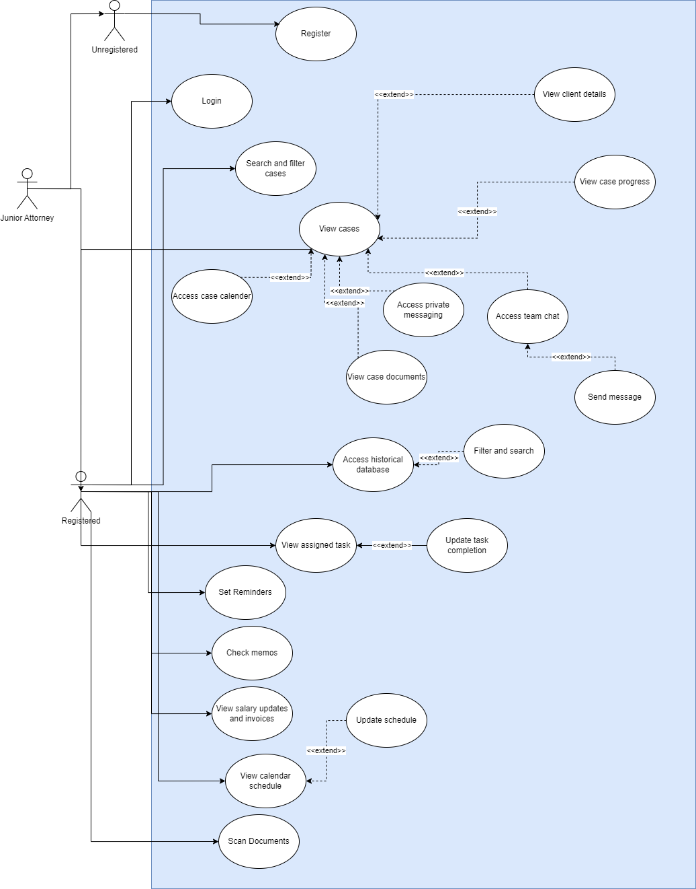

The UCN of search and filter cases, view cases, access historical database, view assigned tasks, check memos, view salary updates, set reminders and view calendar schedule are similar to that of the senior counsel and the junior counsel.

**Use cases narratives for the remaining use cases of the Instructing Attorney**

**Use case : Scan documents**

|  |  |
| --- | --- |
| **Use case ID** | **UC21** |
| **Use case Name** | Scan documents |
| **Preconditions** | The instructing attorney must be logged in |
| **Postconditions** | The instructing attorney can scan documents and fill it |
| **Trigger** | The instructing attorney wants to scan documents |
| **Primary actor** | Instructing attorney |
| **Main Scenario** | * Instructing attorney navigates to the scan documents section. * The system prompts to choose between camera scan in mobile phones and scanner scan in pcs. * The instructing attorney chooses one * The instructing attorney chooses a scan and scans the documents |

**Functionalities of the client**

* **Case Access:**
  + View case details, updates, and documents shared by the legal team.
  + Access financial statements, invoices, and payment history.
* **Communication:**
  + Communicate securely with the legal team regarding case updates and queries.
  + Receive notifications and reminders for scheduled meetings, hearings, and payments.
* **Facilitate Payment Processing:**
  + Integrate a secure payment gateway to enable clients to make payments to the lawyer for legal services rendered.
  + Support various payment methods (e.g., credit/debit cards, bank transfers) based on client preferences and jurisdictional regulations.

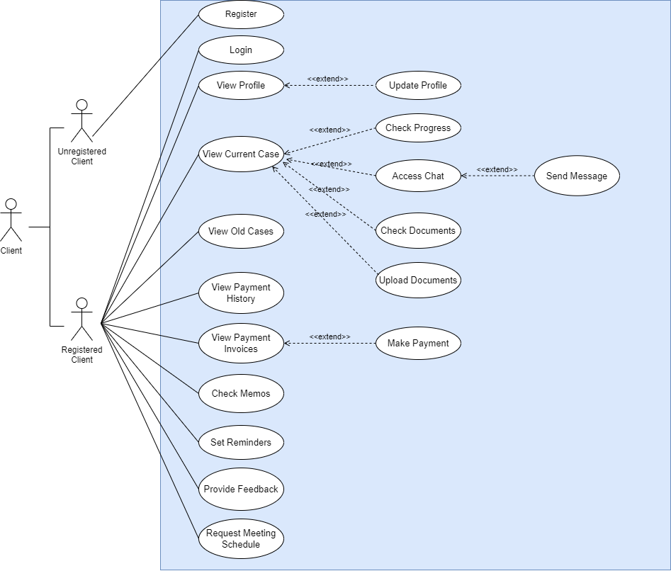

The UCN of the use cases view current case, check memos, set reminders are similar to that of other actors.

**Use case narratives for the remaining use cases**

**Use Case: View Old Cases**

|  |  |
| --- | --- |
| **Use case ID** | **UC22** |
| **Use case Name** | View Old Cases |
| **Preconditions** | The client must be logged in and have past cases in the system**.** |
| **Postconditions** | The client has accessed the details of their old cases. |
| **Trigger** | The client wants to review details of past cases. |
| **Primary actor** | Registered Client |

**Main Scenario**

1. The client navigates to the old cases section.
2. The client selects a specific old case to view details.
3. The system displays the case history and related documents.

**Alternate Scenarios**

* If the old case details fail to load, the system displays an error message.
* If there’s no old cases, the system displays no old case message

**Use Case: View Payment History**

|  |  |
| --- | --- |
| **Use case ID** | **UC23** |
| **Use case Name** | View Payment History |
| **Preconditions** | The client must be logged in. |
| **Postconditions** | The client has accessed their payment history. |
| **Trigger** | The client wants to review their past payments. |
| **Primary actor** | Registered Client |

**Main Scenario**

1. The client navigates to the payment history section.
2. The system displays a list of past payments with details.

**Alternate Scenarios**

* If the payment history fails to load, the system displays an error message.

**Use Case: View Payment Invoices (Make Payment)**

|  |  |
| --- | --- |
| **Use case ID** | **UC24** |
| **Use case Name** | View Payment Invoices (Make Payment) |
| **Preconditions** | The client must be logged in and have outstanding invoices. |
| **Postconditions** | The client has viewed the payment invoices and made a payment. |
| **Trigger** | The client wants to view their invoices and make a payment. |
| **Primary actor** | Registered Client |

**Main Scenario**

1. The client navigates to the payment invoices section.
2. The system displays a list of outstanding invoices.
3. The client selects an invoice to view details.
4. The client initiates the payment process.
5. The system redirects the client to the payment gateway.
6. The client completes the payment.
7. The system updates the payment status.

**Alternate Scenarios**

* If the payment process fails, the system displays an error message and prompts the client to try again.

**Use Case: Provide Feedback**

|  |  |
| --- | --- |
| **Use case ID** | **UC25** |
| **Use case Name** | Provide Feedback |
| **Preconditions** | The client must be logged in. |
| **Postconditions** | The feedback is submitted to the system. |
| **Trigger** | The client wants to provide feedback. |
| **Primary actor** | Registered Client |

**Main Scenario**

1. The client navigates to the feedback section.
2. The client fills out the feedback form with necessary details (e.g., rating, comments).
3. The client submits the feedback form.
4. The system records feedback.

**Alternate Scenarios**

* If the feedback fails to submit, the system displays an error message.

**Use Case: Request Meeting Schedule**

|  |  |
| --- | --- |
| **Use case ID** | **UC26** |
| **Use case Name** | Request Meeting Schedule |
| **Preconditions** | The client must be logged in. |
| **Postconditions** | The meeting request is submitted and scheduled. |
| **Trigger** | The client wants to schedule a meeting. |
| **Primary actor** | Registered Client |

**Main Scenario**

1. The client navigates to the meeting schedule section.
2. The client fills out the meeting request form with necessary details (e.g., date, time, purpose).
3. The client submits the meeting request.
4. The system forwards the request to the legal team.
5. The legal team reviews and confirms the meeting schedule.
6. The system updates the client with the meeting confirmation.

**Alternate Scenarios**

* If the meeting request fails to submit, the system displays an error message.

**Functionalities of the Database Admin**

* **Manage Historical Database:**
  + Add ,edit and update entries in the historical database of completed cases.
  + Search and filter cases

The UCN of search and filter cases are similar to that of the other actors

**Use case narratives for the use cases of the database admin**

**Use Case: Add new case**

|  |  |
| --- | --- |
| **Use case ID** | **UC27** |
| **Use case Name** | Add new case |
| **Preconditions** | The actor must be logged in. |
| **Postconditions** | The new case is added to the system |
| **Trigger** | There’s a new case to be added |
| **Primary actor** | Database admin |

**Main Scenario**

* The admin navigates to the add new case section
* The admin fills out the details of the case
* The admin submits the form
* The new case is added to the database

**Use Case: Edit cases**

|  |  |
| --- | --- |
| **Use case ID** | **UC28** |
| **Use case Name** | Edit cases |
| **Preconditions** | The admin must be logged in. |
| **Postconditions** | The case is edited |
| **Trigger** | The admin wants to edit some wrong information |
| **Primary actor** | Database admin |

**Main Scenario**

* The admin selects the case to be edited
* The admin edits the data
* The admin submits the form
* The system updates the new case details

**Functionalities of the system admin**

* **Oversee System Maintenance:**
  + Monitor system performance and conduct regular maintenance activities to ensure optimal functionality.
  1. **Quality Attributes**

**Security**

Ensuring the security of our legal case management system is paramount. Our system employs robust login verification to ensure that only authorized users can access the platform. Additionally, we implement user-level permissions, which restrict access to specific features and data based on the user's role within the system. This approach helps maintain confidentiality and prevents unauthorized access to information. By focusing on strong authentication and precise access control, our legal case management system provides a secure environment for managing legal information, giving legal professionals and their clients confidence in the safety and integrity of their data.

**Availability**

Ensuring the availability of our legal case management system is critical to maintaining seamless operations for legal professionals. Our system is designed with a robust infrastructure to provide high availability and minimize downtime. Regular maintenance and updates are performed with minimal impact on system availability, often scheduled during off-peak hours to reduce any potential inconvenience to users.

Additionally, our system is hosted on a scalable cloud platform, allowing it to handle varying loads efficiently and maintain optimal performance even during peak usage times. Continuous monitoring of system performance helps us quickly identify and address any potential issues before they impact users. Our commitment to high availability ensures that legal professionals can rely on our system for uninterrupted access to their case management tools, enhancing their productivity and efficiency in managing legal matters.

**Performance**

Ensuring the performance of our legal case management system is essential to providing a smooth and efficient user experience for legal professionals. Our system is optimized for fast load times and responsive interactions, enabling users to access and manage their cases quickly and effectively. We achieve this through a combination of efficient coding practices and optimized database queries.

By prioritizing performance, our legal case management system helps legal professionals work more efficiently, reducing the time spent on administrative tasks and allowing them to focus on their core responsibilities. This commitment to performance ensures that our system can support the demanding needs of legal practices, providing a reliable and effective tool for managing legal matters.

**Usability**

Ensuring the usability of our legal case management system is central to providing a seamless and intuitive experience for legal professionals. Our system is designed with a user-friendly interface that prioritizes simplicity and ease of navigation. Key features and functions are readily accessible, minimizing the learning curve and allowing users to quickly become proficient with the system.

We employ user-centered design principles. Consistent and clear labeling, intuitive workflows, and logical organization of information help users efficiently manage their cases without unnecessary complexity. Responsive design ensures that the system is accessible and functional across various devices, including desktops, tablets, and smartphones, allowing users to work from anywhere at any time.

**Scalability**

Ensuring the scalability of our legal case management system is essential to accommodate the growing needs of legal professionals and firms. Our system is designed to handle an increasing number of users, cases, and data without compromising performance or reliability. We achieve scalability through a modular architecture, allowing us to efficiently add new features and expand existing capabilities as demand grows.

Our database management practices include optimized indexing and query processing to handle large volumes of data efficiently, ensuring quick access and retrieval times even as the database grows.

By focusing on scalability, our legal case management system is prepared to support the evolving needs of legal professionals, ensuring that the system remains robust, efficient, and reliable as usage expands. This scalability ensures that our system can grow alongside legal practices, providing a sustainable solution for long-term case management.

**9. Technologies to be used**

The proposed web-based legal case management system will leverage a carefully selected suite of technologies tailored to ensure robust functionality, security, and scalability without reliance on additional frameworks.

**Front End: HTML, CSS, JavaScript**

* **HTML (Hypertext Markup Language):**

Provides the structural foundation of the application, ensuring content is well-organized and accessible across devices. It universally supported by all web browsers, ensuring that our legal case management system is accessible to users regardless of their preferred browser.

* **CSS (Cascading Style Sheets):**

Used for styling the user interface, ensuring a visually appealing and responsive design. It provides powerful tools for creating responsive designs that adapt to different screen sizes and devices

* **JavaScript:**

Enables dynamic and interactive elements within the application. With JavaScript, we can implement features that improve the usability of our legal case management system. This includes creating interactive forms, implementing drag-and-drop functionality, and providing instant search results. These enhancements make the system more intuitive and easier to navigate for legal professionals.

**Back End: PHP**

* **PHP:**

PHP integrates seamlessly with various database management systems, most notably MySQL, which is commonly used in web applications. This integration facilitates efficient data storage, retrieval, and management within our system, ensuring robust database interactions for storing case details, user information, and system configurations.

**Database: MySQL**

* **MySQL:**

A reliable and scalable relational database management system (RDBMS) ideal for handling structured data. It provides ACID compliance to ensure data integrity, crucial for legal case management applications. It also supports complex queries and transactions necessary for managing large volumes of case-related information securely.

**Designing tools: Figma and Canva**

* **Figma:**

Figma enhances our ability to deliver a user-friendly and visually appealing interface for our legal case management system while maintaining efficiency and collaboration among our design team.

* **Canva:**

Canva enhances our ability to create engaging and professional visuals for our legal case management system, ensuring consistency and quality across our design assets

**Development Tools and Deployment**

* **Version Control:**

Git for managing codebase changes, facilitating collaboration among developers and maintaining version history.

* **IDE (Integrated Development Environment):**

Visual Studio Code for code editing, enhancing productivity and code quality.

**10. Project Timeline**

The project's timeline is 9 months, aligning with the academic year. We are adopting the traditional waterfall development method in hybrid with the V model, signifying a structured approach to software development and focusing on the testing phase. In the waterfall methodology, phases progress linearly, with each phase building upon the previous one and typically includes requirements gathering, design, implementation, testing, deployment, and maintenance. This approach ensures thorough planning and documentation early on.

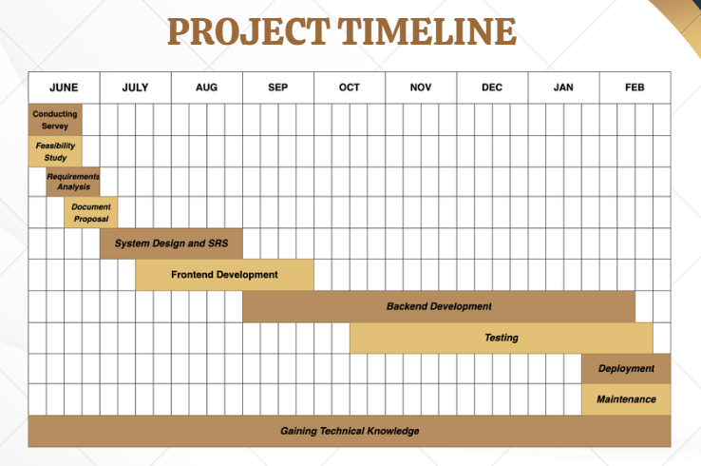

**11. Declaration**

We, as members of the project 'Themis - Legal Case Management System,' solemnly certify our commitment to executing this project in strict accordance with the guidelines stipulated by our course coordinators and supervisors. We pledge not to incorporate any material from previous academic submissions without proper acknowledgment. Furthermore, we assure that our project work will not include any content previously published or authored by another individual or ourselves, except where appropriately referenced within the text. This declaration underscores our dedication to upholding academic integrity, ensuring the originality and ethical standards of our project at all stages of its development and completion.

|  |  |  |
| --- | --- | --- |
| **Name** | **Index No** | **Signature** |
| A.N.F.N Arafa | 22000151 |  |
| H.M.N.J Deeranatha | 22000364 |  |
| S.V. Abeywickrama | 22000089 |  |
| C.D. Abeysinghe | 22000046 |  |