DBMS – PAYMENT MANAGEMENT
Project Title: ONE8 Footwear E-Commerce System
Skill Task: DBMS
Week: 3

1. Database Design

1.1 Orders Table (prerequisite reference)
Attribute | Data Type | Constraint
Order_ID | NUMBER | Primary Key
Customer_ID | NUMBER | NOT NULL
Order_Date | DATE | —
Total_Amount | NUMBER(10,2) | —
Order_Status | VARCHAR2(20) | —

1.2 Payment Table
Attribute | Data Type | Constraint
Payment_ID | NUMBER | Primary Key
Order_ID | NUMBER | NOT NULL, Foreign Key
Payment_Mode | VARCHAR2(30) | NOT NULL
Payment_Date | DATE | NOT NULL
Amount | NUMBER(10,2) | NOT NULL
Payment_Status | VARCHAR2(20) | NOT NULL, DEFAULT 'Pending', CHECK IN ('Success','Failed','Pending')

2. Primary and Foreign Key Relationship
Orders → Payment
- Orders.Order_ID → Primary Key
- Payment.Payment_ID → Primary Key
- Payment.Order_ID → Foreign Key referencing Orders.Order_ID
- Relationship: One-to-One (1:1) — every order has exactly one payment record

3. Table Creation

3.1 Create Orders Table
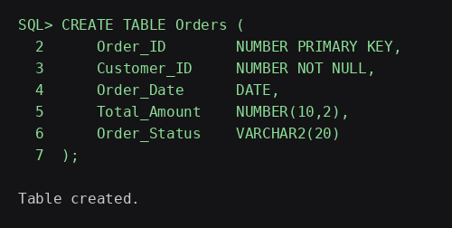

3.2 Create Payment Table
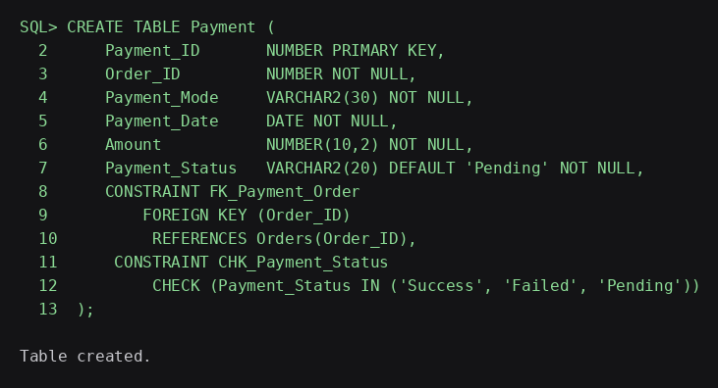

4. Data Insertion

4.1 Orders Records
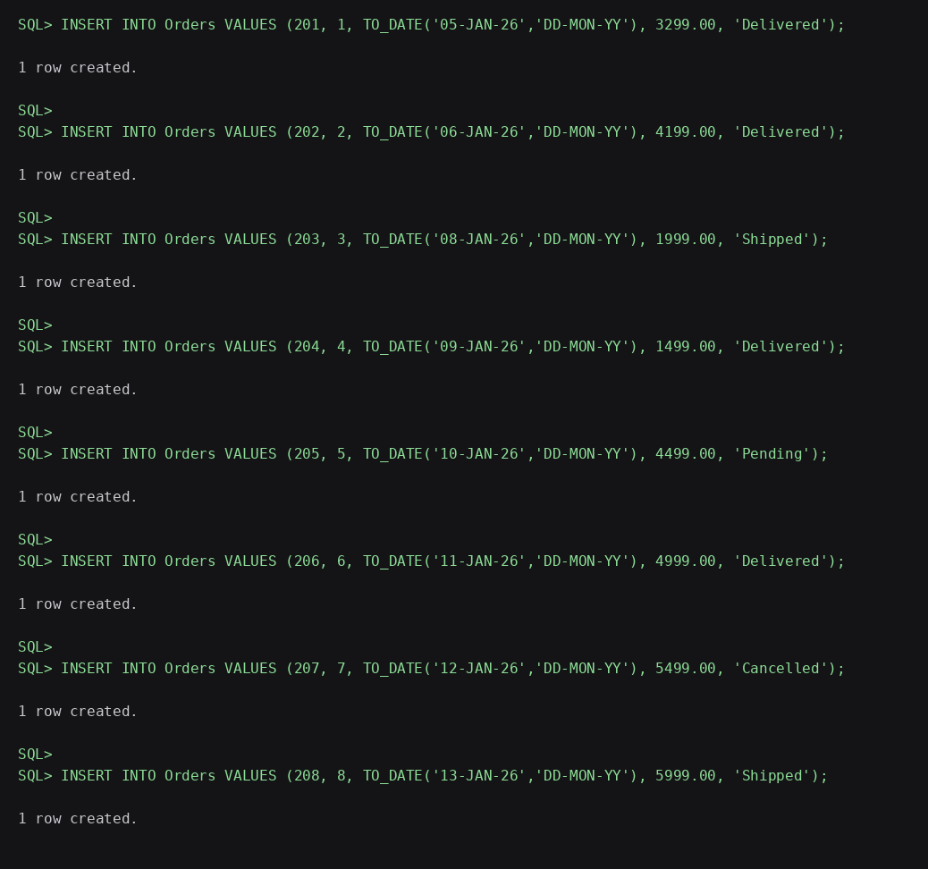

4.2 Payment Records
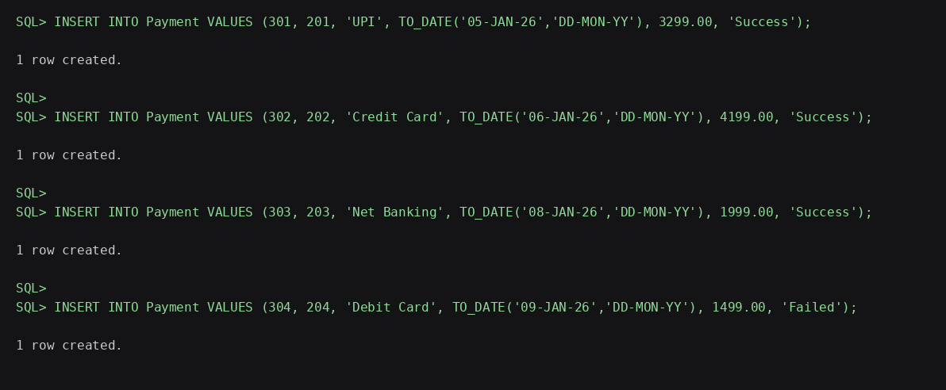
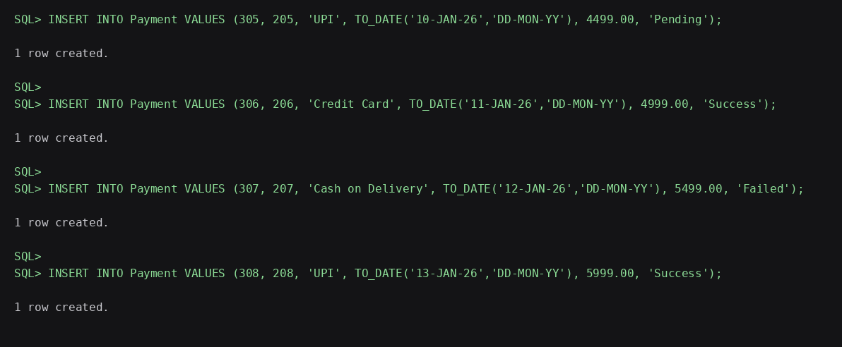

5. Data Retrieval

5.1 Display Payment Records
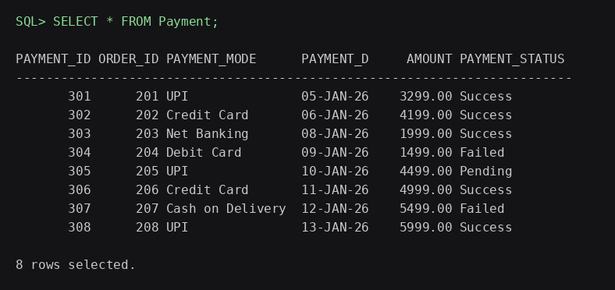

6. Managing Successful and Failed Transactions
View all successful transactions:
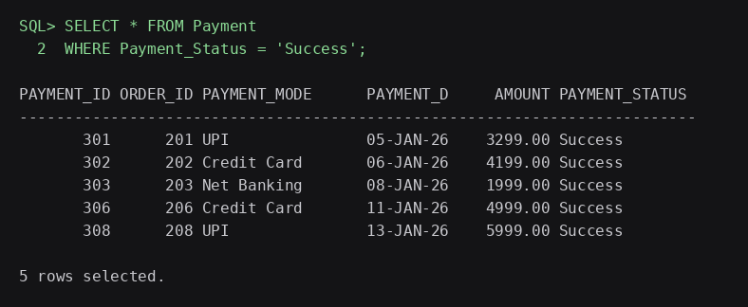
View all failed transactions:
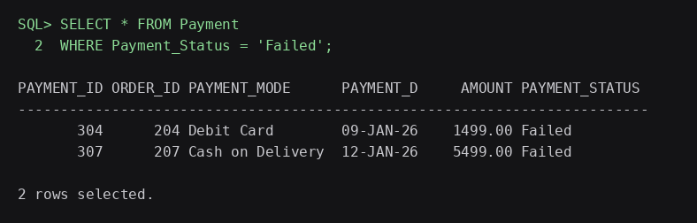
Retry a failed payment and mark it successful:
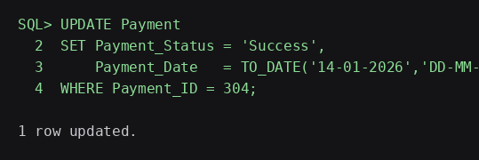
Resolve a pending payment:
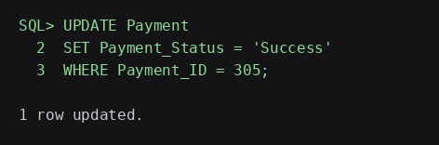
Verify the updated records:
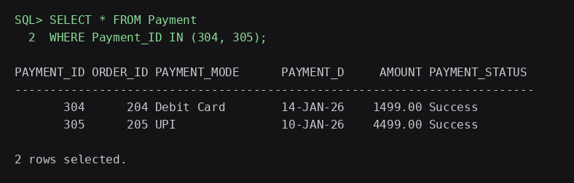

7. Payment Method Analysis
Total transactions and amount collected by payment mode:
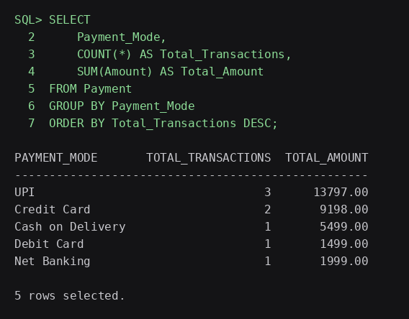
Payment status summary:
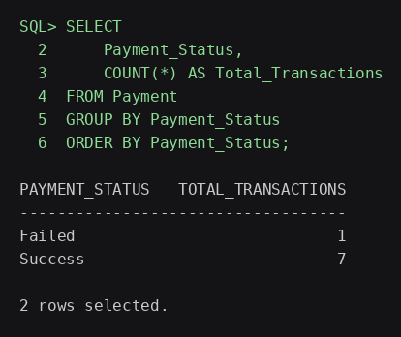

8. Payment Transaction Reports
This report displays each payment transaction along with the customer name, order, payment mode, date, amount and status, ordered by payment date.
