Rajalakshmi Engineering College (Autonomous, affiliated to Anna University, Chennai)
Department of Artificial Intelligence and Data Science

AD23532 — Principles of Data Science
Lab Oriented Theory | Category: Professional Core (PC) | L-T-P-C: 2-0-4-4

AirGuard India
A Vulnerability-Weighted Health Advisory Index and Next-Day Air Quality Forecasting System for Indian Cities

Review 1: Problem Statement and Dataset
Maximum marks: 30

Degree and Branch | B.Tech. Artificial Intelligence and Data Science
Regulation | 2023
Academic Year | 2026-27 (ODD)
Semester | V
Batch | 2024-2028

Project team
S. No. | Register Number | Name
1 | 260586 | Nishanth Rajendran
2 | 260598 | <NAME>
3 | 260600 | <NAME>

Generated 30 September 2026 · Repository: https://github.com/nishaids/airguard-india

Table of Contents
Section | Title | Rubric row addressed
1 | Problem Statement and Research Objectives | Problem statement and research objectives (4)
2 | Dataset Selection, Relevance and Quality | Dataset selection, relevance, quality, understanding (4)
3 | Project Charter | Project Charter (10)
4 | Methodology and Algorithm Justification | Methodology and algorithm justification (4)
5 | Planning, Timeline, Resources and Deliverables | Planning, timeline, resources, deliverables (4)
6 | References and Rubric Coverage | Technical report quality (4)

1. Problem Statement and Research Objectives

1.1 The public-health burden
Air pollution is among the largest environmental determinants of mortality in India. The Global Burden of Disease study for 2017 attributed 1.24 million deaths in India to air pollution in that year, equivalent to 12.5 per cent of all deaths recorded, and estimated that average national life expectancy would have been 1.7 years higher had ambient concentrations met the levels considered attainable (Balakrishnan et al., 2019). The World Health Organization revised its global air quality guideline for annual mean PM2.5 downward from 10 to 5 micrograms per cubic metre in 2021, and its 24-hour guideline from 25 to 15 micrograms per cubic metre, on the basis of accumulated evidence that harm occurs at concentrations previously regarded as acceptable (WHO, 2021). Indian urban concentrations routinely exceed both thresholds by a substantial margin.
The Government of India operates a Continuous Ambient Air Quality Monitoring Station network through the Central Pollution Control Board and publishes a National Air Quality Index derived from it (CPCB, 2014). That index is the primary instrument through which air quality information reaches the public.

1.2 The specific gap this project addresses
The National Air Quality Index is well constructed for its purpose, but it has two structural properties that limit its usefulness as a personal health signal. Both are consequences of its design rather than defects in its implementation.
- The index is a single population-average number. It is computed as the maximum of the pollutant sub-indices and reported identically to every person in a city. A child whose airways are still developing, an adult with chronic obstructive pulmonary disease, a person with existing ischaemic heart disease and a healthy adult all receive the same figure and the same instruction, although the epidemiological literature documents materially different exposure-response relationships for each group.
- The index is retrospective. It describes air that has already been breathed. A person deciding whether to send a child to outdoor sport tomorrow, or a school deciding whether to move an event indoors, needs an expectation about tomorrow rather than a summary of today.
- The maximum rule discards the remainder of the pollutant mixture. A day on which one pollutant sits at sub-index 210 while the other five sit near zero receives the same index as a day on which all six sit between 190 and 210, although the total inhaled burden differs.

1.3 Problem statement
Given daily pollutant concentrations for Indian cities, construct a system that forecasts the next day's air quality rather than summarising the current day, and that translates that forecast into an advisory resolved by population vulnerability cohort rather than issued as a single population-average number, while remaining at all times at least as protective as the official index.

1.4 Research objectives
The objectives below are specific, measurable and bounded by the evidence the dataset can support. Objective O5 states explicitly what cannot be established with these data, because an objective that promises more than the data can deliver is not a research objective.
Table 1. Research objectives and their measurable success criteria
ID | Objective | Description | Measurable success criterion
O1 | Forecast next-day AQI | Build a regression model predicting the following day's AQI per city. | Mean absolute error strictly below that of a persistence baseline, measured on a time-ordered held-out period.
O2 | Forecast next-day AQI band | Build a classifier predicting the following day's CPCB band. | Macro-averaged F1 above the persistence baseline, with the rare Severe class reported separately.
O3 | Construct a cohort-resolved index | Define a vulnerability-weighted Health Advisory Index for seven cohorts, grounded in cited exposure-response literature. | The index is bounded, monotone and provably never less protective than the official AQI; divergence from the AQI is measured on real observations.
O4 | Discover city archetypes | Cluster cities on the composition of their pollutant mix and map each archetype to a distinct policy lever. | A partition stable across two clustering algorithms, reported with internal validity indices.
O5 | State the limits of the evidence | Document what the dataset cannot support, including the absence of meteorology and of any health outcome data. | A data card and a model card enumerating every limitation, with no claim of clinical validation.
O6 | Deliver a working product | Ship a deployed application exposing the forecast, the cohort advisory, the archetypes and a counterfactual simulator. | Four functional pages, multilingual advisory text, no unhandled exception on any valid input.

2. Dataset Selection, Relevance and Quality

2.1 Source and provenance
The dataset was acquired programmatically and every property reported in this section was produced by executed code. The acquisition module writes a machine-readable provenance record containing SHA-256 checksums for every file, the licence string read from the live dataset page at download time, and a full column-level schema profile. A reviewer can re-run the module and compare digests.
Table 2. Dataset identity and licence, recorded as displayed rather than assumed
Field | Value
Title (read from the source page) | Air Quality Data in India (2015 - 2020)
Upstream producer | Central Pollution Control Board (CPCB), Ministry of Environment, Forest and Climate Change, Government of India
Mirror | https://www.kaggle.com/datasets/rohanrao/air-quality-data-in-india
Uploader | Vopani (rohanrao)
Licence as displayed | CC0: Public Domain
Licence verified live at download | True
Acquisition method | Path A - programmatic download via kagglehub (anonymous)
Retrieved (UTC) | 2026-09-28T17:29:24Z
Code licence of this repository | MIT

The licence recorded above is the string the source page actually displayed at the moment of download. It was not assumed from the upstream agency's usual terms, and the verification method is recorded alongside it in the provenance artefact. This distinction matters because the compiled dataset and its upstream source are separately licensed artefacts, and conflating them would misstate the terms under which this work redistributes anything.

2.2 Size, structure and features
Table 3. Structure of the primary working file
Property | Value
Rows in the primary daily file | 29,531
Columns | 16
Cities in the source | 26
Date coverage | 2015-01-01 to 2020-07-01
Unit of observation | one city-day
Pollutants measured | PM2.5, PM10, NO, NO2, NOx, NH3, CO, SO2, O3, Benzene, Toluene, Xylene
Targets available | AQI (continuous) and AQI_Bucket (six ordered categories)
Supporting files | city_hour.csv, station_day.csv, stations.csv

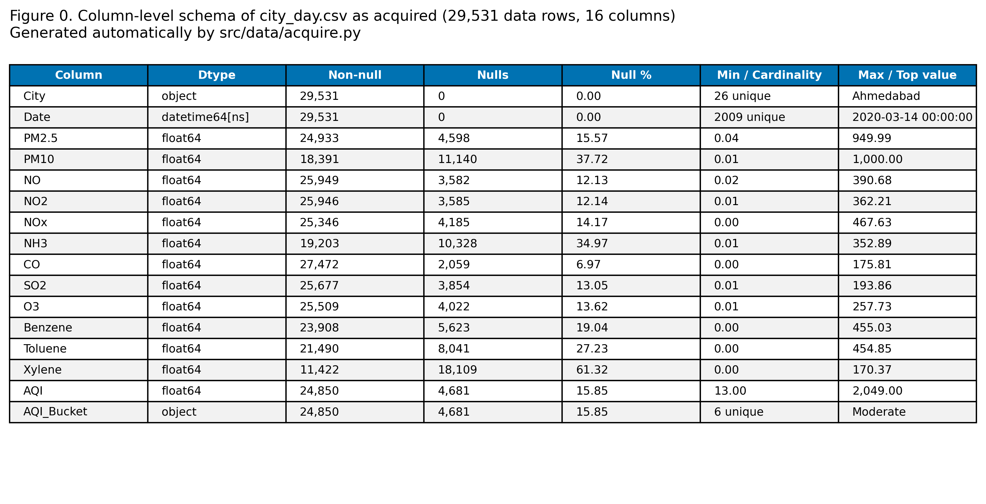
Figure 1. Column-level schema of city_day.csv rendered directly from the acquired file by src/data/acquire.py. This figure is documentary evidence that the schema was read rather than transcribed. [00_dataset_proof_schema.png]

2.3 Initial quality assessment
A full quality assessment was executed before any modelling decision was taken. The table below reports its principal findings; the complete record is in results/data_quality_report.json.
Table 4. Principal findings of the automated data quality assessment
Check | Result
Fully duplicated rows | 0
Duplicate (City, Date) keys | 0
Missing calendar days across all cities | 0
Negative concentrations | 0
Columns failing an order-of-magnitude unit check | 0
City naming consistency | consistent
Rows complete on all pollutants and AQI | 6,236 (21.117%)
AQI values above the CPCB 0-500 scale | 543 (2.185%)
Observed AQI range | 13.0 to 2049.0
AQI_Bucket reproducible from AQI | 100.0% agreement, 0 mismatches

Table 5. Missingness by column, ranked
Column | Missing values | Share of records
Xylene | 18,109 | 61.322%
PM10 | 11,140 | 37.723%
NH3 | 10,328 | 34.973%
Toluene | 8,041 | 27.229%
Benzene | 5,623 | 19.041%
AQI | 4,681 | 15.851%
AQI_Bucket | 4,681 | 15.851%
PM2.5 | 4,598 | 15.57%
NOx | 4,185 | 14.172%
O3 | 4,022 | 13.62%
SO2 | 3,854 | 13.051%
NO2 | 3,585 | 12.14%
NO | 3,582 | 12.13%
CO | 2,059 | 6.972%

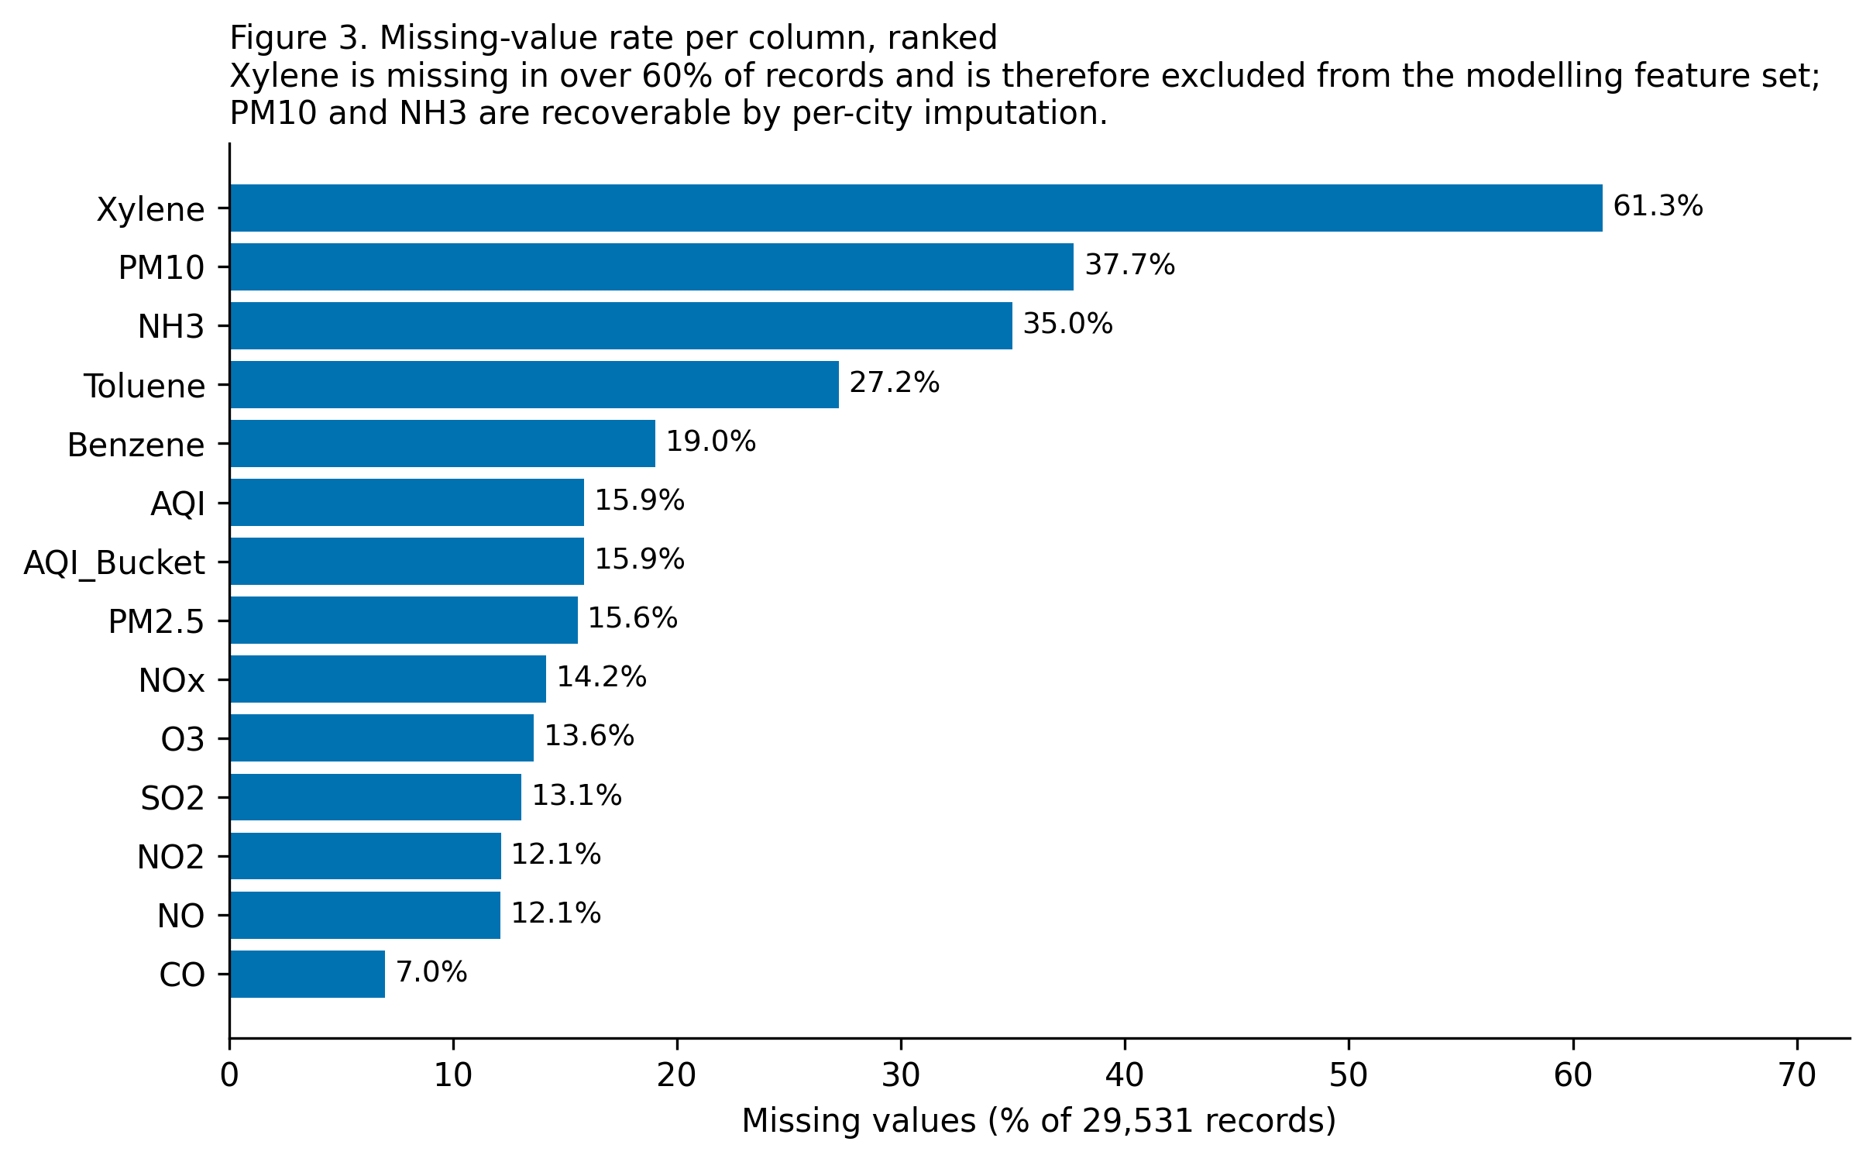
Figure 2. Missing-value rate per column. Xylene is absent from more than three records in five, which is the basis for excluding it from the modelling feature set rather than reconstructing it. [03_null_percentage_bar.png]
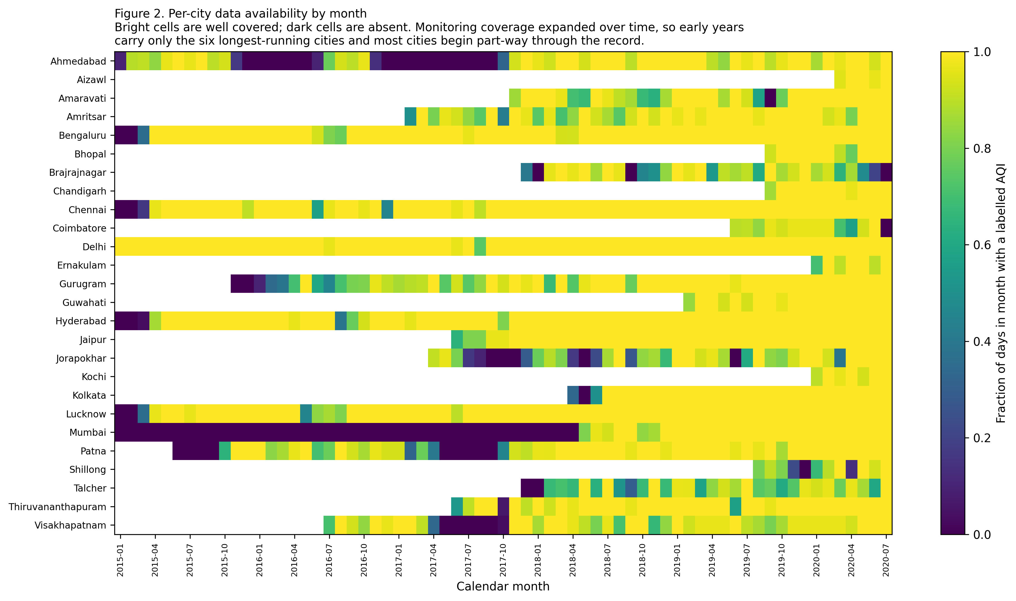
Figure 3. Per-city data availability by month. Monitoring coverage expanded over the record, so the early years carry only the longest-running cities. This is the structural reason a national trend across the full span cannot be claimed from these data. [02_city_availability_heatmap.png]

2.4 Fitness for purpose
The dataset is fit for the stated objectives for four reasons, each of which is a property the objectives actually require rather than a general merit.
- Temporal density. Daily observations over more than five years give enough consecutive days per city to construct genuine lag and rolling features, which a forecasting formulation requires and a cross-sectional dataset could not supply.
- Pollutant breadth. All six species for which CPCB publishes sub-index breakpoints are present, which is what makes an independent reconstruction of the index, and therefore a re-weighted variant of it, possible at all.
- A labelled target. Both the continuous AQI and its ordered band are supplied, so regression and classification can be posed on the same record and compared like for like.
- Event coverage. The span contains five Diwali seasons, five post-monsoon crop-residue burning seasons and the 2020 national lockdown, which supplies both the event structure the advisory system must handle and a natural experiment against which the policy simulator can be sanity-checked.

2.5 Alternatives considered and rejected
Table 6. Alternative data sources considered, with the reason each was rejected
Alternative | What it offers | Reason for rejection
CPCB CCR portal (live) | Authoritative and current. | Rejected. The portal is rate-limited and exposes no stable bulk historical endpoint, so a five-year record could not be assembled reproducibly. A reviewer could not re-derive the same dataset from it.
OpenAQ global aggregation | Open API, multi-country, includes some Indian stations. | Rejected. Indian coverage is sparser and less consistent than the CPCB record for the period of interest, and the aggregation mixes reporting conventions across sources, which would confound city-to-city comparison.
Satellite aerosol optical depth | Complete spatial coverage including rural areas. | Rejected. Column aerosol optical depth is not a surface concentration; converting it requires a calibration model that would itself be the research problem, and it yields no NO2, SO2 or CO at the resolution needed.
Station-level file within this dataset | Finer spatial resolution than the city aggregate. | Not selected as primary. Station series carry substantially more missingness and frequent station retirements, which would make the per-city continuity that lag features depend on much harder to establish. Retained as supporting evidence.

2.6 City selection
Two gates were fixed before any model was fitted: at least 80% of the calendar days in a city's own observation span must carry a labelled AQI, and the city must contribute at least 730 labelled days. 12 of 26 cities passed. No city was dropped silently: every exclusion appears below with its completeness figure and its reason.
Table 7. City retention decisions, with the reason for every exclusion
City | Labelled days | Completeness | Decision | Reason
Ahmedabad | 1,334 | 66.4% | Excluded | Excluded: completeness 66.4% < 80%.
Aizawl | 111 | 98.2% | Excluded | Excluded: only 111 labelled days < 730.
Amaravati | 841 | 88.4% | Retained | AQI completeness 88.4% >= 80% and 841 labelled days >= 730.
Amritsar | 1,126 | 92.2% | Retained | AQI completeness 92.2% >= 80% and 1,126 labelled days >= 730.
Bengaluru | 1,910 | 95.1% | Retained | AQI completeness 95.1% >= 80% and 1,910 labelled days >= 730.
Bhopal | 278 | 96.2% | Excluded | Excluded: only 278 labelled days < 730.
Brajrajnagar | 713 | 76.0% | Excluded | Excluded: completeness 76.0% < 80%; only 713 labelled days < 730.
Chandigarh | 299 | 98.4% | Excluded | Excluded: only 299 labelled days < 730.
Chennai | 1,884 | 93.8% | Retained | AQI completeness 93.8% >= 80% and 1,884 labelled days >= 730.
Coimbatore | 344 | 89.1% | Excluded | Excluded: only 344 labelled days < 730.
Delhi | 1,999 | 99.5% | Retained | AQI completeness 99.5% >= 80% and 1,999 labelled days >= 730.
Ernakulam | 153 | 94.4% | Excluded | Excluded: only 153 labelled days < 730.
Gurugram | 1,453 | 86.5% | Retained | AQI completeness 86.5% >= 80% and 1,453 labelled days >= 730.
Guwahati | 495 | 98.6% | Excluded | Excluded: only 495 labelled days < 730.
Hyderabad | 1,880 | 93.7% | Retained | AQI completeness 93.7% >= 80% and 1,880 labelled days >= 730.
Jaipur | 1,094 | 98.2% | Retained | AQI completeness 98.2% >= 80% and 1,094 labelled days >= 730.
Jorapokhar | 771 | 66.0% | Excluded | Excluded: completeness 66.0% < 80%.
Kochi | 158 | 97.5% | Excluded | Excluded: only 158 labelled days < 730.
Kolkata | 754 | 92.6% | Retained | AQI completeness 92.6% >= 80% and 754 labelled days >= 730.
Lucknow | 1,893 | 94.2% | Retained | AQI completeness 94.2% >= 80% and 1,893 labelled days >= 730.
Mumbai | 775 | 38.6% | Excluded | Excluded: completeness 38.6% < 80%.
Patna | 1,459 | 78.5% | Excluded | Excluded: completeness 78.5% < 80%.
Shillong | 205 | 66.1% | Excluded | Excluded: completeness 66.1% < 80%; only 205 labelled days < 730.
Talcher | 698 | 75.5% | Excluded | Excluded: completeness 75.5% < 80%; only 698 labelled days < 730.
Thiruvananthapuram | 1,052 | 94.6% | Retained | AQI completeness 94.6% >= 80% and 1,052 labelled days >= 730.
Visakhapatnam | 1,171 | 80.1% | Retained | AQI completeness 80.1% >= 80% and 1,171 labelled days >= 730.

Two independent gates are applied. The completeness gate (80% of the calendar days in a city's own observation span must carry a labelled AQI) ensures that per-city lag and rolling features are computed over a near-contiguous series rather than across long gaps, since a lag of one row is only a lag of one day when the series is dense. The volume gate (at least 730 labelled days, i.e. two years) ensures each retained city contributes at least two full annual cycles, so that seasonal structure is estimable and a time-ordered split leaves a usable test period. Both thresholds were fixed before any model was fitted and are not tuned against model performance.

2.7 Initial insights that shape the design
- The AQI band distribution is uneven by a factor of 6.6 between the most and least common class, with Severe at 5.384 per cent of labelled days. Overall accuracy is therefore not an adequate summary, and macro-averaged F1 is adopted as the primary classification metric.
- AQI_Bucket is reproducible from AQI at 100.0 per cent agreement with 0 mismatches. This is verified rather than assumed, and it establishes the label-leakage hazard that Section 4.4 addresses.
- 543 records carry an AQI above the CPCB 0-500 scale, reaching 2049.0. These are retained and flagged rather than truncated: they mark the genuine extreme days the advisory system exists to warn about.
- Monitoring coverage expanded over the record, so the set of cities represented in 2015 differs from the set represented in 2020. Any apparent national trend across the full span would be confounded with this compositional change, and none is claimed.

3. Project Charter

3.1 Mission and context
AirGuard India converts a retrospective, population-average air quality number into a forward-looking, cohort-resolved health advisory, and delivers it as a working public-facing tool rather than as an analysis. The context is the gap described in Section 1.2: the information the official index provides is accurate but is neither personalised nor actionable in advance.

3.2 Scope
Table 8. Project scope boundaries
 | Definition
In scope | Next-day forecasting of AQI value and band for the retained cities; a vulnerability-weighted Health Advisory Index for seven cohorts; unsupervised discovery of city pollution archetypes; a safest-exposure-window recommender built from hourly data; event-aware analysis of festival, crop-burning and lockdown periods; SHAP explainability; a counterfactual policy simulator; a deployed multilingual application; responsible-AI documentation.
Out of scope | Real-time ingestion from a live sensor feed; sub-city or street-level resolution; forecast horizons beyond one day; source apportionment by receptor modelling; chemical transport modelling; any clinical or diagnostic function; regulatory compliance assessment; cities outside the retained set; rural areas; any claim about air quality after 1 July 2020.

3.3 Stakeholders and the decision each output serves
Table 9. Stakeholder and beneficiary matrix
Stakeholder | Decision they face | Output that serves it
Citizens in the covered cities | Whether to undertake outdoor activity tomorrow | Next-day band with confidence; plain-language advisory in three languages
Vulnerable cohorts (children, elderly, asthma and COPD, cardiac, pregnant women, outdoor workers) | Whether the general advisory is sufficient for their own risk | Cohort-specific Health Advisory Index, band and action text
Parents and schools | Whether to move outdoor sport or assembly indoors | Children's cohort index plus the safest outdoor window for the day
Hospitals and clinics | Whether to anticipate a respiratory or cardiac admissions surge | Next-day forecast with the severity distribution across bands
Urban local bodies | Which mitigation lever to prioritise in this city | City archetype and its mapped policy lever; per-city risk ranking
CPCB and state pollution control boards | Which reduction target to set and what it would achieve | Counterfactual simulator reporting advisory-days averted per scenario
Outdoor worker associations | How to schedule shifts to reduce cumulative exposure | Outdoor-worker cohort index and the hourly exposure climatology
Academic reviewers | Whether the work is sound and reproducible | Provenance record with checksums; every number generated by executed code; one-command reproduction

3.4 Success criteria
Table 10. Success criteria with their measurement
Criterion | Target | How it is measured
Forecast accuracy | Regression MAE below the persistence baseline on the held-out period | MAE and the percentage improvement over persistence
Classification quality | Macro-F1 above the persistence baseline, with Severe-class F1 reported separately | Macro-F1, per-class F1, ROC-AUC
Index validity | The Health Advisory Index is bounded, monotone and never less protective than the official AQI | Assertions executed at every pipeline run
Index informativeness | The cohort index must disagree with the official AQI on a material share of days, or it adds nothing | Percentage of city-days on which a cohort band differs from the AQI band
Clustering validity | A partition stable across two algorithms | Silhouette, Davies-Bouldin, Calinski-Harabasz, adjusted Rand index
Reproducibility | A fresh clone regenerates every result and figure with one command | run_all.py completing without error; fixed seed; pinned dependencies
Product completeness | Four functional application pages with no unhandled exception on any valid input | Smoke test across every city, cohort and date combination
Honesty of reporting | No metric written by hand anywhere in any report | Every document generated from the results artefacts

3.5 Risks and mitigations
Table 11. Risk register with mitigations
Risk | Likelihood | Impact | Mitigation
Data acquisition fails or credentials are unavailable | Medium | High | Two acquisition paths implemented; the programmatic path was verified to work without credentials, and a documented manual path exists as fallback.
Label leakage inflates reported performance | High | Critical | A forecasting formulation is adopted so the hazard does not arise; the leakage a same-day formulation would suffer is measured and reported rather than merely avoided.
Temporal leakage through shuffled validation | High | Critical | Fixed calendar split; TimeSeriesSplit throughout; an assertion fails the run if the boundary is violated.
Imputation distorts the distribution the analysis reads | Medium | High | Five strategies compared by a masking experiment on training rows only; selection made on measured reconstruction error and distribution shift.
Genuine pollution spikes removed as outliers | Medium | High | The outlier rule exempts documented event windows; only physically impossible or isolated single-day excursions are removed, and the counts are reported.
Class imbalance hides failure on the Severe class | High | High | Macro-F1 declared as the primary metric before fitting; per-class F1 reported; two imbalance remedies compared head to head.
The 2020 distribution shift degrades the model | High | Medium | Explicit lockdown flag; the period is retained in the test set and reported separately as a stress-test slice.
Cohort weights mistaken for validated clinical risk | Medium | High | The prototype status is stated in the module docstring, the model card and the application; no clinical validation is claimed.
Over-reliance on a single dataset | High | Medium | Limitations enumerated in the data card, including the absence of meteorology and of rural coverage.
Deployment exceeds free-tier resources | Low | Medium | Model artefacts compressed; caching on load; no GPU requirement; cold start kept small.

3.6 Assumptions
- The CPCB measurements are accepted as the best available estimate of ambient concentration at the monitored locations. No independent calibration was possible.
- A city-level daily mean is treated as representative of that city for advisory purposes, while the data card acknowledges that it represents monitored locations rather than population-weighted exposure.
- The CPCB sub-index breakpoints are treated as fixed and authoritative, which they are by regulation.
- Day-to-day persistence in pollutant concentrations is assumed strong enough that same-day information is predictive of the next day. This assumption is tested rather than asserted: the persistence baseline measures exactly how strong it is.
- Relative cohort vulnerability is assumed to be reasonably approximated by the ordering documented in the cited literature. This is the weakest assumption in the project and is flagged as such wherever the index appears.

3.7 Ethical considerations
The dataset contains no personal data and no individual-level records, so there is no privacy risk in its use. The ethical exposure of this project lies in its output rather than its input. An advisory that understates risk could lead a vulnerable person to expose themselves unnecessarily, and an advisory that overstates it repeatedly would erode the trust on which any public-health communication depends. Three design decisions follow directly.
- The Health Advisory Index is constructed so that it can never be less protective than the official AQI for any cohort. This is a property of the formula, proved by assertion at every pipeline run rather than checked by inspection.
- The rate at which the classifier understates severity by two bands or more is reported as a first-class safety statistic rather than left implicit inside an averaged score.
- Every advisory the application issues carries a medical disclaimer, and the model card states plainly that the index has not been validated against health outcomes because the dataset contains none.

3.8 Feasibility
Table 12. Feasibility assessment
Resource | Assessment
Software | Python 3.10 with pandas, NumPy, scikit-learn, XGBoost, LightGBM, imbalanced-learn, SHAP, matplotlib, seaborn, Plotly, Streamlit and python-docx. All open source, all pinned in requirements.txt.
Hardware | A mid-range laptop. No GPU is required at any stage. Peak memory is bounded by streaming the 66 MB hourly file in chunks rather than loading it whole.
Cost | Zero. No paid API, no cloud compute and no licensed software. Deployment targets a free hosting tier.
Data | Publicly available and openly licensed; acquisition verified to work without credentials.
Skills | Supervised and unsupervised learning, time-series validation, feature engineering, explainability, application development and technical writing, all within the scope of the course.
Time | Six weeks, planned in Section 5 and aligned to the three review milestones.

4. Methodology and Algorithm Justification
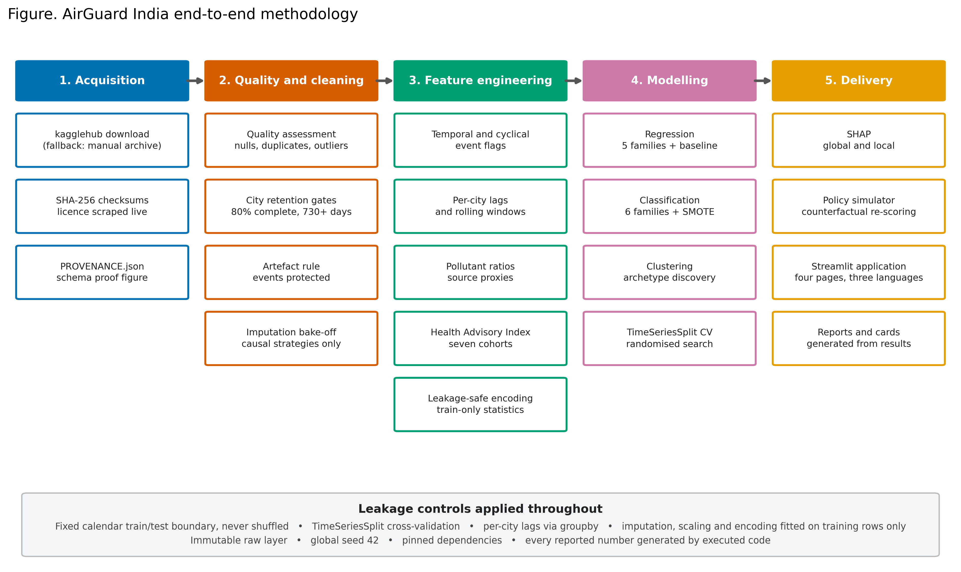
Figure 4. End-to-end methodology. The leakage controls in the lower band apply at every stage rather than at a single checkpoint. [39_pipeline_diagram.png]

4.1 Why these algorithm families
Five regression families and six classification families are fitted, each chosen to answer a specific question rather than to lengthen a list.
Table 13. Algorithm families and the specific question each answers
Family | Task | Why it is included
Persistence baseline | Both | Daily AQI is strongly autocorrelated, which makes 'tomorrow equals today' a genuinely competitive forecaster. Without it an R-squared above 0.9 is uninterpretable. Any learned model must beat it to justify its complexity.
Linear and Logistic Regression | Both | The interpretable reference. Coefficients are directly readable, and the gap between the linear model and the ensembles measures how much non-linearity the problem actually contains.
Ridge Regression | Regression | The correlation analysis shows severe multicollinearity among the nitrogen oxide species and within the lag family. An L2 penalty stabilises coefficients that ordinary least squares leaves ill-determined.
Decision Tree | Classification | A single tree whose decision path can be read directly, which has value for a health advisory. The gap to the ensembles quantifies the variance one tree suffers.
Random Forest | Both | Bagging reduces that variance while retaining the ability to capture pollutant interactions and the city-by-season structure without either being specified.
XGBoost and LightGBM | Both | Gradient boosting is the strongest default family for tabular problems. Both are included because they differ in tree-growth strategy, level-wise against leaf-wise, and can disagree materially on a heavily skewed target.
SVM with an RBF kernel | Classification | The pairwise exploratory structure shows curved class boundaries that a linear classifier cannot express. A kernel method tests whether that curvature is worth the computational cost.
K-Nearest Neighbours | Classification | A purely local, non-parametric benchmark. Its distance from the ensembles indicates how much of the signal is captured by local similarity alone.
K-Means and Ward agglomerative | Clustering | K-Means for the archetype partition, with Ward agglomerative clustering as an independent check. A partition that survives a change of algorithm objective is more likely to reflect structure than method.

4.2 Evaluation strategy
The evaluation is time-aware throughout. The record is split at a fixed calendar boundary so that the training period strictly precedes the test period, and cross-validation uses expanding-window folds in which every validation fold lies after its training folds.
Random k-fold cross-validation is invalid for this problem, and the reason is worth stating precisely. Consecutive days in a pollutant series are strongly autocorrelated. Shuffling places days from the same week, and sometimes the immediately adjacent day, on both sides of the split. A model evaluated that way is scored partly on its ability to interpolate between observations it has already seen, which is not the task. The resulting optimism is not a small bias: on autocorrelated series it can be large enough to reverse a model ranking. Shuffling is therefore never used at any point in this project, and an assertion fails the run if the training and test date ranges ever overlap.

4.3 Metrics and why each is primary
Table 14. Evaluation metrics, with the primary metric declared in advance
Task | Metrics | Justification for the primary metric
Regression | MAE (primary), RMSE, R-squared, MAPE, bias | MAE is primary because the AQI distribution is strongly right-skewed, so RMSE would rank models largely by their behaviour on a small number of extreme days. MAE is in the units of the target and reads as 'the typical miss in AQI points'.
Classification | Macro-F1 (primary), accuracy, weighted F1, balanced accuracy, per-class F1, ROC-AUC (one-versus-rest), Cohen's kappa, ordinal error | Macro-F1 is primary because the bands are imbalanced and the rarest of them, Severe, is the one on which the public-health purpose rests. Accuracy is least sensitive to exactly the error that matters most.
Clustering | Silhouette, Davies-Bouldin, Calinski-Harabasz, adjusted Rand index | Three internal validity indices are reported because they disagree, and the disagreement is itself informative. The adjusted Rand index measures whether the partition survives a change of algorithm.

4.4 Leakage controls
Five distinct leakage hazards were identified before modelling began, and each has a specific control. They are enumerated here because a claim of correctness that is not specific is not verifiable.
Temporal. The split is a fixed calendar boundary; shuffle is never used. TimeSeriesSplit is used for cross-validation. Lags and rolling windows are computed with groupby('City') so no city contributes to another city's history, and no window extends past the current day.
Target. AQI_next and AQI_Bucket_next are mutually excluded from each other's feature matrix, and an assertion in build_feature_matrix fails the run if either appears among the candidates. Same-day AQI and AQI_Bucket_ordinal are retained as legitimate predictors because they are known at prediction time; the distinct same-day nowcast leakage is demonstrated empirically in models/train_classification.py.
Encoder. The encoding is fitted on the training period only. Applying a full-sample city mean would allow each test row to contribute to the value of its own encoded feature.
Scaler. Scaling is performed inside a scikit-learn Pipeline so that fit_transform touches training folds only; no scaler is ever fitted on the test partition.
Imputation. All imputation statistics were estimated on pre-boundary rows in src/data/clean.py, and the adopted strategy uses no forward-looking information within a city's series.

4.5 The Health Advisory Index
The index is the project's principal methodological contribution. For a city-day, each CPCB pollutant sub-index is rescaled to a 0-100 range, multiplied by a cohort-specific vulnerability factor, and combined as the largest cohort-adjusted sub-index plus 0.25 times the mean of the remainder, capped at 100. The first term preserves the precautionary logic of the official maximum rule; the second adds a surcharge for days on which several pollutants are elevated together, which the maximum rule discards.
Because every vulnerability factor is at least one and the reference cohort carries a factor of exactly one throughout, the index is provably never less protective than the official AQI. That property, together with boundedness, monotonicity in each pollutant and preservation of cohort ordering, is asserted in code and re-verified at every pipeline run.
On the cleaned record of 17,057 city-days, at least one cohort receives a different advisory band from the one the official AQI implies on 66.92 per cent of days. That divergence is the evidence that the index carries information the official index does not.

4.6 Status of the vulnerability factors
The factors encode the direction and the relative ordering of associations documented in the cited literature. They are not the output of a formal meta-analytic pooling of effect sizes, and no claim is made that they reproduce any published risk ratio. The index has not been validated against health outcomes, because the dataset contains none. It is an advisory-prioritisation instrument, not a clinical risk score. This limitation is restated in the model card and in the application itself.

5. Planning, Timeline, Resources and Deliverables
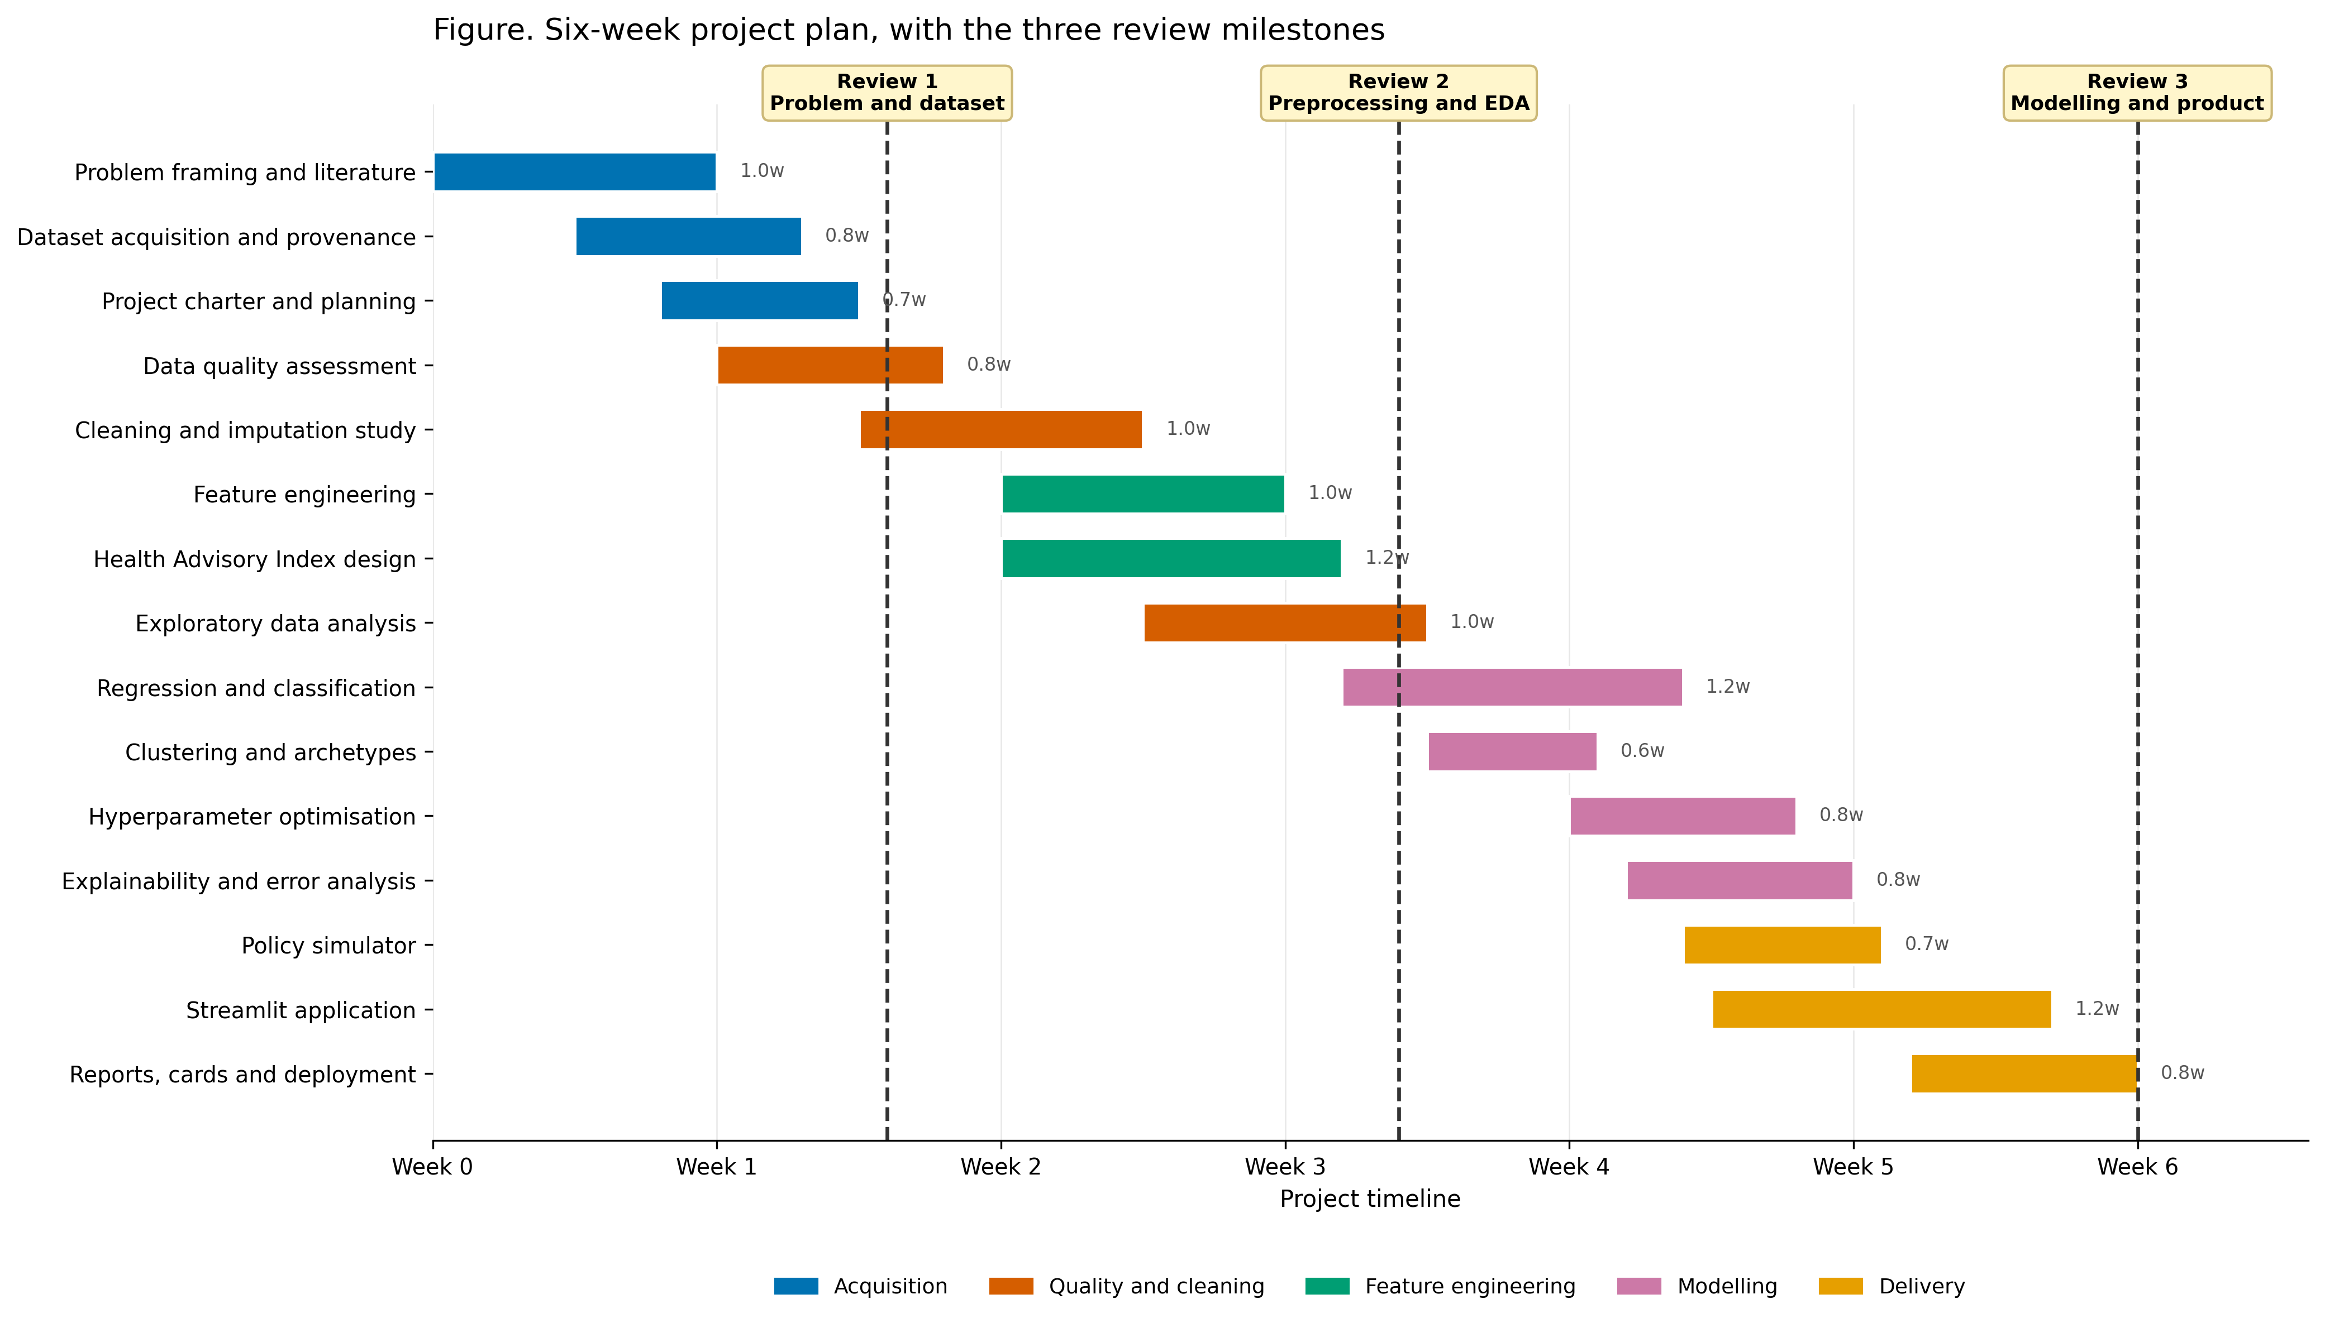
Figure 5. Six-week project plan with the three review milestones marked. [40_project_gantt.png]
Table 15. Milestones and their mapping to the review schedule
ID | Due | Milestone | Review
M1 | End of week 1 | Problem framing complete; dataset acquired with a verified provenance record; project charter written. | Review 1
M2 | End of week 2 | Quality assessment executed; cleaning and the imputation study complete; validation assertions passing. | Review 2
M3 | End of week 3 | Feature matrix and Health Advisory Index built; exploratory analysis complete with the insight list. | Review 2
M4 | End of week 4 | All three model families trained, validated and compared. | Review 3
M5 | End of week 5 | Tuning, explainability, error analysis and the policy simulator complete. | Review 3
M6 | End of week 6 | Application deployed; reports, data card and model card generated; repository published. | Review 3

Table 16. Deliverable list
Deliverable | Description
Code | Modular Python package under src/, importable by the notebooks and by the application
Data artefacts | Immutable raw layer with checksums; interim and processed layers; documented train and test partitions
Results | JSON and CSV files that are the single source of truth for every number in every report
Figures | Numbered PNG figures at 300 DPI using a colour-blind-safe palette
Notebooks | Three phase notebooks containing orchestration and narrative, with all logic imported from src/
Reports | Three review documents generated programmatically from the results artefacts
Responsible-AI artefacts | Data card and model card, both generated from results
Application | Deployed multipage Streamlit application with multilingual advisory text
Reproduction | run_all.py regenerating every artefact from a fresh clone with one command

References
Every source below was consulted directly. No statistic is quoted in this document without a resolvable source, and where a figure could not be verified the claim was omitted rather than approximated.
[1] Central Pollution Control Board (2014). National Air Quality Index: Report of the Expert Group. Ministry of Environment, Forest and Climate Change, Government of India. Available at: https://cpcb.nic.in/upload/Downloads/AQI_Report_0.pdf
[2] Rao, R. (2020). Air Quality Data in India (2015 - 2020) [Data set]. Kaggle. Licence as displayed: CC0: Public Domain. Available at: https://www.kaggle.com/datasets/rohanrao/air-quality-data-in-india. Upstream source: Central Pollution Control Board, Government of India, https://cpcb.nic.in/
[3] World Health Organization (2021). WHO Global Air Quality Guidelines: Particulate Matter (PM2.5 and PM10), Ozone, Nitrogen Dioxide, Sulfur Dioxide and Carbon Monoxide. Geneva: WHO. Available at: https://www.who.int/publications/i/item/9789240034228
[4] Balakrishnan, K., Dey, S., Gupta, T., et al. (2019). The impact of air pollution on deaths, disease burden, and life expectancy across the states of India: the Global Burden of Disease Study 2017. The Lancet Planetary Health, 3(1), e26-e39. https://doi.org/10.1016/S2542-5196(18)30261-4
[5] Health Effects Institute (2024). State of Global Air. Available at: https://www.stateofglobalair.org
[6] Pope, C. A. 3rd, and Dockery, D. W. (2006). Health effects of fine particulate air pollution: lines that connect. Journal of the Air and Waste Management Association, 56(6), 709-742. https://doi.org/10.1080/10473289.2006.10464485
[7] Brook, R. D., Rajagopalan, S., Pope, C. A. 3rd, et al. (2010). Particulate matter air pollution and cardiovascular disease: an update to the scientific statement from the American Heart Association. Circulation, 121(21), 2331-2378. https://doi.org/10.1161/CIR.0b013e3181dbece1
[8] Gauderman, W. J., Urman, R., Avol, E., et al. (2015). Association of improved air quality with lung development in children. New England Journal of Medicine, 372(10), 905-913. https://doi.org/10.1056/NEJMoa1414123
[9] Orellano, P., Quaranta, N., Reynoso, J., Balbi, B., and Vasquez, J. (2017). Effect of outdoor air pollution on asthma exacerbations in children and adults: systematic review and multilevel meta-analysis. PLOS ONE, 12(3), e0174050. https://doi.org/10.1371/journal.pone.0174050
[10] Pedersen, M., Giorgis-Allemand, L., Bernard, C., et al. (2013). Ambient air pollution and low birthweight: a European cohort study (ESCAPE). The Lancet Respiratory Medicine, 1(9), 695-704. https://doi.org/10.1016/S2213-2600(13)70192-9
[11] Pedregosa, F., Varoquaux, G., Gramfort, A., et al. (2011). Scikit-learn: Machine Learning in Python. Journal of Machine Learning Research, 12, 2825-2830.
[12] Chen, T., and Guestrin, C. (2016). XGBoost: A Scalable Tree Boosting System. In Proceedings of the 22nd ACM SIGKDD International Conference on Knowledge Discovery and Data Mining, 785-794. https://doi.org/10.1145/2939672.2939785
[13] Ke, G., Meng, Q., Finley, T., et al. (2017). LightGBM: A Highly Efficient Gradient Boosting Decision Tree. In Advances in Neural Information Processing Systems 30, 3146-3154.
[14] Bergstra, J., and Bengio, Y. (2012). Random Search for Hyper-Parameter Optimization. Journal of Machine Learning Research, 13, 281-305.
[15] Okabe, M., and Ito, K. (2008). Color Universal Design: How to make figures and presentations that are friendly to colorblind people. Available at: https://jfly.uni-koeln.de/color/
[16] Mitchell, M., Wu, S., Zaldivar, A., et al. (2019). Model Cards for Model Reporting. In Proceedings of the Conference on Fairness, Accountability, and Transparency, 220-229. https://doi.org/10.1145/3287560.3287596

Rubric Coverage
Each row of the Review 1 assessment rubric is mapped below to the section of this document that satisfies it and to the evidence that supports it. Total marks addressed: 30 of 30.
Table 17. Review 1 rubric coverage map
Rubric row | Marks | Section(s) | Evidence in this document
Problem statement and research objectives | 4 | Section 1 | Cited health burden (Balakrishnan et al. 2019; WHO 2021); the specific gap in 1.2; a sharp problem statement in 1.3; six measurable objectives with success criteria in Table 1.
Dataset selection, relevance, quality, understanding | 4 | Section 2 | Provenance with SHA-256 checksums and a live-verified licence; 29,531 rows profiled; schema proof figure; missingness table and two figures; fitness-for-purpose argument; four named alternatives rejected with reasons; every city retention decision tabled.
Project Charter | 10 | Section 3 | Mission and context; in-scope and out-of-scope definitions; an eight-row stakeholder matrix naming the decision each output serves; eight success criteria with their measurement; a ten-row risk register; five assumptions; ethical considerations; a six-dimension feasibility assessment.
Methodology and algorithm justification | 4 | Section 4 | Full pipeline diagram; per-family justification for nine algorithm families; time-aware evaluation strategy with an explicit argument against random k-fold; primary metrics declared in advance; five leakage controls enumerated.
Planning, timeline, resources, deliverables | 4 | Section 5 | Six-week Gantt chart; six milestones mapped to the review schedule; nine-item deliverable list; resource table in Section 3.8.
Technical report quality | 4 | Throughout | Cover page with full academic metadata; table of contents mapped to rubric rows; numbered and captioned figures and tables; a reference list of resolvable sources; this coverage map. No metric in this document was written by hand.

