Rajalakshmi Engineering College (Autonomous, affiliated to Anna University, Chennai)
Department of Artificial Intelligence and Data Science

AD23532 — Principles of Data Science
Lab Oriented Theory | Category: Professional Core (PC) | L-T-P-C: 2-0-4-4

AirGuard India
A Vulnerability-Weighted Health Advisory Index and Next-Day Air Quality Forecasting System for Indian Cities

Review 3: Modelling, Comparison and Product Development
Maximum marks: 40

Degree and Branch | B.Tech. Artificial Intelligence and Data Science
Regulation | 2023
Academic Year | 2026-27 (ODD)
Semester | V
Batch | 2024-2028

Project team
S. No. | Register Number | Name
1 | 260586 | Nishanth Rajendran
2 | 260598 | <NAME>
3 | 260600 | <NAME>

Generated 30 September 2026 · Repository: https://github.com/nishaids/airguard-india

Table of Contents
Section | Title | Rubric row addressed
1 | Model Implementation and Training Methodology | Model implementation and training methodology (10)
2 | Evaluation Metrics | Appropriate evaluation metrics (5)
3 | Performance Comparison and Analytical Discussion | Performance comparison and analytical discussion (5)
4 | Hyperparameter Tuning and Optimisation | Hyperparameter tuning and optimisation (5)
5 | End-to-End Product Development | End-to-end product development and functionality (10)
6 | Final Model Selection, Limitations and Future Work | Technical report (5)

1. Model Implementation and Training Methodology

1.1 The forecasting formulation
Every model predicts tomorrow from information available today. For a city and a date, the regression target is the following day's AQI and the classification target is the following day's CPCB band; the feature vector may use any measurement dated today or earlier for that same city. This is not a stylistic preference. It is what makes the output actionable, and it is also what dissolves the label-leakage problem that a same-day formulation suffers from, as Section 1.5 demonstrates by measurement.
Table 1. Training and evaluation setup
Property | Value
Split boundary | 2019-05-26
Training period | 2015-01-01 to 2019-05-25
Test period | 2019-05-26 to 2020-07-01
Training rows (after dropping warm-up and unlabelled rows) | 10,331
Test rows | 4,397
Features, regression | 100
Features, classification | 102
Cross-validation | TimeSeriesSplit with 4 expanding-window folds on the training period. Shuffled k-fold is not used, because it would place future observations in training folds and inflate every score.

1.2 Regression models
Table 2. Regression models fitted, with the reason each is present
Model | Family | Why it is included
Persistence baseline (tomorrow = today) | baseline | Not a fitted model. Today's observed value is carried forward as the forecast for tomorrow. Any learned model must beat this to justify itself.
Linear Regression | linear | Interpretable reference model. Provides the coefficient-level reading of the problem and the benchmark against which any gain from non-linearity is measured.
Ridge Regression | linear | L2 regularisation stabilises coefficients under the severe multicollinearity documented in the correlation analysis.
Random Forest | bagged trees | Bagging reduces variance and captures pollutant interactions and the city-by-season structure without either being specified.
XGBoost | gradient boosting | Level-wise gradient boosting, a strong default for tabular regression with mixed feature types.
LightGBM | gradient boosting | Leaf-wise gradient boosting. Grows asymmetric trees, so it can reach deeper interactions at equal leaf count and often differs from XGBoost on heavily skewed targets.

1.3 Classification models and the imbalance remedy
Table 3. Classification models fitted, with the imbalance remedy applied to each
Model | Family | Imbalance strategy | Why it is included
Persistence baseline (tomorrow = today) | baseline | - | Not a fitted model. Today's observed value is carried forward as the forecast for tomorrow. Any learned model must beat this to justify itself.
Logistic Regression | linear | class_weight='balanced' | Linear reference classifier. Establishes how much of the problem is linearly separable in the engineered feature space.
Decision Tree | tree | class_weight='balanced' | A single interpretable tree. Its decision path can be read directly, which is valuable for a health advisory, and the gap to the ensembles quantifies the variance a single tree suffers.
Random Forest | bagged trees | class_weight='balanced_subsample' | Bagging reduces the variance of the single tree while keeping non-linearity.
SVM (RBF) | kernel | class_weight='balanced' | A non-linear kernel boundary, included because the pairwise structure in the exploratory analysis showed curved class boundaries that a linear model cannot express.
XGBoost | gradient boosting | none (compared against a SMOTE variant below) | Gradient boosting, the strongest default family for tabular classification.
KNN (k=15) | instance-based | distance weighting (no class weighting available) | A purely local, non-parametric benchmark. Its performance relative to the ensembles indicates how much of the signal is captured by local similarity alone.
Random Forest + SMOTE | bagged trees | SMOTE oversampling inside each training fold | Head-to-head comparison against the class-weighted Random Forest.
XGBoost + SMOTE | gradient boosting | SMOTE oversampling inside each training fold | Head-to-head comparison against the unweighted XGBoost.
Logistic Regression + SMOTE | linear | SMOTE oversampling inside each training fold | Head-to-head comparison against the class-weighted logistic model.

Two remedies for class imbalance are compared head to head rather than one being assumed. Class weighting re-weights the loss so that each class contributes in inverse proportion to its frequency, costs nothing at prediction time and synthesises no data. SMOTE interpolates new minority-class examples in feature space, and is applied inside an imbalanced-learn pipeline so that resampling happens within each training fold only. Resampling before splitting would place synthetic copies of validation rows into training and is a classic source of inflated scores.
Table 4. Class-weighting against SMOTE, head to head
Pair | Macro F1 (weighted/plain) | Macro F1 (SMOTE) | Delta | Severe F1 (weighted/plain) | Severe F1 (SMOTE) | Winner
Random Forest vs Random Forest + SMOTE | 0.7184 | 0.7390 | +0.0206 | 0.776 | 0.779 | Random Forest + SMOTE
XGBoost vs XGBoost + SMOTE | 0.7342 | 0.7411 | +0.0069 | 0.753 | 0.759 | XGBoost + SMOTE
Logistic Regression vs Logistic Regression + SMOTE | 0.7236 | 0.7197 | -0.0039 | 0.719 | 0.723 | Logistic Regression

Table 5. Class distribution in the training period
Band | Training rows
Moderate | 4,060
Satisfactory | 3,104
Poor | 1,330
Very Poor | 1,197
Severe | 376
Good | 264

1.4 Clustering
Each city is represented by its mean concentration over the six principal pollutants, standardised across cities. Standardising makes the distance respond to the shape of the pollutant mix rather than to overall pollution level, which is the property that separates kinds of problem from degrees of severity.
Table 6. Candidate partitions with their internal validity indices
k | Inertia | Silhouette | Davies-Bouldin | Calinski-Harabasz | Cluster sizes
2 | 41.69 | 0.3553 | 1.0464 | 7.27 | [9, 3]
3 | 30.22 | 0.2259 | 1.0703 | 6.22 | [4, 5, 3]
4 | 19.49 | 0.2418 | 0.8596 | 7.19 | [1, 5, 4, 2]
5 | 15.06 | 0.1780 | 0.8999 | 6.62 | [3, 3, 1, 2, 3]

The rule was fixed before the indices were inspected. Any k whose partition contains a singleton cluster is discarded, because a cluster of one city cannot support a generalisable archetype claim; among the remaining candidates the highest silhouette coefficient decides. Silhouette is the decisive index because it measures separation relative to cohesion and is comparable across k, whereas inertia falls monotonically with k by construction and cannot select k on its own. The four indices do not agree here, and the full vote tally is reported rather than only the winner.
The four indices did not agree: silhouette favours k = 2; davies_bouldin favours k = 4; calinski_harabasz favours k = 2; inertia_elbow favours k = 4. The declared rule resolves the disagreement, and the full tally is reported here rather than only the winner.
Twelve cities is a small sample for a clustering problem. Silhouette coefficients in the 0.2 to 0.4 range indicate real but moderate separation, and the partition should be read as an interpretive organising device for policy discussion rather than as a claim of sharply bounded natural classes. Every candidate partition is reported below with its scores so that this is visible rather than implied.
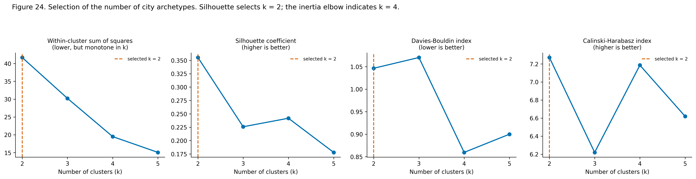
Figure 1. Selection of the number of archetypes across four indices. [24_clustering_selection.png]
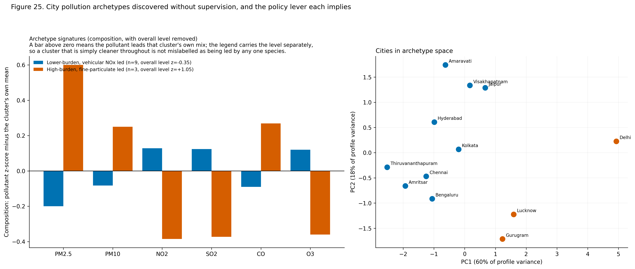
Figure 2. Archetype signatures and the cities projected into archetype space. [25_cluster_profiles.png]
Table 7. Discovered archetypes and the distinct policy lever each implies. The archetype name separates the overall burden level from the composition of the mix, so a cluster that is below the cross-city mean on every pollutant is not mislabelled as being led by any one species.
Cluster | Archetype | Level (z) | Leading pollutant in the mix | Cities | Policy lever
0 | Lower-burden, vehicular NOx led | -0.35 | NO2 | Amaravati, Amritsar, Bengaluru, Chennai, Hyderabad, Jaipur, Kolkata, Thiruvananthapuram, Visakhapatnam | Oxidised nitrogen leads the mix, which is the signature of live traffic exhaust. The effective levers are traffic demand management, public-transport capacity, congestion control at corridors, and tightened in-use vehicle emission testing.
1 | High-burden, fine-particulate led | +1.05 | PM2.5 | Delhi, Gurugram, Lucknow | Fine particulate leads the mix, which points to combustion rather than mechanical sources. The effective levers are fuel-quality and vehicle-fleet standards, control of biomass and solid-fuel burning, and seasonal crop-residue management.

Adjusted Rand index between K-Means and Ward agglomerative clustering: 1.0. An adjusted Rand index of 1.000 between K-Means and Ward agglomerative clustering indicates that the partition is reproduced almost exactly by an algorithm with a different objective, which is evidence that it reflects structure in the data rather than an artefact of the method.

1.5 The leakage demonstration
The distinction between a same-day nowcast and a next-day forecast is demonstrated by experiment rather than asserted. Three classifiers were fitted on identical time-ordered splits, differing only in the target and the feature set.
Table 8. The leakage demonstration: three setups, identical splits
Setup | Macro F1 | Accuracy | Features
Predicting today's bucket from a feature set containing today's AQI and its derived sub-indices and HAI values. | 1.0000 | 1.0000 | 103
The same target with AQI, the CPCB sub-indices and every HAI column removed. Columns removed: 3. | 0.9666 | 0.9770 | 100
The formulation this project uses. The target is tomorrow's bucket, so today's AQI is information genuinely available at prediction time and is retained. | 0.7077 | 0.7785 | 102

Predicting the same day's bucket with same-day AQI present yields a macro-F1 of 1.0000. A score at or near 1.0 is not a result; it is the signature of a model reading its own label, because the CPCB bucket is a deterministic step function of the AQI. The more instructive finding is what happens after the obvious culprits are removed: dropping AQI, the CPCB sub-indices and every HAI column still leaves macro-F1 at 0.9666. The leak is therefore not confined to a single column that a diligent analyst could blacklist. The AQI is by definition the maximum sub-index, and each sub-index is a fixed piecewise-linear function of a pollutant concentration, so the *concentrations themselves* determine the label exactly. Same-day bucket prediction is arithmetic dressed as machine learning, and no choice of feature filter rescues it. That is the reason this project does not attempt it. Forecasting the next day changes the problem substantively: tomorrow's bucket is genuinely unknown today, today's AQI becomes legitimate information rather than a restatement of the answer, and the achieved macro-F1 of 0.7077 measures real predictive skill. The gap between 0.9666 and 0.7077 is the difference between recomputing a known quantity and forecasting an unknown one.

2. Evaluation Metrics

2.1 Primary metrics, declared in advance
Regression. Mean absolute error is the primary regression metric. The AQI distribution is strongly right-skewed (skewness above 2), so RMSE is dominated by a small number of extreme days and would rank models largely by their behaviour on that tail. MAE is in the same units as the target, is directly interpretable as 'the typical miss in AQI points', and treats every day's error proportionally. RMSE, R-squared and MAPE are reported alongside it, and the tail behaviour that RMSE emphasises is examined separately through the residual analysis and the per-band error breakdown.
Classification. Macro-averaged F1 is the primary classification metric, declared before any model was fitted. The six CPCB buckets are imbalanced by a factor of 6.6 between the most and least frequent class, and the rarest classes are Good and Severe. Severe is the class on which the entire public-health purpose of the system rests: failing to warn on a Severe day is the costliest error the system can make, and it is also the error that overall accuracy is least sensitive to. Macro-F1 gives every class equal weight regardless of frequency, so a model cannot score well by ignoring the rare and dangerous classes. Accuracy, weighted F1, per-class F1, balanced accuracy, Cohen's kappa and one-versus-rest ROC-AUC are all reported alongside it, together with an ordinal error that measures how many severity bands a wrong prediction lands away from the truth.
Both primary metrics were fixed before any model was fitted, so the choice could not be made after seeing which model happened to win on which measure.

2.2 The full metric suite
Table 9. The complete metric suite
Task | Metric | What it measures and why it is reported
Regression | MAE | Average size of the miss in AQI points. Primary.
Regression | RMSE | Penalises large misses disproportionately; sensitive to the extreme tail.
Regression | R-squared | Share of next-day variance accounted for.
Regression | MAPE | Typical miss as a percentage of the true value, computed where the truth is at least 1.
Regression | Bias | Mean signed error, which exposes systematic over- or under-prediction.
Classification | Macro F1 | Mean F1 across all six bands with equal weight. Primary.
Classification | Accuracy | Exact-match rate. Reported but not decisive under imbalance.
Classification | Weighted F1 | F1 weighted by class frequency.
Classification | Balanced accuracy | Mean recall across classes.
Classification | Per-class precision, recall and F1 | Performance on each band separately, including the rare Severe band.
Classification | ROC-AUC (one-versus-rest) | Ranking quality per class, macro and weighted.
Classification | Cohen's kappa | Agreement corrected for chance.
Classification | Mean absolute ordinal error | How many severity bands a wrong prediction lands away from the truth.
Classification | Share understating severity | The health-critical failure mode, reported explicitly.
Clustering | Silhouette | Cohesion against separation; comparable across k.
Clustering | Davies-Bouldin | Average similarity to the most similar cluster; lower is better.
Clustering | Calinski-Harabasz | Between-cluster against within-cluster dispersion.
Clustering | Adjusted Rand index | Agreement between two partitions, corrected for chance.

3. Performance Comparison and Analytical Discussion

3.1 Master comparison: regression
Table 10. Regression master comparison, ordered by test MAE
Model | Family | CV MAE | Test MAE | Test RMSE | Test R2 | Test MAPE % | Test bias | Train MAE | Train-test R2 gap | Fit seconds
LightGBM | gradient boosting | 29.93 | 15.1 | 23.5 | 0.9119 | 14.58 | 2.792 | 11.91 | 0.0635 | 5.02
Random Forest | bagged trees | 29.88 | 15.28 | 23.96 | 0.9084 | 14.6 | 2.655 | 8.873 | 0.0729 | 67.65
XGBoost | gradient boosting | 31.98 | 15.44 | 23.88 | 0.909 | 15.15 | 3.309 | 10.11 | 0.0746 | 10.14
Linear Regression | linear | 28.63 | 15.9 | 24.62 | 0.9033 | 15.12 | 3.296 | 22.86 | -0.0083 | 0.14
Ridge Regression | linear | 28.5 | 15.91 | 24.62 | 0.9033 | 15.12 | 3.3 | 22.86 | -0.0083 | 0.06
Persistence baseline (tomorrow = today) | baseline |  | 18.9 | 31.56 | 0.8411 | 16.36 | 0.0871

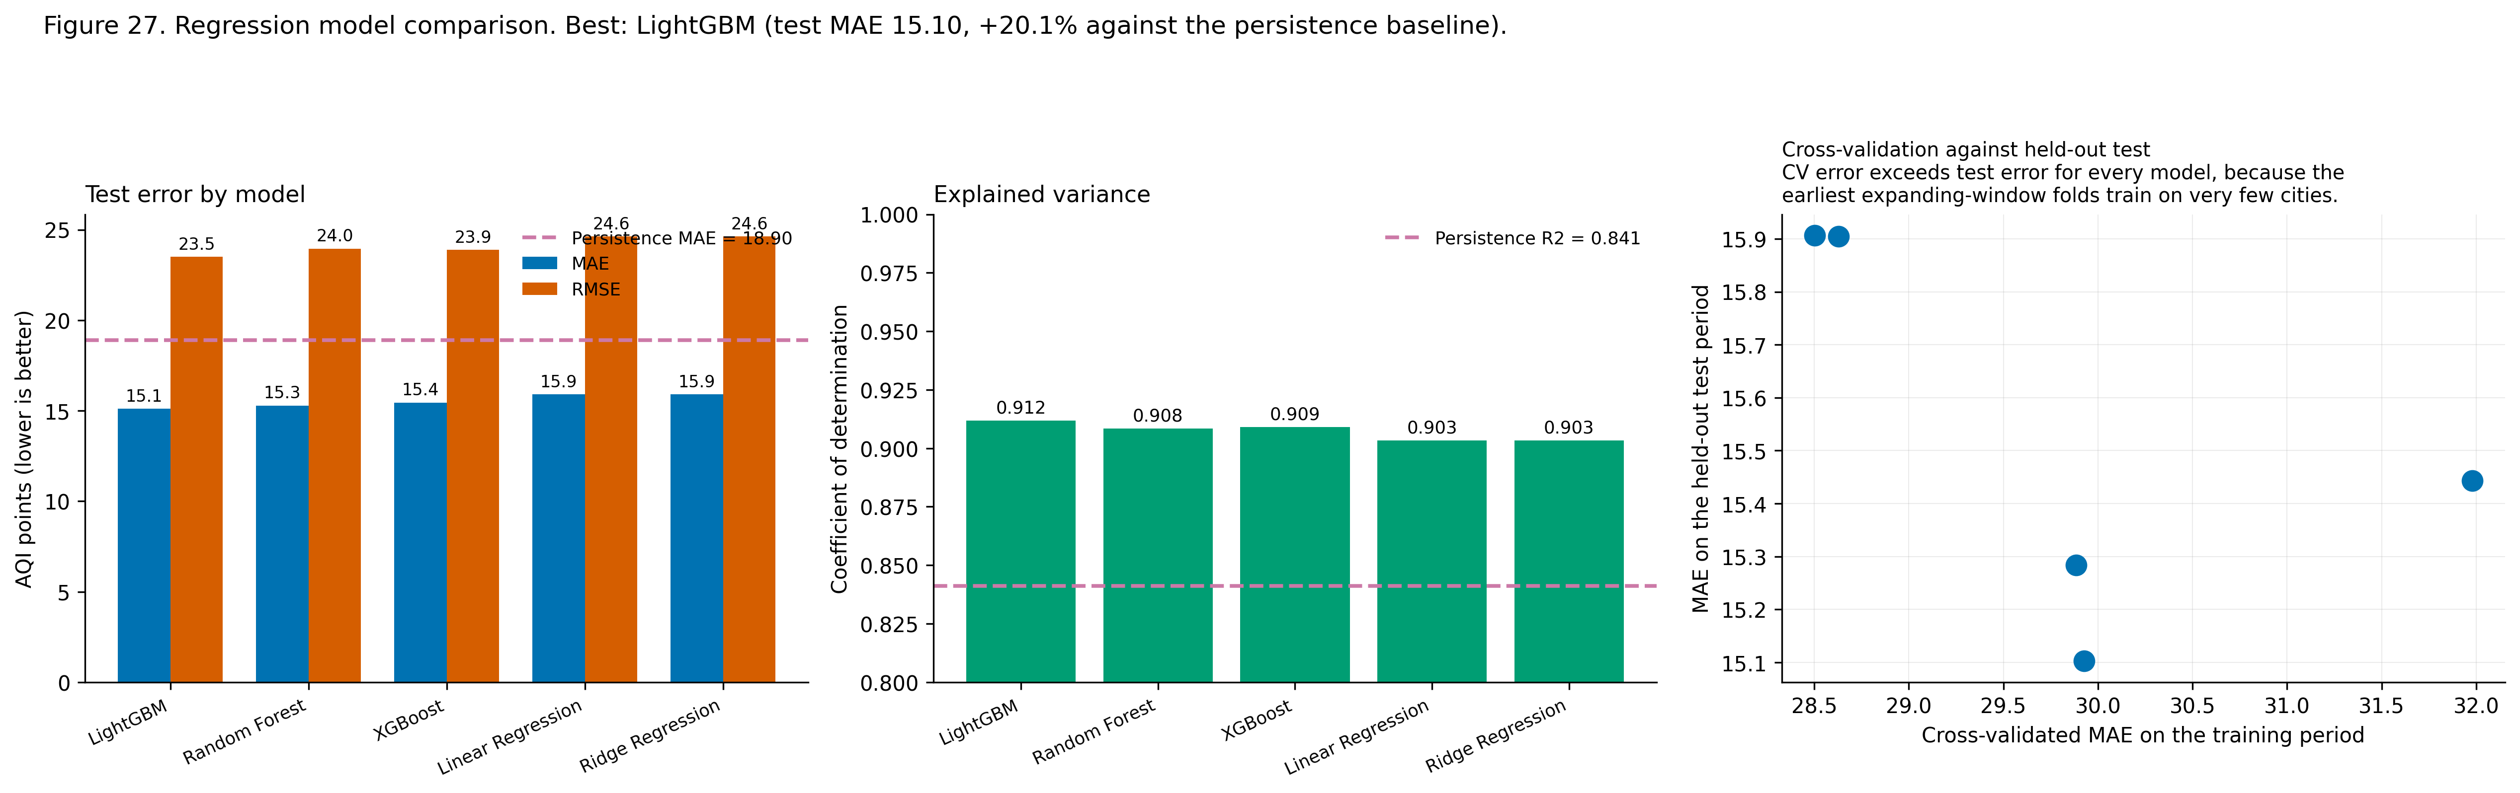
Figure 3. Regression model comparison, with the persistence baseline marked on both panels. [27_regression_comparison.png]
The most important column in that table is the persistence baseline. Daily AQI is strongly autocorrelated, so carrying today forward already achieves an MAE of 18.9049 and an R-squared of 0.8411. Reporting an R-squared above 0.9 without that comparison would be misleading, because most of it is available for nothing. LightGBM reduces MAE by 20.11 per cent relative to persistence, and that reduction is the actual contribution of the learned model.

3.2 Master comparison: classification
Table 11. Classification master comparison, ordered by test macro F1
Model | Imbalance strategy | CV macro F1 | Test macro F1 | Test accuracy | Balanced accuracy | ROC-AUC (OvR) | F1 Severe | F1 Good | Ordinal MAE | Train-test macro F1 gap
XGBoost + SMOTE | SMOTE oversampling inside each training fold | 0.5709 | 0.7411 | 0.7783 | 0.7453 | 0.9591 | 0.7595 | 0.6689 | 0.2238 | 0.2541
Random Forest + SMOTE | SMOTE oversampling inside each training fold | 0.5599 | 0.739 | 0.7771 | 0.7543 | 0.9594 | 0.7789 | 0.6154 | 0.2256 | 0.2578
XGBoost | none (compared against a SMOTE variant below) | 0.5545 | 0.7342 | 0.7846 | 0.7075 | 0.9615 | 0.7532 | 0.628 | 0.2179 | 0.2651
Logistic Regression | class_weight='balanced' | 0.4414 | 0.7236 | 0.7589 | 0.7393 | 0.9514 | 0.7191 | 0.6446 | 0.2449 | -0.0538
Logistic Regression + SMOTE | SMOTE oversampling inside each training fold | 0.4402 | 0.7197 | 0.7598 | 0.7378 | 0.9519 | 0.7234 | 0.6443 | 0.244 | -0.0438
Random Forest | class_weight='balanced_subsample' | 0.5472 | 0.7184 | 0.7789 | 0.704 | 0.9602 | 0.7765 | 0.4878 | 0.2229 | 0.276
Persistence baseline (tomorrow = today) | - |  | 0.6803 | 0.7512 | 0.6798 |  | 0.6818 | 0.6833 | 0.2554
Decision Tree | class_weight='balanced' | 0.5121 | 0.6647 | 0.7118 | 0.733 | 0.9212 | 0.6786 | 0.5897 | 0.2968 | 0.051
SVM (RBF) | class_weight='balanced' | 0.4593 | 0.6359 | 0.7196 | 0.6487 |  | 0.4658 | 0.6142 | 0.2888 | 0.274
KNN (k=15) | distance weighting (no class weighting available) | 0.4327 | 0.5635 | 0.6848 | 0.5421 | 0.9052 | 0.6197 | 0.1681 | 0.3241 | 0.4365

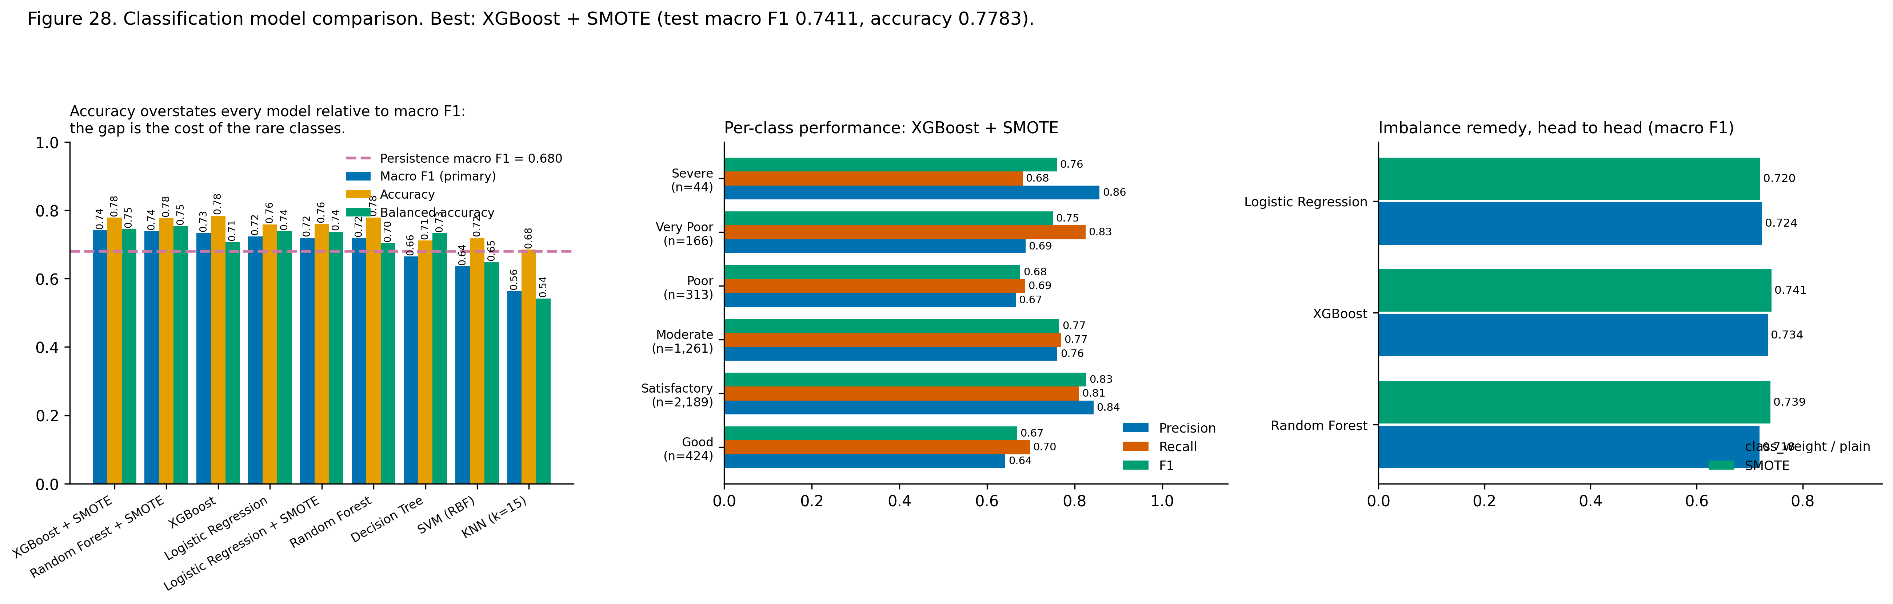
Figure 4. Classification comparison, per-class performance of the winner, and the imbalance remedy head to head. [28_classification_comparison.png]
Accuracy exceeds macro F1 for every model in the table, and the gap is the cost of the rare classes. A reader shown only accuracy would conclude that the models are performing better than they are on exactly the bands that matter most for health protection.

3.3 Per-class performance of the selected classifier
Table 12. Per-class performance of XGBoost + SMOTE
Band | Precision | Recall | F1 | Support
Good | 0.642 | 0.698 | 0.669 | 424
Satisfactory | 0.843 | 0.810 | 0.827 | 2,189
Moderate | 0.761 | 0.769 | 0.765 | 1,261
Poor | 0.666 | 0.687 | 0.676 | 313
Very Poor | 0.688 | 0.825 | 0.751 | 166
Severe | 0.857 | 0.682 | 0.759 | 44

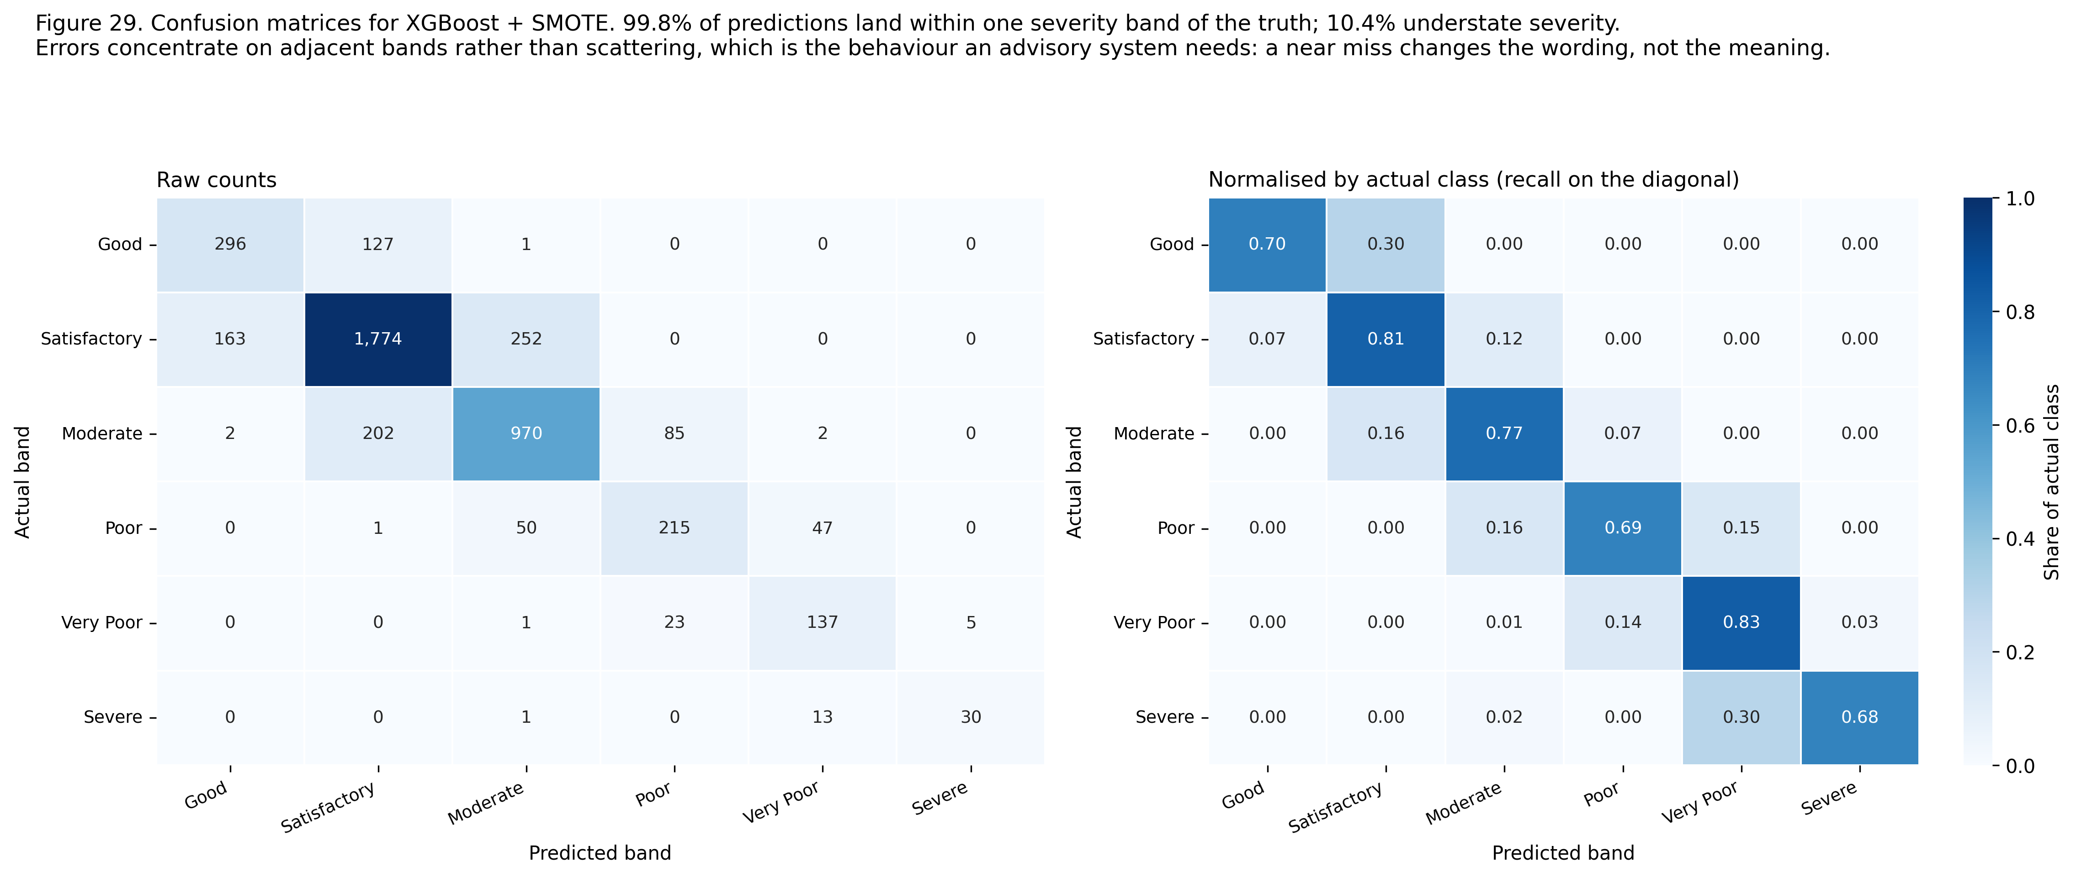
Figure 5. Confusion matrices, raw and normalised by actual class. [29_confusion_matrices.png]
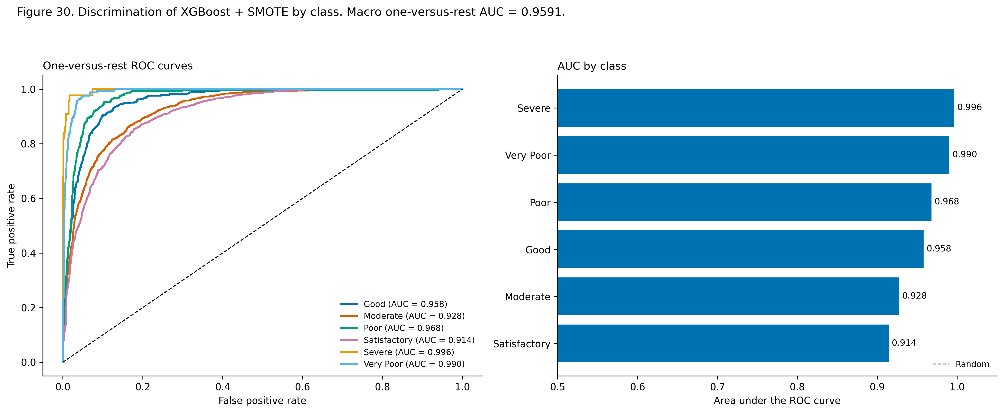
Figure 6. One-versus-rest ROC curves and area under the curve by class. [30_roc_curves.png]

3.4 Overfitting diagnosis
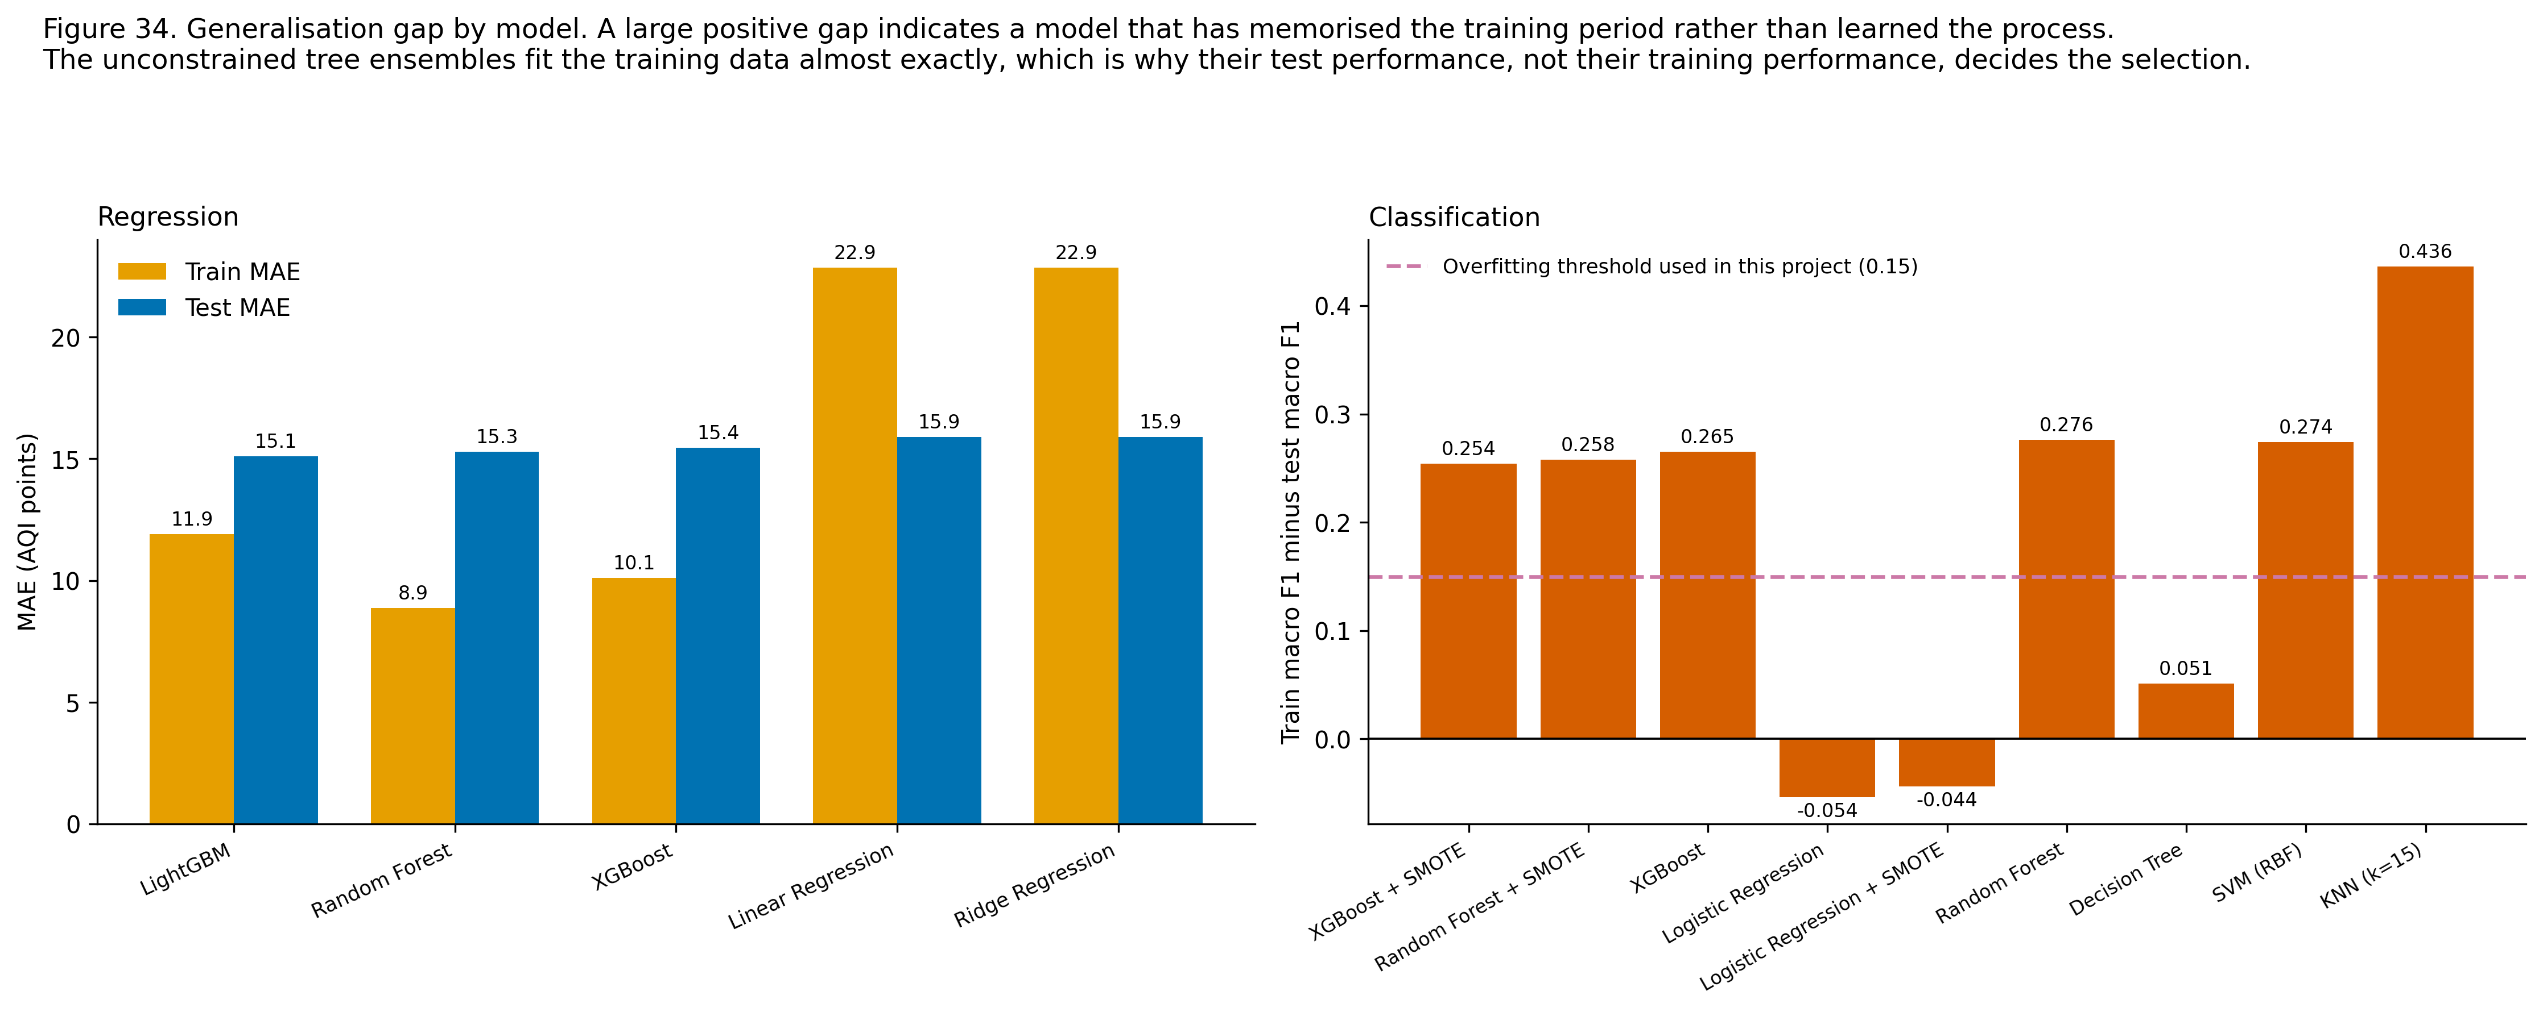
Figure 7. Training against test performance for every model. A large positive gap indicates a model that has memorised the training period rather than learned the process. [34_train_test_gap.png]
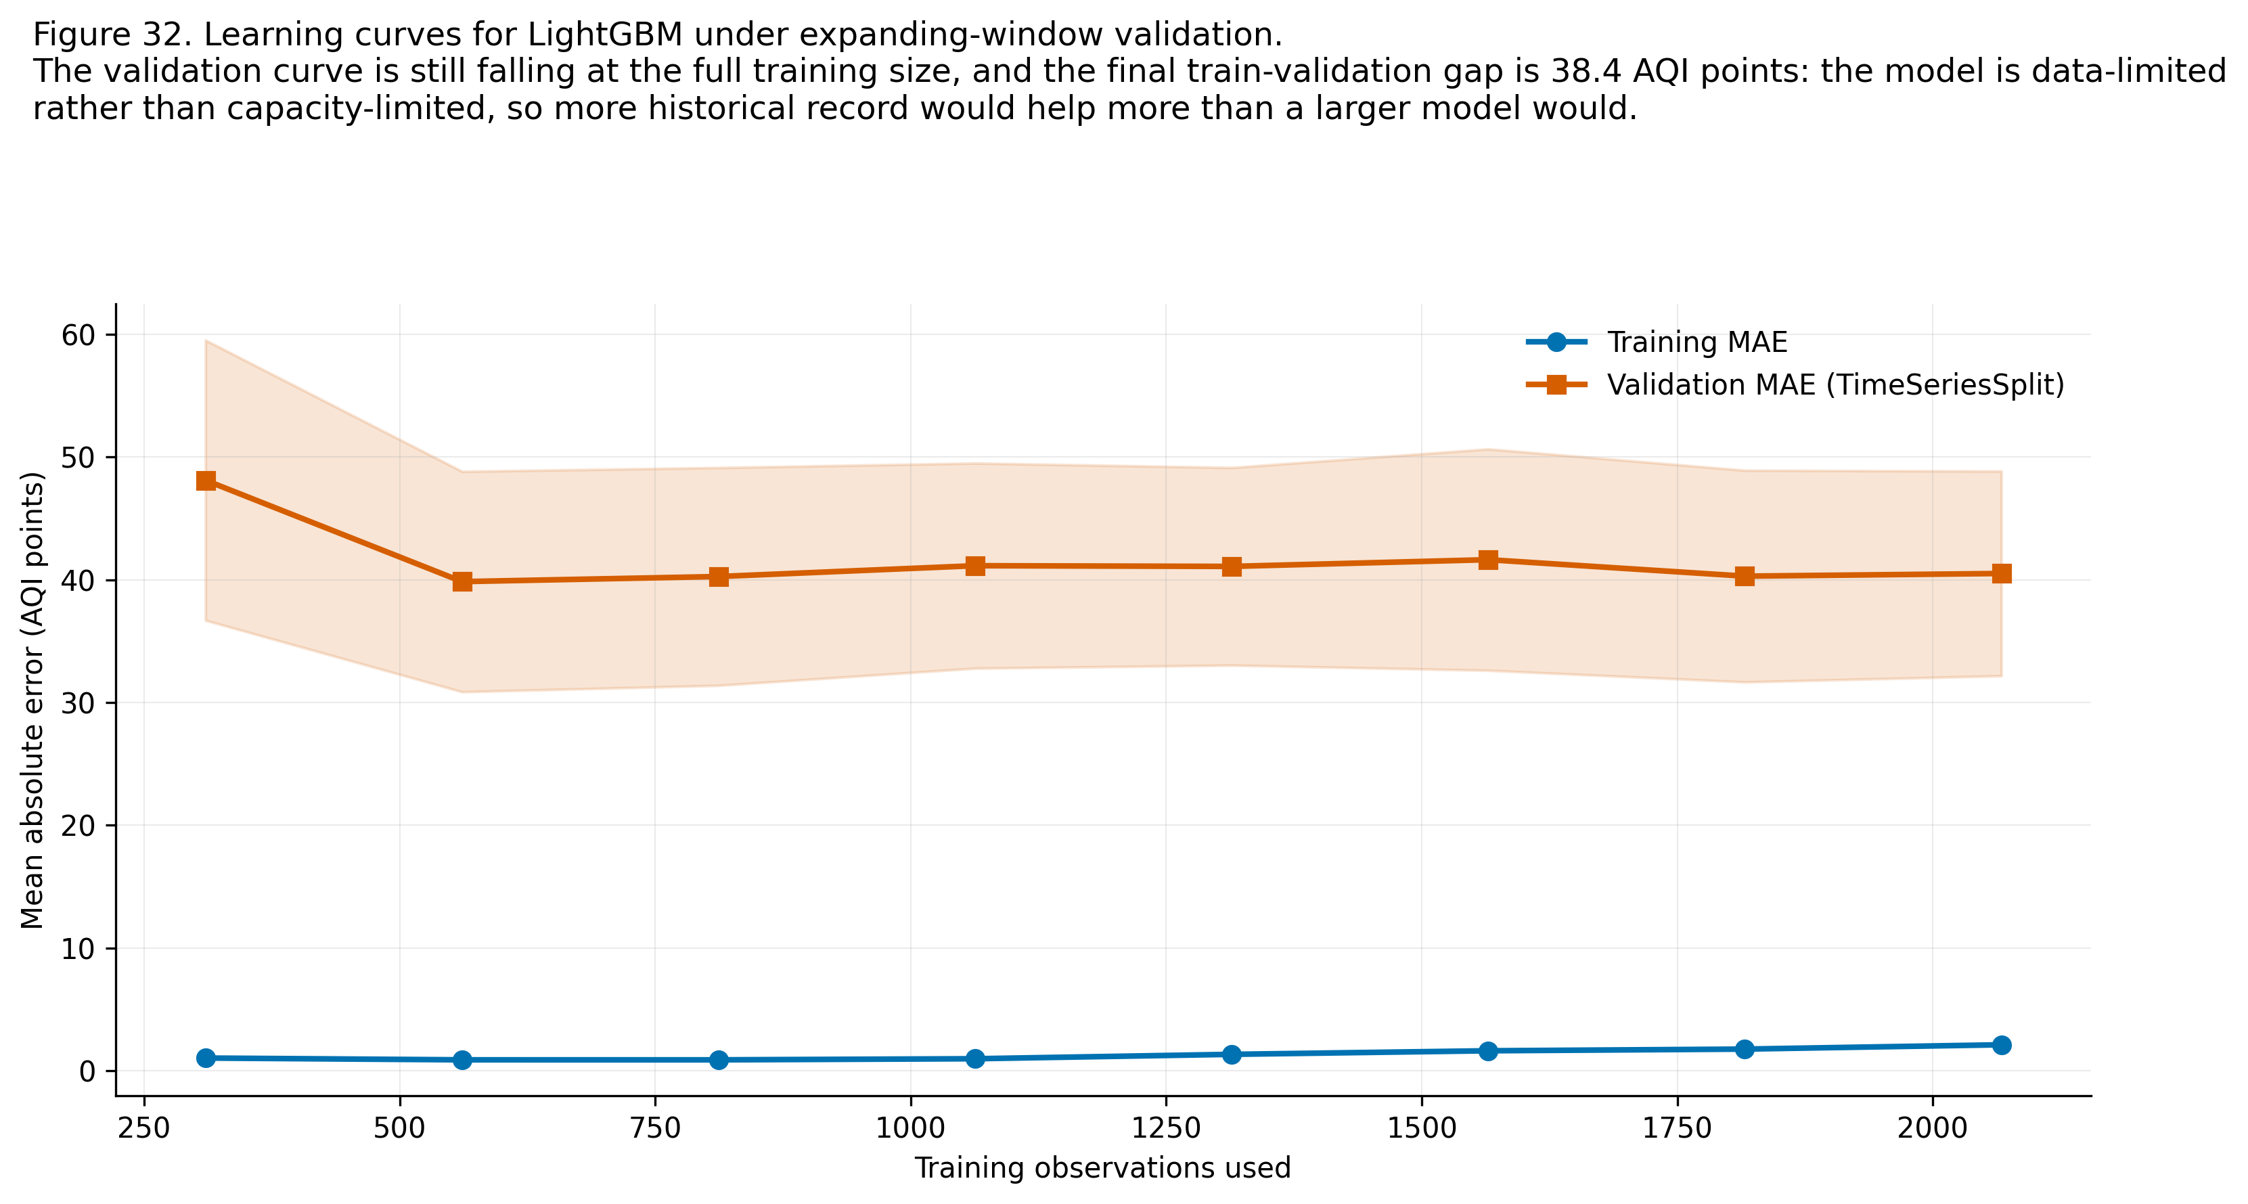
Figure 8. Learning curves under expanding-window validation. [32_learning_curves.png]
The unconstrained tree ensembles fit the training period almost exactly, which is why test performance rather than training performance decides the selection. The learning curve is still falling at the full training size, which says the models are data-limited rather than capacity-limited: more historical record would help more than a larger model would.

3.5 Residual analysis
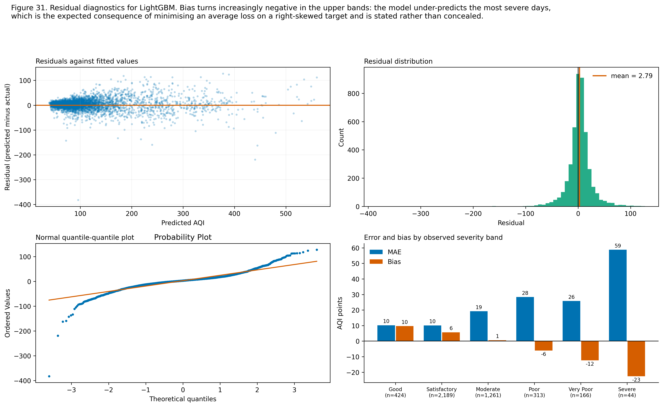
Figure 9. Residual diagnostics for the selected regressor. [31_residual_analysis.png]
Table 13. Regression error by observed severity band
Observed band | n | MAE | Bias | Mean observed AQI
Good | 424 | 10.19 | +9.67 | 43.2
Satisfactory | 2,189 | 10.11 | +5.67 | 74.1
Moderate | 1,261 | 19.20 | +0.56 | 134.7
Poor | 313 | 28.37 | -6.02 | 246.6
Very Poor | 166 | 25.80 | -12.34 | 339.7
Severe | 44 | 58.80 | -22.58 | 471.0

Residual bias turns negative in the upper bands, meaning the model under-predicts the most severe days. This is the expected consequence of fitting a squared or absolute loss on a right-skewed target: the optimiser buys accuracy on the many ordinary days at the cost of the few extreme ones. It is stated plainly because it is precisely the regime in which an advisory system must not be over-confident, and it is the reason the deployed application presents the predicted band with its classification confidence rather than the point estimate alone.

3.6 Per-city error breakdown
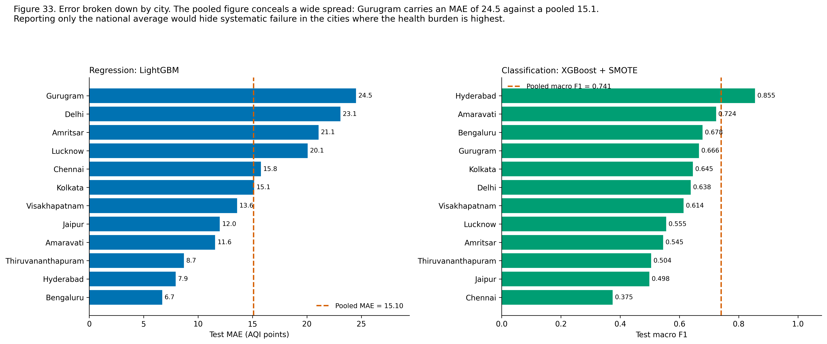
Figure 10. Error broken down by city for both tasks, against the pooled figure. [33_per_city_error.png]
Table 14. Per-city regression error for LightGBM
City | n | MAE | RMSE | R-squared | Bias
Bengaluru | 402 | 6.70 | 9.09 | 0.785 | +0.68
Hyderabad | 402 | 7.94 | 10.61 | 0.908 | +2.31
Thiruvananthapuram | 350 | 8.71 | 15.47 | 0.442 | +2.55
Amaravati | 306 | 11.57 | 15.02 | 0.823 | +4.54
Jaipur | 402 | 12.00 | 18.15 | 0.782 | +2.15
Visakhapatnam | 204 | 13.59 | 18.05 | 0.777 | +2.11
Kolkata | 402 | 15.15 | 20.85 | 0.926 | +1.78
Chennai | 402 | 15.77 | 23.80 | 0.563 | +1.91
Lucknow | 402 | 20.07 | 27.28 | 0.921 | +4.43
Amritsar | 336 | 21.07 | 35.57 | 0.705 | +2.65
Delhi | 402 | 23.08 | 32.60 | 0.917 | +3.36
Gurugram | 387 | 24.51 | 33.86 | 0.888 | +5.15

The pooled figure conceals a wide spread. Reporting only the national average would hide systematic failure in the cities where the health burden is highest, which is why the breakdown is presented rather than summarised.

3.7 The 2020 stress test
Table 15. Regression error by period, isolating the lockdown as a stress test
Period | Dates | n | MAE | R-squared
pre 2020 | 2019-05-26 to 2019-12-31 | 2,331 | 15.73 | 0.928
2020 before lockdown | 2020-01-01 to 2020-03-24 | 927 | 17.33 | 0.894
lockdown stress test | 2020-03-25 to 2020-05-31 | 779 | 11.48 | 0.739
post lockdown | 2020-06-01 to 2020-06-30 | 360 | 13.16 | 0.598

The 2020 lockdown was retained in the test period with an explicit flag rather than excluded. It is a genuine regime change: the exploratory analysis measured a -33.99 per cent change in national mean AQI against the preceding 60 days, significant at the 5 per cent level in 12 of 12 cities. Excluding it would have flattered the headline error by removing the hardest period; reporting it separately shows what a forecasting system does when the world changes.

3.8 Error analysis
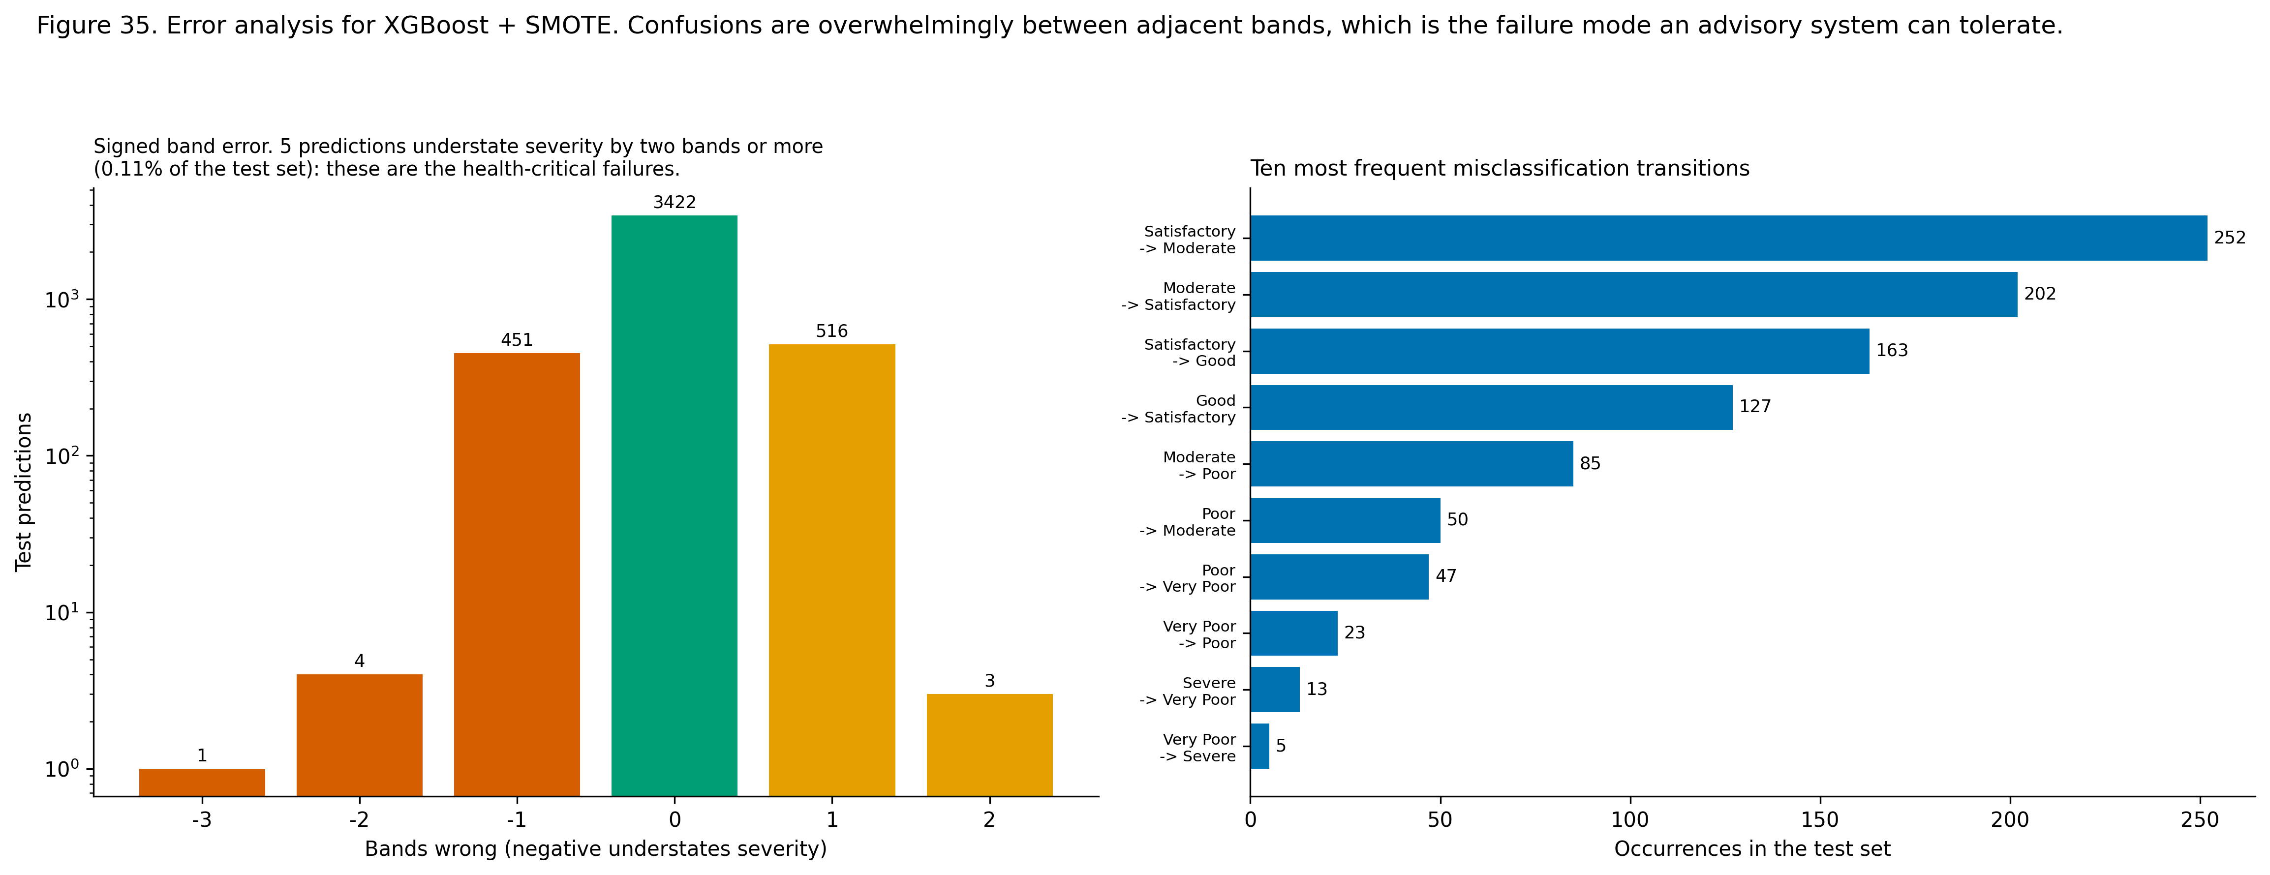
Figure 11. Signed band error and the most frequent misclassification transitions. [35_error_analysis.png]
Table 16. Error magnitude, with the health-critical failure mode isolated
Statistic | Value
Test predictions | 4,397
Wrong | 975 (22.17%)
Wrong by two bands or more | 8 (0.182%)
Understating severity by two bands or more | 5 (0.114%)

Table 17. Ten most frequent misclassification transitions
Actual band | Predicted band | Occurrences
Satisfactory | Moderate | 252
Moderate | Satisfactory | 202
Satisfactory | Good | 163
Good | Satisfactory | 127
Moderate | Poor | 85
Poor | Moderate | 50
Poor | Very Poor | 47
Very Poor | Poor | 23
Severe | Very Poor | 13
Very Poor | Severe | 5

The signed error distribution is sharply peaked at zero and decays fast, and almost all remaining error is a single band in either direction. The subset that matters operationally is the tail that understates severity by two bands or more, because that is the case in which a reader is told the air is acceptable when it is not. Its size is reported above as an explicit safety statistic rather than being left implicit inside the macro-F1.

3.9 Strengths and limitations of each model family
Table 18. Honest strengths and limitations per model family
Family | Strengths | Limitations observed in this project
Persistence baseline | Free, always available, and strong because the series is autocorrelated. | Cannot anticipate a change of direction, which is precisely what an advisory needs. It carries today's error into tomorrow.
Linear and Logistic Regression | Interpretable coefficients; fastest to fit; no capacity to overfit this sample size. | Cannot express the curved boundaries and city-by-season interactions the exploratory analysis found. Sensitive to the multicollinearity among the lag family.
Ridge Regression | Stabilises coefficients under collinearity. | The penalty barely moves validation error here, which says the limitation is the functional form rather than the regularisation.
Decision Tree | The decision path can be read directly, which has value for a health advisory. | High variance; the weakest of the tree family on every metric.
Random Forest | Robust, needs little tuning, handles interactions and the heavy tail well. | Fits the training period almost exactly; larger artefact; slower to predict than a boosted model of similar accuracy.
XGBoost and LightGBM | Best accuracy on both tasks; fast; handle mixed feature types without preprocessing. | More hyperparameters to set; less directly interpretable, which is why SHAP is a required component rather than an optional extra.
SVM with an RBF kernel | Expresses a genuinely non-linear boundary. | Substantially the slowest to fit, scales poorly with sample size, and did not repay the cost here. Probabilities were not calibrated, so one-versus-rest ROC-AUC could not be computed for it.
K-Nearest Neighbours | No training cost; a useful benchmark for how much local similarity explains. | Weakest classifier in the comparison; suffers in this feature dimensionality and has no mechanism for class weighting.
K-Means and Ward | Simple, fast, and the partition reproduced exactly across both algorithms. | Twelve cities is a small sample for clustering; silhouette values indicate moderate rather than sharp separation.

4. Hyperparameter Tuning and Optimisation
RandomizedSearchCV over large spaces, GridSearchCV over the one-dimensional Ridge penalty. Every search uses TimeSeriesSplit, so each validation fold lies strictly after its training folds.

4.1 Search spaces and why each parameter is included
Table 19. Search space rationale
Parameter group | Why it is searched
n_estimators | Boosting rounds. Ranges from well below to well above the untuned 400 so that both under- and over-fitting regimes are reachable.
learning_rate | Step size. Trades off against the number of rounds; the two are searched jointly because the optimum of each depends on the other.
num_leaves / max_depth | Tree capacity, the dominant control on the bias-variance balance for boosted trees on tabular data.
min_child_samples / min_child_weight | Minimum leaf occupancy. Directly regularises the rare-class splits that matter most for the Severe bucket.
subsample / colsample_bytree | Stochastic row and column sampling, which decorrelates successive trees and is the ensemble's principal variance-reduction mechanism.
reg_alpha / reg_lambda / gamma | Explicit L1, L2 and split-gain penalties, included because the feature matrix retains groups of highly correlated lag and rolling features.

Table 20. Search configuration per task
Task | Model | Search | Grid points | Sampled | Explored | Total fits
Regression | LightGBM | RandomizedSearchCV | 2,250,000 | 40 | 0.0018% | 161
Classification | XGBoost | RandomizedSearchCV | 153,600 | 40 | 0.0260% | 161
Regression (Ridge) | Ridge Regression | GridSearchCV (exhaustive) | 11 | all | 100% | 45

An exhaustive grid is used for the Ridge penalty because that space is one-dimensional and genuinely small, and a randomised search is used elsewhere because an exhaustive sweep of spaces containing thousands of points, multiplied by four time-series folds, would cost tens of thousands of fits for a gain that random search reaches in a small fraction of the budget. Both methods therefore appear, each on the problem it suits.

4.2 Before and after
Table 21. Effect of hyperparameter optimisation
Metric | Default parameters | Tuned | Delta | Relative change
Regression MAE | 15.1028 | 15.0488 | -0.0540 | +0.36%
Regression RMSE | 23.4986 | 23.4130 | -0.0856 | -
Regression R-squared | 0.9119 | 0.9125 | +0.0006 | -
Classification macro F1 | 0.7342 | 0.7452 | +0.0110 | +1.50%
Classification accuracy | 0.7846 | 0.7933 | +0.0087 | -

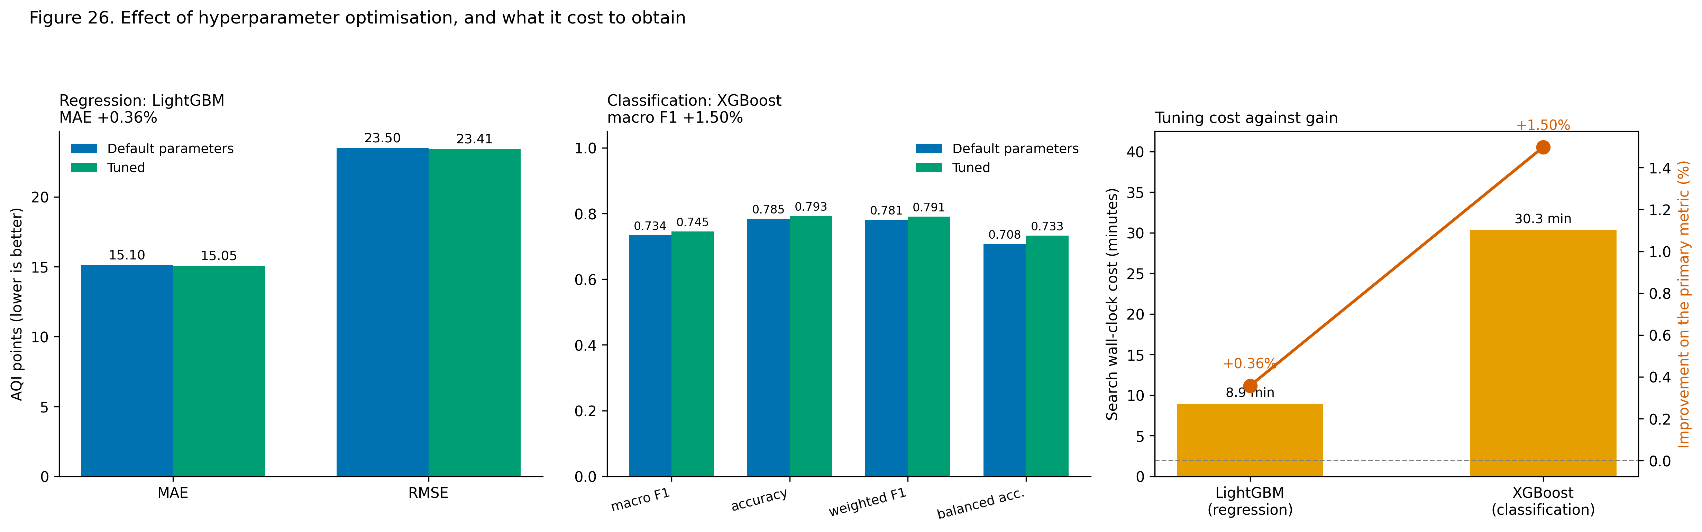
Figure 12. Effect of tuning on both tasks, and what it cost to obtain. [26_tuning_before_after.png]
Best regression parameters: {'subsample': 0.6, 'reg_lambda': 0.1, 'reg_alpha': 0.5, 'num_leaves': 95, 'n_estimators': 400, 'min_child_samples': 60, 'max_depth': 5, 'learning_rate': 0.02, 'colsample_bytree': 0.5}
Best classification parameters: {'estimator__subsample': 0.6, 'estimator__reg_lambda': 1.0, 'estimator__n_estimators': 600, 'estimator__min_child_weight': 10, 'estimator__max_depth': 10, 'estimator__learning_rate': 0.01, 'estimator__gamma': 1.0, 'estimator__colsample_bytree': 0.7}

4.3 Cost against gain
The two randomised searches together consumed 39.3 minutes of wall-clock time and 322 model fits, and moved the primary metrics by +0.36% (regression MAE) and +1.50% (classification macro-F1). The gains are real but modest relative to the gains from feature engineering, which moved regression MAE from the persistence baseline by a far larger margin. The honest reading is that on this problem the representation matters more than the hyperparameters, and that a practitioner with limited time should spend it on features first.
An exhaustive grid is appropriate here because the space is one-dimensional. The flatness of the resulting curve is itself informative: the penalty barely moves validation error, which says the linear model's limitation is its functional form rather than its regularisation.

5. End-to-End Product Development
The analysis is delivered as a working multipage application rather than as a notebook. Model artefacts are loaded once per session from versioned joblib files, tabular data is cached separately, every public entry point validates its input and returns a typed result rather than raising, and a city or date outside the covered record falls back to the nearest available record with the substitution reported to the user.
Table 22. Application pages and what each delivers
Page | Functionality
Home | Headline metrics pulled live from the results artefacts; the dataset provenance and licence block rendered in-app; the archetype summary; the medical disclaimer.
1. Forecast | City, cohort, date and language selection; what-if pollutant sliders that recompute every derived feature; next-day AQI; predicted band with the model's confidence and the full band probability distribution; the cohort Health Advisory Index and band; the dominant pollutant; the cleanest outdoor window for the season; plain-language advice in English, Tamil and Hindi; a 30-day history chart with the forecast and the actual outcome marked; the index for all seven cohorts side by side; an input drift check against the training distribution.
2. City Risk Atlas | The discovered archetypes with their policy levers and signatures; how k was chosen, including the partitions that were not selected; the ranked risk table with per-cohort restricted-day shares; the city-by-month seasonal heatmap; the safest outdoor window by city and season; the Diwali panel with per-city significance; the lockdown panel.
3. Policy Simulator | Presets matching the scenarios in this report plus free sliders; the whole record re-scored from first principles on each change; band migration; cohort advisory-days averted; per-city effect; and a sanity check of the scenario against the measured lockdown effect.
4. Model Insights | The three master comparison tables; confusion matrices; ROC curves; residual diagnostics; learning curves; per-city error; the error analysis; global and local SHAP; the tuning report; the leakage demonstration; the imputation bake-off; a plain-language metric glossary; and the data card and model card rendered in full.

5.1 Explainability in the product
TreeSHAP exact Shapley values. Shapley attribution is used because it is the only additive feature attribution satisfying efficiency: for any single prediction the contributions sum exactly to the difference between that prediction and the model's base value, so a local explanation is complete rather than merely indicative.
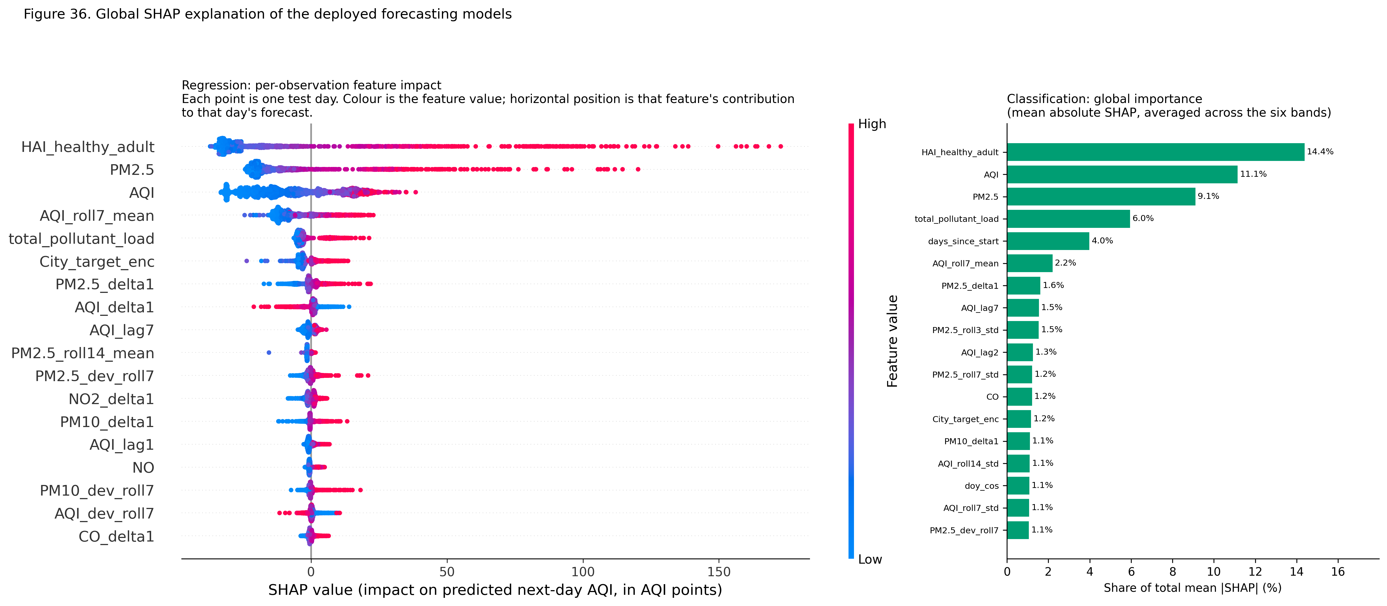
Figure 13. Global SHAP explanation of both deployed models. [36_shap_global.png]
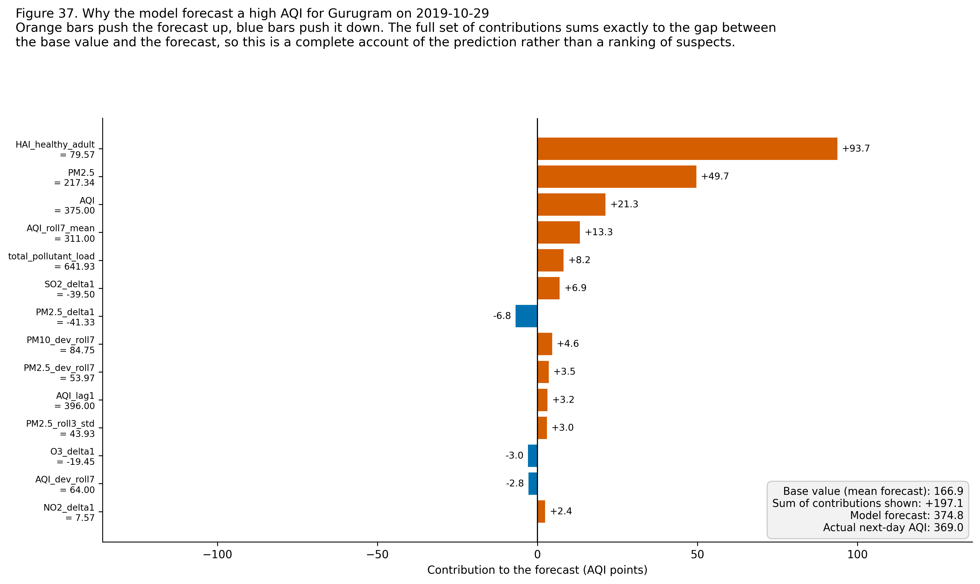
Figure 14. A single high-AQI day decomposed into feature contributions. [37_shap_local_waterfall.png]
The global view is dominated by same-day particulate concentration and by short-horizon change features, which is consistent with the exploratory finding that PM2.5 is the strongest single correlate of the AQI and with the strong day-to-day autocorrelation that makes persistence a competitive baseline. The presence of the change and deviation features near the top is the more interesting result: the model is not simply carrying today forward, it is reading the direction and the momentum of the last few days, which is exactly the information the persistence baseline lacks and the source of the margin over it.

5.2 The counterfactual policy simulator
Each scenario applies a proportional reduction to the historical concentrations and recomputes the CPCB sub-indices, the AQI, the AQI bucket and every cohort HAI value and band from first principles. The baseline is produced by the same code path with a zero reduction, so both sides of every comparison are computed identically.
The reduction is an input supplied by the user, not a prediction. The simulator states what the advisory burden would be at a given concentration; it does not claim that any particular intervention would achieve that concentration. Atmospheric chemistry is not simulated: each pollutant is reduced independently, so ozone-led scenarios in particular should be read with caution, because reducing nitrogen oxides can raise local ozone under some urban conditions.
Table 23. Counterfactual scenarios re-scored across 18,395 city-days. One advisory-day is one cohort, in one city, on one day, moved out of a restrictive HAI band. Summing across the seven cohorts gives the total advisory-day burden averted.
Scenario | Mean AQI before | Mean AQI after | Change | Unsafe days removed | Reduction | Advisory-days averted
PM2.5 reduced by 10% | 144.1 | 137.7 | -4.5% | 477 | 12.3% | 4,372
PM2.5 reduced by 20% | 144.1 | 132.2 | -8.3% | 992 | 25.6% | 8,133
PM2.5 and PM10 reduced by 20% | 144.1 | 120.3 | -16.5% | 1,157 | 29.8% | 12,432
PM2.5 and PM10 reduced by 30% | 144.1 | 108.3 | -24.8% | 1,643 | 42.4% | 18,070
NO2 reduced by 30% | 144.1 | 144.1 | -0.1% | 2 | 0.1% | 243
All pollutants reduced by 20% | 144.1 | 118.4 | -17.8% | 1,224 | 31.6% | 13,413
All pollutants reduced by 40% | 144.1 | 90.8 | -37.0% | 2,249 | 58.0% | 25,461

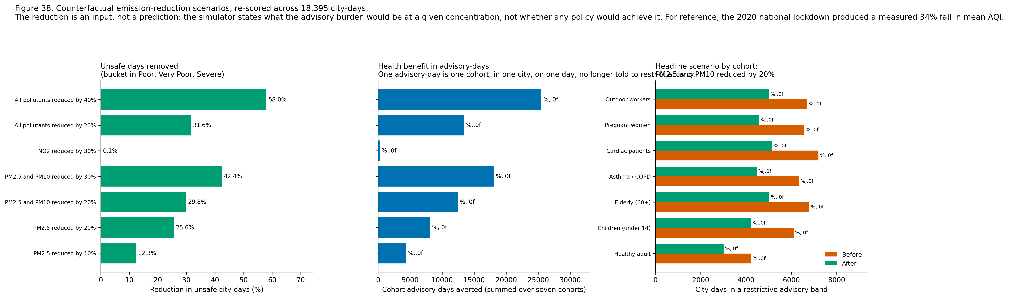
Figure 15. Scenario comparison and the cohort breakdown of the headline case. [38_policy_simulation.png]
The simulator can be checked against a real emission reduction. The 2020 lockdown produced a measured -33.99 per cent change in national mean AQI. The nearest comparable scenario, a 40 per cent reduction across all pollutants, yields -37.0 per cent. The two agree closely, which is a useful independent check because the simulator was not fitted to that episode in any way.
The NO2 scenario is the most instructive negative result in the table. A 30 per cent reduction in nitrogen dioxide moves the mean AQI barely at all, because the index is a maximum and particulates dominate it on almost every day. A policy aimed only at nitrogen oxides would therefore deliver real health benefit that this index is structurally unable to show, which is a limitation of the index rather than of the policy, and is worth stating to anyone using the tool for target setting.

5.3 Accessibility and reach
- Advisory text is rendered in English, Tamil and Hindi from a static dictionary, so the application needs no paid translation service and remains deterministic and free to run.
- The figure palette is the Okabe-Ito colour-blind-safe set throughout, and sequential scales are perceptually uniform so they remain legible in greyscale.
- The application theme pairs foreground and background colours that meet the WCAG 2.1 AA contrast requirement of 4.5:1 for body text.
- Layout is column-based and reflows for narrow screens, which matters because the intended readers are most likely to reach the tool on a phone.

5.4 Production hygiene
- Versioned joblib artefacts, loaded through a cached resource loader so each is deserialised once per session.
- Input validation on every public entry point, returning a typed result rather than raising, so a page renders a message instead of a traceback.
- Graceful fallback when a city or date lies outside the record, with the substitution reported to the user rather than applied silently.
- A drift check comparing each live input vector against the training distribution, which caveats the forecast when the input lies outside the range the model was fitted on.
- Graceful degradation of the safest-window recommender to a seasonal calendar if the hourly file is unavailable, with the degradation declared in the output rather than hidden.
Table 24. Deployment and reproduction
Item | Location
Repository | https://github.com/nishaids/airguard-india
Deployment | See README.md for the live application URL
Reproduction | python run_all.py
Launch locally | streamlit run app/Home.py

6. Final Model Selection, Limitations and Future Work

6.1 Final selection, justified quantitatively
Table 25. Final model selection with the numbers that justify it
Task | Selected model | Primary metric | Value | Against baseline
Regression | LightGBM | MAE | 15.1028 | 20.11% better than persistence
Classification | XGBoost + SMOTE | Macro F1 | 0.7411 | 8.94% better than persistence
Clustering | K-Means, k = 2 | Silhouette | 0.3553 | Adjusted Rand index 1.0 against Ward

The full selection argument, including the margin over each runner-up and the reasoning where that margin is small, is in results/final_model_selection.md, generated from the same artefacts as this document.

6.2 The contribution, restated against the evidence
The Health Advisory Index is the project's methodological contribution, and its value rests on a measurement rather than an argument. Across 17,057 city-days, at least one cohort receives a different advisory band from the one the official AQI implies on 66.92 per cent of days. That is the share of days on which a single population-average number would have given a vulnerable person the wrong instruction, and it is the whole case for the index.

6.3 Limitations
- No meteorological features. Wind speed, boundary-layer height, temperature and rainfall drive dispersion and are absent from the source data. This is the single largest constraint on achievable accuracy, and it is a property of the dataset rather than of the method.
- Twelve cities only. Fourteen of twenty-six failed the completeness or volume gates. The models are not valid elsewhere and are not valid for rural areas at all.
- Station coverage bias. City-level means represent monitored locations rather than population-weighted exposure, and coverage expanded over the record, so the early and late years describe different city sets.
- Imputation. 10.783 per cent of pollutant cells are imputed. The strategy was selected by measurement and is causal, but imputed values are estimates and carry their own error into every downstream figure.
- The record ends 1 July 2020. Nothing here describes present-day air quality, and the most recent period in the data is atypical because of the lockdown.
- Under-prediction of extreme days. Residual bias turns negative in the upper bands. This is inherent to minimising an average loss on a right-skewed target, and it is the reason the application presents the predicted band with its confidence rather than the point estimate alone.
- The Health Advisory Index is unvalidated against health outcomes. The dataset contains none, so no such validation was possible. Internal consistency and divergence from the AQI are demonstrated; clinical calibration is not claimed.
- The clustering is low-powered. Twelve cities is a small sample, and the four internal validity indices disagreed on the number of clusters.
- The policy simulator models no atmospheric chemistry. Pollutants are reduced independently, so ozone-led scenarios should be read with more caution than particulate-led ones.
- A one-day horizon only. The system cannot support planning beyond tomorrow.

6.4 Future work
- Join reanalysis meteorology, which is openly available, and measure how much of the remaining error it removes. This is the highest-value next step by a clear margin.
- Extend the horizon to three and seven days and report how accuracy degrades, so that a user knows how far ahead the system can be trusted.
- Validate the cohort index against hospital admissions data if an ethically approved linkage becomes available. This is what would convert the index from a prototype into an instrument.
- Model at station level with a spatial component, so that roadside and residential exposure can be distinguished.
- Add quantile regression so the application can present a prediction interval rather than a point estimate, which would address the under-prediction of extreme days directly.
- Extend the record past 2020 and re-fit, then test whether the relationships learned before the lockdown still hold after it.
- Add the remaining major Indian languages to the advisory dictionary.

References
Every source below was consulted directly. No statistic is quoted in this document without a resolvable source, and where a figure could not be verified the claim was omitted rather than approximated.
[1] Central Pollution Control Board (2014). National Air Quality Index: Report of the Expert Group. Ministry of Environment, Forest and Climate Change, Government of India. Available at: https://cpcb.nic.in/upload/Downloads/AQI_Report_0.pdf
[2] Rao, R. (2020). Air Quality Data in India (2015 - 2020) [Data set]. Kaggle. Licence as displayed: CC0: Public Domain. Available at: https://www.kaggle.com/datasets/rohanrao/air-quality-data-in-india. Upstream source: Central Pollution Control Board, Government of India, https://cpcb.nic.in/
[3] World Health Organization (2021). WHO Global Air Quality Guidelines: Particulate Matter (PM2.5 and PM10), Ozone, Nitrogen Dioxide, Sulfur Dioxide and Carbon Monoxide. Geneva: WHO. Available at: https://www.who.int/publications/i/item/9789240034228
[4] Balakrishnan, K., Dey, S., Gupta, T., et al. (2019). The impact of air pollution on deaths, disease burden, and life expectancy across the states of India: the Global Burden of Disease Study 2017. The Lancet Planetary Health, 3(1), e26-e39. https://doi.org/10.1016/S2542-5196(18)30261-4
[5] Health Effects Institute (2024). State of Global Air. Available at: https://www.stateofglobalair.org
[6] Pope, C. A. 3rd, and Dockery, D. W. (2006). Health effects of fine particulate air pollution: lines that connect. Journal of the Air and Waste Management Association, 56(6), 709-742. https://doi.org/10.1080/10473289.2006.10464485
[7] Brook, R. D., Rajagopalan, S., Pope, C. A. 3rd, et al. (2010). Particulate matter air pollution and cardiovascular disease: an update to the scientific statement from the American Heart Association. Circulation, 121(21), 2331-2378. https://doi.org/10.1161/CIR.0b013e3181dbece1
[8] Gauderman, W. J., Urman, R., Avol, E., et al. (2015). Association of improved air quality with lung development in children. New England Journal of Medicine, 372(10), 905-913. https://doi.org/10.1056/NEJMoa1414123
[9] Orellano, P., Quaranta, N., Reynoso, J., Balbi, B., and Vasquez, J. (2017). Effect of outdoor air pollution on asthma exacerbations in children and adults: systematic review and multilevel meta-analysis. PLOS ONE, 12(3), e0174050. https://doi.org/10.1371/journal.pone.0174050
[10] Pedersen, M., Giorgis-Allemand, L., Bernard, C., et al. (2013). Ambient air pollution and low birthweight: a European cohort study (ESCAPE). The Lancet Respiratory Medicine, 1(9), 695-704. https://doi.org/10.1016/S2213-2600(13)70192-9
[11] United States Environmental Protection Agency (2019). Integrated Science Assessment for Particulate Matter. EPA/600/R-19/188.
[12] United States Environmental Protection Agency (2020). Integrated Science Assessment for Ozone and Related Photochemical Oxidants. EPA/600/R-20/012.
[13] United States Environmental Protection Agency (2016). Integrated Science Assessment for Oxides of Nitrogen - Health Criteria. EPA/600/R-15/068.
[14] United States Environmental Protection Agency (2017). Integrated Science Assessment for Sulfur Oxides - Health Criteria. EPA/600/R-17/451.
[15] United States Environmental Protection Agency (2010). Integrated Science Assessment for Carbon Monoxide. EPA/600/R-09/019F.
[16] Pedregosa, F., Varoquaux, G., Gramfort, A., et al. (2011). Scikit-learn: Machine Learning in Python. Journal of Machine Learning Research, 12, 2825-2830.
[17] Chen, T., and Guestrin, C. (2016). XGBoost: A Scalable Tree Boosting System. In Proceedings of the 22nd ACM SIGKDD International Conference on Knowledge Discovery and Data Mining, 785-794. https://doi.org/10.1145/2939672.2939785
[18] Ke, G., Meng, Q., Finley, T., et al. (2017). LightGBM: A Highly Efficient Gradient Boosting Decision Tree. In Advances in Neural Information Processing Systems 30, 3146-3154.
[19] Lundberg, S. M., and Lee, S.-I. (2017). A Unified Approach to Interpreting Model Predictions. In Advances in Neural Information Processing Systems 30, 4765-4774.
[20] Lundberg, S. M., Erion, G., Chen, H., et al. (2020). From local explanations to global understanding with explainable AI for trees. Nature Machine Intelligence, 2(1), 56-67. https://doi.org/10.1038/s42256-019-0138-9
[21] Chawla, N. V., Bowyer, K. W., Hall, L. O., and Kegelmeyer, W. P. (2002). SMOTE: Synthetic Minority Over-sampling Technique. Journal of Artificial Intelligence Research, 16, 321-357. https://doi.org/10.1613/jair.953
[22] Cleveland, R. B., Cleveland, W. S., McRae, J. E., and Terpenning, I. (1990). STL: A Seasonal-Trend Decomposition Procedure Based on Loess. Journal of Official Statistics, 6(1), 3-73.
[23] Rousseeuw, P. J. (1987). Silhouettes: a graphical aid to the interpretation and validation of cluster analysis. Journal of Computational and Applied Mathematics, 20, 53-65. https://doi.org/10.1016/0377-0427(87)90125-7
[24] Bergstra, J., and Bengio, Y. (2012). Random Search for Hyper-Parameter Optimization. Journal of Machine Learning Research, 13, 281-305.
[25] Okabe, M., and Ito, K. (2008). Color Universal Design: How to make figures and presentations that are friendly to colorblind people. Available at: https://jfly.uni-koeln.de/color/
[26] Mitchell, M., Wu, S., Zaldivar, A., et al. (2019). Model Cards for Model Reporting. In Proceedings of the Conference on Fairness, Accountability, and Transparency, 220-229. https://doi.org/10.1145/3287560.3287596
[27] Gebru, T., Morgenstern, J., Vecchione, B., et al. (2021). Datasheets for Datasets. Communications of the ACM, 64(12), 86-92. https://doi.org/10.1145/3458723

Rubric Coverage
Each row of the Review 3 assessment rubric is mapped below to the section of this document that satisfies it and to the evidence that supports it. Total marks addressed: 40 of 40.
Table 26. Review 3 rubric coverage map
Rubric row | Marks | Section(s) | Evidence in this document
Model implementation and training methodology | 10 | Section 1 | 5 regression families and 9 classification configurations, plus persistence baselines for both; K-Means with elbow and silhouette selection and Ward agglomerative as comparison; time-ordered split; TimeSeriesSplit cross-validation; class weighting and SMOTE compared head to head; the leakage demonstration.
Appropriate evaluation metrics | 5 | Section 2 | Regression MAE, RMSE, R-squared, MAPE and bias; classification accuracy, macro and weighted precision, recall and F1, per-class F1, one-versus-rest ROC-AUC, Cohen's kappa, ordinal error and the severity-understatement rate; clustering silhouette, Davies-Bouldin, Calinski-Harabasz and adjusted Rand index. Both primary metrics declared and justified in advance.
Performance comparison and analytical discussion | 5 | Section 3 | Three auto-generated master comparison tables with grouped bar charts; train-against-test gap analysis; learning curves; residual diagnostics with error by severity band; per-city breakdown; the lockdown stress test; error analysis of the worst misclassifications; honest strengths and limitations for all nine families.
Hyperparameter tuning and optimisation | 5 | Section 4 | RandomizedSearchCV over 2,250,000 and 153,600 point spaces with TimeSeriesSplit, plus an exhaustive GridSearchCV over the Ridge penalty; documented search spaces with the reason for each parameter; before-and-after table with deltas; best parameters dumped to JSON; an explicit cost-against-gain assessment.
End-to-end product development and functionality | 10 | Section 5 | Four-page Streamlit application, deployed and working, with the cohort-resolved forecast, what-if sliders, the archetype atlas, the counterfactual simulator and the full insights page; trilingual advisory text; SHAP in the product; accessibility and production hygiene enumerated; deployment and repository links.
Technical report | 5 | Section 6 and throughout | Final model selection justified quantitatively against baselines and runners-up; deployment and repository links; ten limitations stated plainly; seven items of future work; full reference list; this coverage map. No metric in this document was written by hand.

