MongoDB CRUD Operations Assignment

Database Information
Database Name: inventoryDB
Collection Name: items

1. Database & Collection Setup
Query:
use inventoryDB
db.createCollection("items")
Screenshot:
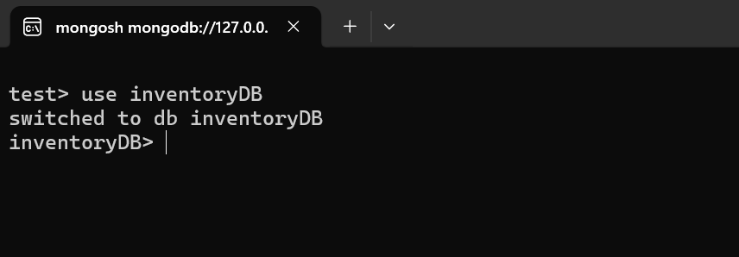
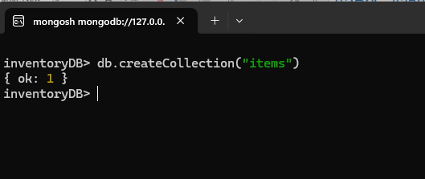

2. Insert Operations

2.1 insertOne()
Description: Insert a single document into the collection.
Query:
db.items.insertOne({
name: "Laptop Pro 15",
category: "Electronics",
price: 75000,
quantity: 10,
supplier: "TechMart India",
inStock: true,
addedOn: new Date("2024-01-15")
})
Output Screenshot:
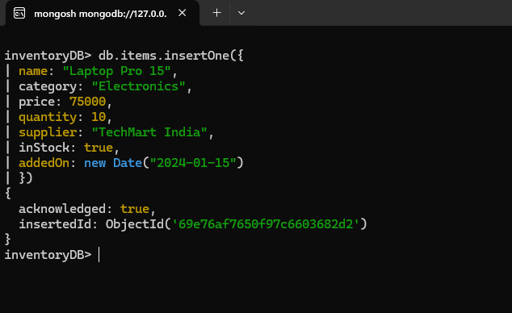

2.2 insertMany()
Description: Insert multiple documents.
Query:
db.items.insertMany([
{
name: "Wireless Mouse",
category: "Accessories",
price: 1200,
quantity: 50,
supplier: "PeripheralZone",
inStock: true,
addedOn: new Date("2024-02-10")
},
{
name: "USB-C Hub",
category: "Accessories",
price: 2500,
quantity: 30,
supplier: "TechMart India",
inStock: true,
addedOn: new Date("2024-02-12")
},
{
name: "Mechanical Keyboard",
category: "Accessories",
price: 4500,
quantity: 20,
supplier: "KeyCraft Co",
inStock: false,
addedOn: new Date("2024-03-01")
},
{
name: "27-inch Monitor",
category: "Electronics",
price: 32000,
quantity: 8,
supplier: "DisplayWorld",
inStock: true,
addedOn: new Date("2024-03-05")
}
])
Output Screenshot:
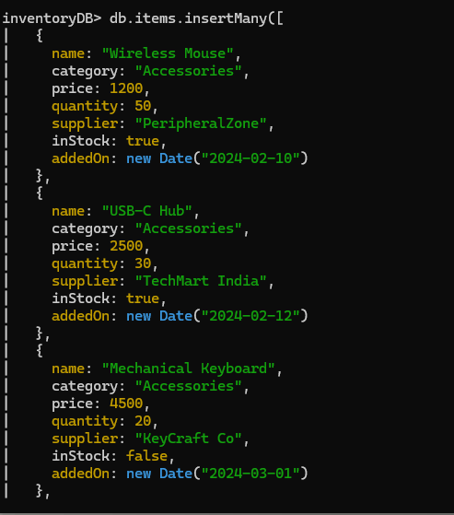
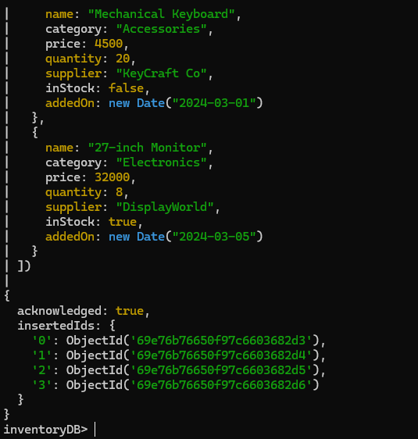

3. Read Operations

3.1 find()
Query:
db.items.find()
Output Screenshot:
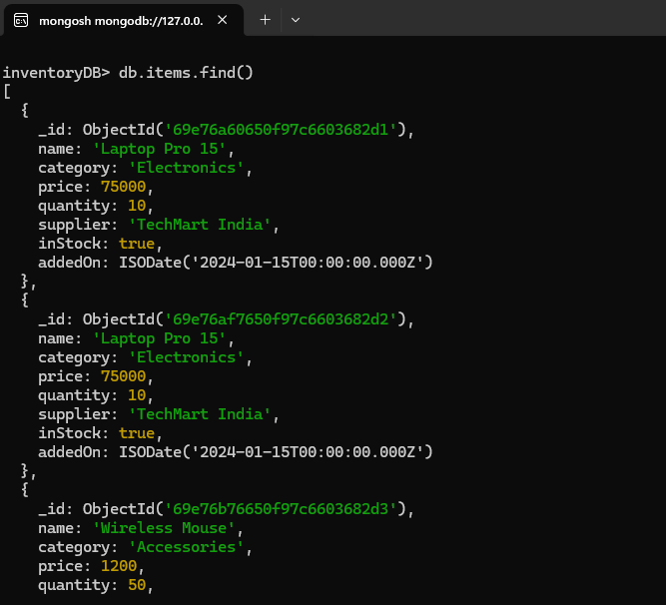
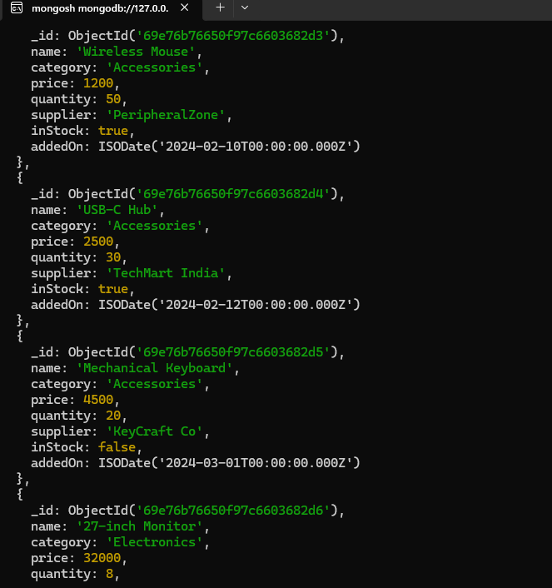
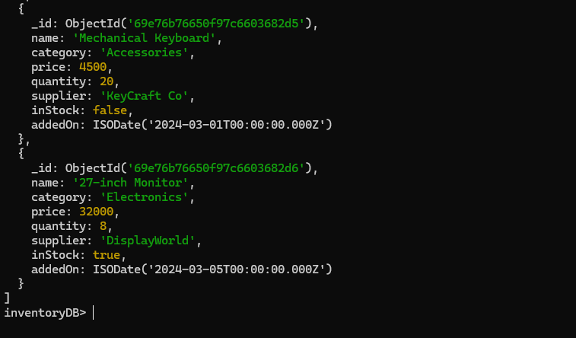

3.2 findOne()
Query:
db.items.findOne({ name: " Mechanical Keyboard" })
Output Screenshot:
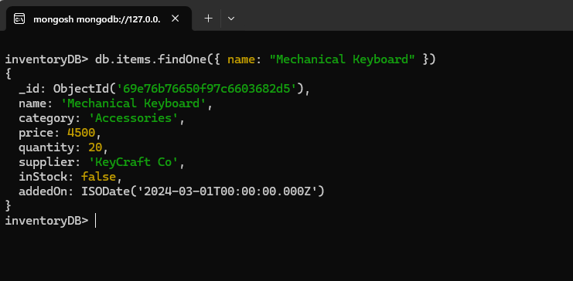

4. Update Operations

4.1 updateOne()
Query:
db.items.updateOne(
{ name: " Mechanical Keyboard " },
{
$set: {
price: 3500,
} }
)

Before Screenshot:
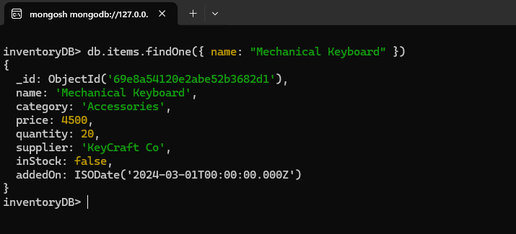
After Screenshot:
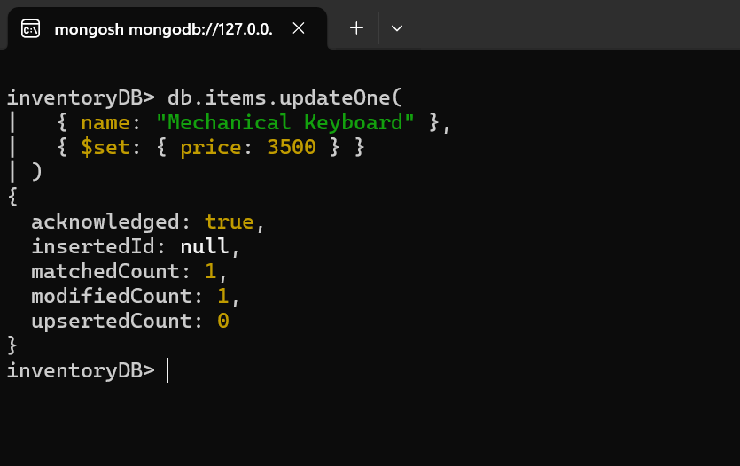

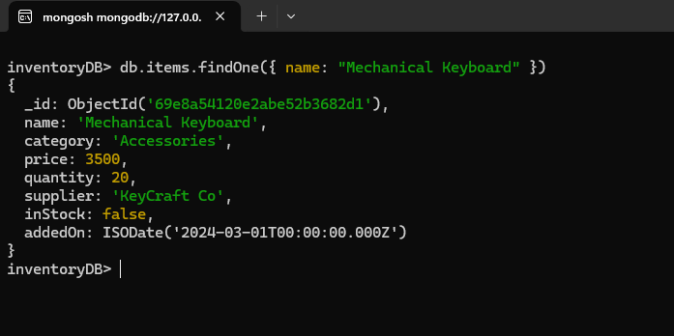

4.2 updateMany()
Query:
db.items.updateMany(
{ category: "Electronics" },
{ $set: { stock: 30 } }
)
After Screenshot:
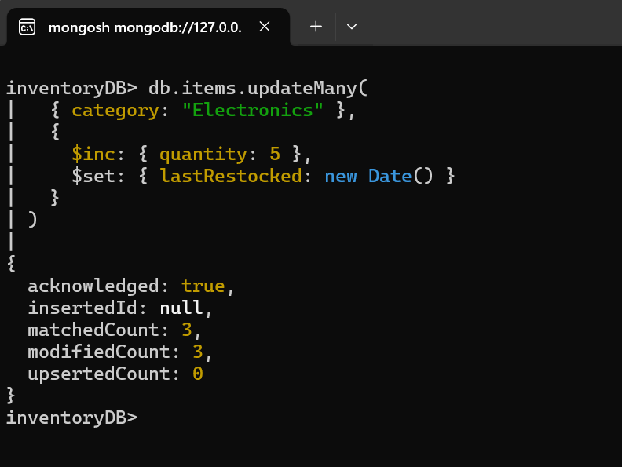

5. Delete Operations

5.1 deleteOne()
Query:
db.items.deleteOne(
{ name: "Mechanical Keyboard" }
)
Output Screenshot:
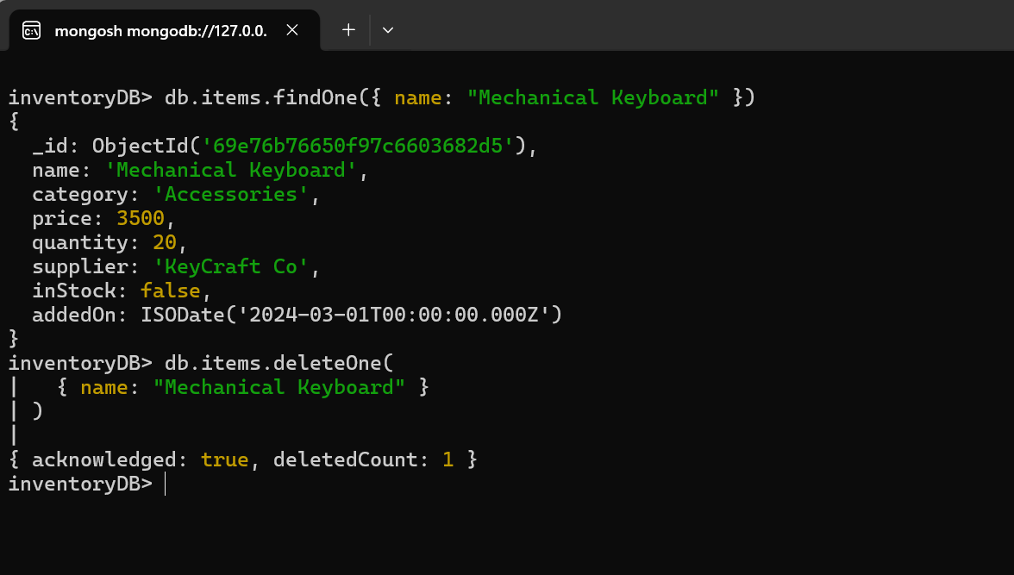

5.2 deleteMany()
Query:
db.items.insertMany([
{ name: "Old Headset", category: "Accessories", price: 800,
quantity: 0, inStock: false },
{ name: "Broken Charger", category: "Accessories", price: 200,
quantity: 0, inStock: false }
])

db.items.deleteMany(
{ inStock: false }
)
Output Screenshot:


Verification
Query:
db.items.find()
Output Screenshot:
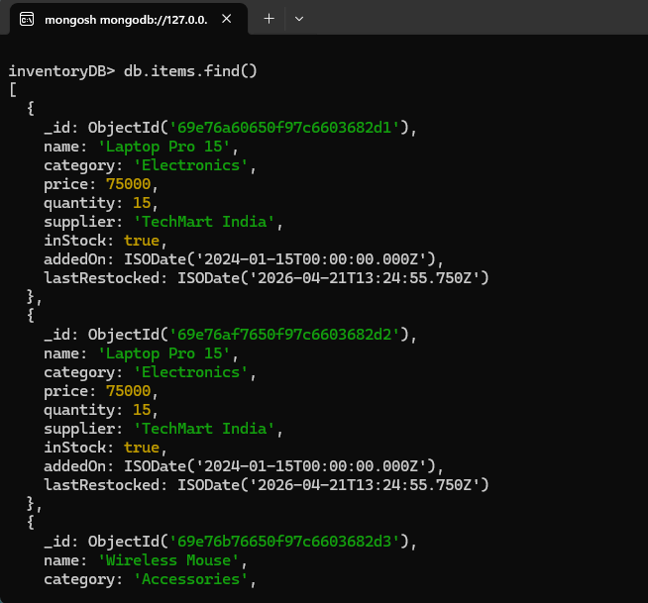
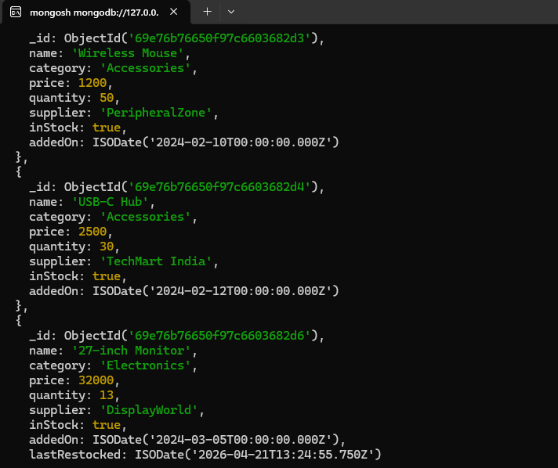

Conclusion
This assignment demonstrates all MongoDB CRUD operations:
- insertOne, insertMany
- find, findOne
- updateOne, updateMany
- deleteOne, deleteMany
All operations were executed successfully with verified outputs.

