## EXERCISE 01

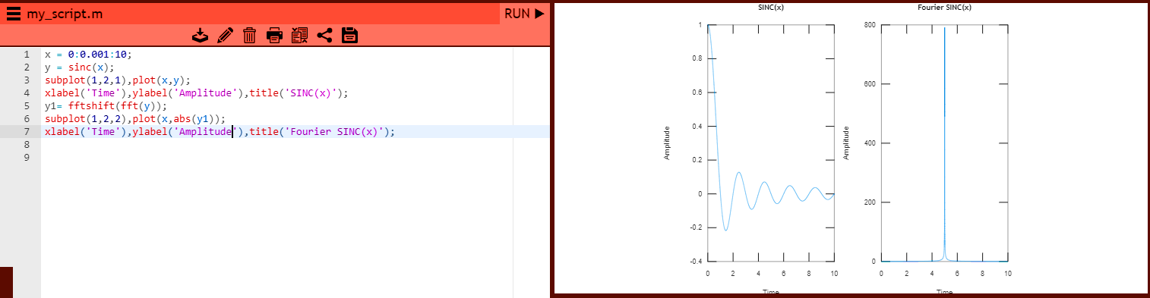

## EXERCISE 02

