Build a servlet application to achieve the below provided flow of actions and responses

1) Create few interactive pages

Create a registration page as shown below which would collect the details of the user and save it in database. The user could be allowed to login , if already registered.

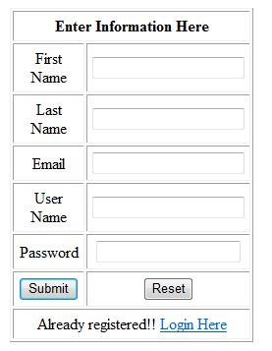 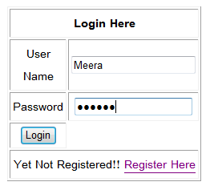

The below form validation needs to be performed

1. All fields are mandatory
2. Field ‘Email ‘ needs appropriate validation
3. All field lengths have to be restricted to 20 characters except email
4. Password needs to be a combination of alphabets and numbers
   * Has a form to collect the above shown details from the user
   * If username has special characters show error message on screen
   * IF username has space, raise custom exception capture it using error page
   * read the form values and calls the method ,
   * Form details to be passed to the method as a Bean

If a user is already registered, allow the user to login , and display a welcome page.

* + T_COMITID_USER

Below are the column names

FIRST_NAME

LAST_NAME

EMAIL_ID

USER_NAME

PASSWORD

Data Base URL

"jdbc:oracle:thin:@10.232.71.29:1521:INATP02","shobana","shobana"

2) As an enhancement add a Text Box with a button to search, in the welcome page.



When the user clicks on search ,the user should be redirected to google search results.

