

***CURRENCY CONVERTER APP USING PYTHON***

***REPORT FILE***

***STUDENT INFORMATION***

* NAME: ***NITESH KESHARWANI***
* COURSE: ***BTECH***
* BRANCH: ***COMPUTER SCIENCE AND ENGINEERING***
* UNIVERSITY ROLL NUMBER: ***190240101067***
* YEAR: ***2nd YEAR (2019-23)***
* COLLEGE NAME: ***ROORKEE INSTITUTE OF TECHNOLOGY***
* PROJECT NAME: ***CURRENCY CONVERTER APP USING PYTHON***
* SUBMITTED TO: ***MR. PRAVEEN KUMAR VERMA***

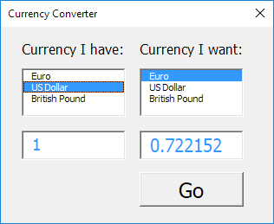

***ABOUT PROJECT:***

* Basically, a currency converter is a software app code (here written in Python language) which is designed in such a way that converts one country’s currency into another country’s currency to its corresponding value.
* In this project, we use Python programming language because Python is a language that is cross-platform, vast range of in-built library, easy to write, etc.
* Here, we use Python Tkinter GUI module because of its easy structured language and built-in availability.
* Currency converter apps are very useful for people who go from one country to another country because via this app such people can do conversion calculations very fast and accurately.
* The basic formula used in this project is:

***Converted_currency_value= currency rate* currency_for_conversion***

Here, currency rate is taken as input from the user using the currency converter app, and then that is multiplied by currency rate.

* The Other Python Modules that are used are –
  + ***Tkinter – For User Interface (UI)***
  + ***requests – to get URL***

***Mechanism involved in developing the Currency Converter App Using Python–***

* Everyday Exchange rates
* Main Function
* Currency Converter Class
* Import required Libraries
* UI for Currency Converter

***REQUESTS–*** In this project, requests module allows you to send HTTP (Hyper Text Transfer Protocol) requests using Python. This HTTP request returns a Response Object with all the response data (content, encoding, status, etc.).

**Syntax**–

requests.methodname(params)

*TKINTER-* Although Tkinter is not the only GUI Programming toolkit for Python but still it is the de-facto standard GUI (Graphical User Interface) package. Creating a GUI application using Tkinter is an easy task. Tkinter provides a powerful object-oriented interface to the Tkinter GUI toolkit. GUI application using Tkinter can be performed in following steps-

* Import the *Tkinter* module.
* Create the *GUI application main window*.
* Add one or more of the above-mentioned widgets to the GUI application.
* Call the main event loop to take action against each event triggered by the user.

***FUTURE SCOPE OF THE PROJECT/APPLICATIONS OF THE PROJECT***

1. Humans have expanded their business worldwide thus, the need of currency converter apps are in high demand because business men have to travel to different countries for business meetings etc.
2. Technologies made to help a person worldwide are fully developed on Earth and therefore, people love to travel to new and beautiful places and simultaneously need to know about currencies all over the places and therefore need currency converter apps.



1. Online shopping facilities have been developed all over the world and thus if we do any online shopping on any international e-commerce site, the payer needs to pay money in dollars, so to know the actual price of the shopped item, they need currency converter apps.
2. Business person travel to different countries in order to expand their business so they continuously require to exchange cash frequently their thus they can use this app to keep themselves updated about the currency rate.
3. Different countries embassy can use these app.

***LANGUAGES USED IN THE PROJECT***

In this project, Currency Converter App, programming language is used in both backend and at frontend. The main language used in both is Python in which Tkinter GUI is the main language used and json module along with Python HTTP library is also used at great extent.

To install the tkinter and requests library, type the following code in your terminal:

* + pip install tkinter
  + pip install requests

***SOURCE CODE***

***# # Python Project on Currency Converter***

***import requests***

***from tkinter import \****

***import tkinter as tk***

***from tkinter import ttk***

***class RealTimeCurrencyConverter():***

***def __init__(self,url):***

***self.data = requests.get(url).json()***

***self.currencies = self.data['rates']***

***def convert(self, from_currency, to_currency, amount):***

***initial_amount = amount***

***if from_currency != 'USD' :***

***amount = amount / self.currencies[from_currency]***

***# limiting the precision to 4 decimal places***

***amount = round(amount * self.currencies[to_currency], 4)***

***return amount***

***class App(tk.Tk):***

***def __init__(self, converter):***

***tk.Tk.__init__(self)***

***self.title = 'Currency Converter'***

***self.currency_converter = converter***

***#self.configure(background = 'blue')***

***self.geometry("500x200")***

***# Label***

***self.intro_label = Label(self, text = 'Welcome to Real Time Currency Convertor', fg = 'blue', relief = tk.RAISED, borderwidth = 3)***

***self.intro_label.config(font = ('Courier',15,'bold'))***

***self.date_label = Label(self, text = f"1 Indian Rupee equals = {self.currency_converter.convert('INR','USD',1)} USD \n Date : {self.currency_converter.data['date']}", relief = tk.GROOVE, borderwidth = 5)***

***self.intro_label.place(x = 10 , y = 5)***

***self.date_label.place(x = 160, y= 50)***

***# Entry box***

***valid = (self.register(self.restrictNumberOnly), '%d', '%P')***

***self.amount_field = Entry(self,bd = 3, relief = tk.RIDGE, justify = tk.CENTER,validate='key', validatecommand=valid)***

***self.converted_amount_field_label = Label(self, text = '', fg = 'black', bg = 'white', relief = tk.RIDGE, justify = tk.CENTER, width = 17, borderwidth = 3)***

***# dropdown***

***self.from_currency_variable = StringVar(self)***

***self.from_currency_variable.set("INR") # default value***

***self.to_currency_variable = StringVar(self)***

***self.to_currency_variable.set("USD") # default value***

***font = ("Courier", 12, "bold")***

***self.option_add('*TCombobox*Listbox.font', font)***

***self.from_currency_dropdown = ttk.Combobox(self, textvariable=self.from_currency_variable,values=list(self.currency_converter.currencies.keys()), font = font, state = 'readonly', width = 12, justify = tk.CENTER)***

***self.to_currency_dropdown = ttk.Combobox(self, textvariable=self.to_currency_variable,values=list(self.currency_converter.currencies.keys()), font = font, state = 'readonly', width = 12, justify = tk.CENTER)***

***# placing***

***self.from_currency_dropdown.place(x = 30, y= 120)***

***self.amount_field.place(x = 36, y = 150)***

***self.to_currency_dropdown.place(x = 340, y= 120)***

***#self.converted_amount_field.place(x = 346, y = 150)***

***self.converted_amount_field_label.place(x = 346, y = 150)***

***# Convert button***

***self.convert_button = Button(self, text = "Convert", fg = "black", command = self.perform)***

***self.convert_button.config(font=('Courier', 10, 'bold'))***

***self.convert_button.place(x = 225, y = 135)***

***def perform(self):***

***amount = float(self.amount_field.get())***

***from_curr = self.from_currency_variable.get()***

***to_curr = self.to_currency_variable.get()***

***converted_amount = self.currency_converter.convert(from_curr,to_curr,amount)***

***converted_amount = round(converted_amount, 2)***

***self.converted_amount_field_label.config(text = str(converted_amount))***

***def restrictNumberOnly(self, action, string):***

***regex = re.compile(r"[0-9,]*?(\.)?[0-9,]*$")***

***result = regex.match(string)***

***return (string == "" or (string.count('.') <= 1 and result is not None))***

***if __name__ == '__main__':***

***url = 'https://api.exchangerate-api.com/v4/latest/USD'***

***converter = RealTimeCurrencyConverter(url)***

***App(converter)***

***mainloop()***

***OUTPUTS***

* The basic output screen will be:

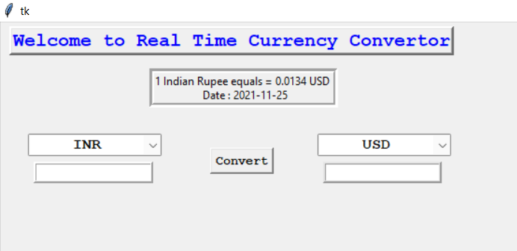

* Output for converting 1 USD in INDIAN RUPEE:

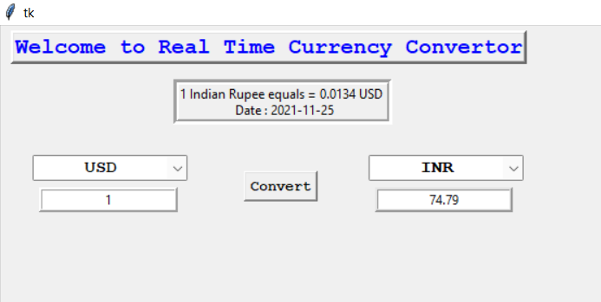

* Output for converting 2 INR in USD:

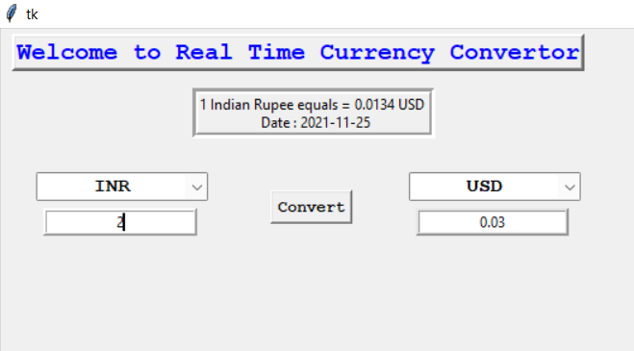

* Output for converting other countries currency:

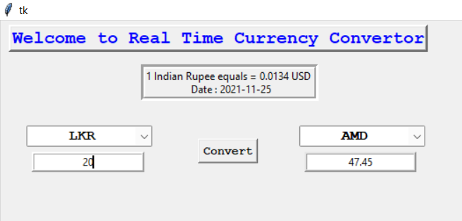

***SUMMARY***

Currency converters are the apps which help you to convert currencies any time and at any place. The economy places a very crucial role in today’s scenario; the covid-19 lockdown has also increased the economy. Currency value keeps changing every second which affects the whole world business. Thus, we can use currency converter app instantly and check the updates prices between any two countries. These apps can provide live exchange prices of currencies along with few more features related to currencies.