DESCRIPTION OF SERVICES

BENCHMARK LABS provides a full turn key solution for medicinal marijuana (MMJ) operations from inception through to ongoing daily production support. Many MMJ operations commonly exceed 30,000 sq. ft., are designed to maximize quality will optimizing cost of operations, and require a level of operational sophistication common to most industrial multi-million dollar operations.
BENCHMARK LABS provides both Professional and Technical Services to successfully take your MMJ opportunity from inception to final realization.
BENCHMARK LABS PROFESSIONAL SERVICES are designed to take a MMJ regulatory application from the inception plan phase, through design, regulatory application filing to the point of implementation prior to pre-license inspection. This includes the selection of cultivation, extraction, dry, cure, package, label, laboratory, and security equipment and instruments, including all required Good Management Practices (GMP's), Standard Operating Procedures (SOP's) and Methods to then be used together with BENCHMARK LABS secure Web based ERP seed-to-sale ISO 17025(2005) and Safe Quality Food (SQF) compliant software.
BENCHMARK LABS TECHNICAL SERVICES are designed to take a MMJ regulatory application from the point of pre-license inspection to ongoing support during daily operations. This includes the sourcing, set-up, training and ongoing support of cultivation, extraction, dry, cure, package, label, laboratory, security equipment and instruments, as well as the BENCHMARK LABS secure Web based ERP seed-to-sale ISO 17025(2005) and Safe Quality Food (SQF) compliant software.

Under the terms of a Professional Services Agreement (PSA) Benchmark will provide:
Facility Operational Plans:
  - cultivation area
  - extraction area
  - processing area
  - decontamination area
  - package & labeling area
  - storage & vault area
  - shipping & receiving area
  - security area
  - analysis laboratory area
Customized SOP's, GMP's and Methods to suit your Plan:
  - HACCP
  - SSOP
  - Clean Premise
  - Clean Equipment
  - Processing
  - Extraction
  - Package & Labeling
  - Chemical and Biological Analysis
  - Health, Safety & Security
  - Patient Order
  - Patient Complaint
  - Product Recall
  - Emergency
Plan to meet and / or exceed Regulatory Compliance:
  - patient management
  - inventory management
  - document management
  - required on-site personnel
  - training
  - communications
  - record keeping
  - user access control
  - quality analysis
  - health, safety & hygiene
  - reporting
  - recall
  - security

These include planning, design, implementation and on going support.

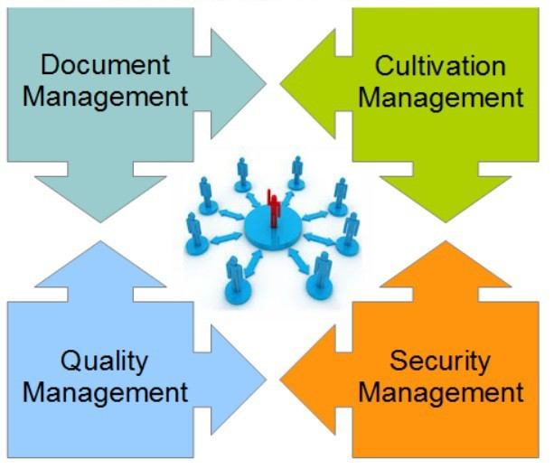
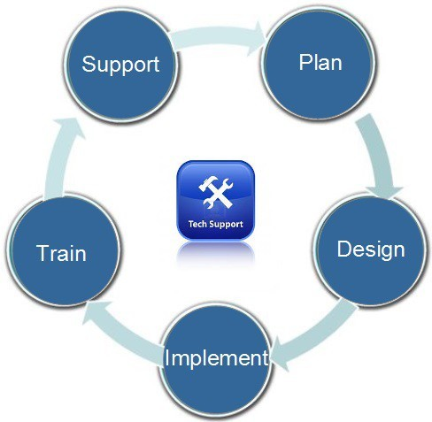

Complete Professional Services Complete Technical Services
These Complete Professional & Technical Services are described as follows:
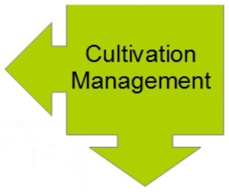

CULTIVATION MANAGEMENT:

(1) Cultivation Planning /Design:

The Cultivation Planning and Design phase shall be provided directly by Cascadia Air Conditioning Inc. (hereinafter “Cultivation Team”). In this phase we will be working closely with your Cultivation Team to complete a Project Plan that provides cultivation area diagrams including power, plumbing, and HVAC requirements as required by MMPR Section 8 and Section 10.
Included in this Project Plan will be the proposed optimal grow area lay-out, along with a list of cultivation equipment and training requirements and a range of environmental, health and safety requirements for the building engineers to use in the design of the HVAC and electrical systems.
We will work with your Cultivation Team to ensure that our SOP's are updated to reflect the proposed growing style and technologies used.
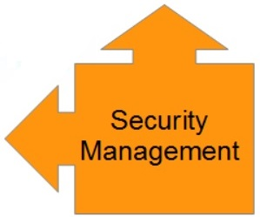

SECURITY MANAGEMENT:
(1) Security Planning:

Shall be provided by the Benchmark Labs Team. The initial planning stage involves the creation of a workable ULC certified Security System that meets the requirements of Health Canada regarding site security, building security, production zone security and storage vault security.
This plan is done together with the Cultivation Plan and the Quality Assurance/Document Management SYSTEM plan to ensure that the Security System is comparable and designed to scale as the operation itself scales in future.
(2) Security Design:
Shall be provided by the Benchmark Labs Team. The Security Planning phase is followed closely by the Security Design phase. In this phase we will be working closely with your Cultivation Team and the BENCHMARK LABS Labs Team to complete a Project Plan that provides security area diagrams including fence, man-trap, camera, door card, vault, and security room layout.
Included in this Design phase will be a list of security equipment and training requirements and a range of security good management practices (GMP's) and standard operating procedures (SOP's) for the building engineers to use in the design of the building to accommodate this security system.
The formation of SOP's and managing any additional regulatory requirements remain part of the Design Phase.
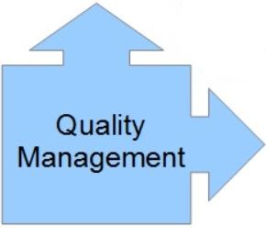

QUALITY ASSURANCE MANAGEMENT:
(1) QAP Selection:
Sourcing a QAP shall be provided by the Benchmark Labs Team At the heart of any MMPR Licensed Location is the Quality Assurance Person (QAP) who has the “training, experience, knowledge” required by Health Canada to “evaluate the operations of the Licensed Producer to ensure compliance with Division 4, and the technical knowledge to be able to assess analytically testing results in order to be able to make the determination of whether the dried Marihuana is suitable for sale.” The QAP must also be responsible “for investigating quality-related complaints and taking corrective and preventative actions, if necessary.”
However, rare is it to find any single individual who has the required “training, experience, knowledge” in Cultivation (including growing, harvesting, packaging, labeling, storage and recall), Chemistry and Biology Analysis (including sampling, analyzing, confirming raw data, publishing verified data, calibration and corrective action), Sanitation (premise and equipment including cultivation control zones and equipment), Hygiene (including cultivation handling, analysis and storage related events), Health & Safety (including managing on site risks including chemicals, high voltage, contaminants, foreign substances, pathogens, high value controlled substances, and environmental control related issues) let alone Rapid Recall events.
BENCHMARK LABS, as discussed as an option in paragraph 2), can assist the CLIENT by successfully finding and providing such unique individuals to our Clients as pre-qualified QAP candidates who are then available for final interview and selection. It is still possible to find potential candidates that meet these requirements. However, given that many potential candidates have already been hired by existing Applicants or Licensed Producers, this will require time and resources to find qualified QAP candidates.

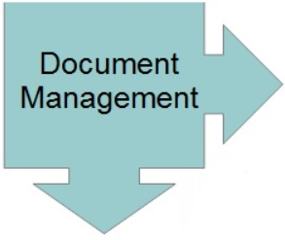
DOCUMENT MANAGEMENT:
(2) Document Management System ONE SYSTEM – ONE SOLUTION:
Upon the CLIENT’s recruitment of a QAP, BENCHMARK LABS begins working immediately to indoctrinate and train your QAP on our HACCP, Sanitary Standard Operating Procedure (SSOP), Clean Premise, Clean Equipment, Handing Processing, Handling Storage, Health Hygiene and Health Safety SOPs and sub-SOPs including our QAP monitoring process for ensuring compliance of these SOPs at your Licensed Location.
All of these SOP's including the daily operations of the Licensed Location, are managed and controlled by the Quality Assurance Person (QAP), utilizing BENCHMARK LABS ONE SYSTEM – ONE SOLUTION. The BENCHMARK LABS SYSTEM is an ISO 17025 (2005) and Safe Quality Food (SQF) compliant and fully integrated Enterprise Relational Process (ERP) system that includes the following modules shown below:

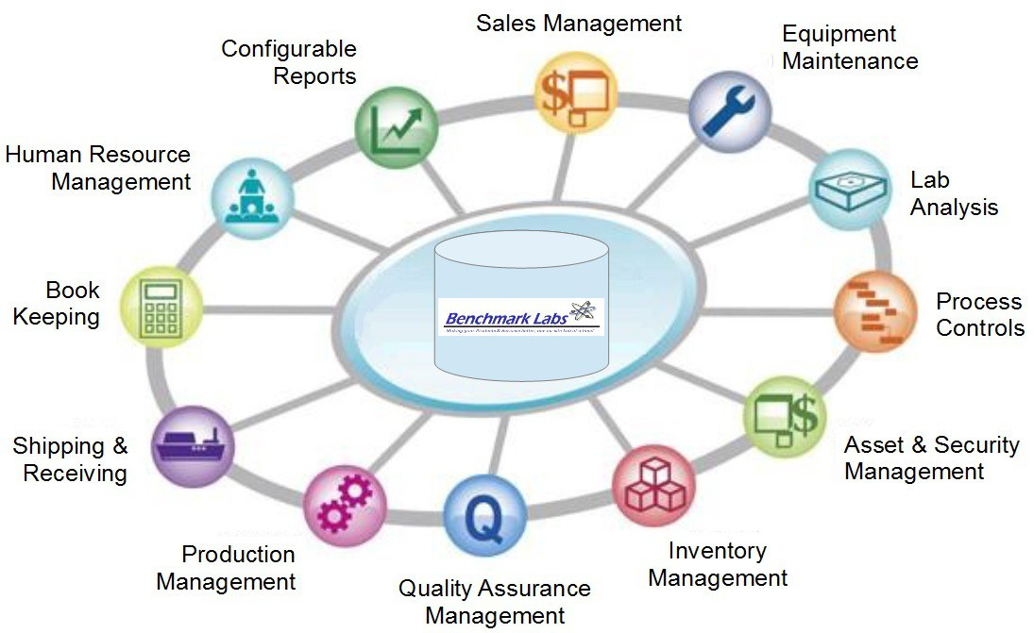

This SYSTEM then incorporates a number of Methods and Procedures that can then be further modified by your QAP to tailor to your specific Licensed Location. These Documents include:
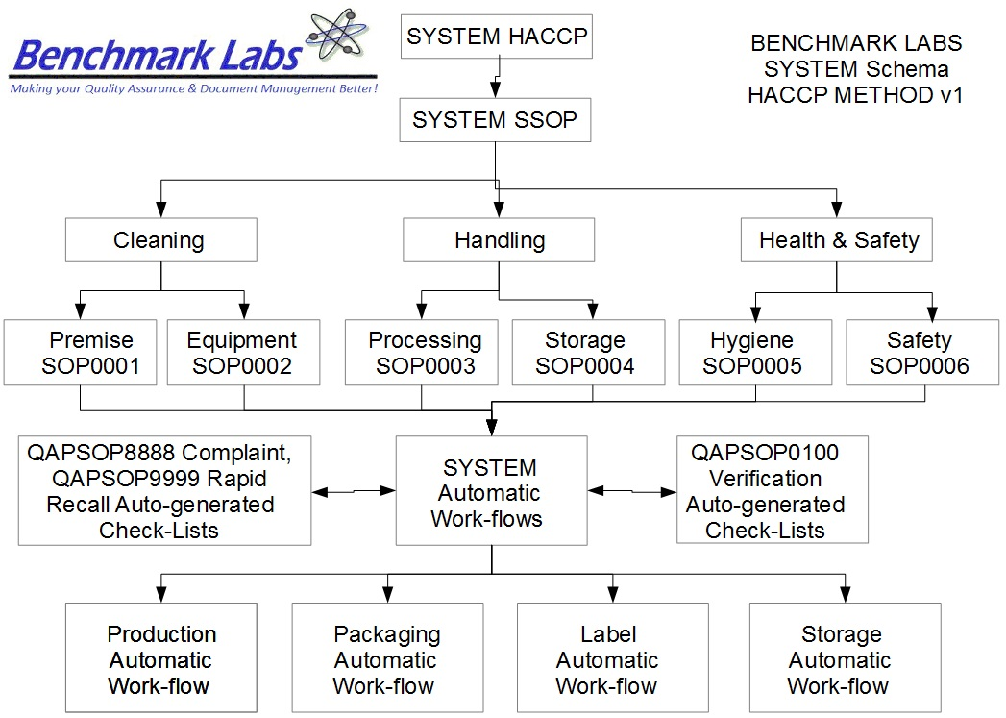

The BENCHMARK LABS SYSTEM then becomes your single source Secure Web Based Application for all of your daily operational requirements (including but not limited to sales, purchasing, marketing, communications, inventory, seed to sale Cultivation, asset management, employee time management, on site laboratory analysis, quality assurance and control, management of complaints and rapid recall, single source file storage, configure reports on all aspects of your operations, role-based User Access, and direct controlled access to Health Canada or other Government Agency, Audit Tracking, Auto-Workflows, Auto-Back-up and Disaster Recovery”.
During the completion of Section 10 and 11 of your MMPR Application, we will work directly with you to ensure that your BENCHMARK LABS SYSTEM is showing to be specifically configured for your Licensed Locations, including your Cultivation Method design and Security System design. The AGREEMENT includes 10 additional hours of support in speaking with Health Canada to answer any questions they may have regarding the use of the SYSTEM at your Licensed Location.
Our SYSTEM provides 99.99% up time and general support is available during regular office hours. Emergency support is also available.

