
THIS DOCUMENT IS OBSOLETE ON DATE OF PRINTING
SOP-4xxxx | ^{TITLE: STORAGE} | ^{Issued Date: June 1, 2014}
^{Supercedes:} New | ^{TITLE: STORAGE} | ^{Effective Date: June 1, 2014}
Initiator: Chris Bolton |   ^{Signature:} | ^{Date:}
^{Reviewer:} | ^{Signature:} | ^{Date:}
^{QA Approval:} | ^{Signature:} | ^{Date:}

- REVISION HISTORY:
Version # | Description of Changes | CC #
0 | New document

DOCUMENT OWNER: Quality Assurance Manager

AFFECTED PARTIES: All site staff who handle the storage of Medicinal Marijuana, related Chemicals, Supplies and Sundry Items.

PURPOSE: To provide a Procedure for the storage of Medicinal Marijuana and related Supplies, Sundry Items and Chemicals related to the day to day operations within the Medicinal Marijuana Licensed Location.

DEFINITIONS:
- Non-MMPR Zones refer to Front Entry, Front Office(s), Board Room, Lunch Room and any other area not directed related to Production, Packaging, Labeling and Storage of Medicinal Marijuana.
- MMPR Zones refer to areas directly related to Production, Packaging, Labeling and Storage of Medicinal Marijuana.
SCOPE: This Procedure applies to the Storage of Raw and Produced Medicinal Marijuana Product that resides within specific designated Zones at the Licensed Location.
KEY WORDS IN SYSTEM: storage, vault, storage closet, storage supplies, Medicinal Marijuana, non-Medicinal Marijuana Zone, Medicinal Marijuana Zone, chemicals, glassware, returned item, returned Medicinal Marijuana, Recall, Recall Event, Section 55.
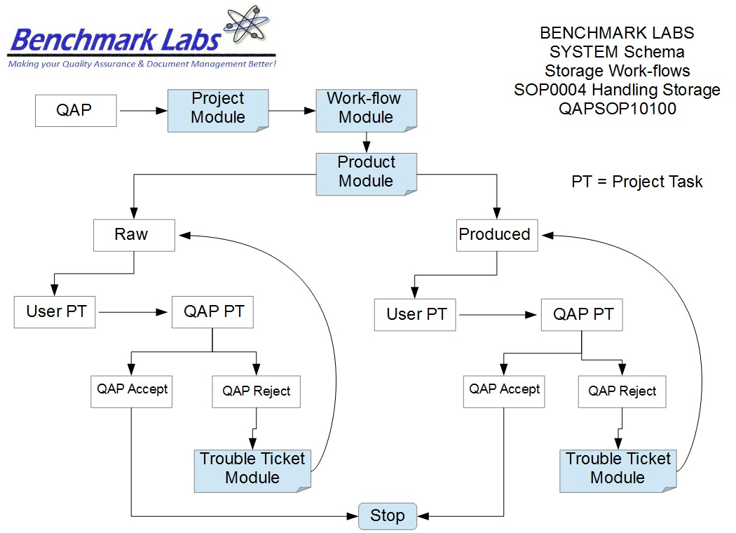
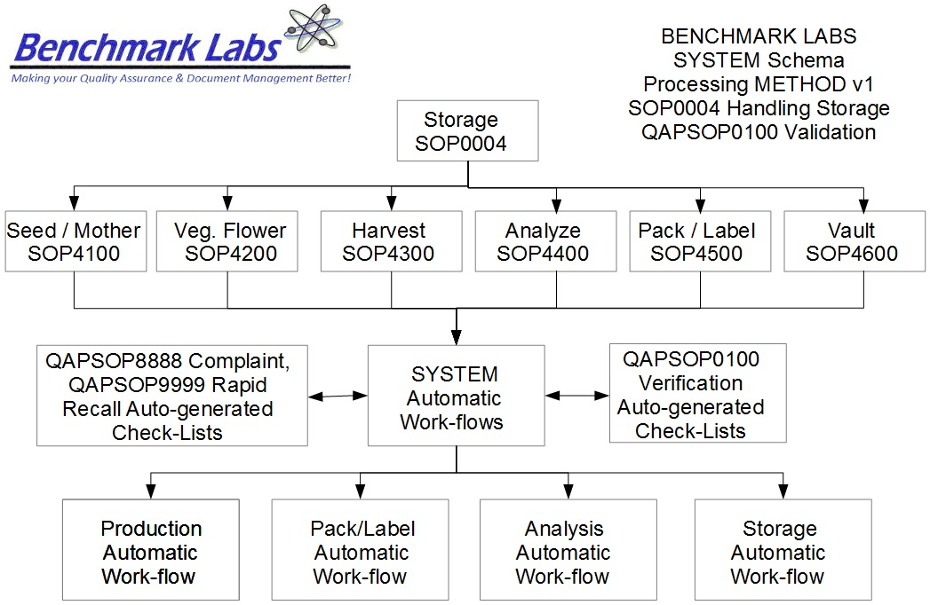
PROCEDURE PROCESS FLOW:
USER PERFORMANCE TASKS (PT) SOPs SPECIFIC TO MMPR ZONES:

GENERAL RULES AND GMP REQUIREMENTS:

- Only Medicinal Marijuana Licensed Location SPIC, RPIC and designed A/RPIC's are authorized to move Medicinal Marijuana Product Inventory from the Packaing and Labeling area to the Secure Vault Area and from the Secure Vault Area to the Shipping Area.
- Only the QAP is authorized to move Raw Inventory and Product Inventory Medicinal Marijuana from the Packaging and Labeling area to the Laboratory Area and from the Laboratory Area to the Secure Vault Area.
- Only the QAP is authorized to move returned Produced Medicinal Marijuana Inventory Material from the Shipping Area to the Laboratory Area and from the Laboratory Area to the Secure Vault Area.

- SPIC and RPIC are responding to responding to alarms concerns unauthorized access to the Secure Vault area, overseeing that maintenance procedures of the Secure Vault area are carried out and the QAP is responsible for updating lists and procedures with respect to storage of both Medicinal Marijuana and non-Medicinal Marijuana.
- Medicinal Marijuana Staff that are involved in the production cycle of the Raw Inventory Product are required to ensure that plants are kept located in their designated zones, rooms and rows at all times.
- Cleaning Staff or designated contractual Cleaning Staff are responsible for ensuring that all Cleaning Supplies are properly stored within the designated Cleaning Storage Area.

- The storage facility (and storage equipment) is a key element in the operation of a Medicinal Marijuana Licensed Location.

- Proper maintenance of the facility and equipment shall be the responsibility of the QAP.

REGULATORY REQUIREMENTS:
- Marihuana for Medical Purposes Regulations, Section 55 Division 4 Good Production Practices, October 2013).

TRAINING REQUIREMENTS: Read, understand and have demonstrate proficiency training (PT) as indicated in the SYSTEM User Profile Record.

RELATED REQUIREMENTS: Read, understand and be familiar with the following related documents:

- SOP4100 Storage Seed / Mother Room
- SOP4200 Storage Vegetative / Mother Room
- SOP4300 Storage Harvest Room
- SOP4400 Storage Analysis Room
- SOP4500 Storage Packaging / Label Room
- SOP4600 Storage Vault
- SOP0001 Cleaning Premise
- SOP0002 Cleaning Equipment
- SOP0003 Handling Processing
- SOP0005 Health Hygiene
- SOP0006 Health Safety

AUTO-GENERATED WORKFLOW(S) REQUIRED TO RECORD LOG:
- WKFL0001: Assign Authorized User, Project Task, Record Date / Time Completed
- QAP0001: Assign Authorized User, Inspection Log, Record Date / Time Completed
- CAR0001: Description of Trouble Ticket auto-generated and emailed to QAP
MATERIALS REQUIRED:

The materials, equipment and forms listed in the following list are recommendations only and may be
substituted by alternative/equivalent products more suitable for the site-specific task or procedure.

Materials and Equipment Materials and Equipment (Zone Specific)
- Back-up power capacity
- Thermometers
- Back-up freezers and refrigerators
- Back-up lighting
- Adequate Liquid Nitrogen Supply
- Alarm systems
- Alarm system contact lists
- Moving Trays
- Tray Buckets
- Shelving Units
- Shelving Drawers
- Secure Vault
SAFETY REQUIREMENTS:
- Refer to the relevant Material Safety Data Sheets for materials being used for cleaning.
- Refer to SOP0004 in relation to Storage to be used.
- Refer to SOP0005 in relation to Hygiene, Health and Clothing to be used.
STORAGE PROCEDURE BY ASSIGNED USER:
- The Medicinal Marijuana Life Cycle will govern where it is located, which determines which MMPR Zone it will reside, which determines how it is to be stored with the Licensed Location. The image below is a Color Representation of the Zones that designate rooms or area's within the Licensed Location that Medicinal Marijuana is stored during its life cycle as either Raw or Produced Product Inventory:
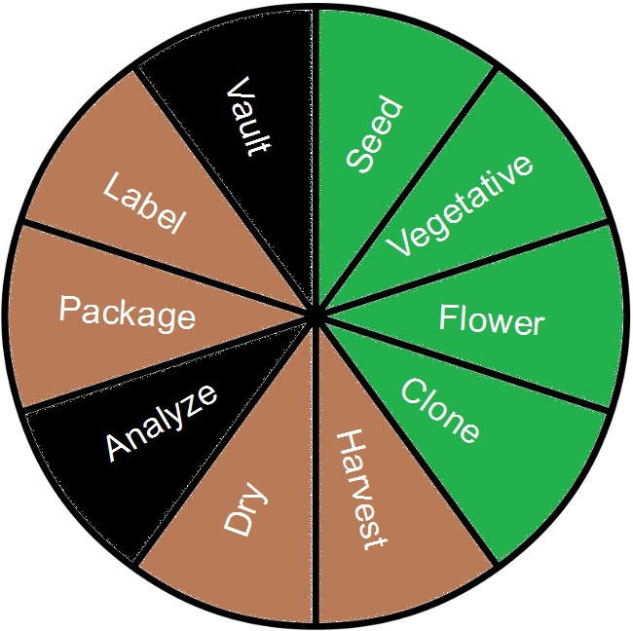

- The Benchmark Labs SYSTEM records, manages and monitors the entire life cycle of both Raw and Produced Medicinal Marijuana that is cultivated, harvested, packaged, labeled, stored, shipped, returned or destroyed at the Licensed Location.
- This is managed by the Benchmark Labs SYSTEM “Product” Module as described below. However, as Raw and Produced Product is likely to be stored differently depending on the stage of its life cycle and the Zone in which it is kept, individual SOP's have been developed to provide step-by-step instructions based on life cycle stage and Zone:
PLEASE NOTE: That all Storage Procedures for specific MMPR Zones shall require that any Medicinal Marijuana related debris or trash that is is found shall be retrieved and placed into a Debris Bag and recorded directly into the Benchmark Labs SYSTEM – as such, it can NEVER be disposed of in the garbage as would NON-Medicinal Marijuana debris or trash.

The Quality Assurance Manager shall:
- Ensure all employees are following proper hygiene requirements when they report to work as per auto-workflow check sheet issued by SYSTEM.
- Non-conformance to this SOP to be followed by Quality Assurance Manager up using the SYSTEM Trouble Ticket Module as necessary.

REFERENCES:
Author | Document Name | Published
Benchmark Labs | SOP0004 Storage | June 2014

