
THIS DOCUMENT IS OBSOLETE ON DATE OF PRINTING
QAPSOP8888 | ^{TITLE: COMPLAINT} | ^{Issued Date: March 5, 2015}
^{Supercedes:} New | ^{TITLE: COMPLAINT} | ^{Effective Date: March 5, 2015}
^{Initiator[s]: Ryan Pincura}  ^{& Zach Yim} |   ^{Signature:} | ^{Date:March 5, 2015}
^{Reviewer:} | ^{Signature:} | ^{Date:March 18, 2015}
^{QA Approval:} | ^{Signature:} | ^{Date: March 18, 2015}

- REVISION HISTORY:
Version # | Description of Changes | CC #
0 | New document

DOCUMENT OWNER: Quality Assurance Manager

AFFECTED PARTIES: All site staff who receive feedback from Patients, Doctors or outside sources in relation to any Produced Inventory Sold or who themselves have a complaint regarding any matter involving the day to day operations of the Licensed Producer.

PURPOSE: To provide a Procedure for the receipt, collection of information, management of complaint, determination of severity of complaint, referral to QAPSOP9999 Recall process if required, recording of information for subsequent annual, bi-annual or immediate report to Quality Assurance Manager, Senor Executive Staff and / or Minister of Health as well as to provide for a mechanism to ensure compliance with ISO 17025(2005) continual improvement commitments.

DEFINITIONS:
- Complaint: Any feedback received directly or indirectly from any party concerning Produced Inventory Products that have been sold by the Licensed Producer.
- Complainant: Any person who the complaint has impacted and therefore does not just mean the person making the complaint but any other person who may be negatively impacted by the subject matter of the complaint.
- Case Report: A Trouble Ticket that is opened or otherwise automatically generated by the SYSTEM.
- Corrective Action Report or CAR: The information provided in the “Solution: field of the Trouble Ticket.
- Adverse reaction: Any noxious and unintended response to dried Marihuana
- Serious adverse reaction: A noxious and unintended response to the dried Marihuana that requires inpatient hospitalization or a prolongation of existing hospitalization that causes congenital malformation, that results in persistent or significant disability or incapacity, that is life threatening or that results in death.
SCOPE: This Procedure applies to any and all Complaints
KEY WORDS IN SYSTEM: Complaint, recall, rapid recall, corrective action, corrective action report, CAR, QAPSOP8888, QAPSOP9999, continual improvement.
REGULATORY REQUIREMENTS:
- Chapter 11-850, Hawaii Administrative Rules, entitled "Medical Marijuana Dispensaries"

TRAINING REQUIREMENTS: Read, understand and demonstrate proficiency training (PT) as indicated in the SYSTEM User Profile Record.

RELATED REQUIREMENTS: Read, understand and be familiar with the following related documents: QAPSOP9999

AUTO-GENERATED WORKFLOW(S) REQUIRED TO RECORD LOG:
- WKFL0001: Assign Authorized User, Project Task, Record Date / Time Completed
- QAP0001: Assign Authorized User, Inspection Log, Record Date / Time Completed
- CAR0001: Description of Trouble Ticket auto-generated and emailed to QAP
MATERIALS REQUIRED:

- The Benchmark Labs SYSTEM is the primary tool required for this SOP.
SAFETY REQUIREMENTS:

- Depending on the nature of the Complaint refer to SOP0006

GENERAL RULES AND GMP REQUIREMENTS:

- Any Licensed Producer staff member can receive a complaint and open a Trouble Ticket in the SYSTEM to commence this procedure. However, only the QAP is authorized to investigate, evaluate and report the findings of any open Trouble Ticket relating to a Complaint.
- Complaints are to be entered directly into the SYSTEM as close to receipt of the complaint as possible. Therefore, complaints by email, phone, or in person should be recorded in the SYSTEM as soon as they are made.
- Complaints that are recorded on paper and hand delivered to the QAP, or that are only verbally communicated to the QAP, are not acceptable and must instead be entered in compliance with paragraph 2 above.

- All complaints are confidential and must be treated in accordance with the confidentiality document signed as between the Licensed Producer and Staff. Discussion of complaints outside the Licensed Location to non-staff members or members of Health Canada are not permitted unless otherwise required by law.
- Once a complaint has been directly entered into the SYSTEM, the QAP is the only person to make further communication with the complaining party, unless the complaint is itself regarding the QAP, in which case only the SPIC or RPIC are authorized to make any further communication with the complainant.

COMPLAINT PROCEDURE:
- Complaints may be presented to the Licensed Producer in a variety of forms, including via Telephone, SMS Text, Email, Web Form Submission, Word of Mouth, News Agency, etc. What is important is to ensure that any perceived complaint, as defined above, is properly recorded into our SYSTEM.
- At the root of our SYSTEM for handling any complaint is our Trouble Ticket Module. This Module is designed to record, track, resolve and report on the progress of any complaint as well as to provide for an historical audit, and summary report of all Complaints in our SYSTEM, which can later be used by the QAP, SPIC or RPIC to determine the issues that are causing the most problems at the Licensed Location.
- The following Flow-Chart highlights how each source of complaint is managed through our SYSTEM both to and from our Trouble Ticket Module:
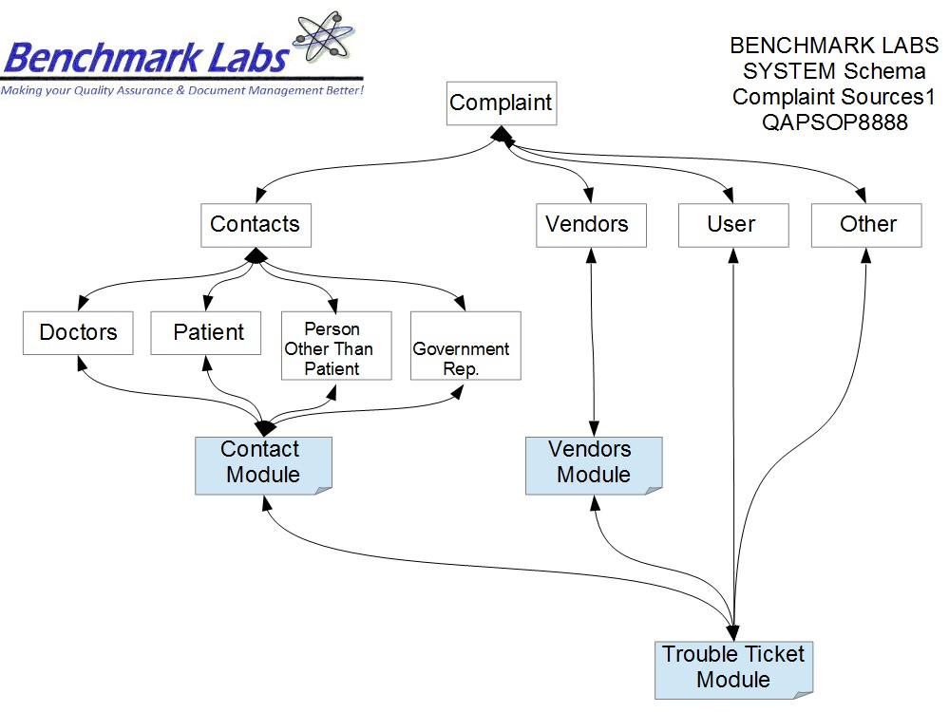
- The following Flow-Chart outlines our QAPSOP8888 procedure:
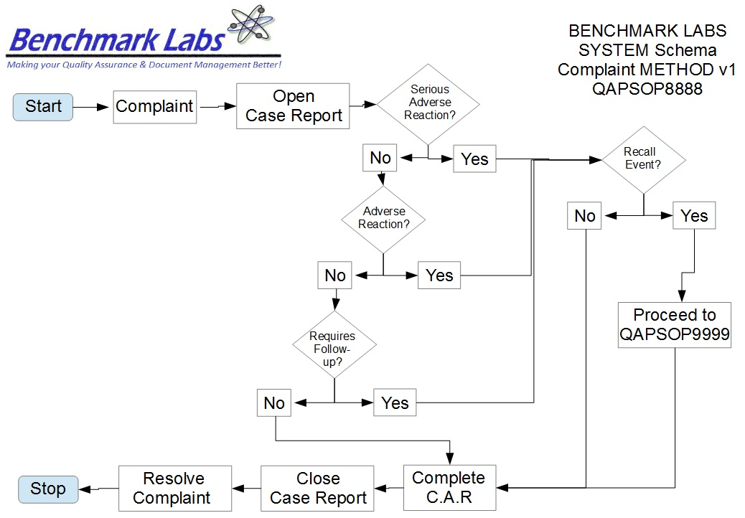
- Depending on the selection of Modules that have been chosen by your SPIC to show on your main tool bar, the presence of the Trouble Ticket module will either be on the tool bar itself or found under the heading “More” as shown below:
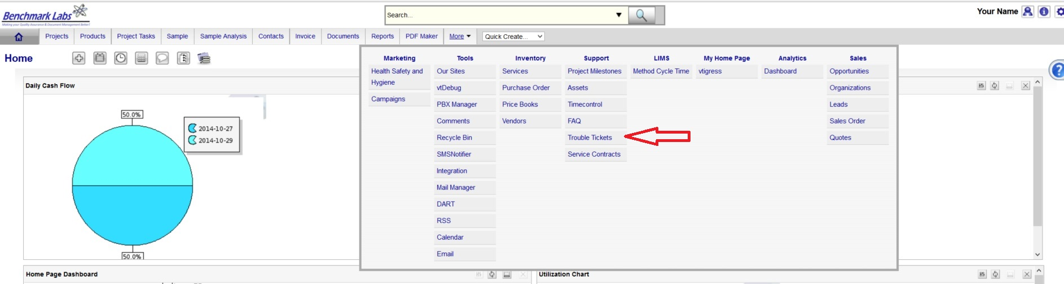
- To open a new Trouble Ticket directly from the Trouble Ticket Module, click on Trouble Ticket, then click on the “+” symbol shown below:
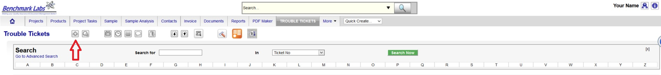
- However, as each Trouble Ticket should be connected to either a Contact, an Organization, a Project, a Project Task, a Product or any other specific activity, you can open Trouble Tickets directly from the module related to the Complaint. For example, were you to receive a complaint directly from a patient regarding a Product (e.g. From John Doe) you would want to record that Trouble Ticket under the Contact John Doe. To do this open the Contact and then click on the “More Information” tab as shown below:
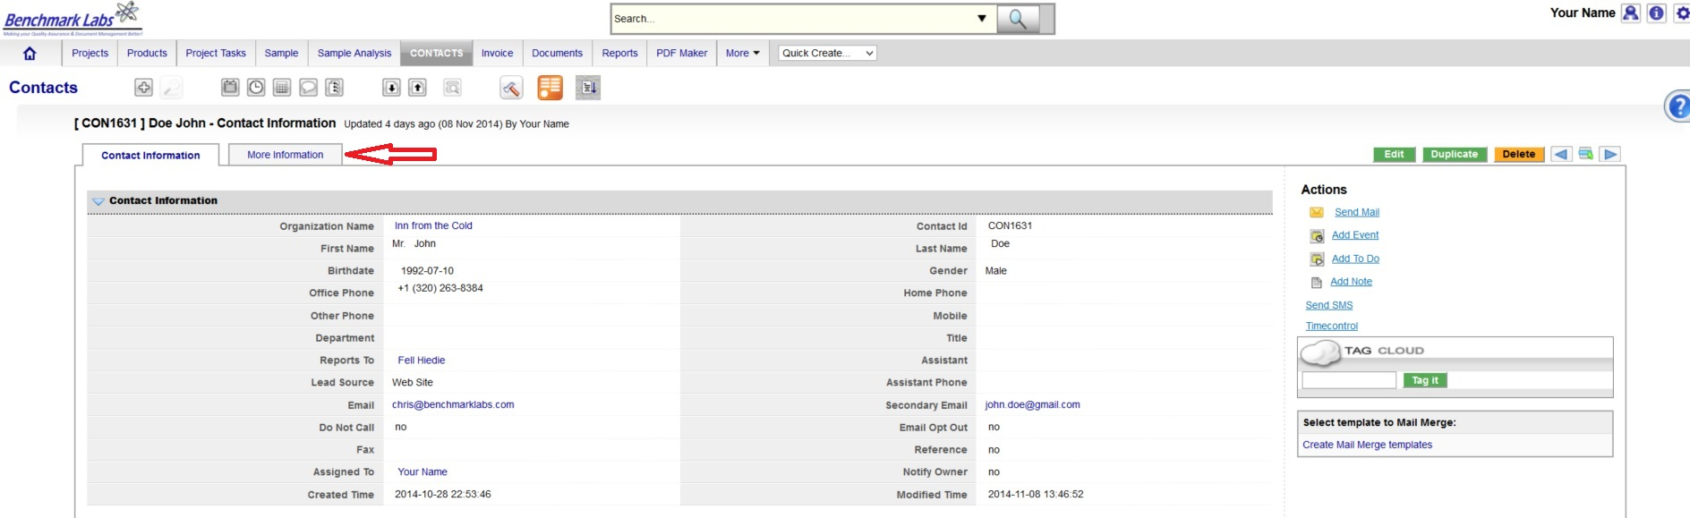
- Then Click on the “Add Trouble Ticket” button as shown below.

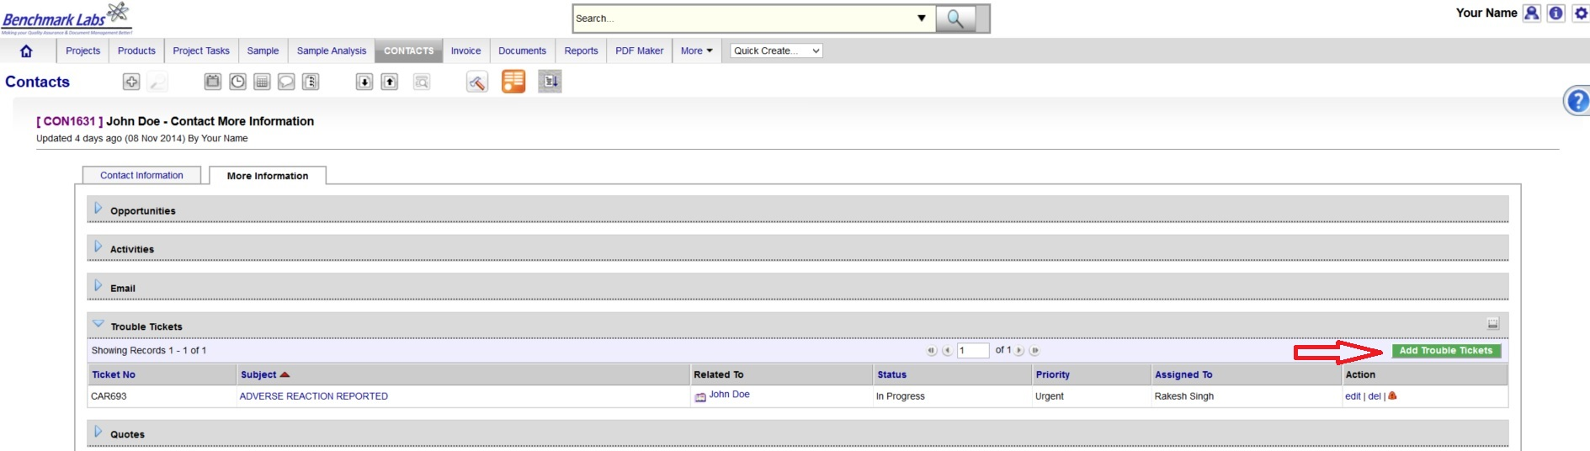
- If the complaint is regarding the Project itself, open the Project Module and then open the “Trouble Ticket” section and click on the “Add Trouble Ticket” button:
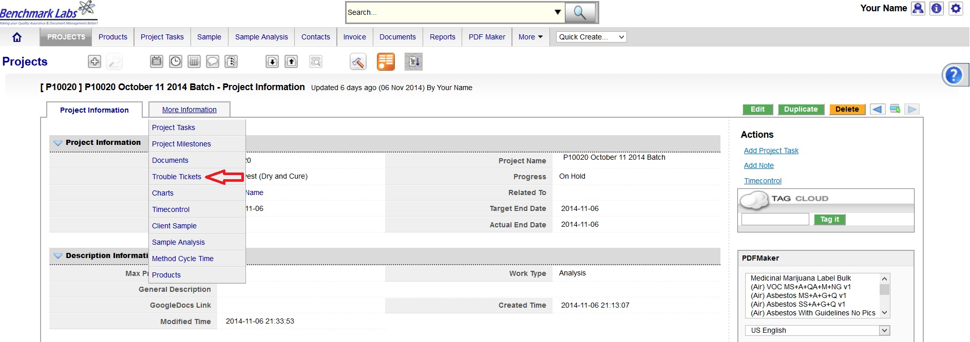
- If the complaint is regarding the Product itself, open the Project Module and then open the “Trouble Ticket” section and click on the “Add Trouble Ticket” button:

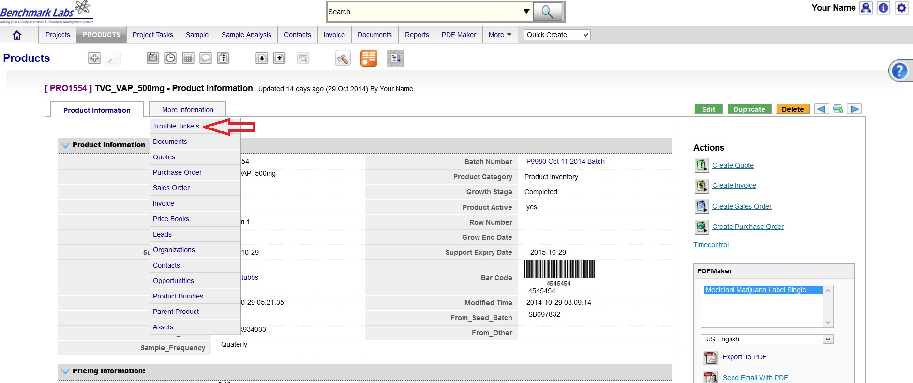

- Once the “Trouble Ticket” is open, proceed to enter the required information referencing “Title”, “Priority”, “Severity”, Category”, and “Description”. All Trouble Tickets shall be “Assigned To” the QAP for your Licensed Facility, and “Created Time” as shown below:

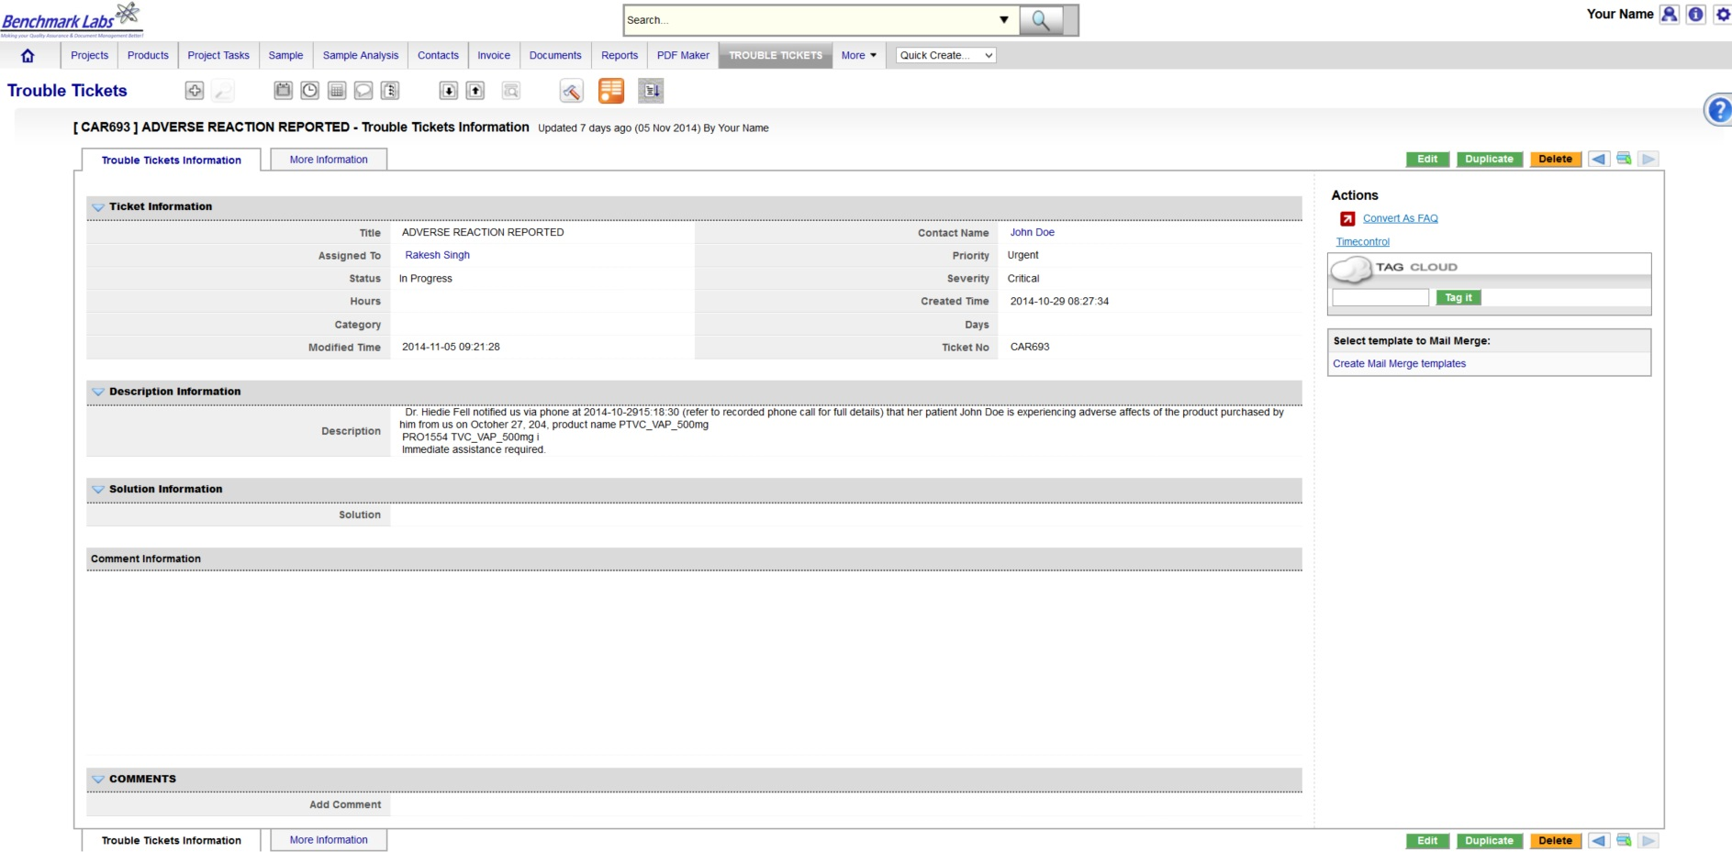
- PLEASE NOTE: MMPR regulations have defined what constitutes an “Adverse Reaction” and a “Serious Adverse Reaction”. These definitions are provided at the beginning of this Procedure. In the event that you have confirmed that this Complaint is either involving an “Adverse Reaction” or a “Serious Adverse Reaction” you must modify the Priority to “Urgent”, “Severity” to “Critical” and include the term “Adverse Reaction” in the “Title” of the Trouble Ticket.
PLEASE NOTE: that if the “Title” of the Trouble Ticket includes the words “Adverse Reaction” then the SYSTEM will auto-generate e-mails to the SPIC, RPIC and A/RPIC's including the QAP notifying them of the Trouble Ticket and requesting there review / participating in resolving this issue. Here is an example of the auto-email sent directly from the SYSTEM:
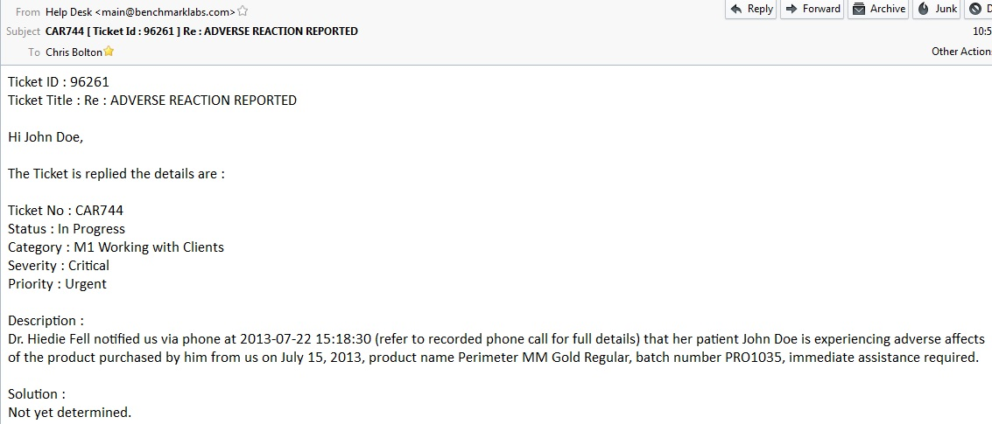
- PLEASE NOTE: To initiate the auto-generation of a Project that then provides pre-sent Project Tasks to determine the proper steps to initiate and complete a Rapid Recall event, you will need to select the Trouble Ticket “Severity” to “Recall” and click the “Save Button” - this will then auto-initiate the Rapid Recall procedure as described in QAPSOP9999.
Once a Trouble Ticket has been opened, if in the event that the Complaint will require a product review, you will want to determine what Batch / Lot of Produced Inventory this particular complaint is related to.

- If this is related to a Contact Complaint, go to Contact, and click on the More Information Tab to find the Invoice Section:
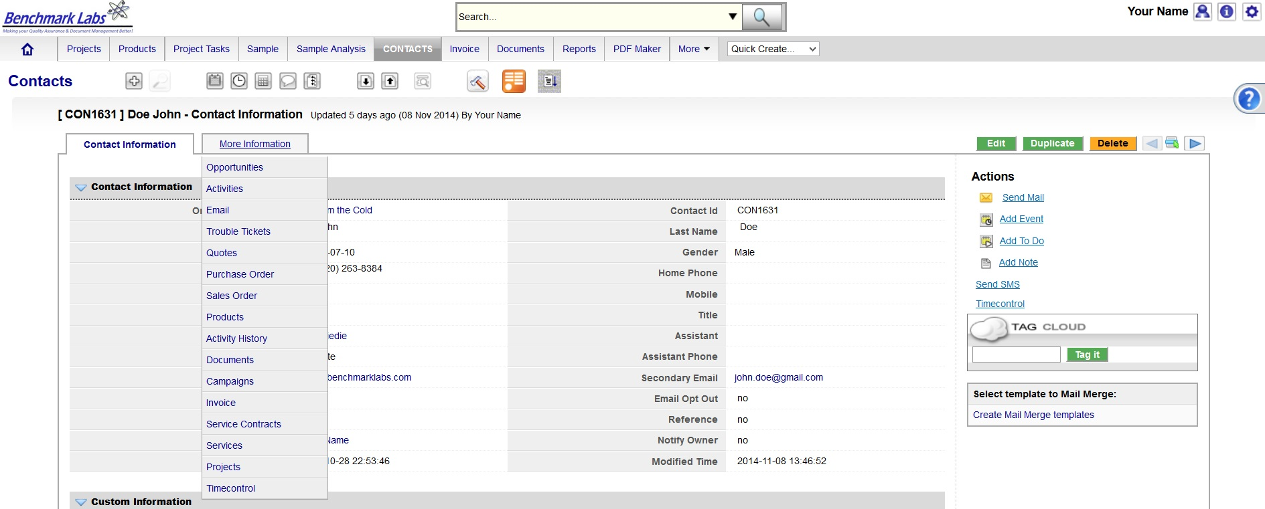
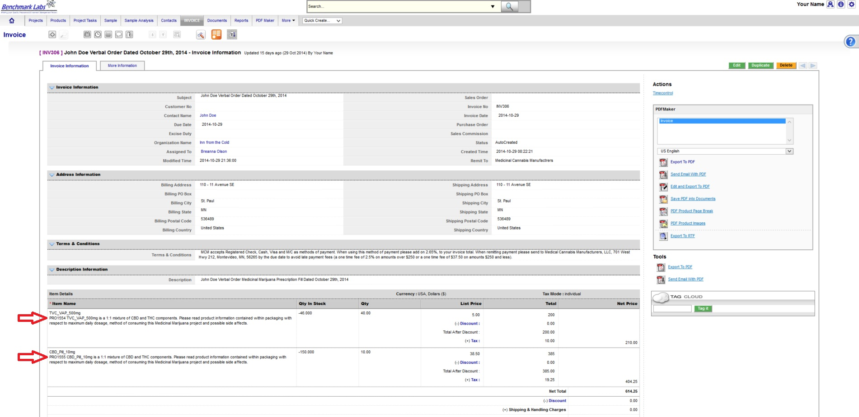
- Under More Information click on “Invoice” to open and then determine which Invoice is in relation to this Complaint and click to open the Invoice:
PLEASE NOTE: All Batch / Lots in the SYSTEM are labelled as “PRO” (which stands for Product) followed by a unique set of numbers, ensuring that this product is unique to this SYSTEM. Record the Batch / Lot Number that is associated with this Complaint directly into the Trouble Ticket:
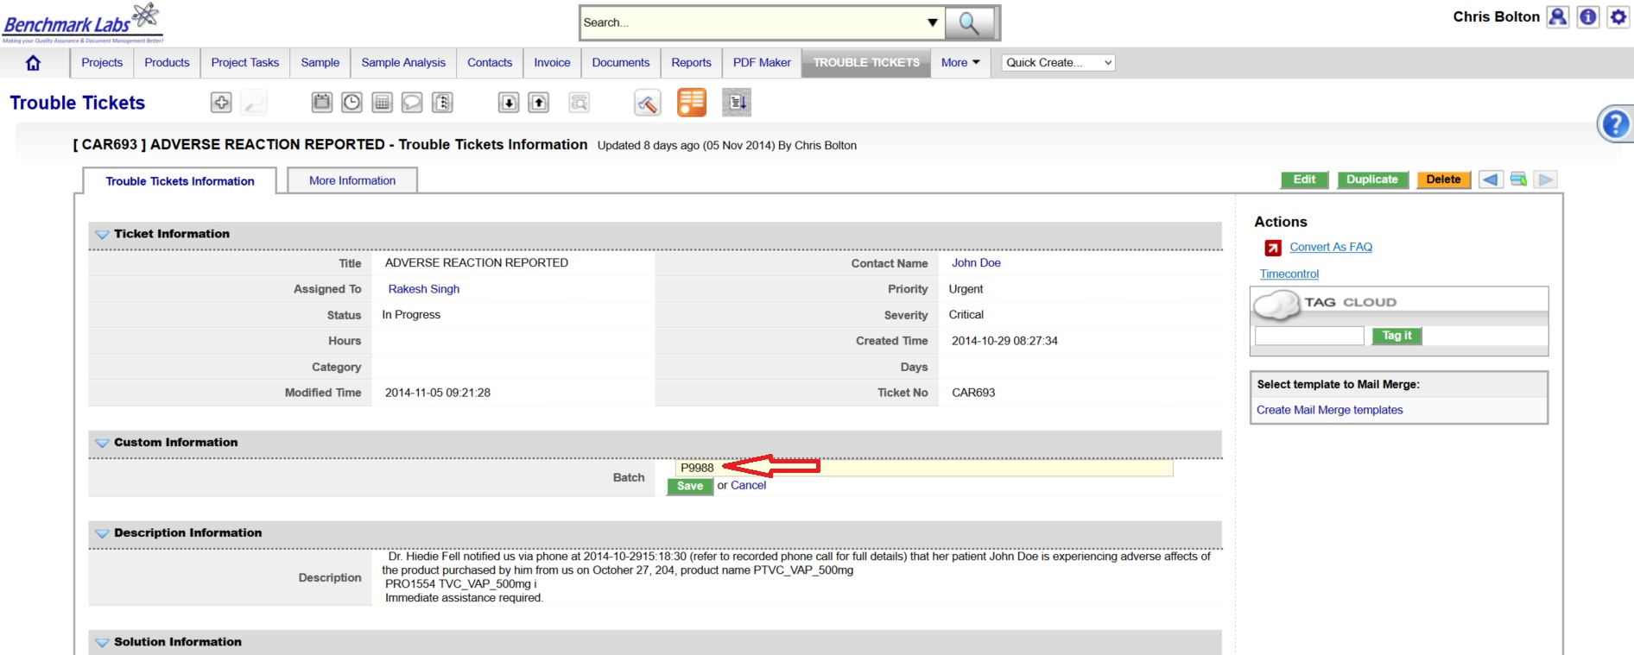
- Once you have completed the investigation of this Complaint and / or Rapid Recall event, then proceed to confirm and record the “Solution” in the “Solution Information” section of the Trouble Ticket and record any special comments in this regard:
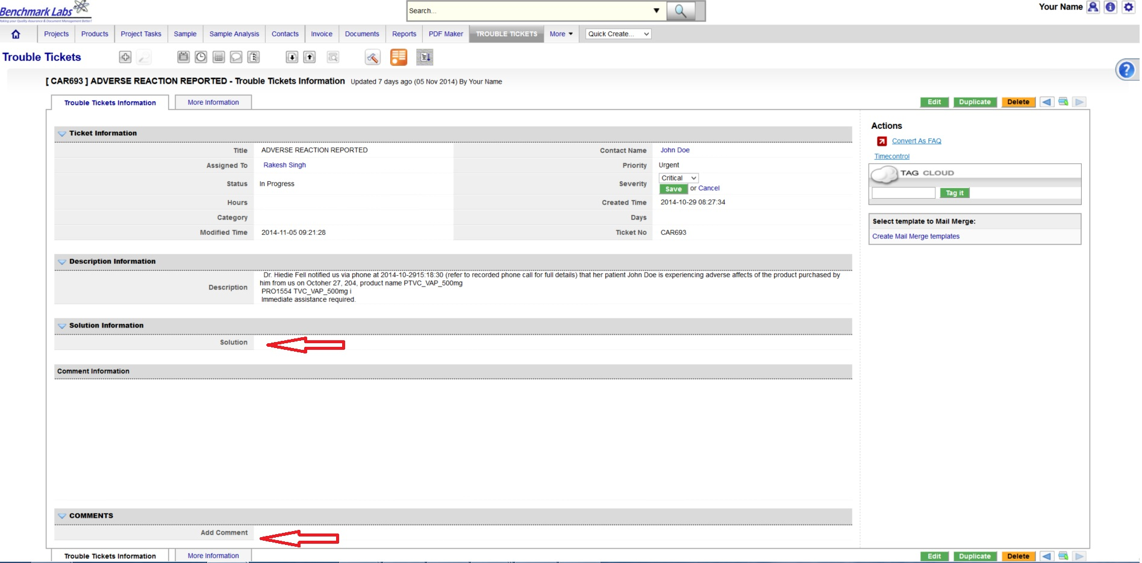

- If this Trouble Ticket is to be used for further training, or to provide useful future information for all users of the SYSTEM to see (including Contacts who have access to Customer Portal) then you can convert this Trouble Ticket to also record this information as a Fact and Question (FAQ) simply by clicking on the FAQ button found under the Actions module highlighted below:
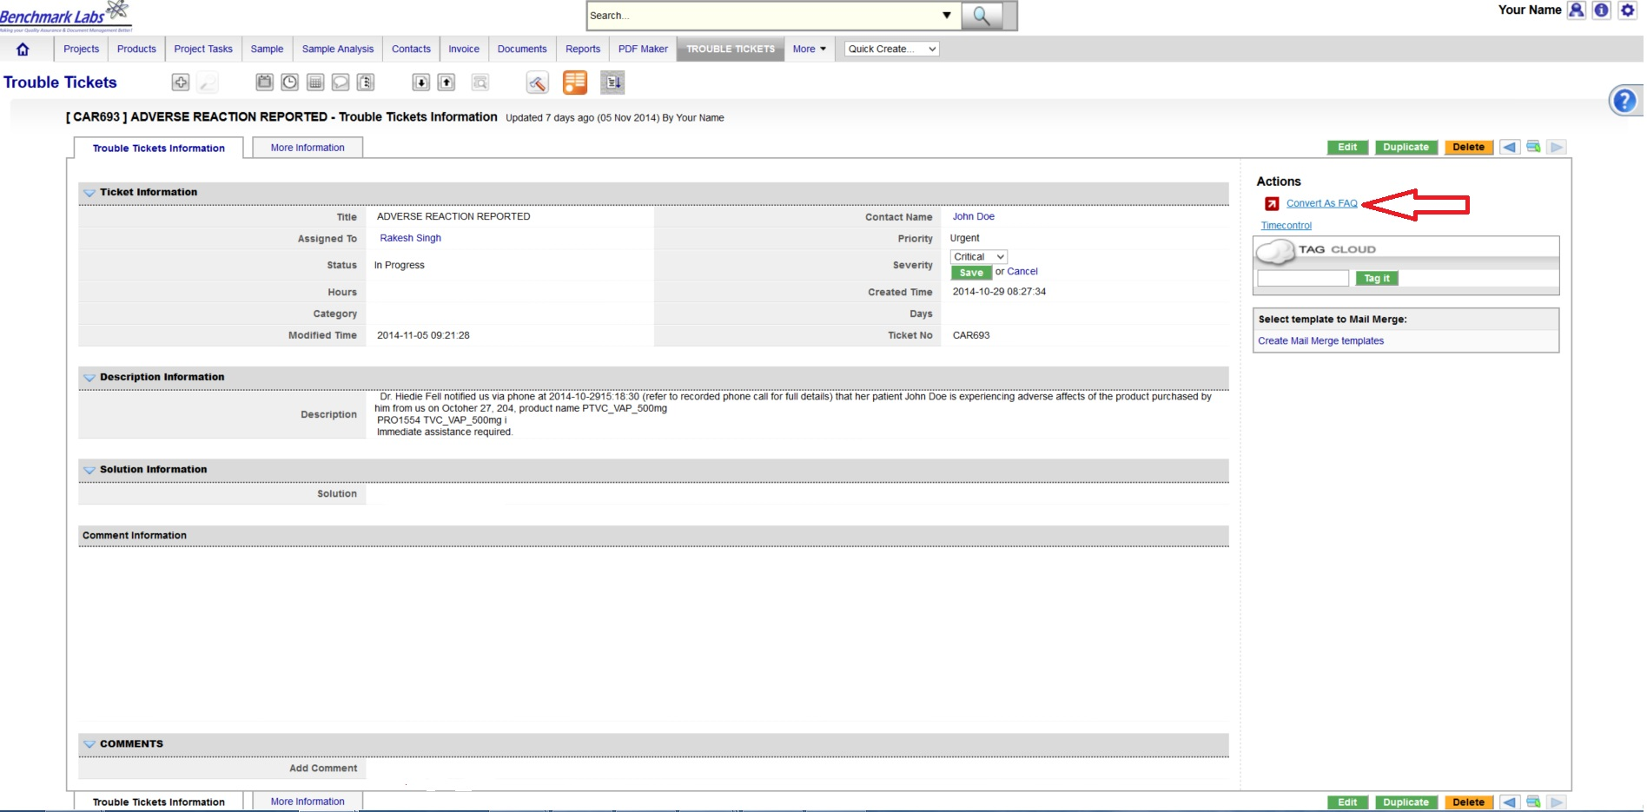
- To access the General List of Trouble Tickets to determine their status click on the Trouble Tickets Module. Trouble Tickets can then be further found either by scrolling each page of Trouble Tickets (listed 50 per page) or by entering key words into the “Search for” field and clicking “Search Now” or by entering key words into the universal “Search” field found on the top tool bar:
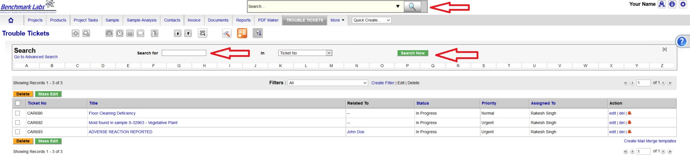
- To access Reports including Summary and Interim Reports regarding Trouble Tickets please refer to the “Trouble Ticket Reports” area of the Report Module as shown below:

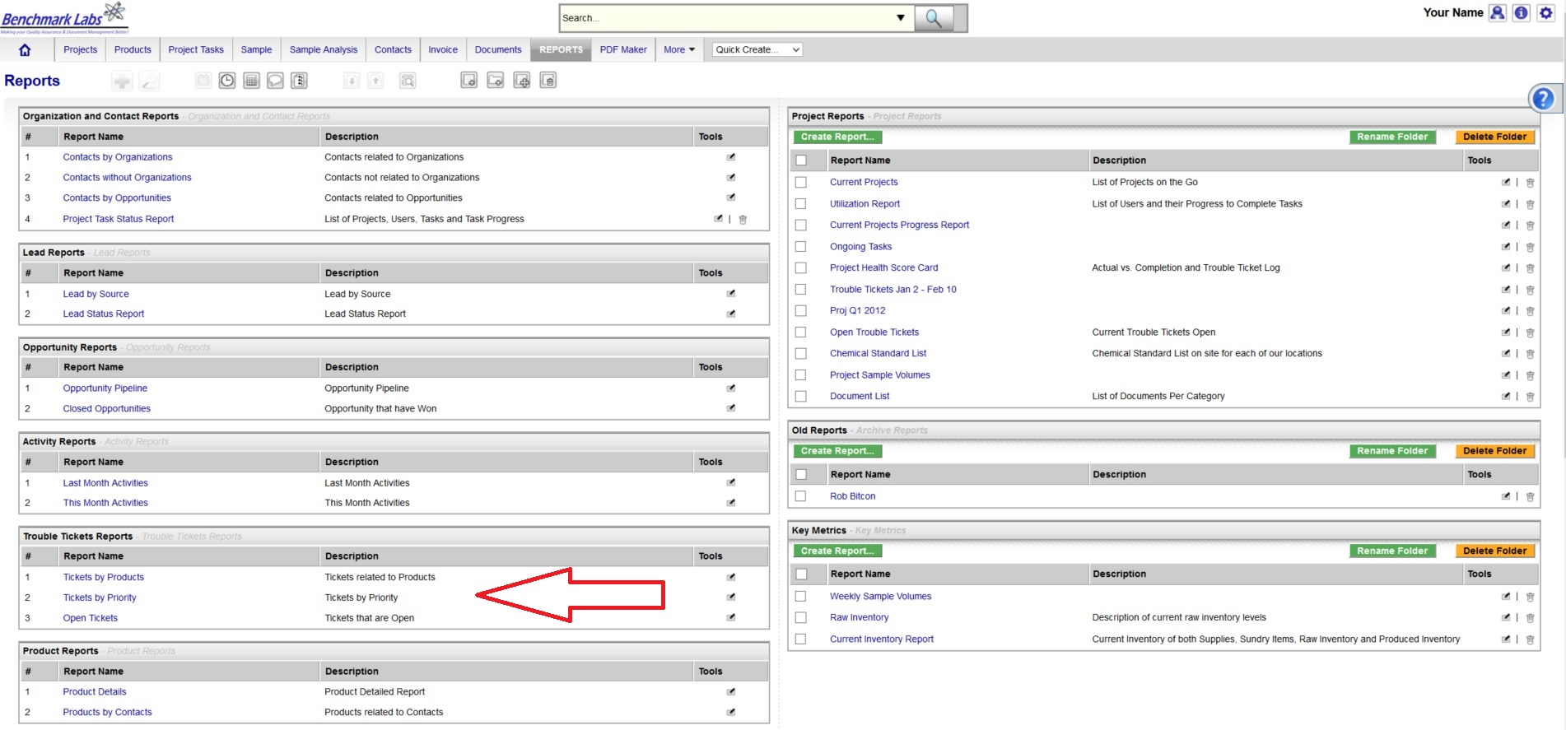
- PLEASE NOTE: Summary Reports, Interim Reports relating to Recall Events as well as Annual Reports relating to all Complaints are to be provided to the Health Minister in compliance with Section 63 of the MMPR. The SYSTEM is set to generate these reports automatically and to automatically send them by email to the Health Minister. However, it is the responsibility of the QAP to ensure the accuracy and completeness of these Reports as well as to confirm that they were received by the Health Minister.

REFERENCES:

Author | Document Name | Published
Benchmark Labs | QAPSOP8888 | June 2014

