
THIS DOCUMENT IS OBSOLETE ON DATE OF PRINTING
SOP-1100 | TITLE: SEED/MOTHER ROOM CLEANING | ^{Issued Date: January 24, 2016}
^{Supersedes:} Revision # 0 | TITLE: SEED/MOTHER ROOM CLEANING | Effective Date: January 24, 2016
Initiator[s]: Ryan Pincura & Zach Yim | 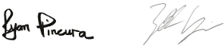  ^{Signature:} | ^{Date: January 24, 2016}
^{Reviewer:} | ^{Signature:} | ^{Date:}
^{QA Approval:} | ^{Signature:} | ^{Date:}

- REVISION HISTORY:
Version # | Description of Changes | CC #
0 | New document
1 | Add signatures, update frequency of seed/mother room

DOCUMENT OWNER: Quality Assurance Person (QAP)

AFFECTED PARTIES: All site staff who utilize the on-site Seed/Mother Room at the Licensed Location.
PURPOSE: To provide a Procedure for the cleaning of the on-site Seed/Mother Room, as well as to confirm a Procedure for Confirmation and Verification for the QAP that the assigned tasks have been performed correctly.

DEFINITIONS:
- Assigned User: The person authorized to perform Project Tasks within the Benchmark Labs SYSTEM.
- GREEN ZONE: The MMPR area in which the Seed/Mother Room is situated at the Licensed Location.
SCOPE: This Procedure applies to the Cleaning of the Seed/Mother Room within the Green Zone at the Licensed Location.
KEY WORDS IN SYSTEM: Seed/Mother Room, cleaning, MMPR Zone, Green Zone, Section 55, Section 57.
PROCEDURE PROCESS FLOW:
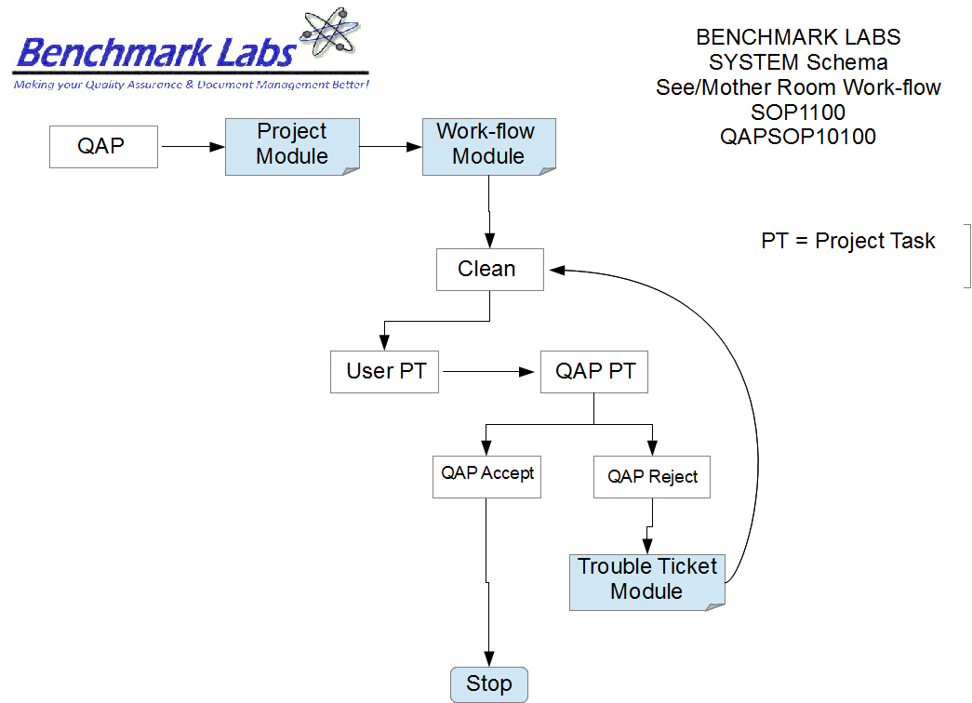


USER PERFORMANCE TASKS (PT) TO CLEANING SEED/MOTHER ROOM:

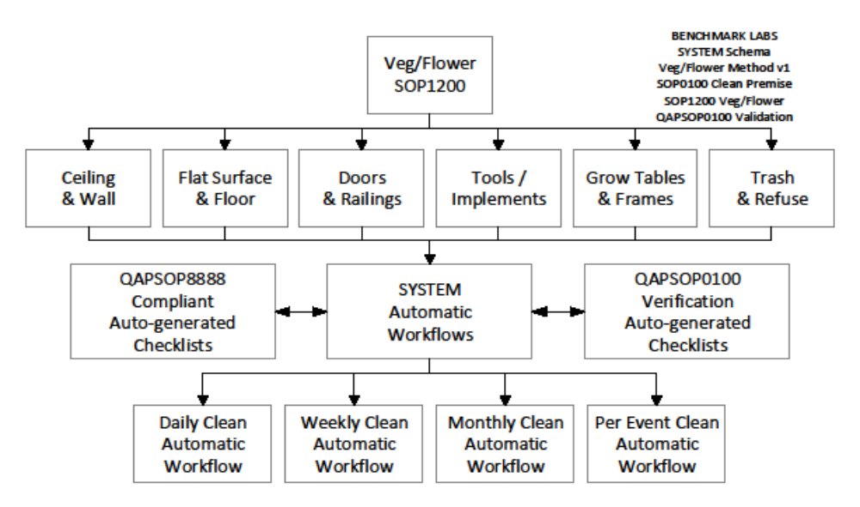

GENERAL RULES AND GMP REQUIREMENTS:
- Only Medicinal Marihuana Licensed Location SPIC, RPIC and designated A/RPIC's are authorized to clean the Seed/Mother Room.
- Only the QAP is authorized to confirm and verify that Cleaning Project Tasks, as outlined below have taken place in the Seed/Mother Room.
- Mothers are not to be moved from the Seed/Mother Room without express permission from the QAP or other authorized personnel.

- SPIC and RPIC are responsible for responding to alarms or concerns of unauthorized access to the Seed/Mother Room, and overseeing that maintenance procedures of the Seed/Mother Room are carried out.

- The QAP is responsible for updating lists and procedures with respect to cleaning the Seed/Mother Room.
- Ensure that ALL mops, dusters, cleaning supplies for the Seed/Mother Room are designated as Green Zone, and that no other Zone mops, dusters, cleaning supplies are being utilized.
- Ensure that all surfaces are cleaned from top to bottom, towards drains, and away from active areas.
- Ensure that all wiping materials are clean prior to use, and changed frequently during use.
- Ensure that the proper cleaning solution is used with the appropriate wiping material on surfaces, growing equipment, and lighting.
- Refer to the appropriate Manufacturer’s Instruction Document for confirmation of cleaning directions. All Equipment Documents are to be kept as electronic documents and stored within the Benchmark Labs SYSTEM.
- The Benchmark Labs SYSTEM shall provide a list of Cleaning Project Tasks to be performed by an Assigned User on a Daily, Weekly, and Per Event basis.
- The Assigned User shall record the progress of each assigned Project Task in the Benchmark Labs SYSTEM as required by SOP0001 Clean Premise.
- The QAP shall determine the list of cleaning agents to use, and record those cleaners in the “Product” Module of the Benchmark Labs SYSTEM.
- The QAP is required to confirm these Project Tasks are complete as per QAPSOP0100.

REGULATORY REQUIREMENTS:
- Marihuana for Medical Purposes Regulations, Section 55 Division 4 Good Production Practices, October 2013).

TRAINING REQUIREMENTS: Read, understand, and demonstrate proficiency training (PT) as indicated in the SYSTEM User Profile Record.

RELATED REQUIREMENTS: Read, understand, and be familiar with the following related documents:
- SOP0001 Cleaning Premise
- SOP0002 Cleaning Equipment
- SOP4100 Storage Seed and Mother Room
- QAPSOP0100 QAP Confirm and Verify

AUTO-GENERATED WORK-FLOW(S) REQUIRED TO RECORD LOG:
- WKFL0001: Assign Authorized User, Project Task, Record Date/Time Completed
- QAP0001: Assign Authorized User, Inspection Log, Record Date/Time Completed
- CAR0001: Description of Trouble Ticket auto-generated and emailed to QAP
MATERIALS REQUIRED:
- Wireless device to log-in to Benchmark Labs SYSTEM.
- Food grade Nitrile Gloves, Clean Suit, Boots, Boot Covers, Hair Net, and Protective Eye Wear (all of which must be from their specific designated zone).
- Cleaning Agent (must be of food grade quality and designed for food production facilities as designated and approved by the QAP and as recorded in the Benchmark Labs SYSTEM).
- Correct Cleaning Kit – a minimum of 1 Cleaning Kit per Zone as defined below:

Buckets:
There are three types of bucket systems used within Site. These are the single, double, and triple bucket system:
Double and Triple Bucket System. This is a trolley holding two large buckets. Over one bucket is suspended a mop squeezer, which is considered the "dirty" bucket. The other bucket, ("clean" bucket) accommodates the clean floor cleaning/disinfecting solution. The buckets shall be cleaned on a daily basis and the mop head and solution changed on a daily basis. The mop shall remain in the clean bucket when not in use. These buckets are the only type that shall be used within the Medicinal Marihuana area and shall be dedicated to each particular colour zone area as described above.

Mops: Cotton mops with a plastic or anodized aluminum handles are used in each of the zones, and shall be dedicated to each particular colour zone area as described above.

Use only open cell hydrophilic mop heads with plastic or anodized aluminum handles. The mops shall be inspected daily by cleaning staff for any signs of shedding. These shall be processed daily, to obtain a guaranteed cleanliness level.
Mops are to be supplied in a sterile state. They are to made of fabric, and must very low in particulate and residue contamination. They are to be used once, and after use, the mop shall be put into a plastic bag and placed in the dirty Sterile garment basket on the dirty side of the change room. They are then cleaned and returned to Seed/Mother Room, again in a sterile state.

Squeegees, Dustpans
These are necessary for broken glass, but are not ideal as dust may be generated.

Vacuum Cleaners
These are preferred for picking up dust from the floor or from containers. Dry vacuums must be equipped with HEPA filtration and approved by the Cleaning Coordinator. Wet vacuum cleaners (to cope with major spills) are available on site in case of large liquid spills.

Buffers, Waxers and Floor Polishers
Floors are to be sealed and coated with an appropriate sealer (providing protection from wear and tear associated with high traffic, and the use of solvents, chemical cleaners, or other biological and/or chemical elements) then polished by machine.
SAFETY REQUIREMENTS:
- Refer to the relevant Material Safety Data Sheets for materials being used for cleaning.
- Refer to SOP0004 in relation to Storage to be used.
- Refer to SOP0005 in relation to Hygiene, Health and Clothing to be used.

CLEAN SEED/MOTHER ROOM BY ASSIGNED USER:

- Proper cleaning of the Seed/Mother Room is critical to the MMPR Licensed Location Operations. All Medicinal Marihuana grown in the facility is linked to the mother plants, and keeping them clean and free of infection is imperative. Contamination of the Seed/Mother Room, or the presence of any extraneous substances that may otherwise negatively impact proper growth of the plants is not acceptable and deemed a serious non-compliance. Therefore, particular care must be taken with respect to the Daily, Weekly and Per Event cleaning events. To ensure that scheduled cleaning events are correctly assigned to Users of the Benchmark Labs SYSTEM, are conducted at the appropriate time, are completed within the appropriate period of time, and are recorded to notify the QAP to confirm and verify that this has been properly performed the Benchmark Labs SYSTEM shall auto-generate Project Tasks to Assigned Users to notify them of these Project Tasks:
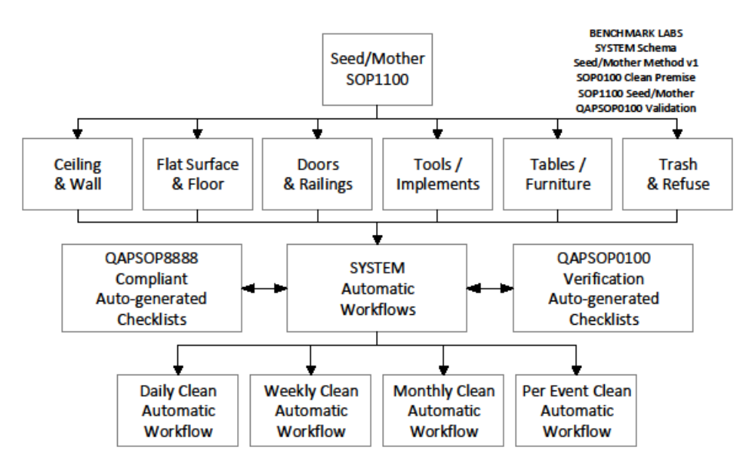
PLEASE NOTE: That all Storage Procedures for specific MMPR Zones shall require that any Medicinal Marihuana related debris or trash that is found shall be retrieved and placed into a Debris Bag and recorded directly into the Benchmark Labs SYSTEM – as such, it can NEVER be disposed of in the garbage as would NON-Medicinal Marihuana debris or trash.

ASSIGNED USER FREQUENCY OF SEED/MOTHER ROOM:
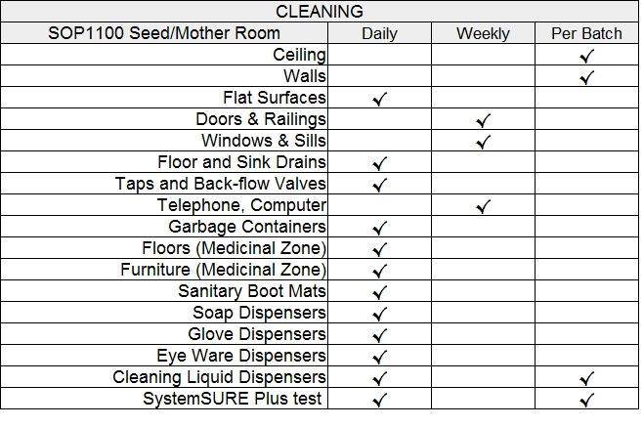

Assigned Users are required to follow the cleaning schedule as outlined above.
NOTE: Cleaning shall be Verified by the QAP as required to do so by SYSTEM Work-flow Cleaning Verification Schedule and Corrective Action Report (CAR) Work-flows

- The Benchmark Labs SYSTEM, prior to 24 hours of its proposed “Start Date”, shall auto-generate an e-mail to the assigned User notifying them of the Project Task, the Start Date, End Date, area or room that the Task is to take place and a description of work that is to be performed:
From: Licensed Location 123145

Date: 2014-10-10

RE: Routine Cleaning of Seed & Mother Room

A Project Task has been Assigned to You

Details of the Project Task are:

Location: Seed & Mother Room
Project: P10028 SOP1100 Seed/Mother Room Cleaning
Start Date: 2014-10-10
Start Time: 00.16.30
Expected Completion Date: 2014-10-10
Expected Completion Time: 00.17.00
Allocated Time: 30 minutes
Category: QC
Zone: Green
Description: Please visit http://crm.benchmarklabs.com/ndex.php?module=Assets&parent

Thank You
Quality Assurance Manager

- The assigned User can then proceed to open the Project Task by either clicking directly on the link found in the email, or by proceeding to the Project module to open a Project Task directly (e.g. “P10028 SOP1100 Seed & Mother Room Cleaning”):
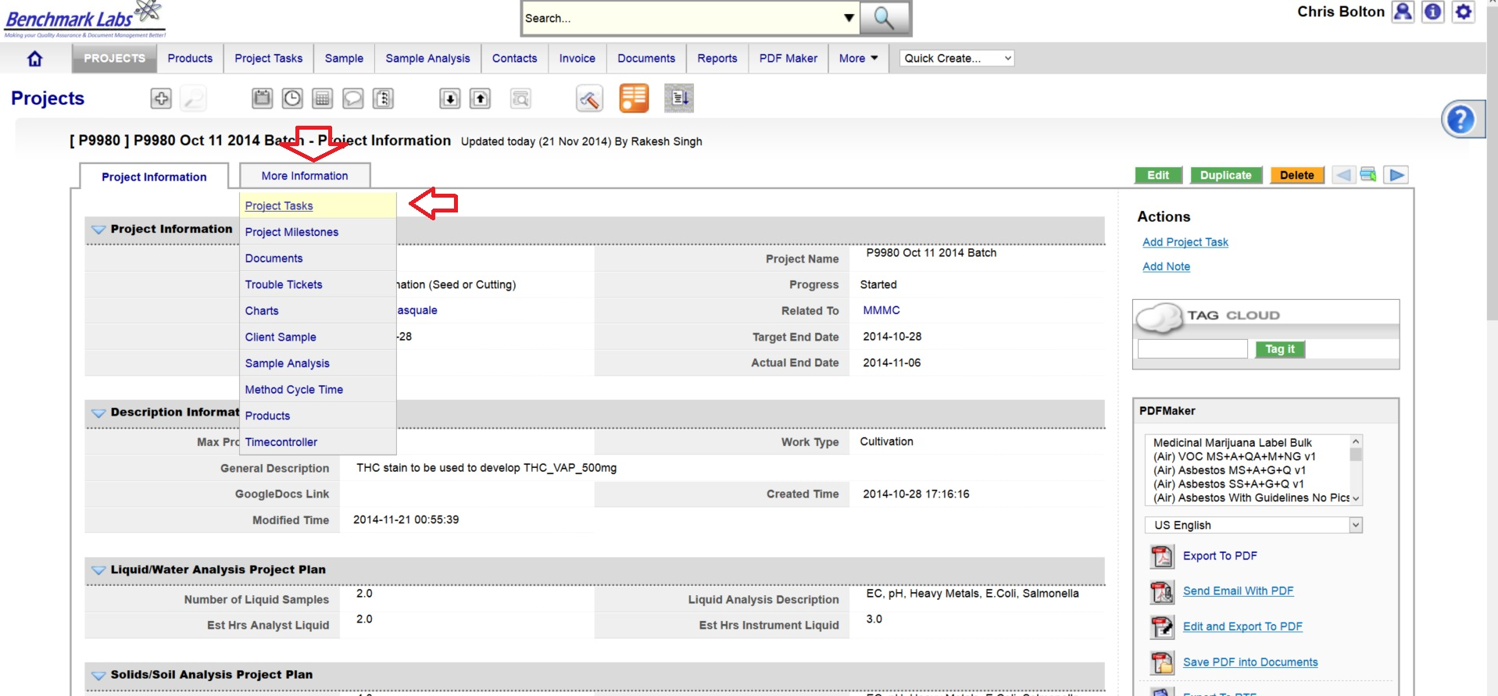
- To open a Project Task simply click on the link below the “Task Name” header:
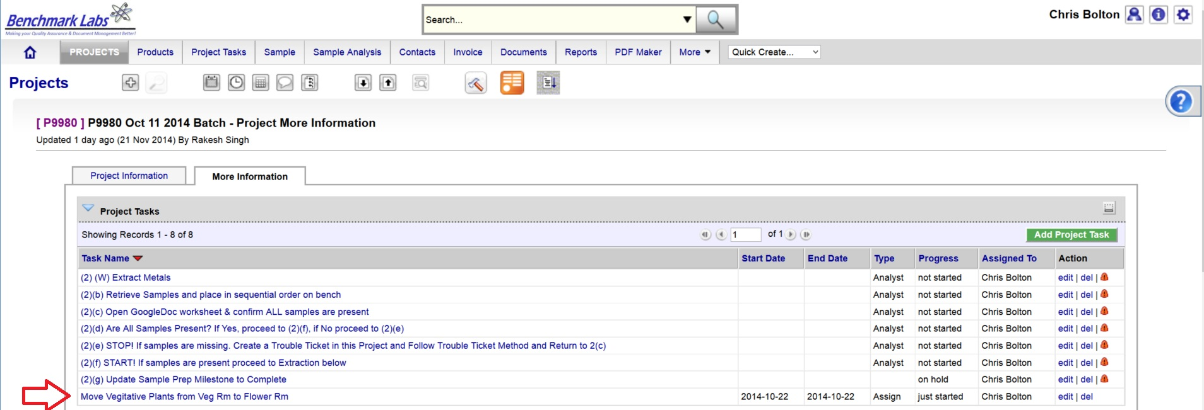
- The clock will then begin to record time spent on this Task until you hit the “Stop Button”:
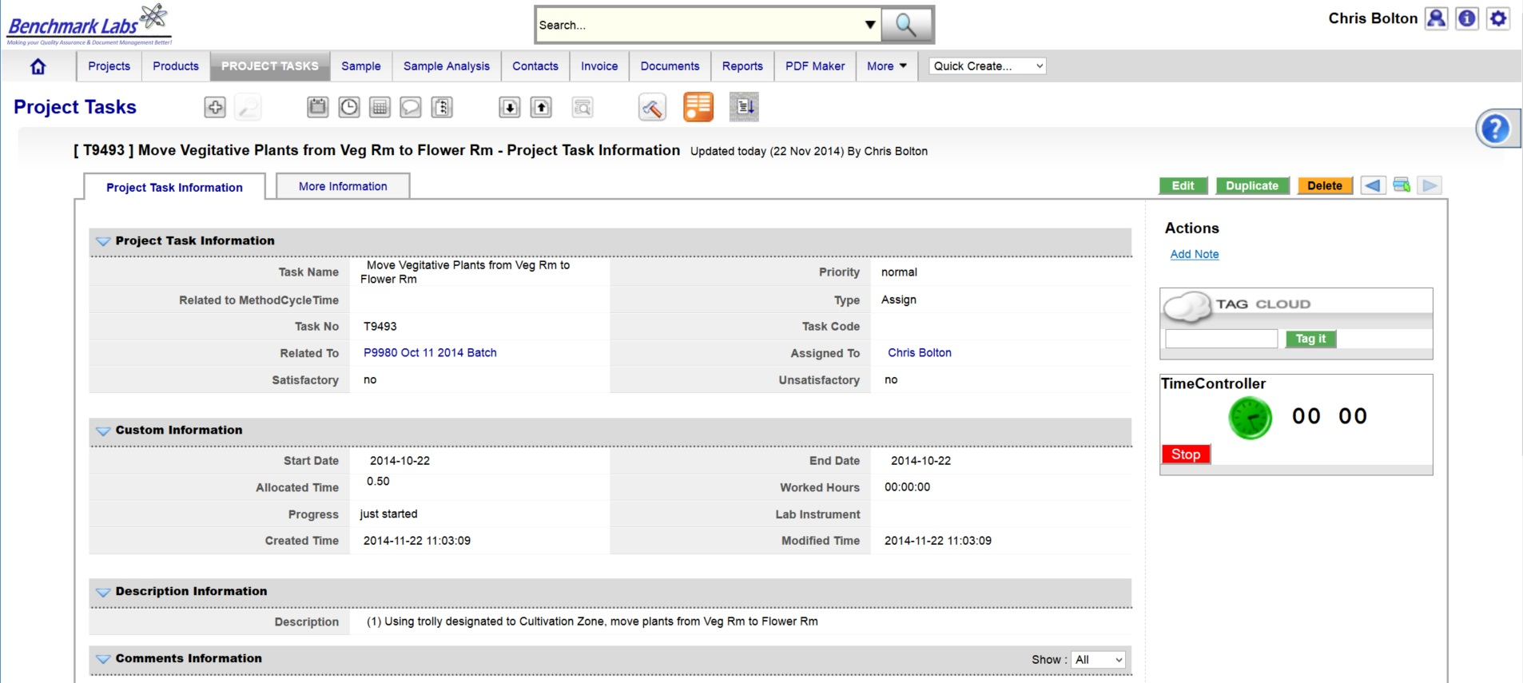
PLEASE NOTE: Once a Project Task has been opened, the Time-Controller Clock begins recording the time it takes to complete the task. If the time taken is significantly greater or less than the “Allocated Time” value, an automatic Trouble Ticket will open to request explanation for the difference in cycle time (the root cause for the variation in time taken to complete Project Task). Therefore, it is critical that you do not open the Task until you are ready to begin and to then focus on the Task until it is done by clicking on the “STOP” button beside the clock.
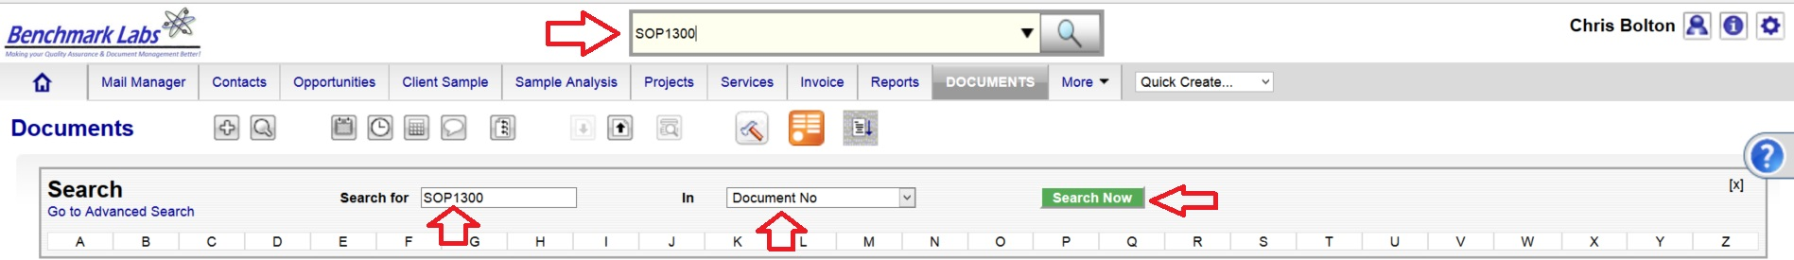
- In the event that the “Description” provided to the assigned User is not sufficient to complete the Cleaning Project Task, the Assigned User can go directly to the individual SOP Document, by using either the Universal Search Box, or the “Search for” box found in the “Document” Module:
PLEASE NOTE: These SOP documents serve multiple purposes including how to set-up, operate, maintain, repair, clean and dispose of what is no longer usable.
- PLEASE NOTE: A document in the SYSTEM can be deleted but only from the view of the average user. All documents Deleted from the SYSTEM are simply moved into “Archive” whereby they are still accessible by the SPIC and Government or Regulatory Auditor.
- Clean Ceiling Procedure:
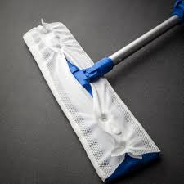
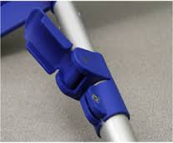
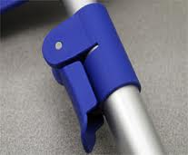
- Retrieve extension pole and adjust to your height to ensure that you can easily touch the ceiling without straining.
- Wearing Food Grade Nitrile gloves, attach a clean and sterile pad to the mop end of the pole.
- Only use Cleaning Agents assigned by the QAP and as recorded in the Benchmark Labs SYSTEM.
- Wearing eye and head protection, begin to wipe ceiling from the back of the room to the center, changing pad as required.
- It is also a good practice to systematically move from one ceiling tile row to the next in order to ensure that there are not missed sections of the ceiling.
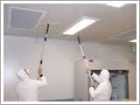
- Ensure cleaning pad is either discarded in the trash bin for disposal or in the cleaning bin for sanitizing and re-use.
- Clean Walls Procedure:
- Retrieve an extension poll and adjust it to your height to ensure that you can easily touch the top of each wall, all corners and to the floor without straining.
- Wearing Food Grade Nitrile gloves, attach a clean and sterile pad to the mop end of the pole. Obtain a secondary style hand wipe to reach into corners between ceiling and wall and wall and floor.
- Only use Cleaning Agents assigned by the QAP and as recorded in the Benchmark Labs SYSTEM.
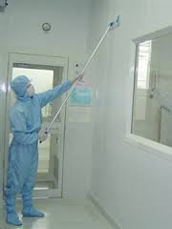
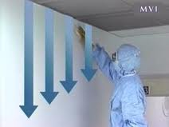
- Wearing eye and head protection, begin to wipe the walls from top to bottom, changing pad as required.
- Systematically move from the top corner of one wall to toward the bottom, then move from top to bottom continuously to the other side corner of the wall to ensure that you do not miss any section of the wall.
- Ensure that the cleaning pad is either put into trash bin or into the cleaning bin for sanitation and re-use.
Clean all Flat Surfaces Procedure:
- Remove all items, debris, dirt etc before cleaning the flat surface
- Apply cleaning solution and wipe the flat surface.
- Only use Cleaning Agent assigned by the QAP and as recorded in the Benchmark Labs SYSTEM.
- Rinse surface with clean water.

Mop and Sweep Floor Procedure:
Floor Care:
All floors are to be swept, dust mopped, wet mopped or auto-scrubbed a minimum of once a day.

Resilient Tile Floors :
When wear paths begin to develop in the finish on resilient tile floors, the floor will require “top scrubbing,” the preferred green solution that does not use toxic stripping chemicals, to remove a layer of finish, dirt and debris. The finish will then be reapplied, as all resilient tile floors are to be maintained with five coats of floor finish.

When floors cannot be restored using the top scrubbing method, a complete stripping of all wax finish is performed using a non-certified (ammonia) based finish remover. A minimum of five coats of finish will then be reapplied according to manufacturer specifications and application timeliness.
- Sweep the floor thoroughly.
- Place appropriate signage to warn of potential slipping and falling risks before mopping floor.
- Mop with a damp cloth to remove all dust and dirt from the surface.
- Use only the Cleaning Agents assigned by the QAP and as recorded in the Benchmark Labs SYSTEM.
- Buff the floor once per month or with greater frequency as needed.
- Clean all marble / tile /wood skirting with a damp cloth daily.
Clean Telephone, Keyboards, Computer Mouse, Computer Monitors Procedure (if applicable):
- Using a dry cloth, and the Cleaning Agents assigned by the QAP, and as recorded in the Benchmark Labs SYSTEM, clean and disinfect telephone mouth and ear pieces, keyboards, computer mice and computer monitors.
- Wipe these surfaces a second time, this time with a new cloth that has been dampened with deionized water.
Clean Door handles, door knobs and push plates:
- Using a dry cloth, and the Cleaning Agents assigned by the QAP, and as recorded in the Benchmark Labs SYSTEM, clean and disinfect any door handles, knobs or push plates by thoroughly wiping them with the cloth.
- Wipe each surface a second time with a new cloth that has been dampened with deionized water.
Clean all Boot Mats:
- Check Boot Mat tray and remove any large foreign materials and place them in the proper waste receptacle.
- If the Boot Mat is found to be dirty, place it in the sink for a complete cleaning.
- Replace the water in the foot bath and add Boot Mat Sanitizer, provided by QAP, ensuring that the proper level has been reached
Clean all Glass Surfaces Procedure:
- Spray windows and glass surfaces with water, or the listed Cleaning Agent assigned by the QAP and as recorded in the Benchmark Labs SYSTEM.
- Clean the surface with the tool assigned by the QAP (e.g., squeegee, cloth, etc.) and as recorded in the Benchmark Labs SYSTEM
- Using a squeegee, pull it down along the surface from top to bottom. Ensure that each stroke is slightly overlapped in order to remove all water or cleaning solution.
- Ensure that the dirty cleaning solution is routed into the proper waste system.
- Using a lint free duster, buff the glass surface so as to leave the entire surface polished.
Clean all Tools and Implements Procedure:
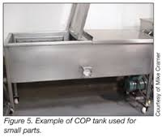
- If a 3-compartment sink is used, setup and use the sink in the following manner:
  - In the first compartment, wash tools with a clean detergent solution that is at or above 43ºC (110ºF) or at the temperature specified by the detergent manufacturer.
  - In the second compartment, rinse tools with clean water.
  - In the third compartment, sanitize tools with a sanitizing solution mixed at a concentration specified on the manufacturer’s label or by immersing in hot water at or above 77ºC (171ºF) for 30 seconds. Test the chemical sanitizer concentration by using an appropriate test kit.

Chairs and Stools Procedure:
- Furniture in the Seed/Mother Room is to be dusted, and all the upholstery cleaned using Cleaning Agent assigned by the QAP and as recorded in the Benchmark Labs SYSTEM.
- Using a clean cloth, apply cleaner as provided by QAP to wipe down each piece of furniture separately, do not use same cloth for other pieces of furniture.
Sink and Drain Procedure (with or without catch-screen):
- Sinks and drains in the floor or elsewhere must be cleaned using the appropriate cleaner assigned by the QAP and as provided to Authorized User by the Benchmark Labs SYSTEM.
- If catch-screen is installed, remove and dispose of foreign materials and place them in the proper waste receptacle.
  - Note: Alert QA/QC staff or direct supervisor if there are large amounts of product in the catch-screens.
- Pour cleaner or spray directly around the drains, into the drains, and into the sinks as prescribed by the Instruction label found on the QAP approved cleaning supply.
- Using a clean glass beaker fill with 100 ml of DI water and place Tap head into water about 5mm below surface for 2 minutes. If water level has dropped below 100 ml the back flow valve is faulty and requires maintenance. In the event of this incident, alert the QA/QC staff or direct supervisor, who will open a Trouble Ticket identifying the Tap and the issue observed.
Clear all trash bins Procedure:
- Remove garbage from waste bins and clean them if required.
- If the QAP has instructed the sorting of recyclables from trash items, and if recyclables have been placed in the waste bin, separate the recyclable items from the trash and place them in separate bins.
  - Note: Ensure that proper safety measures are taken while sorting recyclables from trash, to avoid the possibility of injury due to sharps, or contact with hazardous materials within the waste bin.
- If any non-Medicinal Marihuana related debris or trash is found in the MMPR Zone area, immediately remove it and deposit it in a designated trash bin.
- If any substantial amounts (i.e., of a mass deemed substantial by the QAP) of Medicinal Marihuana related debris or trash is found in the MMPR Zone area prior to cleaning floors, flat surfaces, walls, roof or any other surface area, alert QA/QC staff or direct supervisor to proceed with the following, unless certified to complete this task:
- Log-in to SYSTEM and go to “Products” Module:
- Create a New Product called “MM Debris,” select Product Category “Debris Inventory,” select the room and if applicable, the Row Number that the debris was found in, as well as the associated Growth Stage.
- Retrieve a designated Medicinal Marihuana Debris Bag, weigh the empty bag using a calibrated weigh balance, and record the mass in the “Tare Weight in grams” field, as well as the assigned Barcode Number on the bag.
- Fill the bag and re-weigh it on the same balance. Record the new mass in the “Gross Weight in grams” field. The “”Product Weight in Grams Field” shall now be auto-populated. Confirm that this value is equal to the Tare weight minus the Gross Weight values.
- When completed your SYSTEM Report shall then look like this:
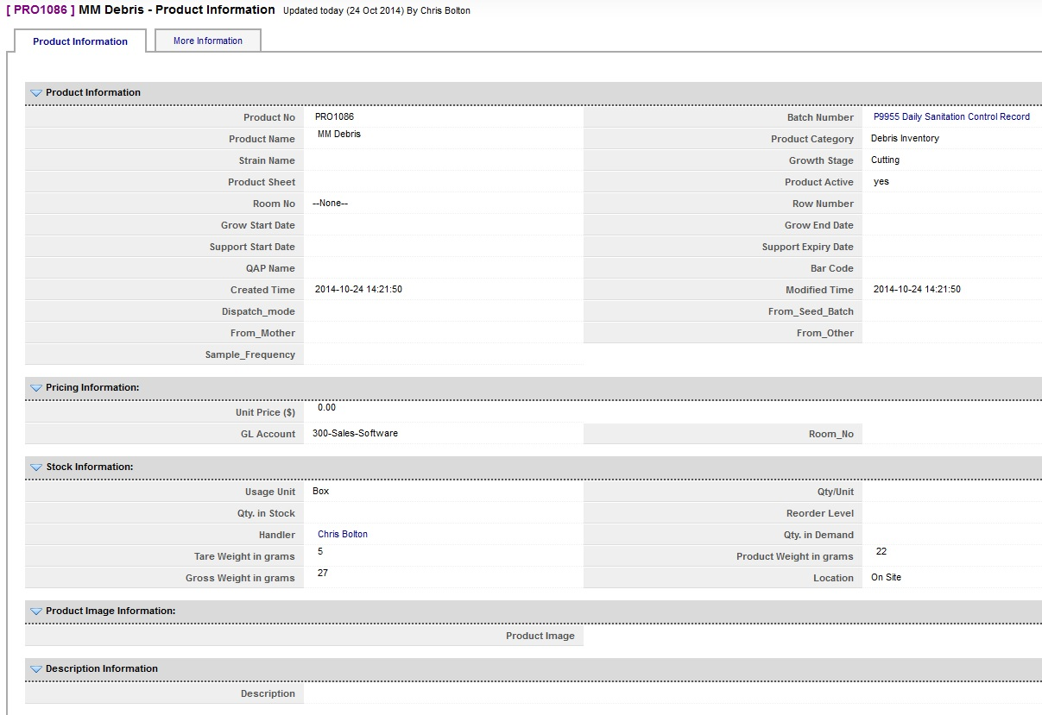
- Record the Product Number onto the MM Debris Bag and move it to the designated MM Debris Security Area for storage until further processing as per SOP0004 Storage.

Daily Stocking of Soap, Glove, Eye Ware and Cleaning Liquid Dispenser:

- Check Soap Dispenser(s) and ensure it is full.

- Check Glove Dispenser(s) and ensure it is full.

- Check Eye Ware Dispenser(s) and ensure it is full.

- Check Cleaning Liquid Dispenser(s) and ensure it is full.

Daily Cleaning SystemSURE Plus Test Task:

- Refer to SystemSURE Plus operators Manual to perform test

- Record result of test in the "Comments Information" section found at bottom of Project Task assigning this task to be performed.
QAP CONFIRMATION & VERIFICATION OF ASSIGNED USER STORAGE:

- The QAP is required to conduct scheduled Seed/Mother Room inspection for each item as per outlined below. This shall then be recorded directly in the QAP's Daily Check List & Project Task List as described in QAPSOP0100.

REFERENCES:

Author | Document Name | Published
Benchmark Labs | SOP0001 Cleaning | ^{January 24, 2016}

