
THIS DOCUMENT IS OBSOLETE ON DATE OF PRINTING
SOP-0002 | ^{TITLE: CLEANING EQUIPMENT} | ^{Issued Date: January 24, 2016}
^{Supersedes:} New | ^{TITLE: CLEANING EQUIPMENT} | Effective Date: January 24, 2016
Initiator[s]: Ryan Pincura & Zach Yim | ^{Signature:}  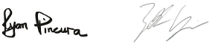 | ^{Date: January 24, 2016}
^{Reviewer:} | ^{Signature:} | ^{Date:}
^{QA Approval:} | ^{Signature:} | ^{Date:}

- REVISION HISTORY:
Version # | Description of Changes | CC #
0 | New document

DOCUMENT OWNER: Quality Assurance Person (QAP)

AFFECTED PARTIES: All site staff who handle equipment or instruments used to process, package, label and store Medicinal Marijuana, including but not restricted to Cultivation, Analysis, Health, Hygiene, Safety, Shipping or Storage.

PURPOSE: To provide a Procedure for cleaning and maintaining equipment and instruments related to the day-to-day operations of the Licensed Producer including processing, packaging, labelling and storing Medicinal Marijuana at the Licensed Location as well as to confirm a Procedure for Confirmation and Verification by the QAP that these Procedures were performed correctly.

DEFINITIONS:
- MMPR: Medical Marijuana Product Regulations
- Non-MMPR Zones refer to Front Entry, Front Office(s), Board Room, Lunch Room and any other area not directly related to Production, Packaging, Labeling and Storage of Medicinal Marijuana.
- MMPR Zones refer to areas directly related to Production, Packaging, Labeling and Storage of Medicinal Marijuana.
SCOPE: This Procedure applies to all equipment and instruments located on the Licensed Location.
KEY WORDS IN SYSTEM: clean, cleaning, equipment, instruments, Medicinal Marijuana, non-Medicinal Marijuana Zone, Medicinal Marijuana Zone, Section 56.
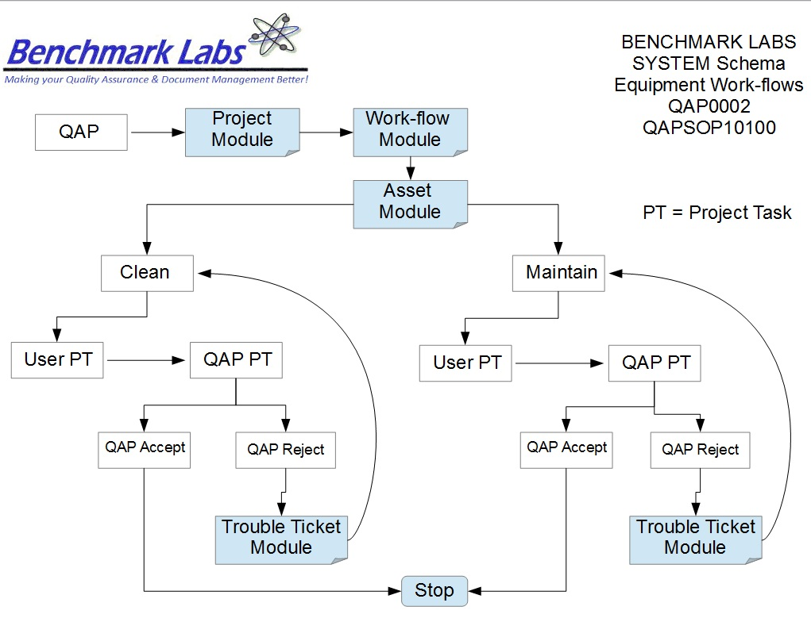
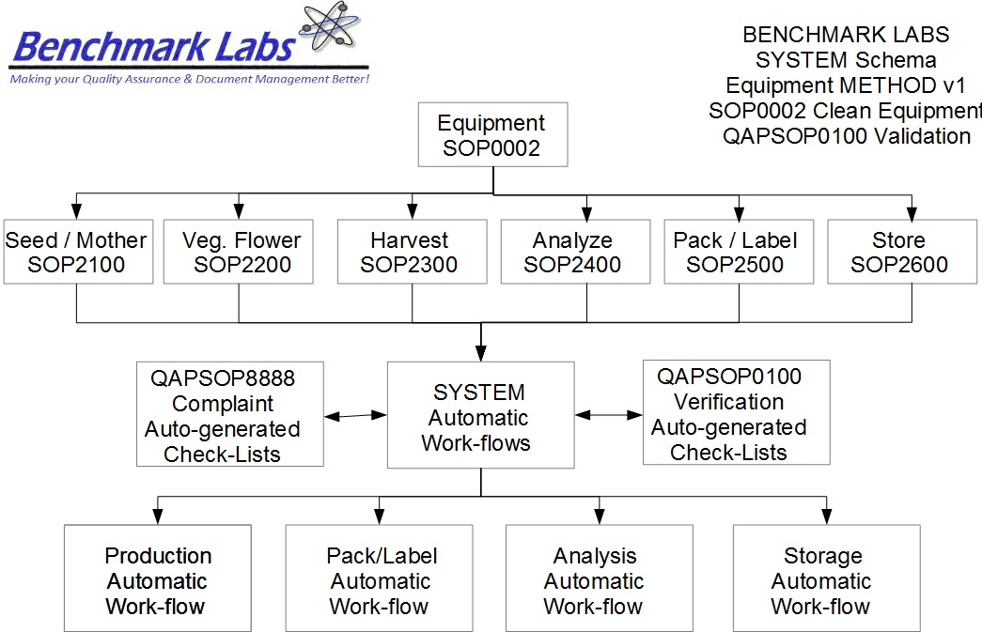

PROCEDURE PROCESS FLOW:
USER PERFORMANCE TASKS (PT) SOPs SPECIFIC TO MMPR ZONES:
GENERAL RULES AND GMP REQUIREMENTS:
1. The rules and GMP requirements apply equally to Contractors and Operations staff.

2. All staff shall undergo training on the use of specific equipment and instruments as they apply to specific zones within the site prior to being able to conduct any cleaning.

3. All cleaning is to be supervised by the QAP who must also record daily, weekly, monthly, quarterly and annual reports as required by the SYSTEM auto-work flow tasks and the use of Trouble Tickets must be used in the case of any failures in cleaning protocol observed by the QAP.

4. Clean uniforms, factory shoes and hair nets or helmets must be worn as applicable in the particular areas. (All cleaners working in the Production areas must be familiar with the requirements of SOP0005 Hygiene)

5. Solutions and cleaning supplies used for cleaning must be changed/renewed daily or whenever they become badly soiled, so as not to spread contamination or introduce extraneous substances during the cleaning process. This is to be done by the Cleaners during the cleaning process.

5. No food or drink can be taken into any zone during the cleaning procedure.

6. Non-Medicinal Marijuana Debris or Rubbish shall be collected in either bins or bags and disposed of cleanly in the correct bins. However, any Medical Marijuana Debris or Rubbish must be collected and stored in accordance with the below procedure until properly disposed of by the SPIC.

7. Nothing shall ever be picked up from the floor and returned to any work surface without being thoroughly cleaned and sanitized.

8. No container that comes in contact with product shall be placed directly on the floor.

9. If Production is continuing while equipment or instruments are to be cleaned, advise the authorized person, and work effectively to avoid contamination or the introduction of extraneous substances during the cleaning process. Otherwise, wait for the zone to shut down so as to be able to effectively clean the equipment or instrument.

10. All Cleaning Tasks shall be either auto-generated by the Benchmark Labs SYSTEM as “Project Tasks” or manually entered as “Project Tasks” to ensure proper record entry and to ensure that confirmation and verification of cleanliness has occurred.
11. The QAP shall receive and complete auto-generated Project Tasks by the Benchmark Labs SYSTEM to ensure proper record entry and to ensure that confirmation and verification of cleanliness has occurred.

12. All problems shall be reported to the QAP and registered using the Trouble Ticket Module of the SYSTEM.

13. All cleaning equipment and bulk solutions must be stored neatly in specific cleaners' rooms.
14. The Cleaners' storage area(s) are to be kept in a neat, tidy, and clean state.
REGULATORY REQUIREMENTS:
- Marijuana for Medical Purposes Regulations, Section 56 Division 4 Good Production Practices, October 2013).

TRAINING REQUIREMENTS: Read, understand and have demonstrated proficiency training (PT) as indicated in the SYSTEM User Profile Record.

RELATED REQUIREMENTS: Read, understand and be familiar with the following related documents:
    - SOP2100 Cleaning Seed/Mother Room
    - SOP2200 Cleaning Vegetative/Flower Room
    - SOP2300 Cleaning Harvest/Cure Room
    - SOP2400 Cleaning Lab Analysis Room
    - SOP2500 Cleaning Packaging/Label Room
    - SOP2600 Cleaning Storage Room
    - SOP0001 Cleaning Premise
    - SOP0003 Handling Processing
    - SOP0004 Handling Storage
    - SOP0005 Health & Safety Hygiene
    - SOP2600 Vault
AUTO-GENERATED WORKFLOW(S) REQUIRED TO RECORD LOG:
- WKFL0001: Assign Authorized User, Project Task, Record Date / Time Completed
- QAP0001: Assign Authorized User, Inspection Log, Record Date / Time Completed
- CAR0001: Description of Trouble Ticket auto-generated and emailed to QAP
MATERIALS REQUIRED:
- Wireless device to log-in to SYSTEM
- Food Grade Nitrile Gloves, Clean Suit, Boots, Boot Covers, Hair Net, Protective Eye Wear.
- 70% Isopropyl Alcohol (IPA). PLEASE NOTE: IPA has an expiry date of one month and is to be displayed on the label of the bottle. It must not be used after the expiry date.
- Specific Cleaning Kits may be required for each piece of Equipment or Instrument so please be sure to check individual SOP for clarification.

SAFETY REQUIREMENTS:
- Refer to the relevant Material Safety Data Sheets for materials being used for cleaning.
- Refer to SOP0004 in relation to Storage to be used for all materials.
- Refer to SOP0005 in relation to Hygiene, Health and Clothing to be used.
- Refer to SOP0006 in relation to Safety during cleaning.
EQUIPMENT LIST TO BE CLEANED:
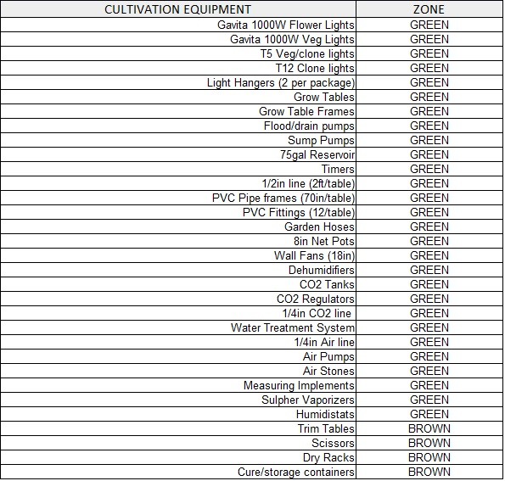

EQUIPMENT LIST TO BE CLEANED: (continued)
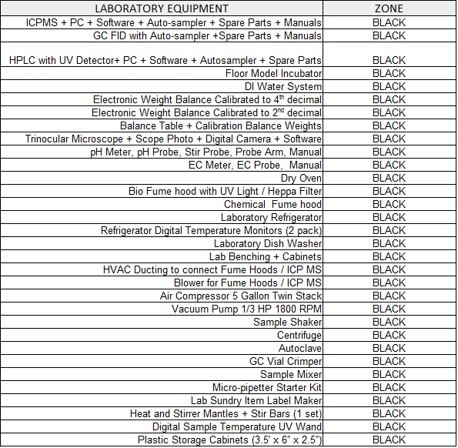
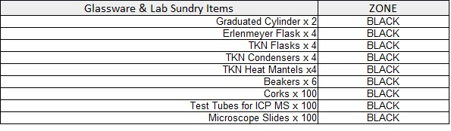

EQUIPMENT LIST TO BE CLEANED: (continued)

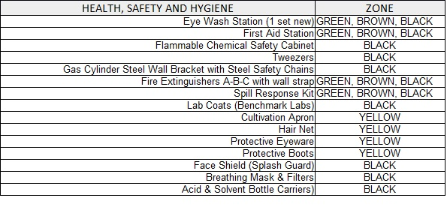
PLEASE NOTE: Current list of Equipment & Instruments can be found by opening the Benchmark Labs SYSTEM “Asset Module” that is found under the “More Support” Category:
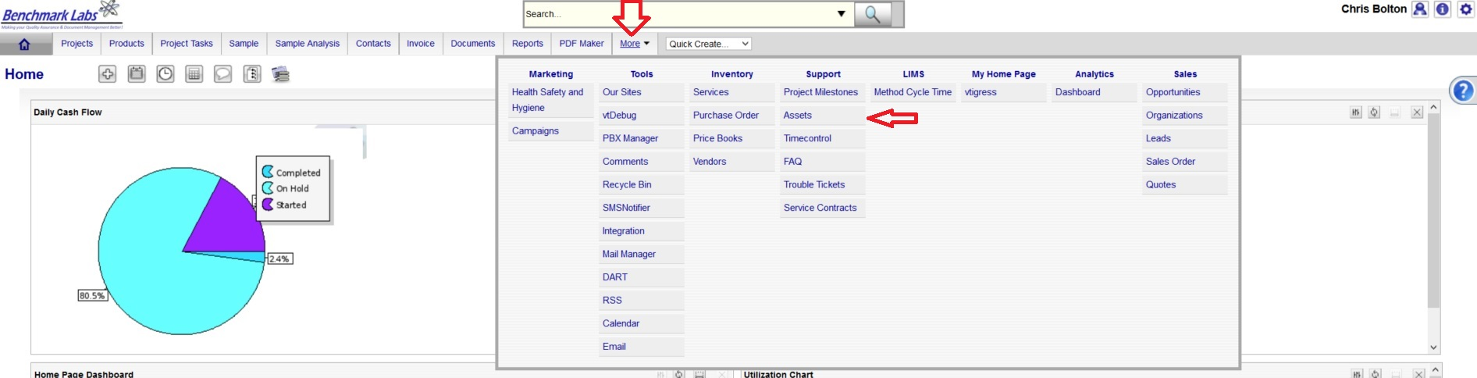
The Benchmark Labs SYSTEM will auto-generate both an equipment maintenance and cleaning schedule to assigned Users of the SYSTEM as Project Tasks. These Project Tasks are then auto-generated in an e-mail reminder to the User to perform these tasks, and to provide the User with an “at a glance” list of Project Tasks that are to be performed on any given day.
To review the status of current maintenance and cleaning of specific equipment, using the Asset Module's “Filters” drop down, select “Equipment Cleaning and Maintenance Report”:

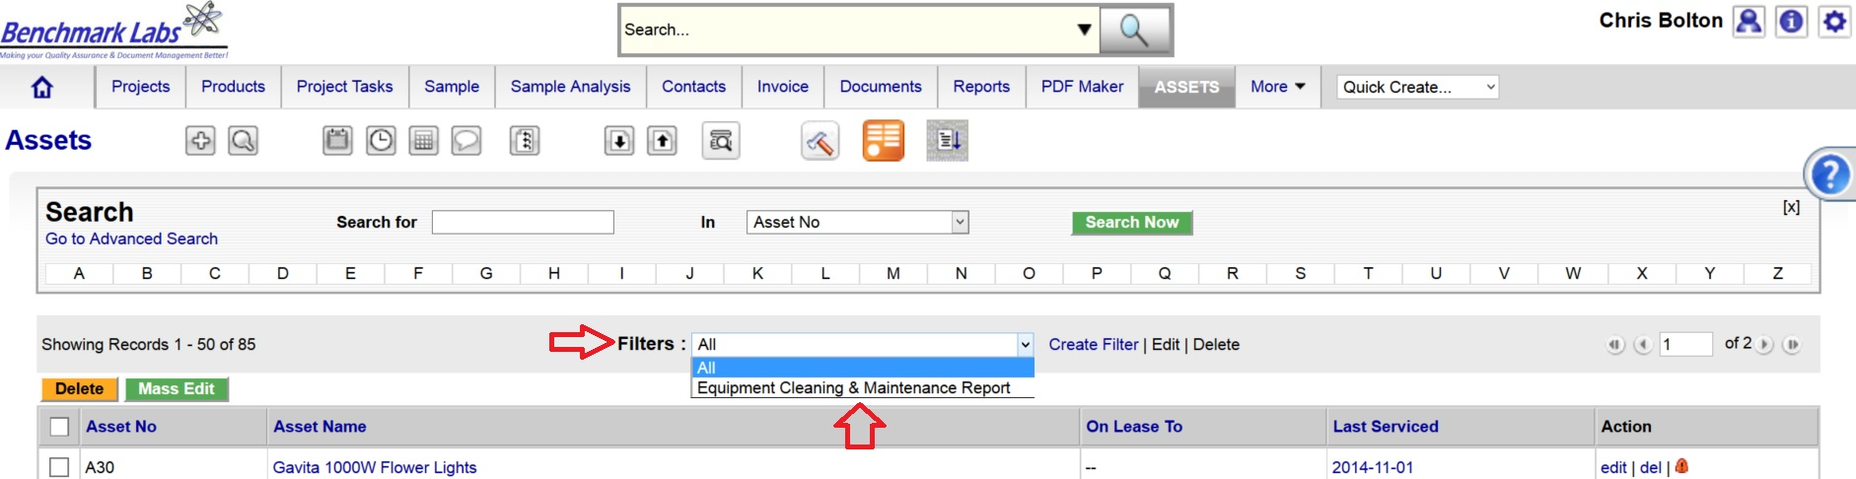
This complete list includes the Category (e.g. Cultivation, Analysis etc.), the Status (e.g. “In Service”), Date of Service, date Last Serviced, the name of the QAP assigned to monitor the correct operating condition and cleanliness of this equipment or instrument, Associated SOP's relating to maintenance or cleaning, and the Zone in which this equipment or instrument can be found:
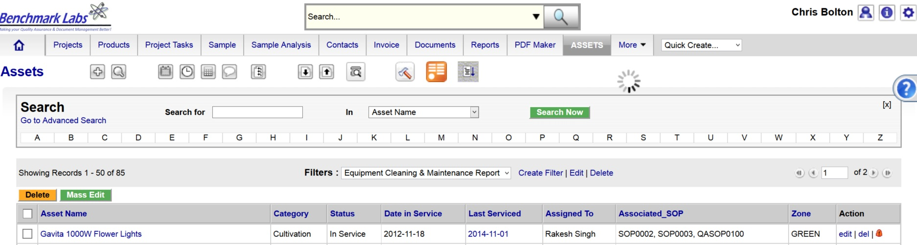
PLEASE NOTE: As equipment and instruments are likely to be replaced on a regular basis, the SYSTEM shall record what “Assets” are “In Service” so as to confirm for the User what “Assets” require regular cleaning.
PLEASE NOTE: The Benchmark Labs SYSTEM shall maintain a historical record of all Assets, cleaning and maintenance schedules, inspections and related Trouble Tickets for future Audit Tracking and detailed Reports.
EQUIPMENT CLEANING FREQUENCY & QAC VERIFICATION FREQUENCY:

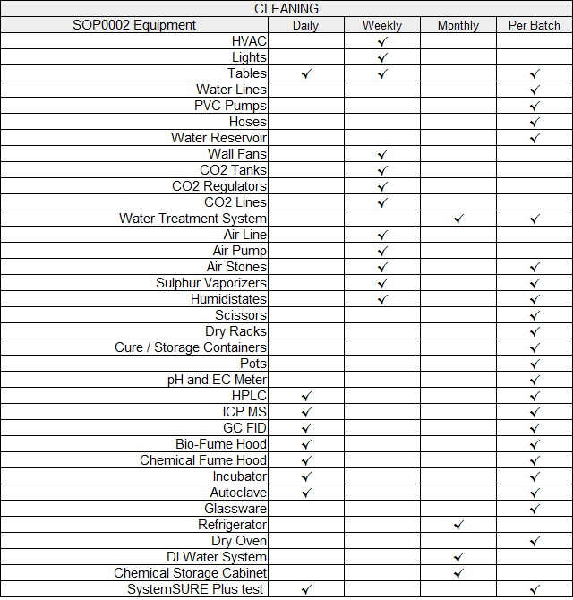
NOTE: Cleaning shall be Verified by the QAP as required to do so by SYSTEM Work-flow Cleaning Verification Schedule and Corrective Action Report (CAR) work flows as required by QAPSOP0100.
EQUIPMENT CLEANING PROCEDURE BY ASSIGNED USER:

- Each piece of equipment or instrument shall have its own unique process for cleaning to ensure that the equipment or instrument is effectively cleaned, is able to function for its intended use, will not contaminate or otherwise introduce extraneous substances into the Medicinal Marijuana Processing Procedure SOP0003.
PLEASE NOTE: That all Premise Cleaning Procedures for specific MMPR Zones shall require that any Medicinal Marijuana related debris or trash that is found shall be retrieved and placed into a Debris Bag and recorded directly into the Benchmark Labs SYSTEM – as such, it can NEVER be disposed of in the garbage as would NON-Medicinal Marijuana debris or trash.

- These instructions are found as individual SOP's that are attached to each “Asset” recorded in the Benchmark Labs SYSTEM. This will ensure that any updates made to those documents are immediately available to all Users assigned to provide maintenance and cleaning to this equipment or instrument:

- To access these instructions for Maintenance and Cleaning, go directly to the “Asset” in the Benchmark Labs SYSTEM that is this piece of equipment or instrument. This can be done a number of ways including:
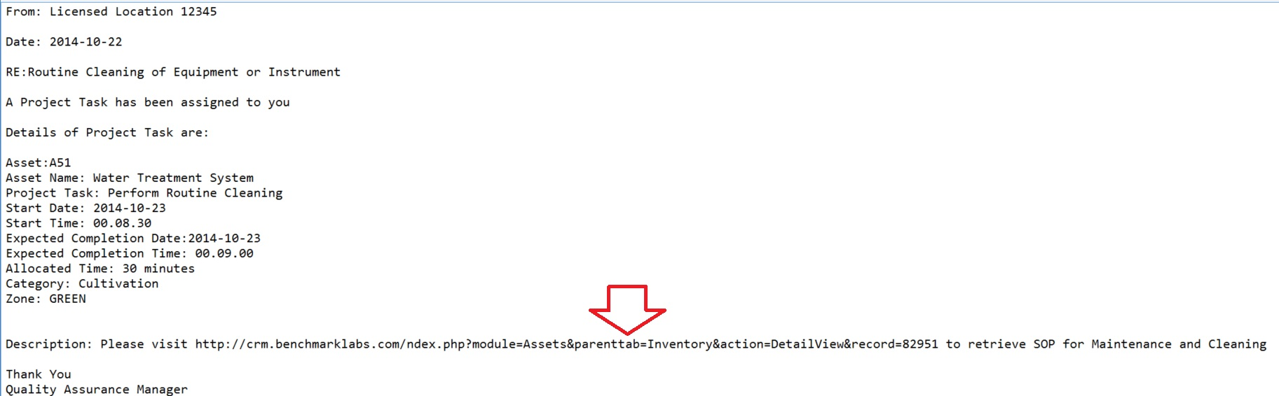
  - clicking on the link for this “Asset” as provided in the auto-email that was generated by the SYSTEM to the User,
  - Using the Universal Search Box by typing in the name of the equipment or instrument, its Asset number or other description,
  - Using the “Asset” Module function and scroll through the list of equipment and instruments listed,
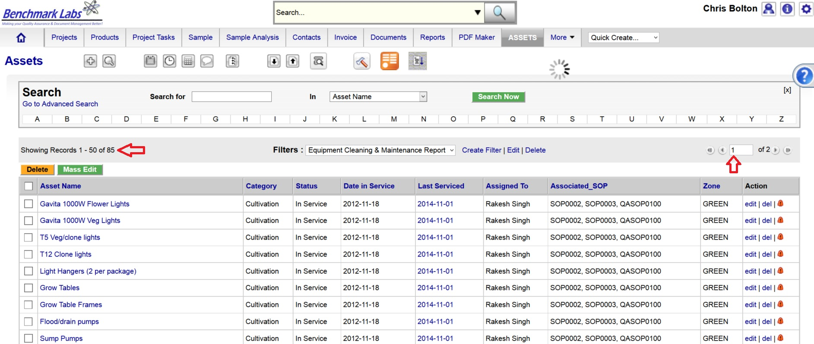
  - Using the “Asset” Module “Search For” Box to locate by those fields shown:
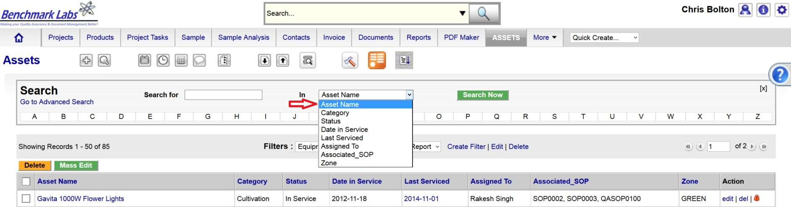
  - Using the “Asset” Module “Filters” Box to locate by those fields shown:

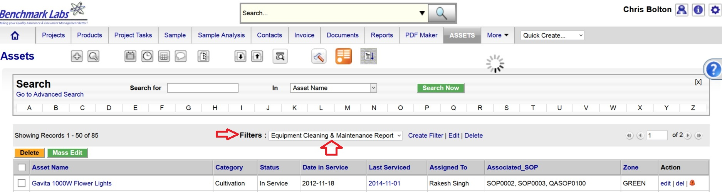
- Once you have selected the correct “Asset” open and proceed to the “More Information” Tab and click on “Project Task”:

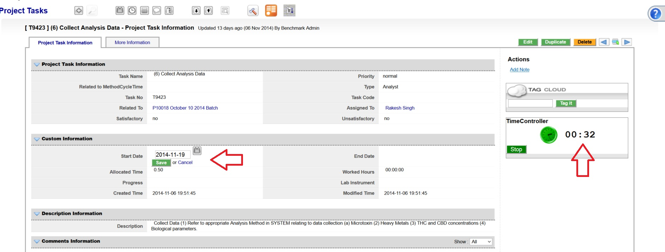
PLEASE NOTE: Once a Project Task has been opened, the Time-Controller Clock begins recording the time it takes to complete this task. If the time taken is significantly greater or less than the “Allocated Time” value, an automatic Trouble Ticket will open to request explanation as for the cycle time difference (the root cause for the variation in time taken to complete Project Task). Therefore, it is critical that you do not open the Task until you are ready to begin and to then focus on the Task until it is done by clicking on the “STOP” button beside the clock.
- In the event that the Description provided at the bottom of the Project Tasks window is not sufficient for completion of this Task, proceed to the “Asset” Module by clicking on the Asset link provided and proceed to the “More Information” Tab and click on “Documents”:
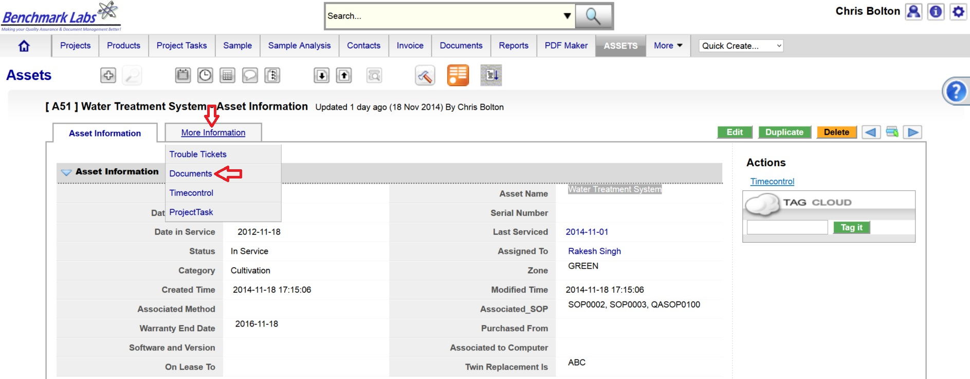
- Clicking on “Documents” provides direct access to the link to the document relating the cleaning and maintenance of this particular piece of equipment:
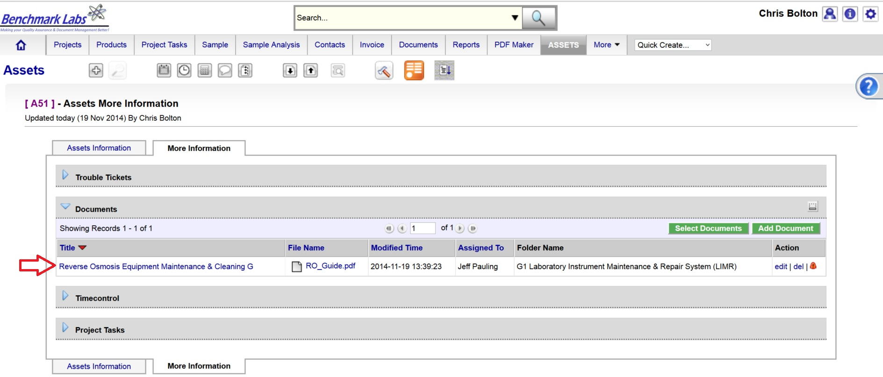
PLEASE NOTE: These documents serve multiple purposes including how to set-up, operate, maintain and repair, clean and dispose of what is no longer usable.
PLEASE NOTE: A document in the SYSTEM can be deleted but only from the view of the average User. All documents Deleted from the SYSTEM are simply moved into “Archive” whereby they are still accessible by the SPIC and Government or Regulatory Auditor.

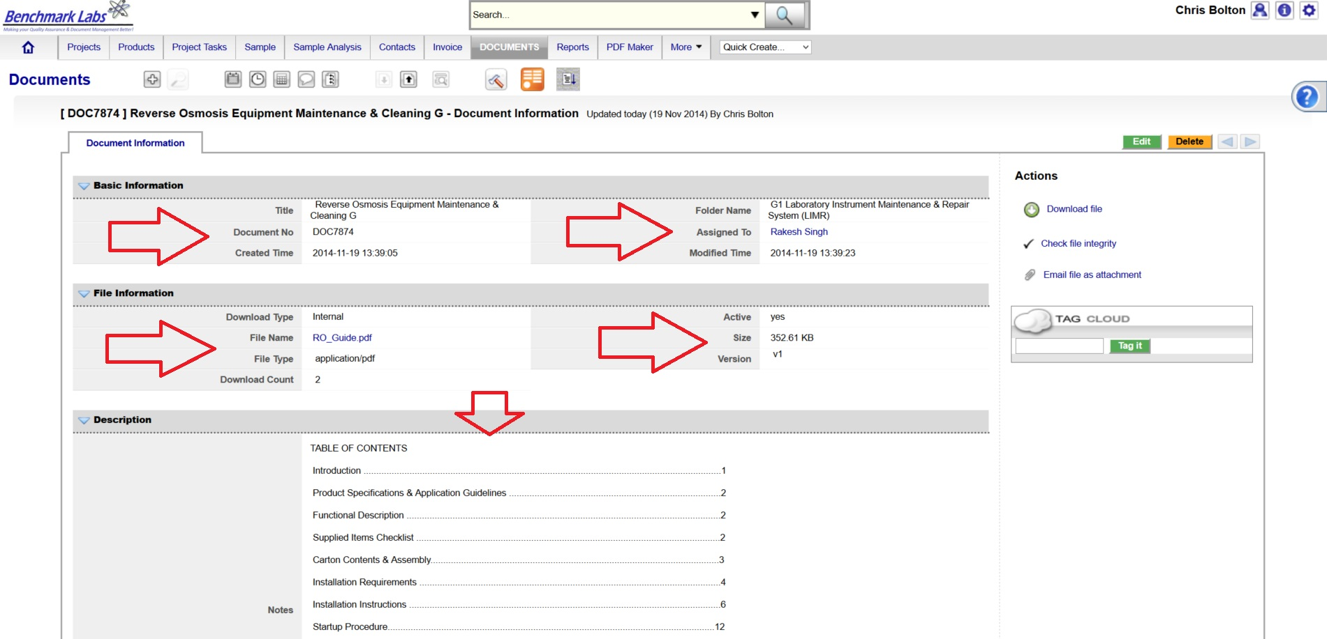
- Clicking on the hyperlink below “Title” provides direct access to this file as well as a wealth of information related to this file, including the description of its contents (e.g. Table of Contents), date the document was added to the SYSTEM, date it was last updated, date the document will expire, the document version number and how often it has been downloaded for viewing by the Users of the SYSTEM:
EQUIPMENT CLEANING CONFIRMATION & VERIFICTION PROCEDURE BY QAP:
- Once the processing, packaging, analyzing, or labeling Premise Project Task “Progress” status has been saved as “100%,” the Benchmark Labs SYSTEM will auto-generate an email to the QAP the need to confirm and verify that processing, packaging, analyzing, or labeling was completed to acceptable standards as outline below. This procedure is governed by QAPSOP0100.
SUMMARY REPORTS:
- Summary Record Reports for a list of all historical “Project Tasks” associated with SOP can be found by clicking on the “Project Task” Module:
- Summary Record Reports for a list of all Equipment of Instruments associated with this SOP can be found by clicking on the “Asset” Module:
- Summary Record Reports for a list of Project Tasks performed on a specific piece of equipment or instrument can be found by clicking on the “Project” Module and clicking on the Project associated with Cleaning that specific equipment or instrument, clicking on “More Information” and clicking on “Project Tasks”:
- Summary Record Reports of a list of Trouble Tickets associated with this SOP can be found by clicking on the “Trouble Ticket” Module:
- Summary Reports of scheduled cleaning and / or maintenance of equipment or instruments associated with this SOP can be found by clicking on the “Calendar” Module:

REFERENCES:
Author | Document Name | Published
Benchmark Labs | SOP0002 Clean Equipment | January 24, 2016

