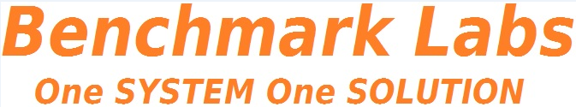

THIS DOCUMENT IS OBSOLETE ON DATE OF PRINTING
SOP-2700 | ^{TITLE: APEKS Cleaning} | ^{Issued Date: January 24, 2016}
^{Supersedes:} New | ^{TITLE: APEKS Cleaning} | Effective Date: January 24, 2016
^{Initiator[s]: Zach Yim} | 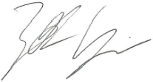 | Signature: Date: January 24, 2016
^{Reviewer:} | ^{Signature:} | ^{Date:}
^{QA Approval:} | ^{Signature:} | ^{Date:}

REVISION HISTORY:
Version # | Description of Changes | CC #
0 | New document
DOCUMENT OWNER: Quality Assurance Manager

AFFECTED PARTIES: All site staff and contractors that enter the Medicinal Marijuana Licensed Location.

PURPOSE: This Cleaning SOP is designed to provide a step by step process for the cleaning of the Apeks Super-critical Fluid Extraction apparatus.
Note: Although a written SOP plan is not required by most international Federal Medicinal Marijuana Organizations (including the FDA), it is recommended that we explain the Licensed Location procedures

DEFINITIONS:
- Authorized User: The person authorized to perform Project Tasks within the Benchmark Labs SYSTEM.
- Project Milestones: Are related to the group of “Project Tasks” associated with step-by-step instructions of APEKS Cleaning of Medicinal Marijuana in the Extraction Room within the Licensed Location.
SCOPE: This Procedure applies to cleaning of the Apeks Extraction System with the Green Zone, of the Licensed Location.
KEY WORDS IN SYSTEM: Apeks, cleaning, extraction, super-critical, Green Zone

GENERAL RULES AND GMP REQUIREMENTS:
1. The rules and GMP requirements apply equally to Contractors and Operations staff.

2. All staff shall undergo training on the use of this specific instrument as its maintenance is vital to the facility.

3. All cleaning is to be supervised by the QAP who must also record daily, weekly, monthly, quarterly and annual reports as required by the SYSTEM auto-work flow tasks and the use of Trouble Tickets must be used in the case of any failures in cleaning protocol observed by the QAP.

4. Clean uniforms, factory shoes and hair nets or helmets must be worn as applicable in the Green Zone of the facility. (All cleaners working in the Production areas must be familiar with the requirements of SOP0005 Hygiene)

5. Solutions and cleaning supplies used for cleaning must be changed/renewed daily (as per the QAP's direction), so as not to spread contamination or introduce extraneous substances during the cleaning process. This is to be done by the Cleaners during the cleaning process.

5. No food or drink can be taken into any zone during the cleaning procedure.

6. Non-Medicinal Marijuana debris or rubbish shall be collected in either bins or bags and disposed of cleanly in the correct bins. However, any Medical Marijuana debris or rubbish must be collected and stored in accordance with the below procedure until properly disposed of by the SPIC.

7. Nothing shall ever be picked up from the floor and returned to any work surface.

8. No container that comes in contact with product shall be placed directly on the floor.

9. If Production is continuing while equipment or instruments are to be cleaned, advise the authorized person and work effectively to avoid creating contamination or introduction of extraneous substances during the cleaning process. Otherwise, wait for the zone to shut down so as to be able to effectively clean the equipment or instrument.

10. All Cleaning Tasks shall be either auto-generated by the Benchmark Labs SYSTEM as “Project Tasks” or manually entered as “Project Tasks” to ensure proper record entry and to ensure confirmation and verification of cleanliness has occurred.
11. The QAP shall receive and complete auto-generated Project Tasks by the Benchmark Labs SYSTEM to ensure proper record entry and to ensure confirmation and verification of cleanliness has occurred.

12. All problems shall be reported to the QAP and registered using the Trouble Ticket Module of the SYSTEM.

13. All cleaning equipment and bulk solutions must be stored neatly in specific cleaners' rooms.
14. The Cleaners' storage area(s) are to be kept in a neat, tidy, and clean state.

REGULATORY REQUIREMENTS:
- Marihuana for Medical Purposes Regulations, Section 56 Division 4 Good Production Practices, October 2013.

TRAINING REQUIREMENTS: Read, understand and demonstrate proficiency training (PT) as indicated in the SYSTEM User Profile Record.
RELATED REQUIREMENTS: Read, understand and be familiar with the following related documents:
- SOP0001 Clean Premise
- SOP0002 Clean Equipment
- SOP0004 Handling Storage
- SOP0005 Health & Hygiene
- SOP0006 Health & Safety
- QAPSOP0100 Confirmation and Verification
AUTO-GENERATED WORKFLOW(S) REQUIRED TO RECORD LOG:
- WKFL0001: Assign Authorized User, Project Task, Record Date/Time Completed
- QAP0001: Assign Authorized User, Inspection Log, Record Date/Time Completed
- CAR0001: Description of Trouble Ticket auto-generated and emailed to QAP

SAFETY REQUIREMENTS:
- Refer to the relevant Material Safety Data Sheets for materials being used for APEKS Cleaning.
- Refer to SOP0004 in relation to Storage to be used for all materials.
- Refer to SOP0005 in relation to Hygiene, Health and Clothing to be used.
- Refer to SOP0006 in relation to Safety during APEKS Cleaning.
GENERAL MATERIALS REQUIRED:
- Wireless device to log-in to Benchmark Labs SYSTEM.
- Food Grade Nitrile Gloves, Clean Suit, Boots, Boot Covers, Hair Net, Protective Eye Wear.
- Utilize only the assigned equipment or instruments to each designated Zone.

MATERIALS REQUIRED FOR APEKS SYSTEM CLEANING:

- Plastic bucket
- QAP approved antimicrobial cleaning solution (ethanol or another form of alcohol work)
- Cloth or cleaning sponge (freshly sanitized)
- Chemical squeeze bottle
PLEASE NOTE: All supplies, equipment used for cleaning within the Facility is to be recorded as an “Asset” in the Benchmark Labs SYSTEM pursuant to SOP0002 and carry an easy to identify specific Zone Colour Tag and marked e.g., “Extraction Room” using an appropriately coloured Sharpie Pen to separate these tools from those designated for use in other Zones.
PLEASE NOTE: ONLY AUTHORIZED USERS AND STAFF ARE PERMITTED TO RECEIVE AND PERFORM PROJECT TASKS WITHIN EACH ZONE THAT REQUIRES CLEANING OF THE APEKS SYSTEM.
PLEASE NOTE: BEFORE ANY PROCESSING ACTIVITY TAKES PLACE ENSURE THAT the room is clean and tidy, that all surfaces have been effectively sanitized, and that the Extraction Room itself will be left in a condition that will not contaminate or otherwise introduce extraneous substances into the Medicinal Marijuana Processing Procedure SOP0003.
PLEASE NOTE: That all Premise APEKS Cleaning Procedures for the Extraction Room shall require that any Medicinal Marijuana related debris or trash that is found, be retrieved and placed into a Debris Bag and recorded directly into the Benchmark Labs SYSTEM – as such, it can NEVER be disposed of in the garbage as would NON-Medicinal Marijuana debris or trash AS PER SOP0001 CLEAN PREMISE.
APEKS CLEANING PROCEDURE:
Please note: The following applies only to cleaning the CO2 extraction system

Daily Cleaning
- Remove any extracted oil from the collector cup, and the walls separating the two extraction areas
- Clean both the cup and walls in each extraction chamber by spraying the alcoholic cleaning solution, and generously wiping them down
- Remove any debris from the orifice, and dispose of appropriately
- Ensure that the separator gaskets and grooves are clean
- Flush the alcoholic cleaning solution through the piping that runs between separator 1 and 2
- Wipe down the outlet on separator 2, which leads to the pump, ensure that valve 11 is open
- Remove the rest of the spent material from the extraction vessel by vacuuming it through the top flange, NOTE: ensure that the temperature probe is not damaged
- Check the extractor filters to ensure that they are free from debris
- Ensure that the extraction vessel O-rings and O-ring grooves are undamaged, and replace if necessary
- Inspect the threads on the extraction vessel and ensure that they are free of debris, and are properly greased (NOTE: failure to apply anti-seizing grease will cause damage to the threads, and can cause injury and/or a void of the system's warranty
Periodic cleaning/maintenance: after 80 hours of use
- Check the water level in the chiller/heater, and ensure that it is between the min and max lines on the back of the chiller. If this water has become dirty, or the level has dropped, refill the tank with clean, sterilized water
- Clean all flexible metal lines, going in and out of the separators, with warm water and alcoholic cleaning solution
- Clean CO2 flow lines between pump and coiled heat exchanger with alcoholic cleaning solution
- Run the system without any plant material present for 1 hour, to clean the high pressure side of the extraction vessels
Periodic cleaning/maintenance: after 160 hours of use
- Check the tension of the diaphragm compressor belts
- Unscrew the bottom extraction vessel to clean with warm water and alcoholic cleaner
- Inspect the temperature probe and filters, clean them if necessary

Please Note: On a yearly basis, an Apeks engineer should be called upon to perform a full system check.

EQUIPMENT CLEANING PROCEDURE BY ASSIGNED USER:

- The step-by-step procedure cleaning the Apeks extraction system is provided as individual work-flows within the Benchmark Labs SYSTEM:

Please Note: The following screenshots and workflows are meant as an example of the integration of generic SOPs within the SYSTEM
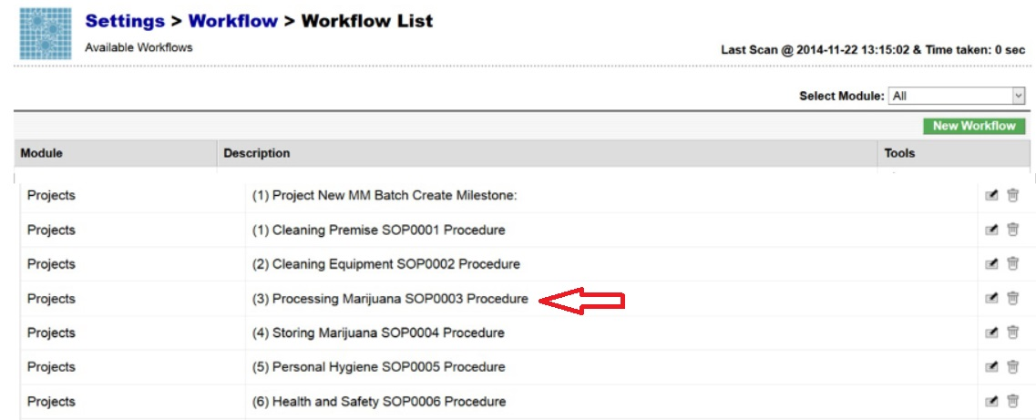
- The Benchmark Labs SYSTEM work-flows represent the Licensed Producers SOPs procedures that have been reviewed and accepted by the QAP for each Extraction area at the Licensed Location (See below for a specific example from SOP 3100):
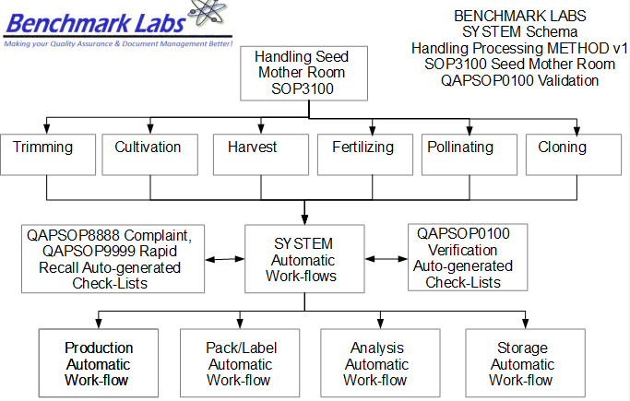


- The Benchmark Labs SYSTEM auto-generates these work-flows upon the creation of a new Batch/Lot of Medicinal Marijuana. This is done through the creation of a new “Project” within the Benchmark Labs SYSTEM that then auto-generates a unique Project Number to provide for a unique set of records associated with that particular Batch/Lot at this Licensed Location:
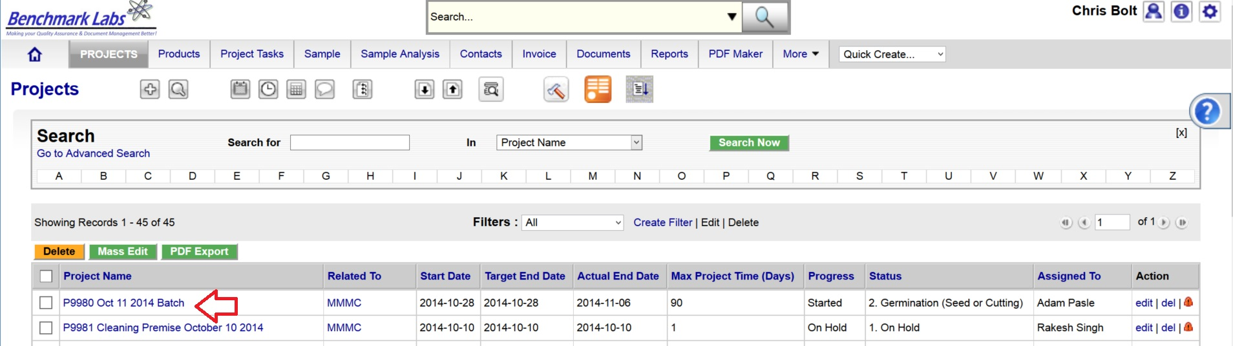
- Once a new Project has been entered into the Benchmark Labs SYSTEM, the SYSTEM auto-generates a series of “Project Milestones” associated with the procedures of APEKS Cleaning of Medicinal Marijuana and assigns. These “Project Milestones” have estimated dates of completion to assist with Project planning and allocation of resources including personnel, assets and sundry supplies:
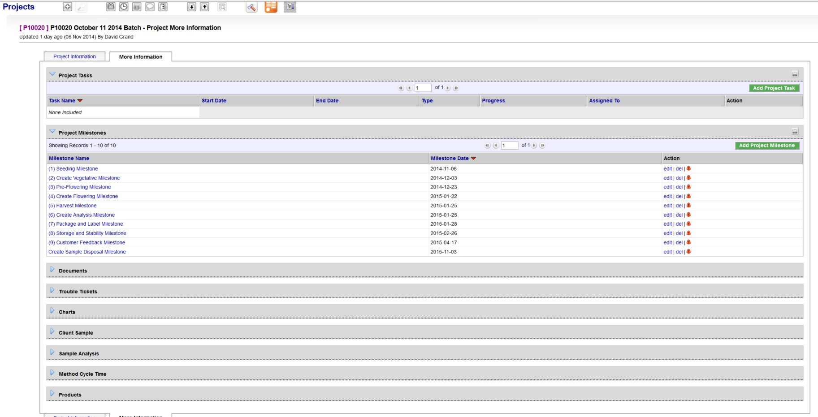
- A GANTT Chart Calendar showing the scheduled completion date of each Milestone is provided by clicking on the arrow symbol next to the “Charts” heading:
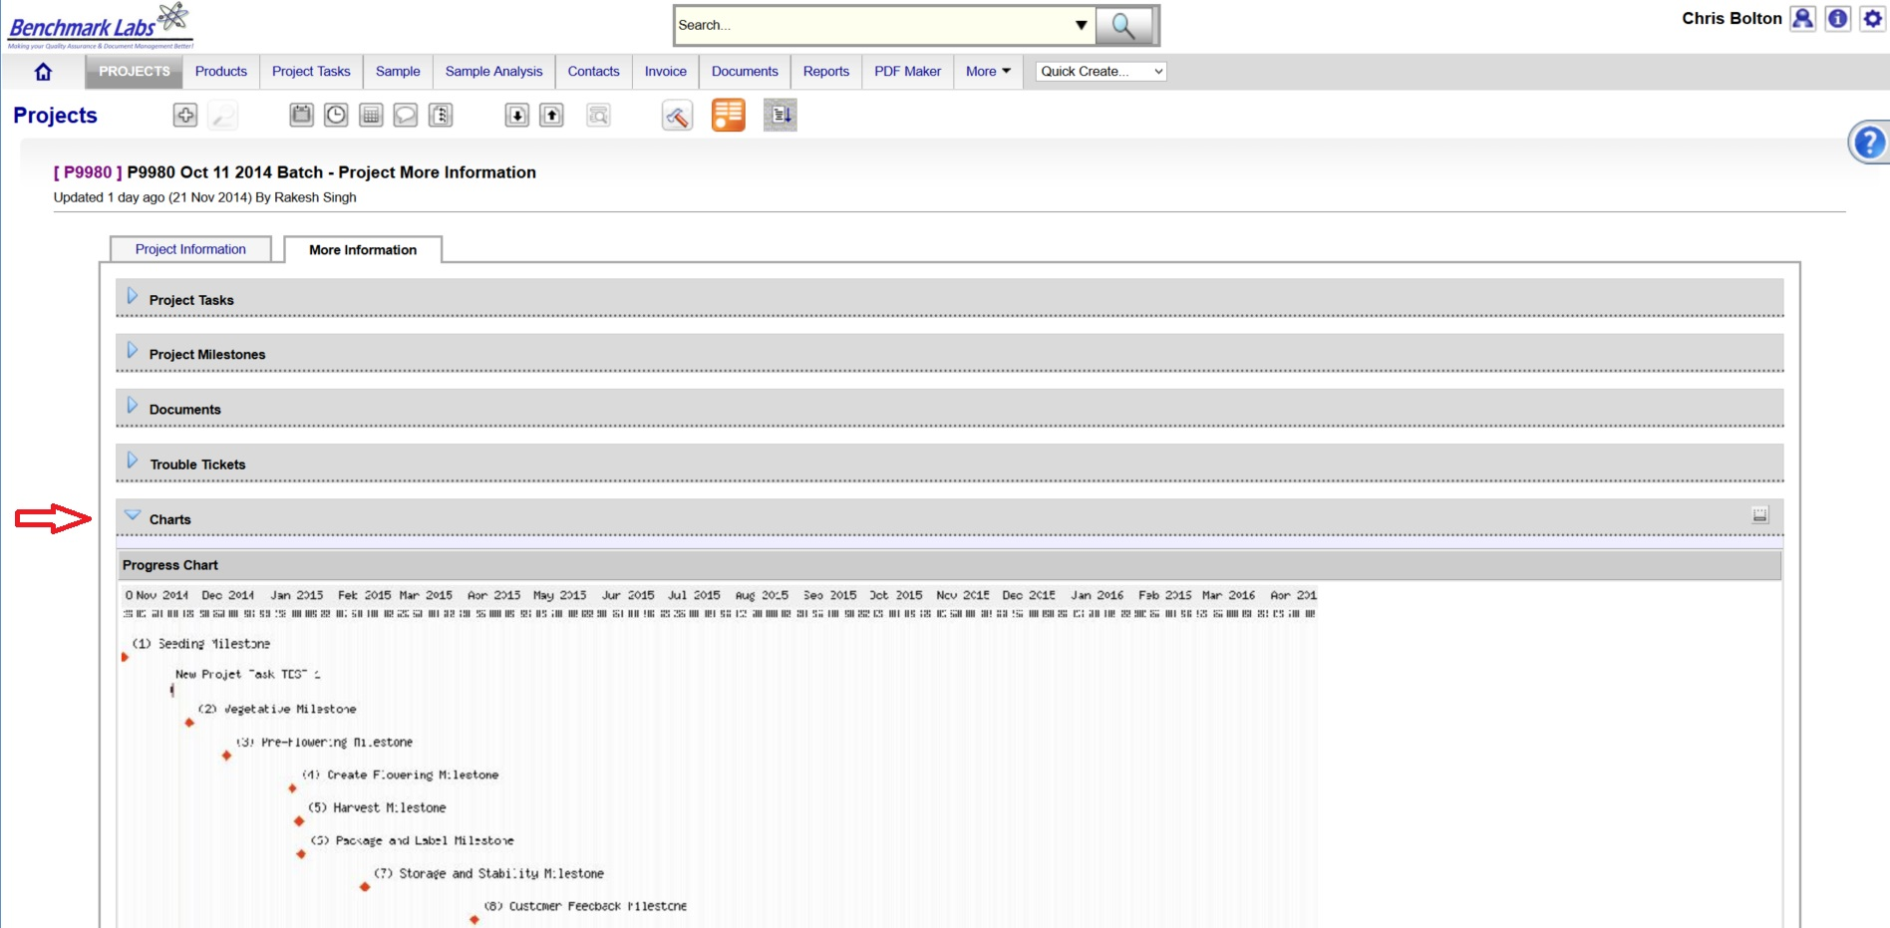
PLEASE NOTE: Clicking the GANTT Chart will open a new Browser Window. Clicking on the GANTT Chart in this new window will enable a “zoom in” on specific Project Milestones dates.
- For each Project Milestone, the Benchmark Labs SYSTEM auto-assigns “Project Tasks” that provide a consistent and logical order of tasks to be performed. Generic Project Tasks are provided by the Benchmark Labs SYSTEM to new SYSTEM Users that are then reviewed and customized by the QAP to better suit their specific Licensed Location.
PLEASE NOTE: All Project Tasks associated with APEKS Cleaning shall be verified by the QAP as required to do so by SYSTEM Work-flow APEKS Cleaning Verification Schedule and Corrective Action Report (CAR) Work-flows.
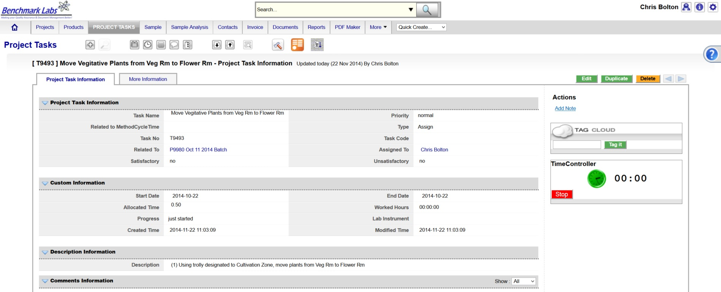
- Project Tasks are then assigned to authorized Users of the SYSTEM. The SYSTEM then provides those Users with notification of a “Start Date” and “End Date” as well as providing an allotment of “Allocated Time” measured in minutes, to complete those assigned tasks:
NOTE: APEKS Cleaning within the Licensed Location shall be verified by the QAP as required to do so by SYSTEM Work-flow APEKS Cleaning Verification Schedule and Corrective Action Report (CAR) Work-flows.
- The Benchmark Labs SYSTEM, prior to 24 hours of its proposed “Start Date”, shall auto-generate an e-mail to the assigned User notifying them of the Project Task, the Start Date, End Date, area or room that the Task is to take place and a description of work that is to be performed:
From: Licensed Location 123145

Date: 2015-03-05

RE: Perform the Daily Cleaning and Maintenance Task on the Apeks Extraction System

A Project Task has been Assigned to You

Details of the Project Task are:

Location: Green Zone
Project: P10028 SOP2700 Apeks System Cleaning
Start Date: 2015-03-05
Start Time: 00.14.30
Expected Completion Date: 2015-03-05
Expected Completion Time: 00.16.30
Allocated Time: 120 minutes
Category: QC
Zone: Green
Description: Please visit http://crm.benchmarklabs.com/ndex.php?module=Assets&parent

Thank You
Quality Assurance Manager
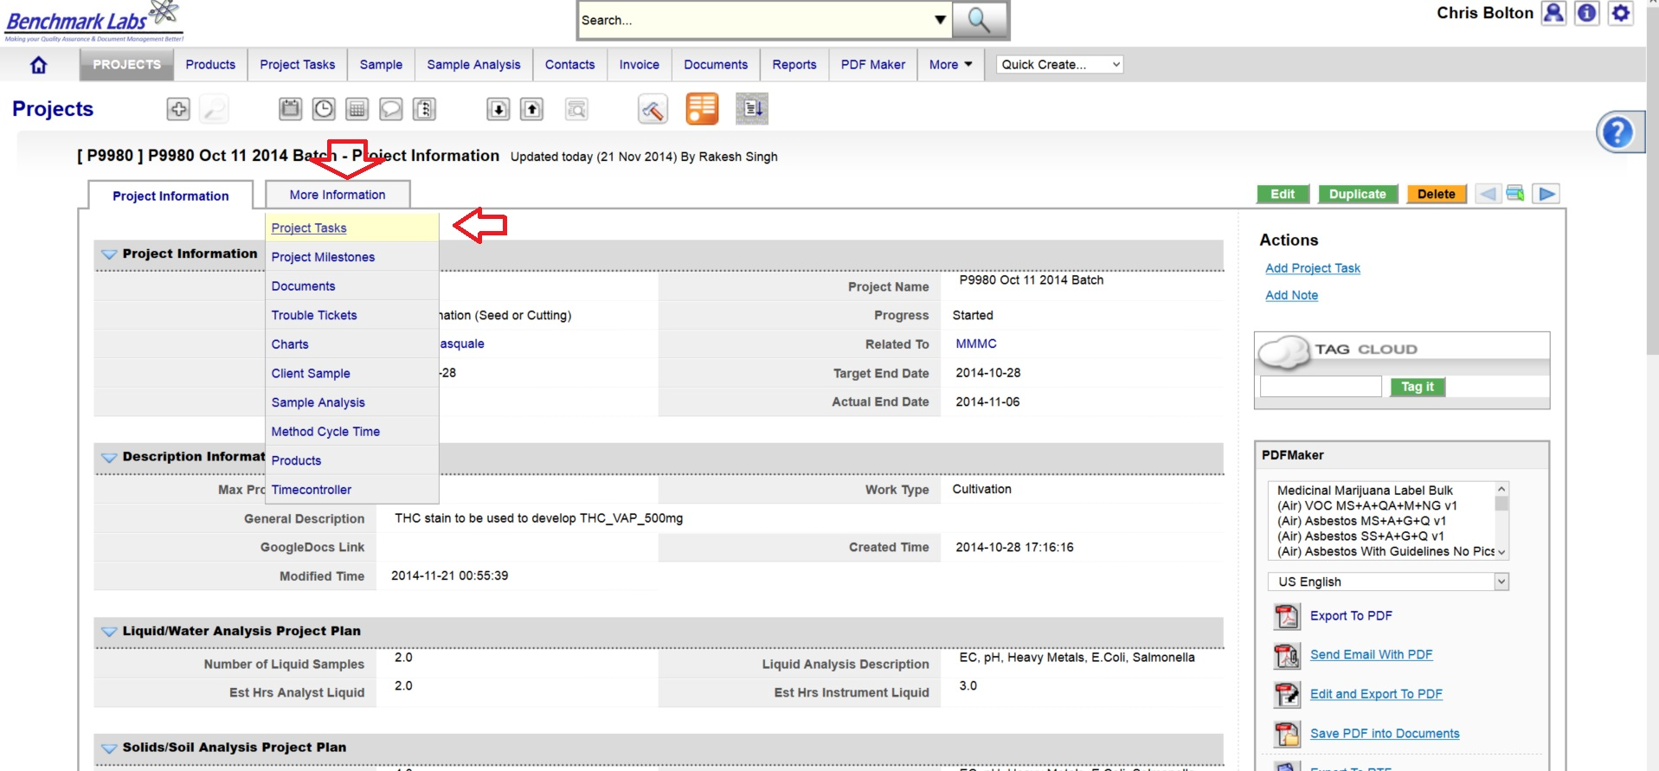
9. The assigned User can then proceed to open the Project Task either by clicking directly on the link found in the email or proceed directly to the Project (e.g., “P9980 Oct 11 2014 Batch”) to open a Project Task from the Project Module directly:
- To open a Project Task simply click on the link below the “Task Name” header:
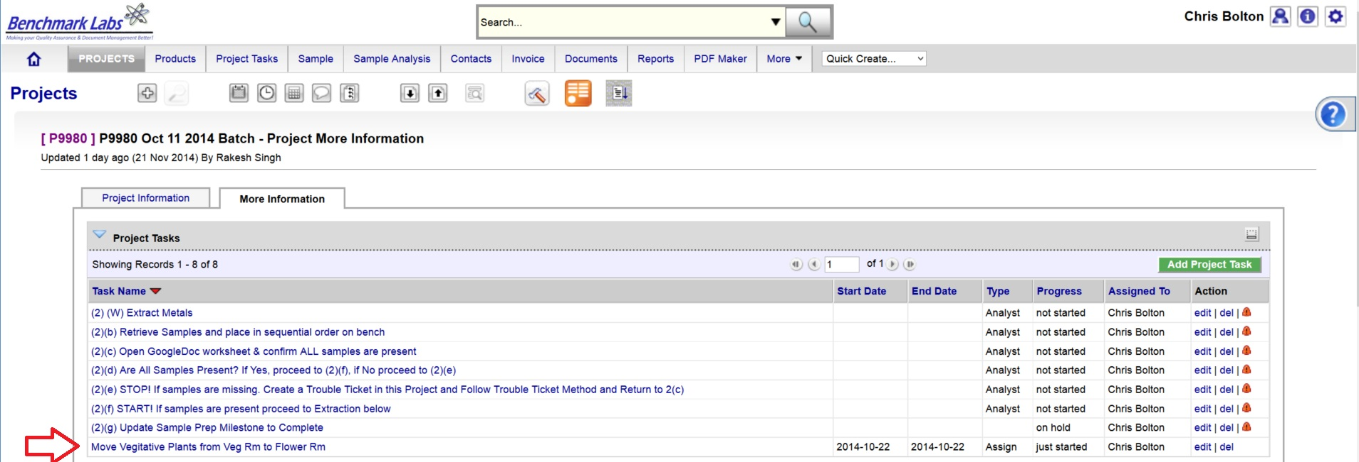
- The clock will then begin to record time spent on this Task until you hit the “Stop Button”:
PLEASE NOTE: Once a Project Task has been opened, the Time-Controller Clock begins recording the time it takes to complete this task. If the time taken is significantly greater or less than the “Allocated Time” value, an automatic Trouble Ticket will open to request explanation for the cycle time difference (the root cause for the variation in time taken to complete Project Task). Therefore, it is critical that you do not open the Task until you are ready to begin and to then focus on the Task until it is done by clicking on the “STOP” button beside the clock.
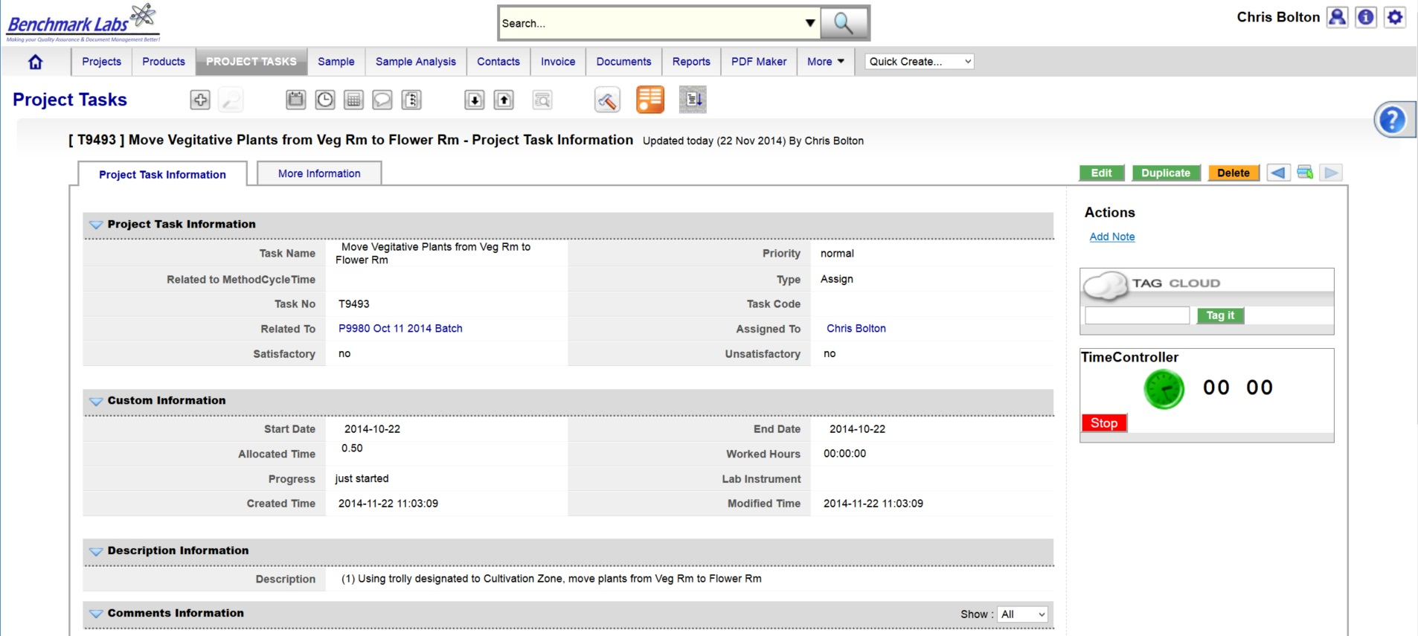
- In the event that the “Description” provided to the assigned User is not sufficient to complete this Project Task, the Assigned User can go directly to the individual SOP Document, by using either the Universal Search Box or using the “Search for” box found in the “Document” Module:

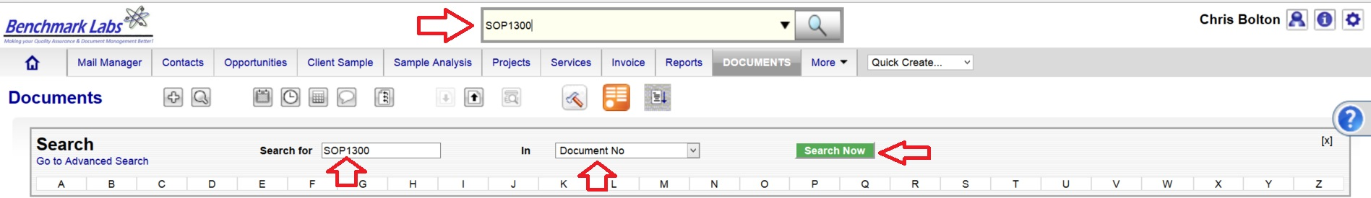
PLEASE NOTE: These SOP documents serve multiple purposes including how to set-up, operate,
maintain and repair, clean and dispose of products when they are no longer usable.
PLEASE NOTE: A document in the SYSTEM can be deleted but only from the view of the average User. All documents Deleted from the SYSTEM are simply moved into “Archive” whereby they are still accessible by the SPIC and Government or Regulatory Auditor.

APEKS EXTRACTOR CLEANING PROCESS CONFIRMATION & VERIFICTION PROCEDURE BY QAP:
- Once the APEKS cleaning Project Task “Progress” status has been saved as “100%,” the Benchmark Labs SYSTEM will auto-generate an email to the QAP with the need to confirm and verify that cleaning was completed to acceptable standards as set forth by the QAP. This procedure is governed by QAPSOP0100.

SUMMARY REPORTS:
- Summary Record Report for a list of all historical “Project Tasks” associated with this SOP can be found by clicking on the “Project Task” Module:
- Summary Record Report for a list of Project Tasks performed for the Facility can be found by clicking on the “Project” Module and clicking on the Projects associated with APEKS cleaning that are specific to a room or zone, clicking on “More Information” and clicking on “Project Tasks”:
- Summary Record Report of a list of Trouble Tickets associated with this SOP can be found by clicking on the “Trouble Ticket” Module:
- Summary Report of scheduled APEKS cleaning and/or maintenance of the equipment associated with this SOP can be found by clicking on the “Calendar” Module:

REFERENCES:
Author | Document Name | Published
Benchmark Labs | SOP0002 Clean Equipment | January 24, 2016
Benchmark Labs | SOP0003 Handling Processing | January 24, 2016
Benchmark Labs | SOP0004 Storage | January 24, 2016
Apeks Super-Critical | System Manual | October 2015

