
THIS DOCUMENT IS OBSOLETE ON DATE OF PRINTING
SOP-0003 | ^{TITLE: HANDLING PROCESSING} | ^{Issued Date: January 24, 2016}
^{Supersedes:} New | ^{TITLE: HANDLING PROCESSING} | Effective Date: January 24, 2016
Initiator[s]: Ryan Pincura & Zach Yim |   ^{Signature:} | ^{Date: January 24, 2016}
^{Reviewer:} | ^{Signature:} | ^{Date:}
^{QA Approval:} | ^{Signature:} | ^{Date:}

REVISION HISTORY:
Version # | Description of Changes | CC #
0 | New document

DOCUMENT OWNER: Quality Assurance Person (QAP)

AFFECTED PARTIES: All site staff who process, analyze, package, and label Medicinal Marijuana.
PURPOSE: To provide a Procedure for the Production, Packaging, Analysis and Labelling of Medicinal Marijuana at the Licensed Location as well as to confirm a Procedure for Confirmation and Verification for the QAP that this procedure has been performed correctly.

DEFINITIONS:
- “Authorized User” means the person authorized to perform Project Tasks within the Benchmark Labs SYSTEM.
- “Project Milestones” are related to the group of “Project Tasks” associated with step-by-step instructions of Processing, Analysis, Packaging, and Labelling of Medicinal Marijuana at the Licensed Location.
SCOPE: This Procedure applies to the Processing, Analysis, Packaging, and Labelling of Medicinal Marijuana conducted within specific designated Zones at the Licensed Location.
KEY WORDS IN SYSTEM: Production, packaging, labelling, storage, cultivation, harvest, dry, cure, vegetative, flower, Zone, analysis, seed, mother, clone, Section 57
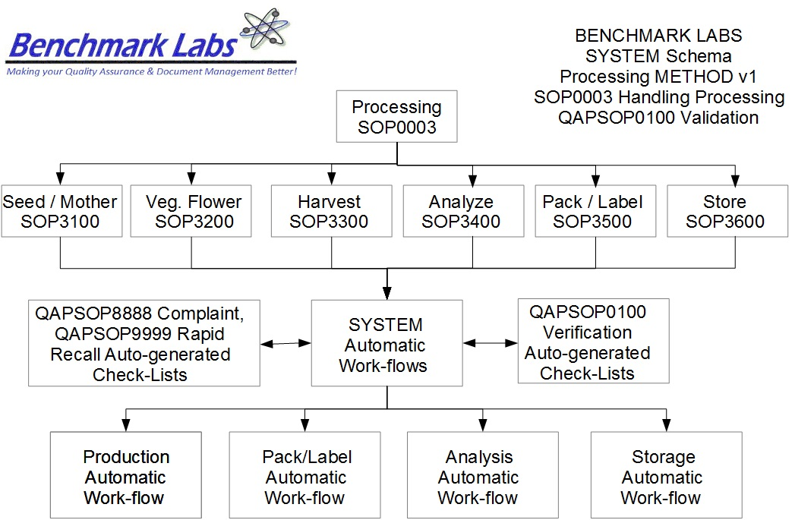
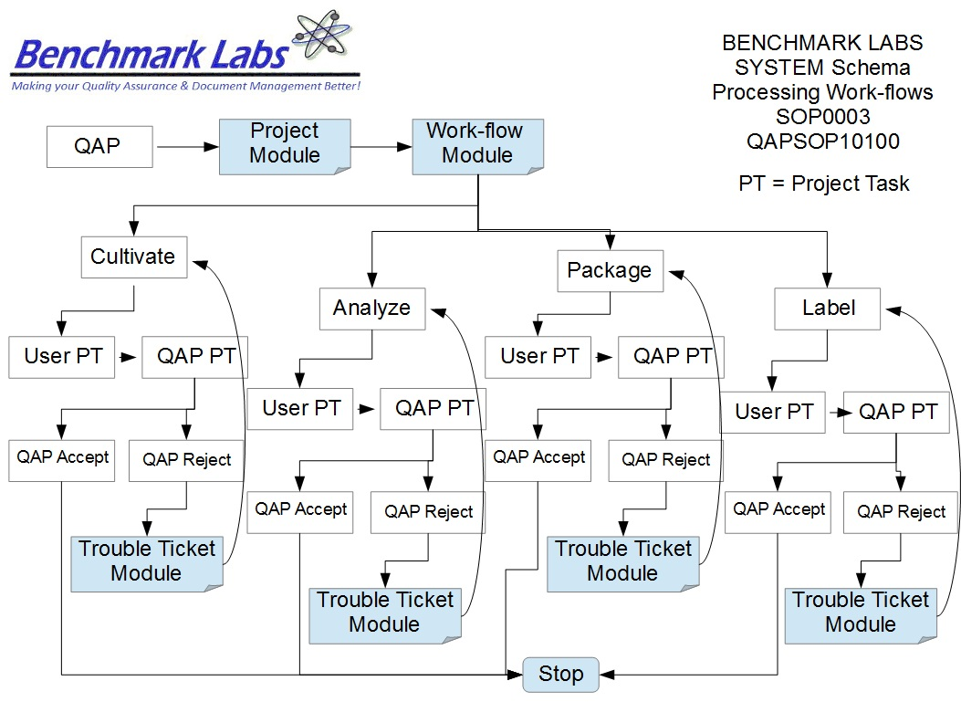

PROCEDURE PROCESS FLOW:
USER PERFORMANCE TASKS (PT) SOPs SPECIFIC TO MMPR ZONES:
GENERAL RULES AND GMP REQUIREMENTS:
- The rules and GMP requirements apply equally to Contractors and Operations staff.

- All staff shall undergo an introduction walk though of the site, be trained on the use of specific procedures as they apply to specific zones within the site prior to being able to conduct any processing, packaging, analyzing, or labelling activities.

- All processing, packaging, analyzing, or labelling is to be supervised by the QAP, who must also record daily, weekly, monthly, quarterly and annual reports as required by the SYSTEM auto-work-flow tasks.

- Trouble Tickets must be used in the case of any failures in processing, packaging, analyzing, or labelling protocol observed by the QAP.

- Clean uniforms, factory shoes and hairnets or helmets must be worn as applicable in the particular areas. (All cleaners working in the Production areas must be familiar with the requirements of SOP0005 Hygiene.)

- Equipment and Instruments used for processing, packaging, analyzing, or labelling shall be clean and in proper working order prior to use. (Refer to SOP0002 Clean Equipment for more details.)

- No food or drink can be taken into any zone during the processing, packaging, analyzing, or labelling process.

- NON-Medicinal Marijuana Debris or Rubbish shall be collected in either bins or bags and disposed of cleanly in the correct bins. However, any Medical Marijuana Debris or Rubbish must be collected and stored in accordance with SOP0001 Clean Premise.

- Nothing shall ever be picked up from the floor and returned to any work surface without being fully cleaned and sterilized (unless it is a consumable product, in which case it should be disposed of accordingly).

- No container that comes in contact with product shall be placed directly on the floor.

- All processing, packaging, analyzing, or labelling Tasks shall be either auto-generated by the Benchmark Labs SYSTEM as “Project Tasks,” or manually entered as “Project Tasks” to ensure proper record entry and to ensure confirmation and verification of cleanliness has occurred.
- The QAP shall receive and complete auto-generated Project Tasks by the Benchmark Labs SYSTEM pursuant to QAPSOP0100 to ensure proper record entry and to ensure confirmation and verification of cleanliness has occurred.

- All problems shall be reported to the QAP and registered using the Trouble Ticket Module of the SYSTEM.

- All processing, packaging, analyzing, or labelling processing activities shall be performed only by Users of the Benchmark Labs SYSTEM who are deemed to be proficient in completing assigned SYSTEM Project Tasks.

- No processing, packaging, analyzing, or labelling processing activities may be conducted without recording those activities as “Project Tasks” in the Benchmark Labs SYSTEM.

REGULATORY REQUIREMENTS:
- Marijuana for Medical Purposes Regulations, Section 57, Division 4 Good Production Practices, October 2013).

TRAINING REQUIREMENTS: Read, understand and have demonstrated proficiency training (PT) as indicated in the SYSTEM User Profile Record.
RELATED REQUIREMENTS: Read, understand and be familiar with the following related documents:
- SOP3100 Process Seed / Mother Room
- SOP3200 Process Vegetative / Flower Room
- SOP3300 Process Harvest / Cure Room
- SOP3400 Process Lab Analysis Room
- SOP3500 Process Packaging / Label Room
- SOP3600 Process Storage Room
- QAPSOP0100 Confirming and Verification of processing, packaging, analyzing, or labelling & Maintenance Tasks
- SOP0001 Clean Premise
- SOP0002 Clean Equipment
- SOP0004 Handling Storage
- SOP0005 Health & Safety Hygiene
- SOP2600 Vault

AUTO-GENERATED WORKFLOW(S) REQUIRED TO RECORD LOG:
- WKFL0001: Assign Authorized User, Project Task, Record Date/Time Completed
- QAP0001: Assign Authorized User, Inspection Log, Record Date/Time Completed
- CAR0001: Description of Trouble Ticket auto-generated and emailed to QAP
MATERIALS REQUIRED:
- Wireless device to log-in to Benchmark Labs SYSTEM.
- Food Grade Nitrile Gloves, Clean Suit, Boots, Boot Covers, Hair Net, Protective Eye Wear.
- Utilizing only the assigned equipment or instruments to each designated Zone.

SAFETY REQUIREMENTS:
- Refer to the relevant Material Safety Data Sheets for materials being used for processing, packaging, analyzing, or labelling.
- Refer to SOP0004 in relation to Storage to be used for all materials.
- Refer to SOP0005 in relation to Hygiene, Health and Clothing to be used.
- Refer to SOP0006 in relation to Safety during processing, packaging, analyzing, or labelling.
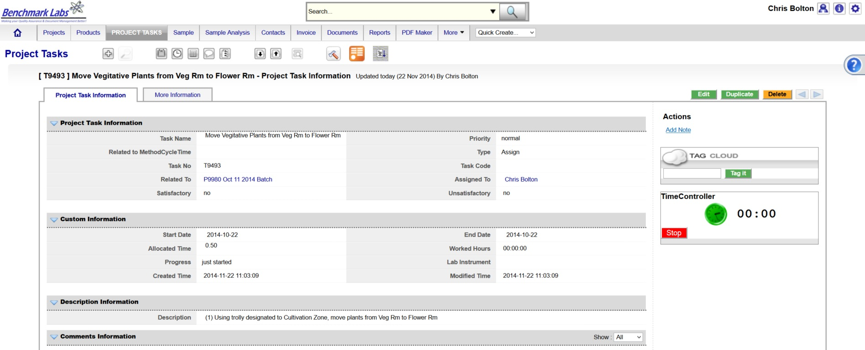
MMPR AREAS THAT INCLUDE PROCESSING, PACKAGING, ANALYZING, OR LABELING:
- Within each controlled MMPR Zone there are a number of Rooms that may require specific processing, packaging, analyzing, or labelling instructions. These individual processing, packaging, analyzing, or labelling instructions are provided as individual SOP's designed to each defined area (e.g., rooms).
Processing, Packaging, Analyzing, or Labelling MMPR Zone Areas:
- Production Area: GREEN ZONE shall include such areas as the Mother Room, Vegetative Room, and Flowing Room area.
- Production Area: BROWN ZONE shall include such areas as the Harvest/Cure Room, Package Room and Labelling Room area.
- Analysis & Storage Area: BLACK ZONE shall include such areas as the Laboratory Analysis Room, and Secure Storage Room area.
PLEASE NOTE: All equipment or instrumentation used for processing, packaging, analyzing, or labelling supplies for each MMPR ZONE is to be recorded as “Assets” in the Benchmark Labs SYSTEM pursuant to SOP0002 and carry an easy to identify specific Zone Colour Tag and marked “MMPR Zone” using Black Sharpie Pen to separate these processing, packaging, analyzing, or labelling tools from other processing, packaging, analyzing, or labelling Tools and Supplies designated for other Zones.
PLEASE NOTE: ONLY AUTHORIZED USERS AND STAFF ARE PERMITTED TO RECEIVE AND PERFORM processing, packaging, analyzing, or labelling PROJECT TASKS WITHIN THE MMPR ZONES.
PLEASE NOTE: BEFORE ANY PROCESSING ACTIVITY TAKES PLACE ENSURE THAT each area or room is clean and tidy, that all surfaces have been effectively sanitized, and that the Zone itself will be left in a condition that will not contaminate or otherwise introduce extraneous substances into the Medicinal Marijuana Processing Procedure SOP0003.
PLEASE NOTE: That all Premise processing, packaging, analyzing, or labelling Procedures for specific MMPR Zones shall require that any Medicinal Marijuana related debris or trash that is found shall be retrieved and placed into a Debris Bag and recorded directly into the Benchmark Labs SYSTEM – as such, it can NEVER be disposed of in the garbage as would NON-Medicinal Marijuana debris or trash AS PER SOP0001 CLEAN PREMISE.
PROCESSING, PACKAGING, ANALYZING, OR LABELLING PROCEDURE
- The step-by-step procedures for processing, packaging, analyzing, or labelling of Medicinal Marijuana is provided as individual work-flows within the Benchmark Labs SYSTEM:
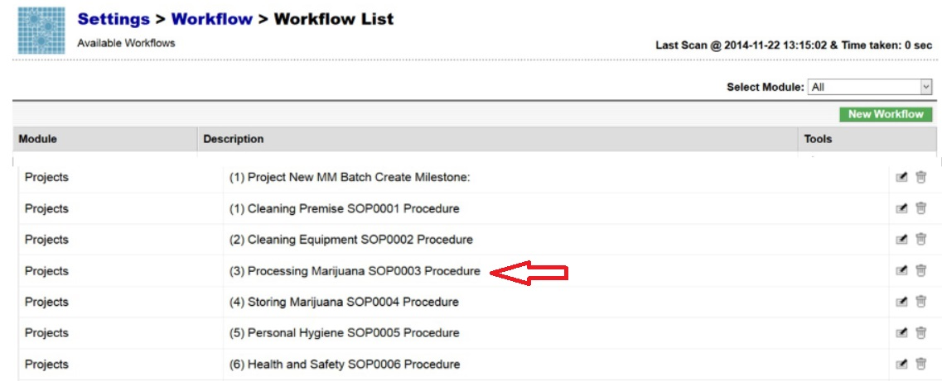
- The Benchmark Labs SYSTEM work-flows represent the Licensed Producers SOPs procedures that have been reviewed and accepted by the QAP for each processing area at the Licensed Location:

- The Benchmark Labs SYSTEM auto-generates these work-flows upon the creation of a new Batch/Lot of Medicinal Marijuana. This is done through the creation of a new “Project” within the Benchmark Labs SYSTEM that then auto-generates a unique Project Number to provide for a unique set of records associated with that particular Batch/Lot at this Licensed Location:
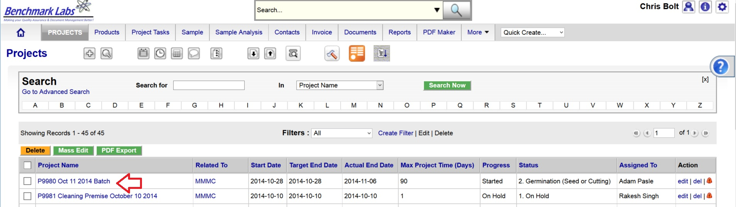
- Once a new Project has been entered into the Benchmark Labs SYSTEM, the SYSTEM auto-generates a series of “Project Milestones” associated with the procedures of processing, analyzing, packaging and labelling Medicinal Marijuana and assigns. These “Project Milestones” have estimated dates of completion to assist with Project planning and allocation of resources including personnel, assets and sundry supplies:
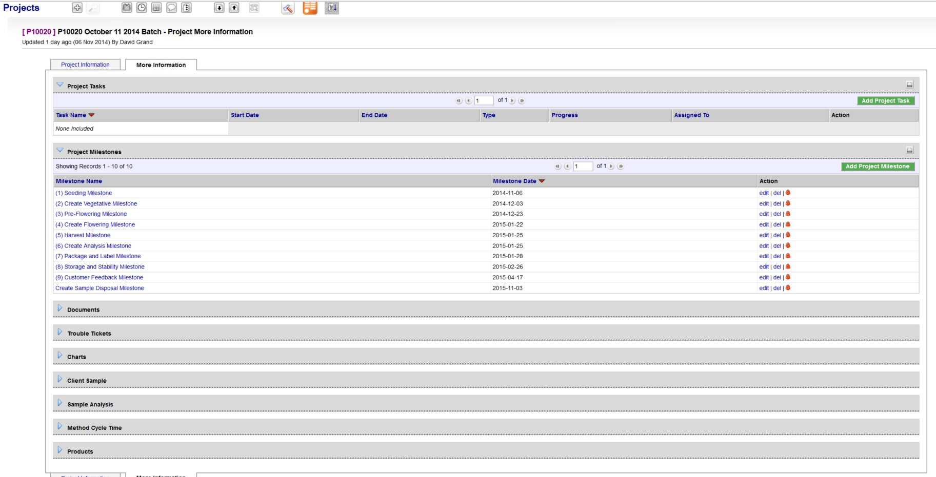
- A GANTT Chart Calendar showing the scheduled completion date of each Milestone is provided by clicking on the arrow symbol next to the “Charts” heading:
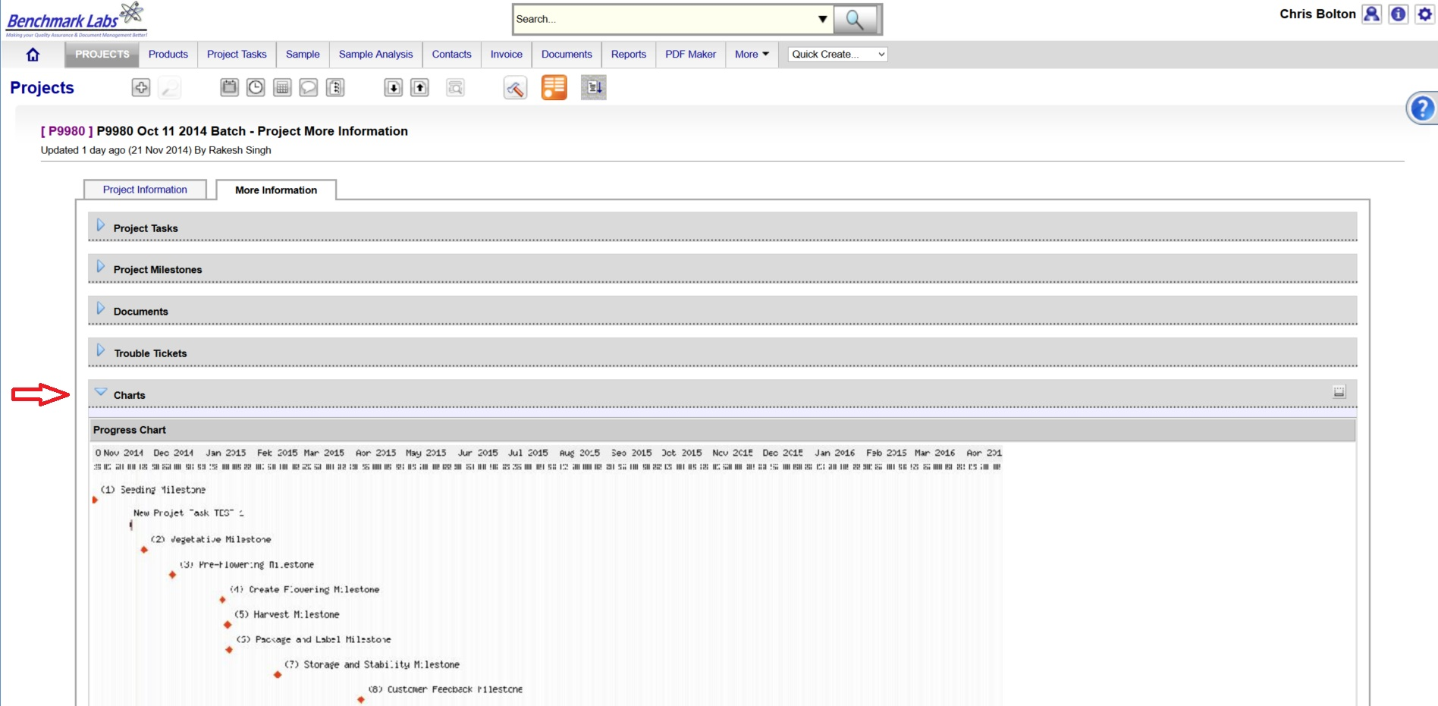
PLEASE NOTE: Clicking the GANTT Chart will open a new Browser Window. Clicking on the GANTT Chart in this new window will enable a “zoom in” on specific Project Milestones dates.
- For each Project Milestone, the Benchmark Labs SYSTEM auto-assigns “Project Tasks” that provide a consistent and logical order of tasks to be performed. Generic Project Tasks are provided by the Benchmark Labs SYSTEM to new SYSTEM Users that are then reviewed a customized by the QAP to better suite their specific Licensed Location.
PLEASE NOTE: All Project Tasks associated with processing, packaging, analyzing, or labelling shall be verified by the QAP as required to do so by SYSTEM Work-flow processing, packaging, analyzing, or labelling Verification Schedule and Corrective Action Report (CAR) Work-flows.
- Project Tasks are then assigned to authorized Users of the SYSTEM. The SYSTEM then provides those Users with notification of a “Start Date” and “End Date” as well as providing an allotment of “Allocated Time” measured in minutes, to complete those assigned tasks:

NOTE: processing, packaging, analyzing, or labelling shall be verified by the QAP as required to do so by SYSTEM Work-flow processing, packaging, analyzing, or labelling Verification Schedule and Corrective Action Report (CAR) Work-flows.
- The Benchmark Labs SYSTEM, prior to 24 hours of its proposed “Start Date”, shall auto-generate an e-mail to the assigned User notifying them of the Project Task, the Start Date, End Date, area or room that the Task is to take place and a description of work that is to be performed:
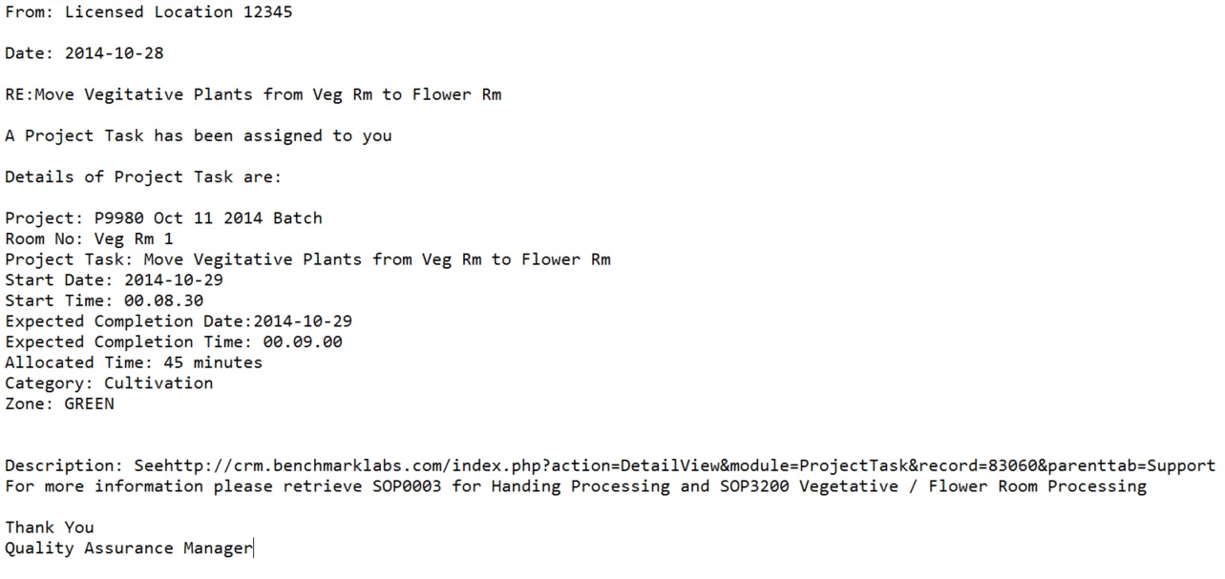
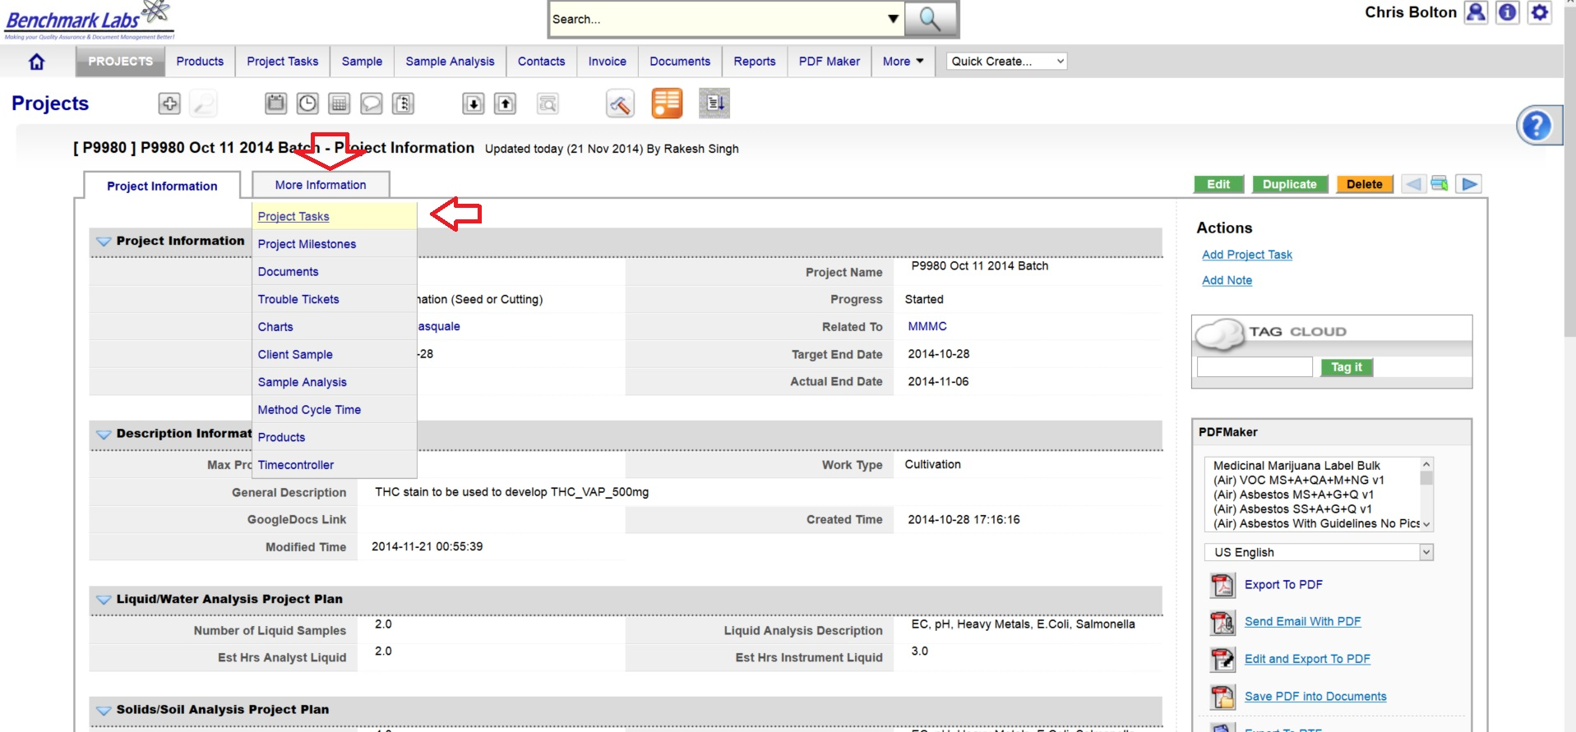
The assigned User can then proceed to open the Project Task either by clicking directly on the link found in the email or proceed directly to the Project (e.g., “P9980 Oct 11 2014 Batch”) to open a Project Task from the Project Module directly:
- To open a Project Task simply click on the link below the “Task Name” header:
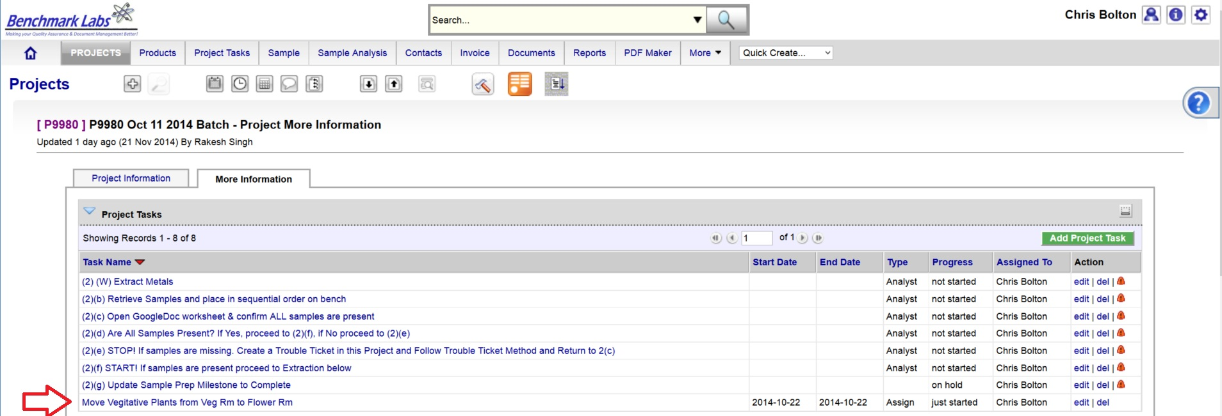
- The clock will then begin to record time spent on this Task until you hit the “Stop Button”:
PLEASE NOTE: Once a Project Task has been opened, the Time-Controller Clock begins recording the time it takes to complete this task. If the time taken is significantly greater or less than the “Allocated Time” value, an automatic Trouble Ticket will open to request explanation as for the cycle time difference (the root cause for the variation in time taken to complete Project Task). Therefore, it is critical that you do not open the Task until you are ready to begin and to then focus on the Task until it is done by clicking on the “STOP” button beside the clock.
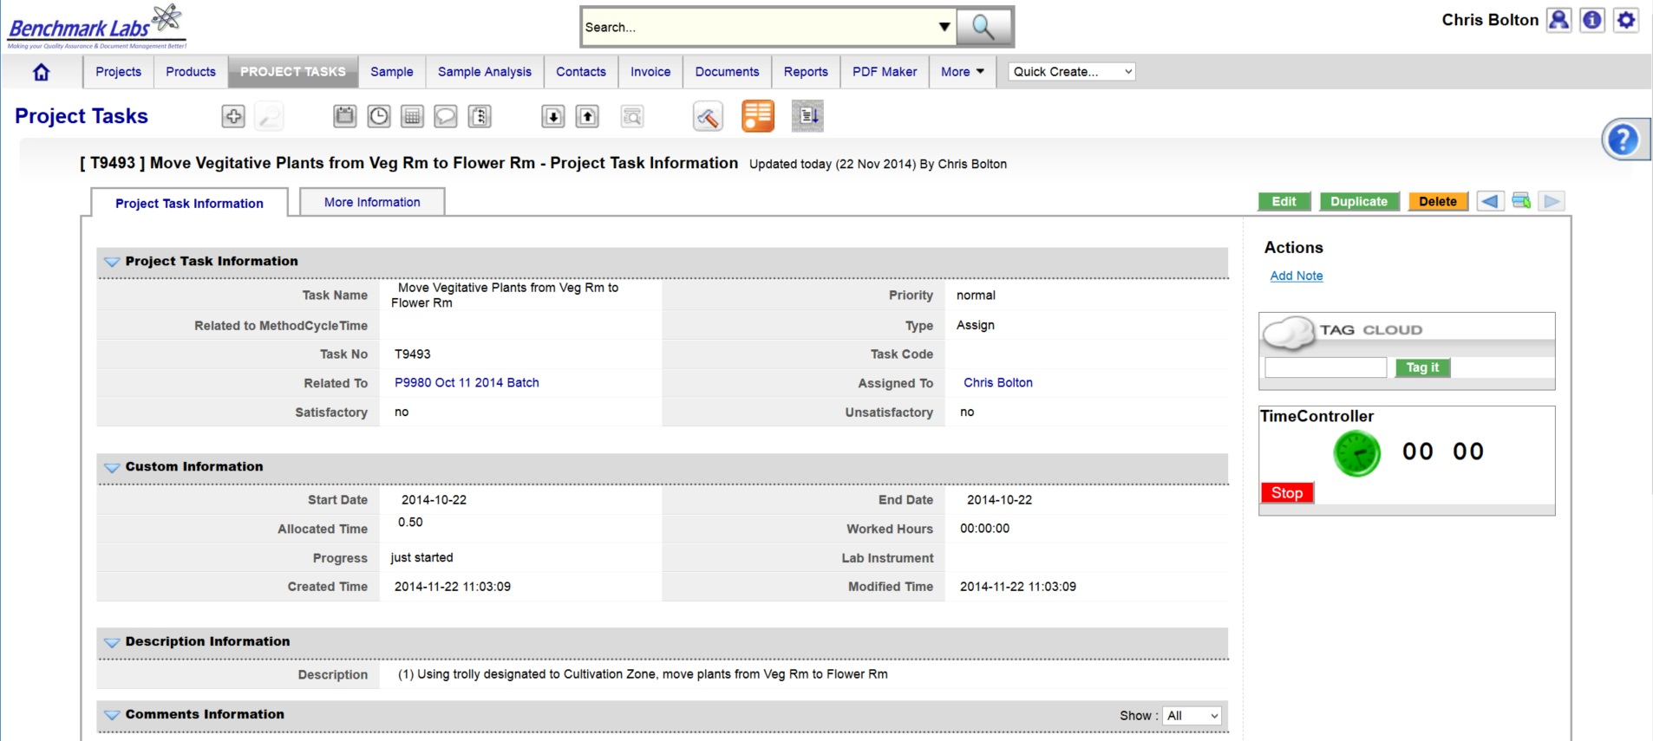

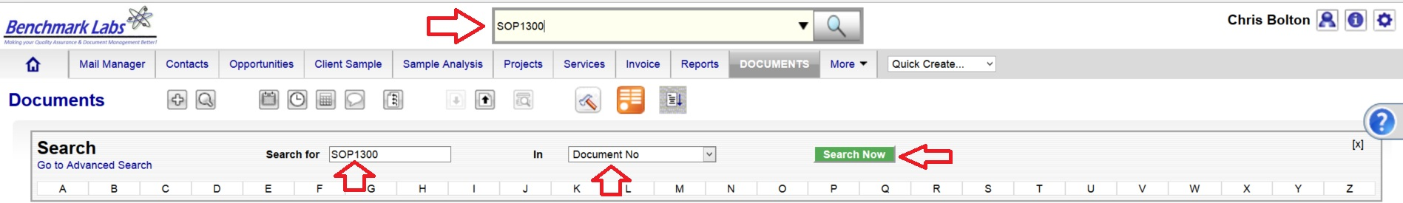
- In the event that the “Description” provided to the assigned User is not sufficient to complete this Project Task, the Assigned User can go directly to the individual SOP Document, by using either the Universal Search Box or using the “Search for” box found in the “Document” Module:

PLEASE NOTE: These SOP documents serve multiple purposes including how to set-up, operate, maintain and repair, clean and dispose of products when no longer usable.
PLEASE NOTE: A document in the SYSTEM can be deleted but only from the view of the average User. All documents Deleted from the SYSTEM are simply moved into “Archive” whereby they are still accessible by the SPIC and Government or Regulatory Auditor.
PROCESS OF PROCESSING, PACKAGING, ANALYZING, OR LABELLING CONFIRMATION & VERIFICTION PROCEDURE BY QAP:
- Once the processing, packaging, analyzing, or labelling Premise Project Task “Progress” status has been saved as “100%” the Benchmark Labs SYSTEM will auto-generate an email to the QAP the need to confirm and verify that processing, packaging, analyzing, or labelling was completed to acceptable standards as outline below. This procedure is governed by QAPSOP0100.

SUMMARY REPORTS:
- Summary Record Report for a list of all historical “Project Tasks” associated with SOP can be found by clicking on the “Project Task” Module:
- Summary Record Report for a list of Project Tasks performed for a specific area or zone (e.g., Harvest room) can be found by clicking on the “Project” Module and clicking on the Project associated with processing, packaging, analyzing, or labelling that specific room or zone, clicking on “More Information” and clicking on “Project Tasks”:
- Summary Record Report of a list of Trouble Tickets associated with this SOP can be found by clicking on the “Trouble Ticket” Module:
- Summary Report of scheduled processing, packaging, analyzing, or labelling and/or maintenance of the premise associated with this SOP can be found by clicking on the “Calendar” Module:

REFERENCES:
Author | Document Name | Published
Benchmark Labs | SOP0003 Handling Processing | January 24, 2016

