
THIS DOCUMENT IS OBSOLETE ON DATE OF PRINTING
SOP-3100 | TITLE: HANDLING PROCESSING SEED MOTHER ROOM | ^{Issued Date: January 24, 2016}
^{Supersedes: NEW} | TITLE: HANDLING PROCESSING SEED MOTHER ROOM | Effective Date: January 24, 2016
^{Initiator: Zach Yim} |   ^{Signature:} | ^{Date: January 24, 2016}
^{Reviewer:} | ^{Signature:} | ^{Date:}
^{QA Approval:} | ^{Signature:} | ^{Date:}

REVISION HISTORY:
Version # | Description of Changes | CC #
0 | New document

DOCUMENT OWNER: Quality Assurance Person (QAP)

AFFECTED PARTIES: All site staff who handle or process Medicinal Marijuana within the Seed Mother Room.
PURPOSE: To provide a Procedure for the Production, Handling and Processing of Medicinal Marijuana in the Seed Mother Room within the Licensed Location as well as to confirm a Procedure for Confirmation and Verification for the QAP that this procedure has been performed correctly.

DEFINITIONS:
- Authorized User: The person authorized to perform Project Tasks within the Benchmark Labs SYSTEM.
- Project Milestones: Are related to the group of “Project Tasks” associated with step-by-step instructions of Handling and Processing of Medicinal Marijuana in the Seed Mother Room within the Licensed Location.
SCOPE: This Procedure applies to the Handling, Processing, Packaging, and Labelling of Medicinal Marijuana conducted within the Seed Mother Room, a Green Zone, within the Licensed Location.
KEY WORDS IN SYSTEM: Production, handling, processing, seed, mother, clone, Section 57
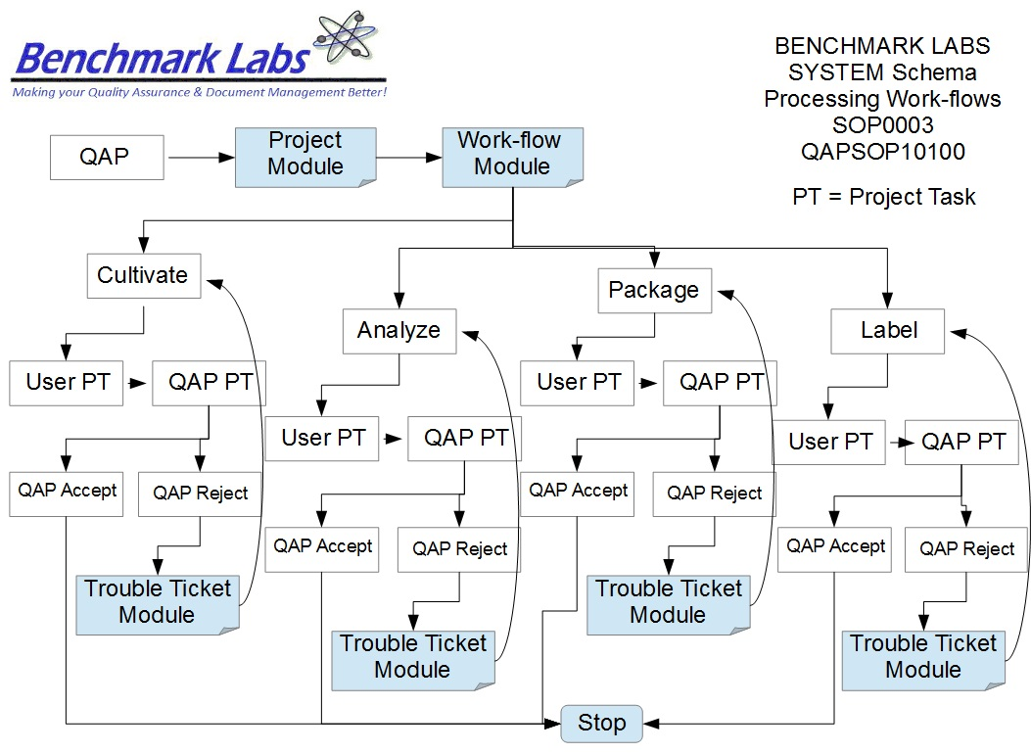

PROCEDURE PROCESS FLOW:

USER PERFORMANCE TASKS (PT) SOPs SPECIFIC TO MMPR ZONES:
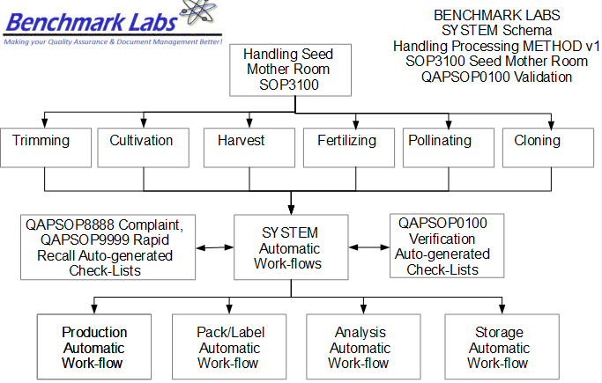
GENERAL RULES AND GMP REQUIREMENTS:
- The rules and GMP requirements apply equally to Contractors and Operations staff.

- All staff shall undergo an introductory walk though of the site, be trained on the use of specific procedures as they apply to specific zones within the site prior to being able to conduct any handling, processing, packaging, analyzing, or labelling activities.

- All handling, processing, packaging, analyzing, or labelling is to be supervised by the QAP, who must also record daily, weekly, monthly, quarterly and annual reports as required by the SYSTEM auto-work-flow tasks.

- Trouble Tickets must be used in the case of any failures in processing, packaging, analyzing, or labelling protocol observed by the QAP.

- Clean uniforms, factory shoes and hairnets or helmets must be worn as applicable in the particular areas. (All cleaners working in the Production areas must be familiar with the requirements of SOP0005 Hygiene).

- Equipment and Instruments used for handling, processing, packaging, analyzing, or labelling shall be clean and in proper working order prior to use. (Refer to SOP0002 Clean Equipment for more details.)

- No food or drink can be taken into any zone during any handling, processing, packaging, analyzing, or labelling procedures.

- NON-Medicinal Marijuana Debris or Rubbish shall be collected in either bins or bags and disposed of cleanly in the correct vessels. However, any Medical Marijuana Debris or Rubbish must be collected and stored in accordance with SOP0001 Clean Premise.

- Nothing shall ever be picked up from the floor and returned to any work surface without being fully cleaned and sterilized (unless it is a consumable product, in which case it should be disposed of accordingly).

- No container that comes in contact with product shall be placed directly on the floor.

- All processing, packaging, analyzing, or labelling Tasks shall be either auto-generated by the Benchmark Labs SYSTEM as “Project Tasks,” or manually entered as “Project Tasks” to ensure proper record entry and to ensure confirmation and verification of cleanliness has occurred.
- The QAP shall receive and complete auto-generated Project Tasks by the Benchmark Labs SYSTEM pursuant to QAPSOP0100 to ensure proper record entry and to ensure confirmation and verification of cleanliness has occurred.

- All problems shall be reported to the QAP and registered using the Trouble Ticket Module of the SYSTEM.

- All processing, packaging, analyzing, or labelling processing activities shall be performed only by Users of the Benchmark Labs SYSTEM who are deemed to be proficient in completing assigned SYSTEM Project Tasks.

- No processing, packaging, analyzing, or labelling processing activities may be conducted without recording those activities as “Project Tasks” in the Benchmark Labs SYSTEM.

REGULATORY REQUIREMENTS:
- Marijuana for Medical Purposes Regulations, Section 57, Division 4 Good Production Practices, October 2013).

TRAINING REQUIREMENTS: Read, understand and demonstrate proficiency training (PT) as indicated in the SYSTEM User Profile Record.
RELATED REQUIREMENTS: Read, understand and be familiar with the following related documents:
- SOP3100 Process Seed / Mother Room
- SOP3200 Process Vegetative / Flower Room
- SOP3300 Process Harvest / Cure Room
- SOP3400 Process Lab Analysis Room
- SOP3500 Process Packaging / Label Room
- SOP3600 Process Storage Room
- QAPSOP0100 Confirming and Verification of handling, processing, packaging, analyzing, or labelling & Maintenance Tasks
- SOP0001 Clean Premise
- SOP0002 Clean Equipment
- SOP0004 Handling Storage
- SOP0005 Health & Safety Hygiene
- SOP2600 Vault

AUTO-GENERATED WORKFLOW(S) REQUIRED TO RECORD LOG:
- WKFL0001: Assign Authorized User, Project Task, Record Date/Time Completed
- QAP0001: Assign Authorized User, Inspection Log, Record Date/Time Completed
- CAR0001: Description of Trouble Ticket auto-generated and emailed to QAP
SAFETY REQUIREMENTS:
- Refer to the relevant Material Safety Data Sheets for materials being used for handling, processing, packaging, analyzing, or labelling.
- Refer to SOP0004 in relation to Storage to be used for all materials.
- Refer to SOP0005 in relation to Hygiene, Health and Clothing to be used.
- Refer to SOP0006 in relation to Safety during processing, packaging, analyzing, or labelling.
GENERAL MATERIALS REQUIRED:
- Wireless device to log-in to Benchmark Labs SYSTEM.
- Food Grade Nitrile Gloves, Clean Suit, Boots, Boot Covers, Hair Net, Protective Eye Wear.
- Utilize only the assigned equipment or instruments to each designated Zone.

MATERIALS REQUIRED: SEED PROPAGATION
- 5gal bucket or equivalent reservoir
- Package of seeds
- Started medium (Rockwool cubes, Peat cups, etc.)
- 2-propagation trays, one with and one without perforation
- 1-propagation dome
- 1-propagation tray heating mat
- Required nutrients, as per the QAP and Master Grower’s schedule
- Reverse osmosis treated or otherwise filtered water

PROCESSING: SEED PROPOGATION
- Prepare the required nutrient solution, and adjust for pH, as per the formula created by the Master Grower and the QAP
- Moisten the chosen medium
- Place the perforated propagation tray on top of the non-perforated tray
- Place heating element beneath propagation tray
- Lay enough propagation medium to receive the required amount of seeds upon the propagation trays
- Each medium will have a small depression in which the seeds can be placed and covered, making sure the seed is not exposed to light
- Once all seeds have been placed within their respective media, the propagation dome can be placed over the tray
- The tray is then be placed within the propagation (Seed/Mother) room, under the light specified by the QAP and Master Grower
- Leave the propagation tray under light, making sure to maintain the moisture levels in the propagation medium, for between 5-14 days, at which point small stalks sprouting 2 small proto-leaves will emerge from each seed spot
- When the stalks have emerged, it is then time to remove the propagation dome, and place each sprouted seedling in a larger medium, according to the QAP and Master Grower’s instructions
- Adjust lights to proper levels using Adjusting Light Levels sub-task
- Begin the next stage of the cycle: Mother plants.
MATERIALS REQUIRED: PROCESSING MOTHERS
- Cultivation medium (coco, soil mixture, hydroponic rock, etc.)
- Reverse-osmosis or otherwise filtered water
- Plant training stakes (bamboo, fiberglass, etc.)
- Plant training wire
- Required nutrients, as per Master Grower’s schedule
- Pruning shears
- pH/ppm/temp meter

PROCESSING: PLANTING MOTHERS
- Prepare required medium, as per the QAP and Master Grower's instructions
- Prepare required nutrient solution, as per the QAP and Master Grower's instructions
- Using either the sprouted seedling or rooted clone (see SOP3100/process/cloning) gently place each shoot within its required medium, as per the QAP and Master Grower's instructions
- Moisten medium with required nutrient solution, and place under specified lighting
- Perform Adjusting Light Levels sub-task
PROCESSING: MAINTAINING MOTHERS
- Maintain proper moisture levels at all times in growth medium, as per the QAP and Master Grower's instructions
- Mother plants required a minimum of 18 hours of light every 24 hours
- When each Mother plant reaches the predesigned level, they will be pruned at the peak of each branch, the top 1 or 2 nodes being removed as per master growers requirements
- Individual branches are staked and trained as each Mother Plant develops, to create an increase in overall node production
- Mother plants can be cloned once the plant has developed a sufficient number of available cuttings
- Perform the Pruning sub-task as needed
- Continuously check plants for pests and other contaminates
- Mother plants should be replaced with fresh cuttings every 6 months, using either the Seed process described above, or the cloning process described in SOP3200
- Continue to perform Adjusting Light Levels sub-task as needed
PLEASE NOTE: All supplies, equipment or instrumentation used for handling or processing within the Seed Mother Room is to be recorded as “Assets” in the Benchmark Labs SYSTEM pursuant to SOP0002 and carry an easy to identify specific Green Zone Colour Tag and marked “Seed Mother Room” using Black Sharpie Pen to separate these tools from those designated for use in other Zones.
PLEASE NOTE: ONLY AUTHORIZED USERS AND STAFF ARE PERMITTED TO RECEIVE AND PERFORM PROJECT TASKS WITHIN THE SEED MOTHER ROOM THAT REQUIRE EITHER HANDLING OR PROCESSING.
PLEASE NOTE: BEFORE ANY PROCESSING ACTIVITY TAKES PLACE ENSURE THAT the room is clean and tidy, that all surfaces have been effectively sanitized, and that the Seed Mother Room itself will be left in a condition that will not contaminate or otherwise introduce extraneous substances into the Medicinal Marijuana Processing Procedure SOP0003.
PLEASE NOTE: That all Premise handling or processing Procedures for the Seed Mother Room shall require that any Medicinal Marijuana related debris or trash that is found, be retrieved and placed into a Debris Bag and recorded directly into the Benchmark Labs SYSTEM – as such, it can NEVER be disposed of in the garbage as would NON-Medicinal Marijuana debris or trash AS PER SOP0001 CLEAN PREMISE.
HANDLING, PROCESSING PROCEDURE
- The step-by-step procedures for handling or processing of Medicinal Marijuana is provided as individual work-flows within the Benchmark Labs SYSTEM:
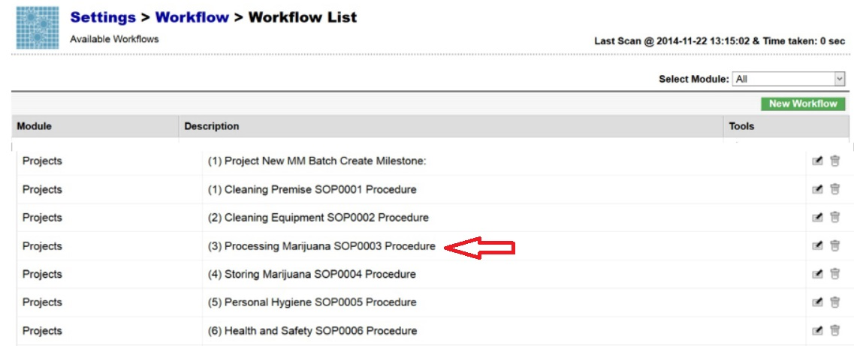
- The Benchmark Labs SYSTEM work-flows represent the Licensed Producers SOPs procedures that have been reviewed and accepted by the QAP for each processing area at the Licensed Location:

- The Benchmark Labs SYSTEM auto-generates these work-flows upon the creation of a new Batch/Lot of Medicinal Marijuana. This is done through the creation of a new “Project” within the Benchmark Labs SYSTEM that then auto-generates a unique Project Number to provide for a unique set of records associated with that particular Batch/Lot at this Licensed Location:
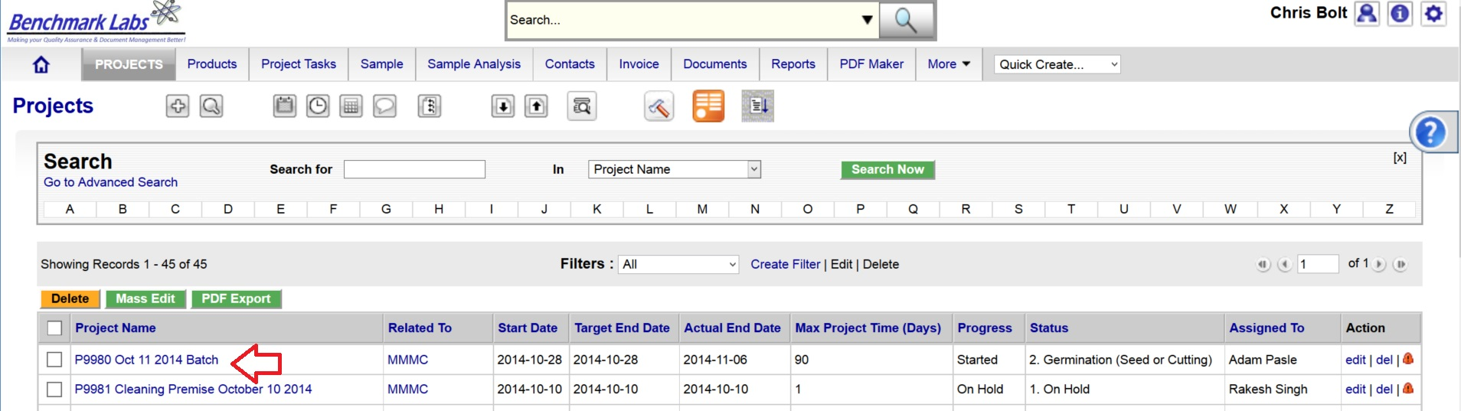
- Once a new Project has been entered into the Benchmark Labs SYSTEM, the SYSTEM auto-generates a series of “Project Milestones” associated with the procedures of handling and processing of Medicinal Marijuana and assigns. These “Project Milestones” have estimated dates of completion to assist with Project planning and allocation of resources including personnel, assets and sundry supplies:
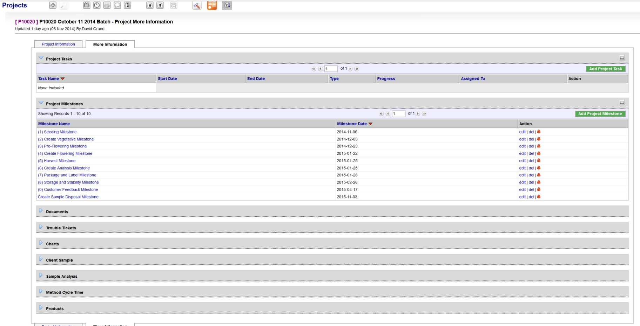
- A GANTT Chart Calendar showing the scheduled completion date of each Milestone is provided by clicking on the arrow symbol next to the “Charts” heading:
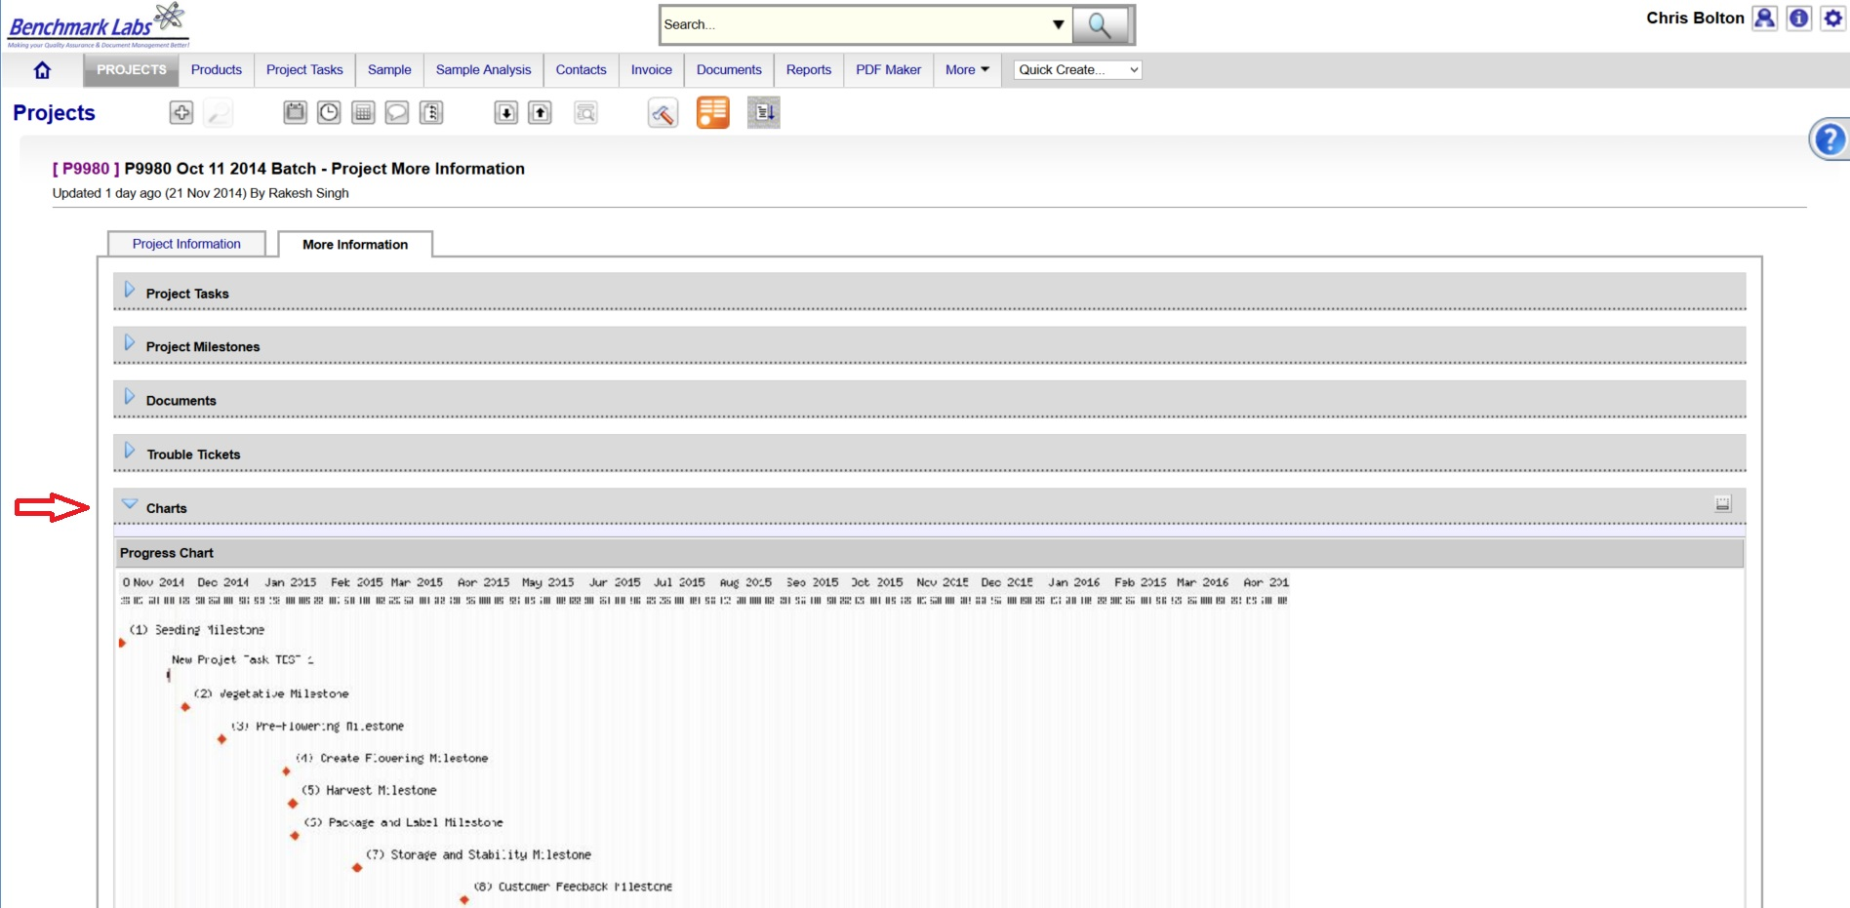
PLEASE NOTE: Clicking the GANTT Chart will open a new Browser Window. Clicking on the GANTT Chart in this new window will enable a “zoom in” on specific Project Milestones dates.
- For each Project Milestone, the Benchmark Labs SYSTEM auto-assigns “Project Tasks” that provide a consistent and logical order of tasks to be performed. Generic Project Tasks are provided by the Benchmark Labs SYSTEM to new SYSTEM Users that are then reviewed and customized by the QAP to better suit their specific Licensed Location.
PLEASE NOTE: All Project Tasks associated with handling or processing shall be verified by the QAP as required to do so by SYSTEM Work-flow handling or processing Verification Schedule and Corrective Action Report (CAR) Work-flows.
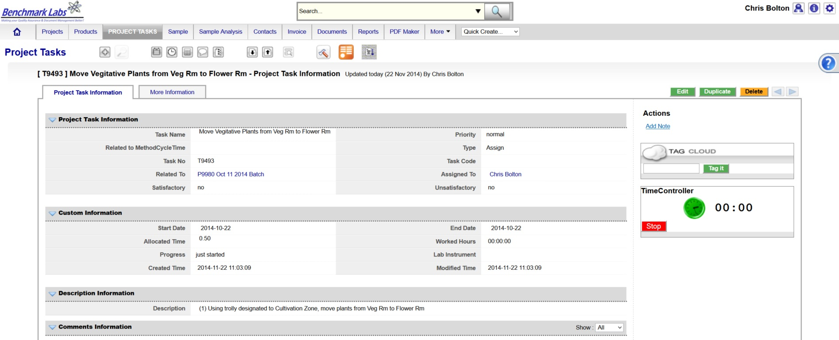
- Project Tasks are then assigned to authorized Users of the SYSTEM. The SYSTEM then provides those Users with notification of a “Start Date” and “End Date” as well as providing an allotment of “Allocated Time” measured in minutes, to complete those assigned tasks:

NOTE: Handling or processing within the Seed Mother Room shall be verified by the QAP as required to do so by SYSTEM Work-flow processing, packaging, analyzing, or labelling Verification Schedule and Corrective Action Report (CAR) Work-flows.
- The Benchmark Labs SYSTEM, prior to 24 hours of its proposed “Start Date”, shall auto-generate an e-mail to the assigned User notifying them of the Project Task, the Start Date, End Date, area or room that the Task is to take place and a description of work that is to be performed:
From: Licensed Location 123145

Date: 2015-03-05

RE: Begin propagation of strain XXX

A Project Task has been Assigned to You

Details of the Project Task are:

Location: Seed Mother Room
Project: P10028 SOP3100 Handling Seed Mother Room
Start Date: 2015-03-05
Start Time: 00.09.30
Expected Completion Date: 2015-03-05
Expected Completion Time: 00.16.30
Allocated Time: 420 minutes
Category: QC
Zone: Green
Description: Please visit http://crm.benchmarklabs.com/ndex.php?module=Assets&parent

Thank You
Quality Assurance Manager
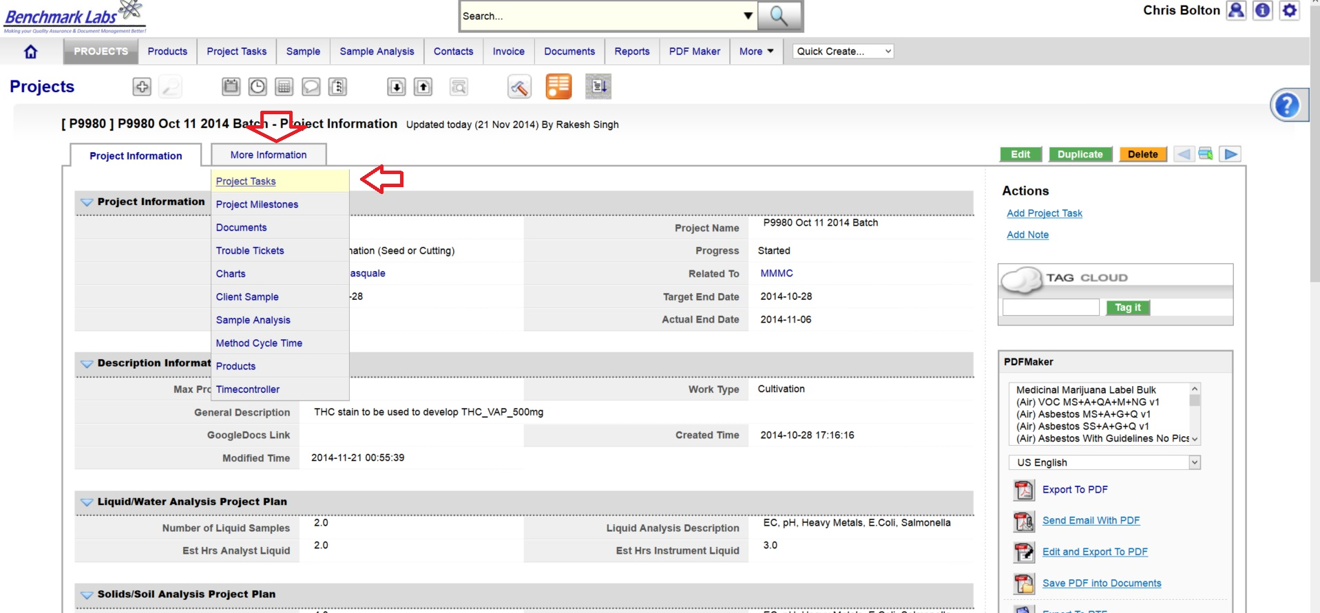
The assigned User can then proceed to open the Project Task either by clicking directly on the link found in the email or proceed directly to the Project (e.g., “P9980 Oct 11 2014 Batch”) to open a Project Task from the Project Module directly:
- To open a Project Task simply click on the link below the “Task Name” header:
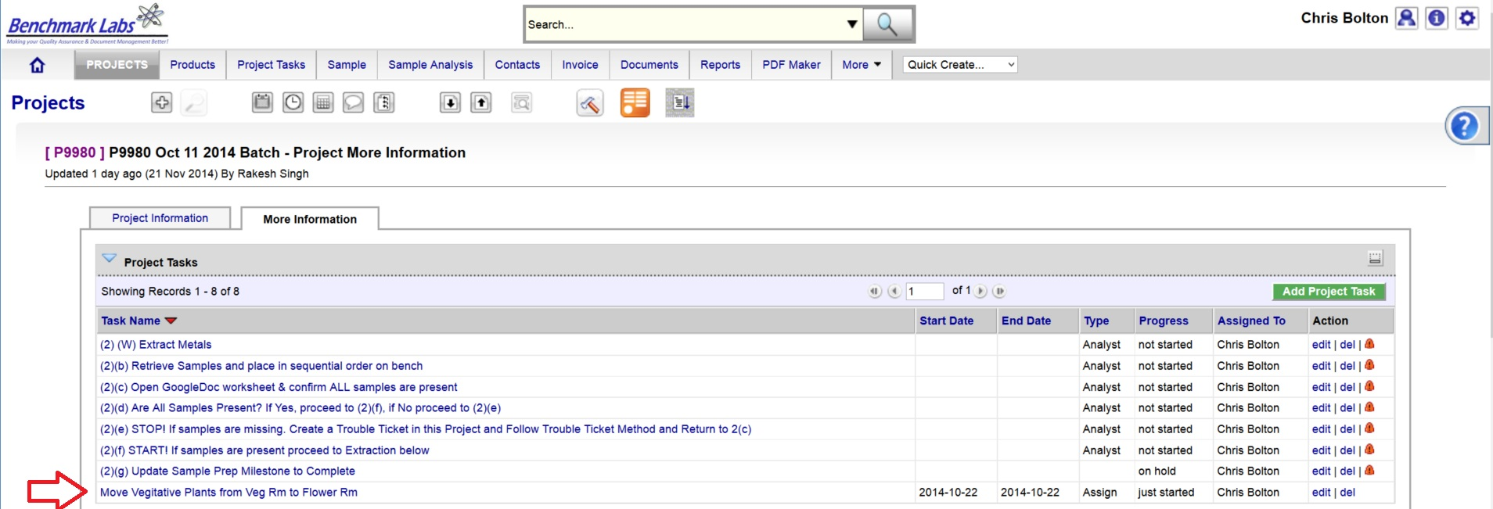
- The clock will then begin to record time spent on this Task until you hit the “Stop Button”:
PLEASE NOTE: Once a Project Task has been opened, the Time-Controller Clock begins recording the time it takes to complete this task. If the time taken is significantly greater or less than the “Allocated Time” value, an automatic Trouble Ticket will open to request explanation for the cycle time difference (the root cause for the variation in time taken to complete Project Task). Therefore, it is critical that you do not open the Task until you are ready to begin and to then focus on the Task until it is done by clicking on the “STOP” button beside the clock.
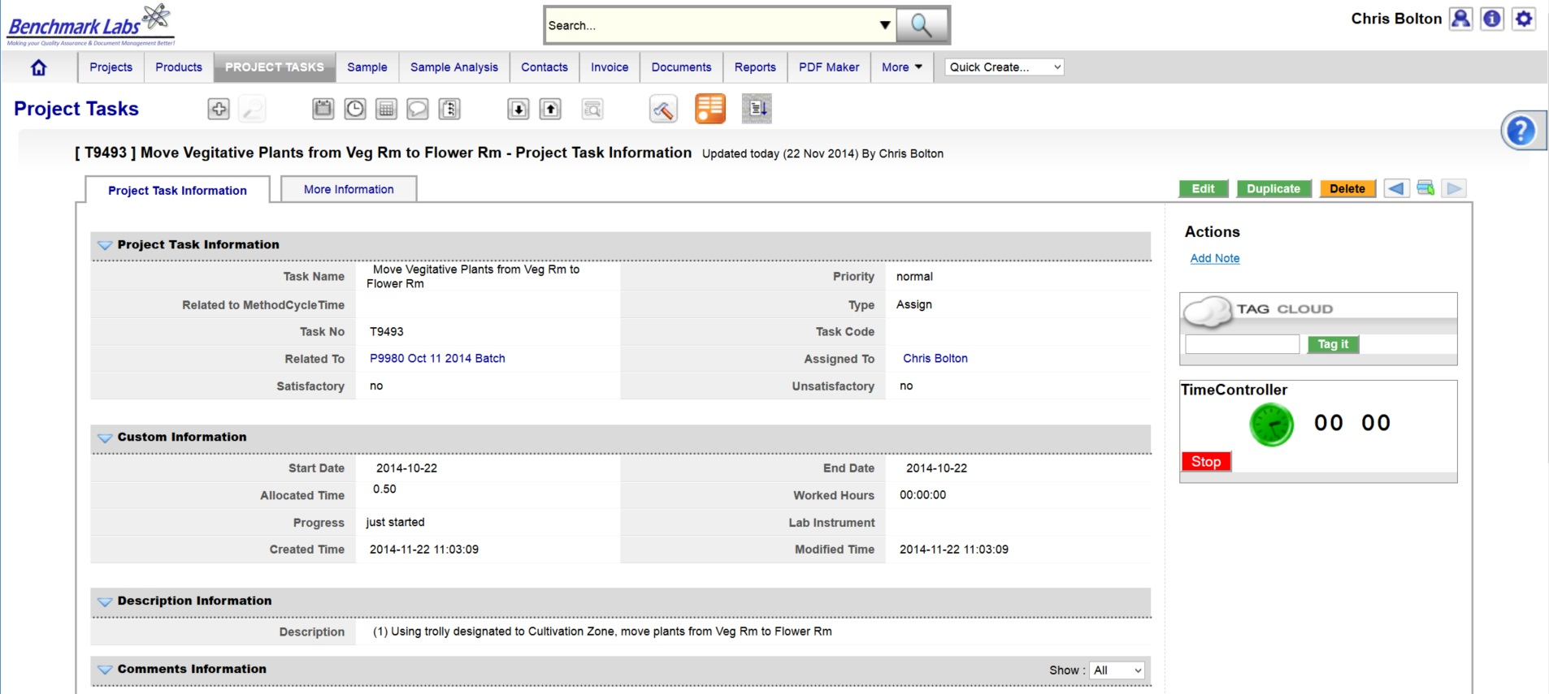
- In the event that the “Description” provided to the assigned User is not sufficient to complete this Project Task, the Assigned User can go directly to the individual SOP Document, by using either the Universal Search Box or using the “Search for” box found in the “Document” Module:

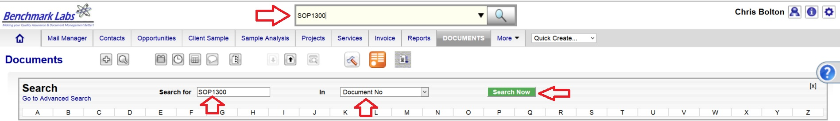
PLEASE NOTE: These SOP documents serve multiple purposes including how to set-up, operate,
maintain and repair, clean and dispose of products when they are no longer usable.
PLEASE NOTE: A document in the SYSTEM can be deleted but only from the view of the average User. All documents Deleted from the SYSTEM are simply moved into “Archive” whereby they are still accessible by the SPIC and Government or Regulatory Auditor.
PROCESS OF HANDLING OR PROCESSING CONFIRMATION & VERIFICTION PROCEDURE BY QAP:
- Once the handling or processing Premise Project Task “Progress” status has been saved as “100%,” the Benchmark Labs SYSTEM will auto-generate an email to the QAP with the need to confirm and verify that handling or processing was completed to acceptable standards as outline below. This procedure is governed by QAPSOP0100.

SUMMARY REPORTS:
- Summary Record Report for a list of all historical “Project Tasks” associated with this SOP can be found by clicking on the “Project Task” Module:
- Summary Record Report for a list of Project Tasks performed for the Seed Mother Room can be found by clicking on the “Project” Module and clicking on the Project associated with handling or processing that is specific to a room or zone, clicking on “More Information” and clicking on “Project Tasks”:
- Summary Record Report of a list of Trouble Tickets associated with this SOP can be found by clicking on the “Trouble Ticket” Module:
- Summary Report of scheduled handling or processing and/or maintenance of the premise associated with this SOP can be found by clicking on the “Calendar” Module:

REFERENCES:
Author | Document Name | Published
Benchmark Labs | SOP0003 Handling Processing | January 24, 2016

