
THIS DOCUMENT IS OBSOLETE ON DATE OF PRINTING
SOP-3200 | TITLE: HANDLING VEG. FLOWER ROOM | ^{Issued Date: January 24, 2016}
^{Supersedes:} New | TITLE: HANDLING VEG. FLOWER ROOM | Effective Date: January 24, 2016
^{Initiator: Zach Yim} |   ^{Signature:} | ^{Date: January 24, 2016}
^{Reviewer:} | ^{Signature:} | ^{Date:}
^{QA Approval:} | ^{Signature:} | ^{Date:}

REVISION HISTORY:
Version # | Description of Changes | CC #
0 | New document

DOCUMENT OWNER: Quality Assurance Person (QAP)

AFFECTED PARTIES: All site staff who handle and/or process Medicinal Marijuana.
PURPOSE: To provide a Procedure for the Handling and Processing of Medicinal Marijuana in the Vegetative Flower Room within the Licensed Location as well as to confirm a Procedure for Confirmation and Verification for the QAP that this procedure has been performed correctly.

DEFINITIONS:
- Authorized User: The person authorized to perform Project Tasks within the Benchmark Labs SYSTEM.
- Project Milestones: Step-by-step instructions of Handling and Processing of Medicinal Marijuana in the Vegetative Flower room within the Licensed Location that are related to the “Project Tasks” requiring Handling or Processing.
SCOPE: This Procedure applies to the Handling and Processing Medicinal Marijuana conducted within the Vegetative Flower Room at the Licensed Location.
KEY WORDS IN SYSTEM: Handling, processing, storage, cultivation, vegetative, flower, Zone, clone, Section 57
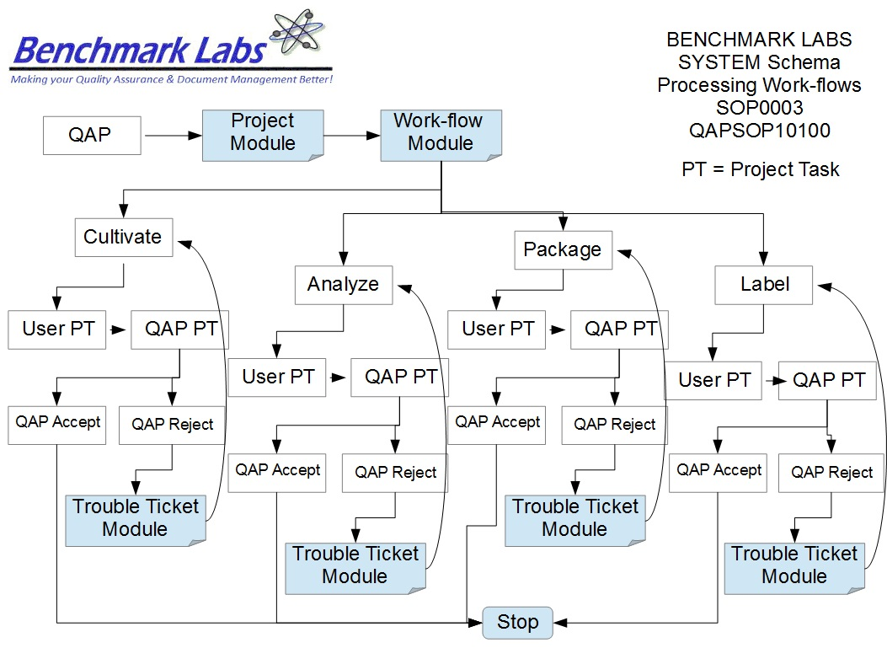

GENERAL
PROCEDURE PROCESS FLOW:

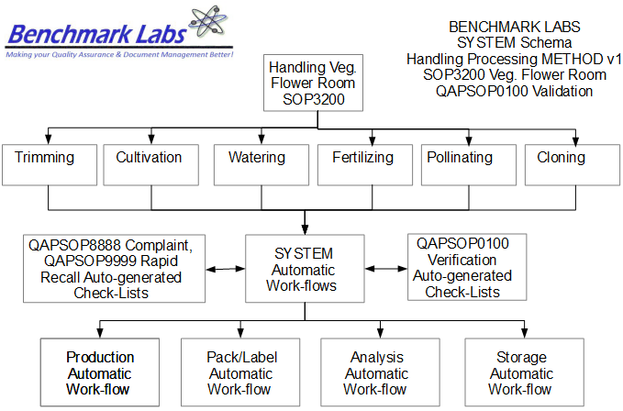
USER PERFORMANCE TASKS (PT) SOPs SPECIFIC TO MMPR ZONES:
GENERAL RULES AND GMP REQUIREMENTS:
- The rules and GMP requirements apply equally to Contractors and Operations staff.

- All staff shall undergo an introductory walk though of the site, be trained on the use of specific procedures as they apply to specific zones within the site prior to being able to conduct any handling or processing.

- All handling or processing is to be supervised by the QAP, who must also record daily, weekly, monthly, quarterly and annual reports as required by the SYSTEM auto-work-flow tasks.

- Trouble Tickets must be used in the case of any failures in handling or processing protocol observed by the QAP.

- Clean uniforms, factory shoes and hairnets or helmets must be worn as applicable in the particular areas. (All cleaners working in the Production areas must be familiar with the requirements of SOP0005 Hygiene.)

- Equipment and Instruments used for handling or processing shall be clean and in proper working order prior to use. (Refer to SOP0002 Clean Equipment for more details.)

- No food or drink can be taken into any zone during the handling or processing process.

- NON-Medicinal Marijuana Debris or Rubbish shall be collected in either bins or bags and disposed of cleanly in the correct vessels. However, any Medical Marijuana Debris or Rubbish must be collected and stored in accordance with SOP0001 Clean Premise.

- Nothing shall ever be picked up from the floor and returned to any work surface without being fully cleaned and sterilized (unless it is a consumable product, in which case it should be disposed of accordingly).

- No container that comes in contact with product shall be placed directly on the floor.

- All handling or processing Tasks shall be either auto-generated by the Benchmark Labs SYSTEM as “Project Tasks,” or manually entered as “Project Tasks” to ensure proper record entry and to ensure confirmation and verification of cleanliness has occurred.
- The QAP shall receive and complete auto-generated Project Tasks by the Benchmark Labs SYSTEM pursuant to QAPSOP0100 to ensure proper record entry and to ensure confirmation and verification of cleanliness has occurred.

- All problems shall be reported to the QAP and registered using the Trouble Ticket Module of the SYSTEM.

- All handling or processing processing activities shall be performed only by Users of the Benchmark Labs SYSTEM who are deemed to be proficient in completing assigned SYSTEM Project Tasks.

- No handling or processing processing activities may be conducted without recording those activities as “Project Tasks” in the Benchmark Labs SYSTEM.

REGULATORY REQUIREMENTS:
- Marijuana for Medical Purposes Regulations, Section 57, Division 4 Good Production Practices, October 2013).

TRAINING REQUIREMENTS: Read, understand and demonstrate proficiency training (PT) as indicated in the SYSTEM User Profile Record.
RELATED REQUIREMENTS: Read, understand and be familiar with the following related documents:
- SOP3100 Process Seed / Mother Room
- SOP3200 Process Vegetative / Flower Room
- SOP3300 Process Harvest / Cure Room
- SOP3400 Process Lab Analysis Room
- SOP3500 Process Packaging / Label Room
- SOP3600 Process Storage Room
- QAPSOP0100 Confirming and Verification of handling or processing & Maintenance Tasks
- SOP0001 Clean Premise
- SOP0002 Clean Equipment
- SOP0004 Handling Storage
- SOP0005 Health & Safety Hygiene
- SOP2600 Vault

AUTO-GENERATED WORKFLOW(S) REQUIRED TO RECORD LOG:
- WKFL0001: Assign Authorized User, Project Task, Record Date/Time Completed
- QAP0001: Assign Authorized User, Inspection Log, Record Date/Time Completed
- CAR0001: Description of Trouble Ticket auto-generated and emailed to QAP
SAFETY REQUIREMENTS:
- Refer to the relevant Material Safety Data Sheets for materials being used for handling or processing.
- Refer to SOP0004 in relation to Storage to be used for all materials.
- Refer to SOP0005 in relation to Hygiene, Health and Clothing to be used.
- Refer to SOP0006 in relation to Safety during handling or processing.
GENERAL MATERIALS REQUIRED:
- Wireless device to log-in to Benchmark Labs SYSTEM.
- Food Grade Nitrile Gloves, Clean Suit, Boots, Boot Covers, Hair Net, Protective Eye Wear.
- Utilizing only the assigned equipment or instruments designated to the Green Zone.

MATERIALS REQUIRED: VEGETATIVE GROWTH
- Grow medium (QAP/Master grower approved) with proper containers
- Nutrient schedule determined by the Master Grower
- Filtered water
- Proper sized nutrient reservoir
- Air Pumps with air diffusers
- 6in x 6in plant-safe netting
- Zip ties with minimum 40lb rating
- Pruning Shears
- pH/ppm/temp meter
- pH adjustment solution
- Plant training stakes
- Plant-safe training wire
- Plant labels/pen

PROCESSING: VEGETATIVE GROWTH
- Fill the required amount of grow containers with the proper amount of grow medium
- Using the Mixing Nutrient Reservoirs sub-task, mix the required nutrient solution, as per the schedule laid out by the QAP and the Master Grower
- Place one rooted clone in each grow medium container, and cover
- Water the grow medium with the nutrient solution immediately following planting the clone, and then continue to water each according the aforementioned vegetative growth schedule
- Perform the Netting sub-task on the schedule dictated by the QAP and Master Grower
- Perform the Plant Training sub-task as needed throughout the vegetative stage
- Perform the Adjusting Light Level sub-task as determined by plant growth and the Master Grower’s schedule
- Perform the Defoliation sub-task throughout the vegetative cycle as needed
- Continuously check plants for pests and other contaminates
- Once each batch of vegetative plants has completed the growth cycle determined by the Master Grower, the plants can then be moved into the next stage of growth; the flowering cycle
MATERIALS REQUIRED: FLOWERING
- Grow medium with proper containers
- Nutrient schedule determined by the Master Grower
- Filtered water
- Proper sized nutrient reservoir
- Air Pumps with air diffusers
- 15 cm x 15 cm plant-safe netting
- Zip ties with minimum 18 kg rating
- Pruning Shears
- pH/ppm/temp meter
- pH adjustment solution
- Plant training stakes
- Plant-safe training wire
- Plant labels/pen

PROCESSING: FLOWERING
- When plants have reached the end of the vegetative cycle, they can then be moved into the flowering room
- Place the proper amount of plants under each light to create a sufficient sized canopy, as per the instructions of the QAP and Master Grower
- Using the Mixing Nutrient Reservoirs sub-task, mix the required nutrient solution, as per the QAP and Master Grower’s schedule
- Begin to utilize the Flowering Nutrient schedule, as determined by the QAP and Master Grower once the flowering stage has begun
- Water the grow media, and maintain proper moisture levels according to the QAP and Master Grower's specifications throughout the flowering cycle
- Perform the Netting sub-task on the schedule dictated by the QAP and Master Grower
- Perform the Plant Training sub-task as needed throughout the vegetative stage
- Perform the Adjusting Light Level sub-task as determined by plant growth and the in schedule
- Perform the Defoliation sub-task throughout the vegetative cycle as needed
- Perform the Flush cycle Defoliation routine in the final 2 weeks of the flowering period
- Continuously check plants for pests and other contaminates
- Once the flowering cycle is determined to be complete, the plants can move to the Harvest stage of the growth cycle (refer to SOP3300)
PLEASE NOTE: All equipment or instrumentation used for handling or processing supplies for the Veg. Flower Room is to be recorded as “Assets” in the Benchmark Labs SYSTEM pursuant to SOP0002 and carry an easy to identify specific Green Zone Colour Tag and marked “Veg. Flower Room” using a Black Sharpie Pen to separate these handling or processing tools from other handling or processing Tools and Supplies designated for other Zones.
PLEASE NOTE: ONLY AUTHORIZED USERS AND STAFF ARE PERMITTED TO RECEIVE AND PERFORM handling or processing PROJECT TASKS WITHIN THE MMPR ZONES.
PLEASE NOTE: BEFORE ANY PROCESSING ACTIVITY TAKES PLACE ENSURE THAT each area or room is clean and tidy, that all surfaces have been effectively sanitized, and that the Zone itself will be left in a condition that will not contaminate or otherwise introduce extraneous substances into the Medicinal Marijuana Processing Procedure SOP0003.
PLEASE NOTE: That all Premise handling or processing Procedures for specific MMPR Zones shall require that any Medicinal Marijuana related debris or trash that is found shall be retrieved and placed into a Debris Bag and recorded directly into the Benchmark Labs SYSTEM – as such, it can NEVER be disposed of in the garbage as would NON-Medicinal Marijuana debris or trash AS PER SOP0001 CLEAN PREMISE.
HANDLING OR PROCESSING PROCEDURE
- The step-by-step procedures for handling or processing of Medicinal Marijuana is provided as individual work-flows within the Benchmark Labs SYSTEM:
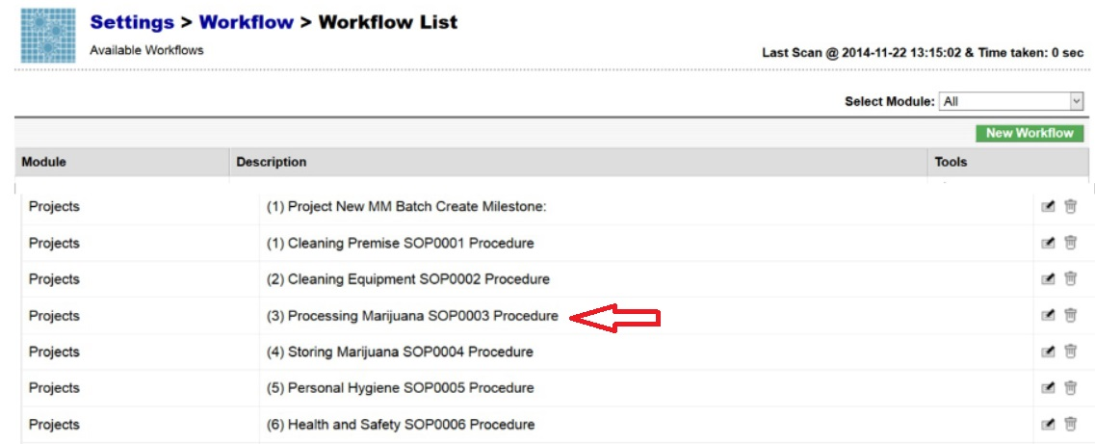
- The Benchmark Labs SYSTEM work-flows represent the Licensed Producers SOPs procedures that have been reviewed and accepted by the QAP for each processing area at the Licensed Location:

- The Benchmark Labs SYSTEM auto-generates these work-flows upon the creation of a new Batch/Lot of Medicinal Marijuana. This is done through the creation of a new “Project” within the Benchmark Labs SYSTEM that then auto-generates a unique Project Number to provide for a unique set of records associated with that particular Batch/Lot at this Licensed Location:
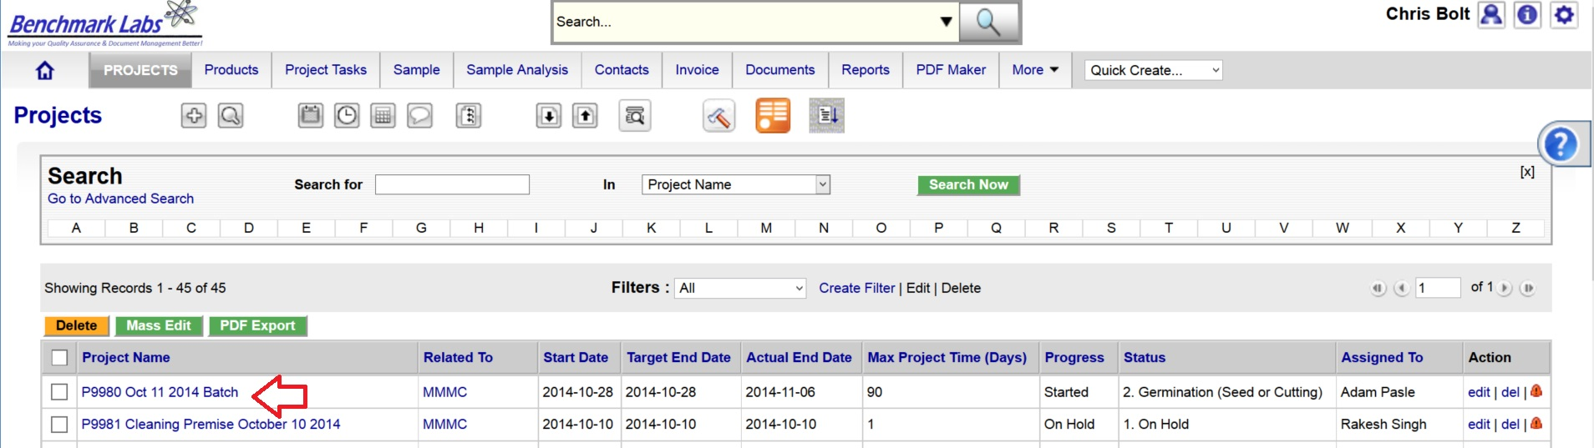
- Once a new Project has been entered into the Benchmark Labs SYSTEM, the SYSTEM auto-generates a series of “Project Milestones” associated with the procedures of handling or processing Medicinal Marijuana and assigns. These “Project Milestones” have estimated dates of completion to assist with Project planning and allocation of resources including personnel, assets and sundry supplies:
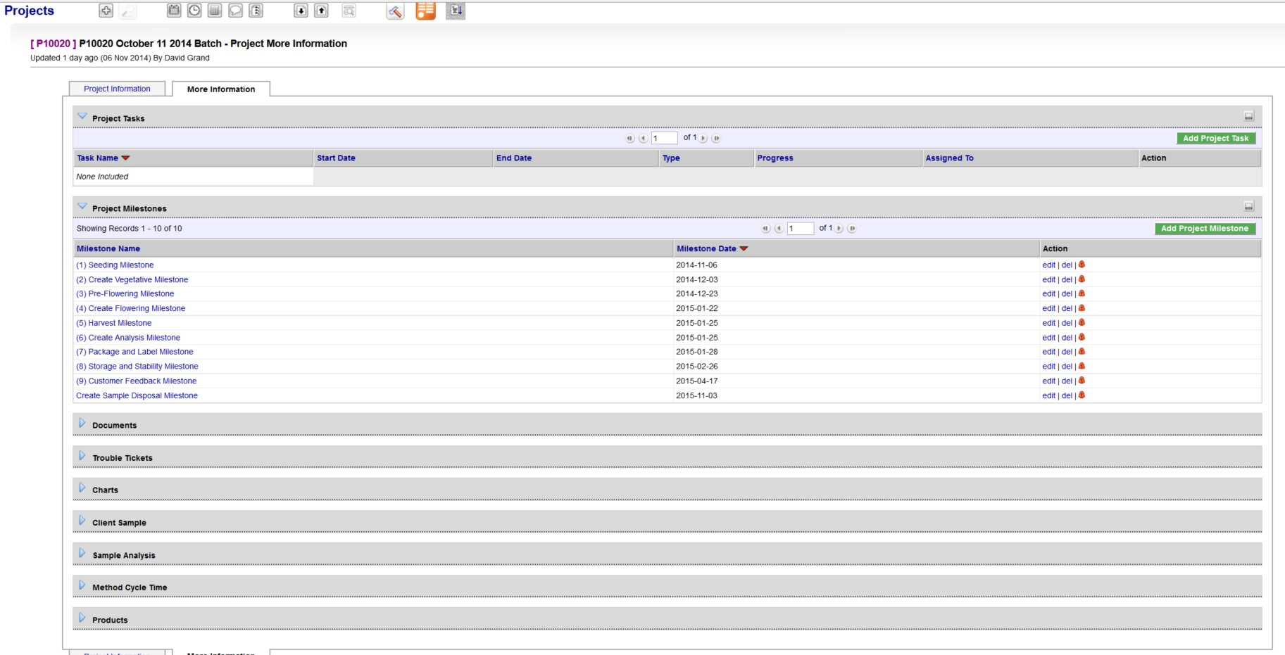
- A GANTT Chart Calendar showing the scheduled completion date of each Milestone is provided by clicking on the arrow symbol next to the “Charts” heading:
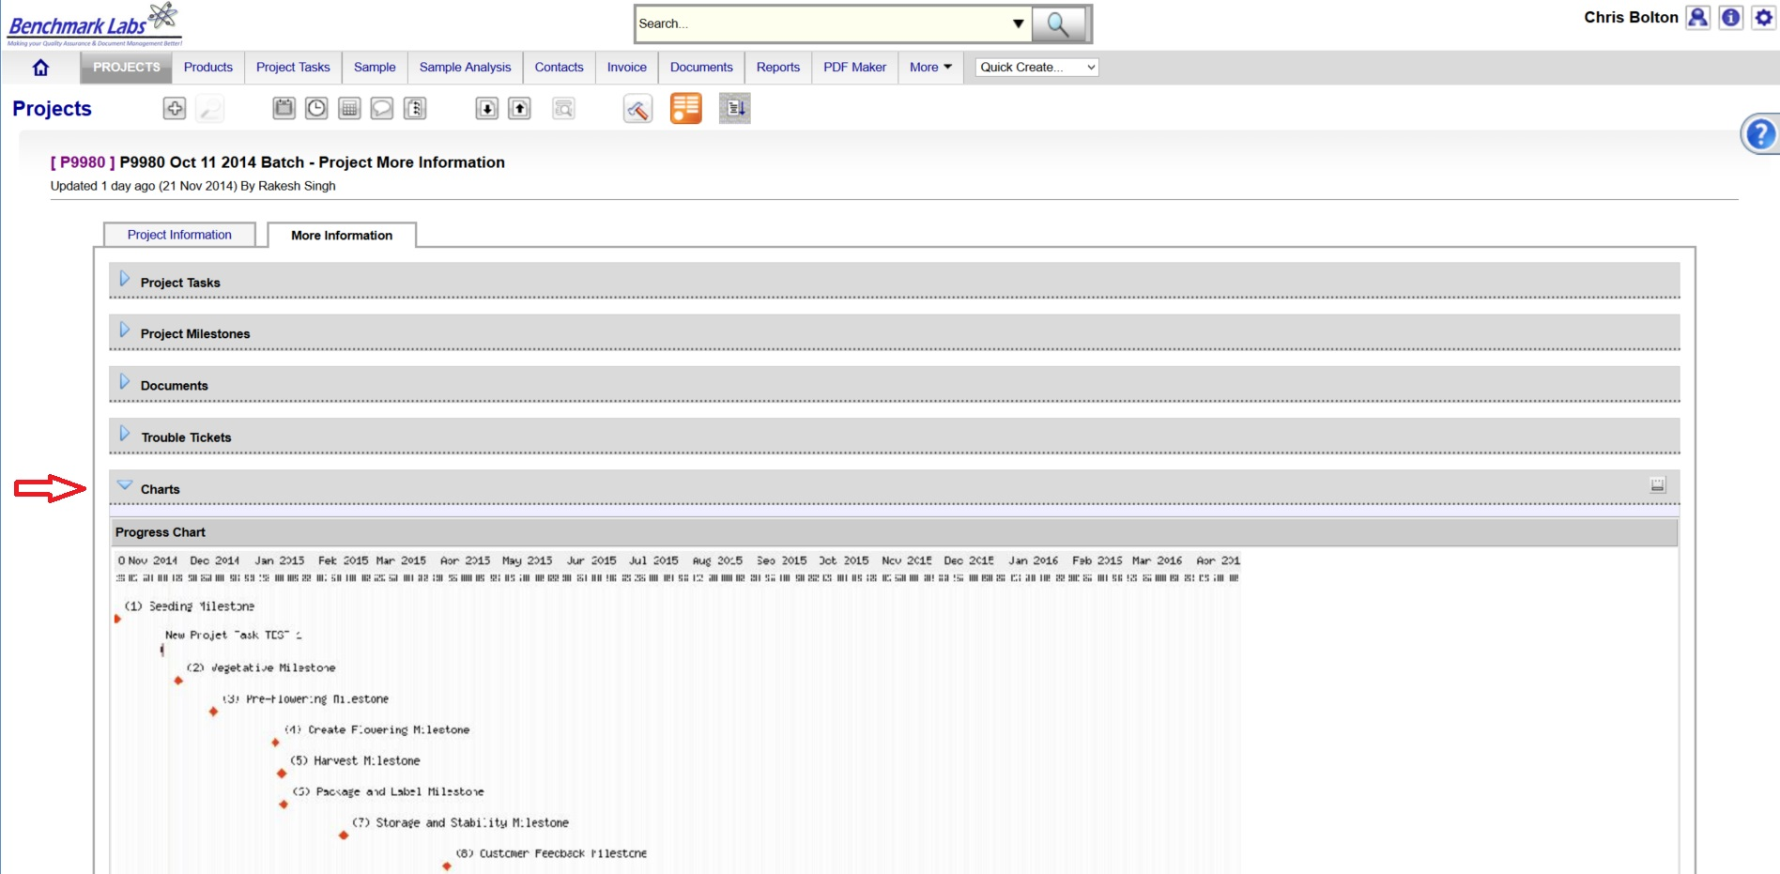
PLEASE NOTE: Clicking the GANTT Chart will open a new Browser Window. Clicking on the GANTT Chart in this new window will enable a “zoom in” on specific Project Milestones dates.
- For each Project Milestone, the Benchmark Labs SYSTEM auto-assigns “Project Tasks” that provide a consistent and logical order of tasks to be performed. Generic Project Tasks are provided by the Benchmark Labs SYSTEM to new SYSTEM Users that are then reviewed an customized by the QAP to better suite their specific Licensed Location.
PLEASE NOTE: All Project Tasks associated with handling or processing shall be verified by the QAP as required to do so by SYSTEM Work-flow handling or processing Verification Schedule and Corrective Action Report (CAR) Work-flows.
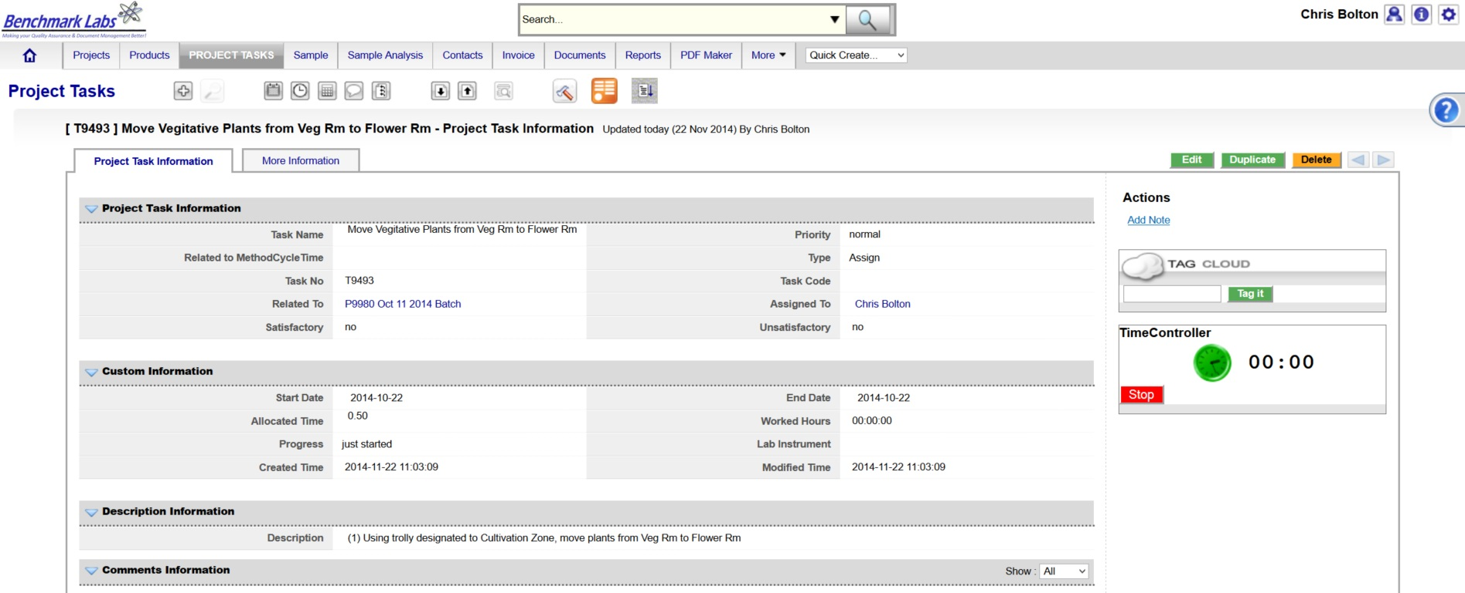
- Project Tasks are then assigned to authorized Users of the SYSTEM. The SYSTEM then provides those Users with notification of a “Start Date” and “End Date” as well as providing an allotment of “Allocated Time” measured in minutes, to complete those assigned tasks:

NOTE: handling or processing shall be verified by the QAP as required to do so by SYSTEM Work-flow handling or processing Verification Schedule and Corrective Action Report (CAR) Work-flows.
- The Benchmark Labs SYSTEM, prior to 24 hours of its proposed “Start Date”, shall auto-generate an e-mail to the assigned User notifying them of the Project Task, the Start Date, End Date, area or room that the Task is to take place and a description of work that is to be performed:
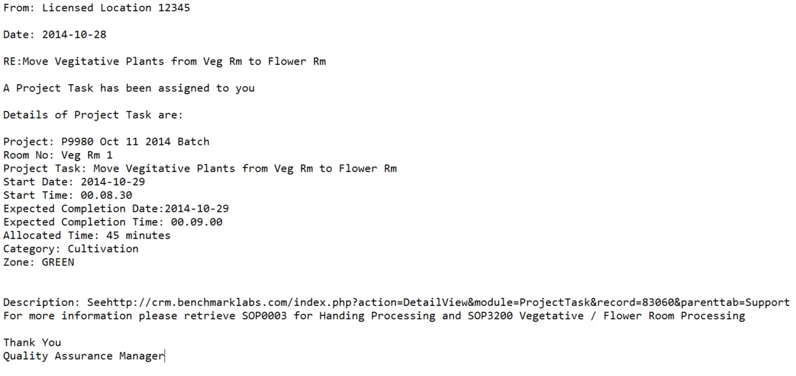
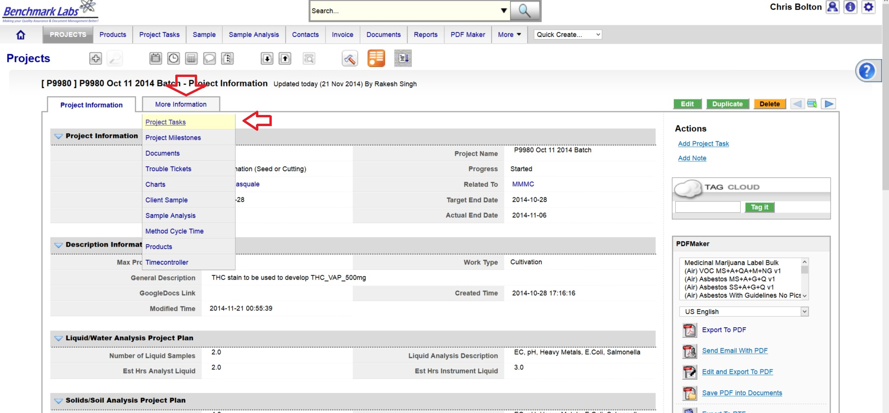
The assigned User can then proceed to open the Project Task either by clicking directly on the link found in the email or proceed directly to the Project (e.g., “P9980 Oct 11 2014 Batch”) to open a Project Task from the Project Module directly:
- To open a Project Task simply click on the link below the “Task Name” header:
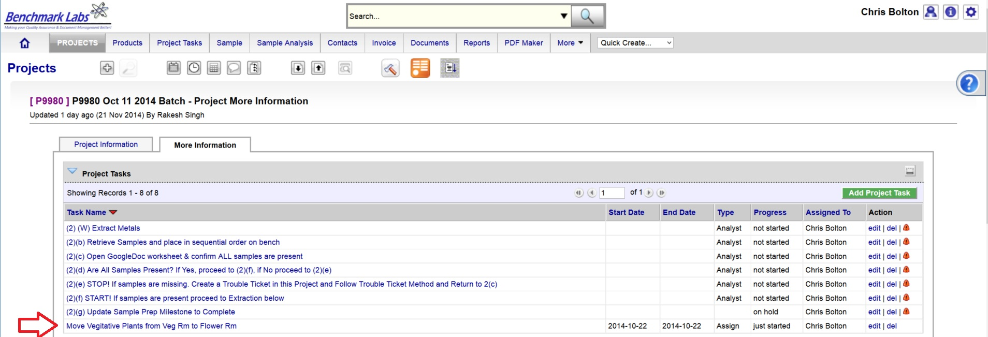
- The clock will then begin to record time spent on this Task until you hit the “Stop Button”:
PLEASE NOTE: Once a Project Task has been opened, the Time-Controller Clock begins recording the time it takes to complete this task. If the time taken is significantly greater or less than the “Allocated Time” value, an automatic Trouble Ticket will open to request explanation as for the cycle time difference (the root cause for the variation in time taken to complete Project Task). Therefore, it is critical that you do not open the Task until you are ready to begin and to then focus on the Task until it is done by clicking on the “STOP” button beside the clock.
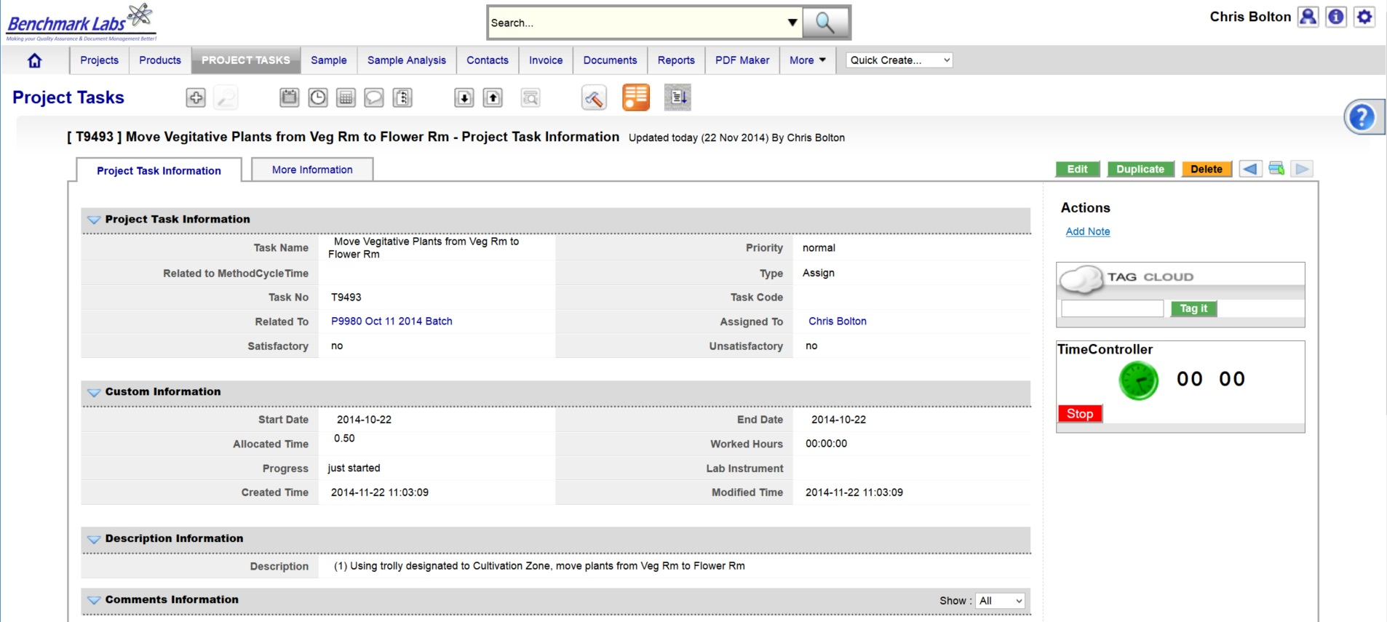
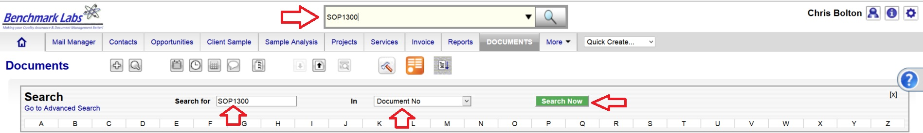
- In the event that the “Description” provided to the assigned User is not sufficient to complete this Project Task, the Assigned User can go directly to the individual SOP Document, by using either the Universal Search Box or using the “Search for” box found in the “Document” Module:

PLEASE NOTE: These SOP documents serve multiple purposes including how to set-up, operate, maintain and repair, clean and dispose of products when no longer usable.
PLEASE NOTE: A document in the SYSTEM can be deleted but only from the view of the average User. All documents Deleted from the SYSTEM are simply moved into “Archive” whereby they are still accessible by the SPIC and Government or Regulatory Auditor.
PROCESS OF HANDLING OR PROCESSING CONFIRMATION & VERIFICTION PROCEDURE BY QAP:
- Once the handling or processing Premise Project Task “Progress” status has been saved as “100%” the Benchmark Labs SYSTEM will auto-generate an email to the QAP the need to confirm and verify that handling or processing was completed to acceptable standards as outline below. This procedure is governed by QAPSOP0100.

SUMMARY REPORTS:
- Summary Record Report for a list of all historical “Project Tasks” associated with SOP can be found by clicking on the “Project Task” Module:
- Summary Record Report for a list of Project Tasks performed for a specific area or zone (e.g., Harvest room) can be found by clicking on the “Project” Module and clicking on the Project associated with handling or processing that specific room or zone, clicking on “More Information” and clicking on “Project Tasks”:
- Summary Record Report of a list of Trouble Tickets associated with this SOP can be found by clicking on the “Trouble Ticket” Module:
- Summary Report of scheduled handling or processing and/or maintenance of the premise associated with this SOP can be found by clicking on the “Calendar” Module:

REFERENCES:
Author | Document Name | Published
Benchmark Labs | SOP0003 Handling Processing | January 24, 2016

