
THIS DOCUMENT IS OBSOLETE ON DATE OF PRINTING
SOP-3300 | TITLE: HANDLING HARVEST CURE ROOM | ^{Issued Date: January 24, 2016}
^{Supersedes:} New | TITLE: HANDLING HARVEST CURE ROOM | Effective Date: January 24, 2016
^{Initiator: Zach Yim} |   ^{Signature:} | ^{Date: January 24, 2016}
^{Reviewer:} | ^{Signature:} | ^{Date:}
^{QA Approval:} | ^{Signature:} | ^{Date:}

REVISION HISTORY:
Version # | Description of Changes | CC #
0 | New document

DOCUMENT OWNER: Quality Assurance Person (QAP)

AFFECTED PARTIES: All site staff who handle and process Medicinal Marijuana.
PURPOSE: To provide a Procedure for the Handling and Processing of Medicinal Marijuana in the Harvest Cure room within the Licensed Location, as well as to confirm a Procedure for Confirmation and Verification for the QAP that this procedure has been performed correctly.

DEFINITIONS:
- Authorized User: The person authorized to perform Project Tasks within the Benchmark Labs SYSTEM.
- Project Milestones: Step-by-step instructions of Handling and Processing of Medicinal Marijuana in the Harvest and Cure Room within the Licensed Location that are related to the “Project Tasks” requiring Handling and Processing.
SCOPE: This Procedure applies to the Handling and Processing of Medicinal Marijuana conducted in Harvest and Cure room within the Licensed Location.
KEY WORDS IN SYSTEM: Handling, processing, production, storage, cultivation, harvest, dry, cure, Zone, clone, Section 57
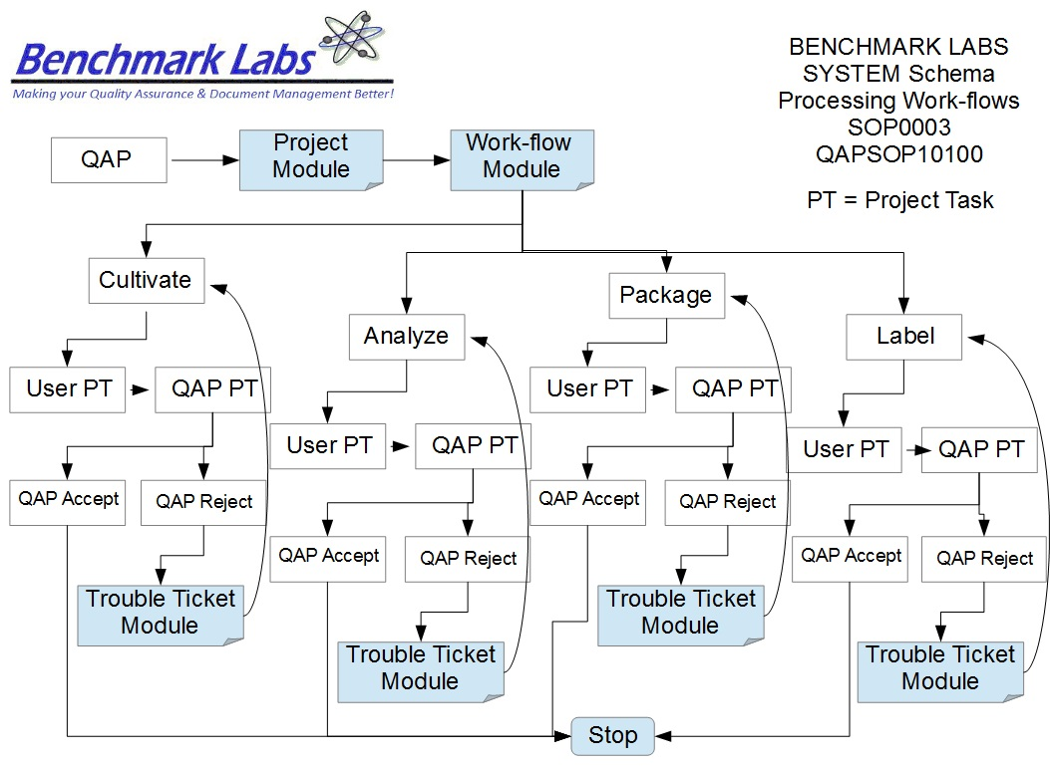

PROCEDURE PROCESS FLOW:

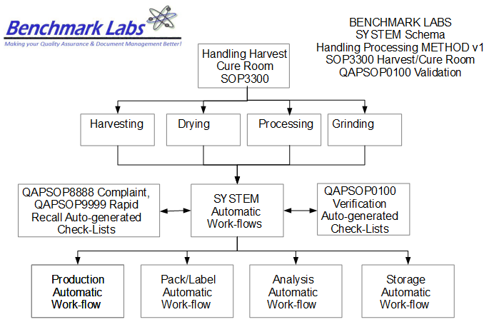
USER PERFORMANCE TASKS (PT) SOPs SPECIFIC TO MMPR ZONES:
GENERAL RULES AND GMP REQUIREMENTS:
- The rules and GMP requirements apply equally to Contractors and Operations staff.

- All staff shall undergo an introductory walk though of the site, be trained on the use of specific procedures as they apply to specific zones within the site prior to being able to conduct any handling or processing activities.

- All handling or processing is to be supervised by the QAP, who must also record daily, weekly, monthly, quarterly and annual reports as required by the SYSTEM auto-work-flow tasks.

- Trouble Tickets must be used in the case of any failures in handling or processing protocol observed by the QAP.

- Clean uniforms, factory shoes and hairnets or helmets must be worn as applicable in the particular areas. (All cleaners working in the Production areas must be familiar with the requirements of SOP0005 Hygiene.)

- Equipment and Instruments used for handling processing, packaging, analyzing, or labelling shall be clean and in proper working order prior to use. (Refer to SOP0002 Clean Equipment for more details.)

- No food or drink can be taken into any zone during the processing, packaging, analyzing, or labelling process.

- NON-Medicinal Marijuana Debris or Rubbish shall be collected in either bins or bags and disposed of cleanly in the correct bins. However, any Medical Marijuana Debris or Rubbish must be collected and stored in accordance with SOP0001 Clean Premise.

- Nothing shall ever be picked up from the floor and returned to any work surface without being fully cleaned and sterilized (unless it is a consumable product, in which case it should be disposed of accordingly).

- No container that comes in contact with product shall be placed directly on the floor.

- All handling or processing Tasks shall be either auto-generated by the Benchmark Labs SYSTEM as “Project Tasks,” or manually entered as “Project Tasks” to ensure proper record entry and to ensure confirmation and verification of cleanliness has occurred.
- The QAP shall receive and complete auto-generated Project Tasks by the Benchmark Labs SYSTEM pursuant to QAPSOP0100 to ensure proper record entry and to ensure confirmation and verification of cleanliness has occurred.

- All problems shall be reported to the QAP and registered using the Trouble Ticket Module of the SYSTEM.

- All handling or processing processing activities shall be performed only by Users of the Benchmark Labs SYSTEM who are deemed to be proficient in completing assigned SYSTEM Project Tasks.

- No handling or processing processing activities may be conducted without recording those activities as “Project Tasks” in the Benchmark Labs SYSTEM.

REGULATORY REQUIREMENTS:
- Marijuana for Medical Purposes Regulations, Section 57, Division 4 Good Production Practices, October 2013).

TRAINING REQUIREMENTS: Read, understand and demonstrate proficiency training (PT) as indicated in the SYSTEM User Profile Record.
RELATED REQUIREMENTS: Read, understand and be familiar with the following related documents:
- SOP3100 Process Seed / Mother Room
- SOP3200 Process Vegetative / Flower Room
- SOP3300 Process Harvest / Cure Room
- SOP3400 Process Lab Analysis Room
- SOP3500 Process Packaging / Label Room
- SOP3600 Process Storage Room
- QAPSOP0100 Confirming and Verification of processing, packaging, analyzing, or labelling & Maintenance Tasks
- SOP0001 Clean Premise
- SOP0002 Clean Equipment
- SOP0004 Handling Storage
- SOP0005 Health & Safety Hygiene
- SOP2600 Vault
AUTO-GENERATED WORKFLOW(S) REQUIRED TO RECORD LOG:
- WKFL0001: Assign Authorized User, Project Task, Record Date/Time Completed
- QAP0001: Assign Authorized User, Inspection Log, Record Date/Time Completed
- CAR0001: Description of Trouble Ticket auto-generated and emailed to QAP
SAFETY REQUIREMENTS:
- Refer to the relevant Material Safety Data Sheets for materials being used for processing, packaging, analyzing, or labelling.
- Refer to SOP0004 in relation to Storage to be used for all materials.
- Refer to SOP0005 in relation to Hygiene, Health and Clothing to be used.
- Refer to SOP0006 in relation to Safety during processing, packaging, analyzing, or labelling.
GENERAL MATERIALS REQUIRED:
- Wireless device to log-in to Benchmark Labs SYSTEM.
- Food Grade Nitrile Gloves, Clean Suit, Boots, Boot Covers, Hair Net, Protective Eye Wear.
- Utilizing only the assigned equipment or instruments to each designated Zone.

PLEASE NOTE: All equipment or instrumentation used for handling or processing supplies within the Harvest Cure Room is to be recorded as “Assets” in the Benchmark Labs SYSTEM pursuant to SOP0002 and carry an easy to identify specific Zone Colour Tag and marked “BROWN Zone” using Black Sharpie Pen to separate these handling or processing tools from those designated for other Zones.
PLEASE NOTE: BEFORE ANY PROCESSING ACTIVITY TAKES PLACE ENSURE THAT each area or room is clean and tidy, that all surfaces have been effectively sanitized, and that the Zone itself will be left in a condition that will not contaminate or otherwise introduce extraneous substances into the Medicinal Marijuana Processing Procedure SOP0003.
MATERIALS REQUIRED: HARVESTING
- Pruning shears
- Scissor sharpener
- Receptacles for each byproduct, as per instructions of Master Grower
- Digital scale
- Nitrile or latex gloves (optional)
- Deep freezer (optional)

PROCESSING: HARVESTING
Method A
- Identify batch of cannabis plants marked for harvest
- Verify all pruning instruments are sharp and clean
- At the base of each plant cut each individual cannabis plant with as much of the plant material attached as possible
- Weigh entire plant and record data
- Using the pruning shears, immediately begin to remove outer fan-leaves of plant, as per instructions of the QAP and Master Grower
- Begin to trim smaller leaves from around the flower, placing each in their correct receptacle
- Manicure all flowers according to the QAP and Master Growers specifications
- Weigh and record all required data for regulatory and internal tracking purposes
- Next the manicured flower along with any usable byproducts can be moved into the drying process (some extractions will use fresh harvested plant material, in which case the byproducts will be moved into the deep freezer)
- Dispose of all waste materials (stems, fan-leaves, etc.) according to the standard operating procedures set forth by the QAP
Method B
- Determine which batch of cannabis plants are marked for harvest
- Verify all pruning instruments are sharp and clean
- At the base of each plant cut each individual cannabis plant with as much of the plant material attached as possible
- Weigh entire plant and record data for regulatory or internal tracking as needed
- Using the pruning shears, remove all fan-leaves each plant
- The plant can then be moved to the drying process until the moisture levels have reached their ideal levels
- Once finished the Drying process, the plants can be moved back into the trimming area at which point the remainder of the leaves are removed from the flower
- Finish manicuring all flowers according to Master Grower’s instructions
- Place all flower and byproducts in their respective receptacles
- Weigh all flower and byproducts and record for regulatory and internal tracking purposes as needed
- The flower and byproducts will then be moved into the Curing process
- Dispose of all waste materials (stems, fan-leaves, etc.) according to standard operating procedures

PLEASE NOTE: The methods used to Harvest Medical Marijuana vary based on the grow style of the facility where growing is taking place, and the handling and processing tasks are to be determined by the Master Grower and the QAP. The above standard procedures illustrate two separate methods of harvesting Medical Marijuana, and can be used for most forms of growing.
MATERIALS REQUIRED: DRYING
- Drying shelves/racks
- Digital scale
- Labels
PROCESSING: DRYING
- Determine whether Harvesting method A or method B has been used
- Method A: place each flower or byproduct on its respective drying shelf or rack if hang drying
- Method B: place the entire plant upside down on its respective drying rack
- Verify environment is at Master Grower specifications
- Check on each plant daily for moisture levels, as determined by the QAP and Master Grower
- When correct moisture levels have been achieved, and the each plant has been manicured, the product can be moved to the curing process

MATERIALS REQUIRED: CURING
- Curing bins/jars
- Curing shelves
- Lab analysis containers
- Labels
PROCESSING: CURING
- Once cannabis in the Drying process has reached its required moisture level, the product can be placed in the Curing process
- Place each batch of cannabis flower into the specified curing container and close and seal container
- Verify environmental conditions are at Master Grower specifications
- Check each container every 12 hours to verify moisture levels (use lab analysis for proper results)
- When product has reached the predetermined moisture levels, the product can move to the SOP3500: packaging and storage process

PLEASE NOTE: The Curing Process will continue in the vault due to moisture loss over time. Therefore, it is imperative that the environment within the Storage Vault be maintained under similar conditions as those in the Curing Room and as specified by the QAP and Grow Master.
PLEASE NOTE: ONLY AUTHORIZED USERS AND STAFF ARE PERMITTED TO RECEIVE AND PERFORM handling or processing PROJECT TASKS WITHIN THE MMPR ZONES.
PLEASE NOTE: That all Premise handling or processing Procedures for specific MMPR Zones shall require that any Medicinal Marijuana related debris or trash that is found shall be retrieved and placed into a Debris Bag and recorded directly into the Benchmark Labs SYSTEM – as such, it can NEVER be disposed of in the garbage as would NON-Medicinal Marijuana debris or trash AS PER SOP0001 CLEAN PREMISE.
HANDLING OR PROCESSING PROCEDURE
- The step-by-step procedures for handling or processing of Medicinal Marijuana is provided as individual work-flows within the Benchmark Labs SYSTEM:
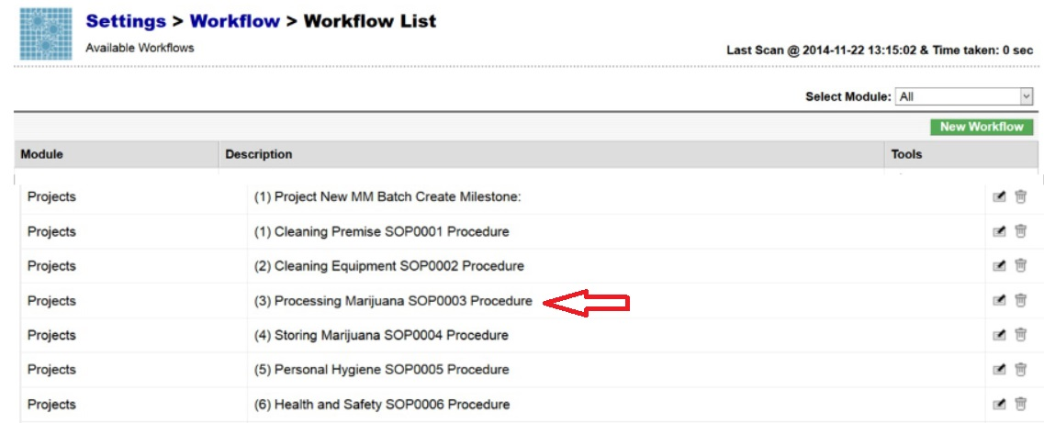
- The Benchmark Labs SYSTEM work-flows represent the Licensed Producers SOPs procedures that have been reviewed and accepted by the QAP for each processing area at the Licensed Location:

- The Benchmark Labs SYSTEM auto-generates these work-flows upon the creation of a new Batch/Lot of Medicinal Marijuana. This is done through the creation of a new “Project” within the Benchmark Labs SYSTEM that then auto-generates a unique Project Number to provide for a unique set of records associated with that particular Batch/Lot at this Licensed Location:
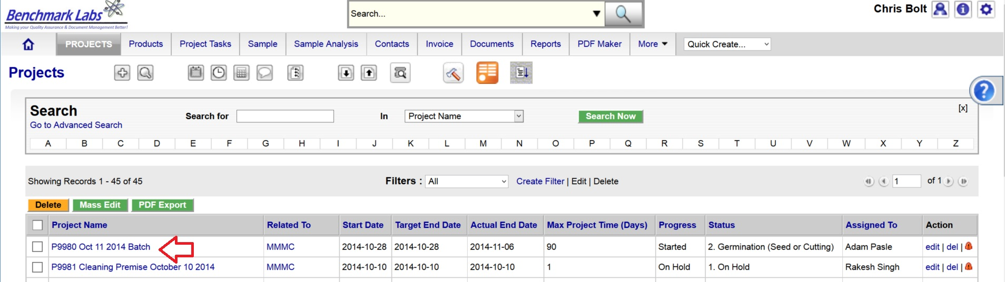
- Once a new Project has been entered into the Benchmark Labs SYSTEM, the SYSTEM auto-generates a series of “Project Milestones” associated with the procedures of handling, processing, analyzing, packaging and labelling Medicinal Marijuana. These “Project Milestones” have estimated dates of completion to assist with Project planning and allocation of resources including personnel, assets and sundry supplies:
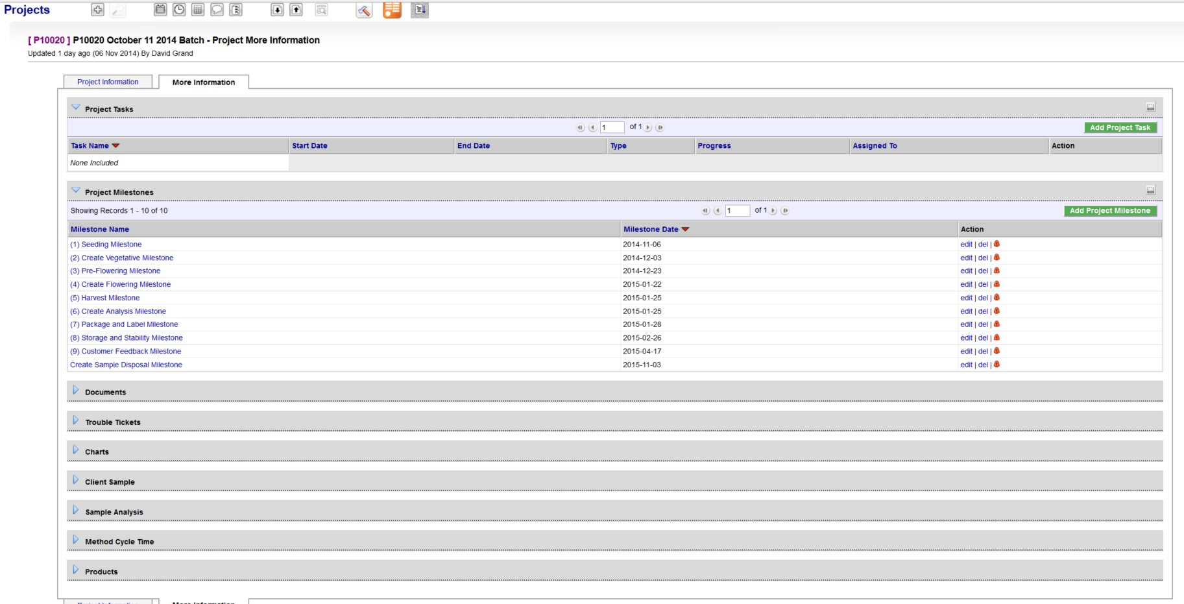
- A GANTT Chart Calendar showing the scheduled completion date of each Milestone is provided by clicking on the arrow symbol next to the “Charts” heading:
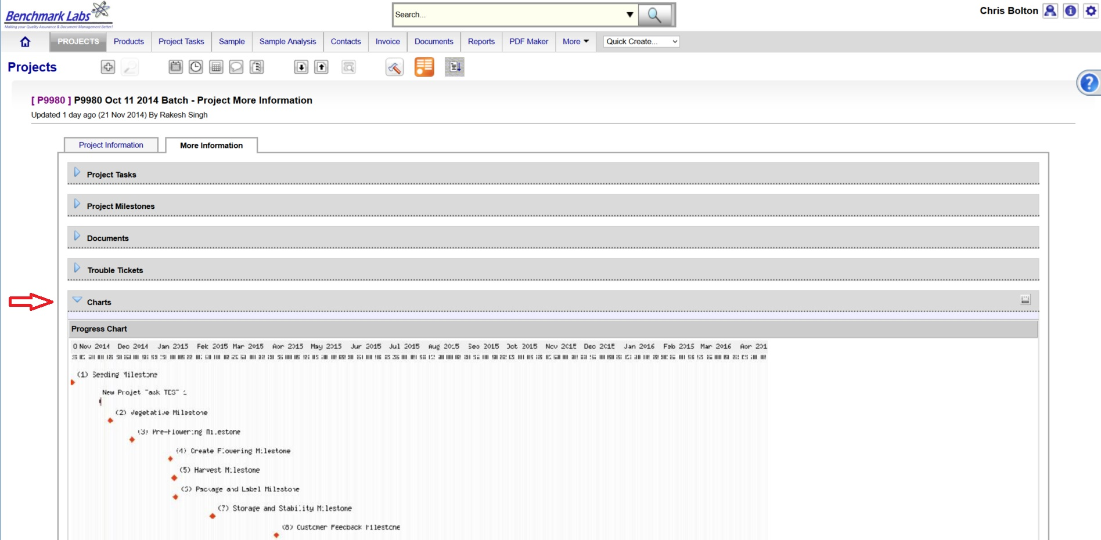
PLEASE NOTE: Clicking the GANTT Chart will open a new Browser Window. Clicking on the GANTT Chart in this new window will enable a “zoom in” on specific Project Milestones dates.
- For each Project Milestone, the Benchmark Labs SYSTEM auto-assigns “Project Tasks” that provide a consistent and logical order of tasks to be performed. Generic Project Tasks are provided by the Benchmark Labs SYSTEM to new SYSTEM Users that are then reviewed an customized by the QAP to better suite their specific Licensed Location.
PLEASE NOTE: All Project Tasks associated with handling or processing shall be verified by the QAP as required to do so by SYSTEM Work-flow handling or processing Verification Schedule and Corrective Action Report (CAR) Work-flows.
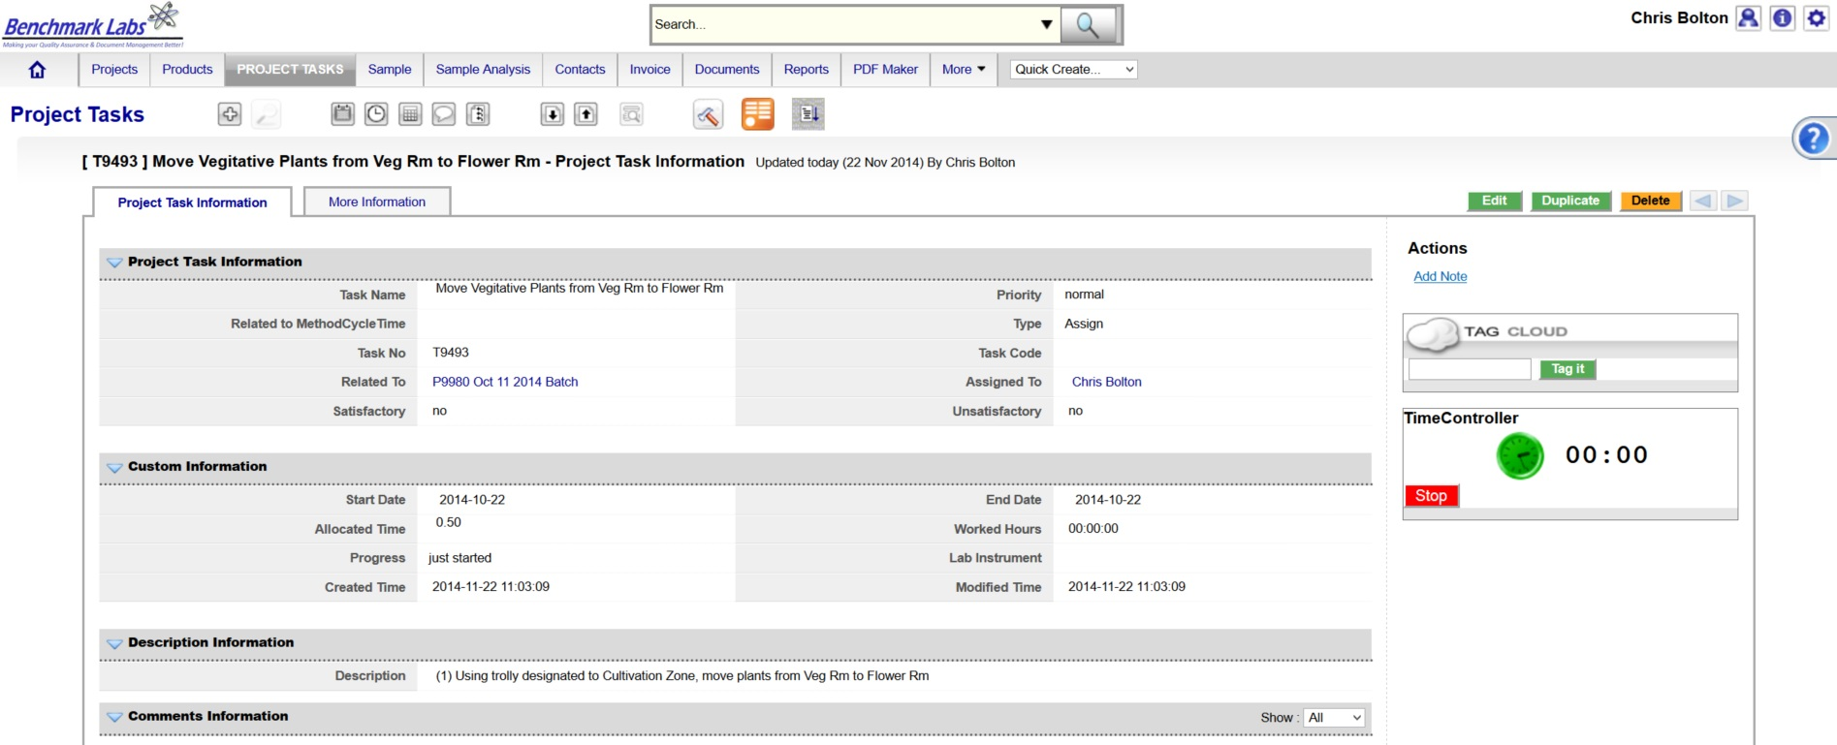
- Project Tasks are then assigned to authorized Users of the SYSTEM. The SYSTEM then provides those Users with notification of a “Start Date” and “End Date” as well as providing an allotment of “Allocated Time” measured in minutes, to complete those assigned tasks:

NOTE: handling or processing shall be verified by the QAP as required to do so by SYSTEM Work-flow handling or processing Verification Schedule and Corrective Action Report (CAR) Work-flows.
- The Benchmark Labs SYSTEM, prior to 24 hours of its proposed “Start Date”, shall auto-generate an e-mail to the assigned User notifying them of the Project Task, the Start Date, End Date, area or room that the Task is to take place and a description of work that is to be performed:
From: Licensed Location 123145

Date: 2015-03-05

RE: Harvest and Dry Buds from fully flowered plants

A Project Task has been Assigned to You

Details of the Project Task are:

Location: Harvest Cure Room
Project: P10028 SOP3300 Handling Harvest Cure Room
Start Date: 2015-03-05
Start Time: 00.09.30
Expected Completion Date: 2015-03-05
Expected Completion Time: 00.12.30
Allocated Time: 120 minutes
Category: QC
Zone: Brown
Description: Please visit http://crm.benchmarklabs.com/ndex.php?module=Assets&parent

Thank You
Quality Assurance Manager
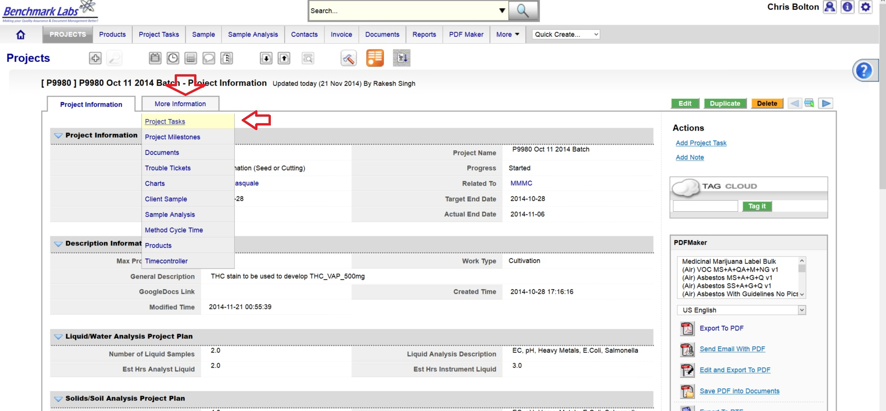
9. The assigned User can then proceed to open the Project Task either by clicking directly on the link found in the email or proceed directly to the Project (e.g., “P9980 Oct 11 2014 Batch”) to open a Project Task from the Project Module directly:
- To open a Project Task simply click on the link below the “Task Name” header:
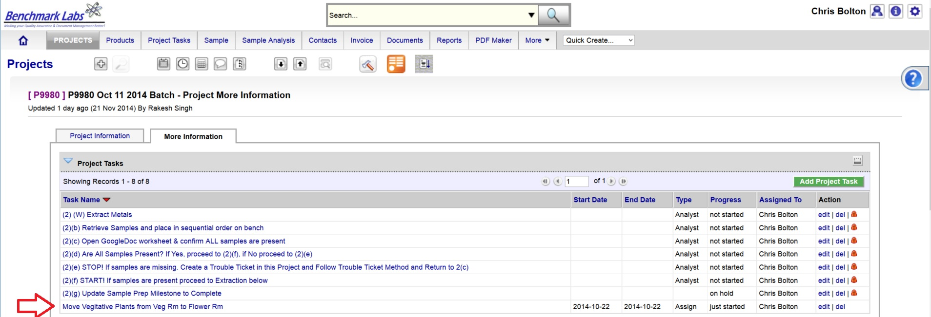
- The clock will then begin to record time spent on this Task until you hit the “Stop Button”:
PLEASE NOTE: Once a Project Task has been opened, the Time-Controller Clock begins recording the time it takes to complete this task. If the time taken is significantly greater or less than the “Allocated Time” value, an automatic Trouble Ticket will open to request explanation for the cycle time difference (the root cause for the variation in time taken to complete Project Task). Therefore, it is critical that you do not open the Task until you are ready to begin and to then focus on the Task until it is done by clicking on the “STOP” button beside the clock.
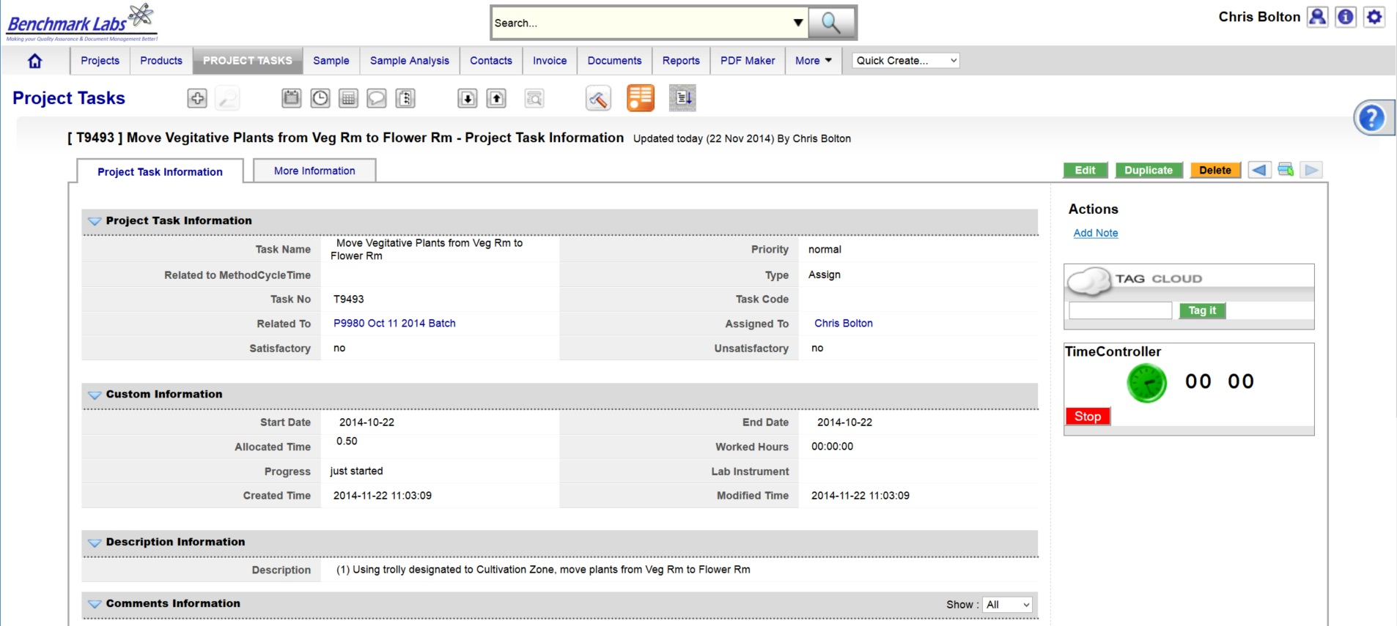
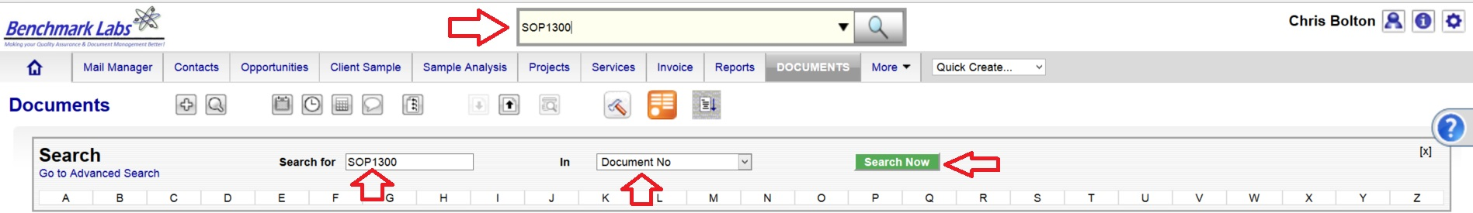
- In the event that the “Description” provided to the assigned User is not sufficient to complete this Project Task, the Assigned User can go directly to the individual SOP Document, by using either the Universal Search Box or using the “Search for” box found in the “Document” Module:

PLEASE NOTE: These SOP documents serve multiple purposes including how to set-up, operate, maintain and repair, clean and dispose of products when they are no longer usable.
PLEASE NOTE: A document in the SYSTEM can be deleted but only from the view of the average User. All documents Deleted from the SYSTEM are simply moved into “Archive” whereby they are still accessible by the SPIC and Government or Regulatory Auditor.
PROCESS OF HANDLING OR PROCESSING CONFIRMATION & VERIFICTION PROCEDURE BY QAP:
- Once the handling or processing Premise Project Task “Progress” status has been saved as “100%” the Benchmark Labs SYSTEM will auto-generate an email to the QAP the need to confirm and verify that handling or processing was completed to acceptable standards as outline below. This procedure is governed by QAPSOP0100.

SUMMARY REPORTS:
- Summary Record Report for a list of all historical “Project Tasks” associated with SOP can be found by clicking on the “Project Task” Module:
- Summary Record Report for a list of Project Tasks performed for a specific area or zone (e.g., Harvest room) can be found by clicking on the “Project” Module and clicking on the Project associated with handling or processing that specific room or zone, clicking on “More Information” and clicking on “Project Tasks”:
- Summary Record Report of a list of Trouble Tickets associated with this SOP can be found by clicking on the “Trouble Ticket” Module:
- Summary Report of scheduled handling or processing and/or maintenance of the premise associated with this SOP can be found by clicking on the “Calendar” Module:

REFERENCES:
Author | Document Name | Published
Benchmark Labs | SOP0003 Handling Processing | January 24, 2016

