

THIS DOCUMENT IS OBSOLETE ON DATE OF PRINTING
SOP-3700 | TITLE: Waste Collection and Fermentation | ^{Issued Date: January 24, 2016}
^{Supersedes:} New | TITLE: Waste Collection and Fermentation | Effective Date: January 24, 2016
Initiator[s]: Ryan Pincura & Zach Yim |   ^{Signature:} | ^{Date: January 24, 2016}
^{Reviewer:} | ^{Signature:} | ^{Date:}
^{QA Approval:} | ^{Signature:} | ^{Date:}

REVISION HISTORY:
Version # | Description of Changes | CC #
0 | New document
DOCUMENT OWNER: Quality Assurance Manager

AFFECTED PARTIES: All site staff and contractors that enter the Medicinal Marijuana Licensed Location.

PURPOSE: This Waste collection and Fermentation (SOP) is designed to provide detailed step by step instructions for how a Licensed Producer shall collect, ferment and dispose of waste product within the Licensed Location.
Note: Although a written SOP plan is not required by most international Federal Medicinal Marijuana Organizations (including the FDA), it is recommended that we explain the Licensed Location procedures

DEFINITIONS:
- Authorized User: The person authorized to perform Project Tasks within the Benchmark Labs SYSTEM.
- Project Milestones: Are related to the group of “Project Tasks” associated with step-by-step instructions of waste collection and fermentation of Medicinal Marijuana in the Seed Mother Room within the Licensed Location.
SCOPE: This Procedure applies to the caste collection and summary disposal of Medicinal Marijuana conducted within all Zones, of the Licensed Location.
KEY WORDS IN SYSTEM: Destruction, handling, processing, Waste Disposal, Zone, Section 144, Section 145

GENERAL RULES AND GMP REQUIREMENTS:
- The rules and GMP requirements apply equally to Contractors and Operations staff.

- All staff shall undergo an introductory walk though of the site, be trained on the use of specific procedures as they apply to specific zones within the site prior to being able to conduct any handling, processing, packaging, analyzing, or labelling activities.

- All handling, processing, packaging, analyzing, or labelling is to be supervised by the QAP, who must also record daily, weekly, monthly, quarterly and annual reports as required by the SYSTEM auto-work-flow tasks.

- Trouble Tickets must be used in the case of any failures in processing, packaging, analyzing, or labelling protocol observed by the QAP.

- Clean uniforms, factory shoes and hairnets or helmets must be worn as applicable in the particular areas. (All cleaners working in the Production areas must be familiar with the requirements of SOP0005 Hygiene).

- Equipment and Instruments used for handling, processing, packaging, analyzing, or labelling shall be clean and in proper working order prior to use. (Refer to SOP0002 Clean Equipment for more details.)

- No food or drink can be taken into any zone during any handling, processing, packaging, analyzing, or labelling procedures.

- NON-Medicinal Marijuana Debris or Rubbish shall be collected in either bins or bags and disposed of cleanly in the correct vessels. However, any Medical Marijuana Debris or Rubbish must be collected and stored in accordance with SOP0001 Clean Premise.

- Nothing shall ever be picked up from the floor and returned to any work surface without being fully cleaned and sterilized (unless it is a consumable product, in which case it should be disposed of accordingly).

- No container that comes in contact with product shall be placed directly on the floor.

- All processing, packaging, analyzing, or labelling Tasks shall be either auto-generated by the Benchmark Labs SYSTEM as “Project Tasks,” or manually entered as “Project Tasks” to ensure proper record entry and to ensure confirmation and verification of cleanliness has occurred.
- The QAP shall receive and complete auto-generated Project Tasks by the Benchmark Labs SYSTEM pursuant to QAPSOP0100 to ensure proper record entry and to ensure confirmation and verification of cleanliness has occurred.

- All problems shall be reported to the QAP and registered using the Trouble Ticket Module of the SYSTEM.

- All processing, packaging, analyzing, or labelling processing activities shall be performed only by Users of the Benchmark Labs SYSTEM who are deemed to be proficient in completing assigned SYSTEM Project Tasks.

- No processing, packaging, analyzing, or labelling processing activities may be conducted without recording those activities as “Project Tasks” in the Benchmark Labs SYSTEM.

REGULATORY REQUIREMENTS:
- Marijuana for Medical Purposes Regulations, Section 144, Section 145, Destroyed Cannabis October 2013.

TRAINING REQUIREMENTS: Read, understand and demonstrate proficiency training (PT) as indicated in the SYSTEM User Profile Record.
RELATED REQUIREMENTS: Read, understand and be familiar with the following related documents:
- SOP0001 Clean Premise
- SOP0002 Clean Equipment
- SOP0004 Handling Storage
- SOP0005 Health & Hygiene
- SOP0006 Health & Safety
- QAPSOP0100 Confirmation and Verification
AUTO-GENERATED WORKFLOW(S) REQUIRED TO RECORD LOG:
- WKFL0001: Assign Authorized User, Project Task, Record Date/Time Completed
- QAP0001: Assign Authorized User, Inspection Log, Record Date/Time Completed
- CAR0001: Description of Trouble Ticket auto-generated and emailed to QAP

SAFETY REQUIREMENTS:
- Refer to the relevant Material Safety Data Sheets for materials being used for waste collection and fermentation.
- Refer to SOP0004 in relation to Storage to be used for all materials.
- Refer to SOP0005 in relation to Hygiene, Health and Clothing to be used.
- Refer to SOP0006 in relation to Safety during waste collection and fermentation.
GENERAL MATERIALS REQUIRED:
- Wireless device to log-in to Benchmark Labs SYSTEM.
- Food Grade Nitrile Gloves, Clean Suit, Boots, Boot Covers, Hair Net, Protective Eye Wear.
- Utilize only the assigned equipment or instruments to each designated Zone.

MATERIALS REQUIRED CANNABIS DESTRUCTION:

- 55 Gallon Drum with matching lid
- Band Clamps
- Culture Mixture for promotion of fermentation
- Material Shredder
- Mixing Pail
PLEASE NOTE: All supplies, equipment or instrumentation used for waste collection and fermentation within the Facility are to be recorded as “Assets” in the Benchmark Labs SYSTEM pursuant to SOP0002 and carry an easy to identify specific Zone Colour Tag and marked e.g., “Seed Mother Room” using an appropriately coloured Sharpie Pen to separate these tools from those designated for use in other Zones.
PLEASE NOTE: ONLY AUTHORIZED USERS AND STAFF ARE PERMITTED TO RECEIVE AND PERFORM PROJECT TASKS WITHIN EACH ZONE THAT REQUIRES EITHER WASTE COLLECTION OR FERMENTATION.
PLEASE NOTE: BEFORE ANY PROCESSING ACTIVITY TAKES PLACE ENSURE THAT the room is clean and tidy, that all surfaces have been effectively sanitized, and that the Seed Mother Room itself will be left in a condition that will not contaminate or otherwise introduce extraneous substances into the Medicinal Marijuana Processing Procedure SOP0003.
PLEASE NOTE: That all Premise waste collection and fermentation Procedures for the Seed Mother Room shall require that any Medicinal Marijuana related debris or trash that is found, be retrieved and placed into a Debris Bag and recorded directly into the Benchmark Labs SYSTEM – as such, it can NEVER be disposed of in the garbage as would NON-Medicinal Marijuana debris or trash AS PER SOP0001 CLEAN PREMISE.
WASTE DISPOSAL AND FERMENTATION PROCEDURE:

Table 1: Inoculating, Shredding, and Packing of 55 Gallon Drum Fermenters
Collected waste is inoculated, shredded and packed into fermenters daily. Fermenters are sealed when full – see below.
Fermenters are 55 gallon (208 liter) drums specific for utilization in a Bokashi fermentation process
- Confirm that all equipment is present, available, and clean before beginning the process
  - Process requires a minimum of one (1) 55 gallon drum (fermenter); matching lid(s); band clamps; drums are empty and marked clean; shredder
- Pre-use inspection:
  - Operator will check that each fermenter is clearly marked as a fermentation barrel
  - Operator will confirm that the Clean sticker is present, will note the sticker in the Waste Management Area (WMA) log, and remove it to regular waste
  - Operator will check that each fermenter is uniquely identified
  - Operator will visually inspect fermenter for cracks, holes, evidence of leaking, or other physical damage. Pay particular attention to the seal areas and any attachments such as sampling ports or drains.
  - Report any problems in the WMA log and exchange the fermenter
- Operator will log the inspected fermenter ID and date into the WMA log for filling and further processing
- Collect the waste for the fermenter from the weighing area
  - Waste will be different size containers collected as in Table 1
  - Weigh each container and log total weight value into the WMA log
  - Empty waste into a Mixing Pail (10 gallon / 38 liter)
    - Each Mixing Pail will be identified as a Mixing Pail and uniquely numbered.
    - If a pail is not identified correctly, exchange the pail
  - Place emptied waste container (from 4.1) in the area marked To Be Cleaned in the MWA
- When the mixing pail is approximately 2/3 full add ½ pound of Culture Mix to the waste in the Mixing Pail
- Ensure a fermenter is opened and located under the exit chute of the shredder
  - Log the fermenter ID into the MWA log
- Empty the inoculated waste into the hopper of the shredder
  - Adjust the speed of the shredder to properly process the inoculated waste
  - Process the mixture in batches as required
  - Inspect the Mixing Pail for loose waste
- Fill the fermenter barrel to within 6 inches (15 cm) of the top
- When the fermenter(s) are full place the fermenter lid on top
  - Move the fermenter to the fermenting area; DO NOT FASTEN THE BAND CLAMP FOR 24 HOURS.
  - Note the time the fermenter was moved into storage into the MWA log so that the band clamp can be fastened approximately 24 to 28 hours later.
- Place the inspected Mixing Pail(s) in the designated storage spot
  - Note in the MWA log if a mixing pail is damaged during use or showing signs of wear (such as a loose handle)

NOTE: Comments regarding the detail on safety equipment; culture mix; location or source of all components will be provided via the final SOP.

Table 2: Fermenter Processing
After the fermenter contents have fermented they are moved to the on-site location to transfer the contents to the soil as fertilizer and mulch.
Steps: | - When the fermenter has been stored sufficiently (7 to 10 days; see SOP) to allow fermentation of the inoculated waste the barrel needs to be sampled for testing before release  - Operator will use label 3 sampling tubes (15 ml or more) with the fermenter ID number, the date and log the sampling in the MWA log.  - Open the fermenter to draw one solids sample from the top of the mixture  - Fill the tube at least halfway and cap immediately to prevent sample loss  - Using the bottom spout draw two additional liquid samples (fermenter tea), cap samples  - Fermenter will be moved to either HOLD storage or to processing after testing updates the status of the mix  - Approved for disposal fermenters will be moved via company or receiver vehicle to Receiver’s local site: Tillsonburg-area Nursery  - Receiver will initial form for receipt of number of a specific ID number fermenter barrels  - Receiver will use the fermented waste as fertilizer during golf course operations  - Barrels will be returned in a “rinsed” condition and inspected for debris and damage at the {Applicant} site by Operator  - Operator will log returned fermenters into the WMA log.  - The fermenters can be cleaned to municipal sewage. Each fermenter is cleaned then logged into the MWA as “available”
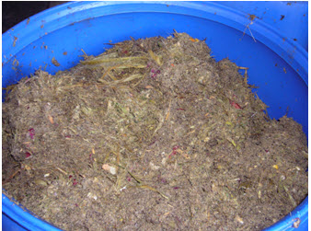

Figure 1: Photo of Shredded and Inoculated Waste Beginning of Fermenting Cycle

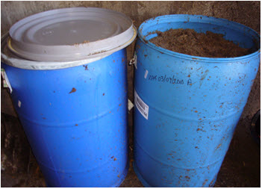
Figure 2: Photo of Fermenting Barrels Used to Process Shredded and Inoculated Waste

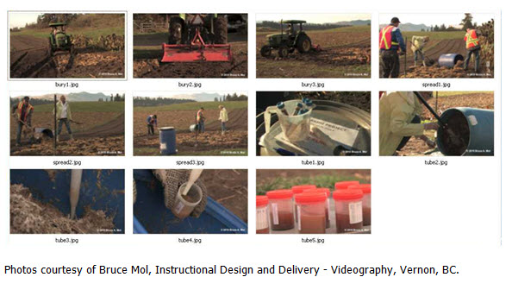 Figure 3: EXAMPLE Soil Preparation, Sample Collections, and Waste Soil Integration Step

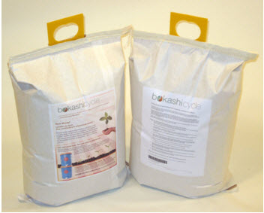
Figure 4: Photo image of Bokashi mixture in 25 pound bag packets.

SAMPLE FORMS

Fermenter ready for use MWA log
Barrel ID (XXX-DD.MM.2010-Y) | Activity
 | Signage in place Barrel empty in AM  ID label on barrel | [ ] Yes No [ ]  [ ] Yes No [ ]  [ ] Yes No [ ]
Observations and Notes:

Inoculating and Shredding of Waste Log
Barrel ID (XXX-DD.MM.2010-Y) | Activity
 | Label on barrel Barrel empty in AM  Waste inoculated  Waste shredded | [ ] Yes No [ ]  [ ] Yes No [ ]  [ ] Yes No [ ]  [ ] Yes No [ ]
Observations and Notes:

Tea Sample Collection | Activity
 | Label on barrel  Barrel sealed  Tea collected | [ ] Yes No [ ]  [ ] Yes No [ ]  [ ] Yes No [ ]
Label 3 conical tubes: Date________________ . Record the labels below.

- ____________________________________________(Barrel ID)
- ____________________________________________(Barrel ID)
- ____________________________________________(Barrel ID)

WASTE DISPOSAL AND FERMENTATION SYSTEM PROCEDURE:

- The step-by-step procedures for waste collection and fermentation of Medicinal Marijuana is provided as individual work-flows within the Benchmark Labs SYSTEM:

Please Note: The following screenshots and workflows are meant as an example of the integration of generic SOPs within the SYSTEM
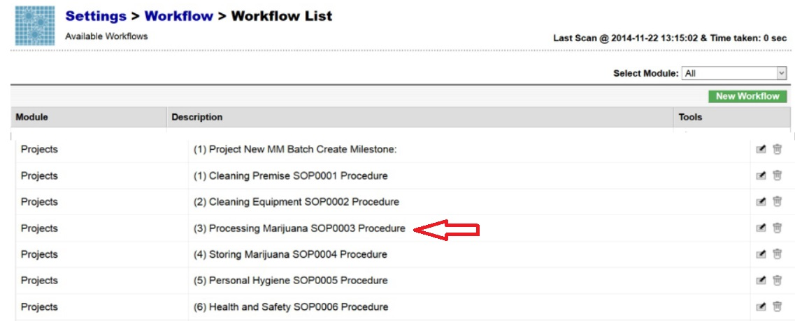
- The Benchmark Labs SYSTEM work-flows represent the Licensed Producers SOPs procedures that have been reviewed and accepted by the QAP for each waste collection area at the Licensed Location (See below for a specific example from SOP 3100):
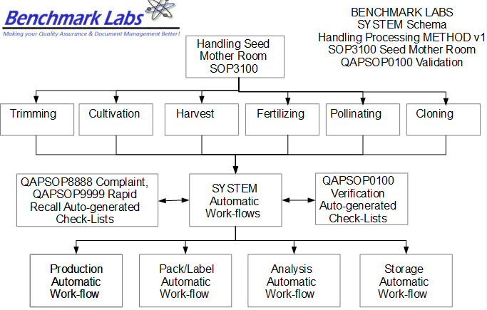


- The Benchmark Labs SYSTEM auto-generates these work-flows upon the creation of a new Batch/Lot of Medicinal Marijuana. This is done through the creation of a new “Project” within the Benchmark Labs SYSTEM that then auto-generates a unique Project Number to provide for a unique set of records associated with that particular Batch/Lot at this Licensed Location:
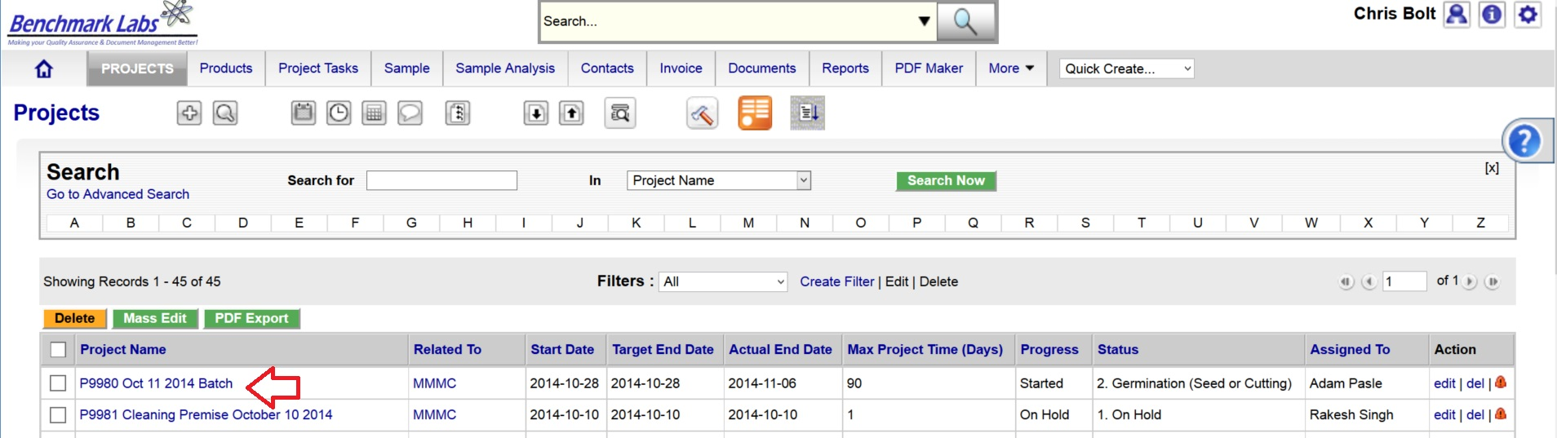
- Once a new Project has been entered into the Benchmark Labs SYSTEM, the SYSTEM auto-generates a series of “Project Milestones” associated with the procedures of waste collection and fermentation of Medicinal Marijuana and assigns. These “Project Milestones” have estimated dates of completion to assist with Project planning and allocation of resources including personnel, assets and sundry supplies:
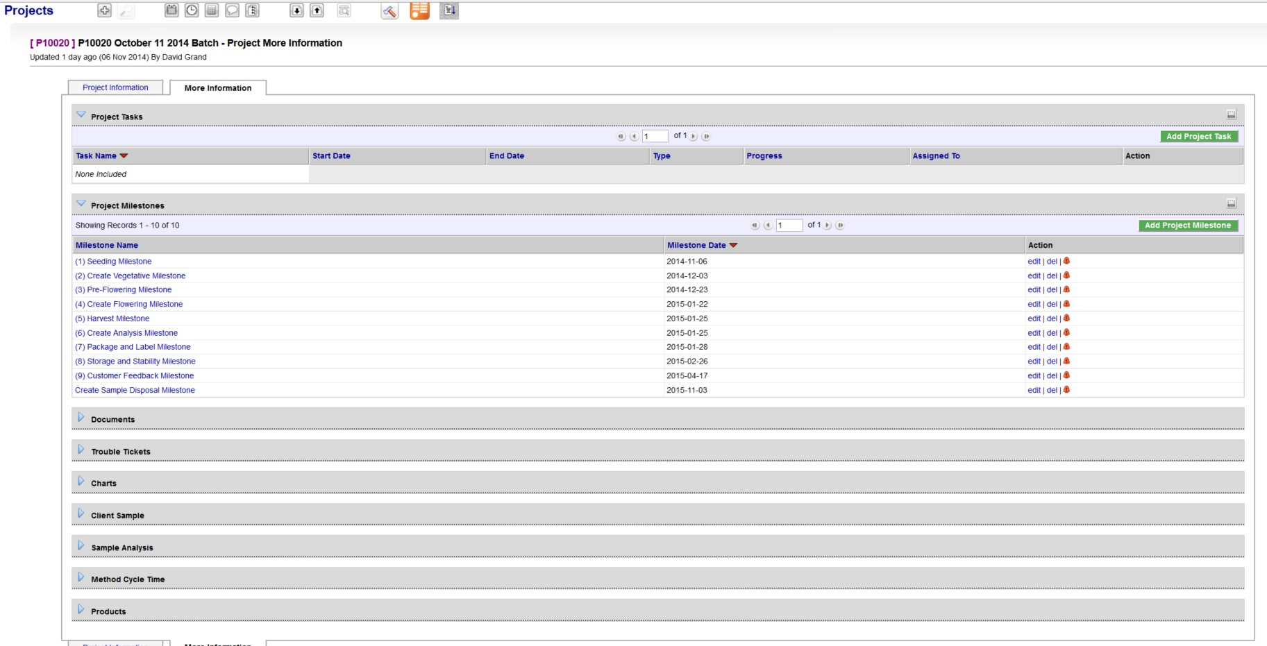
- A GANTT Chart Calendar showing the scheduled completion date of each Milestone is provided by clicking on the arrow symbol next to the “Charts” heading:
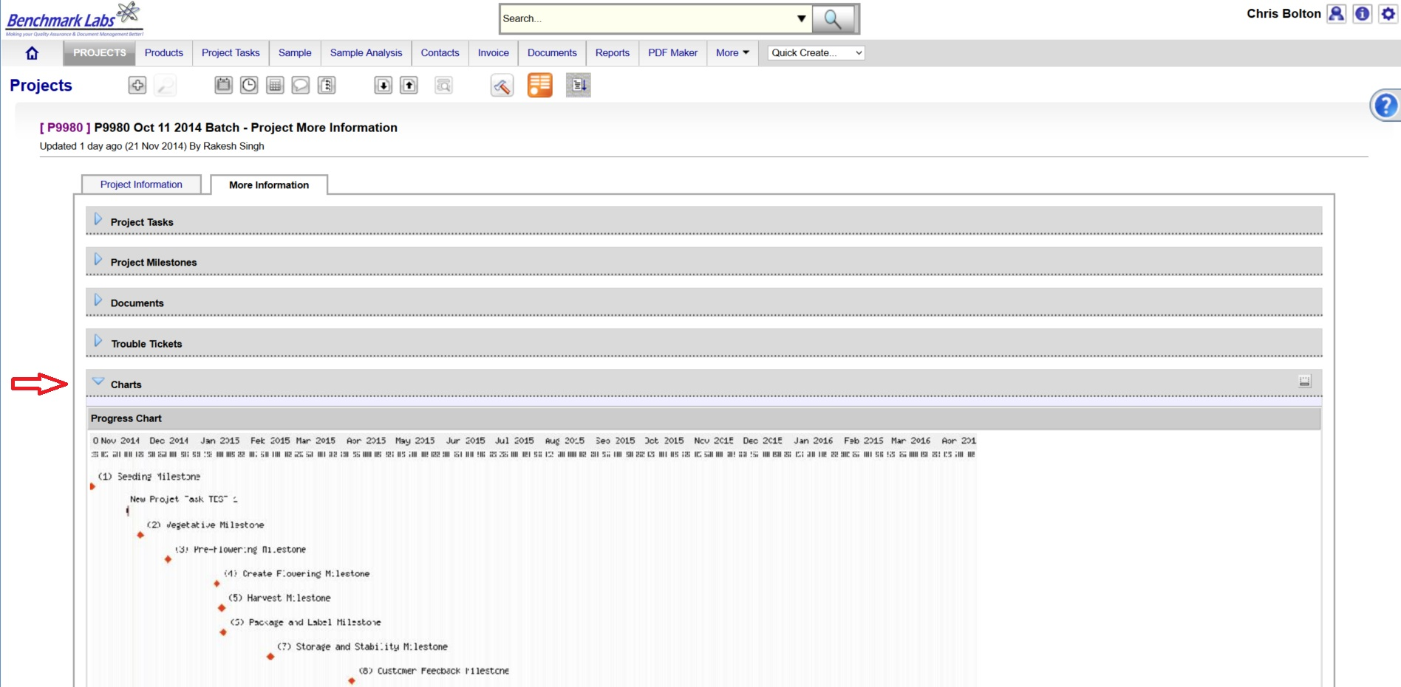
PLEASE NOTE: Clicking the GANTT Chart will open a new Browser Window. Clicking on the GANTT Chart in this new window will enable a “zoom in” on specific Project Milestones dates.
- For each Project Milestone, the Benchmark Labs SYSTEM auto-assigns “Project Tasks” that provide a consistent and logical order of tasks to be performed. Generic Project Tasks are provided by the Benchmark Labs SYSTEM to new SYSTEM Users that are then reviewed and customized by the QAP to better suit their specific Licensed Location.
PLEASE NOTE: All Project Tasks associated with waste collection and fermentation shall be verified by the QAP as required to do so by SYSTEM Work-flow waste collection and fermentation Verification Schedule and Corrective Action Report (CAR) Work-flows.
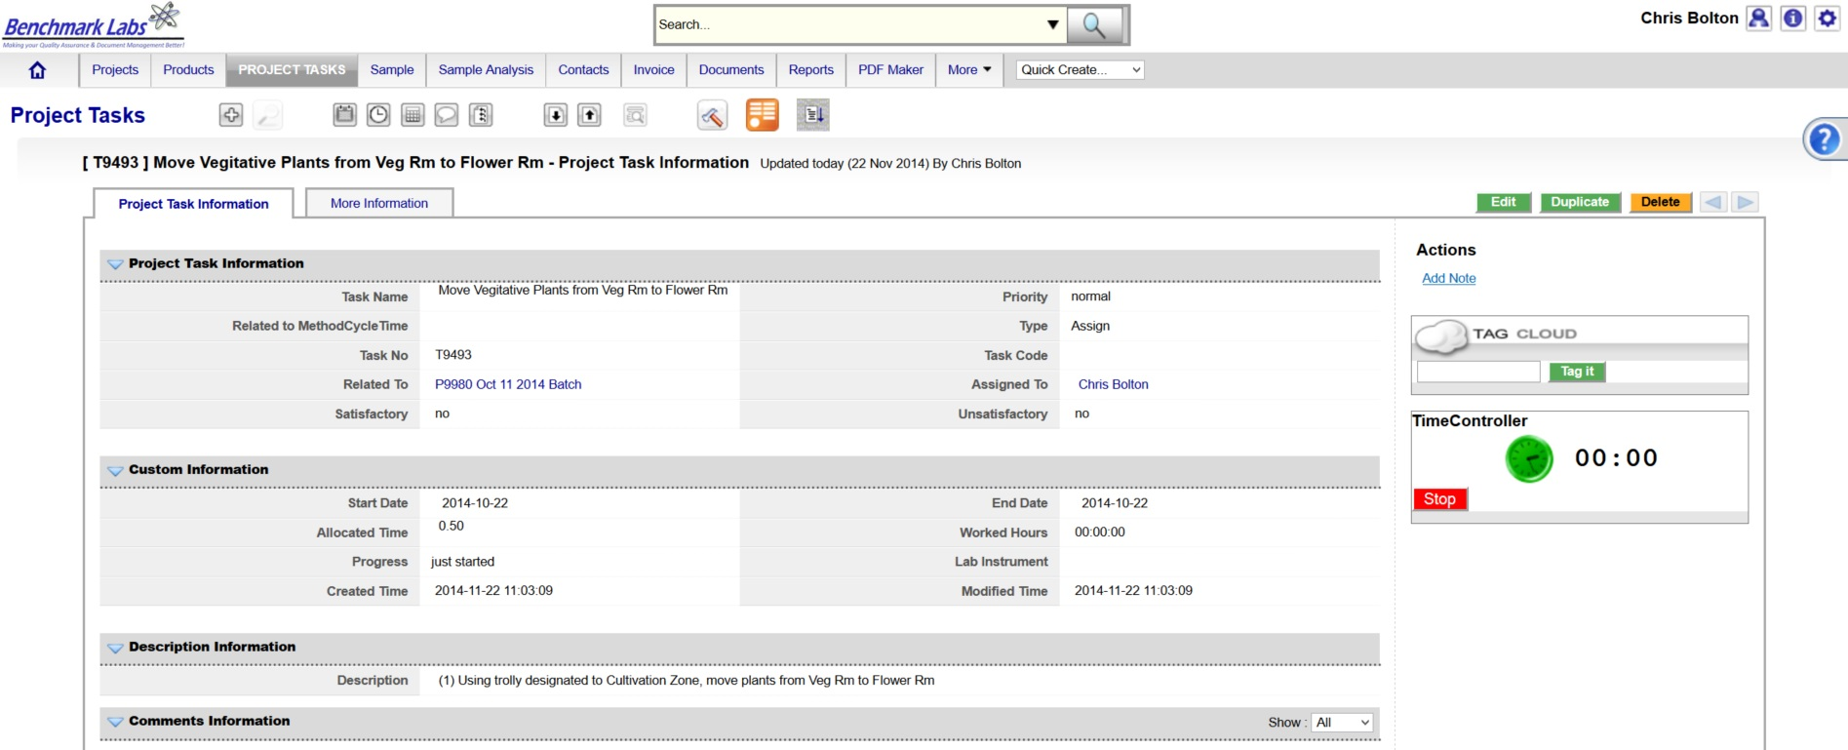
- Project Tasks are then assigned to authorized Users of the SYSTEM. The SYSTEM then provides those Users with notification of a “Start Date” and “End Date” as well as providing an allotment of “Allocated Time” measured in minutes, to complete those assigned tasks:

NOTE: Waste collection and fermentation within the Licensed Location shall be verified by the QAP as required to do so by SYSTEM Work-flow waste collection and fermentation Verification Schedule and Corrective Action Report (CAR) Work-flows.
- The Benchmark Labs SYSTEM, prior to 24 hours of its proposed “Start Date”, shall auto-generate an e-mail to the assigned User notifying them of the Project Task, the Start Date, End Date, area or room that the Task is to take place and a description of work that is to be performed:
From: Licensed Location 123145

Date: 2015-03-05

RE: Collect and destroy waste from Green Zone rooms 1 through 4

A Project Task has been Assigned to You

Details of the Project Task are:

Location: Green Zone
Project: P10028 SOP3700 Waste Collection and Fermentation
Start Date: 2015-03-05
Start Time: 00.09.30
Expected Completion Date: 2015-03-05
Expected Completion Time: 00.16.30
Allocated Time: 420 minutes
Category: QC
Zone: Green
Description: Please visit http://crm.benchmarklabs.com/ndex.php?module=Assets&parent

Thank You
Quality Assurance Manager
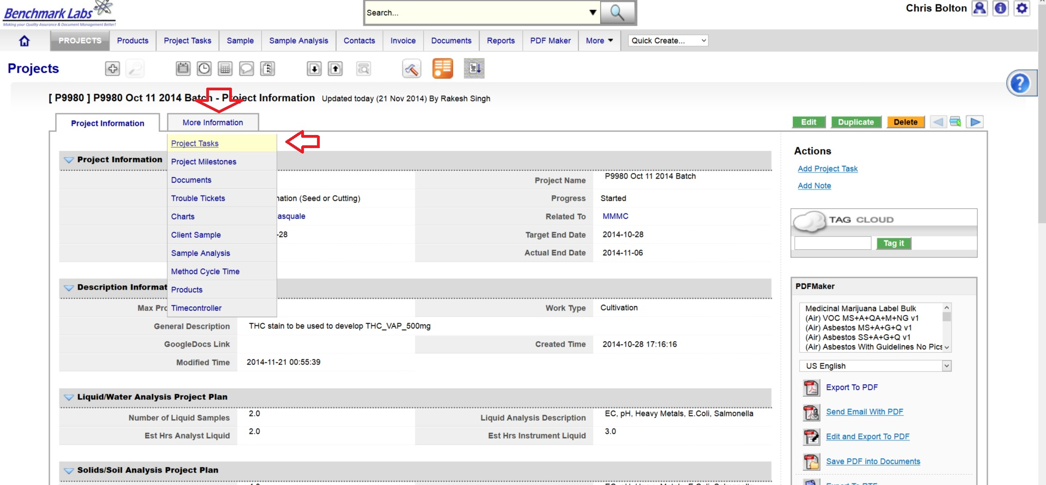
9. The assigned User can then proceed to open the Project Task either by clicking directly on the link found in the email or proceed directly to the Project (e.g., “P9980 Oct 11 2014 Batch”) to open a Project Task from the Project Module directly:
- To open a Project Task simply click on the link below the “Task Name” header:
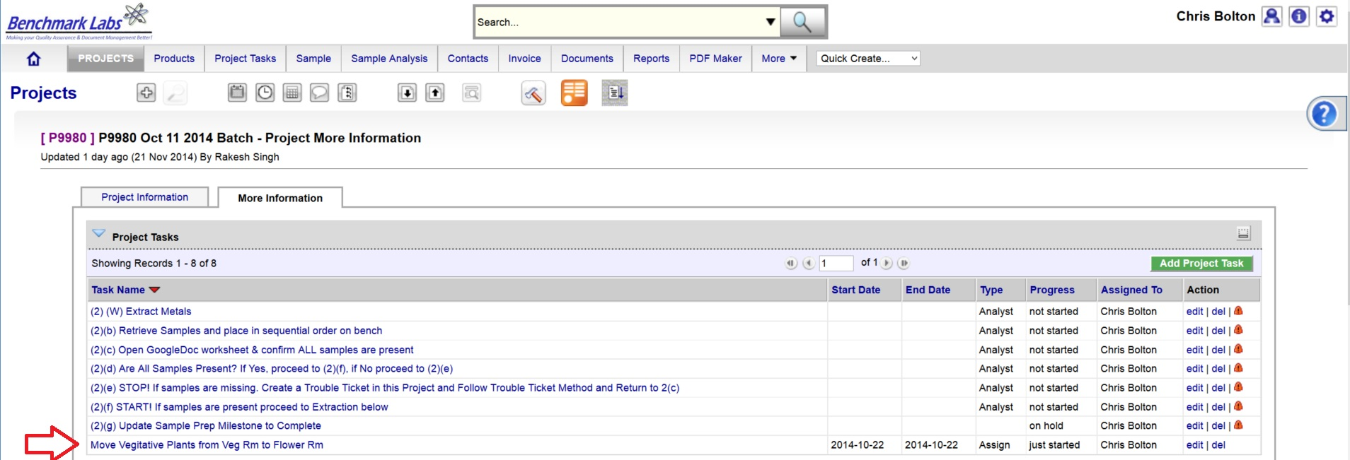
- The clock will then begin to record time spent on this Task until you hit the “Stop Button”:
PLEASE NOTE: Once a Project Task has been opened, the Time-Controller Clock begins recording the time it takes to complete this task. If the time taken is significantly greater or less than the “Allocated Time” value, an automatic Trouble Ticket will open to request explanation for the cycle time difference (the root cause for the variation in time taken to complete Project Task). Therefore, it is critical that you do not open the Task until you are ready to begin and to then focus on the Task until it is done by clicking on the “STOP” button beside the clock.
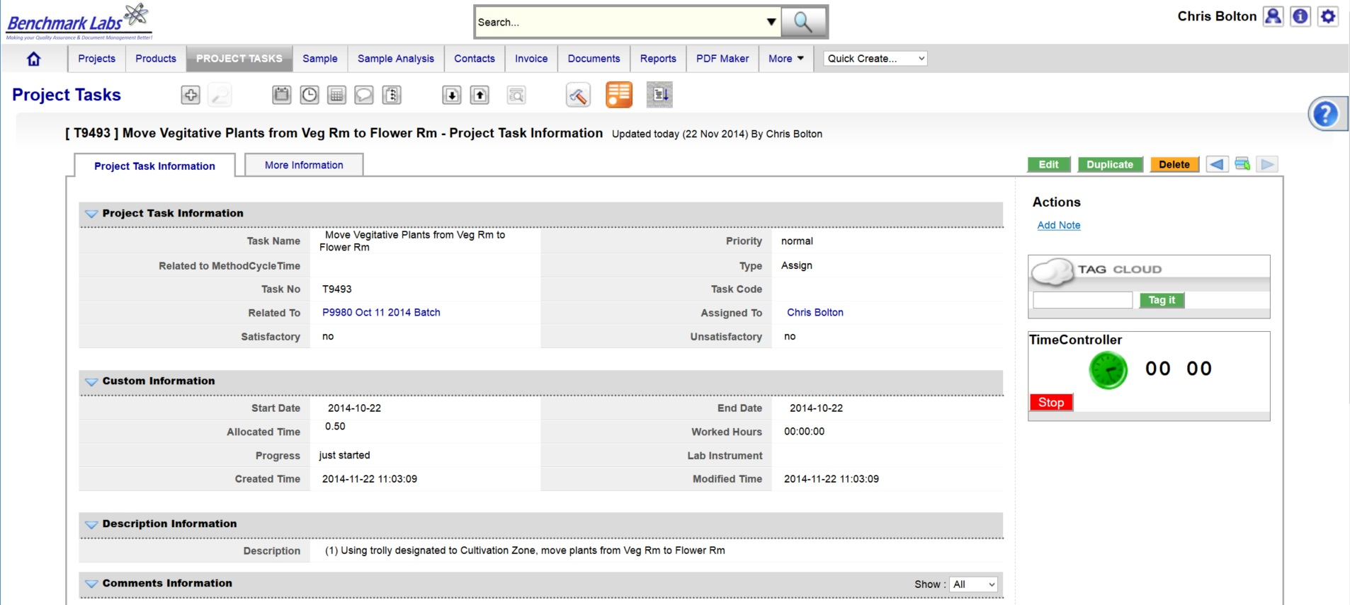
- In the event that the “Description” provided to the assigned User is not sufficient to complete this Project Task, the Assigned User can go directly to the individual SOP Document, by using either the Universal Search Box or using the “Search for” box found in the “Document” Module:

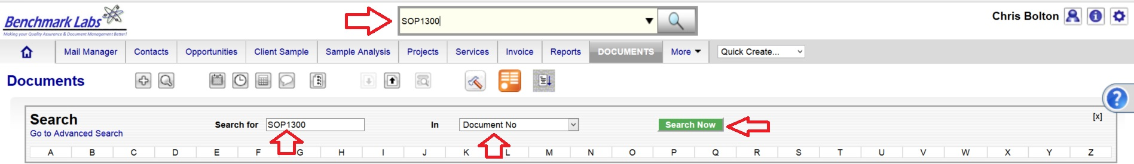
PLEASE NOTE: These SOP documents serve multiple purposes including how to set-up, operate,
maintain and repair, clean and dispose of products when they are no longer usable.
PLEASE NOTE: A document in the SYSTEM can be deleted but only from the view of the average User. All documents Deleted from the SYSTEM are simply moved into “Archive” whereby they are still accessible by the SPIC and Government or Regulatory Auditor.

WASTE COLLECTION AND FERMENTATION PROCESS CONFIRMATION & VERIFICTION PROCEDURE BY QAP:
- Once the waste collection and fermentation Premise Project Task “Progress” status has been saved as “100%,” the Benchmark Labs SYSTEM will auto-generate an email to the QAP with the need to confirm and verify that waste collection and fermentation was completed to acceptable standards as outline below. This procedure is governed by QAPSOP0100.

SUMMARY REPORTS:
- Summary Record Report for a list of all historical “Project Tasks” associated with this SOP can be found by clicking on the “Project Task” Module:
- Summary Record Report for a list of Project Tasks performed for the Facility can be found by clicking on the “Project” Module and clicking on the Projects associated with waste collection and fermentation that are specific to a room or zone, clicking on “More Information” and clicking on “Project Tasks”:
- Summary Record Report of a list of Trouble Tickets associated with this SOP can be found by clicking on the “Trouble Ticket” Module:
- Summary Report of scheduled waste disposal and fermentation and/or maintenance of the equipment associated with this SOP can be found by clicking on the “Calendar” Module:

REFERENCES:
Author | Document Name | Published
Benchmark Labs | SOP0002 Clean Equipment | January 24, 2016
Benchmark Labs | SOP0003 Handling Processing | January 24, 2016
Benchmark Labs | SOP0004 Storage | January 24, 2016

