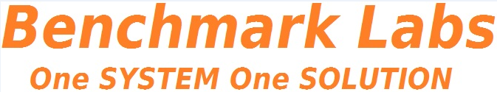
THIS DOCUMENT IS OBSOLETE ON DATE OF PRINTING
SOP-3800 | TITLE: PROCESSING APEKS EXTRACTION | ^{Issued Date: January 24, 2016}
^{Supersedes:} New | TITLE: PROCESSING APEKS EXTRACTION | Effective Date: January 24, 2016
^{Initiator[s]: Zach Yim} | 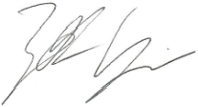 | Signature: Date: January 24, 2016
^{Reviewer:} | ^{Signature:} | ^{Date:}
^{QA Approval:} | ^{Signature:} | ^{Date:}

REVISION HISTORY:
Version # | Description of Changes | CC #
0 | New document

DOCUMENT OWNER: Quality Assurance Person (QAP)

AFFECTED PARTIES: All site staff who utilize the Apeks Super-critical Extractor within the Licensed Location
PURPOSE: To provide a Procedure for Processing Medicinal Marijuana at the Licensed Location utilizing the Apeks Extractor, as well as to confirm a Procedure for Confirmation and Verification for the QAP that this procedure has been performed correctly.

DEFINITIONS:
- “Authorized User” means the person authorized to perform Project Tasks within the Benchmark Labs SYSTEM.
- “Project Milestones” are related to the group of “Project Tasks” associated with step-by-step instructions of extracting Medicinal Marijuana at the Licensed Location.
SCOPE: This Procedure applies to the extraction of Medicinal Marijuana conducted within the Green Zone at the Licensed Location.
KEY WORDS IN SYSTEM: Apeks, extraction, processing, super-critical, harvest, dry, cure, Zone, clone, Section 57
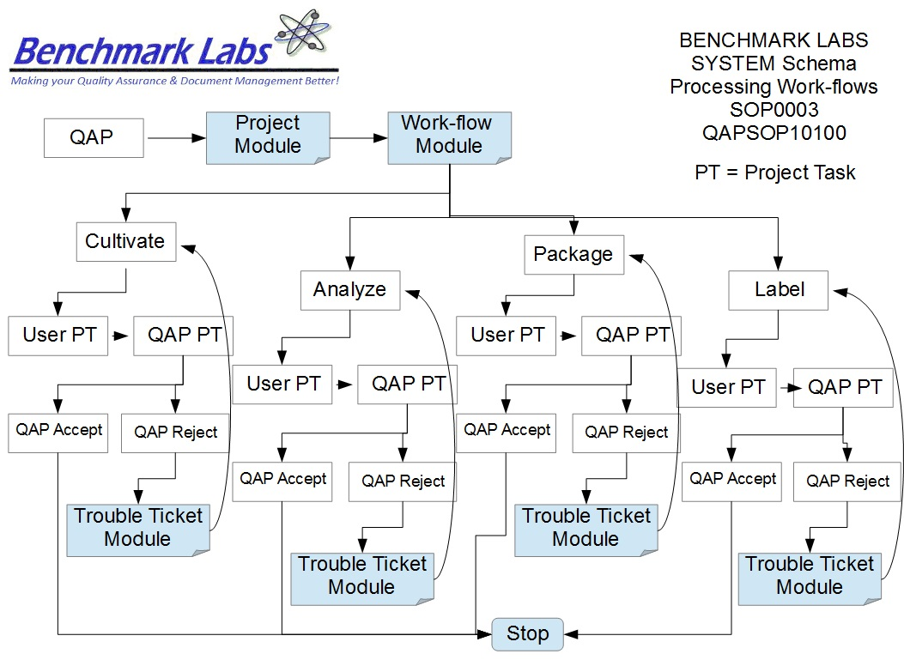

PROCEDURE PROCESS FLOW:
GENERAL RULES AND GMP REQUIREMENTS:
- The rules and GMP requirements apply equally to Contractors and Operations staff.

- All staff responsible for using the Apeks system, will go through an introductory walk through of the facility and will be trained on the specific procedures that take place within the Zone that they will be working in

- All processing of medicinal Marijuana using the Apeks System to be supervised by the QAP, who must also record daily, weekly, monthly, quarterly and annual reports as required by the SYSTEM auto-work-flow tasks.

- Trouble Tickets must be used in the case of any failures in processing protocol observed by the QAP.

- Clean uniforms, factory shoes and hairnets or helmets must be worn as applicable in the particular Zones. (All cleaners working in the Production areas must be familiar with the requirements of SOP0005 Hygiene.)

- Equipment and Instruments used for processing, packaging, analyzing, or labelling shall be clean and in proper working order prior to use. (Refer to SOP0002 Clean Equipment for more details.)

- No food or drink can be taken into any zone during the processing or extracting procedure.

- NON-Medicinal Marijuana Debris or Rubbish shall be collected in either bins or bags and disposed of cleanly in the correct bins. However, any Medical Marijuana Debris or Rubbish must be collected and stored in accordance with SOP0001 Clean Premise.

- Nothing shall ever be picked up from the floor and returned to any work surface without being fully cleaned and sterilized (unless it is a consumable product, in which case it should be disposed of accordingly).

- No container that comes in contact with product shall be placed directly on the floor.

- All processing or extracting Tasks shall be either auto-generated by the Benchmark Labs SYSTEM as “Project Tasks,” or manually entered as “Project Tasks” to ensure proper record entry and to ensure confirmation and verification of cleanliness has occurred.
- The QAP shall receive and complete auto-generated Project Tasks by the Benchmark Labs SYSTEM pursuant to QAPSOP0100 to ensure proper record entry and to ensure confirmation and verification of cleanliness has occurred.

- All problems shall be reported to the QAP and registered using the Trouble Ticket Module of the SYSTEM.

- No processing or extracting activities may be conducted without recording those activities as “Project Tasks” in the Benchmark Labs SYSTEM.

REGULATORY REQUIREMENTS:
- Marijuana for Medical Purposes Regulations, Section 57, Division 4 Good Production Practices, October 2013).

TRAINING REQUIREMENTS: Read, understand and have demonstrated proficiency training (PT) as indicated in the SYSTEM User Profile Record.
RELATED REQUIREMENTS: Read, understand and be familiar with the following related documents:
- SOP3100 Process Seed / Mother Room
- SOP3200 Process Vegetative / Flower Room
- SOP3300 Process Harvest / Cure Room
- SOP3400 Process Lab Analysis Room
- SOP3500 Process Packaging / Label Room
- SOP3600 Process Storage Room
- QAPSOP0100 Confirming and Verification of processing, packaging, analyzing, or labelling & Maintenance Tasks
- SOP0001 Clean Premise
- SOP0002 Clean Equipment
- SOP0004 Handling Storage
- SOP0005 Health & Safety Hygiene
- SOP2600 Vault
AUTO-GENERATED WORKFLOW(S) REQUIRED TO RECORD LOG:
- WKFL0001: Assign Authorized User, Project Task, Record Date/Time Completed
- QAP0001: Assign Authorized User, Inspection Log, Record Date/Time Completed
- CAR0001: Description of Trouble Ticket auto-generated and emailed to QAP
MATERIALS REQUIRED:
- Wireless device to log-in to Benchmark Labs SYSTEM.
- Food Grade Nitrile Gloves, Clean Suit, Boots, Boot Covers, Hair Net, Protective Eye Wear.
- Utilizing only the assigned equipment or instruments to each designated Zone.

SAFETY REQUIREMENTS:
- Refer to the relevant Material Safety Data Sheets for materials being used for processing, packaging, analyzing, or labelling.
- Refer to SOP0004 in relation to Storage to be used for all materials.
- Refer to SOP0005 in relation to Hygiene, Health and Clothing to be used.
- Refer to SOP0006 in relation to Safety during processing, packaging, analyzing, or labelling.

PROCESSING: CO2 EXTRACTION
- Before loading any new product into the extraction vessel, ensure that it has been cleaned properly as per SOP2700
- The settings for the extraction are to be inputted into the HMI (Human Machine Interface) by the QAP, or the technician trained in the use of this instrument. These settings are to be determined prior to use, and differ based on the strain of plant
- Before inserting product into the instrument, ensure that the system is not in use by pressing the “Open Extractor Vessel” button. From there, you will then select the “Open Extractor Vessel” option.
NOTE: The instrument will prompt you to vent all CO2 within the chamber
- When the gauges on both the extractor vessel and the instrument home-screen read “Zero” you may loosen the extractor hammer unions from the top or bottom flange, and pivot it to the open position
NOTE: during this procedure, DO NOT scratch or damage the O-ring seal in any way
- With the extraction vessel now open, you may load the Medicinal Marijuana directly into the chamber. To minimize any spillage, past the ground product through the supplied funnel
NOTE: for the best extractions, the product should be ground to roughly the same consistency as coffee grounds, or about 1.5 μm
- To optimize the amount of product that can be loaded, gently compress the product
- Once the product has been loaded into the vessel, clean all sealing surfaces diligently to remove any excess debris. Pay special attention to the O-ring to ensure it is undamaged
- Before resealing the chamber, grease the threads with the supplied Anti-Seize solution
- Replace the hammer union and tighten to finger tightness, then give it 4-5 hits with the provided rubber mallet
- Once this is accomplished, you may begin instrument start up by turning the chiller on via the main power switch located on the back of the instrument, then set the temperature between 12 and 40 degrees Celsius
- Once the chiller is on, go to the “Manual Screen” on the HMI, and click the “Evacuate” button
- Open valve 10 on the instrument and allow the vacuum pump to run for approximately 2 minutes, then check the gauge to ensure that it has reached -500 mmHg, then close valve 10
- Once this step has been completed, press the message button to acknowledge that evacuation occurred
- If the green start button is not present at the bottom of the home screen, then do one of two things.
- Push the orange button on the bottom of the home screen that says maintenance is required, and this will then turn into a green start button.
- Push the green button on the top right corner of the screen that says “Return to Auto Mode”, and then a green start button will appear on the bottom of the home screen.
- Verify the chiller is on and target temperature is set between 55°F and 100°F
- Verify that a 50-lb, 75-lb or 100-lb cylinder of CO2 with a sufficient amount of CO2 is connected to the system. Any time the bottle has less than 400psi, it is considered low.
- Verify that material is loaded into extraction vessel and extraction vessel is properly closed
- The system can be run with no material in the extraction vessel. This can be used as a way to clean the stainless steel tubing upstream of the separation vessel.
- Verify that the Separator vessels are both closed and sanitary clamps are tight (clamps are considered tight when there is a 1/16-in to 1/8-in between opposing sides of the clamp)
- Press the Start button on the home screen, Figure 29.
- After pressing start the system will prompt the operator to;
- Set Extractor Pressure (between 900-psi and 1900-psi)
- The recommended extractor pressure is between1000 and 1800 psi
- Set the System Run Time (between 1-hour and 48-hours)
- The recommended run time is 2-3 hours per pound of material
- Verify the Extractor is properly closed
- Verify the Separator is properly closed
- Close Valve 10
- Open the CO2 Bottle
- If you have a single extraction vessel, 5L, or 20L, the system will start filling the vessels with CO2 to the target extractor pressure.
- If you have two extraction vessels, 5Lx5L, or 20Lx20L the screen will prompt you to choose which extraction vessel you will be using, either a (Extractor A only), b (Extractor B only) or c (both extractor A and B at the same time.
- After choosing which extraction vessel(s) you will be using, the screen will prompt you to close and/or open valves 3A and 7A or 3B and 7B depending on which extraction vessel(s) you chose to run.
- Then the system will start filling the vessels with CO2 to the target extractor(s) pressure.
- During the filling stage the Home Screen will display a blue box labeled “Filling” to inform the operator of the systems current activities.
- Once the target extractor pressure is reached, the system information box will change from “Filling” to “Running”. An additional information box will appear indicating the direction of the flow, either “Forward Flow” or “Reverse Flow”.
- The system routinely switches the flow direction to keep the filters from clogging with plant material and to prevent the CO2 from forming flow channels inside the plant material.
- The system will continue in run mode until it reaches the target run time, at which point it will begin recovering the CO2 into the CO2 cylinder. The information box will switch from “Running” to “Recovering”.
- The system will prompt the operator to turn up the chiller/heater to 110-F. This helps to speed up the recovery process.
- It is not a required step, the system will recover without turning up the temperature or acknowledging the message.
- Note that increases the chiller/heater temperature also increases the temperature of the oil in the vessels. The system will provide message boxes to instruct the operator through the final shut collection cup. At the end of recovery the system will have approximately 100-psi in all the down process. The prompts are; Close the CO2 cylinder
- Open Valve 10.
- Once the operator acknowledges that the CO2 cylinder and Valve 10 are closed, the system will open all valves, vent any trapped CO2 and wait for the next command.
- At this point, the extraction is complete, you can remove the spent material and clean the instrument

PLEASE NOTE: All equipment or instrumentation used for extraction purposes within the MMPR BROWN ZONE is to be recorded as an “Asset” in the Benchmark Labs SYSTEM pursuant to SOP0002 and carry an easy to identify specific Zone Colour Tag and marked “MMPR Brown Zone” using Black Sharpie Pen.
PLEASE NOTE: ONLY AUTHORIZED USERS AND STAFF ARE PERMITTED TO RECEIVE AND PERFORM extraction PROJECT TASKS WITHIN THE MMPR ZONES.
PLEASE NOTE: BEFORE ANY PROCESSING ACTIVITY TAKES PLACE ENSURE THAT each area or room is clean and tidy, that all surfaces have been effectively sanitized, and that the Zone itself will is left in a condition that will not contaminate or otherwise introduce extraneous substances into the Medicinal Marijuana Processing Procedure SOP0003.
PLEASE NOTE: That all Premise extraction Procedures for the Brown Zone shall require that any Medicinal Marijuana related debris or trash that is found shall be retrieved and placed into a Debris Bag and recorded directly into the Benchmark Labs SYSTEM – as such, it can NEVER be disposed of in the garbage as would NON-Medicinal Marijuana debris or trash AS PER SOP0001 CLEAN PREMISE.
EXTRACTION PROCEDURE WORKFLOWS
- The step-by-step procedure for extraction of Medicinal Marijuana is provided as individual work-flows within the Benchmark Labs SYSTEM:
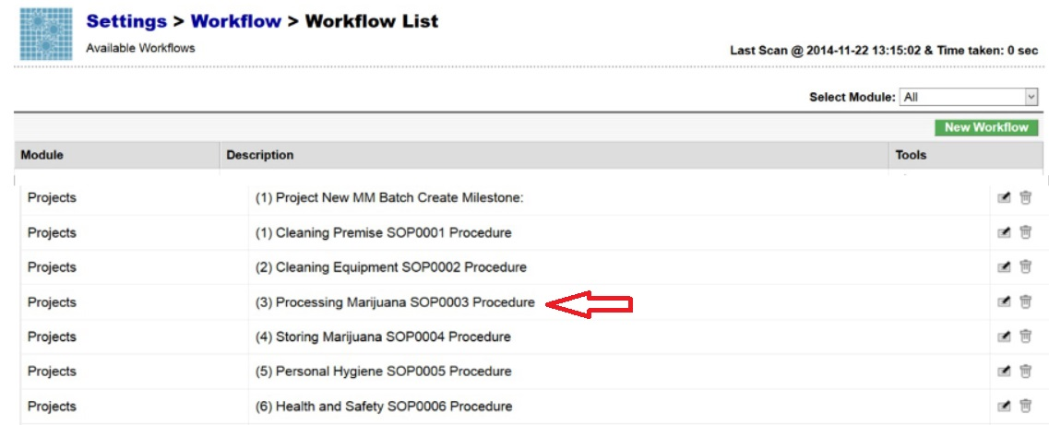
- The Benchmark Labs SYSTEM work-flows represent the Licensed Producers SOPs procedures that have been reviewed and accepted by the QAP for each processing area at the Licensed Location, as seen in the example below
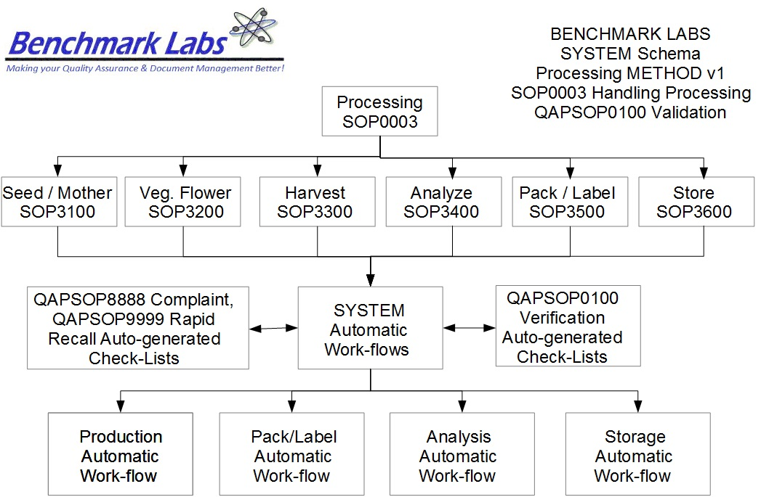

- The Benchmark Labs SYSTEM auto-generates these work-flows upon the creation of a new Batch/Lot of Medicinal Marijuana. This is done through the creation of a new “Project” within the Benchmark Labs SYSTEM that then auto-generates a unique Project Number to provide for a unique set of records associated with that particular Batch/Lot at this Licensed Location:
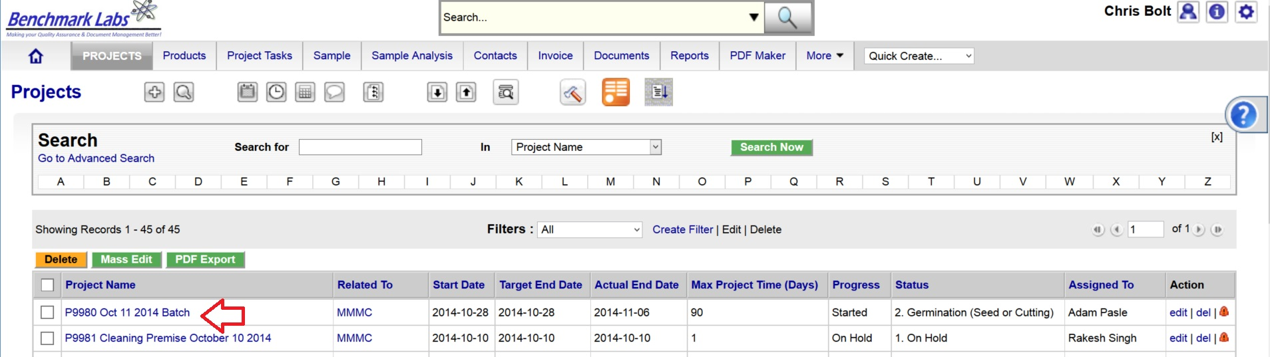
- Once a new Project has been entered into the Benchmark Labs SYSTEM, the SYSTEM auto-generates a series of “Project Milestones” associated with the procedure of extracting Medicinal Marijuana and assigns. These “Project Milestones” have estimated dates of completion to assist with Project planning and allocation of resources including personnel, assets and sundry supplies:
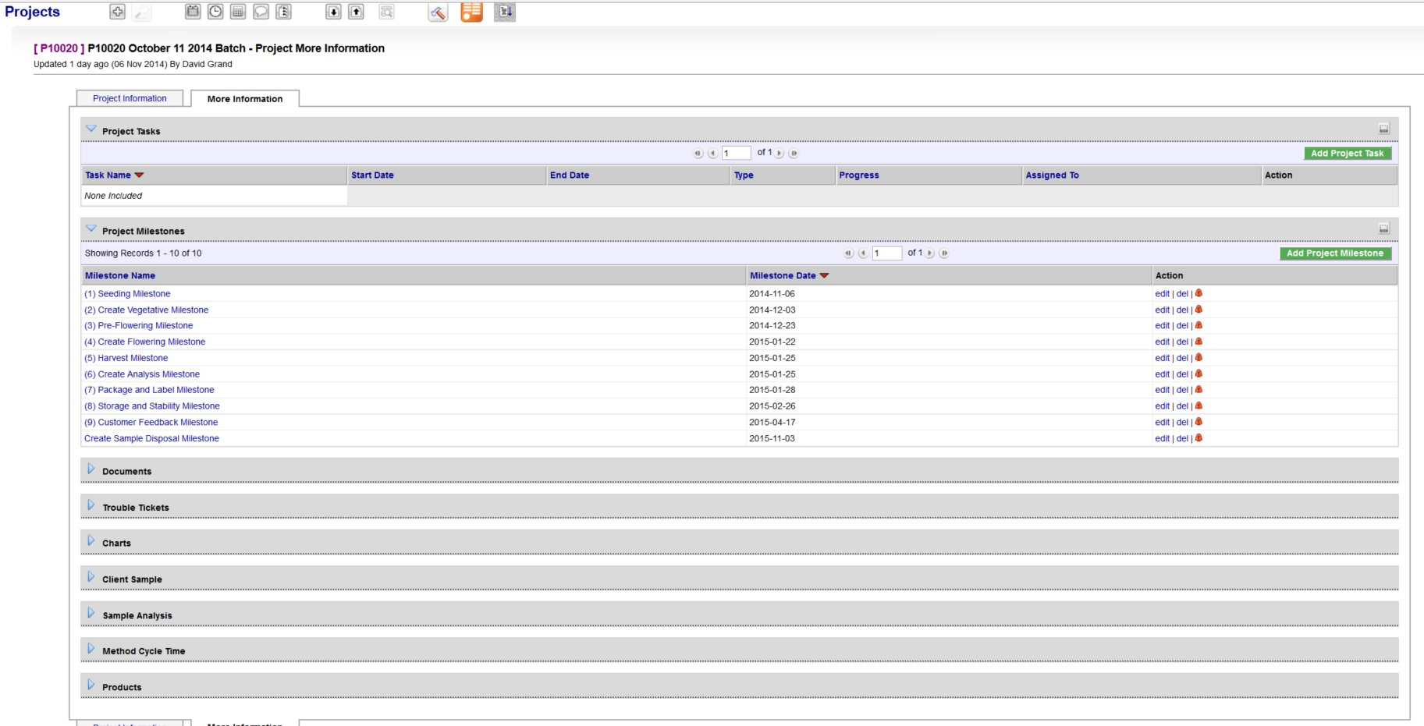
- A GANTT Chart Calendar showing the scheduled completion date of each Milestone is provided by clicking on the arrow symbol next to the “Charts” heading:
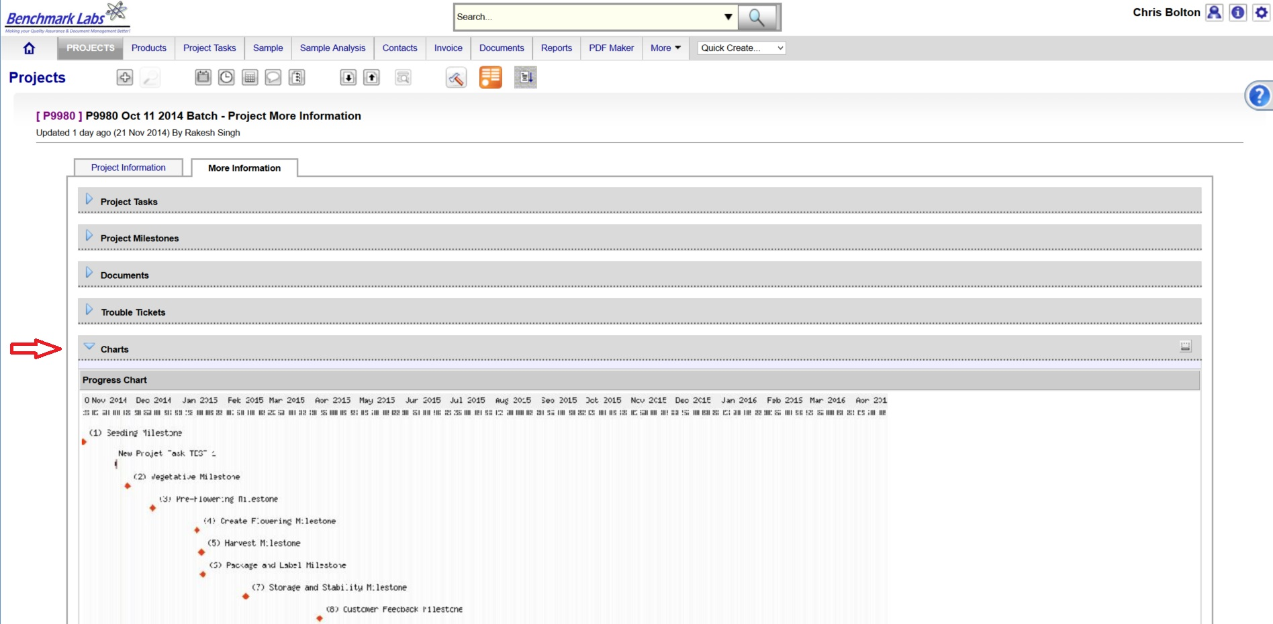
PLEASE NOTE: Clicking the GANTT Chart will open a new Browser Window. Clicking on the GANTT Chart in this new window will enable a “zoom in” on specific Project Milestones dates.
- For each Project Milestone, the Benchmark Labs SYSTEM auto-assigns “Project Tasks” that provide a consistent and logical order of tasks to be performed. Generic Project Tasks are provided by the Benchmark Labs SYSTEM to new SYSTEM Users that are then reviewed and customized by the QAP to better suite their specific Licensed Location.
PLEASE NOTE: All Project Tasks associated with extraction shall be verified by the QAP as required to do so by SYSTEM Work-flow Extraction Verification Schedule and Corrective Action Report (CAR) Work-flows.
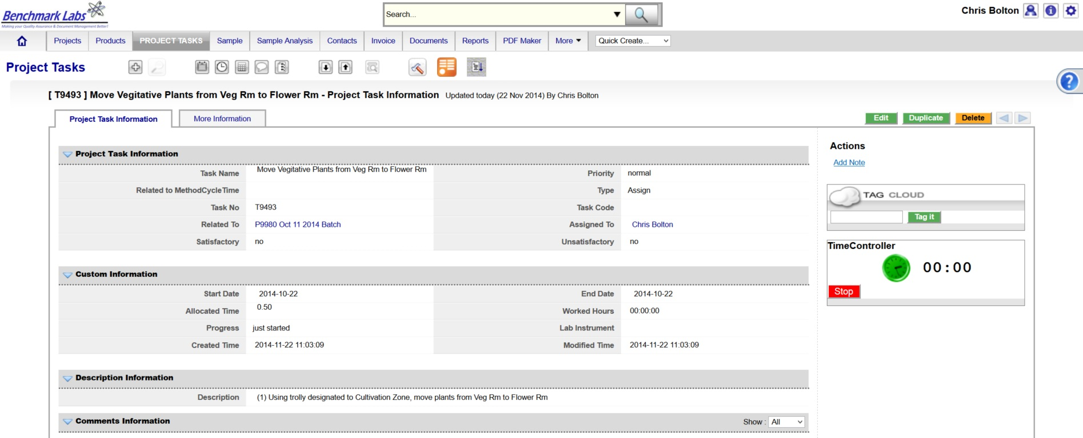
- Project Tasks are then assigned to authorized Users of the SYSTEM. The SYSTEM then provides those Users with notification of a “Start Date” and “End Date” as well as providing an allotment of “Allocated Time” measured in minutes, to complete those assigned tasks:

- The Benchmark Labs SYSTEM, prior to 24 hours of its proposed “Start Date”, shall auto-generate an e-mail to the assigned User notifying them of the Project Task, the Start Date, End Date, area or room that the Task is to take place and a description of work that is to be performed:
From: Licensed Location 123145

Date: 2015-03-05

RE: Perform total THC extraction via the Apeks system

A Project Task has been Assigned to You

Details of the Project Task are:

Location: Harvest Cure Room
Project: P10028 SOP3800 Handling Harvest Cure Room
Start Date: 2015-03-05
Start Time: 00.09.30
Expected Completion Date: 2015-03-05
Expected Completion Time: 00.12.30
Allocated Time: 180 minutes
Category: QC
Zone: Brown
Description: Please visit http://crm.benchmarklabs.com/ndex.php?module=Assets&parent

Thank You
Quality Assurance Manager

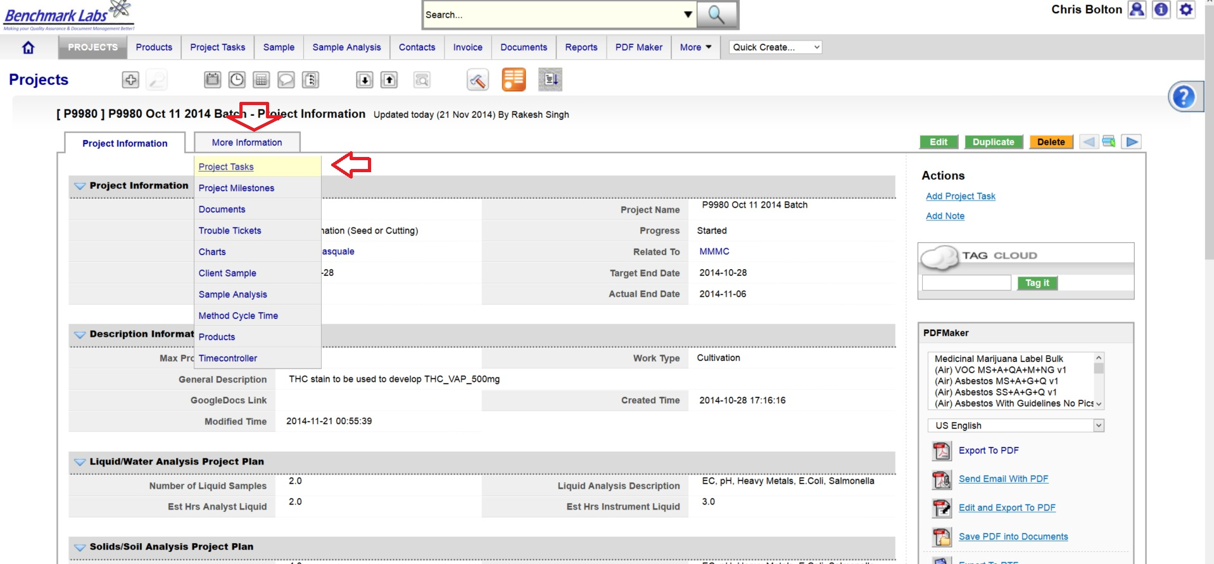
9. The assigned User can then proceed to open the Project Task either by clicking directly on the link found in the email or proceed directly to the Project (e.g., “P9980 Oct 11 2014 Batch”) to open a Project Task from the Project Module directly:
- To open a Project Task simply click on the link below the “Task Name” header:
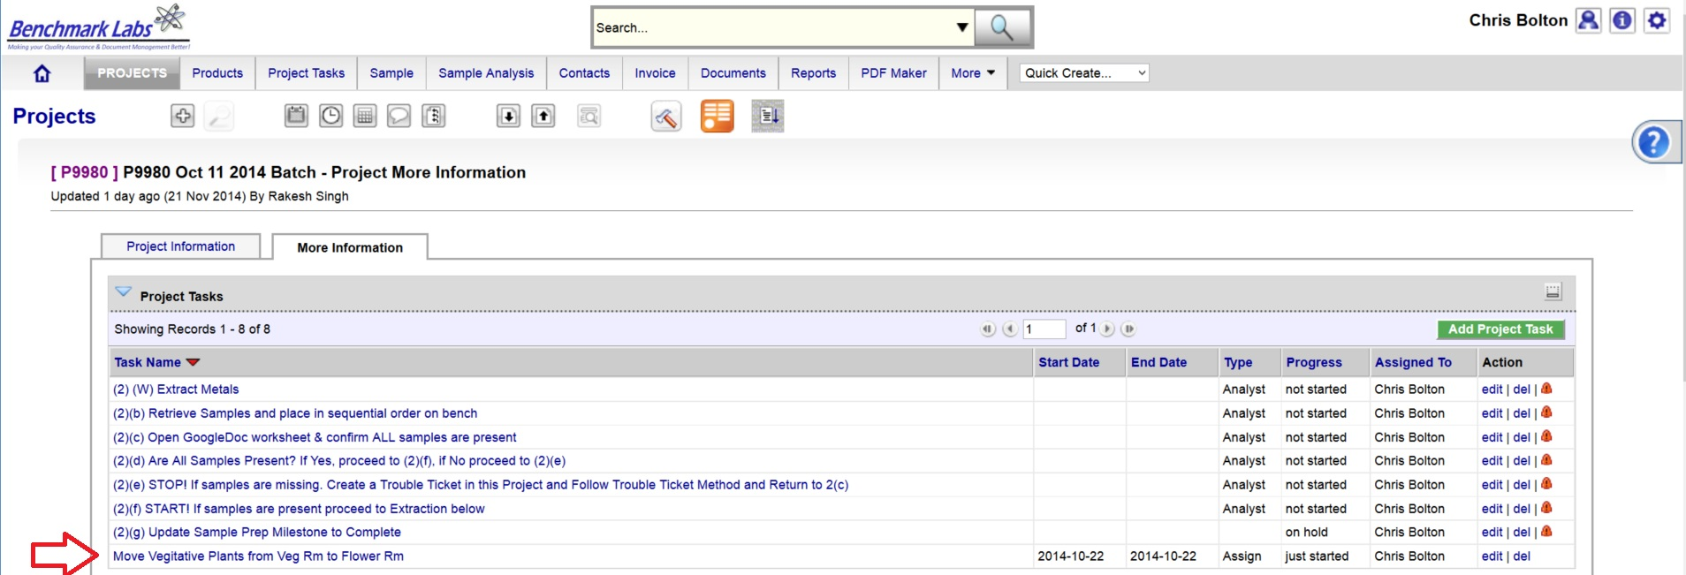
- The clock will then begin to record time spent on this Task until you hit the “Stop Button”:
PLEASE NOTE: Once a Project Task has been opened, the Time-Controller Clock begins recording the time it takes to complete this task. If the time taken is significantly greater or less than the “Allocated Time” value, an automatic Trouble Ticket will open to request explanation as for the cycle time difference (the root cause for the variation in time taken to complete Project Task). Therefore, it is critical that you do not open the Task until you are ready to begin and to then focus on the Task until it is done by clicking on the “STOP” button beside the clock.
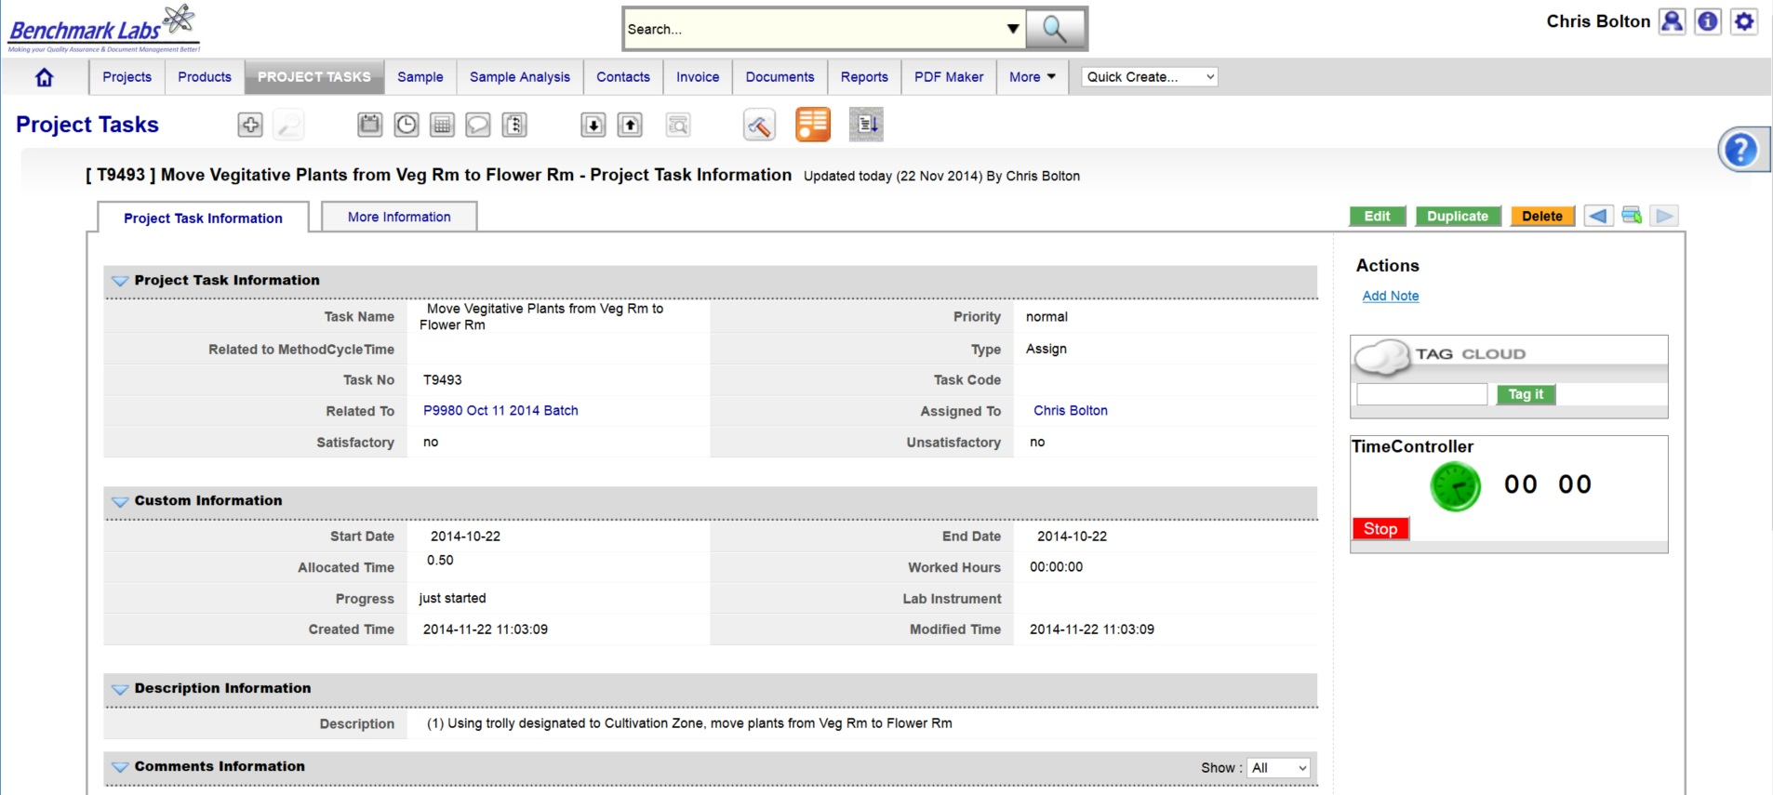
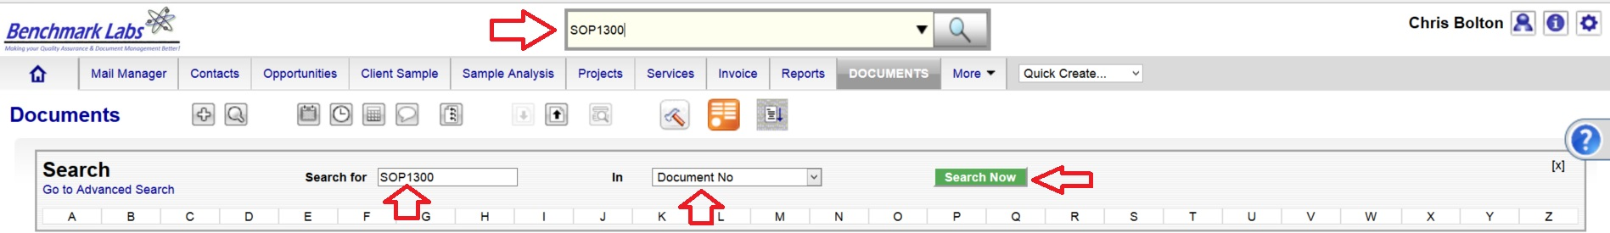
- In the event that the “Description” provided to the assigned User is not sufficient to complete this Project Task, the Assigned User can go directly to the individual SOP Document, by using either the Universal Search Box or using the “Search for” box found in the “Document” Module:

PLEASE NOTE: A document in the SYSTEM can be deleted but only from the view of the average User. All documents Deleted from the SYSTEM are simply moved into “Archive” whereby they are still accessible by the SPIC and Government or Regulatory Auditor.
PROCESS EXTRACTION CONFIRMATION & VERIFICTION PROCEDURE BY QAP:
- Once the Extraction Project Task “Progress” status has been saved as “100%” the Benchmark Labs SYSTEM will auto-generate an email to the QAP the need to confirm and verify it was completed to acceptable standards as outline below. This procedure is governed by QAPSOP0100.

SUMMARY REPORTS:
- Summary Record Reports for a list of all historical “Project Tasks” associated with SOP can be found by clicking on the “Project Task” Module:
- Summary Record Reports for a list of Project Tasks performed for a specific area or zone (e.g., Harvest room) can be found by clicking on the “Project” Module and clicking on the Project associated with extraction in that specific room or zone, clicking on “More Information” and clicking on “Project Tasks”:
- Summary Record Report of a list of Trouble Tickets associated with this SOP can be found by clicking on the “Trouble Ticket” Module:
- Summary Report of scheduled extraction associated with this SOP can be found by clicking on the “Calendar” Module:
REFERENCES:
Author | Document Name | Published
Benchmark Labs | SOP0003 Handling Processing | January 24, 2016
Benchmark Labs | SOP2700 Apeks System Cleaning | October 2015

